CHAPTER-I
INTRODUCTION

Bangladesh is an agricultural based country and its population is too large. About 120 million people lives in rural sector. 25% peoples of the country are directly engaged in livestock sector, and 50% percent peoples are partly associated in livestock production. Agricultural generated 39% of the GDP and the share of the livestock sub-sector 28% (Brammer et al., 1996). Livestock population and poultry population in our country are 47.51 million and 245.89 million respectively(BLRI, 2007). Now-a-days microbes act as a protein producer. Microbes are used as source of food either directly or as a feed through use in pisciculture and poultry farming. Of all the microbes, yeast has been commercially exploited most, for the production of alcohol, vitamins and more recently single cell protein (Nickerson et al., 1965). Yeast is very rich nutritive value of protein and has no toxic substance like other microorganisms like bacteria. Yeast has been used successfully for certain animals such as horses, cows, and as feed for poultry (Rosales, 1984). Baker’s yeast (Saccharomyces cerevisiae) is also interesting as single cell protein because it could provide 53% proteins from molasses substrate (Wain-Wright, 1992).Yeast is one of the potential high quality protein sources because its protein content is high and consists of all essential amino acids for animals. It is known that yeast cell contain high level of lysine and moderate amount of methionine. Saccharomyces cerevisiae contains Lysine 7.7%, methionine 1.7%, valine 5.3%, leucine 7.0%, isoleucine 4.6%, phenylaline 4.1% and Tryptophan 1.0% (Riviere, 1977).These essential amino acids which are limited in plant sources but huge in yeast. Besides digestibility and biological value of Saccharomyces cerevisiae in Rat is 81% and 59% respectively (Riviere, 1977). So yeast supplements will be blessed for the livestock and poultry nutrition. Out of the twenty nutritionally occurring amino acids, L-Lysine is one of the essential (histidine, isoleucine, leucine, lysine, methionine, phenylalanine, threonine, tryptophan and valine) and commercially important amino acids, found in naturally occurring proteins of all living organisms. Lysine is synthesized in Saccharomyces cerevisiae baker’s yeast from a-ketoglutarate via a-aminoadipate in a linear pathway in which eight enzymatic reactions are involved. Some of the enzymes which catalyze the first four steps are located in the mitrocondia, whereas the rest are cytosolic (Kamel et al.,1993).Lysine biosynthesis is regulated by the amino acid general control so that some of the genes are subjected to derepression by starvation for several amino acids, including lysine (Hinnebusch, 1992). The synthesized lysine is stored in vacuoles for protein biosynthesis but cannot be used as a carbon or nitrogen source (Watson, 1976). When a-aminoadipate is added as a nitrogen source, the cells cannot grow (Winston, 1982), even if another nitrogen source is added. Therefore, a lysine overproducer needs to be resistant to high concentrations of both lysine and the intermediate metabolic a-aminoadipate. Its major commercial form is L-Lysine-HCL (L-Lysine monohydrochloride) (Liebl et al., 1991). It is mainly used as a feed additive in the animal feed industry, mixed with various common livestock such as cereals which do not contain sufficient levels of L-Lysin for the livestock’s nutritional requirement, in especially for single-stomach (monogastric) animals like poultry and swine. After hatching, the broiler chicks are exposed to environmental, pathological and nutritional stress. Supplementation with exogenous nutrients such as lysine provides benefits to growing chicks (Plavnik et al., 1989; Jones et al., 1992).
Beet or cane molasses, the main substrate used in yeast production plants. These materials were selected for two main reasons: first, yeasts grow very well using the sugars present in the molasses and second, they were economically interesting since they were a waste product coming from sugar refineries without any other application (Garre et al., 2009). Usually, molasses contain between 65% and 75% of sugars, mainly sucrose (Hongisto and Laakso, 1978); but the composition was highly variable depending on the sucrose-refining procedure and on the weather conditions of that particular year. Sucrose was extracellularly hydrolysed by yeasts in two monosaccharides, glucose and fructose, which were transported to and incorporated into the yeast metabolism as carbon sources. However, molasses were deficient in other essential elements for yeast growth. One of them was nitrogen since its molasses content was very poor (less than 3%). Yeasts could use some of the amino acids present in molasses, but addition of nitrogen sources was needed, generally in the form of ammonium salts or urea. Magnesium and phosphate elements were also supplemented in salt forms. Finally, three vitamins (biotin, thiamine and pantothenic acid), required for fast growth, must be supplemented since their content in molasses was also very low (Oura, 1974; Woehrer and Roehr, 1981). Another negative aspect of molasses being used as a substrate to produce yeasts was the presence of different toxics that could affect yeast growth. Variable amounts of herbicides, insecticides, fungicides, fertilizers and heavy metals applied to beet or cane crops could be found in molasses and in different stocks. All these toxics could decrease yeast performance by inhibiting growth (Perez-Torrado et al., 2005). In fact, a common practice in yeast plants was to mix different stocks to dilute potential toxics. The effects of molasses composition on yeast growth had been recently analyzed at molecular level by determining the transcriptional profile of yeast growing in beet molasses and by comparing it to complete synthetic media (Shima et al., 2005). The results revealed that yeast displays clear gene expression responses when grown in industrial media. Thus it could be concluded that molasses were far from being an optimal substrate for yeast growth. Another interesting conclusion drawn was that molecular approaches can be especially suited to gain insight into the yeast biomass production process. In the last years, the price of molasses had increased because of their use in other industrial applications such as animal feeding or bioethanol production (Arshad et al., 2008; Kopsahelis et al., 2009; Xande et al., 2010), thus rendering the evaluation of new substrates for yeast biomass propagation a trend topic for biomass producers’ research. New assayed substrates include molasses mixtures with corn steep liquor (20:80), different agricultural waste products (Vu and Kim, 2009) and other possibilities as date juice (Beiroti and Hosseini, 2007) or agricultural waste sources, also called wood molasses, that could be substrate only for yeast species capable of using xylose as a carbon source.
In Bangladesh, the cost of yeast is comparatively high. If this yeast is cultured in the locally available media like molasses then it is possible to produce yeast in low cost as the price of molasses is low. Besides, yeast can be use as a protein source of poultry. The use of yeast as a feed ingredient will help to increase the immunity level of the poultry. Beta-glucans derived from yeast cell wall are promising alternatives to antibiotics, as they have been shown to improve growth performance and stimulate the immune system of immature broilers (Rathgeber et al., 2007). If molasses use as a media for yeast production, it will be cost effective and beneficial for the farmers.
This study is conducted for following purposes:
- To produce low cost yeast from locally available resources.
- To estimate Crude Protein percentage of the locally available resource based yeast.

CHAPTER-II
REVIEW OF LITERATURE

Acourene et al. (2007) reported that the objective of this study is the use of dates like substrate for the production of Saccharomyces cerevisiae. The study of the kinetics of growth of four strains of Saccharomyces cerevisiae shows that SDB stain gives best results to know, a generation time reduced, a high growth rate and a high quantity of biomass. The results obtained on fermentation containing molasses and more practically those of the medium of fermentation in Fed-batch show that date musts more practically those of the offal’s of Deglet-Nour and Tinissine give yields in biomass raised compared to the medium of fermentation containing molasses. Nevertheless, the enrichment of these musts with nitrogen, phosphorus and vitamins is necessary in order to improve the yield in biomass and the force of levy. For this purpose the use of the sulfate of ammonia and urea with 50-50% improve of more than 36%, the yield in biomass compared to urea. On the other hand, the use of ammonium phosphate improves it from 38 to 55%. As regards the vitamin source, it is not necessary to bring vitamins during fermentation in spite of a light improvement of the yields in biomass is more than 6% by adding 0.6mg/l of thiamin.

Albert et al. (1969) stated that Yeast Cells grown under optimal and suboptimal concentrations of biotin were analyzed for the amino acid content of their soluble pool and cellular protein. Optimally grown yeast cells exhibited the maximum amino acid content after 18 hr of growth. Biotin-deficient cells were depleted of all amino acid at 26 and 43 hr, with alanine, arginine, aspartate, cysteine, glutamate, isoleucine, leucine, lysine, methionine, serine, threonine, and valine being present in less than half the concentration observed in biotin-optimal cells. At early time intervals, the amino acid pool of biotin-deficient yeast contained lower concentrations of all amino acids except alanine. After more prolonged incubation, several amino acids accumulated to the pool of biotin-deficient yeast, but citrulline and ornithine accumulated to applicable levels. The addition of aspartate to the growth medium resulted in a decrease in the concentration of amino acids in biotin-deficient cells. The pools of biotin deficient yeast growth in the presence of aspartate displayed a marked reduction in every amino acid with the exception of aspartate itself. These data provide evidence that the amino acid content of yeast cells and their free amino acid pools are markedly affected by biotin deficiency as well as supplementation with aspartate, indicating that aspartate plays a major role in the nitrogen economy of yeast underboth normal as well as abnormal nutritional conditions.

Ayanwale et al. (2006) reported that a study was conducted to evaluate the utilization of dried yeast (DY) as a source if lysine in broiler feed. Three feeds, control (0.0% lysine and 0.0%DY), (o.25%lysine) and (0.25%DY) where compounded and tested on 270 Ross broiler chicks for 56 days. Data were collected in the proximate, calcium, phosphorus, amino acid composition of the feeds performance and feed utilization of the broilers. It was observed that substitution of DY for DY for lysine at 0.25% had no significant effect on the proximate, calcium and phosphorus levels of the feeds. The proportion of the amino acids (Valine, arginine, leucine, isoleusine and glutamic acids) increased in DY-feeds compared to the control. Mean final body weight( 1.03+0.12 kg) and body weight gain (0.96+0.11 kg) of DY-feed broilers were significantly higher than (0.90+0.04 kg) and (0.83+o.11kg) of control group but similar to those of lysine-fed broilers(0.98+0.04 kg) and (0.98+0.04 kg) respectively. The results suggest that dried yeast can be used as a lysine source in broiler feeds.

Bechem et al. (2007) mentioned that commercial production using molasses as a raw material. Molasses contain about 50% fermentable carbohydrate (sugar). Big deep tanks of steel or stainless steel are used as containers in the industrial production method. Molasses is diluted to a suitable sugar concentration (15-16%); a small quantity of nitrogen source (e.g. ,ammonium phosphate, urea, ammonium sulphate) and sulphuric acid (H₂so₄) is added in it.P^{H} of this medium is maintained at about 5.0 and an actively growing Saccharomyces cerevisiae culture is added in it. The fermentation starts and is allowed to proceeding for about 24-40 hours at about 25-30⁰C temperature. The yield of ethyl alcohol ranges about 50% of the fermentable sugar concentration present in the medium. The large amount of CO₂ which is produced during the fermentation process as a result of decarboxylation is recovered and compressed to its solid state. The yeast recovered is usually used as an animal feed.

Bekatorou et al. (2006) stated that yeasts(Saccharomyces cerevisiae) have been known to humans for thousands of years as they have been used in traditional fermentation processes like wine, beer and bread making. Today, yeasts are also used as alternative sources of high nutritional value proteins, enzymes and vitamins, and have numerous applications in the health food industry as food additives, conditioners and flavoring agents, for the production of microbiology media and extracts, as well as livestock feeds. Modern scientific advances allow the isolation, construction and industrial production of new yeast strains to satisfy demands of the food industry. Types of commercial food grade yeasts, industrial processes and raw materials are highlighted. Aspects of yeast metabolism, with respect to carbohydrate utilization, nutritional aspects and recent research advances are also discussed.

Chiag et al. (1953) observed that in view of world shortage of dietary protein, and the fact that yeast protein can be used to replace of half of other proteins in the diet of chicks and rats, the possibility of improving the nutritional value of yeasts by raising its protein and methionine content was investigated. Baker’s and brewer’s yeasts are known to be deficient in methionine and cystine, although literature data on percentage present very grately. The methionine content of seven commercial yeasts was found to vary from 0.48 to 0.75% on a dry basis. A fat yeast Rhoodototula gracilis, contained 1.0% of methionine, which is about 20% higher than the commercial Saccharomyces species and nearly double that of the Torula type (0.54%). The protein content and methionine value of yeast where increased by adding more nitrogen salts to the medium. Theoretical precursors of methionine-choline and cystine-added to the medium did not affect the methionine content of yeast.

Gelinas (2011) reported that a review of 236 patents filed between 1900 and 2009, the development of suitable growth media for baker’s yeast was critical to improve its acceptability by the baking industry mainly through reduced cost and improved appearance (pale color). Based on the abandon of patenting activity on artisan yeast production in dough, acceptable commercial baker’s yeast appeared on the North American market around 1920, but probably 5 to 15 year earlier in Europe partly because German inventors were the most active to develop growth media for baker’s yeast. During the same period, grain-based media were replaced by diluted molasses that was cheaper. In the following 20 year, inventors put much energy on molasses clarification and miscellaneous sources of nitrogen to supplement it. Although molasses remains the basic raw material for baker’s yeast manufacturing, alternatives are still sought for this application. In the early patent literature, cases were found where several inventors claimed intellectual property rights for the same invention described in patents filed in different countries and languages, which suggests that only thorough reading of patent specifications may distinguish inventor ship from licenses and thus truly estimate patenting activity.

Gomez-Pastor et al. (2009) mentioned that in contrast to baker’s and brewer’s yeast, seasonal wine production required the development of highly stable dry yeast products. At the end of biomass propagation, wine yeast cells were recovered and dehydrated to obtain active dry yeast ADY. After the maturation step, yeast cells were separated from fermented media by centrifugation, and were subjected to washing separations to reduce non yeast solids, a necessary step because they affected the proper rehydration process of ADY for must fermentation. The separation process yielded a slightly coloured yeast cream containing up to 22% yeast solids. After this step, the yeast cream could be stored at 4°C after adjusting the pH to 3.5 to avoid microbial contaminations. The cream yeast was further dehydrated to 30-35% solids by means of rotary vacuum filters or filter presses. The filtered yeast was usually mixed with emulsifiers prior to its extrusion into yeast strands. The yeast cake was extruded through a perforated plate, while particles were loaded into the dryer and dehydrated to obtain a product with very low residual moisture. Although several types of dryers exist (roto-louvre, belt dryers, spray dryers), the one most commonly used in industry is the fluidized-bed dryer. In this dryer, heated air was blown from the bottom through yeast particles at velocities which keep them in suspension. Air was treated to reduce its water content and to ensure that the yeast temperature did not exceed 35°C or 41°C during drying. Drying times might vary from 15 to 60 min depending on the mass volume and the used conditions. Finally, ADY with less than 8% residual moisture was vacuum-packaged or placed in an inert atmosphere, such as nitrogen and CO2, to reduce oxidation. Depending on the strain, loss of viability was estimated at between 10% and 25% per year at 20°C. For this reason, manufacturers recommend storing ADY at 4°C in a dry atmosphere for a maximum 3-year period.

Haider et al. (2007) reported that the effect of growing yeast Saccharomyces cerevisiae on locally produce Carob Pod extract with respect to single cell protein(SCP) production was assayed. High amount of SCP was achieved after five days of incubation, the percentage of yield being 35.09% (2.36g/L). SCP formation is affected by the level of nitrogen present in the medium; high yield of protein being achieved in fermentation medium containing 0.3% urea in which the percentage of the yield was increased to 41.05% (3.55g/L). The effect of varying nitrogen sources on SCP accumulation was also assayed. Medium containing ammonium phosphate greatly stimulated protein production. The total yield being 5.63 g/L (46%). Conversely medium, containing sodium nitrogen or asparagines had a suppressive effect on SCP production. This evidence clearly suggests that the metabolic versatility of Saccharomyces cerevisiae may be employed in the conversion of low grade material into high SCP product.

Novo et al. (2003) stated that the metabolism of glycogen and trehalose was analysed in a wine yeast strain fermenting at 25 and 13⁰C. Trehalose and glycogen degradation were completed during the lag phase of fermentation. Ammonia was taken up rapidly and once it had been reduced to negligible amounts, the synthesis of trehalose started. Glycogen followed a similar pattern. If trehalose synthesis was taken as a stress indicator, the fermentation at 13⁰C could not be considered stressful because the maximum concentrations are similar at both temperatures. In industrial fermentations, and after a preadaptation in grape must for several hours at 18 ⁰C, the lag phase was reduced significantly, and this may be why trehalose and glycogen were completely depleted at the beginning of the low temperature fermentation. Various preadaptation conditions were tested so that their influence on trehalose and glycogen degradation could be determined. The presence of fermentable carbon sources, such as glucose or fructose, triggered the mobilisation and use of trehalose. However, just increasing the osmotic pressure did not reduce the trehalose content. No such differences were observed in glycogen metabolism.

Reed and Nagodawithana (1988) reported that yeasts had been used by humans to produce foods for thousands of years. Bread, wine, sake and beer were made with the essential contribution of yeasts, especially from the species Saccharomyces cerevisiae. The first references to humans using yeasts were found in Caucasian and Mesopotamian regions and date back to approximately 7000 BC. However, it was not until 1845 when Louis Pasteur discovered that yeasts were microorganisms capable of fermenting sugar to produce CO2 and ethanol. Ancient practices were based on the natural presence of this unicellular eukaryote, which spontaneously starts the fermentation of sugars. As industrialization increased the manufacture of fermented products, the demand of yeast grew exponentially. At the end of the 19th century, addition of exogenous yeast biomass to produce bread and beer started to become a common practice. Wineries were more reluctant to alter traditional practices, and started using exogenous yeast inocula in the 1950’s, especially in countries with less wine tradition (USA, South Africa, Australia and New Zealand). In the 1960’s, yeast biomass-producing plants contributed to the technology of producing large amounts of active dry yeast (ADY), and its use rapidly spread to European countries.

Robert et al. (1975) mentioned that In 18 batch-fermentation, baker’s yeast was grown in an enriched mineral medium, containing 10% by weight glucose, at various p^{H} and temperature levels. The p^{H} and temperature are just two representative engineering variables which and be easily varied at negligible cost. The commercial yeast inoculums .20% by weight or about .16% viable cells, was selected to represent industrial (nonsterile) conditions. Free L-lysine, ethanol, and cell growth were followed in time for each batch run held at a fixed p^{H} and temperature. The maximum free lysine level reached at either 10¹/₂ or 24 hr occurred at a p^{H} of 5 and 32⁰C. At 24 hr, the peak free lysine level, 120 mg/liter, is three times as great as the uncontrolled case, based on an average 3.5% lysine level per cell weight. The greatest measured cell level, .9% by weight in the fermentation broth, or a 5¹/₂ –fold increase over the inoculums, was reached during the 36⁰C and p^{H} 3 run, while the largest measured ethanol value (3%, or 30% conversion by weight from glucose) was achieved during the 28⁰C and p^{H} 6 experiment. The optimal lysine run produced, however, no less than 15% of the maximum cell and 30% of the maximum ethanol levels.

Suhajda et al. (2005) reported that under appropriate conditions yeasts were capable of accumulating large amounts of trace elements, such as selenium, and incorporating them into organic compounds. It had been found that introduction of water-soluble selenium salt as a component of the culture medium for yeasts produced by conventional batch processing results in a substantial amount of selenium being absorbed by the yeast. Using a culture medium supplemented with 30μg/ml sodium-selenite added during the exponential growth phase results in selenium-accumulation in the range of 1200–1400μg/g dried baker's yeast (Saccharomyces cerevisiae) measured by ICP-AES method.. The most important parameters influencing incorporated forms of selenium are pH value and dissolved oxygen level in the culture medium and depending on these the selenium consumption rate of the yeast. A 0.40–0.50 mg/g h-1 specific selenium consumption rate was found to be appropriate to obtain selenium-enriched bakers' yeast of a high quality.

CHAPTER-III
MATERIALS AND METHODS

The experiment was conducted in the laboratory of the Department of Animal Science and Animal Nutrition, PRTC Nutrition laboratory of Chittagong Veterinary and Animal Sciences University.
ORGANISM AND CULTURE:
Yeast (Saccharomyces cerevisiae) was used as inoculums for culturing. Molasses and Urea were used for preparing culture media. Molasses could be used as a raw material for commercial yeast production. In commercial yeast production five types of molasses concentration media were used and other ingredients of each media were constant. Media-1 contained 10% molasses. Media-2 contained 15% molasses. Media-3 contained 20% molasses. Media-4 contained 25% molasses. Media-5 contained 30% molasses. Molasses contain about 50% fermentable carbohydrate. For one liter culture media the ingredients were as follows:-
Table 1; Composition of media (10% molasses) for yeast production
Ingredients | Amount
Molasses | 100 gm
Urea | 1.68 gm
Distilled water | Add to 1000 ml

Table 2; Composition of media (15% molasses) for yeast production.
Ingredients | Amount
Molasses | 150 gm
Urea | 1.68 gm
Distilled water | Add to 1000 ml

Table 3; Composition of media (20% molasses) for yeast production.
Ingredients | Amount
Molasses | 200 gm
Urea | 1.68 gm
Distilled water | Add to 1000 ml

Table 4; Composition of media (25% molasses) for yeast production.
Ingredients | Amount
Molasses | 250 gm
Urea | 1.68 gm
Distilled water | Add to 1000 ml

Table 5; Composition of media (30% molasses) for yeast production.
Ingredients | Amount
Molasses | 300 gm
Urea | 1.68 gm
Distilled water | Add to 1000 ml

Yeast culturing procedures:
- At first the ingredients were dissolved in distilled water in 5 conical flasks and those different concentrations molasses media were autoclaved for sterilization.
- Then p^{H} of those media was adjusted to 5.
- After cooling the media at 30-31⁰c, 1% pure yeast culture were inoculated into the each and every media.
- Few amount of methionine were mixed in each and every media.
- Finally those media were incubated at 31⁰c.
- 15 mg of biotin was added after 24th hour of incubation.
- The growth of the yeast was observed by light microscope in every day for the study of the size, shape and growth of the yeast cells.
- Small amount of sugar was added in every media after 36 hours to avoid nutrient depletion.
- When largest amount of yeast cells were found under microscope (3rd day of incubation) then the media were centrifuged to separate the yeast cells.
- Then the yeast cells of different molasses containing media were weighted.
- Finally estimated CP (%) of each and every sample of different concentrations molasses media.

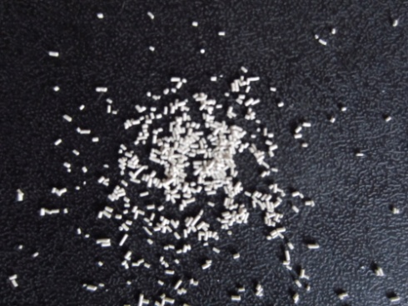
Fig: 1. yeast in naked eye.
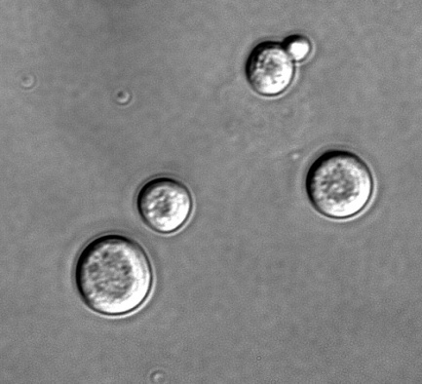
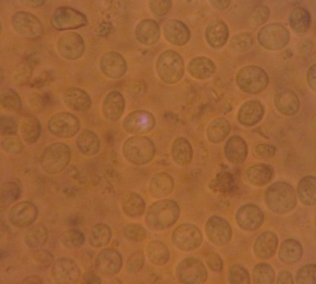
Fig: 2. Yeast cells under light microscope.

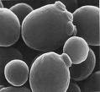
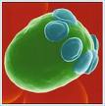

Fig: 3. Yeast cells under electron microscope.
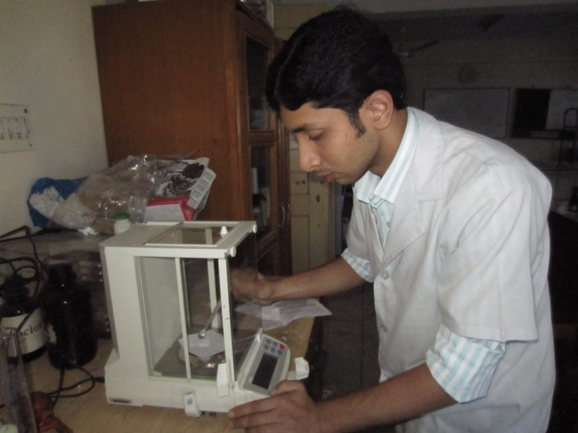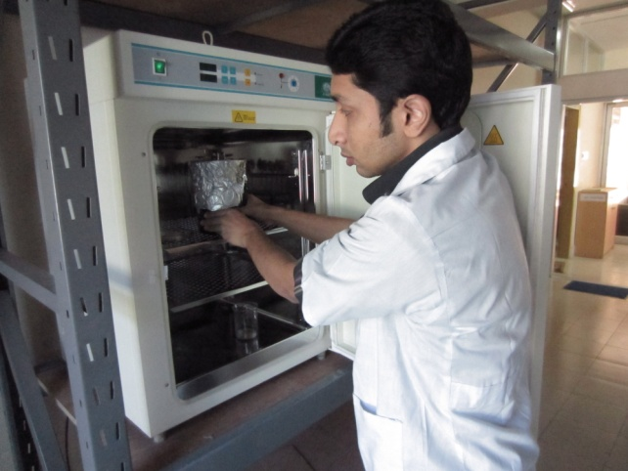

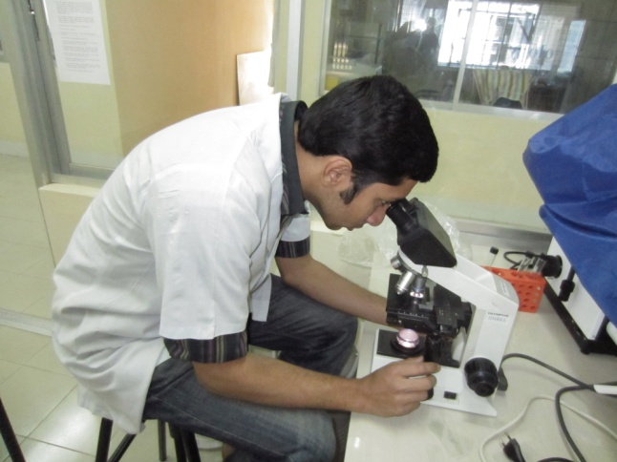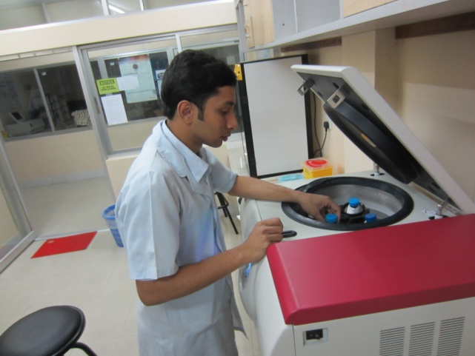

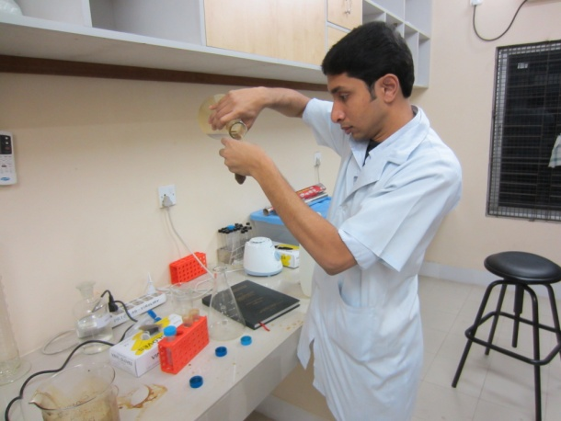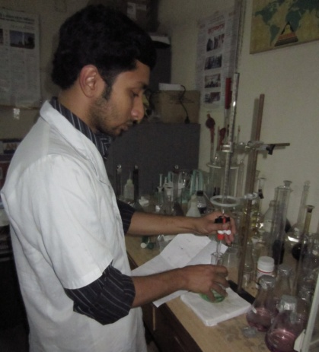

Fig: 4. Activities in CVASU Animal Nutrition Lab. and PRTC Lab.
CHAPTER-IV
RESULT AND DISCUSSION

The yeast cells grow in different concentrations (10%, 15%, 20%, 25% and 30%) molasses media. The obtain result show that the production of yeast cells in different media varies from 7.75 to 10.06%. After this study we will find that which concentration of molasses is better for yeast production.
Table-6: Yield of yeast in different concentrations of molasses.
MEDIA NO. | CONCENTRATION OF MOLASSES | YIELD OF YEAST (%)
01 | 10% | 9.05
02 | 15% | 9.77
03 | 20% | 7.75
04 | 25% | 10.06
05 | 30% | 8.70

Table-7: Crude protein percent in different concentrations of molasses.
MEDIA NO. | CONCENTRATION OF MOLASSES | CRUDE PROTEIN (%)
01 | 10% | 38.52
02 | 15% | 40.23
03 | 20% | 41.1
04 | 25% | 44.52
05 | 30% | 42

Fig: 5. Yield (%) of yeast in different concentrations of molasses.

Fig: 6. CP% of yeast cells in different concentrations of molasses.

Fig: 7. Comparison of yield (%) and CP% of yeast in different concentrations of molasses.
Yeast is a protein source and its production varies in different media. In 10% molasses media production of yeast was 9.05%. In 15% molasses media production of yeast was 9.77%. In20% molasses media production of yeast was 7.75%. In 25% molasses media production of yeast was 10.06%. In 30% molasses media production of yeast was 8.70%. The highest production was in 25% molasses media. To produce an active dry yeast ADY product with acceptable fermentative activity and storage stability, several factors must be taken into account. The drying temperature and rate could be critical for yeast resistance to dehydration and rehydration (Beney et al., 2000; Beney et al., 2001; Laroche and Gervais, 2003). Some studies had shown that cell death during desiccation was strongly related to membrane integrity loss, leading to cell lysis during rehydration (Beney and Gervais, 2001; Laroche et al., 2001; Simonin et al. 2007; Dupont et al., 2010). A gradual dehydration kinetics, which allowed a slow water efflux through the plasmatic membrane and homogenous desiccation, followed by a progressive rehydration during the starter preparation, had been related with high cell viability (Gervais et al., 1992; Gervais and Marechal, 1994¸ Dupont et al., 2010). The amount of cell constituents leaked during rehydration could also be reduced by adding emulsifiers, such as sorbitan monostearate (Chen and Chiger, 1985). Moreover, biomass propagation conditions had a major influence on yeast resistance to dehydration-rehydration. Several cultivation factors could affect cell resistance to desiccation, such as the substrate, growth phase and ion availability (Trofimova et al., 2010).
The crude protein (%) was also varied in different media. In 10% molasses media it was 38.52%. In 15% molasses media it was 40.23%. In 20% molasses media it was 41.1%. In 25% molasses media it was 44.52%. In 30% molasses media it was 42%. The highest cp% was found in 25% molasses containing media.
25% molasses containing media is suitable for production of yeast. In this concentration of molasses the yield (%) is high and crude protein (%) is high. As its protein % is also high in this media, this 25% molasses containing media can be use as commercial media for yeast production.

CHAPTER-V
CONCLUSION

The results of this study indicate that the molasses can serve as a substrate for yeast production by fermentation using pure yeast culture. So the molasses which is the residue of sugar factory can be used in large scale for production of the protein supplement. Protein and essential amino acids are the most important nutrient for poultry and livestock but these are costly items. So, it can easily fulfill the demand. Yeast mostly produces proteins beside this yeast produces enzymes, B-vitamins and other factors to stimulate growth of beneficial bacteria. The yeast cell wall can be used as alternatives to antibiotics. It improves the growth performance and stimulates the immune system of immature broilers. So it can easily use as a feed ingredient. As this yeast stimulate the immune system, it is more effective to protect diseases. The yeast also utilizes oxygen in the digestive tract of animals. Yeast possesses a natural alternative flavor which can improve the palatability of the feed. It contains B-complex vitamins and unknown growth factors, both of which may be essential for the nutrition of specific gastro-intestinal microorganisms and for the host animal metabolism. So yeast can use as a protein supplement. This yeast can be grown easily in 25% molasses media. Besides this molasses is locally available and cost is low. If this low cost molasses is use as a media for the growth of the protein supplement like yeast, it will be beneficial for the farmers.

CHAPTER-VI
REFERENCES

Acourene, S., Khalid, A. K., Bacha, A., Tama, M. and Taleb, B. 2007. Optimization of Baker’s Yeast Production Cultivated on Musts of Dates. J. Appl. Sci. Res. Vol. 3, P. 964-971.
Albert, G., Fazal, A., James, K., Alexander and Isabel J. 1969. Alteration in the amino acid content of yeast during growth under various nutritional conditions. J.Bact. Vol. 98, P. 573-578.
Arshad, M., Khan, Z. M., Khalil-ur-Rehman, Shah, F. A. and Rajoka, M. I. 2008. Optimizatio of process variables for minimization of byproduct formation during fermentation of blackstrap molasses to ethanol at industrial scale. Lett. Appl. Microbiol. Vol. 47, P. 410-414.
Ayanwale, B. A., Ibrahim, M. J. and Aberuagba. 2006. Utilization of Dried Yeast as a Source of Lysine in Broiler Feeds, J. Ani. Vet. Adv. Vol. 5, P. 582-584.
Ayanwale, B. A., Kpe, M. and Ayanwale, V. A. 2006. The Effect of Supplementating Saccharomyces cerevisiae in the Diets on Egg Laying and Egg Quality Characteristics of Pullets. Int. J. Poult. Sci. Vol. 5, P. 759-763.
Bechem, E. E. T., Omoloko, C., Nwaga, D. and Titanji, V. P. K. 2007. Characterization of palm wine yeasts using osmotic, ethanol tolerance and the isozyme polymorphism of alcohol dehydrogenase. Afri. J. Biotechnol. Vol. 6, P. 1715-1719.
Beiroti, A. and Hosseini, S. N. 2007. Production of baker's yeast using date juice. Sheng Wu Gong Cheng Xue Bao. Vol. 23, P. 746-50.
Bekatorou, A., Psarianos, C. and Athanasios A. K. 2006. Production of Food Grade Yeasts. Food Technol. Biotechnol. Vol. 44, P. 407-415.
Beney, L., Martinez, D. M., I, Marechal, P. A. and Gervais, P. 2000. Influence of thermal and osmotic stresses on the viability of the yeast Saccharomyces cerevisiae. Int. J. Food Microbiol., Vol. 55, P. 275-279.
Beney, L. and Gervais, P. 2001. Influence of the fluidity of the membrane on the response of microorganisms to environmental stresses. Appl. Microbiol. Biotechnol. Vol. 57, P. 34-42.
Beney, L., Marechal, P. A. and Gervais, P. 2001. Coupling effects of osmotic pressure and temperature on the viability of Saccharomyces cerevisiae. Appl. Microbiol. Biotechnol. Vol. 56, P. 513-516.
BLRI, 2007. A study on conservation and improvement of potential native livestock through community entrepreneurship development. Animal Production Research. Bangladesh Livestock Research Institute, Savar, Dhaka.
Brammer, H., Azaduzzaman, M. and R. Sultan. 1996. Effects of climate and sea level changes on the natural resources of Bangladesh. In the Implication and Climate and Sea Level Changes for Bangladesh. (Warrick & Ahmed QK eds), P. 143-203. Kluwer Academic Publisher.
Chen, S. L. and Chiger, M. Production of baker's yeast. 1985. In Comprehensive Biotechnology ed. Moo-Young, M., Blarch, H. W., Drew, S. and Wang, D.I.C. P. 429-462. New York: Pergamon Press.
Chiag, J. S. and Peterson, W. H. 1953. Yeast methionine and cystine contents. J. A. and Food chem. Vol. 1, P. 16.
Dupont, S., Beney, L., Ritt, J. F., Lherminier, J. and Gervais, P. 2010. Lateral reorganization of plasma membrane is involved in the yeast resistance to severe dehydration. Biochim.Biophys.Acta. Vol. 1798, P. 975-985.
Garre, E., Perez-Torrado, R., Gimeno- Alcaniz, J. V. and Matallana, E. 2009. Acid trehalase is involved in intracellular trehalose mobilization during postdiauxic growth and severe saline stress in Saccharomyces cerevisiae. FEMS Yeast Res. Vol. 9, P. 52-62.
Gelinas, P. 2011. In Search of Perfect Growth Media for Baker’s Yeast Production: Mapping Patents. Comprehensive Reviews In Food science and food safety.
Gervais, P., Marechal, P. A. and Molin, P. 1992. Effects of the kinetics of osmotic pressure variation on yeast viability. Biotechnol.Bioeng. Vol. 40, P. 1435-1439.
Gervais, P. and Marechal, P. A. 1994. Yeast resistance to high-levels of osmotic-pressure-influence of kinetics. J. Food Engineer. Vol. 22, P. 399-407.
Gomez-Pastor, R., Ptrez-Torrado, R., Garre, E. and Matallana, E. 2009. Recent AdvancesinYeastBiomass Production. Dept. of Biotechno. Spain. Chap.-11. P. 201-219.
Haider, M. M., EL-Tajori, N. N. and Baju, S. H. 2007. Single Cell Protein Production From Carbo. Pod. Extact by the Yeast Saccharomyces cerevisiae. Chapter 5, P-49, Benghazi, Libya.
Hinnebusch, A. G. 1992. General and pathway-specific regulatory mechanisms controlling the synthesis of amino acid biosynthetic enzymes in Saccharomyces cerevisiae. P. 319-414.
Hongisto, H. J. and Laakso, P. 1978. 20th General Meeting, American Society of Sugar Beet Technologists, San Diego, 26 February–2 March.
Jones, G. P. D. and Farrell, D. J. 1992. Early life food restriction of the chicken.1. Methods of Application, Amino acid supplementation and the age at which restriction should commence. Brit. Poult. Sci. Vol. 33, P. 579-587.
Kamel, B. S. and Stauffer, C. E. 1993. Advances in baking technology. P. 38-87. Blackie Academic & Professional, New York, N. Y.
Kopsahelis, N., Nisiotou, A., Kourkoutas, Y., Panas, P., Nychas, G. J. and Kanellaki, M. 2009. Molecular characterization and molasses fermentation performance of a wild yeast strain operating in an extremely wide temperature range. Bioresour Technol. Vol. 100, P. 4854-62.
Laroche, C., Beney, L., Marechal, P. A. and Gervais, P. 2001. The effect of osmotic pressure on the membrane fluidity of Saccharomyces cerevisiae at different physiological temperatures. Appl. Microbiol. Biotechnol. Vol. 56, P. 249-254.
Laroche, C. and Gervais, P. 2003. Achievement of rapid osmotic dehydration at specific temperatures could maintain high Saccharomyces cerevisiae viability. Appl. Microbiol. Biotechnol. Vol. 60, P. 743-747.
Liebl, W., Ehramann M., Ludwig W., Schleifer, K. 1991. Transfer of Brevibacterium divaricatum DSM 20297(T), Brevibacterium flavum DSM 20411, Brevibacterium lactofermentum DSM 20412 and DSM 1412 and corynebacterium lilium DSM 20137(T) to corynebacterium glutamicum and their distinction by rRNA generestriction patterns. Int. J. Syst. Bacterio. 1991. Vol. 41, P. 255-260.
Nickerson, W. J. and Brawn, R. G. 1965. Uses and products of yeasts and yeast like fungi. Adv. Appl. Microbiol. Vol. 7, P. 255.
Novo, M. T., Beltran, G., Torija, M. J., Poblet, M., Roze’s, N., and Guillamo’n, J. M. 2003. Changes in wine yeast storage carbohydrate levels during preadaptation, rehydration and low temperature fermentations . Int. J. Food Microbio. 2003. Vol. 86, P. 153– 161.
Oura, E. 1974. Effect of aeration intensity on the biochemical composition of baker's yeast. I. Factors affecting the type of metabolism. Biotechnol.Bioeng. Vol. 16, P.1197-1212.
Perez-Torrado, R., Bruno-Barcena, J. M. and Matallana, E. 2005. Monitoring stress-related genes during the process of biomass propagation of Saccharomyces cerevisiae strains used for wine making. Appl. Environ. Microbiol. Vol. 71, P. 6831-6837.
Plavnik, I. and Hurwitz, S. 1989. Effects of dietary protein, energy and feed pelleting on the response of chicks to early feed restriction. Poult. Sci. Vol.68, P. 1118-1125.
Rathgeber, B., Budgell, K., Macisaac, J. and Mirza, M. 2007. Feed and Nutrition Articles. Atla.Poult. Rese. Ins.
Reed, G. and Nagodawithana, T. W. 1988. Technology of Yeast Usage in Winemaking. Am. J. Enol. Vitic., Vol. 39, P. 83-90.
Riviere, J. 1977. Microbial Proteins. In Ind. Applic. Microb. Vol. 4, P.105. Surrey University Press.
Robert, D. T., Nabil, T. S. and Richard, M. R. 1975. A fermentation process for producing both ethanol and lysine-enriched yeast. Biotechnology. Vol. 19, P. 27.
Rosales, F. H. 1984. Yeast as protein source for human nutrition. Acta. Microbiol. Hungarica. Vol. 31, P. 159.
Shima, J., Kuwazaki, S., Tanaka, F., Watanabe, H., Yamamoto, H., Nakajima, R., Tokashiki, T. and Tamura, H. 2005. Identification of genes whose expressions are enhanced orreduced in baker's yeast during fed-batch culture process using molasses mediumby DNA microarray analysis. Int. J. Food Microbiol. Vol. 102, P. 63-71.
Simonin, H., Beney, L. and Gervais, P. 2007. Sequence of occurring damages in yeast plasma membrane during dehydration and rehydration: mechanisms of cell death. Biochim. Biophys. Acta. Vol. 1768, P. 1600-1610.
Suhajda, A., Hegoczki, J., Janzso, B., Pais, I., Vereczkey, G., Trace Elem, J. 2005. Med. Biol. Vol. 14, P. 43.
Trofimova, Y., Walker, G. and Rapoport, A. 2010. Anhydrobiosis in yeast: influence of calcium and magnesium ions on yeast resistance to dehydration-rehydration. FEMS Microbiol.Lett. Vol. 308, P. 55-61.
Vu, V. H. and Kim K. 2009. High-cell-density fed-batch culture of Saccharomyces cerevisiae KV-25 using molasses and corn steep liquor. J Microbiol Biotechnol. Vol. 19, P. 1603-11.
Wain-wright, M. 1992. An introduction to fungal biotechnology. John Wiley and Sons, Chichester, UK. P-202.
Watson, T. G. 1976. Amino acid pool composition of Saccharomyces cerevisiae as a function of growth rate and amino acid nitrogen source. J. Gen. Microbiology. Vol. 96, P. 263-268.
Winston, M. K. and Bhattacharjee, J. K. 1982. Growth inhibition by aminoadipate and reversal of the effect by specific amino acid suppliments in Saccharomyces cerevisiae J. bacteriol. Vol. 152, P. 874-879.
Woehrer, W. and Roehr, M. 1981. Regulatory aspects of bakers' yeast metabolism in aerobicfed-batch cultures. Biotechnol. Bioeng Vol. 23, P. 567–581.
Xande, X., Archimede, H., Gourdine, J. L., Anais, C. and Renaudeau, D. 2010. Effects of the level of sugarcane molasses on growth and carcass performance of Caribbean growing pigs reared under a ground sugarcane stalks feeding system. Trop. Anim. Healt. Prod. Vol. 42, P. 13-20.

