A Clinical report on diagnosis & Occurrence of Peste des Petits Ruminants (PPR) in relation to Breed, Sex, Age, duration of Illness and their treatment response in case of PPR infected goats in Boalkhali.

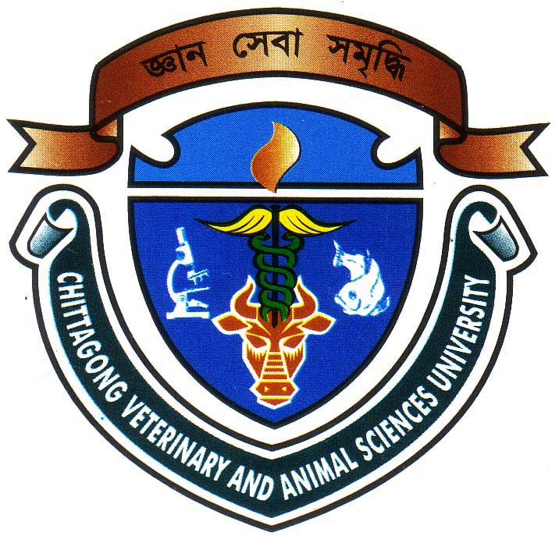

A clinical report submitted by

Roll No: 2003/18
Reg. No: 114
Intern ID:D-16
Session: 2002-2003

A clinical report presented in partial fulfillment of the requirements for the degree of doctor of veterinary medicine (DVM).

Chittagong Veterinary and Animal Sciences University
khulsi, Chittagong.

A Clinical report on diagnosis & Occurrence of Peste des Petits Ruminants (PPR) in relation to Breed, Sex, Age, duration of Illness and their treatment response in case of PPR infected goats in Boalkhali.

A Clinical report submitted as per approved style and contents

…………………..
Signature of Supervisor
Mohammad Belayet Hossain
Associate Professor
Department of Physiology, Biochemistry & Pharmacology
Chittagong Veterinary and Animal Sciences University.

…………………..
Signature of Author
Name: Mohammad Mahfujur Rahman
Roll No: 2003/18
Reg. No: 114
Intern ID: D-16
Session: 2002/2003

April, 2009

CONTENTS

SL. NO. | Contents | Page No.
01. | ACKNOWLEDGEMENT | 0
02. | ABSTRACT WITH KEY WORDS | 01
03. | INTRODUCTION WITH OBJECTIVES | 02-04
04. | REVIEW OF LITERATURE | 05-09
05. | MATERIALS & METHODS | 10-13
06. | RESULTS AND DISCUSSION | 14-18
07. | CONCLUSION | 19
08. | REFERENCES | 20-22

Acknowledgements

All praises are due to Almighty “ALLAH”. WHO enabled the author to complete this study successfully.
The author express deep sense of gratitude, heartfelt respect and immense indebtness to his supervisor Dr. Mohammad Belayet Hossain Associate professor, Department of Physiology, Biochemistry and pharmacology, Chittagong Veterinary and Animal Sciences University for his valuable advice, scholastic guidance, suggestions, and inspiration. Special thanks to Dr.Shahidulla, Veterinary surgeon and Dr.Reajul Hoque, Upozilla livestock officer, Boalkhali veterinary hospital for their sympathy and outmost help, guideline during my study.
The author would like to express his cordial thanks his internship co-ordinator Asraf Ali Biswas, Associate professor, Department of Animal Science and Animal Nutrition, Chittagong Veterinary and Animal Sciences University for his overall co-operation.

Date The author

