CHAPTER –1
INTRODUCTION
Broilers are kept for commercial production of meat in our country. Broiler keeping is a source of pleasure, diet as well as income from selling of meat. Broiler farming has become popular both in urban and rural area. Broiler farming has encouraged the people of different sections such as small farmers, landless laborers and educated unemployed as well as for industrialists to establish broiler farms on small & large scale. The growth performance of broiler bird might simply be a function of higher feed intake. Feed consumption followed similar trend to that of weight gain. These non significant differences in growth performances support the findings of (Oliveira et al, 1974), (Shanmugasundaran et al, 1976), (Haque & Chowdhury, 1994), (Anisuzzaman & Chowdhury, 1996), (Hussain et al, 1996) & (Sarica et al, 1998) the study clearly indicate that all broiler farms made good profit. Bangladesh is a densely populated country. Most of the people suffer from malnutrition. Bangladesh is unable to provide proper nutrition for her people. Protein is the important element of food, which is found in meat, egg and fish. Price of beef, chevon, mutton etc. are too high for most of the people to buy. Broiler meat may be the easy & cheap source of protein. Poultry meat contributes a good percentage of the total meat in Bangladesh. Contribution of poultry to GDP and foreign exchange is essential and increasing day by day. Now-a-days, Bangladesh Government gives more opportunity for developing broiler farms in urban and rural areas. During my internship program I worked in Mirshorai poultry feed and Hatchery,Mirshorai.Broiler farms have not been established in this area as per the demand because of various types of problems including unconsciousness among the people.

Objectives of the study

1 . To know and describe the management skills of broiler farm.
2 . To know the overall husbandry practices of broiler farming practices.
3 . To estimate and assess the average farm profitability of broiler farming.
4. To know the problems faced by the farm owner both in production and marketing.

CHAPTER II
REVIEW OF LITERATURE

Kashem and Sarker (1998) conducted a study at Tarunda union in Mymenshing disrict and determined the extent of problems faced by the farmers in respect of breeding, feeding, housing, prevention and control of diseases in poultry raising. The findings revealed that prevention and control of diseases were the most disturbing problem followed by feeding, breeding and housing.

Yasmin et. al. (1989) studied the characteristics of backyard poultry farmers in Bangladesh. Findings of the indicated that 17% had low knowledge, while 13% had considerable knowledge. Statistical tests revealed that education, family size, occupation, number of birds and extension contact of the farmers had a positive and significant relationship with their knowledge on poultry production.

S. K. Raha – 2004, conducted a research study entitled as poultry Farming Under Participatory Livestock Project: An Agribusiness Study, to examine the cost, benefits and profitability as well as marketing system of the products of different poultry rearer under some areas of PLDP. The study found that the BCR on full cost basis per chick was 1.09 for the chick rearer. The study also revealed that chick rearer sold about 87% of pullets and key rearer sold 825 each of eggs spent hens . Model Breeder sold 97% of eggs and 86% of hens while Mini hathery marketed 100% of the DOC and also identified some problems associated with procurement of inputs, poultry rearing and distribution of outputs are identified and the suggestions as perceived by the concerned participants are also recorded. A few recommendations are also no the basis of the field study for considerable by the policy makers and implementing agencies to improve the workability of the semi-scavenging poultry model in Bangladesh.

Das (2995) reported that 80% poultry products were purchased by institutional buyers and 20% by individual consumers in Sylhet Sadar thana. Egg price was fully dependent on market demand while broiler price was equally dependent on production cost and market demand. Owing to religious belief and social tradition, live poultry birds were purchased by the consumers. The processing and dressing as marketing operation was uncommon in Sylhet town market. This scenery is common in most area of Bangladesh.

Miah (1990 ) surveyed small scale poultry farmers in saver areas. The purpose of the study was to determine the profitability of poultry farmnig. The researcher found that the average numbers of birds in small and medium farms were 589 and 3139 respectively. the average annual costs per small medium farms were Tk. 136788 and 567034 respectively. The income earned from small and medium farms were Tk. 308779 and 1480302 respectively. The researcher also found that the profitability of poultry farming was positively co-related to the size of individual farms.

CHAPTER III
MATERIALS AND METHODS

i. Location:
Mirshorai Poultry feed and Hatchery is situated near the High way of Dhaka – Chittagong road. \
ii. Selection of study area
The area was sleeted due to my Internship placement.
iii. Preparation of the survey schedule
The survey was developed in accordance with the objective of study. Survey schedule was prepared to get the desired information from the broiler farm owner.

iv. Period of data collection
The necessary information of the study was carried out when I was staying at Mirshorai Poultry feed and Hatchery 02/03/2012 to 30/03/2012. During this period I worked actively & collected data on Prospects and problems of Broiler farming at Mirshorai Poultry feed and Hatchery by using an interview schedule through face to face interviewing of owner and workers.

V.Collection of data
During the study period I worked several unite of broiler farms of Mirshorai Poultry feed and Hatchery. Data were collected by taking interview.

vi. Data analytical Techniques
The collected data were analyzed after coding, decoding, summarized when stay in CVASU campus with the correspondence of supervisor.Simple statistical methods such as mean, percentage, standard deviations etc. were applied for analyzed the collected data to meet up the study goals and objectives.

vii. Limitations of the study
The required information of the study were collected by staing only 02/03/2012 to 30/03/2012 ending of one batch of broiler marketing due to shortage of time and fund during the internship placement period at Mirshorai Poultry feed and Hatchery.

CHAPTER IV
Management Practices of Broiler Farming:
A.
Husbandry practice:
i. Collection of Chick:
Collection of broiler chicks is important for broiler farming. The farm owner collect the chicks from different hatcheries. The price of day old broiler chick was paid 70-75 Tk. Per chick.
ii. Flock size:
During my internship period I worked in different size of broiler shed.The average flock sizes were found which is given bellow:
Table no.1 Flock Size of broiler at the study area:
Number of Broiler shed | Flock Size
1 | 1500
2 | 1000
3 | 1100
4 | 700
5 | 1400

- Housing:
A suitable house is the prime need for the rearing of poultry birds in the intensive method. In Mirshorai Poultry feed and Hatchery there are two types of house are observed.
i. Brooder house
ii.Grower cum finisher house.

iv. Floor, feeder and waterer space followed by the farmers are given below:
a. Floor space
Table no.2 Average available floor space of broiler farming
Age of the bird | Floor space / bird
1st week  week | . 5 sq. ft.
2nd week  week | . 5 sq .ft.
3rd week | 1 sq. ft.
4th week | 1 sq. ft.
5th week to finishing | I sq. ft.
Source: Field Survey, 2010

b. Feeder space
Table no.3 Average Feeder space of broiler farming
Age of the bird | Floor space/bird
1st Week | 1 inch
2nd week | 1 ½ inch
3rd week | 1 ½ inch
4th week | 2 inch
5th week to finishing | 2 inch
Source: Field Survey, 2010

c. Water space
Table no.4 Average Water space of broiler farming
Age of the bird (week) | Waterer space / bird
1st | .5 inch
2nd | .75 inch
3rd | .75 inch
4th | 1 inch
5th week to finishing | 1inch
Source: Field Survey, 2010
v. Temperature Schedule
Table no.5 Temperature Schedule of Broiler Farming
Age of bird (week) | Temperature
1st | 95º F
2nd | 90º F
3rd | 85º F
4th | 80º F
5th | 75º F
6th up to restore finishing | 70º F
Source: Field Survey, 2010

vi. Litter management:
Table no.6 Litter management of Broiler farming
Litter material | Depth
Rice husk | Winter Summer
 | 1.5-2 inch 1 inch
Source: Field Survey, 2010

vii. Feeding
Feeding main function to rear broiler chicks. The chicks should be given small quantity of feed frequently for the first week. The owner was used the following way for feeding of the broiler.
Table no. 7 Feeding Practices of Broiler Farming
Age (week) | Nature of feed
1 | Crumble
2 | Crumble
3 | Pellet
4 | Pellet
5th up to finishing | Pellet
6th up to finishing | Pellet
Source: Field Survey, 2010
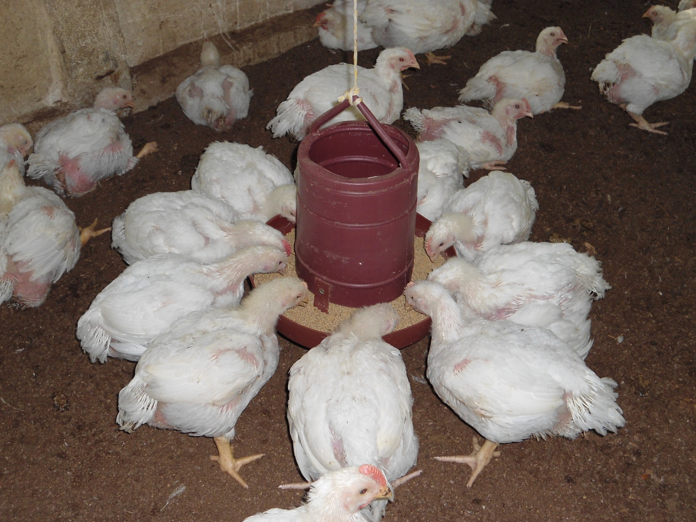
Fig:Feeding of broiler.

viii. Weight gain
After proper feeding weight gain which is recorded by the farm owner are given bellow.

Fig: Graphical Representation of weight gain.

ix. Vaccination schedule
Table no.8 Vaccination schedule of Broiler farming system.
Age | Vaccine | Disease | Dose & route
Days 1-3 | BCRDV | Ranikhat | 1 drop in 1 eye
Days 12-14 | Gumboro (D-78/228E) | Gumboro | 1 drop in 1 eye
Days 21-22 | BCRDV | Ranikhat | 1 drop in 1 eye
Day23-24 | Gumboro (D-78/228E) | Gumboro | 1 drop in 1 eye
Source: Field Survey, 2010

B. Feeding practices of Broiler farming
The broilers need more feed and the farm owner collect the feed from different companies. The owner mainly follow the literature of the Quality and Pro vita feed company for their feeding management. Two companies supply three types feed that is broiler starter, broiler grower and broiler finisher.
Nutritional level of Quality feed is as follows
Table no.9 Feeding Practices of Broiler Farming
 | Quality feed
Nutrients | Broiler starter | Broiler grower | Broiler finisher
Moisture % | 11 | 11 | 11
Cp% | 21 | 21 | 21
CF% | 3.5 | 3.5 | 3.5
Fat% | 5.6 | 5.5 | 5.5
P% | .5 | .5 | .5
Ca% | 1 | 1 | 1
Me kcal/ kg | 3000 | 3000 | 3000
Source: Field Survey, 2010
Table no.10 Standard Level of Broiler Feed
Nutrients | Broiler starter | Broiler grower | Broiler finisher
Moisture % | 11 | 11 | 11
CP% | 22 | 21 | 20
CF% | 3.5 | 3.5 | 4
Fat% | 3 | 3 | 3
P% | .5 | .5 | .5
Ca% | 1 | 1 | 1
ME kcal/ kg | 2900 | 3000 | 3000
Source: Jadhav M. F. Siddiquei-1999, Hand book of Poultry Production &
Management.
CHAPTER - V
RESULTS AND DISCUSSIONS

A. Profitability of Broiler Farming:

Net Profitability: π = TR- TC
Where, TR = Total meat produced (Qty. kg) x
Multiplied by per Kg broiler
TC = Cost for all factors

The cost benefit analysis of a farm is given below (Average Flock size-1140).

Recurring expenditure:
1. Land – Lease.
- Hosing Rent - Tk 35,0000 (one time)
- Day old chick cost: Total chick 1140 at the rate of Tk. 75.00 per chick: 1140 X 75 = Tk.85,500.00
4. Feed cost:
4kg /bird = 1140 X 4 = 4560 kg.
at rate of 32 Tk. Per kg of feed -
4560x 32 = Tk.1,45,920.00
5. Other cost:
(Electricity, medicine and labor) :Tk. 30,000.
Tota1= TK. (35,000+85,500+4,560+1,45,920) = Tk.2,70,980.00
Income: Average weight 2kg / bird
Total weight: 1117.2 X 2 = 2,234.4 (2% mortality)
Total income: 2,234.4 X 145 =3,23,988.00 Tk. (at the rate of 145 Tk./ kg)
Net profit =3,23,988.00 – 2,70,980 = Tk.53,008.00

B. PROBLEMS OF BROILER FARMING IN MIRSHORAI POULTRY FEED AND HATCHERY,MIRSHORAI,CHITTAGONG.

l. Shortage of feed & proper nutrition
Bangladesh is a highly populated country. There is no enough land for feed cultivation. As a result, the farm owner faces the crisis of feed. The feed which are found in the market have less nutritive value. The broiler does not gain proper weight by consuming those feed.

2. Lack of electricity
Electricity is the prerequisite to make broiler farm. Without electricity it is almost impossible to manage a broiler farm from first to last. But in this area there is a huge deficiency of electricity. So broiler farms can not be established though there is a large demand of broiler meat.

3. Low quality feed
The feed which are found in the market are of low quality. The feed suppliers do not maintain proper nutritive composition and hygienic condition.

4. Low quality chick
The hatchery owner supply low quality chicks. As a result the farm owner are deprived from having good and healthy chicks. Many chicks die in their early stage of life. It is very harmful for a farm and farmers lose interest to do farm.

5. High mortality rate of chicks
When the farms become affected by any contagious disease, the mortality rate of the birds is very high. The farm owner do not take proper care and treatment in due time. As a result the farm owner face to huge loss.

6. Lack of knowledge
The farm owner are not well educated and have lack of knowledge about farm management, as a result the broilers do not grow rapidly.

7. Lack of well established diagnostic lab
There are no any opportunities for diagnosis of disease in this level because lack of well established diagnostic laboratory in the area.

8. Lack of post mortem facilities
There is lack of post mortem facilities of dead bird for the diagnosis of disease. As a result they can not know the accurate cause of the diseases and not take proper preventive measure.

9. Lack of proper vaccination
Proper vaccination is also barrier for the establishment of broiler farm in this area. The farm owner do not vaccinate the birds in due time for the lackings of proper knowdge about vaccination.

10. Lack of bio-security knowledge
The farm owner do not maintain bio-security strictly. Local people, cattle, goat, dog, cat, other birds are always threatened for a farm. Farm owner do not use foot bath at the entrance of the farm.

.

11. Absence of proper disease control model
There is no any disease control model in this farm on which the owner can prevent diseases occurred in the farm.

12. Acute shortage of veterinary support staff
There is lack of veterinary doctor and other staff for the suggestion of farm owner for the development of broiler farm.

13. Influence of Drugs Company
Representatives of drug companies communicate with the farm owner and influence them for using their low quality drug. As a result the birds do not get sufficient active ingredients used in drug and die of disease unexpectedly. It acts as a barrier.
14. Influence by feed supplying company
Many feed companies communicate with farm owner and influence them for using their low quality feed. It also acts as a barrier for development of broiler farm.

CHAPTER-VI
CONCLUSION

From the above discussion it can be concluded that Mirshorai poultry feed and hatchery is a very suitable and prospectious zone for broiler production. But first it is crying need to solve the above mention and other constraints,then it would be possible to establish broiler farms to meet the protein demand of the people and to remove the poverty of people creating employment opportunities for the unemployment people. As veterinary student I am very dishearten for such poor condition on broiler farming in my intern placement farm. So by my study I would like to request the authority concerned and ultimately Government to take proper steps and play an important role for establishment of a poultry zone in this area by solving the all problems and giving more opportunities for the existing farm owners.
REFERENCES

Jadhav M.F. Siddiquei-1999, Handbook of Poultry Production and Management
Agarwal, 1986, The Role of Poultry Husbandry, 1:378-381
Oliveira, 1974, handbook of Poultry Keeping, 1:55-57

Haque and Chowdhury, 1994, Current Ststus of Poultry and Marketing System of Bangladesh, Agricultural Research Project – 2.

Verma, 1989, Clinicopathological Study of Poultry, Times of India April-21, page no.23-24.
Anisuzzaman and Chowdhury 1996, An Economic Study On Poultry Farms In Bangladesh Journal of Livestock Research, 1-5:161-174.
Rahman, M (2003 ) Growth of Poultry Industry in Bangladesh. Poverty Alleviation and Employment Opportunity⁷ 3rd International Poultry Show and Seminar, Dhaka, Bangladesh.
Agricultural Census; July, 1999.
Ahmad A. and Hasnath M.A. (1983 ). A Study on the heritability estimates of body weights of Indigenous Chickens. Bangladesh vet. J:17:19-24.

Alam, J, 1997; Lund et al, 2002, Impect of small holder livestock development project in some selected rural areas of Bangladesh.
Livestock for rural Development, 9 (3 ): 1-12.

Haque, Q.M.E. And stem, C. (1993 ). Current status of poultry production and marketing system in Bangladesh. ARP-11 ( Supplement).

Appendix
Questionnaire for data collection
1.
a. Name of the farm..................................................
b. Name of the owner....................
c. Father’s name...........................................................
d. Address: .....................………
2.Husbandry practice:
A. Housing:
a. Brooder house b. Grower cum finisher house
B. Feeding:
- Collection of feed...........................................
- Storage of feed …..........................................
- Types of feed...................................................
- How many times feed supplied daily.............
C. Watering:
- Source of water
a. Deep tube well b. Pond
- System of water storage
a. Water tank b. Water house
- Frequency of water supply
a. Adlibitum b. Insufficient

D. Litter materials................................................................
E. Litter change....................................................................

F. Ventilation
a. Sufficient .b. Insufficient
G. Natural light...................................................................
H. Artificial light.................................................................
I. Bio-security....................................................................
J. Foot bath:
a. Yes b. No
K. System:
a. all in all out b. Not
3. Number of sheds.........
4. Drainage facility:
a. Sufficient b. Insufficient.
5. Have electric fan?
a. Yes b .No
6. Most common diseases prevalence in the farm................
7. Management of disease condition:
a. Self management
b. Quack
c. Veterinary doctor
8. Feature of Veterinary doctor calling:
a. Actively b. occasional c. In critical situation d. Not at all.
9. The farm is profitable or not......................................................

Name of the interviewee............... Name of the interviewer...........
Date.......... Date: ……………
Signature............. Signature ……………………
…....................................................................THE END...................................................................

A REPORT ON
MANAGEMENT, PROSPECTS AND PROBLEMS OF BROILER FARMING OF MIRSHORAI POULTRY FEED AND HATCHERY,MIRSHORAI,CHITTAGONG.



Report Presented in Partial Fulfillment of the
Requirement for the Degree of Doctor of Veterinary Medicine

A Report Submitted by
Roll no. -06/35
Intern ID No- 06/35
Reg. No- 273
Session: 2005-2006

Faculty of Veterinary Medicine
Chittagong Veterinary and Animal Sciences University
A REPORT ON
MANAGEMENT, PROSPECTS AND PROBLEMS OF BROILER FARMING OF MIRSHORAI POULTRY FEED AND HATCHERY,MIRSHORAI,CHITTAGONG.

A Production Report Submitted as per Approved Style and Content

Signature of Author  KAMAL CHANDRA ROY  Roll No. 06/35  Intern ID: D-31  Reg No. 273  Session: 2005-2006 | Signature of Supervisor  Prof. Goutam Buddha Dus  Dept. of Animal Science and Animal Nutrition.  Chittagong Veterinary and Animal Sciences University.

LIST OF ABBREVISTIONS

Abbreviations | Elaboration.
GDP | Gross Domestic Products.
BCR | Benefit Cost Ratio.
PLDP | Participatory Livestock Development Project.
SLDP | Small Holder Livestock Development Project.
Govt. | Government.
Dept. | Department.

CONTENTS

ACKNOWLEDGEMENT = I
ABSTRACT = II

CHAPTER | NAME OF CONTENTS | PAGE NO.
I. | INTRODUCTION | 1-2
II. | REVIEW OF LITERATURE | 3-4
III. | MATERIALS & METHOD | 5-6
IV. | MANAGEMENT PRACTICES | 7-12
V. | RESULTS & DISCUSSIONS | 13-16
VI. | CONCLUSION | 17
 | REFERENCES | 18-19

ACKNOWLEDGEMENT
I am very grateful to Professor Dr. A. S. Mahfuzul Bari, honorable Vice Chancellor, Chittagong Veterinary and Animal Sciences University, Khulshi, Chittagong to give the facilities to complete the study by using the computer facilities at CVASU computer laboratory.

I am also very grateful to my supervisor. Goutam Buddha Dus, Professor, Dept. of Animal science and animal nutrition, Faculty of Veterinary Medicine, Chittagong Veterinary and Animal Sciences University, for his scholastic guidance, simultaneous inspiration, constructive criticism and invaluable suggestions during the entire period of the study and also for the preparation of this report.

The author highly express his sincere gratitude and gratefulness to the internship coordinator Md. Ashraf Ali Biswas, Professor, Department of General Animal Science & Animal Nutrition, Chittagong Veterinary And Animal Sciences University for his constant inspiration, cordial co-operation.

Special thanks to Dr.Abddus Salam khan,Consultant ,Mirshorai poultry feed and hatchery, for his kind co-operation.

I also give big thanks to Md.Karim Islam,Manager, Mirshorai poultry feed and hatchery, for his support and the other workers for giving important information for the study.

ABSTRACT

A report on Management, Prospects and Problems of Broiler farming system of Mirshorai poultry feed and hatchery. The necessary information of the study was carried out when I was staying at Mirshorai poultry feed and hatchery from 02/03/10 to 30/03/2012. During this period I worked actively in the farm & collected data on Prospects and problems of Broiler farming of the Mirshorai poultry feed and hatcher by using an interview schedule through face to face interviewing. There was 5 broiler shed in Mirshorai poultry feed and hatchery and The owner of the farm are interested in rearing broiler under farming system. The estimated net benefit per shed having average flock size 1140 birds during the working period was found Tk.53,008. But he felt always threaten to rear broiler due to they faced various problems like lake of electricity, low quality feed, low quality chicks, high mortality of chicks etc.So the possibility was found high but facility was found very low.If the problems can be removed, he would be more encouraged to establish broiler farms on a large scale in all seasons.

Key Words: Broiler farming, Net Profit, Possibility and Problems

