PROGENY PERFORMANCE OF RIR (Rhode Island Red) CROSSED WITH NAKED NECK AND FAYOUMI
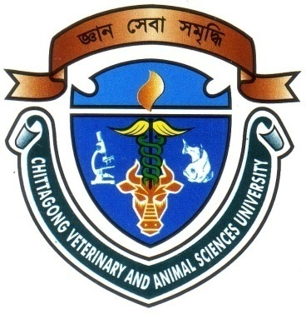

A Production Report Submitted by
Roll No.: 07/35
Registration No.: 321
Internship ID.: C-31
Session: 2006-2007

A Production report presented in partial fulfillment of the requirements for the Degree of Doctor of Veterinary Medicine

CHITTAGONG VETERINARY AND ANIMAL SCIENCES UNIVERSITY
KHULSHI CHITTAGONG

February, 2013
INDEX
SL. NO. | Chapter | CONTENTS | PAGE NO.
1 |  | ACKNOWLEDGEMENT | I
2 |  | ABSTRACT | II
3 | I | INTRODUCTION | 1-6
4 | II | REVIEW OF LITERATURE | 7-11
5 | III | MATERIALS AND METHODS | 12-14
6 | IV | RESULTS AND DISCUSSION | 15-18
7 | V | CONCLUSION AND RECOMMENDATION | 19
8 | VI | REFERENCES | 20-23

ACKNOWLEDGEMENT

All praises are due to Omnipotent GOD who creates everything and who enables the author to complete this report. The author does not have adequate words to express his heartfelt sense of gratification to his benevolent teacher and report supervisor Md. Akhtar-uz-zaman, Professor, Department of Dairy and Poultry Science, Chittagong Veterinary and Animal Sciences University (CVASU), Chittagong. I would like to express my deep sense of gratitude and thanks to my supervisor for his valuable advice, guidance, suggestions, inspiration and who was involved with this study during its inception. I would like to give special thanks to the authorities of Chittagong Veterinary and Animal Sciences University for enable me to finish this report.
The author is immensely grateful to all of them, who help the author through various ways during data collection and analysis although it is not possible to mention every one by name. I am also grateful to all of my well-wishers for their constructive comments and suggestions for improvement of this report.

The Author

I

ABSTRACT

The experiment was conducted at Rangpur Govt. Poultry Farm and the data was collected from the records to compare the performance of RIR x Fayoumi and RIR x Naked Neck crossbreed in the term of survivability, feed intake and age effect under farm condition. The exotic Fayoumi (Fa) and the Indigenous Naked neck (NN) as hen, whereas another chicken breed was the Rhode Island Red (RIR) used as cock to produce two new genotype of chicken naming SONALI (genotype-2)and RIR x NN (genotype-1). The initial no. of bird was 103 and 50 respectively for genotype- 1 and genotype-2 at 1st week. The survivability rate at 1st week was 100% for both genotypes. Then it was estimated 98.97%, 100%, 100%, 98.64%, 97.29% 97.29% ,95.95%, 95,95%, 100%, 100%, 100% and 94% respectively for 2nd, 3rd, 4th, 5th, 6th, 7th, 8th, 9th,10th,11th,12thand 13th weeks in case of genotype-2 presenting average survivability 98.30% which is better than genotype-1(95%). The study having its conclusion that the SONALI (genotype-2) in the environment of Bangladesh, might be recommended for rearing with good management in intensive system, with low input supplies having better survivability rate and good performer regarding feed intake than genotyp-1.

Key words: Fayoumi, RIR, Mortality, Average Feed Intake.

II

