Chapter -I
INTRODUCTION

Bangladesh is one of the most densely populated countries in the world. The Population density (people per sq. km) in Bangladesh was last reported at 1142.29 in 2010, according to a World Bank report published in 2012. Bangladesh's per capita income went up to $848 in the current fiscal year from $816 last year (Bangladesh Bureau of Statistics-2012) but "Bangladesh has world’s highest malnutrition rate". (www.oneworld.net & UNICEF-2012). In Bangladesh, 26% of the population are undernourished and 46% of the children suffers from moderate to severe underweight problem.43% of children under 5 years old are stunted. ("The state of food insecurity in the food 2011". www.fao.org. & "Bangladesh Healthcare Crisis". BBC News. 28 February 2000. Retrieved 14 February 2012.)

The economy of Bangladesh is based primarily on agriculture, and livestock is an essential component of the rural economy and the livelihood of the subsistence farmers. The country has a sub-tropical monsoon climate and 84.4% of its population is living in rural areas. The demand for milk and milk products is increasing because of the rapid increase in population, the spread of education and growing nutrition awareness. National milk production can only meet 13% (approx.) of the current milk consumption. In addition, Bangladesh has a suitable environment for cattle. Therefore, the need for developing the dairy industry, especially, in the rural areas, has been recognized. Although, dairying is the most ancient occupation established in the rural setting of Bangladesh, its development is not satisfactory due to a number of problems. (Shamsuddoha. A.K. 2000).

The importance of bovine livestock to our economy cannot be over stated. Even though the subsector contributes only 3% to the GDP, it provides full and part time employment to about 20% of our rural population and accounts for 18%of our agricultural export earnings. (DLS-2005) While the dairy, meat is also an important contributor to our protein needs .Furthermore the trade and export of leather products, bones and offal also have significant contribution to our economy. Draft power is still a significant source of power for cultivation saving imported energy cost. The consumption of milk and milk products in Bangladesh is very low even when compared to neighboring countries. The average daily consumption is 42ml per day/person against a recommended allowance of 250ml/day. Bangladesh would currently need to import or produce five times its current production if it is to meet the WHO recommended daily requirement. In the past decade, production of milk has increased gradually every year because of efforts of farmers and processors to feed the growing demand for milk thanks to economic growth and rise in people’s per capita income. During fiscal 2009-10, domestic production of milk grew 32 percent to 2.36 million tonnes (2,360 million litres) from 1.78 million tonnes in 2001-02, according to Department of Livestock Services (DLS). However, a huge deficit still forces Bangladesh to import thousands of tonnes of milk powder every year. In the fiscal 2009-10, total milk shortfall was 10.96 million tonnes, according to DLS.
Enzymes play a diversified role in many aspects of everyday life including aiding in digestion, the production of milk and several industrial applications.

It is established fact that Holstein cross losses approximately 40% protein, 38% fat, Crude Fiber 56% and NFE 27% when provided full ration and approximately 33% protein, 27% fat, 45% CF and 18% NFE in maintenance ration.(Eckles-1911 ) .Most of this inefficiency due to presence of antinutritional and indigestible factors that reduce nutrient availability. Supply of microbial enzyme can reduce this type of problem.

A large number of processes in the areas of environment and food biotechnology utilize enzymes at some stage or the other. Current development of biotechnology is yielding new application for enzymes. A large number of microorganisms, plants, roots, tubers, including bacteria, yeast and fungi produce different types of enzymes. One such enzyme known to play a major role in dairy sector is cellulase. This cellulase enzyme can act on non starch polysaccharides (NSP's).The cellulase along with xylanase and other enzymes formed a multi-enzyme complex (e.g. cellulosomes) in degradation of plant cell wall. (Doerner and White, 1990)

The benefits of enzyme application in dairy feed are enhanced fiber digestion, absorption of nutrients especially fats and proteins, increased feed intake, weight gain, increased milk yield and reduced DM losses. Thus it is important that enzymes are useful for least cost formulation of' feed without affecting productive performance. Further they improve health of animal along with environmental hygiene.
So I try to prepare liquid enzyme for following objectives.
1) To collect beneficial organisms available in market.
2) To assess the response of beneficial organism on lactating cows.
3) To compare the cost between prepared organism and organism available in market.
Chapter-II
REVIEW OF LITERATURE

The term enzyme was used in 1878 by Friedrich Wilhelm Kulne to designate these ‘Biological catalyst’ that has previously been called ‘ferments’. The enzyme, as simple or combined proteins acting as specific catalyst. (Jain, 2001.)

Enzymes may be defined as the organic compounds protein in nature, colloidal in physical state, produced by the living beings having specific catalytic activity. (Pant M. C.1993.)

Enzymes are proteins with highly specialized catalytic functions produced by all living organisms. Enzymes are responsible for many essential biochemical reactions in microorganisms, plants, animals, and human beings. Enzymes are essential for all metabolic processes, but are not alive. Although like all other proteins, enzymes are composed of amino acids, they differ in function in that they have the unique ability to facilitate biochemical reactions without undergoing change themselves. This catalytic capability is what makes enzymes unique. (Katchalsi, et al.1968).

Enzymes are natural protein molecules that act as highly efficient catalysts in biochemical reactions, that is, they help a chemical reaction take place quickly and efficiently. Enzymes not only work efficiently and rapidly, they are also biodegradable. Enzymes are highly efficient in increasing the reaction rate of biochemical processes that otherwise proceed very slowly, or in some cases, not at all. (www. enzymedica.com)

Enzyme is complex protein remain in the live cells and act as a catalyst in the bio-chemical reaction. (Vadra. S. K. 2007)

Enzymes are substances made and used by the body to trigger specific chemical reaction. (Jain, J.L.2001)
Enzymes are responsible for digesting, absorbing, transporting, metabolizing, and eliminating the waste of the nutrients. To emphasize again, every organ, every tissue, and all the 100 trillion cells in human -body depend upon the reaction of metabolic enzymes and their energy factor. (www.enzymedica.com)

Enzymes are proteins composed of up to 20 amino acids. The components of enzymes consist of the biologically active proteins. These proteins have highly complex structures and may be conjugated with metals, carbohydrates and / or lipids.
Enzymes are categorized according to the compounds they act upon. Some of the most common include; proteases which break down proteins, cellulases which break down cellulose, Lipases which split tats (lipids) into glycerol and fatty acids, and amylases which break down starch into simple sugars.(Dubey, R.C.-2005)

Aoyagi and Baker, (1995) have shown that phytase may have increased the zinc bioavailability in soybean meal which can increase productive performance of poultry.
Production of enzymes increases with the concentration of culture medium. High concentration of culture medium can produce high amount of enzyme.

Bisset j, (1972) discover an automatic multichamber soil washing apparatus for removing fungal spores from soil those have power to produce enzyme.
Capability of birds by use of cellulolytic enzymes is increased for using high fiber ration, reducing feed cost along with 5-12% improvement in production and feed efficiency. (Remus.J.-2005)

Enzymes are derived from natural resources, such as fungi and bacteria, and then are genetically engineered or “molecularly evolved” in the laboratory to impart specific new properties. The new genetic material is inserted into the nucleus of a recombinant host, such as the fungus Aspergillus or the bacteria Bacillus. (www.enzymedica.com)

Fan et al. (1987) and Kumakura (1997) reported that enzyme help alleviate shortages of food and animal feeds, solve modern waste disposal problem.
Enzymes are protein chemicals, which carry a vital energy factor needed for every chemical action, and reaction that occurs in our body. There are approximately 1300 different enzymes found in the human cell. These enzymes can combine with coenzymes to form nearly 100,000 various chemicals that enable us to see, hear, feel, move; digest food, and think. Every organ, every tissue, and all the 100 trillion cells in our body depend upon the reactions of metabolic enzymes and their energy factor. Nutrition cannot be explained without describing the part that enzymes play. (ww.w.enzymedica.com)
Enzyme is a biocatalyst which accelerates biological reactions. (Jaddav, N.V. 2007)

Fan et al. (1987) and Solomon et al. (1999); have been reported that, Cellulase enzyme has been used for the bioconversion of lignocellulosics.

Fan et al. (1987) reported that Lignocellulosics are abundant sources of carbohydrate, continually replenished by photosynthetic reduction of carbon dioxide by sunlight energy.
Fungal lipase is manufactured from Aspergillus sp. It is used as digestive enzyme, in pancreatic insufficiency. (www.enzymedica.com)

Ghose, (1987) also applied by Solomon et al. (1999) Cellulase activity was determined as a Filter Paper Activity (FPA).

Howell (1978) and Hatakka (1983) reported that develop of aromatic water-soluble products which can repress the cellulolytic action of the enzyme.

Hagspiel K and Masuda, Y. (1995) reported that Isolation of a 6-glucosidase binding and activating polysaccharide from cell walls of Trichoderma reesei.

Kumakura, (1997) reported that the bioconversion of cellulosic materials has been receiving attention in recent years. It is now a subject of intensive research as a contribution to the development of a large-scale conversion process beneficial to mankind.
KDN Xylanase 10,000 Dry is a feed enzyme. Xylanase, which con effectively shut off the β-1, 4 glycosidic bonds of xylose at random, and the hydrolysis efficiency is high. It can promote the absorbability of nutrients and decrease the feed cost of plant feed.

Lease, (1996) and Lonnerdal et al. (1989), Reported that when phytic acid is hdrolyzed by microbial phytase it may release all phytate-bound minerals.

Lonnendal et al. (1989) reported that Phytate has the highest binding affinity for copper, Zinc and manganese.
Lilly, (1979). The leading species of Saccharomyces cerevisiae was employed in many food industry with special strain used for the leavening of bread as top yeasts, for wines and for the production of alcohol, glycerol and invertase.

Microorganisms of the genera Trichoderma and Aspergillus are thought to be cellulase producers. (www.enzymedica.corn)

Mucor; mucor are involved in the spoilage of some food and the manufacture of others. A widely distributed species is Mucor racemsus, M. rouxii, is used in “Amylo” process for the saccharification of starch.
Many microorganisms especially the molds, produces large quantities of extracellular hydrolytic enzymes which can be recovered from the culture fluid. A few of these have been produced in quantities sufficient to make them of industrial importance. Fungal amylase may replace malt in the conversion of cereal starch to maltose for commercial alcohol production. A bacterial amylase produced by Bacillus subtilis is used for the production of dextrin from starch since it does not hydrolyze the starch so much as to from maltose. Several other microbial enzymes are available on a large scale commercial basis. Some of these are proteinase, glucose oxidase, lipase, invertase, pectinase, beta-glucosidase and cellulose. (Walter and Mc bee, 1962).

Menon K, et al. (1995) production of P glycosidase enzyme by Aspergillus terreus, and its use for commercial purpose.
Nutri-xylanase is a bacterial xylanase processed from Bacillus subtilis, and produced by a microfiltration advanced fermentation technique. Nutri-xylanase is a highly efficacious xylanase is degrading both soluble and insoluble arabino-xylans, the most important anti-nutritional factor in cereals and cereal by products used in animal feed so as to improve the utilization of nutrients, animal uniformity and animal performance, increase proportional usage of cereal by products in formulating animal feed to reduce feed cost. (www.ublcorp.com)

Synthesis of bio molecules are achieved by cells smoothly and routinely, principally through the actions of enzymes, the pertinacious catalyst of the biosphere. Enzyme mediate not just the synthesis of' biological compounds, they also catalyze reactions that supply the cell with energy, detoxify compounds and so on. Enzymes are responsible for virtually all of chemical reactions in cell in which covalent bond are formed or broken is the crucial mediators of' biochemical reactions.

Solomon et al. (1999) produced cellulase of 0.056425IU/ml from the growth of Aspergillus flavus on bagasse pre-treated with using ball milling and caustic soda.

Solomon et al. (1999) have previously reported that the enzyme could be harvested at about 12th, when the activity is highest.

Selected strains of Aspergillus niger, are used for the commercial production of citric and gluconic acid and in a verity of enzyme preparation. The Aspergillus flavus group includes molds important in the making of some oriental foods and the production of enzymes.

Solomon et al. (1999) reported that bagasse, corncob and sawdust were used as lignocellulosic substrates for the production of cellulase enzyme using Aspergillucs flavus after ball milling and pretreatment with caustic soda. From the fermentation studies, sawdust gave the best result with an enzyme activity value of 0.07431U/ml while bagasse and corncob gave 0.05731U/ml and 0.05021U/ml respectively.

Solomon et al. (1990) achieved hydrolysis of sawdust using cellulase with activity of 0.0561IU/ml.

Solis.S. Flores, M. S., and Huitron. C. (1997) reported that Pectinase activity on plums in juice manufacture can result in greater availability in the final juice product of antioxidant components, which otherwise might not have been yielded during processing.
Xylanase is an industrial enzyme used in animal feed to help with digestion. (www.enzymedica.com)

Chapter-III
MATERIALS AND METHODS

3.1. Statement of the experiment:
A trail works was conducted in CVASU dairy farm, with three dairy cows (HF cross) for a period of 25 days, a period covered from 3rd December to 28th December, 2012. The trail assessed the feasibility of using enzyme on milk production.

3.2. Layout of the experiment:
A total of three dairy cows were divided into 3 groups [prepared enzyme group (liquid), prepared enzyme group (Powder), commercial group]
Table1: Experimental layout showing the distribution of cows to treatments.
Traits | Prepared group (liquid) | Prepared group (powder) | Commercial group
No. of cows | 1 | 1 | 1
Body wt. | 200 kg | 130 kg | 150 kg
Lactation | 4th | 1st | 1st
Age of calf | 4 months | 15 days | 1 month

3.3. Preparation of experimental shed:
The experimental shed for cows was properly washed and cleaned by using tape water every morning during experiment. Ceiling, walls and floor were also thoroughly cleaned. Sometimes the whole shed washed with antiseptic solution. Cow dung and other dirt were regularly cleaned.

3.4. Ration for experimental cows:
The ration was mainly concentrate based. Besides the animal were taken to the small grazing land for a particular period of the day.

Table2: Experimental layout of the supplied ration.
Traits | Prepared group(liquid) | Prepared group (pulv) | Commercial group
Grazing hours | 3 hrs. | 3 hrs. | 3 hrs.
Concentrate mixture | 4 kg | 2 kg | 3 kg
Straw | 4 kg | 3 kg | 4 kg

Table 3: The composition of the concentrate mixture.
SL. NO. | Feed ingredient | Percentage
1 | Wheat bran | 24.5
2 | Rice polish | 17.0
3 | Broken rice | 06.0
4 | Maize | 13.0
5 | Molasses | 02.0
6 | Pea bran | 20.5
7 | Soybean meal | 07.0
8 | Soybean oil cake | 08.5
9 | Salt | 01.5

Table 4: Proximate analysis of the concentrate mixture
Sample | DM % | Moisture | CP % | EE % | Ash %
Soybean meal | 89.0 | 11.0 | 42.44 | 1.2 | 6.97
Maize | 85.2 | 14.8 | 7.00 | 3.6 | 3.11
Wheat bran | 89.0 | 11.0 | 12.14 | 4.2 | 5.44
Rice polish | 97.2 | 2.8 | 12.25 | 18.5 | 8.10
Broken rice | 87.8 | 12.2 | 7.00 | 4.6 | 1.09
Til oil cake | 98.6 | 1.4 | 10.50 | 6.3 | 6.40
Pea bran | 91.4 | 8.6 | 22.75 | 1.7 | 3.70

3.5. Preparation of beneficial organism:
Two types of beneficial organisms are prepared at Animal Science and Animal Nutrition laboratory. One is liquid and the other one is powder. After the production, organisms are tested in the laboratory of Microbiology department and in the laboratory of Poultry Research and Training Center (PRTC).

3.6. Collection of beneficial organism regarding e available in the market.

3.7. Management procedure:
The milk of three cows was recorded at regular basis. The cows were observed for any abnormalities.

3.8. Feeding and watering:
Feed was supplied on the basis of requirement (maintenance and production) and clean fresh water offered to the cows’ adlibitum.

3.9. Incorporation of beneficial organisms:
Organisms were incorporated in concentrate mixture. The amounts of the organisms were gradually increased one week interval. Day (1 to 8) 10 gm, day (9 to 16)15 gm and day (17 to 25) 20 gm organisms were incorporated in feed. All three types of beneficial organisms were incorporated in the same dose.

3.10. Body weight measurement of the cows:
Body weight of the cows was measured by electronic cattle weighing scale.

3.11. Ration formulation for the cows:
Ration for the cows was formulated by ‘Thumb rules” method. Roughage dry matter was maintained by straw and road side grass and concentrate dry matter was maintained by concentrate mixture.

3.12. Deworming of the cows:
Deworming was done before the trail. Deworming was on the basis of coproscopy. In coproscopy there were some nematode eggs in the feaces. So that anti nematodal drug was given. Next week after medication the coproscopy was performed again.

3.13. Sanitation:
Strict sanitary measures were taken during the experimental period. Disinfectant was used to disinfect the manger and gutter.

3.14. Data collection:
The following records were kept during 25 days.
1. Live weight: Weight was recorded before ration formulation.
2. Feed consumption.
3. Milk weight: Weight was recorded regularly in the morning and afternoon.
4. Date of deworming.

3.15. Statistical analysis:
Milk performance data were a 3 x 3 factorial experiment in a Complete Randomized Design (CRD). We assume that our null hypothesis is “There is no significant difference among the treatments.” Least significant differences (LSD) were calculated for significant factors to compare differences among treatment combinations.

3.16. Production cost:
Production cost was included considering expense on labor, feed & medicine. Feed cost was calculated on the basis of the present market price of the feed ingredients used for ration formulation.

3.16. Costing analysis of the beneficial organisms:
250 ml prepared (liquid) organisms = 8 Tk.
250 gm prepared (Powder) organisms = 15 Tk.
1 kg market beneficial organisms = 500 Tk.
So, the price of our formulated beneficial organisms is less than the beneficial organisms available in the market.

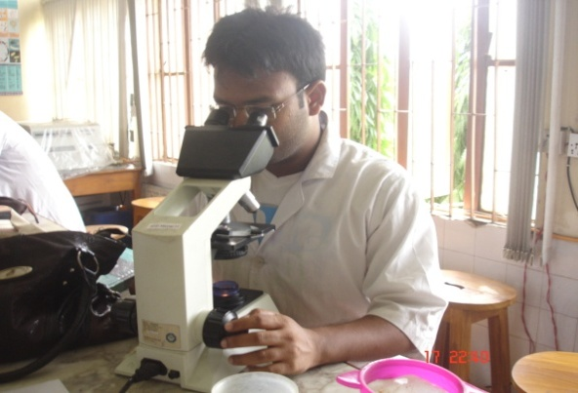
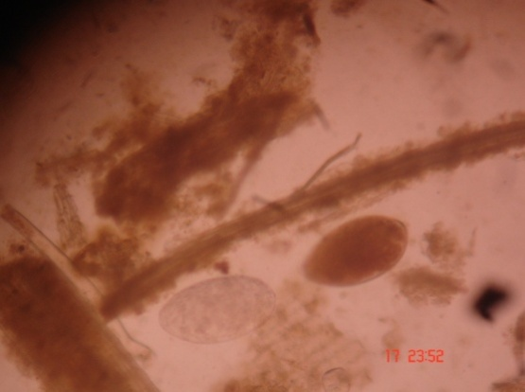

Fig. 1: Microscopic examination of feaces Fig.2: Egg of nematode

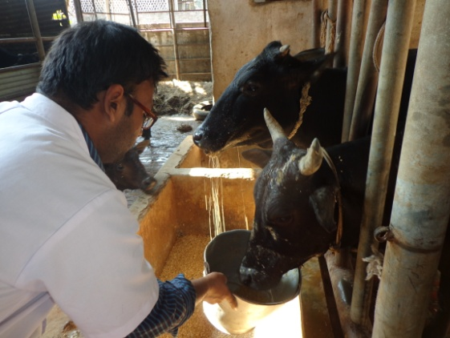
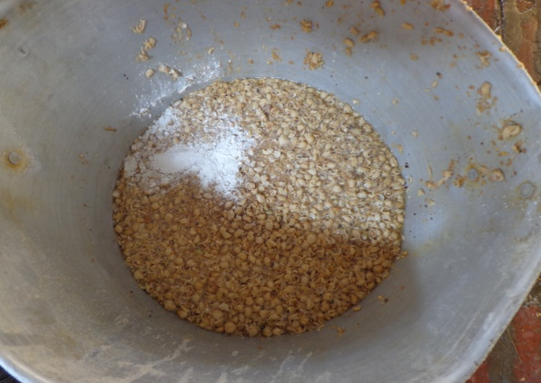

Fig. 3: Concentrate mixture with beneficial organisms Fig. 4: Feeding of liquid organisms

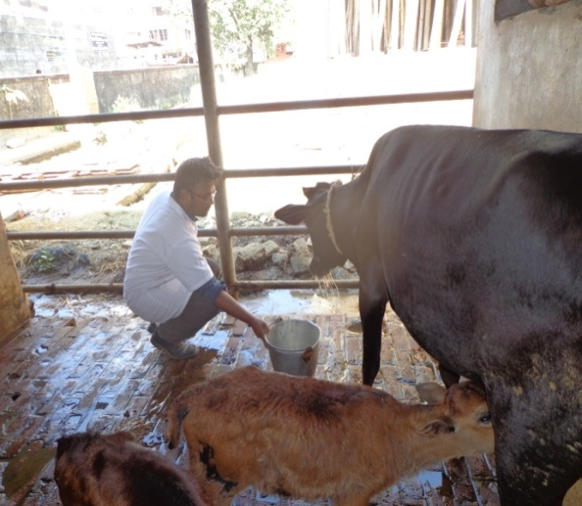
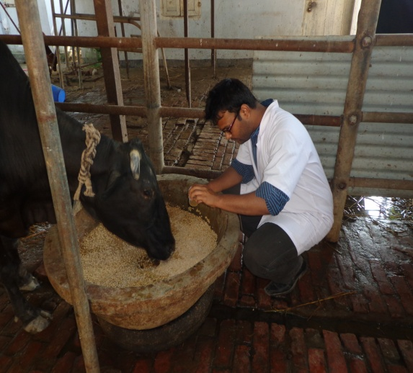

Fig.5: Feeding of prepared powder organisms Fig.6: Feeding of commercial organisms

Chapter-IV
RESULT AND DISCUSSION

Data getting after feeding trail are shown in table. In case of milk production, statistically there was no significant difference among the treatment groups but there was mathematical difference among the groups. Highest milk increased was in liquid group (342.86±27.66 ml) and lowest milk increased was (106.25±72.23ml). In case of commercial group, highest milk increased was in liquid group (298.75±17.98 ml) and lowest milk increased was (121.43±34.26ml) and in case of prepared group highest milk increased was in liquid group (509.42±20.34 ml) and lowest milk increased was (202±43.44ml).

Table 5: Statistical analysis of efficiency of different beneficial organisms on lactation
Weeks | Variables | Mean ± SE (ml) | Range (Min-Max) ml | P-value | Sig.
1st week | Liquid | 235.71±56.39 | 0-500 | 0.11 | NS
 | Commercial | 121.43±34.26 | 0-200
 | Liquid | 235.71±56.39 | 0-500 | 0.75 | NS
 | Prepared | 207.14±65.85 | 0-500
 | Commercial | 121.43±34.26 | 0-200 | 0.27 | NS
 | Prepared | 207.14±65.85 | 0-500
2nd week | Liquid | 342.86±27.66 | 250-400 | 0.08 | NS
 | Commercial | 298.75±17.98 | 200-300
 | Liquid | 342.86±27.66 | 250-400 | 0.06 | NS
 | Prepared | 509.42±20.34 | 250-500
 | Commercial | 298.75±17.98 | 200-300 | 0.09 | NS
 | Prepared | 509.42±20.34 | 250-500
3rd week | Liquid | 106.25±72.23 | (-200)-300 | 0.37 | NS
 | Commercial | 178.57±37.57 | 50-300
 | Liquid | 106.25±72.23 | (-200)-300 | 0.29 | NS
 | Prepared | 202±43.44 | 0-300
 | Commercial | 178.57±37.57 | 50-300 | 0.65 | NS
 | Prepared | 202±43.44 | 0-300
NS= Not significant.
S= Significant.
Again in ANOVA, we can see that the tabulated value is higher than calculated (F) value so, our null hypothesis is accepted. There is no significant variation among the treatments.
In our study we used two types of prepared beneficial organisms. One was liquid at the rate of 8 tk. /250 ml and other one was powder at the rate of 15 tk. /250 gm. The commercial beneficial organisms were also used at the rate of 125 tk. /250 gm.
By our study it is clear that the main difference among the treatment group in terms of price of the products.

Table 6: Summary of effects of exogenous fibrolytic beneficial organisms on animal performance.
Enzyme | Application method | Main diet ingredients | Apparatus or  animal (s) | Main responses | References
Xylanase and cellulase | Sprayed onto alfalfa hay during cubing  (1 or 2 g/kg DM) | Alfalfa cubes;  barley-based concentrate | Lactating cows | Applied at 2 g/kg DM, EFE increased milk  yield; no effects on DMI or milk composition | Yang et al. (1999)
Enzymes (mainly xylanase)  from  T. longibrachiatum | Applied onto forages  (2 or 5 L/t forage) | Corn silage;  alfalfa hay; concentrate | Lactating cows | Applied at 2 L/t, EFE increased milk yield, but  not milk composition | Kung, Jr. et al. (2000)
Cellulase and xylanase | Applied onto forage(0.7, 1.0 or 1.5 L/t) | Alfalfa hay;  corn silage; concentrate | Lactating cows | Enzymes increased milk yield, milk fat and  protein yield | Schingoethe et al. (1999)
Cellulase and xylanase  from  T. longibrachiatum | Applied onto TMR or onto  concentrate  (50 mg/kg TMR) | Corn silage; alfalfa hay  and barley concentrate | Lactating cows | Milk yield increased by EFE applied onto  concentrate, but not onto TMR; no effects on  DMI or milk composition. | Yang et al. (2000)
Extract of  A. oryzae with  multiple enzyme activities | Mixed with supplement and  topdressed onto TMR  (1.5, 3 or 6 g/d) | Alfalfa hay; concentrate | Lactating cows | No effect on milk yield, milk composition or  body weight change | Denigan et al. (1992)
Extract of  A. oryzae with  multiple enzyme activitie | Mixed with supplement and  topdressed onto TMR (3 g/d) | Alfalfa hay; steam flaked  or rolled corn | Lactating cows | No effect on DMI, milk yield, or milk  composition | Yu et al. (1997)

Chapter-V

CONCLUSION

By this study work we observed that the average milk increasing with the prepared beneficial organism regarding enzyme is higher and cost effective than the marketed beneficial organism regarding enzyme .So we can use these prepared products efficiently on lactating cows.

BIBLIOGRAPHY

Aoyagi, S. And D. Baker, (1995). Effect of microbial phytase and 1, 25 dihdroxycholecalciferol on dietary copper utilization in chicks. Poult. Sci., 74:121-126.

BBC News. 28 February 2000. Retrieved 14 February 2012, ("The state of food insecurity in the food 2011". www.fao.org. & "Bangladesh Healthcare Crisis")

B.B.S. (2012). Statistical pocket book of Bangladesh, ministry of planning, Government of peoples republic of Bangladesh.

Bhat, K.M. and Hazlewood, G. P. (2001). Enzymology and other characteristics of cellulases and xylanases. In: Enzymes in farm animal nutrition. pp 11-50.

Denigan et al. (1999), Rumen Microbes, Enzymes and Feed Digestion-A Review, Agriculture and Agri-Food Canada Research Centre, Lethbridge, Canada. PP- 1668.

DLS (2001& 2005), Department of Livestock Services.

Doerner and White, (1990), Rumen Microbes, Enzymes and Feed Digestion-A Review, Agriculture and Agri-Food Canada Research Centre, Lethbridge, Canada. PP- 1660.

Dubey, R.C. (2005). A text book of biotechnology. PP- 282.

Eckles, C.H. (1911), Digestion trial with two Jersey cows on full ration and on maintenance American rail road journal, Collection: MU Agricultural Experiment Station Publications.

Fan L. T., Gharpuray MM and Lee YH (1987). Cellulose hydrolysis. Berlin, Germany: Springer- Verlag 3; 1-68.

Ghose T.K. (1987). Measurement of cellulose activities. Pure Appl. Chem. 59:257-268

Hagspiel, K. and Masuda, Y. (1995). Arch Microbial 154; 150-155.

Hatakka A.I. (1983) Pretreatmnent of wheat straw by white-rot fungi for enzymatic saccharification of cellulose. Eur. J. Appl. Microbiol. Biotechnol. 18:350-357.

Howell J.A. (1978). Enzymatic deactivation during cellulose hydrolysis. Biotechnol. Vioeng. 20: 847-863.

Jaddav, N. V. (2007). Hand book of poultry production and management, 2nd Ed, PP164-166.

Jain, J. L.(2001). Fundamental of Biochemistry. PP 277-289

Katchalsi-Katzin and L. Goldstein (eds.), (1968). Enzyme Technology. PP-(71-95).

Kumakura M (1997). Preparation of immobilized cellulose beads and their application to hydrolysis of cellulosic materials. Process Biochem. 32:555-559.

Kung, Jr. et al. (2000), Rumen Microbes, Enzymes and Feed Digestion-A Review, Agriculture and Agri-Food Canada Research Centre, Lethbridge, Canada. PP- 1668.

Lilly, M.D. (1979). Intracellular microbial enzyme production, in L.B. Wingard, E. Katchalsi-Katzin, and L, Goldstein (eds.), Enzyme technology. New York: Academic press.

Menon, K., Rao, KK. Pushalkar, (1995). Curr Microbial 30:255-258.

Pant M. C. (1993). Self assessment in Biochemistry. Jaypee brothers’ medical publishers, PP-25.

Schingoethe et al. (1999), Rumen Microbes, Enzymes and Feed Digestion-A Review, Agriculture and Agri-Food Canada Research Centre, Lethbridge, Canada. PP- 1668.

Shamsuddoha.A.K. (2000), Paper for AARES 2000 Conference, “Dairy Industry in Bangladesh: Problems and Prospects”.

Solis, S., M.E. Flores and C. Huitron. (1997). Improvement of pectinase production by interspecific hybrids of Aspergillus strains. Letters in Appl. Microbiol. 24:77-81.

Solomon B.O., Layoku S.K., Nwesigwe P.K. and Olutiola PO (1990). Hydrolysis of sawdust by cellulase enzyme derived from Aspergillus flavus Linn Sinitsyn, A. P., Gusakov, A. V. and Yu Vlasenko, E. 1990. Effect of structural and physico-chemical features of cellulosic substrates on the efficiency of enzymatic hydrolysis. Applied Biochemistry and Biotechnology 30: 43-59.

Solomon B.O., Amigun B, Betiku E, Ojumu T.V. and Layikun S.K. (1999). Optimization of cellulose production by Aspergillus flavus Linn Isolate NSPR 101 Grown on Bagasse. JNSChE, 16: 61-68.

Vadra, S.K. (2007). Biotechnology and its use, PP- 44.

Walter and Mc Bee, (1962). Industrial microbiology in: General microbiology. 2nd, reprinted Feb. 1963. P- 309.

Yang et al. (1999), Rumen Microbes, Enzymes and Feed Digestion-A Review, Agriculture and Agri-Food Canada Research Centre, Lethbridge, Canada. PP- 1668.

Yu et al. (1999), Rumen Microbes, Enzymes and Feed Digestion-A Review, Agriculture and Agri-Food Canada Research Centre, Lethbridge, Canada. PP- 1668.

Website:
www.enzymedia.com
www.ublcorp.com
www.oneworld.net
www.fao.org.com

