Nutritional Assessment of Jack Fruit (Artocarpus heterophyllus) and Bamboo Leaves (Bambusa tulda) Used as Goat Feed at Chandanish, Chittagong

A Report Submitted by:
Intern ID: B-14
Roll No. : 2005/14
Reg. No.: 206
Session: 2004-2005

A Production Report Submitted in Part of Fulfillment of The
Degree of Doctor of Veterinary Medicine (DVM)

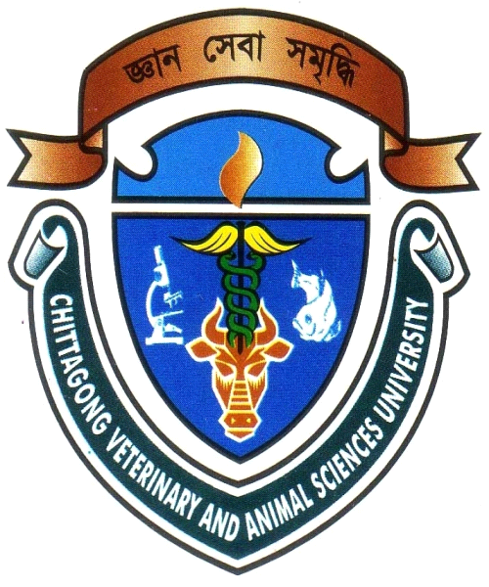

Faculty of Veterinary Medicine
Chittagong Veterinary and Animal Sciences University
Khulshi, Chittagong - 4202

January 2011
Nutritional Assessment of Jack Fruit (Artocarpus heterophyllus) and Bamboo Leaves (Bambusa tulda) Used as Goat Feed at Chandanish, Chittagong

A Production Report
Submitted as per Approved Style and Contents

Signature of Supervisor

-------------------------------------
Name: Md. Manirul Islam
Designation: Assistant Professor
Department of Animal Science and Animal Nutrition

Faculty of Veterinary Medicine
Chittagong Veterinary and Animal Sciences University
Khulshi, Chittagong - 4202

January 2011
CONTENTS

Chapter | Topics | Page No.
 | Acknowledgement | i
 | Acronyms used | ii
 | Abstract | iii
1 | Introduction | 01
2 | Review of Literature | 02
3 | Materials and Method | 03-04
4 | Result | 05-07
5 | Discussion | 08
6 | Conclusion | 09
7 | References | 10
 | Appendix | 11

LIST OF TABLES

SL. NO. | NAME OF TABLES | PAGE NO.
1 | Chemical composition of shade dried and sun dried jack fruit leaves (Artocarpus heterophyllus) | 5
2 | Chemical composition of shade dried and sun dried bamboo leaves (Bambusa tulda) | 6
3 | Chemical composition of shade dried jack fruit (Artocarpus heterophyllus) and bamboo leaves (Bambusa tulda) | 6
4 | Chemical composition of sun dried jack fruit (Artocarpus heterophyllus) and bamboo leaves (Bambusa tulda) | 7
5 | Proximate composition (g/100g DM, except for DM which is on fresh basis) of the studied tree foliages | 11

Acknowledgement

This production report is the part of my internship program under Chittagong Veterinary and Animal Sciences University (CVASU), Khulshi, Chittagong. It is based on my study at Nutrition lab, CVASU, Chittagong.

I want to take privilege to acknowledge the Almighty God, who enables me the opportunity to accomplish the report.

I would like to express deep sense of gratitude to my supervisor Assistant Prof. Md. Manirul Islam, Department of Animal Science and Animal Nutrition, CVASU for his valuable advice, working detection & co-operation.

I am really grateful to Mrs. Jannatara Khatun, Associate professor & Head of department of Animal Science and Nutrition, CVASU and Md. Khorshade Alam, Lab technician, dept. of animal science and animal nutrition, for their help and kind co-operation during the study.

I convey thanks to those who help me in various aspects to complete this report.

The Author

i
Acronyms Used

DM Dry Matter
CP Crude Protein
CF Crude Fiber

ii
NUTRITIONAL ASSESSMENT OF JACK FRUIT (Artocarpus heterophyllus) AND BAMBOO LEAVES (Bambusa tulda) USED AS GOAT FEED AT CHANDANISH, CHITTAGONG

Abstract

The study was carried out to observe the nutritional quality of unconventional shrubs and tree foliages for indigenous goat feed. The DM, CP, CF and Ash contents of jack fruit (Artocarpus heterophyllus) and bamboo leaves (Bambusa tulda) were calculated. The DM content of sun dried and shade dried jack fruit and bamboo leaves were 55.18% & 80.91% and 55.12% & 80.73%, respectively. The CP content was 8.42% & 19.69% and 8.39% & 19.38% in sun dried and shade dried leaves, respectively. The CF content was 36.97% & 24.43% and 7.07% & 24.12% in sun dried and shade dried leaves, respectively. The Ash content was 6.4% & 12.09% and 6.23% & 11.98% in sun dried and shade dried leaves, respectively. The unconventional tree foliages were found to be good quality in terms of nutrient contents and these may be used as scavenging goat rearing.

Key words: Chemical composition, jack fruit and bamboo leaves.

iii

