Chapter 1
Introduction
Goats play a vital role in the subsistence economy of smallholder farmers in most countries such as Bangladesh, Zimbabwe and Nepal. Goats depend mainly on the rangeland for their nutritional requirements, a situation unlikely to change. The rangelands are characterized by perennial grasses and Acacia species. Acacia trees and other browse species produce pods and leaves which could be harvested and processed as supplementary feed throughout the year for livestock including goats. Browse pods are high in nutritive value (Ncube and Mpofu, 1994) and can be used as supplements to low quality roughages. Crude protein of browse pods ranges from 15-20 per cent. One of the major disadvantages of browse as a livestock feed is the presence of perceived antinutritional factors such as phenolic compounds, of which tannins represent a large part. Certain browse species have medicinal properties. The medicinal uses are based on the astringent property of tannins present in the roots and bark (Timberlake, et. al 1999).
From the above discussion the following objective were settle down for my research study:
1. To assess the nutritional quality of locally available unconventional feed resources.
2. To study feasibility study of foliage used as goat feed.
3. To develop the feeding strategy of goat using non-conventional feed resources.

Chapter 2
Review of Literature
Nazaruddin and Muchlisah (1994) reported that jack fruit is a perennial tree which grows over a wide range of altitude and soil types in Bangladesh.

Keir et al (1997) reported that the farmers have been using jack fruit leaves as animal feed, especially during the dry seasons.

Phengvilaysouk and Kaensombath (2006) reported that fresh jack fruit leaves can be a valuable feed resource for ruminants when combined with nitrogen sources such as legume leaves.

Mui et al., 2001; Aregheore and Perera, (2004); Van et al., (2005) reported that foliage from jack fruit (Artocarpus heterophyllus) was good protein sources and has a high intake potential for goats.

Chapter 3
Material and Methods
3.1 Location of study area
Chandanaish Upazilla (Chittagong district) with an area of 201.99 sq km, is bounded by patiya and rangunia Upazilla on the north, Satkania Upazilla on the south, bandarban sadar and Satkania Upazilla on the east, Anwara Upazilla on the west. Main rivers are sangu and Chankhali.
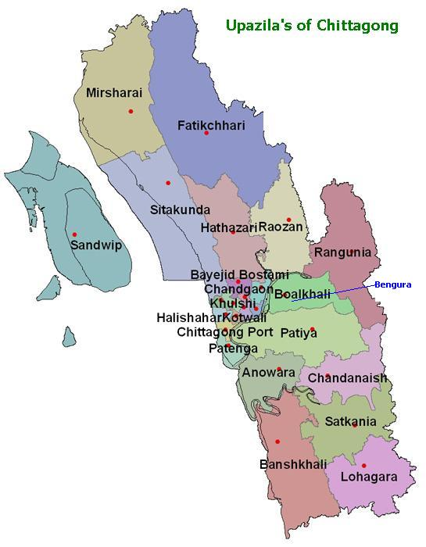

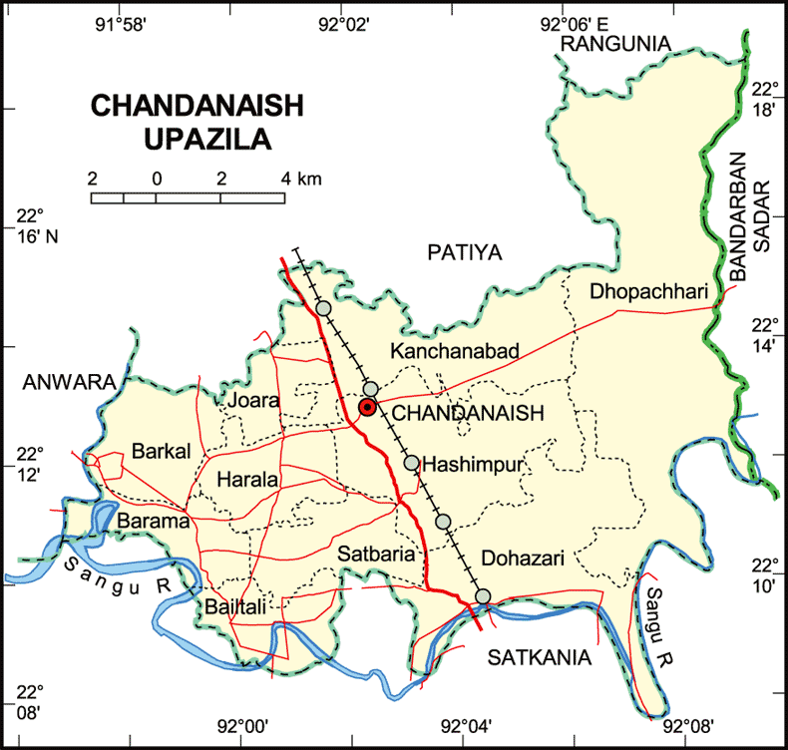

3.2 Chemical Composition
This study was conducted using leaves harvested from two naturally growing common trees and shrubs namely: Artocarpus heterophyllus and Bambusa tulda found within and around Chandanaish. Foliages from each of the sampled plants were collected fresh and almost immediately dried in sun and shade. Then both were dried in a house under atmospheric condition and rest of the sample was dried on the open sun. Dried samples were then placed in a forced-air oven at 105ºC until constant weight was attained to determine their DM contents and then milled to pass through a 1mm mesh sieve for subsequent analyses. Crude protein was determined by the micro-kjeldahl procedure (Nx6.25) and the ash was determined by incineration at 500ºC for 6h in a muffle furnace. All analyses in this study were done following standard procedures as outlined by AOAC (1990). All analysis was done in laboratory of Department of Animal Science and Animal Nutrition, Chittagong Veterinary and Animal Sciences University.
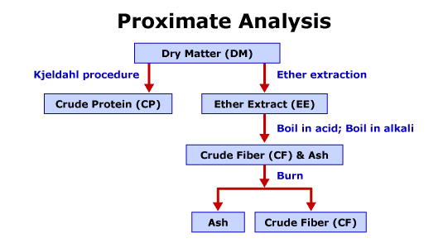

Chapter 4
Result
The table 1 shows the Chemical composition of sun dried and shade dried jack fruit leaves. DM content of sun dried and shade dried leaves of jackfruit were 55.12% & 55.18%. and CP content of sun dried and shade dried leaves of jackfruit were 8.39% & 8.42% , CF content of sun dried and shade dried leaves of jackfruit were 36.07% & 36.97% and Ash content of sun dried and shade dried leaves of jackfruit were 6.23% & 6.44%.
Table 1: Chemical composition of shade dried and sun dried jack fruit leaves (Artocarpus heterophyllus)
Parameter | Shade dried  (Mean ±SD) | Sun dried  (Mean ±SD) | Level of significance
Dry matter (g/100g) | 55.18±3.51 | 55.12±6.51 | 0.193
CP (g/100g) | 8.42±3.61 | 8.39±2.52 | 0.259
CF (g/100g) | 36.97±0.24 | 37.07±8.82 | 0.716
Ash (g/100g) | 6.44±0.42 | 6.23±0.15 | 0.189

The table 2 shows the Chemical composition of shade dried and sun dried bamboo leaves. DM content of sun dried and shade dried leaves of bamboo were 80.73% & 80.91% and CP content of sun dried and shade dried leaves of bamboo were 80.73% & 80.91%, CF content of sun dried and shade dried leaves of bamboo were 24.17% & 24.40% and Ash content of sun dried and shade dried leaves of bamboo were 11.91% & 12.09%.

Table 2: Chemical composition of shade dried and sun dried bamboo leaves (Bambusa tulda)

Parameter | Shade dried  (Mean ±SD) | Sun dried  (Mean ±SD) | Level of significance
Dry matter (g/100g) | 80.91±0.26 | 80.73±0.21 | 0.383
CP (g/100g) | 19.78±0.16 | 19.38±0.43 | 0.202
CF (g/100g) | 24.40±1.00 | 24.17±0.12 | 0.057
Ash (g/100g) | 12.09±7.37 | 11.91±3.22 | 0.018

The table 3 shows the chemical composition of shade dried jack fruit and bamboo leaves. DM content of shade dried jack fruit leaves were 55.18% and bamboo leaves were 80.91%.CP content of shade dried jack fruit leaves were 8.42% and bamboo leaves were 19.78%. CF content of shade dried jack fruit leaves were 36.97% and bamboo leaves were 24.40%. Ash content of shade dried jack fruit leaves were 6.40% and bamboo leaves were 12.09%.
Table 3: Chemical composition of shade dried jack fruit (Artocarpus heterophyllus) and bamboo leaves (Bambusa tulda)

Parameter | jack fruit  (Mean ±SD) | Bamboo  (Mean ±SD) | Level of significance
Dry matter (g/100g) | 55.18±3.51 | 80.91±0.26 | .00
CP (g/100g) | 8.42±3.61 | 19.78±0.16 | .00
CF (g/100g) | 36.97±0.42 | 24.40±1.0 | .00
Ash (g/100g) | 6.40±0.1 | 12.09±7.37 | .00
The table 4 shows the chemical composition of sun dried jack fruit and bamboo leaves. DM content of sun dried jack fruit leaves were 55.12% and bamboo leaves were 80.73%.CP content of sun dried jack fruit leaves were 8.39% and bamboo leaves were 19.38%. CF content of sun dried jack fruit leaves were 37.07% and bamboo leaves were 24.17%. Ash content of sun dried jack fruit leaves were 6.23% and bamboo leaves were 11.91%.

Table 4: Chemical composition of sun dried jack fruit (Artocarpus heterophyllus) and bamboo leaves (Bambusa tulda)

Parameter | jack fruit  (Mean ±SD) | Bamboo  (Mean ±SD) | Level of significance
Dry matter (g/100g) | 55.12±6.51 | 80.73±0.21 | .00
CP (g/100g) | 8.39±2.52 | 19.38±0.43 | .00
CF (g/100g) | 37.07±0.15 | 24.17±0.12 | .00
Ash (g/100g) | 6.23±0.15 | 11.91±3.22 | .00

Chapter 5
Discussion

Crude protein contents in the investigated leaves were high in bamboo leaves where as crude protein content was less in jack fruit leaves. In case of sun drier and shade dried jack fruit leaves (Artocarpus heterophyllus) the chemical parameters were almost same. In case of shade dried and sun dried bamboo leaves (Bambusa tulda) the chemical parameters were almost same. In case of shade dried jack fruit (Artocarpus heterophyllus) and bamboo leaves (Bambusa tulda) dry matter content of bamboo leaves were high 80.91% and crude protein were also high 19.78%, but CF content of jack fruit leaves were higher (36.97%) than bamboo leaves. Ash content was also high in bamboo leaves 12.09%. In case of sun dried jack fruit (Artocarpus heterophyllus) and bamboo leaves (Bambusa tulda) the dry matter content of bamboo leaves were also higher (80.73%) than jack fruit leaves (55.12%), crude protein were also high (19.38%) in bamboo leaves. But quite less than shade dried leaves in both samples due to loss of nitrogen at the time of sun drying. But due to high content of CF of jack fruit leaves and palatability it was more potential than bamboo leaves.
Chapter 6
Conclusion
Goat is a potential livestock resource for farmers at Chandanish Upazilla. This area is endowed with indigenous feed resources, which need exploitation with maximum utilization and conservation. The results of this study generally showed that the shrubs and tree foliages have a high potential for goat in terms of their chemical compositions especially the high crude protein and CF contents. Though there are some problems of feeding goat, it is a promising sector for the development of economic condition of the rural people of the said area and all over the Bangladesh as well. To overcome the limitations for goat rearing indigenous feed resources may be used. In this regard, further nutritional researchers should be conducted to assess the nutritional quality of unconventional feed resources under rural condition.

Chapter 7
REFERENCES

AOAC, 1990. Official Methods of Analysis, 15th edition. Association of Official Analytical Chemists. Washington, DC.
ARC, 1985. The nutrient requirement of farm animals. Technical Review and Summaries, Agricultural Research Council, London UK.
A1am J., 1993. The sector for more investment in Bangladesh. Asian Livestock 7: 77-78.
Banerjee G.C., 2004. A text book of Animal Husbandry. Oxford & IBH Publishing Co. Pvt. Ltd. New Delhi. 8th edition; pp: 933-961.
Chowdhury et a.l, 2002. Production of sheep and Goat. Elsevier Scientific Publishing Company.
Devendra, C., 1992. Studies in the nutrition of the indigenous goat at Malaya and requirement of live weight gain. Malaysian Agric. J. 46: 98-11 8.
Devendra, C & Burns.M., 1983.Goat production in the tropics. Commonwealth Agricultural Bureaux. Slough, U.K.

Daovy Kongmanila, Inger Ledin . June, 2009. Chemical composition of some tropical foliage species and their intake and digestibility by goats. Asian - Australasian Journal of Animal Sciences.

Appendix
Table1: Proximate composition (g/100g DM, except for DM which is on fresh basis) of the studied tree foliages
Nutrition | Sample  no | Shade dried |  |  |  | Sun dried
Nutrition | Sample  no | Jack fruit leaves | Mean | Bamboo leaves | Mean | Jack fruit leaves | Mean | Bamboo leaves | Mean
DM | 1 | 55.22 |  | 81.15 |  | 55.18 |  | 80.95
DM | 2 | 55.15 | 55.18 | 80.64 | 80.91 | 55.05 | 55.12 | 80.69 | 80.73
DM | 3 | 55.18 |  | 80.95 |  | 55.12 |  | 80.54
CP | 1 | 8.43 |  | 19.96 |  | 8.36 |  | 18.89
CP | 2 | 8.38 | 8.42 | 19.7 | 19.69 | 8.39 | 8.39 | 19.58 | 19.38
CP | 3 | 8.45 |  | 19.68 |  | 8.41 |  | 19.67
CF | 1 | 36.5 |  | 24.3 |  | 37.1 |  | 24.1
CF | 2 | 37.3 | 36.97 | 24.5 | 24.4 | 36.9 | 37.07 | 24.3 | 24.12
CF | 3 | 37.1 |  | 24.4 |  | 37.2 |  | 24.1
ASH | 1 | 6.3 |  | 12.12 |  | 6.2 |  | 11.9
ASH | 2 | 6.4 | 6.4 | 12.01 | 12.09 | 6.1 | 6.23 | 11.95 | 11.98
ASH | 3 | 6.5 |  | 12.15 |  | 6.4 |  | 11.89

