CHAPTER: I
INTRODUCTION
The economy of Bangladesh is agro based. The poultry is an important sub-sector of livestock. The poultry sector in private sector has been growing up rapidly. At the demand of day old chicks is very high a number of hatcheries have been established by the private entrepreneurs for getting a higher profit within shorter possible time. It has been found by the survey (ATDP/IFDC) that there are 63 hatchers in the ends in the year 1999. Now 75 numbers of hatcherie in Bangladesh (Poultry Khmer Bechitra; 2006).

Poultry provides hard-cash income and creates employment opportunities for the rural farmers and landless women. Poultry meat contributes 37 percent of the total meat production in the country, and poultry contributes 22-27 percent of the total animal protein supply. The number of eggs produced in the country is less than the demand and there is a shortfall of 87 percent. Egg production over recent years has gone up by 3.8 percent, and poultry meat production increases by 7.2 percent annually. The most significant limiting factor has been the shortage of poultry feed and sustained promotion is needed to facilitate the growth of the poultry industry in the country. (FAO Statistics, 2002)

The demand of meat and egg is high in our country but the supply is not enough. Indigenous chicken are principle of supplies of poultry meat, eggs of the country though their predominance are poor (Khondoker et al. 1996). Rural scavenging chicken contribute about 75.06%egg on the country (Haque; 1993). The egg production of deshi hen is about 30-70 egg per year is egg size stand about 30-50 gm (All et all. 1996) where are the exotic strains turn to 300 eggs per hen per year (Haque; 1999). Emerging poultry industry are increasing and high producing commercial exotic strains farmed very intensively by the industrialist.

South Asian countries (India, Pakistan, Bangladesh, Sri Lanka, Nepal, Bhutan and the Maldives) represent about 22 percent of the world population. However, they contribute only about 5 percent of the total egg production of the world and even less in poultry meat production, with chicken slaughter in these countries amounting to only 2.7 percent of the chickens slaughtered in the world.

Table-1: World chicken meat production, 2002.
Rank | country | Chicken meat production
1 | USA | 14764
2 | China | 9475
3 | Brazil | 6660
4 | Mexico | 1914
5 | UK | 1250
6 | Japan | 1190
7 | France | 1155
19 | India | 595
33 | Pakistan | 355
2 | Bangladesh | 99
76 | Sri-Lonka | 82
Source: FAO Statistics, 2002.

Table-2: Poultry Meat Consumption in South Asian Countries (kg/person/yr).
Country | Year
Country | 1985 | 1991 | 1996 | 2000
India | 0.2 | 0.5 | 0.5 | 0.6
Pakistan | 1.0 | 1.4 | 2.6 | 2.3
Bangladesh | 0.6 | 0.7 | 1.0 | 0.8
Sri Lanka | 0.6 | 0.8 | 3.1 | 3.4
Nepal | 0.3 | 0.5 | 0.5 | 0.6
Bhutan | 0.2 | 0.2 | - | -
Maldives | - | 1.1 | 1.8 | 4.1
World | - | - | 9.7 | 10.9
Source: FAO Statistics, 2002.

Table-3: Growth in Chicken Population in South Asian Countries (million).
Country | Year
Country | 1991 | 1997 | 1998 | 1999 | 2002
India | 294 | 343 | 375 | 383 | 413
Pakistan | 78 | 200 | 145 | 148 | 155
Bangladesh | 90 | 153 | 138 | 138 | 140
Sri Lanka | 9 | 9 | 10 | 10 | 11
Nepal | 12 | 16 | 16 | 18 | 21
Source: FAO Statistics, 2002.

The nutritional and disease problem are the major constraints in Bangladesh for the development and maintenance of poultry. Suitable breed and proper knowledge of management results in profitable poultry production which are lake in traditional poultry rearing system. Considering the market facilities and poverty alleviation there are so many small holder commercial farm are just selling up on urban and rural area of Bangladesh and also increasing the hatcheries. Which help proper supply of egg and meat also help the nutritional supply like protein. In Bangladesh Poultry meat most of the world with 55 million ton 28% of the total meet consumption in 1999. (Alam, 2001). The study was conducted commercial broiler units, kazi farm limited, Chawkpara, Sreapur, Gazipur to gain the skills in commercial broiler management practices and Food Conversion Ratio (FCR); mixing theoretical knowledge with practical in an established commercial broiler farm (broiler breeder farm rearing Cobb-500 strain)

CHAPTER: II
- MATERIALS AND METHOD

3.1. LOCATION AND DURATION
The study was conducted 30 days of time from 15th September to 14th October 2010, at kazi farm limited; Chawkpara, Sreapur, Gazipur.
3.2. TOTAL BIRDS: The total number of bird per shed 19968.
3.3. HOUSE: There was one controlled house for broiler.
3.4. FARM PREPARATION FOR NEXT CYCLE
Individual sites should manage birds of a single age (that was they should be managed on the principles of ‘all-in, all-out’). Before starting of new cycle the fumigation step was done. There were two type of fumigation was done-a) strong fumigation) weak fumigation. For 100sq.ft area were contain 20gm potassium and 60ml formalin and at list 8hs for stay. Cleaning programmers were done of better management through the shed. Houses, the areas surrounding the houses, and all equipment must be thoroughly cleaned and disinfected before the arrival of the bedding material and chicks. Subsequently, management systems should be in place to prevent pathogens entering the building. Before entry, vehicles, equipment and people should be disinfected. Litter material should be spread evenly to a depth of 4-5 centimeter where the floor temperatures ware adequate (28-30°C).

3.5. BROODING HOUSE MANAGEMENT
Chicks cannot regulate their own body temperature until they are around 7days of age (it depend upon the climatic condition of the environment). Floor temperature at chick placement was as important as air temperature, so preheating of the house was essential. Temperature and relative humidity should be stabilized for at least 24 hours prior to chick arrival. Recommended values ware:
- Air temperature of 30°C (measured at chick height in the area where feed and water ware positioned)
- Litter temperature of 28-30°C
- Relative humidity of 60-70%,
These should be monitored regularly to ensure a uniform environment throughout the whole brooding area, but by far the best indicator of temperature was chick behavior. Prior to delivery of chicks, a final check must be made of feed and water availability and distribution within the house. All chicks must be able to eat and drink immediately on placement in the housed. For the first seven days, provide 23.30 hours light and 30 min dark with 30-40 lux intensity to help the chick adapt to the new environment and encourage feed and water intake. Adequate fresh, clean water must be available at all times to all birds with access points at an appropriate height. Nipple lines should be installed at 12 birds per nipple and manual drinkers at a minimum of six mini drinkers per 1,000chicks.
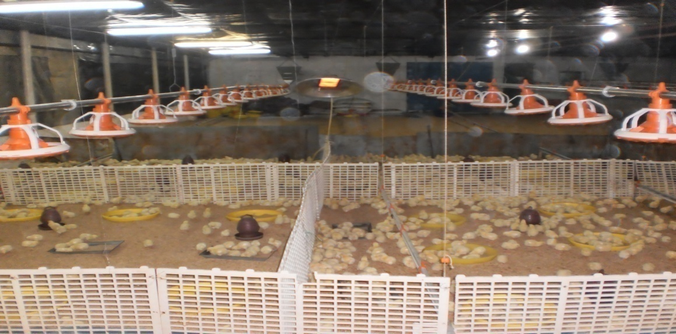
Picture-1: Brooding house management.
3.6. BROODIMG TEMPARATURE
Table-4: Brooding House Temperature (from 1 to 7 days).
Day | °C | °F
1st day | 34 | 93.2
2nd day | 33.5 | 92.3
3rd day | 33 | 91.4
4th day | 32.5 | 90.5
5th day | 32 | 89.6
6th day | 31.5 | 88.7
7th day | 31 | 87.8
3.7. CHICK MANAGEMENT
For the best commercial broiler performance, the chicks should be delivered to the broiler farm as soon as possible and fed immediately which contain ME-3000Kcal/Kg, CP-21%, Lysine-1.2%, Methionin-0.49%, Cystine-0.4%, Tryptophan-0.19%, Thionine-0.79%, and Argenine1.26%. They must be provided with the correct environment which should be managed to meet all their requirements. Deficiencies in the early environment will depress both current and final flock performance. Chicks must adapt to establish healthy feeding and drinking. Once on the farm, the chick was offered Starter feed in mini pellet for feeding system. It was very important that the seven-day weight should be 4 times greater than the day-old chick weight.

3.8. CHICK START ASSESSMENT
In the period immediately after the chicks were introduced to feed for the first time they were hungry, which means that they should eat well and fill their crops. Check a sample of birds eight and 24 hours after arrival on the farm to make sure that all the chicks have found feed and water. To do this, samples of 30-40 chicks should be collected at three or four different places in the house. Each chick’s crop should be felt gently. In chicks that have found food and water, the crop will be full, soft and rounded. If the crop was full, but the original texture of the crumb is still apparent, the bird has not yet consumed enough water. Target crop fill at eight hours after delivery is 80% and at 24 hours after delivery 95-100%.

Picture-2: The chick on the left has a full, rounded crop while
The chick on the right has an empty crop.
3.9. GROWING MANAGEMENT
The drinkers and feeders had to be changed after the second week and at the fifth week, and larger-sized equipment needs to be provided to allow adequate space for feeders and drinkers, as already suggested. Clean, potable water should be provided. In the early morning, as the first duty in the daily routine, the drinkers should be emptied, cleaned and filled with fresh water. Water and feed must be given three times a day. Fill the drinkers and feeders only to two-thirds of their capacity. Take care not to spill water on the litter. During the first two weeks, broiler starter mash with 21 percent of crude protein and 3000 Kcal per kg of metabolic or metabolized energy (ME.) must be fed, and this should be repeated after three weeks. Until they are marketed, broiler finisher mash with 20 percent crude protein and 3100 Kcal per kg of ME. must be given. The broilers may also be fed in three phases from 0 to 2 weeks, 3-4 weeks, and from the fifth week to market age. During feeding and watering, the birds should be disturbed as little as possible. If possible, the same person should attend to each batch. Feeding and watering may also be done at the same time every day to minimize stress. Take all possible steps to avoid feed wastage. Provide an adequate number of feeders; make provisions to adjust the height of feeders so that the brim of the feeder or drinker is at the same level as the back of the growing broiler. Watch the growth of the broilers up to market age by weighing at least ten birds of average size at the end of every day to make sure that they were gaining weight normally. Watch the daily consumption of feed and water, as any drastic change has to be investigated.

3.10. LIGHTING FOR BROILERS
A lighting programmed should be simple in design. Light was an important management technique in broiler production. This system consists of a long continuous light period, followed by a Short dark period of 30-60 minutes. Exposure to darkness influences bird productivity, health, hormonal profiles, metabolic rate, heat production, metabolism, physiology and behavior.
Table-5: Lighting management in broiler shed:
Age (days) | Intensity (lux) | Day length (hours)
0-10 | 30-40 | 23light 1dark
11- up to finish | 5-10 | 22light 2dark

3.11. LITTER MANAGEMENT
Local economics and raw material availability will dictate the choice of litter material used.
Litter should provide:
• Good moisture absorption.
• Biodegradability.
• Bird comfort.
• Low dust level.
• Freedom from contaminants.
• Availability.
Rice husk material should be evenly distributed to a depth of 4-5 cm. Where floor temperatures are correct (28-30°C) the litter depth can be reduced when litter disposal was an issue.
3.12. VENTILATION
The principle means of controlling the bird’s environment was by control of ventilation. It was essential to deliver a constant and uniform supply of good quality air at bird level. Fresh air was required at all stages of growth to allow the bird to remain in good health and achieve full potential. Ventilation helps to maintain in-house temperatures within the birds’ comfort zone. The housing and ventilation systems used will depend upon climate, but in all cases effective ventilation should remove excess heat and moisture, provide oxygen and improve air quality by removing harmful gases. The main contaminants of air within the house environment are dust, ammonia, carbon dioxide, carbon monoxide and excess water vapor. When in excess, they damage the respiratory tract, decreasing the efficiency of respiration and reducing bird performance. Continued exposure to contaminated and moist air may trigger disease (e.g. ascites or chronic respiratory disease), affect temperature regulation and contribute to poor litter quality. A combination of heat and ventilation was very important for young chicks.
Oxygen --------› In
Carbon dioxide, ammonia---------› out
Cold air in and mixed heat air, contaminated hot air out.
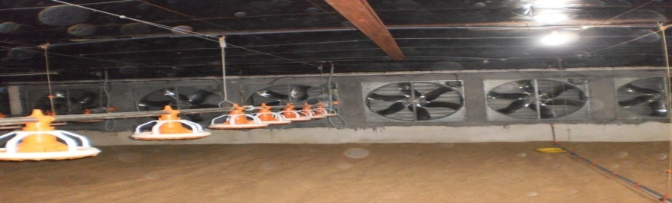
Picture-3: The exhaust fan for ventilation.
3.13. PROVITION OF FEED
Feed was a major component of the total cost of broiler production. To support optimum performance, broiler rations should be formulated to give the correct balance of energy, protein and amino acids, minerals, vitamins and essential fatty acids. Broiler growth and efficiency of feed use will generally be better if the Starter feed was crumbs or mini-pellets and the Grower and Finisher feeds were pellets (Table:6). Depending on pellet size fed, it may be necessary to provide the first delivery of Grower feed as crumbs or mini-pellets.
Table-6: Form of Feed by Age in Broilers.
Age | Feed Form and Size
0-10 days | mini-pellets.
11-24 days | 2-3.5 mm diameter pellet.
25 days to processing | 3.5 mm diameter pellet.

Table-7: Different stage for nutritional level of commercial broiler.
Stage | Age or wt. | Nutritional status
Stage | Age or wt. | CP% | CF% | Fat% | Ash% | Moisture% | Lysine(g/100g) | Methionine(g/100g) | Cystine(g/100g) | Tryptophen(g/100g) | Thionine(g/100g) | Argenine(g/100g)
Broiler starter | 0-14 days | 21 | 5 | 6 | 8 | 13 | 1.2 | 0.49 | 0.40 | 0.19 | 0.79 | 1.26
Broiler grower | 15-24 days | 19 | 5 | 6 | 8 | 13 | 1.1 | 0.47 | 0.39 | 0.18 | 0.75 | 1.18
Broiler finisher | 25-upto selling | 17.5 | 5 | 6 | 8 | 13 | 1 | 0.45 | 0.37 | 0.18 | 0.70 | 1.09

3.14. PROVITION OF WATER
Nipple drinkers should be installed at 12 birds per nipple; additional supplementary manual drinkers should be supplied (six per 1,000 chicks) for the first 3-4 days. The actual number of birds per nipple will depend on flow rates, depletion age, climate and design. Water lines need to be managed daily during the flock to obtain optimum performance.
The back of the chick should form an angle of 35-45° with the floor whilst drinking was in progress. As the bird grows, the nipples should be raised so that the back of the bird forms an angle of approximately 75-85° with the floor and so that the birds.

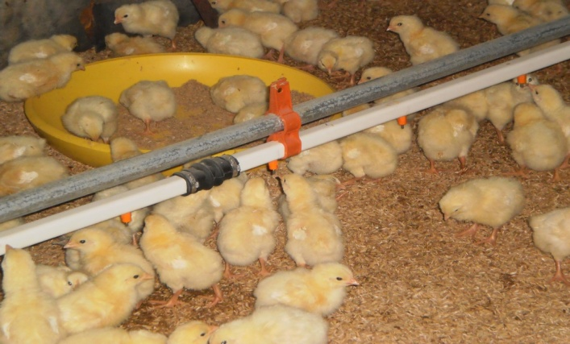
Picture-3: Nipple drinker.

At day old, a minimum of six manual drinkers (40 cm diameter) should be provided per 1,000 chicks; additional sources of water in the form of six mini-drinkers or plastic trays per 1,000 chicks should also be available. As the broilers become older and the area of the house in use was expanded, a minimum of eight manual drinkers (40 cm diameter) must be provided per 1,000 chicks. These should be placed evenly throughout the house so that no broiler was more than two meters from water. As a guide, water level should be 0.6 cm below the top of the drinker until approximately 7-10 days. After 10 days there should be 0.6 cm of water in the base of the drinker. Additional mini-drinkers and trays used at day-old should be removed gradually so that by 3-4 days all chicks were drinking from the automatic drinkers. Minimum drinker requirements per 1,000 birds post-brooding were given in Table 8.
Table-8: Minimum drinker requirements per 1,000 birds Post brooding.
Drinker type | Drinker requirements
Manual drinkers | 8 drinkers (40 cm diameter) per 1,000 birds
Nipples | 83 nipples per 1,000 birds  (12 birds per nipple, or for broilers >3kg 9-10 birds per nipple).

Table-9: Avg. water intake of 19968 birds in 30 days.
^{AGE(DAY)} | ¹ | ² | ³ | ⁴ | ⁵ | ⁶ | ⁷ | ⁸ | ⁹ | ¹⁰ | ¹¹ | ¹² | ¹³ | ¹⁴ | ¹⁵ | ¹⁶ | ¹⁷ | ¹⁸ | ¹⁹ | ²⁰ | ²¹ | ²² | ²³ | ²⁴ | ²⁵ | ²⁶ | ²⁷ | ²⁸ | ²⁹ | ³⁰
^{AVG.WATER INTAKE (ML)} | ³⁰ | ³² | ³⁴ | ³⁸ | ⁴⁰ | ⁴² | ⁴⁵ | ⁴⁸ | ⁷⁰ | ⁶⁵ | ⁷⁰ | ⁸⁰ | ⁸⁵ | ⁹⁰ | ¹⁰⁰ | ¹⁰⁸ | ¹¹⁵ | ¹²² | ¹²¹ | ¹⁷³ | ¹⁷⁶ | ¹⁶⁰ | ¹⁶⁵ | ¹⁷⁰ | ¹⁸⁰ | ¹⁹⁸ | ¹⁹⁶ | ²⁰¹ | ²¹¹ | ²²⁵

3.15. VACCINATION SCHEDULE
Table: 10: Vaccination for commercial broiler:
Day of vaccine | Name of vaccine
1st day | ND vaccine & IB vaccine
13th days | Gumboro vaccine
17th days | ILT vaccine
21st days | Gumboro vaccine
28th days | ND vaccine

3.16. MEDICATION SCHUDLE OF COMMERCIAL BROILER
Table: 11: Medication schedule of commercial broiler.
AGE (DAY) | MEDICATION
1 | Dextrose, vitamin C
2 | Enroflox =1000; amilyte=500gm.
3 | Enroflox =1000; amilyte=500gm
4 | Enroflox =1000; amilyte=500gm
5 | Enroflox =1000; amilyte=500gm
6 | Toxinil plus=500; amilyte=500;cal+=1L
7 | Toxinil plus=500; amilyte=500;cal+=1L
8 | Toxinil plus=500; amilyte=500;cal+=1L
9 | Acid pak=600;G-PROminarel=1L.
10 | Acid pak=600;G-PROminarel=1L.
11 | Acid pak=600;G-PROminarel=1L.
12 | Acid pak=600;G-PROminarel=1L.
13 | Acid pak=600;G-PROminarel=1L.
14 | .G-PRO=1L.
15 | G-PRO=2L; CAL+=3500ml
16 | Fresh water
17 | Fresh water
18 | -PRO=2L; CAL+=3500ml
19 | Enroflox=2L;vitaminsol=1L
20 | Acid pak=600; G-PRO=2L.
21 | Vitaminsol=2L.
22 | Amprosol=2L.
23 | Amprosol=2L.
24 | Amprosol=2L; Enroflox=2L.
25 | Enroflox=2L;vitaminsol=1L.
26 | Enroflox=2L;vitaminsol=1L.
27 | Enroflox=2L;vitaminsol=1L.
28 | Enroflox=2L;vitaminsol=1L.
29 | Enroflox=2L;vitaminsol=1L.
30 | Enroflox=2L; vitaminsol=1L.

3.17. MORTALITY RATE
Number of birds during starting = 19968.
Number of bird at the age of 30^{th =} 19177.
So mortality of bird = 791.
Mortality rate = (791 x 100)/19968.
=3.96%.
So mortality was that farm =3.96%.

3.18. BICSICURITY
Bird health is of utmost importance in broiler production. Poor chick health will have a negative impact on all aspects of production and flock management, including growth rate, feed conversion efficiency, condemnations, and live ability. The flock should start with day-old chicks of good quality and health. The chicks should be sourced from a minimal number of breeder flocks with similar health status; ideally, one donor flock per house.
On-farm disease control programme involve:
- Disease prevention
- Early detection of ill health
- Treatment of identified disease conditions
- Less late mortality
Biosecurity and vaccination are both integral to successful health management. Biosecurity that prevent to the introduction of disease. A robust biosecurity programme is critical to maintain flock health. Biosecurity will prevent flock exposure to disease-causing organisms. When developing a biosecurity programme, three components should be considered:
• Location: Farms should be located so that they are isolated from other poultry and livestock.
• Farm design: A barrier (fence) is necessary to prevent unauthorized access. Housing should be designed to minimize traffic flow, to facilitate cleaning and disinfection, and constructed to be bird and rodent proof.
• Operational procedures: Procedures must control the movement of people, feed, equipment and animals on the farm to prevent the introduction and spread of disease.

3.19. RECORD KEEPING
- Daily report- mortality, feed, water, temperature, food conversion ratio--- weekly report and summery.
- Costing report.
- Medicine and vaccination report.
- Feed stock report.
- Postmortem record.
- Sales report.

CHAPTER: III
RESULT AND DISCUSSION
Table: 12: Mortality, FCR, Max. And Min. Temperature, Feed & Water intake in a Broiler Shed.
Date | Age | Mortality |  |  |  | Feed |  |  |  | Body weight |  |  | Water (Ml) | Temp
Date | Age | T.birds | Daily | total | % | Daily (kg) | Gm | Cum. daily | Cum. (gm) | Avg. (gm) | Weight (kg) | FCR(daily) | Water (Ml) | max°C | min°C
15/9/10 | 1 | 19968 | 8 | 8 | .04 | 300 | 15 | 300 | 15 | 58 | 1157.68 | 1.25 | 30 | 34 | 30
16/9/10 | 2 | 19960 | 10 | 18 | .09 | 300 | 15 | 600 | 30 | 68 | 1357.28 | 1.50 | 32 | 33 | 30
17/9/10 | 3 | 19950 | 28 | 46 | .23 | 350 | 17.5 | 950 | 47.7 | 79 | 1576.05 | 1.60 | 34 | 32 | 30
18/9/10 | 4 | 19922 | 37 | 83 | .41 | 400 | 20.1 | 1350 | 67.9 | 89 | 1773.058 | 2.01 | 38 | 32 | 30
19/9/10 | 5 | 19885 | 9 | 92 | .46 | 400 | 20.1 | 1750 | 88 | 103 | 2048.155 | 1.43 | 40 | 32 | 29
20/9/10 | 6 | 19876 | 22 | 114 | .57 | 400 | 20.1 | 2150 | 108.3 | 110 | 2186.36 | 2.87 | 42 | 31 | 28
21/9/10 | 7 | 19854 | 7 | 121 | .60 | 450 | 22.67 | 2600 | 131 | 122 | 2422.188 | 1.89 | 45 | 32.8 | 27
22/9/10 | 8 | 19847 | 7 | 128 | .64 | 500 | 25.19 | 3100 | 156.2 | 132 | 2619.804 | 2.52 | 48 | 33 | 27
23/9/10 | 9 | 19840 | 10 | 138 | .69 | 800 | 40.3 | 3900 | 196.7 | 147 | 2916.48 | 2.68 | 70 | 33 | 27.2
24/9/10 | 10 | 19830 | 9 | 147 | .73 | 600 | 30.3 | 4500 | 227 | 162 | 3211.002 | 2.02 | 65 | 32 | 27.7
25/9/10 | 11 | 19821 | 13 | 160 | .80 | 950 | 47.9 | 5450 | 275.1 | 201 | 3984.021 | 1.22 | 70 | 32.6 | 26.8
26/9/10 | 12 | 19808 | 14 | 174 | .87 | 1050 | 53 | 6500 | 328.3 | 217 | 4298.336 | 3.31 | 80 | 32.6 | 26.5
27/9/10 | 13 | 19794 | 17 | 191 | .97 | 1050 | 53 | 7550 | 381.4 | 243 | 4809.942 | 2.03 | 85 | 33.2 | 25.8
28/9/10 | 14 | 19777 | 22 | 213 | 1.06 | 800 | 40.3 | 8350 | 422.6 | 265 | 5240.905 | 1.83 | 90 | 33.2 | 26.4
29/9/10 | 15 | 19755 | 24 | 237 | 1.18 | 950 | 48.0 | 9300 | 470.7 | 280 | 5531.4 | 3.13 | 100 | 32.5 | 26.8

30/9/10 | 16 | 19731 | 17 | 254 | 1.27 | 1000 | 50.6 | 10300 | 519.4 | 305 | 6017.955 | 2.024 | 108 | 32.8 | 26.6
1/10/10 | 17 | 19714 | 15 | 269 | 1.34 | 1050 | 53.2 | 11350 | 575.7 | 345 | 6801.33 | 1.33 | 115 | 33.8 | 26.3
2/10/10 | 18 | 19699 | 21 | 290 | 1.45 | 1050 | 50.7 | 12400 | 627.6 | 383 | 7544.717 | 1.33 | 122 | 33.8 | 25.3
3/10/10 | 19 | 19678 | 19 | 309 | 1.54 | 1200 | 60.9 | 13600 | 689.2 | 437 | 8599.339 | 1.12 | 121 | 33.8 | 25.9
4/10/10 | 20 | 19659 | 12 | 321 | 1.60 | 950 | 48.3 | 14550 | 737.5 | 477 | 9377.343 | 1.20 | 173 | 34.2 | 26.4
5/10/10 | 21 | 19647 | 26 | 347 | 1.73 | 1200 | 61.0 | 15750 | 799 | 516 | 10137.852 | 1.56 | 176 | 33.6 | 25.2
6/10/10 | 22 | 19621 | 20 | 367 | 1.83 | 1300 | 66.2 | 17050 | 866.4 | 560 | 10987.76 | 1.50 | 160 | 30.4 | 24.8
7/10/10 | 23 | 19601 | 24 | 391 | 1.95 | 1400 | 71.4 | 18450 | 939.8 | 610 | 11956.61 | 1.43 | 165 | 26.3 | 24.9
8/10/10 | 24 | 19577 | 58 | 449 | 2.24 | 1400 | 71.5 | 19850 | 1014.3 | 686 | 13429.822 | 0.94 | 170 | 26.7 | 24.3
9/10/10 | 25 | 19519 | 51 | 500 | 2.50 | 1300 | 66.6 | 21150 | 1083.8 | 728 | 14209.832 | 1.58 | 180 | 28.6 | 24.6
10/10/10 | 26 | 19468 | 93 | 593 | 2.96 | 1450 | 74.4 | 22600 | 1163.8 | 790 | 15379.72 | 1.20 | 198 | 31.1 | 23.3
11/10/10 | 27 | 19375 | 63 | 656 | 3.28 | 1600 | 82.5 | 24200 | 1250.5 | 844 | 16352.5 | 1.53 | 196 | 30.6 | 23.5
12/10/10 | 28 | 19312 | 75 | 731 | 3.66 | 1700 | 88.0 | 25900 | 1346.3 | 910 | 17573.92 | 1.33 | 201 | 30.1 | 23.6
13/10/10 | 29 | 19237 | 60 | 791 | 4.11 | 1800 | 93.6 | 27700 | 1439.9 | 980 | 18852.26 | 1.33 | 211 | 30.2 | 23.5
14/10/10 | 30 | 19177 | 65 | 856 | 4.46 | 1900 | 99.0 | 29600 | 1440.89 | 1050 | 20135.85 | 1.41 | 225 | 30.6 | 23.3

(Stating weight of chick 46gm.)
The table which has given above has shown daily FCR of per bird.
Now the average FCR of that farm was= total intake of feed/total body wt (following 30 days)
=1440.89/1050=1.41.
So the avg. FCR was 1.41.
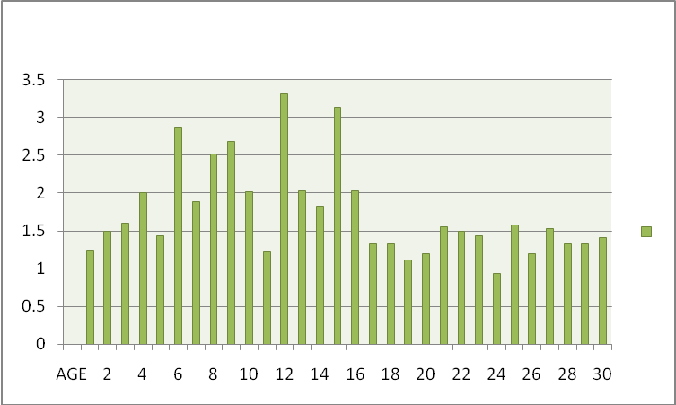
FCR
Chart: 1. The FCR of the selected farm was shown 2-D column.
In my experimental study I was taken the body weight of birds (COOB-500) at different stage (broiler starter, broiler growler, broiler finisher) of live. I took the weight of birds at day old chick to 30 days. So the FCR of that farm at the age of 30th was 1.41. It was better than the standard value (1.60-1.80).

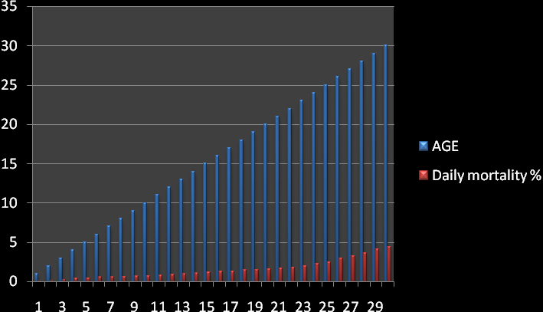
Chart: 2. The FCR of the selected farm was shown 2-D column.

I was taken the daily mortality record keeping in shed. The average mortality of that farm was 3.96% which was less than the standard value (5%). So there were maintained the good management, bio-security and no outback of disease.

CHAPTER: IV
AIM:
- 1st week body weight = 4 times greater than the day old chicks.
- 2nd week body weight = 400 to 430gm.
- Less evenly mortality & no late mortality.
- FCR = 1.6 to 1.7.
- Lifting age 30 to 35 days.
- Average body weight 1.3 to 1.5.
- No diseases outbreak.
- Less cost of production.

CHAPTER: V
LIMITATION OF THE STUDY
SHORTAGE OF STUDY PERIOD
The study period was short to perform such type of work.
RECALL BIAS
I was study only one shed of broiler so there was no comparison with other shed. Variable measurements were depending on reporting of the worker in most of the cases that recall or incorrect information could have gathered on the way. The actual causes of mortality of birds were unknown but postmortem of bird and tentative diagnosis was performed due to lack of lab. diagnostic facilities of the farm. Sometimes variation of duty time also hampers the collection of appropriated data.
IN ADEQUATE LITERATURE
Reference books, journals & other papers were inadequate in library for enriching the report.

CHAPTER: VI

CONCLUSION AND RECOMMENDATION

CONCLUTION
Form the current study it may be concluded that it is possible to achieve the target FCR in commercial broiler production shed to better than the standard value, reared in controlled housed with proper management of brooding, feeding, watering, litter management, bio-security as well as vaccination and medication schedule progrmme. The production performance FCR was 1.41that was better than the standard value (1.60-1.80) and other hand the mortality presentence 3.96% that was lesser than the standard value 5%. So we can say that the production performance was better in Kazi farm limited, Chawkpara, Sreapur, Gazipur.
RECOMMENDATION
- Strictly maintaining the biosecurity program in the farm.
- Proper hygienic measurement should be taken.
- Vehicle disinfection should be done properly.
- Litter management should be done properly.

REFERENCES
- Applegate, T. J., L. P. V. Potturi, and R. Angel. 2003. Model for estimating poultry manure nutrient excretion: a mass balance approach. Pages 296-302 in Proceedings of the Ninth International Animal, Agricultural and Food Processing Wastes Symposium, Research Triangle Park, NC.

- Aneja, V. P., P. A. Roelle, G. C. Murray, J. Southerland, J. W. Erisman, D. Fowler, W.A. H. Asman, and N. Patni. 2001. Atmospheric nitrogen compounds II:emissions, transport, transformation, deposition and assessment. Atmos.Environ. 35:1903-1911.

- Arbor Aeres – Broiler Management Guide (2009). WWW.aviagen.com

- Anderson, N., R. Strader and C. Davidson, 2003. Airborne reduced nitrogen: ammoniaemissions from agriculture and other sources. Environ. International 29:277-286.
- B.B.S. (1998), Statistical pocket book of Bangladesh. Ministry of planning, Government of peoples republic of Bangladesh, Dhakha.

- Broiler parents stock production in Bangladesh. Proc.3 rd WPSA, International poultry show and seminar, pp.15-23.

- Chowdury, S.D., Das, C.,Pramanik, H.A.M.,Roy, C.R., and Saha, K.S.(2003)., Miah M.S., Islam, A.M. and Ali, A.M.(2003). Growth and egg production performances of purebred and crossbred chicks. The Bangladesh Veterianian, 19(1), 43-47.

- Coob-Ventress.com. Broiler Management Guide.

- Czarick, Mand M, P Lacy, 1999, importance of air movement vs. bird age. Poultry housing tips Vol. 11, No.8.

- Coob-Ventress.com. Brooding Fundamentals Guide.

- Coob-Ventress.com. Broiler Performance and Nutrition Supplement.

- Charles H.Goan. Management of Nipple Watering Systems for Broilers.

- Czairck, Mand M, P Lacy, 1999, Importance of air movement vs. bird age. Poultry housing tips Vol. 11, No.8.
- Dr, William A. Dozier, 111, PhD. Ventilation and Management for Large Broilers.

- Ewa Sosnowka-Czajka, Renata Muchacka. Effect on Management System on Behaviour and Productivity of Broiler Chickes, National Research Institute of Animal Production, 32–083 Balice, Poland.

- G.D. Butcher, DVM, PhD, Amir H. Nilipour, PhD. Broiler Management. The First 24 Hours.

- Habbard Broiler Management Guide.

- Jannifer L.Rhodes, Jennifer Timmons, J.Richard Nottingham. Broiler Production Management For potential And Existing Growers.

- L.R.I. Broiler Management Manual, (2009). WWW. .aviagen.com.

- Michael Garden, Regional Technical Manager – Turkey, Middle East & Africa, Aviagen Robin Singleton, Technical Service Manager – Asia, Aviagen. Broiler Management for Birds Grown to Low Kill Weights (3.3-4.0 lb / 1.5-1.8 kg).

- Management Manual, (2009). WWW. aviagen.com.

- R.Prabakaran,FAO, (2003). Good practices in planning and management of integrated commercial poultry production in south Asia.

- Robert A. Swick, Broiler Management in Warm Climates.
- Rahaman, S.A., Islam, J.M., Howlider, R.A.M., and Rahaman, H.M.(2002). Status of poultry production and consumption pattern of poultry meat and egg. The Bangladesh Veterinarian, 19(1), 39-42.

- Rabianson, F.E…R,A, Renema, J.J.R., Feddes, M.J., Zuidhef and J.L., Wilson(1995).Egg production and fertility traits of broiler breeder hens as influenced by strain and early feed allocation.

- Saleque, M.A. (2001). Poultry as a tool in poverty alleviation; a special programme for the rural poor in Bangladesh, Proc. 2nd WPSA. International poultry show and seminar, pp.66-69.

ACKNOWLEDGEMENTS

All praises are due to almighty creator, who enabled the author to complete this work successfully.
The author fells proud to express his deepest sense of indebtedness and gratitude to his respected supervisor Goutam Buddha Das, Professor & Dean, Faculty of Food Science & Technology, Chittagong Veterinary and Animal Sciences University for his guidance, kind help and constructive criticism during the study period and the preparation of this report.

I am also grateful to honorable professor Dr. A.S Mahfuzul Bari, Vice Chancellor, and Professor Dr. Abdul Mothin Prodhan, Dean, Faculty of Veterinary Medicine of Chittagong Veterinary and Animal Sciences University for arranging this type of work as a compulsory part of the internship program.

The author is also thankful to the stuff of the farm for their scholastic guidance, valuable suggestions, and inspiration for this study report.
The author is grateful to his friends for their constructive comments and suggestions to improve this report.

The author
February, 2011
STUDY ON MANAGEMENT AND FCR (FEED CONVERSION RATIO) ON COMMERCIAL BROILER COBB-500 IN KAZI FARM LIMITED.

ABSTRACT
The study was conducted to monitor the management and production performance of broiler in commercial broiler farm in Kazi farm limited at Cawkpara, Sraepur, Gazipur. During working periods (15th September to 14th October 2010). The farm manager introduced with us and briefly discuses in broiler management of Cobb-500. They were rearing 19968 chicks in a single shed. Record keeping was such as- mortality (3.96%), Total feed intake 29600kg, Average feed intake per bird(1440.89gm), Average body weight gain (1050gm), Water intake, Maximum (34.2°C) and minimum (23.3°C) temperature, vaccination and medication and finally daily postmortem record. The average FCR performance was show in kazi farm 1.41 at the days of 30.

Key words: Commercial broiler management, Food Conversion Ratio, Coob-500.

