CHAPTER-I

INTRODUCTION

Bangladesh is the country of south Asia, bordering the Bay of Bengal, between Burma and India. Bangladesh has a total area of 143,999 sq. km. The total population is 164 million (BBS, 2012). Of them 47% live below the poverty line and 27% live in extreme poverty. Over 25 million people are classified as the poorest by any standard of development (BBS, 2005).Bangladesh is by mid 2008 classified as a low income country, i.e. with a GINA per capita of US $ 450 in 2006 below the cutting line of US $ 935 (World Bank, 2008). Its population is more than 144 million in 2006 places it as the seventh most populous country in the world (Xist, 2008). The economy of Bangladesh is agro based. About 21.77% of Gross Domestic products (GDP) come from agriculture sector of which livestock alone share 7.23%. (BBS, 2005-2006)’Bangladesh have 24.7 million cattle,0.86 million buffalo,1.34 million sheep and goat,195 million poultry(DLS2006).Livestock plays an important role in the national economy of Bangladesh with a direct contribution of around 3 % percent to the agricultural GDP and providing 15 percent of total employment in the economy. The livestock sub-sector that includes poultry offers important employment and livelihood opportunities particularly for the rural poor people, including the functionally landless, many of whom regard livestock as a main livelihood option. About 75 percent people rely on livestock to some extent for their livelihood, which clearly indicates that the poverty reduction potential of the livestock sub-sector is high.
Bangladesh is an agricultural country. Animal is important for both agriculture and feed source. For animal health there are So many Conventional and unconventional feed. But price of Conventional feed is much than unconventional feed. So we can use unconventional feed as feed source of animal. There are multiple source of unconventional tree fodder's for animal in Bangladesh .But many of them contain low nutrient component’s. Throughout the tropics, and especially in the humid regions, there exist a variety of feed resources. These include a variety of forages and abundant supplies of crop residues, agro-industrial by-products and also non-conventional feed resources. Among these, approximately 50 to 60% of the feeds produced are dry bulky roughages, mainly cereal straws and stovers. In Asia, the volume of production is increasing at about 3% annually. However, not all these feeds are put to maximum and efficient use. Inefficient utilization is identified with low levels of animal production in which the contribution from ruminants (buffaloes, cattle, goats and sheep) compared to non-ruminants is especially low.We can use Ipil Ipil (Leucaena leucocephala) krisnachura (Delonex regia), Neem (Azadirachta indica), kanchan flower (Bauhinia variegata) Raintree (Samanea saman), Chrismass tree (Abies alba) Mehogony Khaya spp. Family: Meliaceae. Koroi(Albzzia lebbek).as these contain good nutrient ingrident.

The availability of feed and fodder is a major constraint in developing the full potential of the livestock sector. Improvement in breeding to be stable should go along with adequate feeding. Even the best animal deteriorates soon in the absence of a sufficient and balanced ration. Unless adequate feeding is first provided for, no substantial improvement in milk yield could be achieved. While the excessive number of animals in relation to available feed supply has been identified as one of the major causes of the low productivity of cattle, better-fed animals could be more healthy and productive. Estimates of feed availability based on supplies of straw, bran and husk of food grains, whole grain and oil cake used in animal feed indicated that the total availability is much less than what is required for meeting the nutritional requirements of animals. Chronic shortages of feed and fodder, together with poor nutritive value of such feeds as are available, have lowered the productive capacity and fertility of Bangladesh livestock. The important sources of fodder are: a) fodder from forest, b)fodder from open grazing grounds, c) fodder from the fallow lands and areas sown once, d) fodder from weeding of major crops, e) fodder from forage crops, and f)fodder from semi-forage crop residues. With the increasing number of dairy farms, the demand for fodder has increased but supply in the local markets is inadequate to Cater to the growing demand. Expert opinion is that the present total feed need is 30 million tons whereas supply is less than 15 million tons (Khamar, 1995).
To overcome the feed sortage of ruminants different types tree leaves and leguminous trees are a potential source of relatively high quality fodder and can be a available source of many small holders. However farmers are often unaware of appropriate feeding strategies for combining tree fodders with poorer quality feeds to improve animal production. Lack of techniques to asses the nutritive value of fodder hampers livestock production. So this research programme undertaken with the following objectives:
1. To assess the physical and functional qualities of unconventional feed.
2. To determine the nutrient composition of unconventional feed.
3. To compare nutritive value of different unconventional feed.

CHAPTER-II

REVIEW OF LITERATURE

Those feed ingredients which are potentially used as animal feed but not yet exploit interms of chemical composition proper feeding trial is not completed and is not available in the market are called unconventional feed. Here 8 unconventional tree leaves nutrients are analyzed and they can be considered as animal feed as they contain reasonable amount of nutrient composition. Fodder trees and shrubs represent an enormous potential source of protein for ruminants in the tropics. Until relatively recently, these feed resources have been generally ignored in feeding systems for ruminants, mainly because of inadequate knowledge on various aspects of their potential use, as well as initiatives associated with the development of more innovative systems of feeding. The use of fodder trees and shrubs has been secondary to these efforts, despite their potential value in prevailing small farm systems (Devendra, 1983). These alternative feeds merit increased research and development in the future (Devendra, 1990a). This analysis highlights the potential value of fodder trees and shrubs as sources of feeds, draws attention to results of work where there are clear demonstrable benefits, practical technologies that are potentially important, and emphasises the need to accelerate their wider utilisation in feeding systems for ruminants. However, not all these feeds are put to maximum and efficient use. Inefficient utilisation is identified with low levels of animal production in which the contribution from ruminants (buffaloes, cattle, goats and sheep) compared to non-ruminants is especially low. Wild plants have since ancient times, played a very important role in human life. They have been used for food, medicine, fiber and other purposes and also as fodder for domestic animals. In search for wild edible food plants many of which are potentially valuable for human being has been identified to maintain a balance between population growth and agricultural productivity, particularly in the developing countries. In these regions starch based foods are the main staple food which supply both energy and protein requirements. Thus protein deficiency is generally found among these people. To alleviate the situation, efforts are underway to explore the lesser-known wild edible plants as sources of nutrient supplements. Increasing the utilization of wild edible herbs in our diet known to be rich source of nutrients as well as dietary fiber can be a food based approach for ensuring the intake of these nutrients.

Chemical and statistical analysis: Proximate composition of the diets and test ingredients were determined by standard method of AOAC (1990).

Table 1: Proximate composition of untreated and water soaked
neem seed cake:
Untreated neem Water soaked
Constituent (%) seed cake neem seed cake
Dry matter 69.26 70.74
Crude protein 14.24 14.48
Crude fibre 36 36
Ash 10 11
Ether extract 6 5.12
Nitrogen free extract 33 34.73
Gross energy (kcal/kg) 1964 2000
(A.A. Odunsi, et al. 2009).
The Ipil-ipil (Leucaena leucocephal) leaf analyzed for crude protein (CP), fat, crude fibre (CF), ash content, moisture content and nitrogen free extract (NFE). The CP 23± 0.12 % , fat 5± 0.11 %, CF 40 ± 0.15 % , ash 10 ± 0.13 %, moisture 14. ± .16% and NFE 22.± 1.10 % were recorded . A twenty one days experiment was conduced to assess the response of juvenile monosex tilapia with different iso-nitrogenous formulated diets for find out the feasibility study of using ipil-ipil leaf meals as feed ingredient for juvenile tilapia. Three experimental diets were formulated by using fish meal, soybean meal, rice bran and ipil ipil leaf meal. One control diet was formulated by using fish meal, soybean meal and rice bran. Considering the high demand, limited availability of fish meal and soybean meal, ipil ipil leaf meal was incorporated in juvenile tilapia feed. Among plant protein ingredients ipil ipil leaf meal was considered as the most nutritive plant protein source after soybean meal. However, high concentration of toxic element limited the incorporation level of ipil ipil leaf meal in fish feed. Use of 15 % ipil ipil leaf meal in fish feed was more significant from the view of growth performance and economics. The higher Absolute Growth was 1119.26 gm, higher Specific Growth Rate was 6.52% /day higher Feed Conversion Efficiency was 41.23% , higher Protein Efficiency Ratio was 1.178 and higher Average Daily Growth rate was 14.00% recorded in diet-4 ( which contained 15% IILM). The lower Feed Conversion Ratio 2.42 and lower cost for per unit production 34.65 taka/kg were recorded in diet-4. The higher cost for per unit fish production 45.6 tk./kg was recorded for diet-1 where no ipil ipil leaf meal.. The results suggest that tree legumes Ipil-ipil (Leucaena leucocephal) leaf has potential and excellent source of feed ingredients as protein supplements for juvenile monosex (Zamal et al).Bauhinia purpurea Leaves.CF (26±0.816),CP (21±0.59)DM (54.60±0.39)ME (2110 kcal/kg). Emir. J. Food Agric. 2011. 23 (6): 554-560.koroi DM (57.55%) Ash (5.40%), CP(22.85%),EE(10.15%).Feed and fodder in NEPAL NARC.

CHAPTER-III

RESEARCH METHODOLOGY

The investigation on “Nutritional quality and value in addition to unconventional feed” was carried out October 2012 to December 2012. The material and methods adopted for the study are stated in this section.

3.1 Sampling
A total of 8 unconventional tree fodder were randomly collected from different areas of Chittagong.

3.2. Preparation of unconventional feed sample
At first the samples were collected from different trees. Then the leaves are separated and dust were removed from the leaves. The samples were air dried and grinded separately and stored in air tight container for proximate analysis.

3.3. Analysis of Nutrient composition of unconventional feed
The feed samples were analysed for proximate composition such as, Drymatter (DM) moisture, crude protein (CP), crude fat(EE), crude fibre (CF) Nitrogen free extract(NFE),Metabolic energy(ME) and total mineral matter (ash) and expressed in percentage.

3.3.1 Moisture
Five grams of powdered sample (1sqmm) was weighed into a previously weighed crucible and dried in an oven at 60°C till a constant weight was attained (AOAC.,1990)

Initial weight (g) – Final weight (g)
Moisture % = ------------------------------------------× 100
Sample weight (g)

3.3.2 Crude protein
The nitrogen content of feed was estimated by Microkjeldahl method in Parnas and Wagner apparatus (AOAC,1990). The crude protein content was calculated by multiplying with factor 6.25 and expressed on per cent basis.

(Titre—Blank ) × Normality of HCL × 14.007 × 6.25
Protein % = ------------------------------------------------------------- × 100
Sample weight (g)

3.3.3 Crude fat
Moisture free sample was weighed in moisture free thimbles and crude fat was extracted by refluxing in soxhlet apparatus using petroleum ether as solvent. Per cent crude fat was calculated by difference (AOAC)., 1990).
Initial weight (g) – Weight after extraction (g)
Crude fat % = --------------------------------------------------------- × 100
Sample weight (g)

3.3.4 Crude fibre
Fat free tree leave sample was hydrolyzed with dilute sulphuric acid (0.255 N) and dilute alkali (0.313 N) to estimate crude fibre by employing the methods of Mayanard (1970).

Weight residue with crucible (g) – Weight of ash with crucible
Crude fibre %=-------------------------------------------------------------- ×100
Weight of fat free sample (g)

3.3.5 Total mineral matter
Total mineral matter (ash) was determined by igniting samples in muffle furnace at 600°c for 3 - 4 hours (AOAC., 1990). The total mineral matter was expressed as per cent.
Weight of crucible with ash (g)
Total mineral matter % = -------------------------------------------- × 100
Weight of crucible with sample (g)

3.3.6 Calculation of NFE:
The NFE content was calculated by deducting the sum of the values for moisture, crude protein, crude fat, crude fibre and total mineral matter in 100 (Raghuramulu et al., 1983).

3.3.8 Metabolizable energy
The metabolizable energy content was calculated by using the following formula (Lodhi et al, 1976).
ME=32.95(% CP + % EE * 2.25 +% NFE) -29.20

3.4 Statistical analysis
All data were recorded after chemical analysis. The recorded data were tabulated for further analysis and average value were analyzed by using micro soft excel 2007.

CHAPTER-IV

RESULT AND DISSCUSSION

4.1 Dry matter: Dry matter content of different tree fodder is shown in the graph 1 and the table 4.1. The DM content is higher in case of Neem (68%) lower in case of kanchan flower (52%). The DM percentage of Mehogony,Chrismass tree,krisnachura ,koroiu ranges from 52-68. Zamal et al.(2008) found the Ipil-ipil (Leucaena leucocephal) leaf dry matter (65.84%) which is similar to this study. koroi DM (55.55%) was recorded by Feed and fodder in NEPAL NARC. Kanchan flower DM(53%) was recorded by J.Emir.Neem DM(69.26%) was recorded also by A.A. Odunsi, et al. 2009.

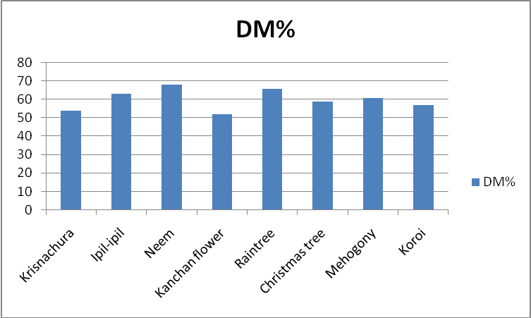
Figure 1 : DM contents of different unconventional tree leaves

4.2. Proximate analysis of eight selected tree leaves:

INGRIDIENT | DM% | ASH% | EE% | CP% | CF% | NFE% | ME(kcal/kg)
Krisnachura | 54 | 6.56 | 6 | 20 | 34 | 10 | 1404
Ipil-ipil | 63 | 10 | 5 | 23 | 40 | 22 | 1824
Neem | 68 | 11 | 6 | 14 | 36 | 33 | 1964
Kanchan flower | 52 | 8 | 4 | 21 | 28 | 36 | 2105
Raintree | 66 | 9 | 2 | 11 | 31 | 34 | 1601
Christmas tree | 59 | 6 | 3 | 12 | 43 | 23 | 1346
Mehogony | 61 | 7 | 11 | 13 | 25 | 27 | 2104
Koroi | 57 | 4.51 | 13.4 | 14.8 | 32.50 | 7.29 | 1776

4.3Ash: Ash content of different tree leaves is shown in the graph 1.2 and the table 4.2. The ash content is higher incase of Neem(11%) lower in case of kori(4.11%). The ash percentage ranges from 4-11.Zamal et al.(2008) Said analysed Ipil-ipil (Leucaena leucocephal) leaf and ash( 10 ± 0.13 %) was recorded and 5.40% Ash was recorded in koroi leaf. Ash percentage of Kanchan flower was recorded (8%) by J.Emir 2011. Neem Ash(10%) recorded by A.A. Odunsi, 2009.

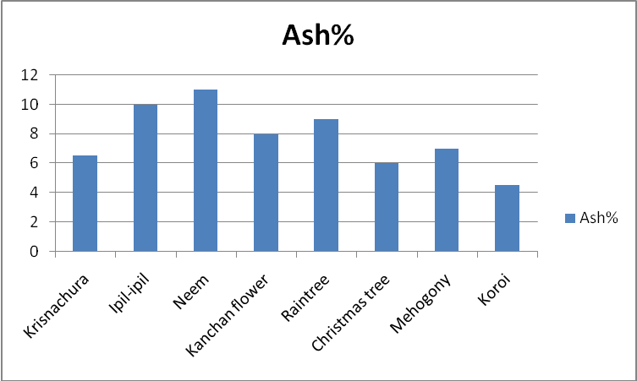
Figure 2: Ash contents of different unconventional tree leaves(%).

4.4.Ether Extract: Ether extract content of different tree leaves is shown in the graph 1.3 and the table 4.2. The ether extract content is higher incase of Koroi (13.4%) lower in case of Raintree(2%).The EE percentage ranges from 2-13. The Ipil-ipil (Leucaena leucocephal) leaf analyzed for , EE( 6 ± 0.11 % ) was recorded by Zamal et al.(2008) . Koroi EE(10.15%) was recorded by Feed and fodder in NEPAL NARC. Kanchan flower EE(4%) was recorded by Emir 2011.Neem EE(6%) was recorded by A.A. Odunsi, et al. 2009
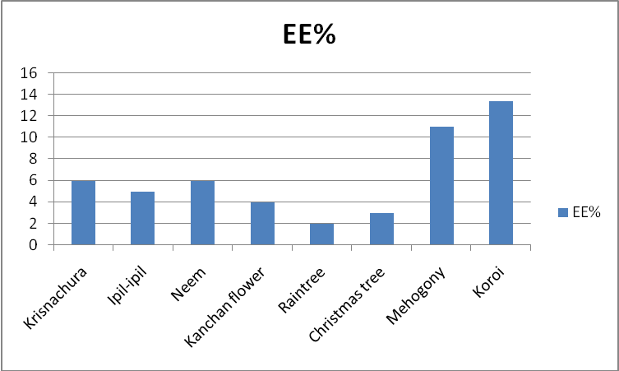
Figure 3: EE contents of different unconventional tree leaves(%).

4.5.Crude protein: : Crude protein content of different tree leaves is shown in the graph 1.4 and the table 4.2. The crude protein content is higher incase of Ipil-ipil(23%) , lower in case of Raintree (11%).The crude protein percentage ranges from 11-23. The Ipil-ipil (Leucaena leucocephal) leaf analyzed and the CP 23± 0.12 % was recorded by Zamal et al.(2008) . Koroi CP(14.85%) was recorded by Feed and fodder in NEPAL NARC.Neem CP (14.24%) was recorded by A.A. Odunsi, et al. 2009.

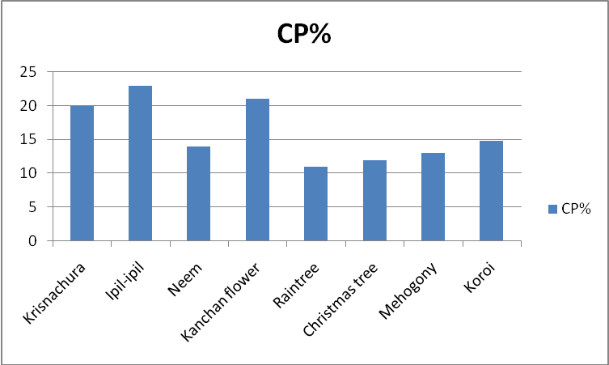
Figure 4: CP contents of different unconventional tree leaves(%).

4.6.Crude fiber: Crude fiber content of different tree leaves is shown in the graph 1.5 and table 4.2 . The crude fiber content is higher incase of Christmass tree (43%), lower in case of Mehogony (25%) .The CF percentage ranges from 25-43. The Ipil-ipil (Leucaena leucocephal) leaf analyzed for CF( 41 ± 0.15 % ) was recorded by Zamal et al.(2008).Neem CF(36%) was recorded by A.A. Odunsi, et al. 2009.

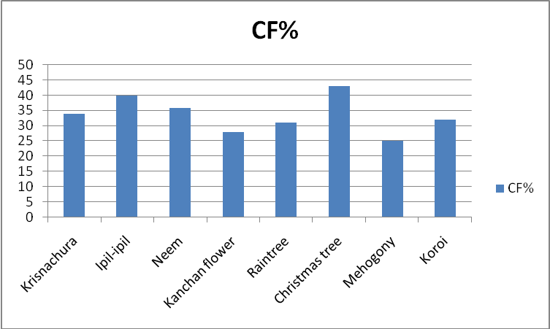
Figure 5: CF contents of different unconventional tree leaves(%).

4.7.Nitrogen free extract: The Nitrogen free extract is higher in Kanchan flower(36%) and lower in Koroi(7.29%). The Nitrogen free extract percentage ranges from 7-36. Nitrogen free extract in Neem ( 33 %) was recorded by (A.A. Odunsi, et al. 2009). Ipil-ipil NFE ( 22.± 1.10 %) was recorded by(Zamal et al).
4.8 .Metabolic energy: The Metabolic energy is higher in Kanchan flower(2105kcal/kg) lower in case of Krisnachura (1404 kcal/kg).The Metabolic energy percentage ranges from 1404-2105 Kcal/kg. The Metabolic energy of kanchan flower (2110 kcal/kg) was recorded by Emir. J 2011. Metabolic energy of Neem was ( 2000 kcal/kg ) found by
A.A. Odunsi, et al. 2009.
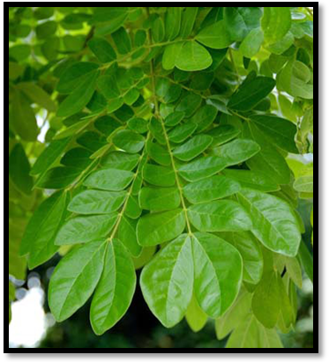
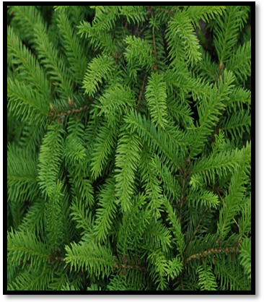

Fig: 2.1 RAIN TREE Fig: 2.2 CHRISTMASS TREE

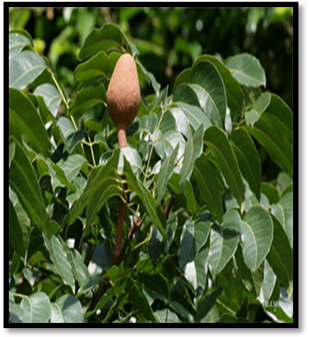
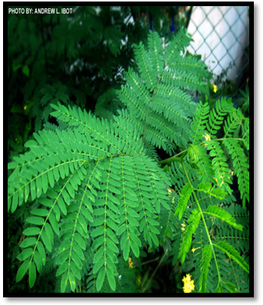

Fig:2.3 MEHOGONY TREE Fig:2.4 IPIL-IPIL

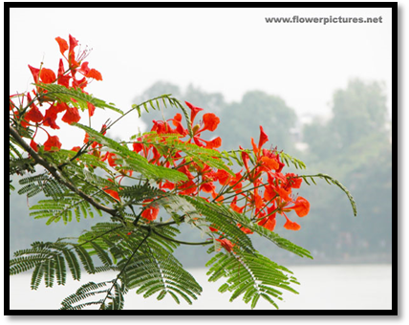
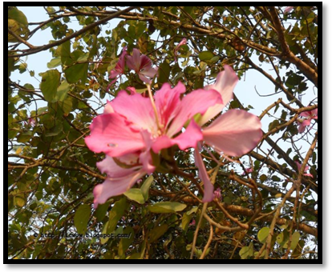

Fig:2.5 Krisnachura Fig:2.6 Kanchan flower
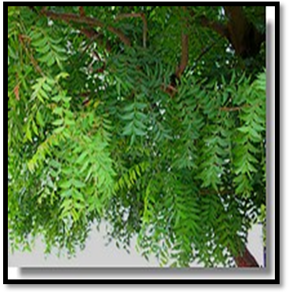
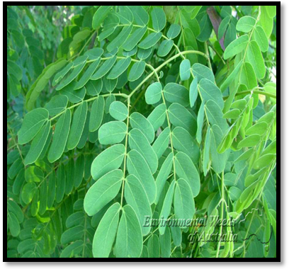

Fig:2.7 Neem Fig:2.8 koroi

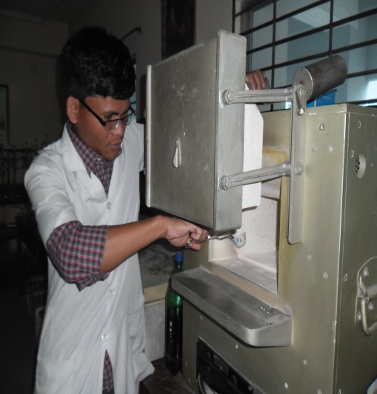
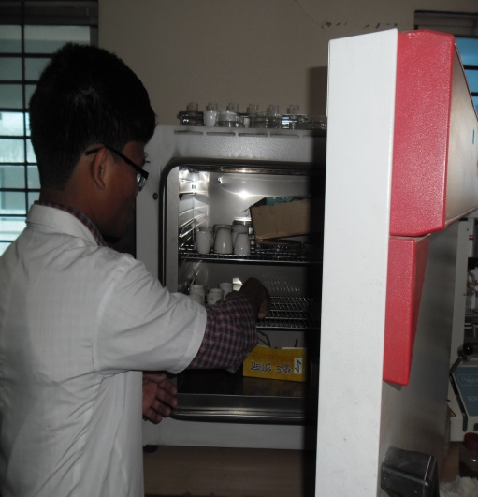

.

Fig 3.5: Estimation of Ash. Fig3.6: Estimation of DM.

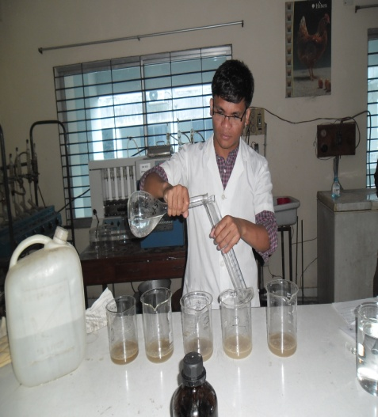
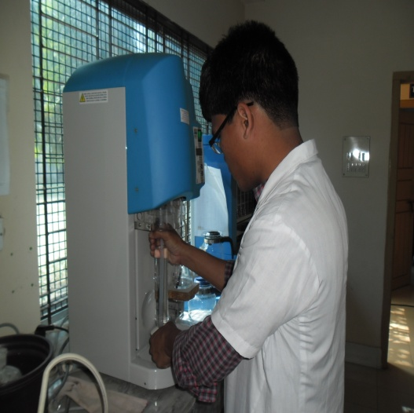

Fig3.7: Estimation of CF. Fig3.8: Estimation of CP.

CHAPTER-V

CONCLUSION
From the above discussion it can be concluded that the nutritive value of these tree leaves was satisfactory. The DM content is higher incase of Neem (68%) lower in case of kanchan flower (52%). The ash content is higher incase of Neem(11%) lower in case of kori(4.11%). The ether extract content is higher incase of Koroi (13.4%) lower in case of Raintree(2%). The crude protein content is higher incase of Ipil-Ipil(23%) , lower in case of Raintree (11%). The crude fiber content is higher incase of Christmass tree (43%), lower in case of Mehogony (25%) . From this evaluation it is recommended that these unconventional tree leaves may be used as animal feed as alternative to other feed stuffs of animal. A lot of unconventional tree leaves are produced annually. But these are not regarded as animal feed stuff. After this analysis these tree leaves may be used for feeding animal as the number of animal is increasing day by day. Present knowledge on the potential value of fodder trees and shrubs indicates that together with their diversity, these feed resources are extremely useful for feeding domestic ruminants. This tree leaves can improve the performance of animals and reduced cost of feeding. These advantages justify more intensive and wider utilization of fodder trees and shrubs in appropriate feeding systems and represent an important strategy for increasing the current level of contribution from ruminants.
Recommendation:
1. Tree leaves can be used as animal feed however, it detail nutrient profile and toxicity need to be observe through detail analysis.
2. Feeding trial is essential to identify the optimum inclusion level of tree fodder in Animal and poultry feed.

CHAPTER-VI

REFERENCES

A.A. Odunsi, S.A. Adegbile, T.O. Akande and T.B. Olayeni.(2009). Neem (Azadirachta indica) Seed Cake in the Diets of Cockerel Chickens. International Journal of Poultry Science 8 (1): 47-51

A.O. A. C. 1990. Official methods of analysis of Association of Official Analytical Chemists 14th edition. Washington DC.

Abayan, P.E. and Boloran L.B. 1984. The effects of feeding fresh ipil-ipil leaves (Leucaena leucocephala (Lam) de Wit) and para grass (Brachiaria mutica Forsk Staph) combined with concentrate on the growth rate of yearling goat. Reference unknown.

Abilay, T.A. and Arinto, 1981. The influence of ipil-ipil (Leucaena leucocephala(Lam) de Wit), leaves feeding on the reproductive performance of goats. Symposium on Nutrition and Systems of Goat Feeding, Tours, France, Vol. 2: 623–634.

Agarwal, I.S., Verma, M.L., Singh, A.K. and Pandey, Y.C. 1989. Feeding value of ammonia (urea) treated straw in terms of milk production. Indian Journal of Animal Nutrition 6: 89–96.

Anonymous, 1990, Official methods of Analysis of the association of official analytical chemists. 20th Edn., AOAC, Washington, D.C.

Asibey-Berko, E. and F. A. K. Tayie. 1999. Proximate analysis of some underutilized Ghanaian vegetables. Ghana J. Sci. 39:91-92.
BBS (2005). World Bank( 2008). I Xist (2008).BBS(2005-2006)(DLS 2006).

Emir. J. Food Agric. 2011. 23 (6): 554-560.
Feed and fodder in NEPAL NARC.

Mayanard (1970). (Lodhi et al, 1976). (Raghuramulu et al., 1983) (Devendra, 1990a)..

Maynard, A.J., 1970, Methods in Food Analysis. Academic Press, New York, p. 176.

Zamal, Hossain and Barua, Prabal and Uddin, Balal and Islam, Khandakar Shafiqul (2008) Application of ipil- ipil leaf meal (IILM) as feed Ingredient for Monosex tilapia fry (oreochronis niioticus) : In terms of growth and economics. Aquaculture Asia, 13(2), pp. 31-33.

Zamal, Hossain and Barua, Prabal and Uddin, Balal and Islam, Khandakar Shafiqul (2008) Application of ipil- ipil leaf meal (IILM) as feed Ingredient for Monosex tilapia fry (oreochronis niioticus) : In terms of growth and economics. Aquaculture Asia, 13(2), pp. 31-33.

