CHAPTER-I

INTRODUCTION

Bangladesh is a developing country. She has small land area about 1, 47,570 sq km but large amount of population about 160 million. So in the recent years poultry rearing becomes popular than any other livestock in our country because of its small size, easy of handling, low feed intake, high multiplication rate , less space requirement, less cost & quick return.

On the other hand poultry are considered as important source of protein all over the world. The concept of human nutrition has taken as a new dimension and today emphasis has been given on the consumption of high protein .It is obvious that poultry meat and eggs contain high quality proteins and can also be produced more economically than any other growers of equivalent quality. Moreover, high multiplication rate of chicken also makes it more important than any other animal protein. So in our country the poultry meat products become popular, because these are relatively cheap, convenient and nutritious. According to DLS (2007), meat requirement is 120gm/day/head and 6.26 million metric ton/year. But our achievement is 20gm/day/head and 1.04 million metric ton/year. Poultry meats contributes approximately 37% of the total animal protein supplied in the country (Rahman and Rahman 1998) .In Bangladesh, 50 commercial poultry industry has seen a tremendous development in the recent years. According to number provided by government of Bangladesh livestock department, the total chicken population is steadily increasing from about 143 million birds in 2006 (DLS 2007). Recent data showed that total number of chicken in 2008 is 175.15 million (Krishi dairy 2008).

In Bangladesh the existing native breed are Aseel, Sarail, Nacked neck, Yasin etc. Their productive performance is not sufficient. So the commercial poultry industry uses some exotic broiler breed such as Cobb 500, Cobb100, Hubbard classic, Hybro-PN, Hybro-PG, Ross (Saleque & Rozen 2007).

Cobb 500 is an English strain which shows an excellent production & reproduction performance in standard condition. It has a worldwide reputation for the lowest cost of producing chicken meat. Cobb geneticists have developed this breed by the research of more than 30 years progress using a combination of both traditional pedigree selection and new technology. They have developed a very high breeder performance of Cobb 500 .Such as Cobb 500 starts laying at 18 weeks of age .Age at 5% egg production is 24 weeks of age .

For such high breeder performance “BRAC” Poultry Limited choose Cobb- 500 as a broiler parent stock for rearing. Therefore, the present study was undertaken at ”BRAC” POULTRY FARM “Miraisari” Chittagong with the following objectives:

- To learn the management of broiler parent stocks.
- To compare the achieved performance with the standard guideline.
- To know the relation among body weight, feed consumption ,FCR, and egg production performance.
- To observe the production performance of broiler parent stock(Cobb-500)

CHAPTER-II

REVIEW OF LITERATURE

Colin C. Whitehead (2010)’s recent research has demonstrated the importance of the early nutritional status of the hatched chick in enhancing performance. It is therefore vital that , in formulating diets for the parent birds, attention is paid not only to maximizing egg output and hatchability but also to ensuring that the eggs produced contain adequate amounts of the nutrients vital for supporting the early development of hatching chick.

Dr Tom Smith (2009) suggested that breeder bird must not have a deformed beak, slipped wing, blindness in one or both eyes or any defect that may interfere with normal eating, drinking, and maintaining social stature in the flock. Male birds must be aggressive and have straight, sound legs and toes. Females should reflect good egg laying traits and good health and vigor.

R.Keith Bramwell et al (2008) reported that obtaining accurate body weights is a critical part of the process of rearing replacement broiler breeder pullets and managing breeder hens and males. From the first few weeks of age in the pullet house, all feed allocations are determined by the bird’s weekly weight gains. Obtaining accurate body weights is very important to maintaining uniformity, body conformation and the overall development of pullets and young cockerels. Research has shown that accurately and uniformly controlling body weight of both replacement breeders and breeders in the hen house will result in improved performance parameters.
Chowdhury et. Al (2003) reported that the exotic broiler parent’s chicks can successfully reared in open sided house.

K. Rajendran and S. Mohanty (2003) reported that the gross and the net return from egg and others sources is more in cage system than all litter system of management.

Robinson and Wilson (1999) showed that the restricted lighting management programme for broiler breeder can helps to achieve the sexual maturity during 18 to 22 wks of age.

Wilson et. Al (1995) studied with feed allocation and obtained different body weight group of broiler breeders which were regarded as treatment. He got three body weight groups-standard, lower than normal, above than normal body weight. The birds group which have lower than normal body weight can produced less fertile eggs than the other two groups.

Krishnappa et. Al (1992) conducted that restricted feeding during growing period (7-22 weeks old) can significantly reduced body weight, increased age at sexual maturity and also increase egg production.

Whitehead et. Al (1991) concluded that the egg weight was increase with age. The dietary fatty acid increased egg weight by mechanism different from the causing egg related in body weight that the mechanism involves a stimulation of oviduct protein synthesis.

Hurwitz and Plavnik (1989) concluded that during the onset of production the weight of egg is related to both age and body weight. The egg weight and the body weight was significantly correlated for one year of production. They also describe that the relationships among weight, body weight and age at onset of egg production have special importance.

Spralt and Leeson (1987) reported that the excess intake predominantly fat cause gradually results in increased weight. Excessive body weight females were negatively correlated with hen day egg production .

CHAPTER-III

MATERIALS AND METHODS

3.1The study area:
The study was performed at a renowned poultry farm of Bangladesh named “ BRAC” Poultry farm” Miraisari” Chittagong where popular broiler parent stock Cobb 500 was reared in Environmentally Controlled House.

3.2 Study Period:
The study was conducted for one month of time from 1st January to 3oth January 2013 during my internship placement.

3.3 Study Population:
BRAC Poultry farm has five flock of about 10,000 birds of different age group in five shed. But for the facilities of my study I had selected one flock containing 5500 bird of which 5000 were female birds & 500 were male bird.

3.4 Data collection and analysis:
Data were collected from BRAC poultry farm limited. Chittagong ,Bangladesh. Egg production body weight gain along with other related data like housing, lighting , feeding ,of the study batch were recorded. The data is collected from 4 week 6300 of birds and average data is calculated using Microsoft excel 2003. Farm data (standard) was collected from record book of BRAC Poultry farm.
CHAPTER IV

RESULTS AND DISCUSSION

During my study period I observed the following differences between the existing management of broiler parent stock Cobb 500 at “BRAC” Poultry farm and the standard/ recommended management of broiler parent stock Cobb 500 in the “Cobb 500 Breeder Management Guide 2009.

4.1Preparation of the poultry house: (Before arrival of a new flock)
After removing all equipments, litters used for previous flock the shed was cleaned properly with three types of cleaning practice for making the room pathogen free.

i) Dry cleaning
Dry cleaning was done by using different types of sweeping instrument like
brush, coconut leaf made sweeping instrument etc. to remove the dirt as high as possible.

ii)Water Cleaning
Then the house was watered with detergent. After that the room was washed thoroughly with clean water. The liming was done, liming means the whole surface was covered with a layer of lime solution. The lime was used as a disinfectant. Then the room was left for drying for 15 days. During this period routine spray was done with different disinfectant like spraying with formalin (10 litter water +2/3 litter formalin), Disenkape® (Glytaraldehyde 15% + Chlorobenzyl ammonium chloride-10%) at a concentration of 7 ml / litre of water at the rate of 300 ml solution /m^{2.}

iii)Fumigation
After 15 days of drying period, fumigation was done with formalin and potassium per management at the rate PPM: Formalin =1:2 ratios. Then the room was closed for 24 hours. After that it was opened. Before arrival of the chicks, the room was preheated for 2-3 days.

4.2 Brooder House Management for chick both male and female

4.2.1Preparation of Brooder House: In my study area cage brooding was performed. The hover was set approximately 3 feet above from the chick level..

4.2.2Brooding temperature: In BRAC farm follows the recommended brooding temperature for maintain their brooding management which shown in table 4.1

Table 4.1 Recommended and actual (Maintained) brooding temperature existing management system of BRAC poultry farm.

Day | Temp. for brooding (ºC)
Day | Recommended | Maintain
1 | 35-33 | 35-33
2 | 33-32 | 33-32
3-7 | 32-29 | 32-29
7-14 | 29-26 | 29-26
14-21 | 26-23 | 26-23
21-28 | 23-21 | 23-21
28-35 | 21-20 | 21-20
35 and later | 20 | 20

4.2.3Air Management /Ventilation:
Actually temperature and ventilation was maintained according to the condition of the birds
4.2.4 Bedding Material: During cage brooding paper was used as a bedding material. After transfer into grower house litter material was used rice husk for bedding material.
4.2.5 Vaccination programme: Routine vaccination was done in BRAC farm according to the management guide. Which shown on the table no 4.2
Table 4.2: Vaccination, medication & other activities for broiler breeder (0-23 wks) at BRAC poultry farm
Age | Name of vaccine/medicine | Route | Remarks
Day-1 | Ma5+Clone 30 | Eye drop[ED] | 17-6-2012
Day-4 | Immucox | Drinking Water[DW] | 10-6-2012
Day-5 | Reo live[Reo-1133] | Asper recommendation | 11-6-2012
Day 6-8 | •Vittamin K  •Enrofloxacin | ”
Day 7-8 | - Debeaking
Day 8-10 | Pulmotil AC | Drinking Water[DW] | 8mL⁄ 1000Birds ⁄ Day
Day 11 | •Gumboro D 78  •G+NDKilled[1⁄2]Dose | Eye drop  As per recommendation | 16-6-2012  1117-6-2012
Day 14-15 | •Pulmotil AC | •Drinking Water | 20ml ⁄1000birds⁄ day
Day 21 | • Gumboro D78 | •Eyedrop[ED] | 27-6-2012
Day 28 | Ma5+Clone 30 | •Eye Drop | 4-7-2012
Week-5(Day 3&4) | Pox Vaccine | As per recommendation | 8-7-2012
Week-6(Day 1&2) | Pulmotil AC | Drinking Water[DW] | 50ml⁄1000birds⁄ day
Week-6(Day 3&4) | Coryza Vaccine | As per recommendation
Week -7 | •SG-9R  •Deworming | •Asper recommendation  •Drinking Water
Week-8[DI] | •Ma5+Clone30  •MG vaccine | •EYE drop  •As per recommendation | 29-7-2012
Week-9 | •Cholera vaccine[Mult imune K 5] | ” | 5-8-2012
Week-10[D1&2] | Pulmuti-lAC | Drinking Water[DW] | 80ml ⁄1000birds ⁄day
Week-10[D3&4] | Reokilled | As per recommendation | 12-9-2012
Week-12[D1&2] | AE+POXvacction | ” | 27-8-2012
Week-12[day 3] | Deworming | Drinking Water[DW]
Week-13[D-1] | •MA-5+Clone-3  •Coryza | Eye drop  As per recommendation | 2-9-2012
Week-14[D1&2] | Pulmotil | Drinking Water[DW] | 115m ⁄ l1000birds⁄day
Week-14[D4&5] | Mg-Vaccine[MG-inac] | As per recommendation
Week-15[D6&7] | SG-9R | ” | 15-9-2012
Week-16 | Cholera Vaccine[Multi immune K5] | ” | 26-9-2012
Week-17 | •EDS-Vaccine  •Deworming | ASper recommendation | 30-9-2012
Week-19 | REO+IG+NDkilled  NDlasota[on the basis oftitre] | As per recommendation  Eye drop | 17-10-2012
Week-20[D1&3] | PulmotilAC | Drinking water | 175mL ⁄1000birds ⁄Day
Week-23 | Deworming | ”

4.3Grower management Of Female bird:
Lighting stimulation
The lighting program during growing, production allows for a better control of age at sexual maturity in both males and females.. At the study farm the brooding period lighting was 24 hours and after brooding, by gradual decreasing way the growing period lighting was 8 hours.
4.4 Management of Female Bird During Laying Period
4.4.1 Housing system:-
The female birds were kept in the environmentally controlled house (E.C. House) in BRAC Poultry Farm. The Environmental temperature was controlled by cooling pad..
In BRAC five shed was present and each shed contain about 7000 chicken.
The house is facing East-West
Length of house → 400 feet.
Width of house → 100 feet.
Cooling Pad → 60 feet (30 feet on each side wall along the length
direction
Exhaust fan → 5
Roof of the house → Made by tin.

the slat cum lither system followed in BRAC farm:
4.4.2 Slat cum litter system:-
In BRAC maintain the slat cum litter system.. The litter used was rice husk with a depth of 6 inches.
4.4.3 Litter management; In this farm also used Rice husk for litter .
per bag Rice husk was used as litter material. Before using the rice husk it was made disinfected by spraying with proper disinfectant like formalin (2/3 liter formalin + 10 water) at the rate of 300 ml solution /m² with concentration of 7 ml /litre.
4.4.4 Floor space requirement:-
IN “BRAC” poultry farm followed the similar floor space requirement as standard management which represented in table 4.3
Table4. 3 Comparative study floor space requirement of chicken.
 |  | Floor space requirement
 |  | Standard (sq ft/bird) | Given (sq ft/bird)
Female | Brooding  (0-5 days) | 0.36 | 0.36
Female | Growing  (6day-16 weeks) | 1.75 | 1.75
Female | Laying  (15wks-65wks) | 2.75 | 2.75
Male | Brooding  (0-5 days) | 0.36 | 0.36
Male | Growing  (6day-16 weeks) | 3.00 | 3.00

4.4.5.Feeding and watering:
The feed that are supplied to the male and female breeders in their laying period are produced By” BRAC” Poultry feed mill.The feeds ware supplied by automatic chain feeder. Usually the feeds were given once daily for a short period usually at 5.00.The feed ingredient used are shown in table no 4.4

Table4. 4 : Feed ingredients used for feed formulation
Name of Ingle | Starter | Grower | Layer | Male breeder feed
Maize | 60 | 50 | 56 | 50
Soya meal | 28 | 20 | 22 | 15
Full fat soy | - | - | 4 | -
Rice polish | 3 | 11.2 | 8 | 15.4
Calcium | 2 | 8.3 | 8 | 3
DCP | 2 | 1.8 | 2 | 1.6

4.4.6 Lighting Management:- In ”BRAC” farm also used the lighting schedule that is similar to the Recommended lighting schedule for broiler parent stock”Cobb-500”. Which are given in the table no 4.5

Table 4.5 : Comparative study on lighting management :
Age (weeks) | Age (days) | Light (hours) | Light intensity (lux)
1 to 3 | Day-old to 21 | Decreasing from 24 hours at day 1 to 8 hours by 14-21 days | Days 0-2 maximum light (>20 lux) reducing to 20 lux by day 7
3-20  20-21  21-22  22-23  23-60 | 21-140  140-147  147-154  154-161  161-420 | 8  11  13  14  16 | 5-10  40-65  40-65  40-65  40-65

4.4.7 Laying nest:-
In slat cum litter system of rearing nest was supplied to the hen for egg laying .One nest containing 24 boxes. A single box was 12×12×12 inches and a single box was offered for 4 hens. Tenis balls were kept in the nest to stimulate the bird for laying..

4.4.8 Male & Female ratio:-
In the study farm Female & Male were kept separately. The male : Female ratio 1:10

4.4.9 Reproduction:-
The artificial insemination was practiced in every alternative day. First semen was collected from male and then insemination were done. Each cock gave 0.5-0.7 ml of semen per ejaculation .Where the dose on each insemination was 0.1 ml/hen.

4.4.10 Egg collection: Then eggs were cleaned, dried and stored in the storage room. At temp 18-20ºC, The eggs were collected in BRAC FARM 8 times daily at 7.am, 8.am, 9.am, 10.am, 12.am, 2.pm, 5.pm, 9.pm.

4.5Male Management
The key to obtaining good hatchability from today’s broiler breeders is to develop feeding and management programs that allow a correct development of the male’s reproductive system while controlling their growth potential and capacity to deposit breast muscle.

Housing system:
The males were reared separately in the cage system. Size of cage was 2.3 (L)×1.4(W) sq ft .Two birds were kept in each cage . The males were reared in open sided house.

Feeding & watering:-
Feeds are given manually in feed trough of the nest. The management procedure of the cage system was easier than slat cum litter system. 1 nipple drinker was used for watering of 4 birds of 2 nests . Cock was fed upto 115 day to 140g of feed at an increasing manner from 21 weeks to 65 weeks of age.
4.6 Hatchery Management:
4.6.1Hatching Egg Collection:- In BRAC Male and female ratio was 1:10. Cobb500 starts egg production from 18weeks of age, but when 5% egg production was found AI procedure was started & hatching eggs were collected. Eggs were collected from shed 6-8 times in a day. eggs were separated. The dirty eggs were cleaned with luke warm water (45°C) having 50%H₂O₂ and cotton.
4.6.2 Storage of eggs:
Eggs were stored in cooling room which temperature was 18-20°C and relative humidity was 85%.The room was equipped with a cooler unit and humidifier.

Table 4. 6 : Suggestive egg storage conditions: (Md Elias Hossain 2000)
Period of stage | (0-4)days | (5-7)days | (8-14) days
Temperature (°C) | 17-18 | 16-17 | 14-16
Relative humidity (%) | 80 | 85 | 85
Egg position | Broad end up | Broad end up | Broad end up
4.6.3 Fumigation of eggs:
Fumigation of egg was done by mixing 200 ml formalin (40% solution in water of formaldehyde gas) and 100 ml potassium permanganate.
4.6.4 Receiving of egg in Hatchery: Again fumigation of eggs were done before unloading the eggs from the lorry with same disinfectant spray .
4.6.5 Selection and grading of hatching eggs:
Eggs having the following criteria were discarded-
- Small sized egg
- Mis shaped egg
- Large egg
- Double yolked egg
- Thin shelled egg
- The weight of hatching eggs should be 53 to 56 grm ,
4.6.6 Hatchery Operation And Get Hatches:
There are two types of incubator used in BRAC Hatchery,a. V. J. Equipment: The no. of V. J. Equipment is one. Capacity of the setter is 90720. Capacity of the hatchery is 20300.b. Karamsar. Temperature and humidity maintain in these incubator shown in table 4.7.

Table 4.7:Temperature and humidity maintained in different types of incubator of BRAC Poultry Hatchery.

Season | Particulars |  | Karamsar | V.J. Equipment
Summer | Temperature  (°F) | Setter | 99.5 | 98.5
Summer | Temperature  (°F) | Hatcher | 98.5 | 98.2
Summer | Relative Humidity (%) | Setter | 86.5 | 86.5
Summer | Relative Humidity (%) | Hatcher | 87.8-88.0 | 87.8-88.0
Winter | Temperature  (°F) | Setter | 99.8 | 98.8
Winter | Temperature  (°F) | Hatcher | 98.8 | 98.5
Winter | Relative Humidity (%) | Setter | 86.5 | 86.5
Winter | Relative Humidity (%) | Hatcher | 87.8 | 88.0
4.6.7 Preparation of setter and loading of eggs in setter.
All the setting trays were washed with water and bleaching powder. Then the trays were sprayed with antiparasitic acid solution (50% H₂0₂-2 L, Acetic acid-l.0 L, 50% H₂S0₄ -11.0 ml mixing)@3ml / L water. Then the trays were dried in the sunlight.
4.6.8Turning of eggs.
In the setter machine eggs were set by large end up. Eggs were turned in every 3 hours interval automatically till 18th day of incubation.

4.6.9Candling of eggs.
Candling is done at the 18th day of incubation when eggs were transferred from setter to hatchers. Candling was done in a dark room.

4.6.10 Preparation of hatcher and transfer of eggs from setter to hatcher.
When piping occurs within 5 to 10% eggs. Then eggs were transferred from setter to hatcher.
4.6.11 Grading of chicks:
After hatching chicks were graded. Grading was done by the following way
Grade-A:
- Health and rigor (round bright eyes, sturdy legs, ability to stand firmly,)
- Well grown
- Trueness of type
- Freedom of any deformity

Grade-B:
Chicks with unhealed navels, stand up well.
Grade-C:Chick with crooked legs or toes, odd shaped beaks. eyes missing, pasty vents are discarded.

4.6.12 Delivery of the chicks:
Before delivering of the chicks in BRAC FARM some medicinal treatment was given.
Beconex -50 ml
Dextrose- 1000 ml
Gentamycin-50 mg
All are mixed and then injected @1.0 ml to each chick at the neck region s/cly
4.6.13 Disposal of hatchery waste: Any hatching debris from incubators in which disease has been diagnosed or is suspected and contaminated material were buried.

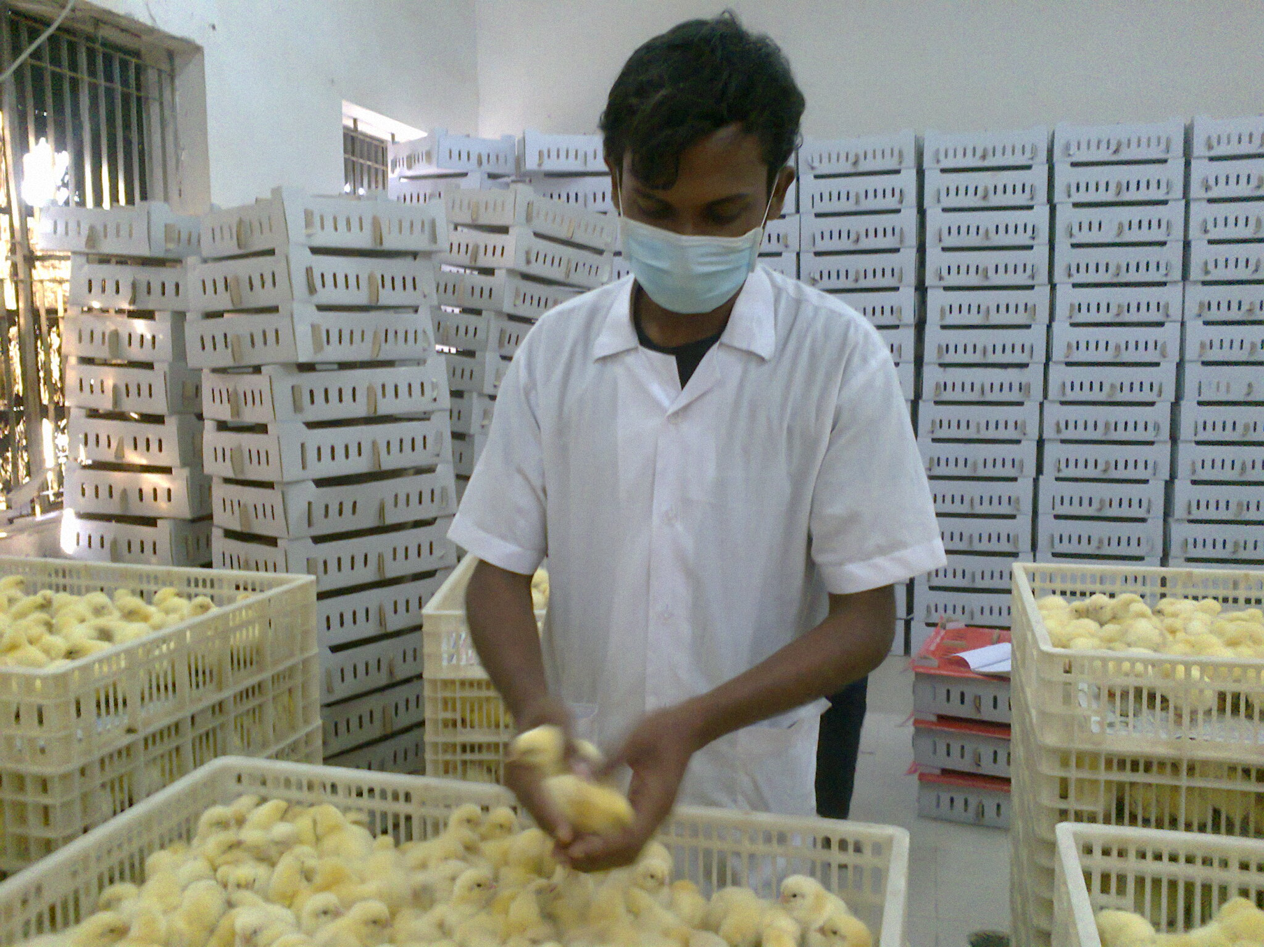

Fig: Grading of chick in hatchery unit.
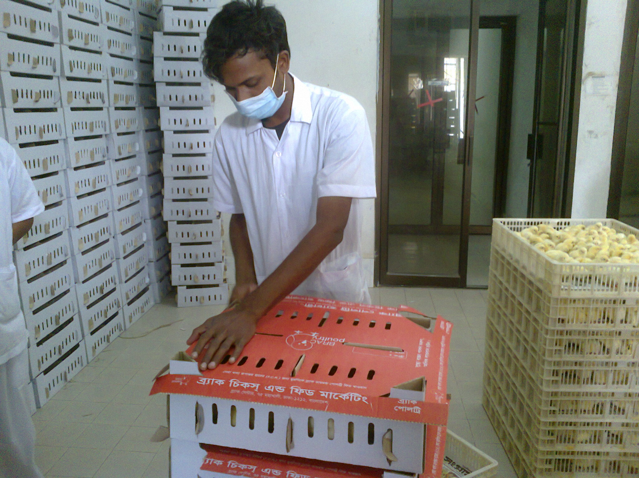

FIG: Packeging of chick after hatching.

4.7 Production performance:

4.7.1 Feed Intake:
Feed intake both male and female is shown in table no 4.8 .It was observed that feed intake of male was higher than female up to 5 month then the feed intake higher of female than male . Lowest amount of feed intake was 29.25 gm and 52.5gm and higher was 165gm and 139 gm for female and male bird respectively. It also can be said that the farm fulfilled the feed requirement of Cobb 500.This table indicate that the highest intake was in 10 to 13 month of age (Both male & female) and that is similar to the recommended value. So it can be obviously say that BRAC farm also follows the recommended guide for broiler parent stock.(Cobb-500)

4.7.2 Bodyweight gain: Body weight gain of male and female bird shown in table 4.9. It is observed from the table very insignificant amount of difference between standard body weights and achieved. Body weight male bird was higher than female over the 13 month and growth increased gradually up to nine month then there is slow growth for both male female. The higher body weight of female was 3.9 kg whereas the higher body weight of male was 4.6 kg in 13 month .The body weight of both male and female was close to the recommended body weight .So it can be said that BRAC farm achieved the target value.

Table 4.8 Comparative study of recommended and given feed to the Cobb 500 birds :
Age  (month) | Feed intake  Grams (female)  Recommended  (Avg.) | Feed intake Grams)  (female  Given in Avg. | Age  (month) | Feed intake Grams  (male)  Recommended  (Avg.) | Feed intake  (male) Grams  Given in  Avg.
1 | 29.25 | 29.25 | 1 | 52.5 | 52.5
2 | 50.00 | 50.00 | 2 | 66.25 | 66.25
3 | 57.00 | 57.00 | 3 | 77.00 | 77.00
4 | 63.25 | 63.25 | 4 | 85.75 | 85.75
5 | 85.5 | 85.5 | 5 | 97.25 | 97.25
6 | 113.25 | 113.25 | 6 | 121.75 | 121.75
7 | 136.5 | 136.5 | 7 | 135.00 | 135.00
8 | 163.25 | 163.25 | 8 | 135.00 | 135.00
9 | 162.75 | 162.75 | 9 | 135.25 | 135.25
10 | 165.00 | 165.00 | 10 | 136.25 | 136.25
11 | 165.00 | 165.00 | 11 | 137.75 | 137.75
12 | 165.00 | 165.00 | 12 | 138.00 | 138.00
13 | 165.00 | 165.00 | 13 | 139.00 | 139.00

Table4.9 : Comparative study of recommended and achieved body weight of Cobb- 500 Female and Male.
Age  (Month) | Body weight  Grams  (Female)  Recommended  (Average.) | Body weight  Grams  (Female)  Achieved  (Average.) | Age  (Month) | Body weight  Grams  (Male)  Recommended  (Average.) | Body weight  Grams  (Male)  Achieved  (Average.)
1 | 334.5 | 351.25 | 1 | 422.50 | 396.25
2 | 798.75 | 806.5 | 2 | 1062.5 | 1064.5
3 | 1198.75 | 1203.25 | 3 | 1587.5 | 1607.5
4 | 1548.75 | 1557.00 | 4 | 2135.00 | 2148.75
5 | 2015.00 | 2016.50 | 5 | 2725.00 | 2698.00
6 | 2760.00 | 2767.00 | 6 | 3411.25 | 3434.5
7 | 3245.00 | 3248.00 | 7 | 3832.50 | 3850.00
8 | 3565.00 | 3563.25 | 8 | 4085.00 | 4162.50
9 | 3665.00 | 3666.75 | 9 | 4247.50 | 4296.25
10 | 3743.75 | 3750.00 | 10 | 4375.50 | 4358.50
11 | 3807.50 | 3817.00 | 11 | 4447.50 | 4455.25
12 | 3867.50 | 3871.25 | 12 | 4575.50 | 4519.75
13 | 3910.00 | 3930.75 | 13 | 4675.50 | 4643.50

4.7.3 Egg production : Egg production of breeder farm are represent in the table 4.10 and fig :1 From the table it is seen that egg production at 8 month age was very high about 81.75% which is higher than the standard value. That is also peak production of a farm. At the starting month of age(6 month) egg production is lower about 2% and during 10-13 month the egg production was vary about 64 to 76%

Table4.10: Comparative study of recommended and achieved monthly egg production
Age  (month) | monthly Egg Prod%
Age  (month) | Recommended (average) | Achieved(average)
6 | 5.00 | 2.00
7 | 47.00 | 41.75
8 | 83.12 | 81.75
9 | 80.50 | 80.25
10 | 76.50 | 76.25
11 | 72.50 | 72.25
12 | 68.50 | 68.00
13 | 64.50 | 64.00

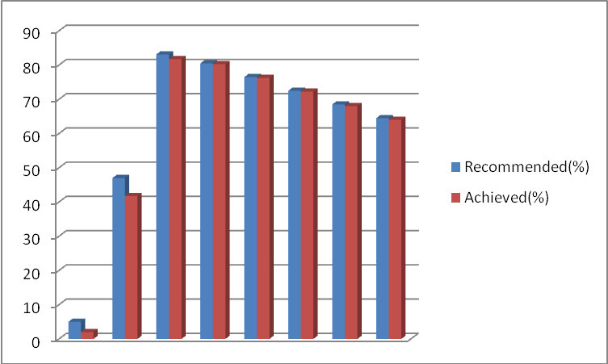

Fig1: Graphical representation of egg production in BRAC farm.

7.4 Hatchability: The hatchability of Cobb -500 at BRAC farm is represented in fig:2 The maximum hatchability percentage was observed 91.5% at 9 month of age which was somewhat higher than the standard hatchability that is 89.57 % in that month. In all times the achieved hatchability percentage was more than the recommended hatchability percentage.

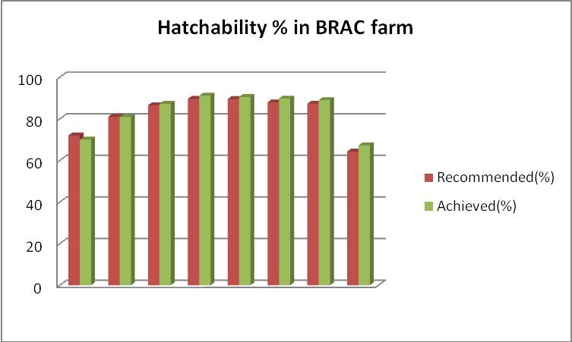

Fig:2 Graphical representation of hatchability of cob-500 in BRAC farm.

4.7.5 Mortality:
From the data it is seen that Mortality percentage of Male & Female in different of month age are variable the standard value(Table 4.11). It is observed from the fig 3 that the mortality was higher in BRAC farm than their target .The mortality of chicken were higher at the late age (11-13 month) and maximum mortality was 11.74% and average mortality was 3-7%
Table 4. 11 : Comparative study of Standard and achieved monthly Mortality % of Cobb 500 .
Age  (month) | Mortality%
Age  (month) | Standard(Average) | Actual (averag)
1 | 1.11 | 1.68
2 | 2.12 | 2.27
3 | 2.9 | 2.94
4 | 3.7 | 3.56
5 | 3.5 | 3.87
6 | 0.10 | 0
7 | 0.67 | 0.35
8 | 1.71 | 2.47
9 | 2.66 | 5.19
10 | 3.5 | 7.78
11 | 4.22 | 10.35
12 | 4.81 | 10.99
13 | 5.25 | 11.44

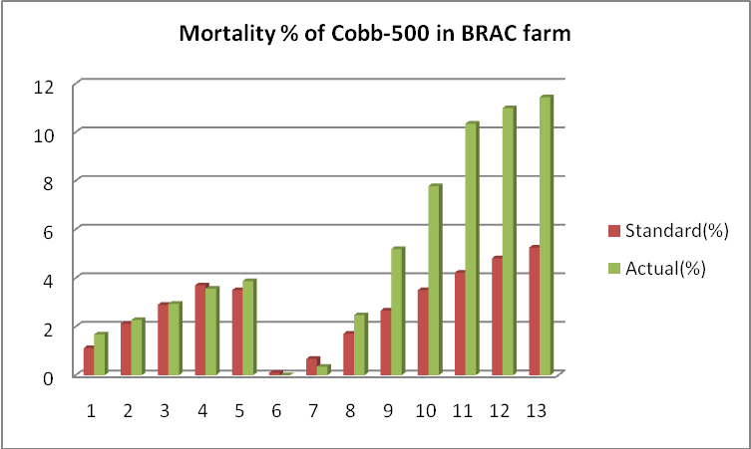

FIG 3: Graphical representation of mortality % of C0bb-500 in B RAC farm.

CHAPTER –I V

CONCLUSION AND RECOMMENDATION

“BRAC” Poultry Farm is a leading parent stock farm in our country .It gets popularity for supplying good quality chicks to the broiler farmer. During my study period I had seen that their management was very good . So the body weight gain , production performance and the hatching percentage of Cobb 500 were higher than the recommended value .But I observed the mortality% was somewhat higher than the standard value and I also observed the lesions of Newcastle Disease and Infectious Bronchitis Disease after post mortem of bird . I think the prevalence of these diseases were due to some mismanagement in Bio-security maintenance which I had observed in that farm .So, if farm maintained optimum Bio-security Rules strictly they could minimize the mortality rate of Cobb 500.

RECOMMENDATION:

- All shed should contain a single age group of birds in order to avoid contamination.
- Both male & female should kept in environmentally controlled house.
- Separate isolation shed should be established.
- Post mortem room should be established and a great distance should be kept
from the hen rearing shed.
V) Strong rodent control program should take regularly.

REFERENCES
Anonymous (1996). Bangladesh Bureau of Statistic's, Ministry of Planning, Dhaka, Bangladesh.

BBS (1995). Year book of Agriculture statistics of Bangladesh , Bangladesh Bureau of Statistics, Ministry of Planning, Dhaka.

Bramwell, R .K. (1999). Sperm penetralion assay steps and procedures. Proceding of University of Arkanss Breeder Management Workshop, Fayettevile, Arkansas, November.

BRAC Report (2006): Report on BRAC Avian influenza preventing programme,
November 2005-August 2006

Chowdhury, S. D. Das, C. Pramanik, H. A .M Roy, C.R, and Shaha.K.S(2003).Broiler parent stock production in Bangladesh : It is possible to achieve target body weight and acceptable uniformity in open sided housed? Proc.3rd WPSA International Poultry Show and Seminar PP: 15-23.

Elibol Okan (2003). The effect of storage and pre-warming periods on hatch time and hatchability. International hatchery Practice. 17(4):17

Fattah , K.A. (2003). Poverty alleviation and poultry development strategies in Bangladesh, Proceeding of the first annual Scientific conference 22-24 February 2003, Chittagong Government Veterinary college, University of Chittagong, PP: 192-200.
Garrison Jerry (2002). A practical look at general hatchery management. International Hatchery Practice .16(7):13-15

Garrison, J. (2002). A practical book at general hatchery management. International hatchery practice. 16(7): 13-15.
Hall Edmud's (2002). Effects of egg storage time on spread of hatch, chick quality and growth, International Hatchery Practice 17(2):17-21

Haque, Q.M.E. (2001) Poultry industry in Bangladesh and strategies for its improvement 2 "^{d} international poultry show and seminar. 16:15-24

Hill Donna (2002) Performance losses: incubation and brooding .International Hatchery Practice .16(8):15-16.

Hurwitz, S and Plavanik, I (1998). Severe feed restriction in pullets during the early growing period: performance and relationship among age, body weight and egg weight at the onset of production, poultry science 68(7): 914-924.

Krishnappa, P, Devagowda, G.R and Ramappa, B.S (1992) Effect of restricted feeding on subsequent performance of broiler breeder dams. Indian Journal of poultry Science 27:1, 29-3 l.

Krishnappa, P. Devagowda, G. R and Ramappa, B. S. (1992). Effect of restricted feeding on subsequent performance of broiler breeder dams. Indian Journal of poultry Science. 27: 1, 29-3 l.

Onagbesan, O. and Tona , K. (2005) effects of turning duration during incubation on embryo growth International Hatchery Practice 19(4):18 Robinson, FE and Wilson, J.L. (1999), Reproductive failure in over weight males and females broiler breeder. Animal feed science and technology .58:145-150.

Robinson, FE, R.A.Renama, J.J.R feddes, M.J Zuidhof and Wilson J.L (1999) Egg production and fertility traits of broiler breeder hens as influenced by strain and early feed allocation. Poultry science (Supp 11) 17.

Saleque, M.A (2001). Poultry as a tool in poverty alleviation: A special programme for the rural poor in Bangladesh, proc. 2^{°d} WPSA International poultry show and seminar.PP: 66-69.

Singh, B., et al. (2000). Genetic parameter of growth, egg production and quality trails in WLH. Indian Journal of poultry Science. 35: 13-16. Singh, B. Singh, H. Singh, C. V (2000) Genetic parameter of growth egg production and quality trials in WLH. Indian Journal Poultry Science .35:13-16

Tona, K and Bamelis, F. (2002) Effects of egg storage on spread of hatch , chick quality and growth. International Hatchery Practice 17(2):17.

