ABASTRACT
A comparative study on the prevalence and blood pictures in Peste des petits ruminants (PPR)-affected goats registered to veterinary hospitals in Bangladesh was conducted at one filed veterinary hospital named Parbatipur Upazila Veterinary Hospital located in Parbatipur, Dinajpur and one referral veterinary hospital named SAQ Teaching Veterinary Hospital located at the Chittagong Veterinary and Animal Sciences University (CVASU). The study was conducted in June-August 2010 at the field veterinary hospital and in December 2010-January 2011 at the referral veterinary hospital. During these two phases of the study prevalence and blood pictures of PPR-affected goats were studied. Detail history, physical examination, clinical examination, hematological examination, postmortem examination, vaccination program and response to treatment were assessed. The results revealed that, the overall prevalence of PPR in the goats registered to veterinary hospitals is 40.2; younger goats of <12 months of age were more susceptible (51.4%) to PPR than the older ones (21.2%). The prevalence of PPR was higher (49.5%) in the unvaccinated compared with the vaccinated (16.7%) goats. The disease was proportionately higher in Black Bengal breed (44.4%) compared with Jamunapari (32.6%). PPR was more prevalent in July-August than in January. The prevalence of PPR in the hospital-registered goats was higher (46.8%) in the field veterinary hospital (Parbatipur Upazila Veterinary Hospital) than the referral hospital at CVASU (21.2%), indicating that PPR is distributed country-wide. The MEAN ± SEM Hb (8.8±1.34g %), PCV (18±3.02%),ESR (0±0 hour), Lymphocyte (60.5±1.84%), Nutrophil (30±1.47%), Monocyte (5.75±1.25%), Eosinophils (3.75±0.75%), Basophiles (0±0%), TEC (9.19±1.59×106/μl) and TLC (9.98±1.50×10³/μl), respectively. Response to treatment with parenteral (I/M) use of oxytetracycline was comparatively higher than that of achieved with the parenteral use of sulphonamide 66.6%) or oral/gut active use of sulphonamide (50.0%).
Key wards: prevalence of peste des petits ruminants, goat, blood pictures

CHAPTER I
INTRODUCTION
Goat is considered as the poor man’s cattle. There are about 33.5 million goats out of 58.98 millions livestock in Bangladesh. Goats are big sources of milk, meat and skin. A few years back Bangladesh government took a national scheme of poverty alleviation through goat rearing. But there are several diseases of goat, especially Pests des petits ruminants (PPR), which cause higher mortality and great economic losses, was one of the major constraints for not having a fully successful implementation of the said programme. PPR is now endemic and epidemic in Bangladesh (Debnath, 1995; Islam et al., 2001).
Rinderpest was arguable the most fearful livestock disease once the farmers in Bangladesh experienced with their cattle which has successfully been eradicated. A related virus of that of rinderpest disease virus however causing the similar nature of disease in goats called PPR particularly in Asian and African countries and international efforts are also underway how to eradicate it (Peter Roeder, FAO).
PPR or stomatitis - pnumoenteritis syndrome is a highly viral contagious disease of small ruminants particularly goat and sheep (Roeder et al., 1994).
Since the first detailed description (Mornet et al., 1956) of PPR it has been found to be widely distributed it Africa and Arabian Peninsula (Taylor, 1984). In the south Asia, PPR was first recorded from India (Shaila et al., 1989), where the disease initially occurred in sheep and subsequently became more prevalent in goats (Kulkarni et al., 1996; Nanda et al., 1996; Shaila et al., 1996). Recorded first in 1993, the disease has now become endemic and epidemic in the country (Debnath, 1995).
PPR is primarily a disease of sheep and goat. But some other animals particularly captive wild ungulates from three families; gazellinae (Dorcas gazelle), caprinae (Nubian ibex and Laristan sheep), Hippotraginae (gemsbox) can be infected. The American white tailer deer (Odocoileus virgininanus) has been infected experimentally (Saliki, 1998). Cattle, buffaloes, camels, and pigs are also susceptible to infection but do not exhibit clinical signs, and are unable to transmit the disease to other animals (Emergency preventing system for trasboundary animal and plant pests and diseases, 1999).
For PPR to spread, close contact between infected and susceptible animals is needed (Ozkul et al., 2002). There are several means of transmission of the virus between animals (Saliki, 1998) - inhalation of aerosols produced by sneezing and coughing of infected animals could be the main way. No carrier state is known to develop in the infected animals. Outbreaks were more frequently reported in the rainy-, dry and cold seasons (Office International des Epizooties, 2002).
It is important to control PPR at first to successfully implement any nation-wide goat production programme in Bangladesh. Although the disease is said to be endemic or epidemic in the country its spatial trends and clinical pictures have not been well documented epidemiologically. Having had an opportunity for being placed at one field veterinary hospital in Northern part and a referral hospital at the Chittagong Veterinary and Animal Sciences University (CVASU), located in Southern part, I have conducted this study on the prevalence and blood pictures of PPR-affected goats registered to these mentioned hospitals.

Specific objectives:
- To have some epidemiological information on PPR occurred in different breeds, age categories of goats along with their vaccination status, its distributions in Northern and East-Southern parts of Bangladesh
- To record characteristic clinical pictures observed in goats of different breeds and age categories
- To perform postmortem examinations on PPR-affected goats to record major gross changes occurred because of the disease
- To have basic information on some blood parameters in PPR-affected goats
- To know the efficacy of different symptomatic treatments given to PPR-affected goats from the two veterinary hospitals

CHAPTER II
REVIEW OF LITERATURE
There are so many literatures about PPR diseases, from which some important research findings are listed below along with references.

2.1. PPR: THE DISEASE
A Peste des petits ruminant (PPR) is an acute viral disease of small ruminants caused by a Morbillivirus and characterized by fever, oculonasal discharges, stomatitis, diarrhoea and pneumonia. The disease is one of the major threats to about 14 million Sheep & Goat population in Bangladesh (BBS, 1999).
The natural disease affects mainly goats and sheep, but it is usually more severe in goats where, it causes severe morbidity and mortality and is only occasionally severe in sheep (Raghavendra et al., 2000). Although, Mornet et al., (1956) reproduced the disease followed by death in calves experimentally infected with PPRV-infected tissue, no natural outbreak has been reported in cattle. It is generally admitted that cattle can only be infected sub-clinically. However, it is possible that cattle in poor health may develop lesions following PPRV infection, clinical signs of which would be ascribed to Rinderpest. Nonetheless, PPRV was Isolated from an outbreak of Rinderpest like disease in Indian buffaloes in 1995 (Govindrajan et al., 1997). PPRV was also suspected to be involved in the epizootic disease that affected single humped camels in Ethiopia in 1995–1996 (Roger et al., 2000, Roger et al., 2001). PPRV antigen and PPRV nucleic acid were detected in some pathological samples collected during that outbreak, but no live virus was isolated. Both experimental and natural infections of PPRV have been reported in wild ruminants (Hamdy and Dardiri, 1976; Furley et al., 1987). Experimentally, subclinical infection in pigs has also been demonstrated (Nawathe and Taylor, 1979).
The clinical disease resembles Rinderpest in ruminants, which is acute, and after an incubation period of 3-6 days, the clinical symptoms become apparent, which include high rise of temperature, oral and ocular discharges, necrotic stomatitis, severe pneumonia, dyspnoea, coughing, enteritis, severe diarrhoea followed by death (Roeder and Obi,1999; Pawaiya et al., 2004). The disease is highly contagious with morbidity and mortality rates reaching as high as 100 per cent and 90 per cent, respectively (Abu-Elzein, 1990). The mortality is usually low in endemic areas, but when associated with other diseases such as capripox, it can approach 100 per cent (Kitching, 1988).
The disease is transmitted by aerosols between animals living in close contact (Lefevre and Diallo, 1990) and substantial amount of virus is known to be present in the ocular and nasal secretions, as well as faeces of the infected animals (Taylor, 1984).

2.2. ETIOLOGY: THE VIRUS
The causative agent of this economically important disease of small ruminants is a Morbiilivirus, the Peste des Petits Ruminants Virus (PPRV), under the family Paramyxoviridae of order Mononegavirales (Murphy et al., 1999). The virus is closely related to Rinderpest virus (RPV), another member of Morbillvirus genus, which causes similar disease in large ruminants (Anderson et al., 1990; Couacy-Hymann et al., 1995). The virus is also serologically related to Measles and Canine distemper virus (Gibbs et al., 1979). A varying degree of cross protection in vivo and serological relationship is known to exist between PPR and RP viruses (Hamdy et al., 1976; Taylor and Abegunde, 1979). Further, the PPR infection in sheep and goats are known to sero-convert and protect in-contact bovines from natural infection, and also may interfere in tissue culture Rinderpest virus (TCRPV) vaccination response (Sudarshan et al., 1995).
The ultra structure of PPR virus has been examined electron microscopically by negative staining technique. The virus particle was found to be pleomorphic with a diameter of intact particles varying between 130-390 nm. The virus has an envelope of 8-15 nm thickness with spikes of 8.5-14.5 nm length. The herring bone like ribonucleoprotien strands measure approximately 14-23 nm in thickness (Durojaiye et al., 1985).
Genome of PPR virus is nonsegmented single stranded RNA of negative polarity. The genome of attenuated vaccine strain of PPRV (Nigeria 75/1) has entirely been sequenced and the physical map of the genome is the same as that of the other morbilliviruses (Rima et al., 1986; Diallo et al., 1990).
Although, there is only one serotype of the virus (Barrett et al., 1993), PPRV isolateson the basis of partial sequence analysis of the fusion (F) protein gene, can be grouped in to four distinct lineages. Lineage 1 and 2 are found exclusively in West Africa, whereas lineage 3 has been found in eastern Africa and Arabia. The fourth lineage is confined exclusively in the Middle East Arabia and Indian subcontinent (Shaila et al., 1996). Except one isolate (TN92/1) from southern India, which belonged to lineage 3, all Indian PPRV isolates identified so far belonged to lineage 4 only (Nanda et al., 1996; Dhar et al., 2002).

2.3. GEOGRAPHICAL DISTRIBUTION OF PPR
PPR has comparatively a shorter history which only dates back to 1940, when it was first described by Gargadennec and Lalane (1942) in Ivory Coast of West Africa. For a longtime, its existence was associated with West African countries.
After development of specific diagnostic tools in late 1980s onwards, our understanding of the geographical distribution of PPR has grown very quickly (Diallo et al., 1995) and recent data indicates the activity of PPRV in all countries of Africa lying between Sahara and the Equator, Arabian peninsula and the Middle East with extension to Turkey, Pakistan, India, Bangladesh and Nepal (Shaila et al., 1996; Dhar et al., 2002; Taylor et al., 2001). It has also been reported in Sudan (Ali and Taylor, 1984), Kenya, Uganda (Wamwayi et al., 1995) and also in Ethiopia (Roeder et al., 1994). Table 2.1 depicts the first report of PPR from different countries. In India, PPR was first reported in 1987 from Tamil Nadu (Shaila et al., 1989). The disease was restricted in southern part of the country (Shaila et al., 1990; Krishna et al., 2001) until 1994, when a series of PPR outbreaks were reported from many northern states such as Himachal Pradesh, Rajasthan, and Uttar Pradesh as well as from West Bengal (Nanda et al., 1996). In Bangladesh, outbreak of Rinderpest like diseases, later confirmed by a reference laboratory to be PPR, have been occurring in goats since 1993 (Debnath,1995).
Since then, the disease has been reported regularly from different parts of the country and is considered as an endemic disease causing a great loss to small ruminants of the country.

2.4. SEROPREVALENCE OF PPR
Durojaiye et al., (1982) demonstrated precipitating antibody in serum of 62.5, 40.0 and 37.5 per cent goats naturally infected with PPR virus following outbreaks of the disease at three locations in Western Nigeria. They concluded that decomplementing the serum gave good result. Neutralizing antibody against PPR virus was readily detected in immune serum and both neutralizing and precipitating antibodies were detectable in the serum of hyper immunized sheep (Durojaiye, 1983).
In a serological survey, Obi et al., (1983) found 52.3 and 47.2 per cent prevalence of PPRV neutralizing antibodies in sheep and goats, respectively.
Table 2.1: First report of PPR from different countries
Sr. No. | Location | Country Reference
1 | Ivory coast | Garagadennec and Lalane (1942)
2 | Senegal | Mornet et al., (1956)
3 | Chad | Provost et al., (1972)
4 | Togo | Benazet et al., (1973)
5 | Benin | Bourdin (1973)
6 | Ghana | Boniwell and Gibbs (1976)
7 | Nigeria | Hamdy et al., (1976)
8 | Oman | Hedger et al., (1980)
9 | Sudan | Ali and Taylor (1984)
10 | Saudi Arabia | Furley et al., (1987)
11 | India | Shaila et al., (1989)
12 | Jordan | Lefevre et al., (1991)
13 | Israel | OIE (1993)
14 | Ethiopia | Roeder et al., (1994)
15 | Bangladesh | Debnath (1995)
16 | Kenya and Uganda | Wamwayi et al., (1995)
17 | Pakistan | Amjad et al., (1996)

Durojaiye and Taylor (1984) recorded a high correlation between neutralization test and CIEP during serological study of PPR and concluded that CIEP was a simple and rapid test for the serodiagnosis of PPRV.
Durojaiye and Taylor (1984) described AGPT to monitor the appearance of antibody in experimentally infected sheep and goats. They found, of the 137 convalescent field serum samples, 80 were positive to this test and 78 to the neutralization test, 71 were positive to both the tests.
In a survey of respiratory viral infections in goats, Obi (1984) found antibody to PPR virus in 54 per cent of an unstated number of goats in Nigeria. They concluded that PPR virus was the principal viral agent responsible for respiratory disease.
Neutralizing antibodies against PPRV and RPV were determined in goats and sheep at different localities in southern Nigeria. Of 195 goats, 21 per cent reacted to PPR virus only, 19.5 per cent to RP virus only and 39.5 per cent to both the viruses. Further, of 67 sheep, 14.9 per cent reacted to PPR virus, only six per cent to RP virus only and 43.3 per cent to both the viruses. It was concluded that in both the species, neutralizing antibodies had high titers to PPR virus (Obi et al., 1984).
Durojaiye (1987) found 70 per cent correlation between indirect precipitation test and neutralization test for the detection of PPR antibodies. He concluded that indirect precipitation test was suitable for screening of PPR antibodies in laboratories lacking facilities for the neutralization test.
Ende et al., (1988) analyzed serum samples collected from 94 adult sheep and 129 goats of 30 herds in Tahoua Department, for antibodies to PPR virus; 62 per cent of sheep and 53 per cent of goats were found positive.
In an epidemiological study of PPRV in Sultanate of Oman, Taylor et al., (1990) found 24.5 per cent sheep and goats positive for PPRV antibodies. Prevalence by region was 26.5 per cent in Batina coast, 32.0 per cent in Oman interior, 24.5 per cent in Sharquiyah and 4.8 per cent in Salalah.
Lefevre et al., (1991) in a serological survey in Jordan found 50 per cent of samples giving unclear results by Rinderpest ELISA kit, were positive for PPR virus, with titres ranging from 32 to 2048.
In a serological survey of antibodies against PPRV in small ruminants in Cameroon during 1986-1988, Ekue et al., (1992) found 46.5 per cent animals positive for PPR virus antibodies.
Tatar et al., (2002) tested sera samples from cattle, sheep and goats using PPR c-ELISA. PPRV antibodies were detected in 28.35 per cent of the sheep and goat serum samples. Presence of anti-PPR antibodies was 8.08 per cent in selected cattle.

2.5. INCIDENCE OF PPR VIRUS
Based on clinical features and cross protection assay with RP vaccine, Asmar et al., (1980) reported two outbreaks of PPR in Saudi Arabia during July 1977 and July 1979. In both the outbreaks, the disease caused up to 60 per cent mortality and at least 90 per cent morbidity.
In an epidemiological study of PPR in Oyo and Ondo States of Nigeria, Mathew (1983) reported 191 outbreaks (115 animals died) in 1977-78, 114 in 1978-79 and 122 during 1979-80. In a similar study in the same country between 1978 and 1981, Mathew and Orafu (1983) reported 521 outbreaks of PPR. They concluded that the disease was mainly confined to the southern states of Nigeria.
Obi et al., (1983) investigated five field outbreaks of PPR in Southern Nigeria between 1976 and 1980. In all the five outbreaks, only goats were affected, with morbidity and mortality rates of 62.0 and 54.6 per cent, respectively.
Between November 1978 and January 1980, four outbreaks of PPR occurred in sheep and goats in the humid forest and derived Savanna zones of Oyo State. Morbidity and mortality rates were highest in goats and 94 goats died during the four outbreaks. Between April 1979 and March 1980, 40 of 188 goats and 32 of 164 sheep kept at two experimental stations (one in the humid forest zone and one in the derived Savanna zone) were clinically affected by the disease and 18 goats and six sheep died. Intercurrent diseases appeared to aggravate the severity of PPR among the goats kept under village conditions (Opasina, 1983).
PPR was confirmed in goats of Nile region of Sudan in 1972 by inoculation of experimental animals with the virus isolates from these goats. The experimental animals showed typical PPR symptoms and cattle survived when challenged with a virulent strain of Rinderpest virus and showed a SN50 antibody end-point 3.04 with PPR serum (Taylor, 1983).
By serological examination and experimental inoculation of cattle, sheep and goats, Ali and Taylor (1984) confirmed the involvement of PPR virus in outbreaks in goats of central Sudan during 1971 and 1972.
Opasina and Putt (1985) reported three outbreaks in village goat populations in southwest Nigeria with an overall attack rates of 42.2, 13.7 and 37.1 per cent and mortality rates of 86.9, 41.0 and 63.9 per cent, respectively.
Ezeokoli et al., (1986) studied the clinical and epidemiological features of PPR among Sokoto Red goats in Zaria (dry Savanna). They observed a pattern similar to that reported among West African dwarf goats in the humid zone of Nigeria. Between 25 and 88 per cent of goats were infected, but the clinical disease was rare (0.7%); 23-56 per cent of the clinically affected goats died. They concluded, the disease was most common at the end of the dry season and the early rainy season, perhaps providing stress situations.
Furley et al., (1987) described an outbreak of PPR in a zoological collection of Al Ain in the Arabian Gulf. Clinically, the outbreak affected gazelles (Gazellinae), ibex and sheep (Caprinae) and gemsbok (Hippotraginae); subclinical involvement of Nilgai (Tragelophinae) was suspected.
Outbreaks of PPR occurred in Oman in 1985 and 1986. In 1985, 732 of 2129 goats were affected and 262 (12.3%) died. In 1986, 206 of 597 goats were sick and 35 (6.1%) died. The disease was diagnosed by agar gel immunodiffusion assay (Ata and Al-Sumry, 1989).
Shaila et al., (1989) reported first outbreak of PPR in India from Tamil Nadu in a flock of 800 sheep during 1987. During the outbreak, 80 animals were affected of which, 20 died. PPR was confirmed by using cDNA probes specific to nucleoprotein gene of the PPR virus. Based on cross neutralization test, Abu-Elzein et al., (1990) reported in April 1988, an outbreak of PPR affecting 90 per cent of indigenous goats in Al-Ahsa oasis in eastern Saudi Arabia. The case mortality rate was 70 per cent.
Ismail and House (1990) reported an outbreak of PPR in a flock of 70 goats (32% mortality) in Embaba Giza province of Egypt in January 1987 and among Ovis ornata in a zoo in the same province. They also obtained an isolate ("Egypt 87") of the virus.
Between 1987 and 1989, Moustafa (1993) reported 41 outbreaks of PPR or a PPR like disease in United Arab Emirates. They concluded that the disease was widespread geographically and seasonally.
An outbreak of PPR occurred in two herds, each of more than 1000 goats, with high rates of morbidity (virtually 100%) and up to 60% mortality (Roeder et al., 1994).
In a survey conducted by Bhowmick (1995) in West Bengal, mortality rate due to PPRV in sheep and goat was 15.2 and 38.1 per cent respectively.
Based on clinical feature, Chandra et al., (1995) reported an outbreak of PPR that caused death of 33 of 98 Jamunapari goats in an organized farm in West Bengal.
Mondal et al., (1995) noticed 73 outbreaks of PPR in goats with mortality rate of 23.8 to 38.2 per cent in West Bengal. The prevalence of disease was higher in Black Bengal goats (57.34%) than in Jamunapari breed (38.76%).
Using VNT, AGPT, microtitre plate and dot ELISA, Mouaz et al., (1995) confirmed PPR infection in three sheep flocks from Giza governorate of Egypt. The rate of infection was 0.11, 0.3, and 0.4 per cent, respectively.
NPRE (1995) reported 132 outbreaks of PPR in sheep and goats in Andhra Pradesh, Tamil Nadu, Karnataka, Maharashtra, Orissa, Rajasthan, Uttar Pradesh, and West Bengal during 1994 -1995.
Akakpo et al., (1996) reported an unusually severe outbreak of PPR virus among goats in the village of Camberene in the suburbs of Dakar in 1992.
A severe outbreak of PPRV infection in a group of 243 recently purchased, young Barbari goats in Lahore, Pakistan in 1994, was reported by Amjad et al., (1996) with high morbidity and mortality. Kajli sheep kept on the same farm were not affected clinically. PPRV was detected in the blood and tissues of two affected goats by polymerase chain reaction.
In outbreaks of PPR in three different flocks of migratory Gaddi sheep and goats in Himachal Pradesh, from November 1994 to January 1995, the mortality rates were 53.5, 26.7 and 17.1 per cent respectively (Joshi et al., 1996).
In Maharashtra, 13.4 and 41.4 per cent mortality due to PPR was observed in goats and kids, respectively, in nine villages (Kulkarni et al., 1996).
The agent responsible for an outbreak of a rinderpest-like disease afflicting sheep and goats in three states of northern India was confirmed as PPR virus using ELISA, RT/PCR, immunofluorescence with virus specific monoclonal antibodies and virus isolation (Nanda et al., 1996).
Singh et al., (1996) reported 70 and 30 per cent attack rate and mortality rate,
respectively, in migratory flock of sheep due to PPR in Kota region of Rajasthan.
Tripathi et al., (1996) reported a severe outbreak of pest of small ruminants at Indian Veterinary Research Institute, Izatnagar, during March-April, 1994. They concluded that goats were more severely affected (275 died) than sheep (80 died).
Paritosh (1997) observed that after introduction of Barbari goats from Makhdoom, (U.P.) to Regional Breeding Farm, Tripura, there was an outbreak of PPR with mortality rate of 45.79 per cent.
Aruni et al., (1998) observed more than ten outbreaks of PPR in goats from Tamil Nadu. They observed that kids were more susceptible than adults.
PPR virus was diagnosed in disease outbreaks affecting goats in Andhra Pradesh by ELISA using lacrimal, nasal and oral swabs and tissue samples (lung, spleen, mesenteric lymph nodes and abomasal and intestinal scrapings). In a total population of 610 sheep and 900 goats in the three districts studied, morbidity ranged from 3.3 to 10 per cent and 16.7 to 30.0 per cent and mortality from zero to 16.6 per cent and 21.3 to 41.6 per cent in the two species, respectively (Rao et al., 1998).
Between 15 May and 12 July 1997, Goswami et al., (1998) reported a severe outbreakof PPR at the regional goat breeding farm in Tripura, India. Highest mortality was observed in crossed Barbari-Black Bengal goats (65.0%). Mortality among kids was higher (62.50%) than in adults (33.77%).
An outbreak of PPRV in approximately 100 goats was diagnosed in Rawalpindi city, Pakistan in June 1997 by Hussain et al., (1998), with mortality rate of 80 per cent. PPRV was detected in blood and various tissue samples using a competitive ELISA and immunocapture ELISA.
Based on clinical features, Shankar et al., (1998) reported an outbreak of suspected PPR and its epidemiological features in 24 villages of Rajpura block of Chakaragar, Etawah (U.P.), between August 1994 and October 1994. Laboratory diagnosis neither revealed the presence of Rinderpest virus antigen by counter immunoelectrophoresis nor Rinderpest antibodies by ELISA, based on which, the outbreak were suspected because of PPR.
Yener et al., (2004) demonstrated presence of PPR viral antigens in 17 (40%) out of 42 pneumonic lungs of goats slaughtered in the region of Bitlis and Van.

2.6. DETECTION OF PPR VIRUS
2.6. (1). ELISA FOR DETECTION OF PPR VIRUS ANTIGEN
In a comparative study, Saliki et al., (1994) observed that sandwich-ELISA was positive for 71.9 per cent PPR suspected samples, while single passage virus isolation was positive for 65.2 per cent samples. They concluded that sandwich-ELISA was significantly more sensitive.
The immunocapture (sandwich) ELISA was found suitable for routine diagnosis of RPV and PPRV in field samples such as ocular and nasal swabs (Diallo et al., 1995).
2.6. (2). RT-PCR FOR DETECTION OF PPR VIRUS
Shaila et al., (1996) studied genetic relationship between PPR viruses of distinct geographical origin, by sequencing a 322 nucleotide cDNA fragment of fusion protein gene generated using RT-PCR. Four separate lineages of the virus were identified and all the virus isolates from Asia over the previous two years were found of one lineage, which had not previously been recorded in Africa or Asia.
Ozkul et al., (2002) described F-gene based RT-PCR for the diagnosis and epidemiological study of PPRV in Turkey. The study revealed cross border transmission of PPRV infection in Turkey.
2.7. MOLECULAR CHARACTERIZATION OF PPR VIRUS
2.7. (1). RT-PCR/RFLP ANALYSIS
Tiwari et al., (2003) developed a quick method of RT-PCR-RE analysis in order to differentiate IBDV isolates/strains. A 480 bp fragment, comprising one of the RNA dependent RNA polymerase motifs of VP1 gene sequence of an Indian classical virus, an attenuated vaccine strain Georgia and two Indian field isolates, which were reported genetically similar to very virulent strains of IBDV, was amplified by RT-PCR. RE digestion of the PCR products with Taq-I enzyme generated a distinct profile for the field isolates, different from the classical and attenuated viruses, whereas restriction profile with BstN-I restriction enzyme was similar for all the viruses, irrespective of the pathotype. Thus, it was suggested that Taq-I digestion could be taken up for the differentiation of field isolates from the classical and vaccine IBDV strains.

CHAPTER III
MATERIALS AND METHODS
3.1. Location and duration of the study: The study was conducted at the Parbatipur Upazila Veterinary Hospital from 27th June 2010 to 26th August 2010, and at the teaching veterinary hospital at CVASU from 30th December 2010 to 28th January 2011.
3.2. Tools of diagnosis: Diagnosis of PPR was made by means of history and clinical signs like fever in the initial stage followed by pneumo-enteritis evidenced by matted mucus in the eye and nostrils, conjunctivitis, dyspnoea, diarrhea, anemic, erosion in oral mucosa and finally death. The degree of dehydration was estimated by conventional skin fold test. Sometimes the tentative diagnosis was supported with hematological findings and post mortem examination results.
3.3. Hematological examination: Five blood samples were taken in the early stage of the disease. Hemoglobin (Hb), Erythrocyte Sedimentation Rate (ESR), Pack Cell Volume (PCV), Total Leukocytes Count (TLC), Total Erythrocyte Count(TEC), Differential Leukocyte Counts in percentages (DLC) were performed using the standard procedures at the department of physiology and pharmacology, Hajee Mohammad Danesh Science and Technology University, Dinajpur. For DLC blood films were stained with Wright’s stain.
3.4. Postmortem examination: Three dead animals were subjected for postmortem examinations. A PPR case was tentatively diagnosed if postmortem examinations revealed the presence of the changes: consolidated and pneumonic lungs, erosive and hemorrhagic enteritis, characteristics Zebra striping in the mucosa in the colon, necrosis and hemorrhagic plugs in the cecum.
3.5. Medication history: Based on the medication histories all the PPR-affected goats were divided into three groups:
Group I: Goats receiving oral/gut acting sulphonamide with other symptomatic therapy.
Group II: Goats receiving parenteral(I/M) sulphonamide with other symptomatic therapy.
Group III: Goats receiving parenteral(I/M) oxytetracycline with other symptomatic therapy.
A response to a treatment as the outcomes - recovery from the disease or death was the success or failure of a treatment given under any of the three groups mentioned above.
3.6. Vaccination history of PPR: Each owner was asked about previous vaccination history of his/her goat suffering from PPR.
3.7. Clinical examinations of PPR cases in goats
3.6. (1). History: Data were recorded from the owners for the breeds/Sex/Age of the animals; probable dates of clinical onset of the disease with the probable signs: fever, diarrhea, nasal and ocular discharges, depressed appetite from the last two days of the clinical onset.
3.6. (2). Clinical inspection:
- Close inspection was done carefully for each case to observe the signs:
a) Rough hair coat
b) Erosion in gum, tongue, and margin of the upper and lower lips
c) Red bright color in conjunctiva
d) Serous nasal discharge with froth becoming mucopurulent
e) Lacrimation on the eyes
f) Diarrhea
- Per rectal temperature was recorded with a thermometer
- Indirect auscultation was performed by means of a stethoscope to hear the lung sound
- A conventional skin fold test was performed to make the rough estimation of the degree of dehydration
3.8. Presumptive diagnosis: On the basis of anamnesis, clinical examinations sometimes supported with postmortem examination findings presumptive diagnoses of PPR cases were made.

3.9. Treatment: Symptomatic treatments were given from the two hospitals in 3 major groups, listed in section 3.5. In addition to prescribing an antibiotic for every case antihistaminic and physiological saline were also recommended. The treatment of a PPR case continued until recovery or death of an animal if the owner brought the animal to the hospital in the subsequent days following registration to a hospital as a case of PPR.
3.10. Statistical analysis: The data obtained were stored and coded accordingly using Microsoft Excel-2000. The data were exported from MS Excel-2000 to STATA/IC-11.0 (Stata Corporation College Station) for analysis. The results were expressed in percentage with p-value for Chi-Square Test. Significance was determined when p<0.05. Difference in occurrence of PPR in different locations was shown by using a χ² test.

CHAPTER IV
RESULTS AND DISCUSSION
4.1 Prevalence of PPR in goats
In the entire period of observation in two temporal phases 127 goats were clinically examined of which 51 were identified with PPR (Table4.1), indicating the overall prevalence 40.2 (Table 4.1). The prevalence among the goats registered to Parbatipur Veterinary Hospital was 46.8 which is significantly higher than the prevalence (21.2) observed in goats registered to CVASU teaching veterinary hospital (p=0.008). The prevalence of PPR in vaccinated and non-vaccinated goats is shown in Table 4.2. The results showed that the prevalence of PPR in non-vaccinated goats was 49.9, significantly higher than that of recorded in the vaccinated animals (p=0.0007).
Table 4.1 Spatial distribution of PPR
Region | No. positive cases | No. negative cases | Total cases | Prevalence% | χ² value  5.63 | p-value  0.008
Parbatipur veterinary hospital. | 44 | 50 | 94 | 46.8 | χ² value  5.63 | p-value  0.008
CVASU-Teaching veterinary hospital. | 7 | 26 | 33 | 21.2 | χ² value  5.63 | p-value  0.008

Table 4.2 Prevalence of PPR in vaccinated and non-vaccinated goats
Immune status | No. positive case | No. negative case | Total cases observation | % of positive cases | χ² value | p-value
Vaccinated | 6 | 30 | 30 | 16.7 | 10.21 | 0.0007
Non-vaccinated | 45 | 46 | 91 | 49.6 | 10.21 | 0.0007

The results on spatial distributions of the PPR cases show that the disease in prevalent all over the country including northern and East-Southern parts, although the prevalence seemed to be higher in the northern districts. Vaccination against the disease seems to decrease the prevalence, but not gives guarantee of being PPR-free. The exact dates of vaccinations against PPR were not known. If vaccines were administered to the animals when they were already incubating the virus the vaccine could not work. However, if vaccination time for an animal was within the recommendation period and still they succumbed to PPR then the potential of the vaccine or vaccination could be in-question. This was beyond the scope of the study; however, because some vaccinated animals were also infected with the virus the potential of PPR vaccine, produced from Livestock Research Institute (LRI), in protecting goats from PPR need to be assessed.

Table 4.3 shows the prevalence of PPR in two breeds of goats. The results revealed that, the prevalence of PPR among the Black Bengal and Jamunapari goats was 42.5 and 28. 6%, respectively (Table 4.3). Although the prevalence of PPR was proportionately higher (43%) in Black Bengal goats it was not found significantly (P=0.13) higher when compared with the breed Jamunapari. This result is not in conformity with (Chowdhury et al., 1995) who reported that, Black Bengal breed is more susceptible to PPR than Jamunapari. Mondal et al., (1995) also noticed a higher prevalence of PPR in Black Bengal goats (57.34%) than in Jamunapari in the West Bengal, India.
Table 4.3 Prevalence of PPR in two goat breeds
Breed | No. positive cases | No. negative cases | Total cases | % | χ² value | p-value
Black Bengal | 36 | 45 | 81 | 44.4 | 1.25 | 0.13
Jamunapari | 15 | 31 | 46 | 32.6 | 1.25 | 0.13

Table 4. 4 Prevalence of PPR in two age categories
Age | No. positive case | No. negative case | Total cases | % | χ² value | p-value
0-12 months | 37 | 35 | 72 | 51.39 | 7.68 | 0.002
>1year | 14 | 41 | 55 | 25.45 | 7.68 | 0.002

The prevalence of PPR in goats below 1 year of age and above this age limit is compared in Table 4.4. The occurrence of PPR was significantly higher (p<0.05) in goats <1 year of age (p=0.002). Although immune status of dams in the study was not performed, nevertheless, it can be assumed that younger goats might have got some maternal antibodies which protected them from the disease.
The temporal distributions of PPR are shown in Table 5. The results showed that PPR cases were proportionately, but not significantly (p=0.223), higher in the month of July-August compared with January. Similar temporal results on the occurrence of PPR was reported by Obi et al., (1983) and Nawathe (1979) who observed that PPR occurred as outbreaks in rainy season, when goats were herded together.
Table 4.5 Temporal distributions of PPR
Season | No. positive case | No. negative case | Total cases observation | Prevalence % | χ² value  3.00 | p-value  0.223
July | 20 | 24 | 44 | 45.45 | χ² value  3.00 | p-value  0.223
August | 24 | 26 | 50 | 48 | χ² value  3.00 | p-value  0.223
January | 7 | 26 | 33 | 21.21 | χ² value  3.00 | p-value  0.223

4.2. Blood pictures of PPR-affected goats
The blood parameter pictures of 4-PPR affected goats were shown compared with 4 normal goats in Table 4.6. The MEAN±SEM Hb (8.8±1.34g %), PCV (18±3.02%),ESR (0±0 hour), Lymphocyte (60.5±1.84%), Nutrophil (30±1.47%), Monocyte (5.75±1.25%), Eosinophils (3.75±0.75%), Basophiles (0±0%), TEC (9.19±1.59×106/μl) and TLC (9.98±1.50×10³/μl), respectively, in the PPR-affected goats which revealed that lymphocyte counts declined in PPR-affected goats, causing immune suppression. An elevation in neutrophils count might be linked to concomitant bacterial infections. Similar reports on lymphocyte and neutrophil counts in PPR-affected were reported in the past. The hemoglobin level could be similar in the PPR-affected and normal goats, but the pack cell volume could slightly decrease in the PPR-affected goats than the normal ones.
Table 4. 6 Blood parameter pictures in PPR-affected and normal Black Bengal goats
SL.NO. | COUNT |  |  | 4 NO. PPR GOAT |  |  |  | MEAN±SEM | 4 NO.NORMAL GOAT |  |  |  | MEAN±SEM
01 | Hb (g %) |  |  | 12 | 7 | 6.2 | 10 | 8.8±1.34 | 7 | 8 | 9.5 | 10 | 8.62±.68
02 | PCV (%) |  |  | 16 | 15 | 14 | 27 | 18±3.02 | 33 | 22 | 23 | 28 | 26.5±2.53
03 | ESR (hour) |  |  | 0 | 0 | 0 | 0 | 0±0 | 0 | 0 | 0 | 0 | 0±0
04 | DLC (%) | Lymphocyte (%) |  | 58 | 65 | 62 | 57 | 60.5±1.84 | 75 | 72 | 67 | 62 | 69±2.84
05 | DLC (%) | Nutrophil (%) |  | 32 | 27 | 28 | 33 | 30±1.47 | 13 | 14 | 21 | 28 | 19±3.48
06 | DLC (%) | Monocyte (%) |  | 7 | 2 | 7 | 7 | 5.75±1.25 | 4 | 7 | 6 | 4 | 6±.70
07 | DLC (%) | Eosinophils (%) |  | 3 | 6 | 3 | 3 | 3.75±0.75 | 7 | 2 | 6 | 5 | 5±1.08
08 | DLC (%) | Basophiles (%) |  | 0 | 0 | 0 | 0 | 0±0 | 1 | 1 | 0 | 1 | 0.75±0.75
09 | TEC (×106/μl) |  |  | 11.05 | 6.86 | 6.15 | 12.71 | 9.19±1.59 | 7.62 | 4.25 | 8.59 | 9.24 | 7.42±1.10
10 | TLC (×10³/μl) |  |  | 14.3 | 7.71 | 8.12 | 9.82 | 9.98±1.50 | 13.3 | 12.3 | 20.3 | 13.21 | 14.77±1.85

Table 4.7 Response of different treatments given for PPR-affected goat
Drug | No. recovered from PPR | No. death | Total case | % recovered | χ² value | p-value
Oral/gut active sulphonamide with symptomatic treatment | 5 | 5 | 10 | 50.00 | 6.00 | 0.199
Parenteral (I/M) sulphonamide | 12 | 6 | 18 | 66.6 | 6.00 | 0.199
Parenteral (I/M) oxytetracycline | 15 | 4 | 19 | 78.9 | 6.00 | 0.199

4.3. Response of treatment
Reponses of different treatments provided for PPR affected goats are summarized in Table 4.7. The results showed that, the recovery percentage from PPR was higher in animals treated with parenteral (I/M) administration of oxytetracycline (78.9%) than intramuscular use of sulphonamide (66.6%) or oral/gut active use of sulphonamide (50%). The higher efficacy of the use of oxytetracycline might be related to the susceptibility of the concomitant bacterial pathogens with PPR to this antibiotic.

CHAPTER V
CONCLUTIONS
The prevalence of PPR among the goats registered to veterinary hospitals is 40.2 and the disease can probably be seen all over the country. However, the prevalence of PPR was significantly higher in the goats registered to Parbatipur Veterinary Hospital, Dinajpur than those to CVASU teaching veterinary hospital. Younger goats of < 1 year of age are more susceptible to PPR than the older ones. The prevalence of PPR was higher in non-vaccinated goats than the vaccinated goats and the disease is proportionately higher in the Black Bengal breed than in Jamunapari. The occurrence of PPR was proportionately higher in July-August than in January. The MEAN ± SEM Hb (8.8±1.34g %), PCV (18±3.02%),ESR (0±0 hour), Lymphocyte (60.5±1.84%), Nutrophil (30±1.47%), Monocyte (5.75±1.25%), Eosinophils (3.75±0.75%), Basophiles (0±0%), TEC (9.19±1.59×106/μl) and TLC (9.98±1.50×10³/μl), respectively indicating a decline of lymphocyte counts, but an increase in the neutrophil counts in the PPR-affected goats. Response of treatment to parenteral (I/M) use of oxytetracycline was higher than the parenteral (I/M) use of sulphonamide or oral/gut active use of sulphonamide.

ACKNOWLEDGEMENT
I take this opportunity to express my profound gratitude to my supervisor Dr. Paritosh Kumar Biswas, Professor, Department of Microbiology, Chittagong Veterinary & Animal Sciences University, Khulishi. Chittagong.
I am also greatful to honorable professor Dr. A.S Mahfuzul Bari, Vice Chancellor, and Professor Dr. Abdul Mothin Prodhan, Dean, Faculty of Veterinary Medicine of Chittagong Veterinary and Animal Sciences University for arranging this type of work as a compulsory part of the internship program.
I also vary thank to Dr. Mohammad Mahmudul Hassan, Assistant Professor, Department of physiology, Biochemistry & Pharmacology, Chittagong Veterinary & Animal Sciences University.
I place my thanks to Dr. Faruk Hossen, VS in Parbatipur veterinary hospital, Parbatipur, Dinajpur for his whole headed support and providing valuable information about PPR in parbatipur.
I also thank to Dr.Fahima Binte, chairman of Biochemistry, physiology and pharmacology department in Hajee Mohammad Danesh Science and Technology University, Dinajpur, to facilities my for blood test in PPR Goats.
I deeply appreciated the help rendered by those three goats’ farmers who facilitated my studies by permitting me to do postmortem examination of their dead goats.

Picture: 1
PPR in a goat: purulent eye & nasal discharges: Discharges from the nose & eyes in advanced PPR infection; the hair below the eyes is wet & there is matting together of the eyelids as well as partial blockage of the nostrils by dried up purulent discharges.
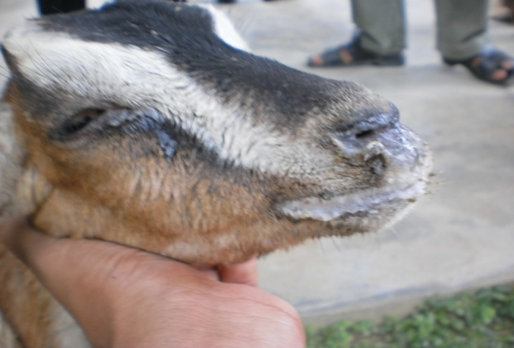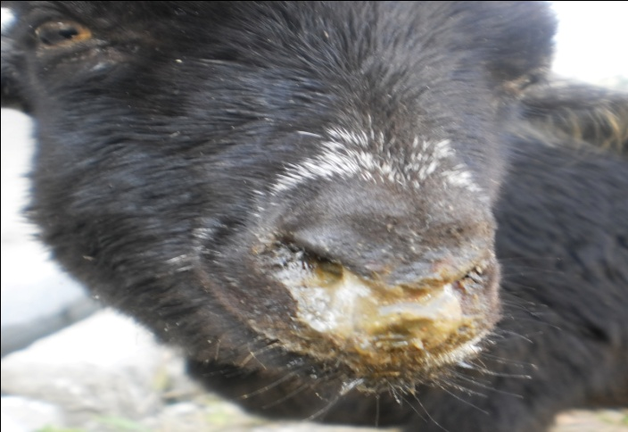
Picture: 2.  PPR in a goat: inflamed (reddened) eye membranes: Reddening of the mucous membranes of the eye (the conjunctiva) in the early stage of infection. Note the Purulent eye discharges. | 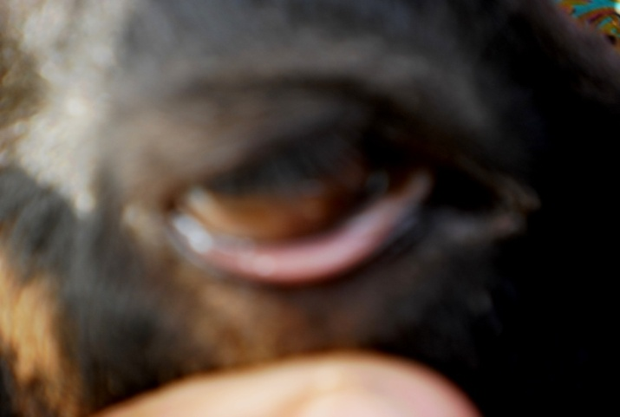

Picture: 3.  PPR in a goat: early mouth lesions showing areas of death cells: Early pale, grey areas dead cells on the gums | 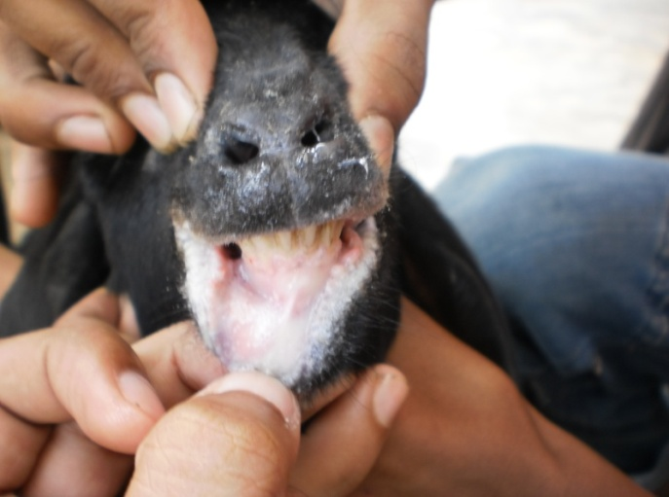

Picture:4  PPR in a goat: later mouth lesions: The membrane lining the mouth is completely obscured by thick cheesy materials; shallow erosions are found on tongue, gum of teethes. | 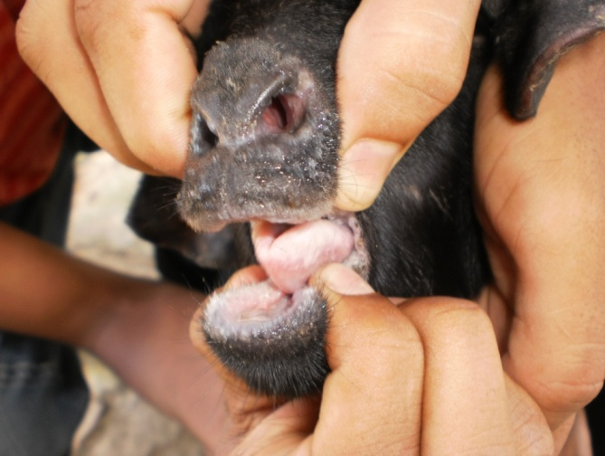

Picture:5  PPR in a goat: swollen, erosion, eroded lips: The lips & nostril are swollen, edematous & show areas of erosion. | 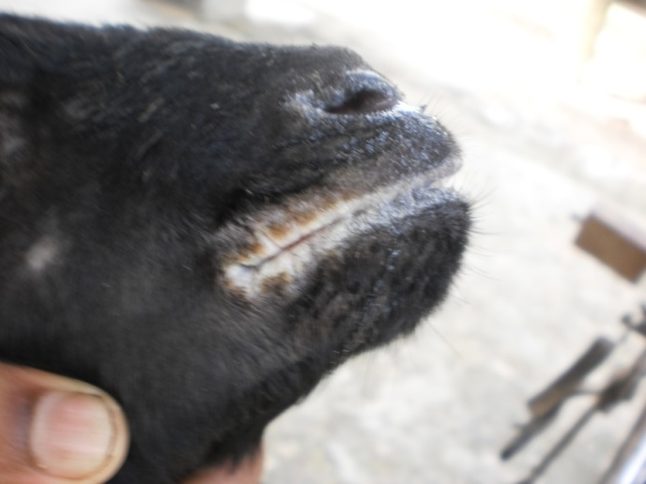

Picture:6  PPR in a goat: sings of diarrhea: The hindquarters are soiled with liquid faeces. | 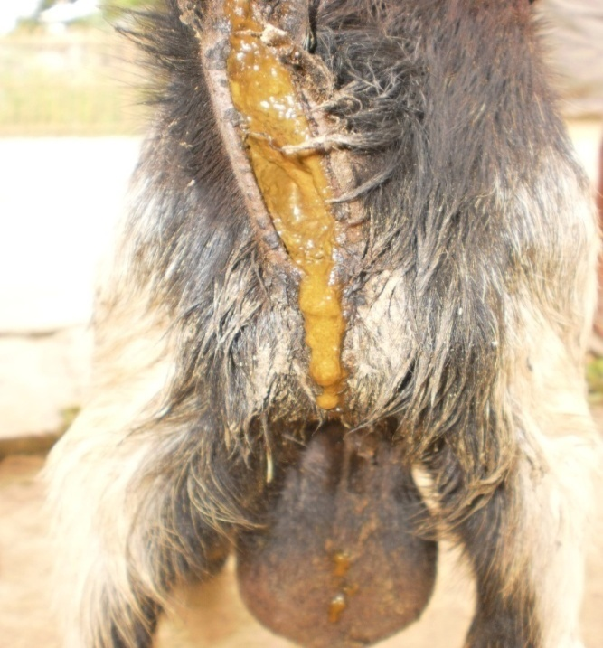

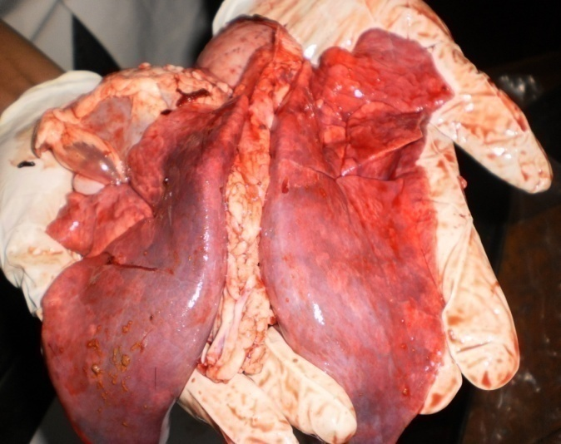
Picrure:7
PPR in a goat: postmortem lesion advance pneumonia: the extensive, dark red/purple areas, firm to the touch, in the anterior & cardiac lobes of the lungs. Although such pneumonia is commonly seen in PPR, it is caused by secondary bacterial infection, most commonly pasteurella haemolytica, these leasions are typical of pneumonia pasteurellosis.

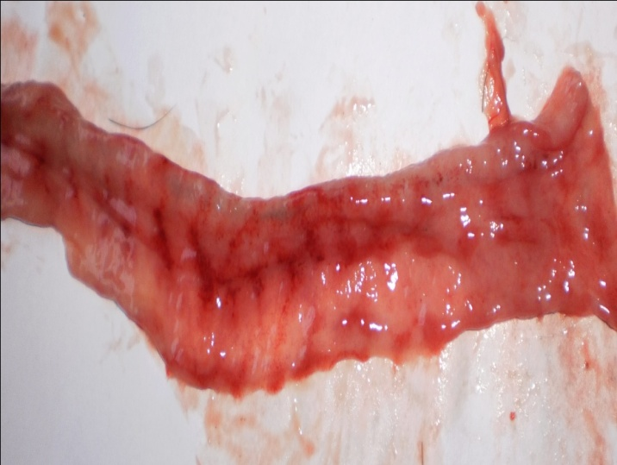
Picture:8
PPR in a goat: “Zebra striping” in the large intestine: The lesions of hemorrhage along the tips of the folds of the lining of the cecum & colon. Late the individual hemorrhages join up and after death, turn black.

Picture:9  PPR in a goat: Necrosis and hemorrhagic plugs in cecum. Lesions in the small intestine are generally moderate, being limited to small streaks of hemorrhages and, sometimes, erosions in the first portion of the duodenum and the terminal ileum | 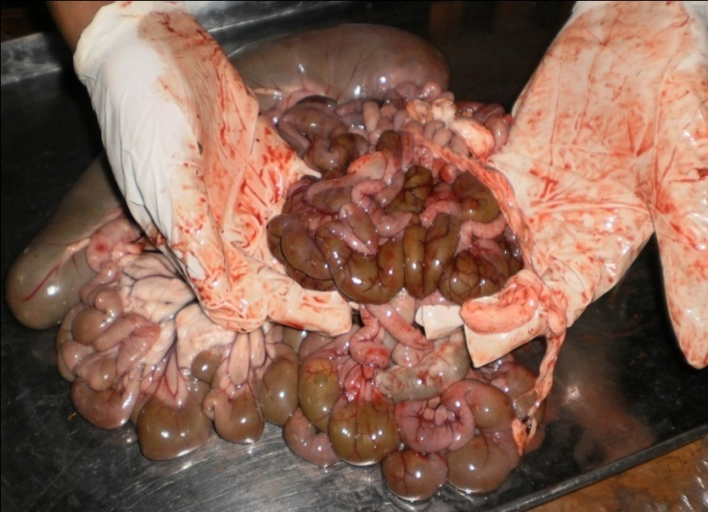

Picture:10  PPR in a goat: Necrosis and hemorrhagic plugs in cecum. Lesions in the small intestine are generally moderate, being limited to small streaks of hemorrhages and, sometimes, erosions in the first portion of the duodenum and the terminal ileum. | 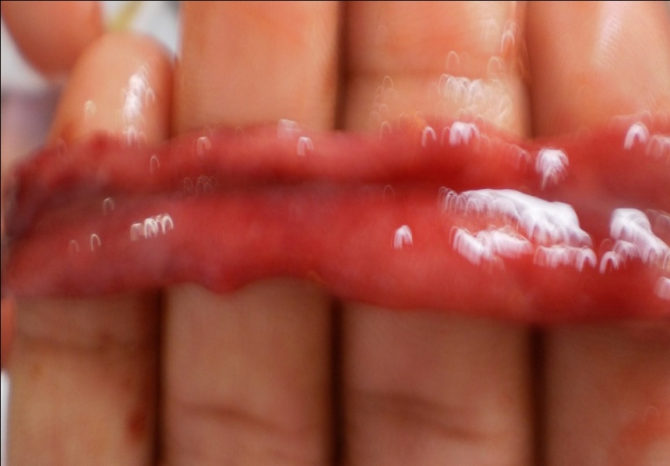

Picture: 11  PPR in a goat: death fetus in uterus | 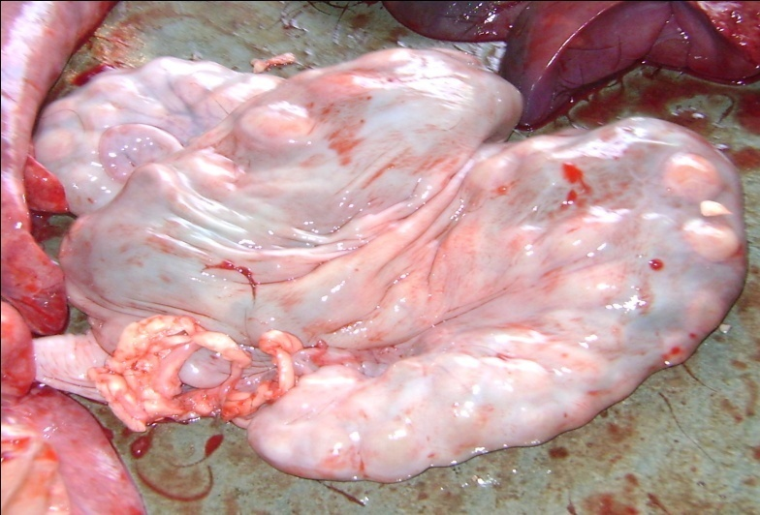

Picture:12  PPR in a goat: congested liver. | 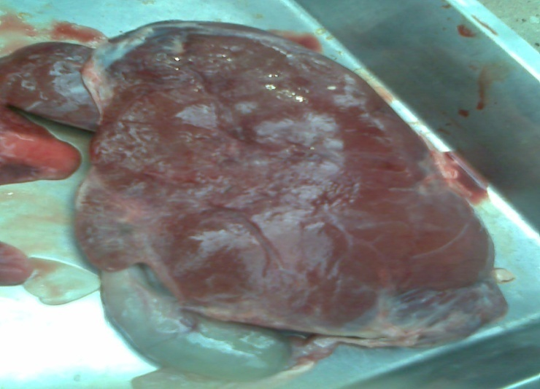

Picture:13  PPR in a goat: Most lymph nodes throughout the body are enlarged, congested, and edematous. | 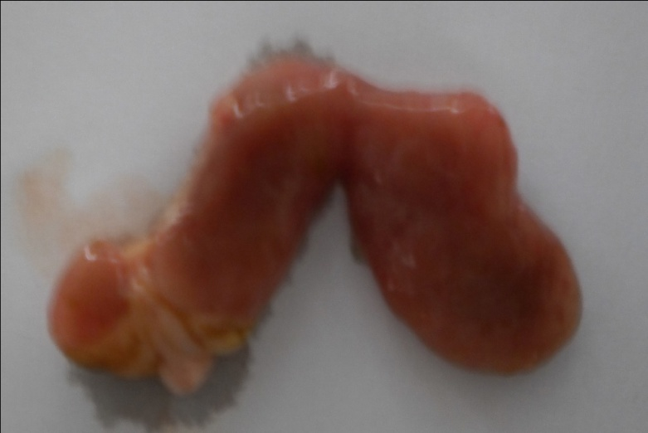

Picture: 14.
PPR in a goat: Posture during the time of death (left picture). Highly dehydrated & anemic condition of conjunctiva (right picture).
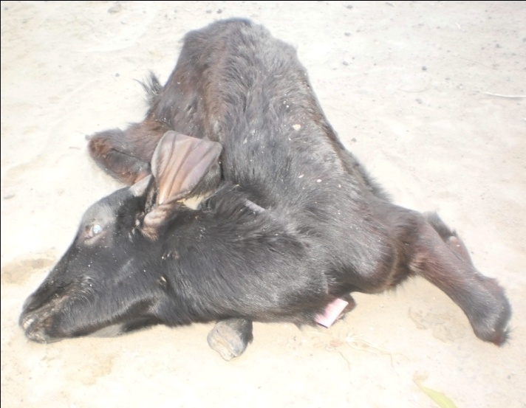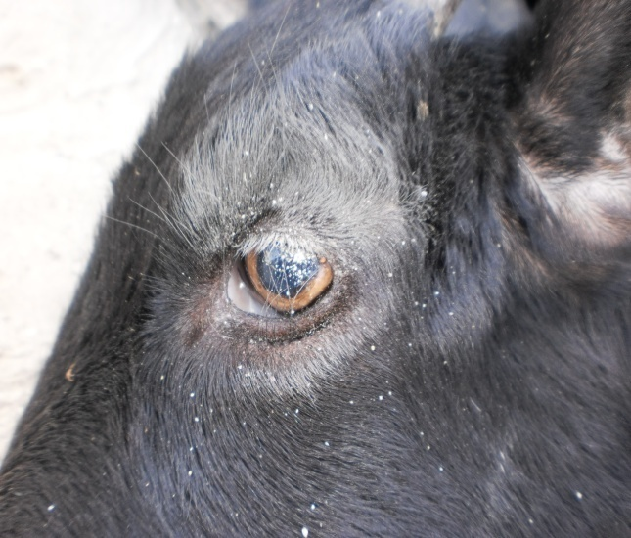
REFFERENCES

- Amjad, H.; Qamar, I.; Forsyth, M.; Barrett, T. and Rossiter, P.B. (1996). Peste des petits ruminants in goats in Pakistan. Vet. Rec. 139 (5): 118-119.

- Aruni, A.W.; Lalitha, P.S.; Mohan, A.C.; Chitravelu, P. and Anbumani, S.P. (1998). Histopathological study of a natural outbreak of peste des petits ruminants in goats of Tamilnadu. Small Rum. Res. 28 (3): 233-240.

- Ali, E.H.B. and Taylor, W.P. (1984). Isolation of peste des petits ruminants virus from the Sudan. Res. Vet. Sci. 36 (1): 1- 4.

- Akakpo, A.J.; Deconinck, P.; Amegatse, K.; Kaboret, Y. and Oudar, J. (1996). An outbreak of pest of small ruminants virus in periurban herds of Dakar, epidemiological and medical importance. Revue de Medecine Veterinaire. 147 (6): 447-452.

- Asmar, J.A.; Radwan, A.I.; Abi, A.H. and Rasheid, A.A. (1980). A PPR-like disease of sheep in central Saudi Arabia: evidence of its immunologic relation to rinderpest; prospects for a control method. Proceedings of the Fourth Conference on the Biological Aspects of Saudi Arabia. University of Riyadh.; Riyadh; Saudi Arabia, 1980. pp. 325-337.

- Ali, E.H.B. and Taylor, W.P. (1984). Isolation of peste des petits ruminants virus from the Sudan. Res. Vet. Sci. 36 (1): 1- 4.

- Ata, F.A. and Al-Sumry, H.S. (1989). Oman. Pest of small ruminants (peste des petits ruminants).World Anim. Rev. 65: 53-55.

- Abu-Elzein, E.M.E.; Hassanien, M.M.; Al-Afaleq, A. I.; Abd-Elhadi M.A. and Housawi, F.M.I. (1990). Isolation of peste des petits ruminants from goats in Saudi Arabia.Vet. Rec. 127 (12): 309-310.

- Anderson, E. C.; Hassan, A.; Barrett, T. and Anderson, J. (1990). Observation on the pathogenicity for sheep and goats and the transmissibility of the strain of virus isolated during the rinderpest outbreak in Sri Lanka in 1987. Vet. Microbiol. 21: 309-318.

- Bonniwell, A. M. (1980). Peste des petis ruminants paper given at the International workshop on PPR held at Ibadan. 24-26 Sept. 1980.

- BBS, (1999) Census of Agriculture 1996. Structure of Agricultural Holdings and livestock Population, Volume- 1, July 1999, Bangladesh Bureau of Statistics, Government of the People’s Republic of Bangladesh Dhaka, Bangladesh.

- Barrett, T.; Romero, C.H.; Baron, M.D.; Yamanouchi, K.; Diallo, A.; Bostock, C.J. and Black, B. (1993). The molecular biology of rinderpest and peste des petits ruminants. Ann. Med. Vet. 137 (2): 77-85.

- Bhowmick, M.K. (1995). National Symposium on Veterinary Pathology, IAVP Abstract No. SR 2: 42.

- BROWN, C.C., MARINER, J.C., and OLANDER, H.J. (1991). An immunohistochemical study of the pneumonia caused by peste des petits ruminants virus. Vet. Pathol., 28: 166-170.

- Couacy-Hymann, E.R.F.; Bidjeh, K.; Angba, A.; Domenech, J. and Diallo, A. (1995). Protection of goats against rinderpest by vaccination with attenuated peste des petits ruminants virus. Res. Vet. Sci. 59: 106-109.

- Chandra, C.S.P.; Bandopadhyay, L.N.; Das, B.; Sabir, M. and Guha, D.K. (1995). Studies on the control of an outbreak of peste-des-petits ruminants in goats in West Bengal. Indian J. Anim. Hlth. 34 (1): 65-66.

- Chowdhury, C.S.R., Bando Padhy, L.N., Das, B., Sabir, M. and Guha, D.K. (1995). Studies on the control of an outbreak of peste des petits ruminants in goats in west Bengal. Indian J. Anim. Health 34:65-66.

- Dhar, P.; Sreenivasa,B. P.; Barrett, T.; Singh, R.P. and Bandyopadhyay, S.K. (2002). Recent epidemiology of peste des petits ruminants virus (PPRV). Vet. Microbiol. 8 (2): 153-159.

- Debnath, N.C. (1995). Pesti des petits ruminant: an overview. Proceeding of the BSVER, Symposium on Eradication of Rinderpest and Related diseases. 2December, 1995, Dhaka, pp: 9-13.

- Diallo, A.; Libeau, G.; Couacy-Hymann, E. and Barbron, M. (1995). Recent developments in the diagnosis of rinderpest and peste des petits ruminants. Vet. Microbiol. 44 (2-4): 307-317.

- Diallo, A. (1990). Morbillivirus group: Genome organization and proteins. Vet. Microbiol. 23:155-163.

- Durojaiye, O.A. (1982). Precipitating antibody in sera of goats naturally affected with peste des petits ruminants. Trop. Anim. Hlth. Prod. 14 (2): 98-100.

- Durojaiye, O.A. (1987). Application of a precipitinogen inhibition test in the detection of antibody to peste des petits ruminants virus. Rev. Elev. Med. Vet. Pays Trop. 40 (1):17-20.

- Durojaiye, O.A. and Taylor, W.P. (1984). Preliminary observations on plaque formation by the virus of peste des petits ruminants.Tropical-Veterinarian. 2 (3): 148-150.

- Durojaiye, O.A.; Taylor, W.P. and Smale, C. (1985). The ultrastructure of peste des petits ruminants virus. Zbl. Vet. Med. B. 32 (6):460-465.

- Durojaiye, O.A.; Obi, T.U. and Ojo, M. (1983). Virological and serological diagnosis of peste des petits ruminants. Trop. Vet. 1 (1): 13-17.

- Ende, M.V.; Sterm, E.; Sollod, A.E. and Salifou, S. (1988). Peste des petits ruminants and cost effectiveness of its prevention in Niger. Acta Veterinaria Scandinavica. Suppl. 84: 126-128.

- Ezeokoli, C.D.; Umoh, J.U.; Chineme, C.N.; Isitor, G.N. and Gyang, E.O. (1986). Clinical and epidemiological features of peste des petits ruminants in Sokoto Red goats. Rev. Elev. Med. Vet. Pays Trop. 39 (3-4): 269-273.

- EMPERS (Emergency Prevention System for Transboundary Animal and Plant Pests and diseases). Recognizing peste des petits ruminants. A field manual. Rome, Italy: FAO (Food and Agriculture Organization of United Nation, 1999).

- Ekue, N.F.; Tanya, V.N.; Ndi, C. and Saliki, J.T. (1992). A serological survey of antibodies against peste des petits ruminants (PPR) virus in small ruminants in Cameroon. Bulletin Anim. Hlth. Prod. Afr. 40 (1): 49-53.

- Furley, C.W.; Taylor, W.P. and Obi, T.U. (1987). An outbreak of peste des petits ruminants in a zoological collection. Vet. Rec. 121 (19): 443-447.

- Gibbs, E.P.J.; Taylor, W.P.; Lawman, M.P.J. and Bryant, J. (1979). Classification of the pestedes- petits-ruminants virus as the fourth member of the genus Morbillivirus.Intervirology 11: 268-274.

- Gargadennec, L. and Lalanne,.A. (1942). La peste des petits ruminants. Bulletin des Services Zootechniques, et des Epizooties de I' Afrique Occid ntale Francaise. 5: 16-21.

- Goswami, K.B.; Saha, R.; Chakrabarty, S. (1998). Studies on age-specific and month-wise mortality pattern and sequele to an onslaught of peste des petits ruminants on reproductive behaviour of goat. Indian J. Anim. Hlth. 37 (1): 29-31.

- Govindarajan, R.; Koteeswaran, A.; Venugopalan, A.T.; Shyam, G.; Shaguna, S.; Shaila, M.S. and Ramachandran, S. (1997). Isolation of pestes des petits ruminants virus from an outbreak in Indian buffalo (Bubalus bubalis). Vet. Rec. 141: 573–574.

- Hamdy, F.M. and Dardiri, A.H. (1976). Response of white tailed deer to infection with peste des petits ruminants virus. J. Wildlife Dis. 1: 516-522.

- Hussain, M.; Afzal, M.; Muneer, R.; Ashfaque, M. and Haq, E.U. (1998). An outbreak of peste des petits ruminants in goats in Rawalpindi. Pak. Vet. J. 18 (4): 224-226.
- Hamdy, F.M.; Dardiri, A.H.; Nduaka, O.; Breese, S.R.Jr. and Ihemelandu, E.C. (1976). Etiology of the stomatitis pneumcenteritis complex in Nigerian dwarf goats. Can. J. Comp. Med. 40: 276-284.

- Islam, M.R., Shamsuddin, M., Rhaman, A., Das, P.M., and Dewan, M.L. (2001). An outbreak of peste des petits ruminants in Bliac Bangle goats in Mymensing, Bangladesh. The Bangladesh Veterinarian, 18(1), pp: 14-19.

- Ismail, I.M. and House, J. (1990). Evidence and identification of 'peste des petits ruminants' from goats inEgypt.ArchifurExperimentelleVeterinarmedizin. 44 (3): 471-474.

- Joshi, V.B.; Nagal, K.B.; Sharma, M.; Katoch, R.C.; Batta, M.K. and Sharma, A.K. (1996). Peste-des-petits ruminants (PPR) among Gaddi sheep and goats in Himachal Pradesh. Indian J. Anim. Sci. 66 (11): 1126-1127.

- Krishna, S .V.; Subharao, M.V and Shaila, M. S. (2001). Neutralising antibodies to peste des petits ruminants virus in small ruminants in Andhra Pradesh- A serological survey. Indian J. Anim. Sci. 71: 228-230.

- Kulkarni, D.D., Bhikane, A.U., Shila, M.S., Varalakshmi, P., Aple, M.P. and Narlabker, B.W. (1996). Pesti des petits ruminant in goat in India. Veterinary recoed, 138, pp: 187-188.

- Kitching, R.P. (1988). The economic significance and control of small ruminant viruses in North Africa and west Asia. In Thompson, F.S. (Ed.). Increasing small ruminant productivity in semi-arid areas, ICARDA. pp 225-236.

- Lefevre, P.C. and Diallo, A. (1990). Peste des petits ruminants virus. Rev. Sci. Tech. Off. Int. Epiz. 9: 951-965.

- Lefevre, P.C.; Diallo, A.; Schenkel, F.; Hussein, S. and Staak, G. (1991). Serological evidence of peste des petits ruminants in Jordan. Vet. Rec. 128 (5): 110.

- Mornet, P.; Orue, J.; Gillbert,Y.; Thiery, G. and Mamadou, S. (1956). La peste des petits ruminants en Afrique occidentail francaise; ses rapports avec la peste bovines. Rev.Elev. Med.Vet. Pays Trop. 9: 313-342.

- Mondal, A.K.; Chottopadhyay, A.P.; Sarkar, S.D.; Saha, G.R. and Bhowmik, M.K. (1995).Report on epizootiological and clinicopathological observations on peste des petits ruminants (PPR) of goats in West Bengal. Indian J. Anim. Hlth. 34 (2):145-148.

- Mouaz, M.A.; Faid, A.A.; Rawwhia, E.D. and Kodeir, M.H. (1995). Studies on peste des petits ruminants (PPR) in Egyptian sheep. Vet. Med. J. Giza. 43 (4): 367-374.

- Moustafa, T. (1993). Rinderpest and peste des petits ruminants-like disease in the Al-Ain region of the United Arab Emirates. Rev. Sci. Tech. Off. Int. Epizoot. 12 (3): 857-863.

- Murphy, F.A.; Gibbs, E.P.J.; Horzinek, M.C. and Studdert, M.J. (1999). Classification and nomenclature of viruses. In: Veterinary Virology, 3rd Edn, Academic press, NewYork. pp 4 13.

- Mathew, Z and Orafu, P.I. (1983). Epidemiology of peste des petits ruminants in Nigeria. Third International Symposium on Veterinary Epidemiology and Economics, Arlington,Virginia, USA, 6-10 September 1982. pp 665.

- Nawathe, D.R. and Taylor, W.P. (1979). Experimental infection of domestic pigs with the virus of peste des petits ruminants. Trop. Anim Hlth. Prod. 11 (2): 120-122.

- Nanda, Y.P.; Chatterjee, A.K.; Purohit, A.; Diallo, A.; Innui, K.; Libeau, G.; Thevasagayam, J.A.; Bruning, A.; Kitching, R.P.; Anderson, J.; Barrett, T. and Taylor,W.P. (1996). The isolation of peste des petits ruminants virus from Northern India. Vet. Microbiol. 51 (3-4): 207-216.

- NPRE (1995). Annual progress report of National Rinderpest Eradication Programme, New Delhi. pp 13-16.

- Nanda, Y.P.; Chatterjee, A.K.; Purohit, A.; Diallo, A.; Innui, K.; Libeau, G.; Thevasagayam, J.A.;Bruning, A.; Kitching, R.P.; Anderson, J.; Barrett, T. and Taylor,W.P. (1996). The isolation of peste des petits ruminants virus from Northern India. Vet. Microbiol. 51 (3-4): 207-216.

- OIC (Office International Des Epizooties/World Organization for animal health). Peste des petits ruminants. Manual of standards for diagnostic tests and vaccines. Ed 4. Chap 2, 1.5 Pairs: OIE, 2002.

- Ozkul, A., Akea, Y., Alkan, F. Prevalence, distribution, and host range of peste des petits ruminants virus, Turkey. Emerg Infect Dis 2002 Jul: 8(7): 708-712.

- Ozkul, A.; Akca, Y.; Alkan, F.; Barrett, T.; Karaoglu, T.; Dagalp, S.B.; Anderson, J.; Yesilbag, K.; Cokcaliskan, C.; Gencay, A. and Burgu, I. (2002). Prevalence, distribution, and host range of Peste des petits ruminants virus, Turkey. Emerging Infec. Dis. 8 (7): 708- 712.

- Obi, T.U. (1984). Respiratory viral infections in goats in Nigeria with emphasis on peste des petits ruminants.Les maladies de la chevre, colloque international, Niort (France), 9-11 octobre 1984. Colloques de l'INRA. 28: 677-682

- Obi, T.U.; Rowe, L.W. and Taylor, W.P. (1984). Serological studies with peste des petits ruminants and rinderpest viruses in Nigeria. Trop. Anim Hlth. Prod. 16 (2): 115-118.

- Obi, T.U.; Ojo, M.O.; Taylor, W.P. and Rowe, L.W. (1983). Studies on the epidemiology of peste des petits ruminants in Southern Nigeria. Trop. Veterinarian. 1(4): 209-217.

- Obi, T.V., Durojaiye, O.A., Taylor, Rowe, L.W. (1983). Studies on the epidemiological of peste des petits ruminants (PPR) in southern Nigeria.

- Opasina, B.A. (1983). Epidemiology of PPR [pest of small ruminants] in the humid forest and the derived savanna zones [Nigeria] in Peste des petits ruminants (PPR) in sheep and goats. Hill, D.H. (Ed.). Proceedings of the international workshop held at IITA, Ibadan,Nigeria, 24-26 September 1980. pp 14-21.

- Opasina, B.A. and Putt, S.N.H. (1985). Outbreaks of peste des petits ruminants in village goat flocks in Nigeria. Trop. Anim. Hlth. Prod. 17 (4): 219-224.

- Paritosh, M. (1997). Studies on incidence of peste des petits ruminants in the regional goat breeding farm at Debipur, Tripura. Indian J. Anim. Hlth. 36 (2): 169-171.

- Pawaiya, R.V.S.; Misra, N.; Bhagwan, P.S.K. andDubey,S.C.(2004).Pathology and distribution of antigen in goats naturally infected with peste des petits ruminants virus. Indian J. Anim. Sci. 74 (1): 35-40.

- Rima, B.K.; Baczko, K.; Clarke, D.K., Curran, M.D., Martin, S.J., Billeter, M.A. and Meulen.V.(1986). Characterization of clones for the sixth (L) gene and a transcriptional map for morbilliviruses. J. Gen.Virol. 67 (9): 1971-1978.

- Rao, T.S.; Babu, R.M.; Devi, V.R. and Rao, A.V.N. (1998). A short note on the occurrence of peste des petits ruminants in Krishna and Guntur districts of Andhra Pradesh. Indian Vet. J. 75 (10): 930-931.

- Roeder, P.L. and Obi, T.U. (1999). Recognizing peste des petits ruminants . A field manual. FAO, Rome. 17: 75-81.

- Reoder, P.L., Abraham, G., Kenfe, G. and Barrett, T. (1994). Pesti des petits ruminant in Ethiopian goats. Tropical Animal health production. 26, pp: 69-76.

- Roeder, P.L.; Abraham, G.; Kenfe, G. and Barrett, T. (1994). Peste des petits ruminants in Ethiopian goats. Trop. Anim. Hlth. Prod. 26 (2): 69-73.

- Roger, F.; Guebre, Y.M.; Libeau, G.; Diallo, A.; Yigezu, L.M. and Yilma, T. (2001). Detection of antibodies of rinderpest and peste des petits ruminants viruses (Paramyxoviridae, Morbillivirus) during a new epizootic disease in Ethiopian camels (Camelus dromedarius). Revue de Med. Vet. 152 (3): 265-268.

- Roger, F.; Yigezu, L.M.; Hurard , C.; Libeau, G.; Mebratu, G.Y., Diallo, A. and Faye B. (2000). Investigations on a new pathological condition of camels in Ethiopia. J. Cam. Prac. Res. 7: 163-165.

- Raghavendra, L.; Setty, D.R.L. and Raghavan, R. (2000). Clinico-biochemical changes in sheep and goats experimentally infected with Vero cell adapted peste-des petits ruminants(PPR) virus. Int. J. Anim. Sci. 15 (2): 171-173.

- Shaila, M.S., Purashothaman, V., Bhavasar, D., Venugopal, K., &Venkatesam, R.A. (1989). Peste des petits ruminants virus from an outbreak in Tamil Nadu sheep. Indian vet.J.67:385-386.

- Shaila, M.S.; Deepa , A.B.; Gopal, T.; Rameshbabu, N.G. and Sreepadh, K. (1990) Preliminary observation on the isolation and identification of rindrepest virus from an ovine outbreak in Karnataka State. Indian Vet. J. 67: 383-384.

- Singh, V.P.; Chum, V.K. and Mondhe, K.S. (1996). Peste des petits ruminants: An outbreak in sheep in Rajasthan. Indian Vet. J. 73: 466-467.

- Shankar, H.; Gupta, V.K. and Singh, N. (1998). Occurrence of pest des petitis ruminants like disease in small ruminants in Uttar Pradesh. Indian J. Anim. Sci. 68 (1): 38-40.

- Shaila, M.S.; Shamaki, D.; Forsyth, M.A.; Diallo, A.; Goatley, L.; Kitching, R.P. and Barrett, T. (1996).Geographic distribution and epidemiology of peste des petits ruminants virus.Virus Res. 43 (2):149-153.

- Shaila, M.S.,Peter, A.B., Varalakshmi, P.,Madhuri; Apte; Rajendran, M.P.,& Anbumani, S.P. (1996). Peste des petits ruminants in Tamil Nadu goats. India Vet J. 73: 587-588.

- Sudharshana, K.J.; Rajasekhar, M. and Upadhye, A.S. (1995). Prevalence of peste des petits ruminants and rinderpest antibodies in small ruminants. Indian Vet. J. 72 (12):1246-1250.

- Shaila, M.S.; Shamaki, D.; Forsyth, M.A.; Diallo, A.; Goatley, L.; Kitching, R.P. and Barrett, T. (1996).Geographic distribution and epidemiology of peste des petits ruminants virus.Virus Res. 43 (2):149-153.

- Shaila, M.S.; Purashothaman, V.; Bhavsar, D.; Venugopal, K. and Venkatesan, R.A. (1989).Peste des petits ruminants of sheep in India. Vet. Rec. 125: 602.

- Saliki, J.T.; Brown, C.C.; House, J.A. and Dubovi, E.J. (1994). Differential immunohistochemical staining of peste des petits ruminants and rinderpest antigens in formalin-fixed, paraffin-embedded tissues using monoclonal and polyclonal antibodies.Journal of Veterinary Diagnostic Investigation. 6 (1): 96-98.

- Shaliki, J.T. Peste des petits ruminants, In;US Animal Health Association, Committee on Foreign Animal Disease. The gray book. Ed 6. Part IV. Rickmond, VA: US Animal Health Assoc, 1998.

- Taylor, W.P. (1984). The distribution and epidemiology of 'peste des petits ruminants'. Prev. Vet. Med. 2: 157-166.

- Tatar, N; Erturk, A.; Kabakli, O.; Akkoca, N.; Incoglu,S.;Ulker,U.andDakmun, A. (2002). Investigation of peste des petits ruminants prevalenceinTurkey.Etlik Veteriner Microbioyoloji Dergisi. 13 (1):15-31.

- Tripathi, B.N.; Chattopadhyay, S.K. and Parihar, N.(1996).Clinicopathological studies on anoutbreak of peste des petits ruminants in goats and sheep. Indian J. Vet. Pathol. 20 (2):99-103.

- Taylor, W.P. and Abegunde, A. (1979). The isolation of peste des petits ruminants virus from Nigerian sheep and goats. Res. Vet. Sci. 26 (1): 94-96.

- Taylor, W.P. (1984). The distribution and epidemiology of 'peste des petits ruminants'. Prev. Vet. Med. 2: 157-166.

- Taylor, W.P.; Busaidy, S.A. and Barrett, T. (1990). The epidemiology of peste des petits ruminants in the Sultanate of Oman. Vet. Microbiol. 22 (4): 341-352.

- Tiwari, A.K.; Kataria, R.S.; Prasad, N. and Gupta, R. (2003). Differentiation of Infectious bursal disease viruses by restriction enzyme analysis of RT-PCR amplified VP1 gene sequence. Indian J. Comp. Immunol. Microbiol. Infect. Dis. 26: 47-53.

- Wamwayi, H.M.; Rossiter, P.B.; Kariuki, D.P.; Wafula, J.S.; Barrett, T. and Anderson, J. (1995). Peste des petits ruminants antibodies in east Africa. Vet. Rec. 136: 199-200.

- Yener, Z.; Saglam, Y.S.; Temur, A. and Keles, H.(2004).Immunohistochemical detection of peste des petits ruminants viral antigens in tissues from cases of naturally occurring pneumonia in goats. Small Rum. Res. 51 (3): 273-277.

