CHAPTER 1
INTRODUCTION

The domestic dog (Canis lupus familiaris) which is one of the most widely kept working and companion animals in history is the first domesticated animal in the world (Larson et al., 2012; Ovodov et al., 2011) and a famous quote always goes with this animal that "dog is the man’s best friend" (Udell et al., 2014). That’s why in the developed country the owners always try to fed good food to their dog. But now in developing countries people are keeping pet dogs and try to feed them according to their income limits.
On the other hand, the clinical well-being of an animal depends greatly on the provision of balanced diet. Concepts in nutrition are expanding to include an emphasis on the use of foods to promote a state of wellbeing with better health and to reduce the risk of diseases (Bontempo, 2005). The feeding and nutrition of pet dogs are quite different compared to developed countries, attributable to divergent social, economical and cultural factors (Vijayakumar et al., 2004). However, there is virtually no information available on the nutritional aspects of pet dogs in Bangladesh.
Nutritional requirements of dog is very unique, varies with age, physiological condition, breed, gender, activity, temperament, environment and state of metabolism (Schenck, 2011). From a nutritional point of view, growth is the most important time in a dog's life. By two months of age, pups can be fed with puppy food. This is very critical phase of life-growth; skeletal development is at its peak for the first six months of life. Puppies in their active growth period should be providing a high-quality diet that fulfills their definite nutritional needs. Growing dogs show omnivorous feeding behavior and so, their diet should be comprised of all nutrients in correct proportions. A puppy food which fulfills all requirements is called a “Balanced” or “Complete” diet. The amount of food a puppy requires changes during growth and depends on the puppy's nutritional deficiencies and/or imbalances during this period are more devastating than at any other time (Hawthorne et al., 2004; Schenck, 2011). At this point of age, dog develops a functioning immune system, radically adds bone and muscle mass, and rising proper socialization behaviors. This is the critical time to make sure proper nutrition. Growth diets have been formulated to meet the increased requirements of puppies.
Many pet food trials were conducted to refine pet food or to evaluate the quality of pet food. Evaluation of food was done considering basic criterion like digestibility of food, growth of dog and overall physical condition of dog. Average digestibility coefficients in dogs reported in literature Dry matter 82.3 ± 5.17 %, Crude protein 82.2 ± 4.50 %, Ether extract 92.8 ± 2.60 (Vhile et al., 2007). Krogdahl et al.(2004) also conducted pet food trial on other Carnivora members to evaluate its digestibility in other carnivore species and average digestibility coefficients in dogs Dry matter 81.69±1.56%, Crude protein 76.64 ± 4.50 %, Ether extract 99.36±0.18 .Crude fiber 19.86±11.
In another experiment, Dilrukshi et al., (2009) fed imported food and newly formulated food to pets and found the mean growth rate of 0.0586 kg/day ± 0.022 in formulated feed groups whereas 0.0628 kg/day ± 0.019 was the weight gain in imported feed group. There was no any significance in terms of electrolyte concentration in blood serum in formulated and imported feed trials.
In connection with the well-being with better health status in dog, we went for a trial with prepared biscuit fulfilling all nutritional requirements of dog. After feeding with biscuit, assessment was done by haematological analysis along with body weight gain.
Hematology and serum clinical chemistry analyses are used for health assessment of domestic animals and a wide range of captive wildlife (Smith, 2000; Fowler and Miller, 2003; Kaneko et al., 2008).
Blood is an important medium in assessing the health status of animals. Both the physiological and pathological conditions of animals can be assessed by the evaluation of hematological and biochemical analyses of the blood.
Considering the above circumstances in mind, the presented work was undertaken to evaluate the prepared dog biscuits with locally available ingredients by observing the health status of the puppies available at CVASU premises.

CHAPTER 2

MATERIALS AND METHOD

2.1 Study area and period
The study was undertaken for a period of 3 months from February, 2015 to April, 2015 at Chittagong Veterinary and Animal Sciences University, Chittagong, Bangladesh.

2.2 Experimental Plan
A feeding trial was also conducted with 18 puppies for 21 days where body weight gain of every week was recorded as well as blood sample of each puppy was collected. In that experiment, total 18 puppies were allocated to three treatment groups (T₀, T₁ and T₂) with three replications, each having 2 puppies per replication.
.
Table 1: Layout of the experiment
Dietary treatment groups | No. of puppies |  | Total no. of puppies per treatments
T₀ (Commercial food) | T₀R₁ | 2 | 6
 | T₀R₂ | 2
 | T₀R₃ | 2
T₁ (Prepared biscuits) | T₁R₁ | 2 | 6
 | T₁R₂ | 2
 | T₁R₃ | 2
T₂ (Homemade food) | T₂R₁ | 2 | 6
 | T₂R₂ | 2
 | T₂R₃ | 2
Grand total = |  |  | 18

2.3 Formulation of dog biscuits
Biscuit was formulated on the basis of requirement of different nutrients and energy in puppy according to the standard of Association of American Feed Control Officials (AAFCO, 2006). The parameters those were considered in ration formulation are Metabolizable energy, Crude protein, Crude fiber, Vitamins and Minerals. Supplementation with different nutrient will also be performed to balance the nutritional composition of prepared dog food.

Table 2: Physical composition of prepared biscuits
Ingredients (kg/100kg) | Amount (kg)
Grounded maize | 22
Grounded wheat | 19.5
Grounded soybean meal | 25
Grounded dry chicken meat | 19
Animal Fat | 6
Vegetable oil | 6
Common salt | .25
Vitamin mineral premix | .25
Egg | 2 pieces
Total | 100

Table 3: Nutritional composition of prepared biscuit
Estimated Chemical composition (DM basis)
Metabolizable Energy (Kcal/kg) | 3384
Crude Protein (%) | 28.5
Crude Fiber (%) | 2.7
Ether Extract (%) | 13
Ash (%) | 4.6

2.4 Target animals and age groups
A total of eighteen (18) stray puppies from CVASU were selected for this study as target sample were selected between age groups 3-4 months and they were from 6 different parents. The approximate age of the stray puppies was estimated by examining the teeth. According to the statement Cynthia et al. (2011) dogs having all white and shiny permanent teeth without worn off cups on the incisors were considered as young (below one year on age).

2.5 Dog catching and handling
The process of dog handling and catching was done by humane method (also as ‘ethological’ handling). The process is defined as causing the minimum stress possible during the procedure to both the animal and the people involved (FAO, 2014). In order to achieve humane handling, the individual dog’s behavior and the immediate environment was taken into account.

2.6 Feed requirement of dogs
Daily feeding requirement was estimated by determining daily need of metabolizable energy.
Resting Energy requirement (RER) of puppies was estimated according to Schenck (2011)
(RER) = 70× (Body weight in kilograms) ^{0.75}
Daily energy requirement for dog is depend on the age, weight, physiological status.
For a growing puppy the Daily Energy Requirement (DER) is
DER= 3×RER (Schenck, 2011)

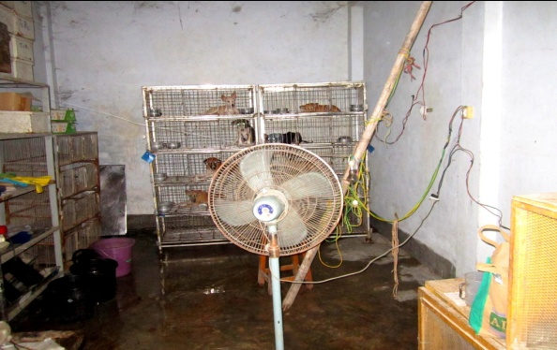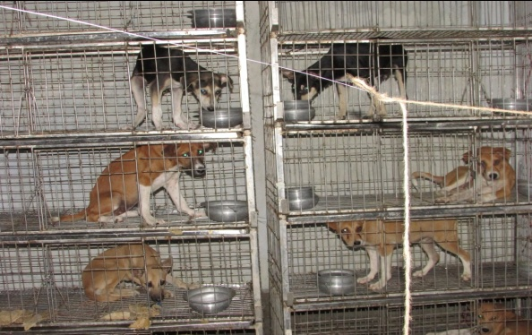

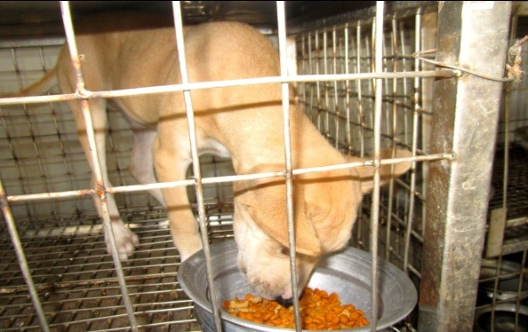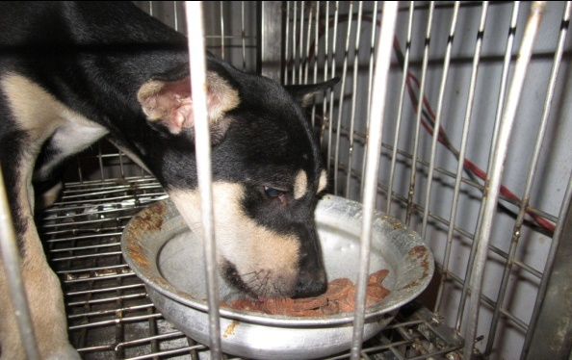

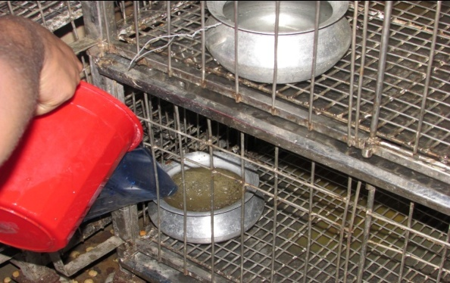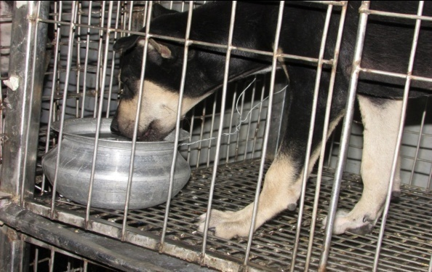
Plate 5: Feeding trial of the puppies

2.7 Feeding trial
A total of 21days (April 09th to April 29th 2015) growth trial was conducted on preselected street puppies. Trial was conducted with three different groups of dogs: (i) with newly formulated dog biscuit, (ii) with the market available dog biscuit (iii) with traditional foods. All three groups were intensively maintained in the field laboratory under the Department of Animal Science and Nutrition. Feed was provided to puppies 2 times in a day i.e. 9.00 a.m. in the morning and 7.00 p.m. in the evening. Regular clean drinking water was provided as ad-lib basis.

2.8 Weekly measuring of weight gain
Weekly body weight was taken to estimate the weight gain and also for the feed requirement. Weighing was done by electronic scale (± 10gm) in the morning in empty gut.
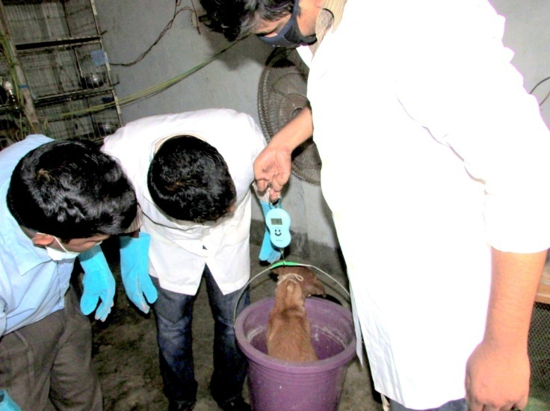
Plate 6: Weighing of dog

2.9 Weekly collection of Blood samples
Blood was collected on weekly basis to do hematological and biochemical analysis. Blood were collected through cephalic vain puncture in two sterile vacutainer (3 ml for each). One containing EDTA (anticoagulant) for hematology and another do not contain anticoagulant which was used for serum separation for biochemical analysis. During blood collection the collection site was disinfected with 70% alcohol solution.

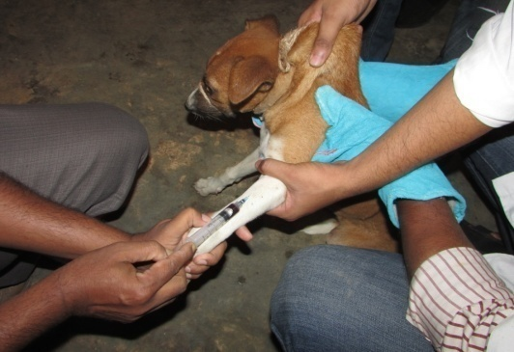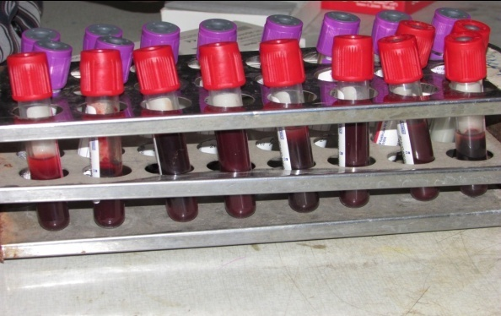

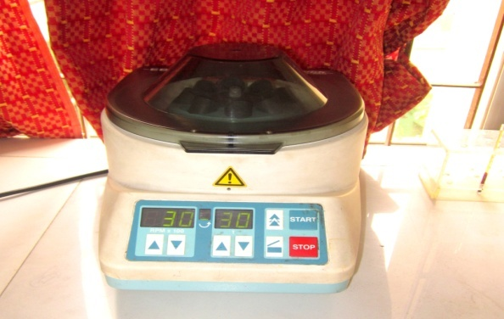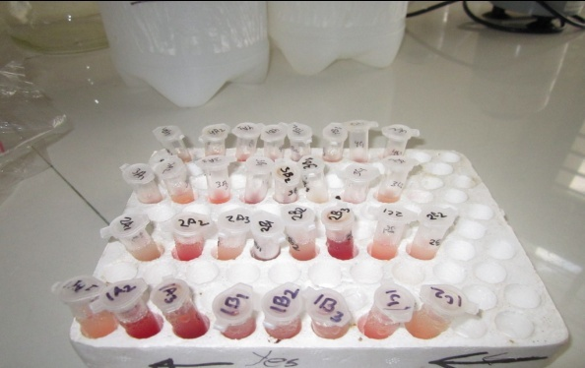

Plate 7: Collection of blood and performing heamatological test.

2.9.1 Hematological Analysis
The samples collected with anticoagulant were analyzed for routine examination of blood as per Weiss and Wardrop (2011). The samples were analyzed within 24 hours of collection. Hemoglobin (Hb), Packed cell volume (PCV), Erythrocyte sedimentation rate (ESR), Total leukocyte count (TLC), Total Erythrocyte count (TEC) and Differential leukocyte count (DLC) were performed in Physiology laboratory of Chittagong Veterinary and Animal Sciences University (CVASU).

2.9.1.1 Haemoglobin (Hb)
Haemoglobin (Hb) was determined by acid hematin method. Hb is converted to acid hematin by dilute HCl which in solution brown in colour. The intensity of this colour depends on the amount of acid hematin in solution which in turn depends on Hb concentration. The colour of the solution is matched against brown tinted glass filter by direct vision and the results were expressed as gm/100ml blood (gm %).

2.9.1.2 Packed Cell Volume (PCV)

Blood samples were centrifuged in a haematocrit tube. The RBC (Sp. gr. =1.09) being heavier than plasma (Sp. gr. = 1.03) get pack towards the bottom of the tube by centrifugal force. The reading of the percentage of blood that is red cells was then noted.

2.9.1.3 Erythrocyte Sedimentation Rate (ESR)
ESR was estimated by Wintrobe’s method. Blood samples were added to hematocrit tube up to the mark 10. The RBC (Sp. gr. = 1.09) being heavier than plasma (Sp. gr. = 1.03) settle down gradually towards the bottom of the tube. The rate in mm at which the RBC settles was noted at the end of certain period.

2.9.1.4 Total Erythrocyte Count (TEC)
The number of RBC was estimated by using Neubaur Haemocytometer. The blood was diluted 200 times with Hayem’s solution. Red blood cells were then counted into Neubaur Haemocytometer under microscope in diluted blood. The TEC in undiluted blood was calculated by multiplying volume correction factor and dilution factor. The results were expressed as number of RBC per ml of blood.

2.9.1.5 Total Leukocyte Count (TLC)
The blood was diluted with 0.1N HCl which destroys the red cells and stains the nuclei of WBC. White blood cells (WBC) were then counted into a Haemocytometer under microscope in diluted blood. The TLC in undiluted blood was calculated by multiplying volume correction factor and dilution factor. The results were expressed as number of WBC per ml of blood.

2.9.1.6 Differential Leukocyte Count (DLC)
A small drop of blood used to make a thin film of blood on a glass slide. Blood film was then stained with Wright’s stain. The different white blood cells on stained film were then counted under microscope based on their morphology. The results were expressed as percentages of different white blood cells.

2.10 Statistical analysis
The collected data were imported in Microsoft Excel 2007. Descriptive analysis of different parameters was done. Comparison of different variable of three different treatment groups was performed by one way ANOVA by using SPSS 16. Comparisons of digestibility trial of two groups were completed by T-test using STATA 11 software.

CHAPTER 3

RESULTS AND DISCUSSION

3.1 Growth trial

A comparative growth trial was conducted with prepared dog biscuit and available dog feed.

3.1.1 Food offered
Food was offered to the puppies according to the standard requirements suggested by AAFCO (2006) to maintain the nutritional level as 3.5-4 Kcal/gm of ME and 28% CP. However, food was offered by following the feeding rule of Schenck (2011), every week after weighing the body weight, feeding was adjusted with the weight gain after satisfying the maintenance requirements of the experimental dogs.
Table 4: Daily offered food (gm/puppies) in different treatment group.
Average feeding amount (Mean±SE)
Treatment group | Day (1-7) | Day (8-14) | Day (15-21)
T₀ | 233.68±13.38 | 261.33±17.91 | 276.33±18.22
T₁ | 235.66±14.72 | 262.33±12.20 | 277.33±11.55
T₂ | 231±1 | 252.67±1.20 | 267.33±1.45

T₀=Diet containing commercial food; T₁=Diet containing prepared biscuits; T₂=Diet containing homemade food. SE= Standard Error.

3.1.2 Body weight gain of dogs
Table 5: Trends of Body weight (kg) of different treatment groups
Week | Dietary treatment groups
 | T₀ (Mean±SE) | T₁ (Mean±SE) | T₂ (Mean±SE)
Initial day | 5.96±0.46 | 6.18±0.5 | 5.42±0.03
1st | 6.89±0.63 | 7.12±0.43 | 6.09±0.04
2nd | 7.44±0.67 | 7.71±0.41 | 6.56±0.05
3rd | 7.98±0.71 | 8.29±0.39 | 7.03±0.03
T₀=Diet containing commercial food; T₁=Diet containing prepared biscuits; T₂=Diet containing homemade food. SE= Standard Error.

Table 6: Body weight gain (kg/week/dog) of experimental dogs of different treatment groups
Week | Dietary treatment groups
 | T₀ (Mean±SE) | T₁ (Mean±SE | T₂ (Mean±SE)
1st | 0.94ª±0.19 | 0.95ª±0.08 | 0.67^{b}±0.02
2nd | 0.55±0.04 | 0.58±0.03 | 0.47±0.01
3rd | 0.54±0.04 | 0.58±0.03 | 0.47±0.02
Total | 2.02ª±0.27 | 2.11ª±0.13 | 1.62^{b}±0.04
T₀=Diet containing commercial food; T₁=Diet containing prepared biscuits; T₂=Diet containing homemade food. SE= Standard Error; Means with different superscripts in the same row differ significantly (p> 0.05)

The mean growth rate of puppies in group T₀ (Commercial food) and T₁ (Prepared biscuit) showed a significantly higher growth rate (2.02±0.27kg/week/puppy and 2.11±0.13kg/week/puppy respectively) than puppies in group T₂ (Homemade food) (1.62±0.04kg/week/puppy). This could be due to inadequate nutritional composition of homemade food. During the adaptation period (1st week) there was significantly higher growth rate (0.94kg±0.19 kg/week/puppy) and 0.95kg±0.08 kg/week/puppy, respectively in group T₀ and T₁ than group number T₂ (0.67kg±0.02 kg/week/puppy) was observed. The result is somewhat similar with the research works of Dilrukshi et al. (2009), who mentioned the weight gain as 1.27±0.43 kg/week/puppy in imported feed and 0.25kg±0.17 kg/week/puppy in homemade food. The present study found that, there was no significant difference (p>0.05) in growth rate of puppies during 2nd and 3rd week though rate of weight gain was higher in T₀ &T₁ group that were fed commercial food and prepared biscuit than the T₂ group that was fed homemade food. The mean weight gain (kg/week/puppy) were 0.58±0.03 in prepared biscuits group where 0.54kg/week ±0.04 was the mean weight gain of commercial food group which was slightly higher than Dilrukshi et al. (2009) found mean weight gain (kg/week/puppies) 0.41 ±0.15 in formulated food and 0.43± 0.13 in imported food. Again in this study there was no significance difference in total mean weight gain (kg/week/puppies) between the groups that were fed prepared biscuits (2.11 ±0.13) and commercial food (2.02 ±0.27). This may be the consequence of similar nutritional, mainly energy and protein balance in prepared biscuit and commercial food.

3.2 Hematological changes

Table 7: Values (Mean±SE) of different hematological parameters in different treatment groups
Variable | Time period | Dietary treatment groups |  |  | P value | Reference value*
 |  | T₀ (Mean±SE) | T₁ (Mean±SE) | T₂ (Mean±SE)
HB  (g/dl) | Initial day | 6.1±0.06 | 7.3±0.70 | 7.47±0.42 | 0.16 | 12-19
 | 1st week | 7.37±0.42 | 7.03±0.12 | 7.37±0.22
 | 2nd week | 7.80±1.53 | 10.03±0.89 | 8.4±0.7
 | 3rd week | 7.60±1.36 | 9.70±0.70 | 7.47±0.62
PCV  (%) | Initial day | 19.33±1.45 | 33±2.52 | 29±1.52 | 0.01 | 25-34
 | 1st week | 40±6.08 | 52.33±2.84 | 52.33±2.72
 | 2nd week | 25.67±1.20 | 40.67±2.33 | 42±4.62
 | 3rd week | 25.33±1.20 | 38.33±1.45 | 39±3.46
TLC  (10³/µl) | Initial day | 7.5±0.42 | 9.07±1.54 | 8.33±1.48 | 0.69 | 6-17
 | 1st week | 7.47±0.42 | 9.2±1.03 | 8.03±1.59
 | 2nd week | 7.70±0.46 | 9.13±0.61 | 8.03±1.09
 | 3rd week | 7.73±0.48 | 9.17±1.02 | 8.3±1.07
TEC  (10⁶/ µl) | Initial day | 10.6±0.35 | 11.73±0.43 | 11.03±0.80 | 0.41 | 5.6-18.7
 | 1st week | 10.47±0.59 | 11.17±0.49 | 11.87±0.59
 | 2nd week | 10.13±0.48 | 10.97±0.37 | 10.70±0.71
 | 3rd week | 10.37±0.60 | 10.83±0.34 | 11.17±0.67
Lymphocyte (%) | Initial day | 28±4.04 | 26±3.79 | 17.67±2.96 | 0.18 | 8-21
 | 1st week | 35.33±7.88 | 30.67±6.96 | 28.33±1.67
 | 2nd week | 33±3.51 | 24.33±4.48 | 27.67±0.33
 | 3rd week | 32.33±3.33 | 25.67±4.33 | 29±1
Monocyte (%) | Initial day | 7±2.52 | 3.67±1.20 | 4.67±0.67 | 0.40 | 2-10
 | 1st week | 10.67±2.33 | 9±2.52 | 7.33±0.67
 | 2nd week | 3.67±0.33 | 2.67±0.33 | 3.33±0.33
 | 3rd week | 3.67±0.33 | 2.67±0.33 | 3.33±0.33
Neutrophil (%) | Initial day | 51.67±3.84 | 61.67±3.48 | 72±3.05 | 0.02 | 58-85
 | 1st week | 51.33±8.84 | 52.33±5.36 | 53.67±2.96
 | 2nd week | 55±3.51 | 62.67±5.36 | 59.11±2.02
 | 3rd week | 56±3.51 | 63.33±4.33 | 60±1.54
Eosinophil (%) | Initial day | 12.67±3.71 | 8.33±2.03 | 5.67±2.33 | 0.28 | 0-9
 | 1st week | 2.67±0.88 | 11±3.21 | 10.67±3.71
 | 2nd week | 8.33±0.88 | 10±1.73 | 9.33±1.76
 | 3rd week | 8±0.58 | 8±0.58 | 9±0.58
Baso  phil  (%) | Initial day | 0.67±0.33 | 0.33±0.33 | 0 | 0.30 | 0-1
 | 1st week | 0 | 0.67±0.67 | 0.67±0.33
 | 2nd week | 0 | 0.33±0.33 | 0
 | 3rd week | 0 | 0.33±0.33 | 0

T₀=Diet containing commercial food; T₁=Diet containing prepared biscuits; T₂=Diet containing homemade food. * Ref. value Kaneko et al. (1997)
Hematological changes in this study showed almost no significant differences (p>0.05) except PCV and neutrophil (p<0.05) count. Complete blood counts are done to monitor overall health, to screen for some diseases, to confirm a diagnosis of some medical conditions, to monitor a medical condition, and to monitor changes in the body caused by medical treatments (Bourgès‐Abella et al., 2014). In the current study complete blood count done mainly to observe the overall health condition of the experimental dogs and to justify whether the newly prepared biscuit have the potentiality to create food allergy symptoms to the dogs. All the hematological parameters were within the range of reference value except Hb. The research work conducted by Weiss and Wardrop (2011) and Rørtveit et al. (2015) showed lower Hb levels in puppies compared to adults. It can be concluded that the dogs are in good health in terms of hematological parameters. As the eosinophil counts were within the range of reference value in all dietary treatment groups, the comments may be drawn that the newly prepared dog biscuit are safe interms of food allergy (Lund et al., 1999).

3.3 Metabolic profile test
The values obtained in this research work are well compared with those of the literature reference (Kaneko et al., 1997). When properly interpreted haematological values give important information concerning clinical status, nutritional balance, deficit condition, treatment monitoring and prognostics.

CHAPTER 4

CONCLUSION

From the growth trial of this study, the positive and significant relationships were observed in mean weight gain and feed intake. The mean weight gain of prepared biscuits, commercial food and homemade food were 2.11kg/week ±0.13; 2.02kg/week ±0.27 and 1.62kg/week±0.04 respectively. And the feed intake of prepared biscuits and commercial food were 257.11 g/day ±16.45; 258.44 g/day ±12.81 and 250.31g/day ±1.17 respectively. Mean weight gain in prepared biscuits and commercial food was significantly higher than the homemade food though feed intake in all treatment was not differing significantly. Thus indicated similar performance of prepared biscuits and commercial food and clearly both treatment groups did better performance than the homemade food.
At the end of the feeding trial and through the haematological analysis along with body weight gain of the puppies it can be said that the prepared dog biscuit, fulfilling all the nutritional requirements will promote a state of wellbeing with better health and reduce the risk of diseases.

REFERENCES

AAFCO, 2006. Association of American Feed Control Officials. Official publication of the Association of American Feed Control Officials; 2006.
Aberle, E., Forrest, J., Gerrard, D., Mills, E., 2001. Meat grading and evaluation. Principles of Meat Science. 4th ed. Kendall/Hunt Publishing Company, Dubuque, IA, 303.
Araujo, J.A., Studzinski, C.M., Larson, B.T., Milgram, N.W., 2004. Comparison of the cognitive palatability assessment protocol and the two-pan test for use in assessing palatability of two similar foods in dogs. American journal of veterinary research 65, 1490-1496.
Bontempo, V., 2005. Nutrition and health of dogs and cats: evolution of petfood. Veterinary research communications 29, 45-50.
Burrows, C., Kronfeld, D., Banta, C., Merritt, A.M., 1982. Effects of fiber on digestibility and transit time in dogs. J. Nutr 112, 1726-1732.
Bostwick, D., Meyer, D., 1995. Bilirubin and bile acids in the diagnosis of hepatobiliary disease. Kirk's Current Veterinary Therapy XII Small Animal Practice. WB Saunders Co., Philadelphia, Pennsylvania, 736-740.
Case, L.P., Daristotle, L., Hayek, M.G., Raasch, M.F., 2010. Canine and feline nutrition: a resource for companion animal professionals. Elsevier Health Sciences.
Clapper, G., Grieshop, C., Merchen, N., Russett, J., Brent, J., Fahey, G., 2001. Ileal and total tract nutrient digestibilities and fecal characteristics of dogs as affected by soybean protein inclusion in dry, extruded diets. Journal of animal science 79, 1523-1532.
Cynthia, M., Kahn, M., Line, S., Susan, E., Aiello, B., 2011. Marck Veterinary Manual, Online Ed. Merck Sharp & Dohme Corp, a subsidiary of Merck & Co., Inc. Whitehouse Station, NJ, USA.

Dilrukshi, H., Jayaweera, B., Gamika, A.P., 2009. Formulation of dog food using locally available ingredients. Wayamba Journal of Animal Scicence.
Farrell, D., Girle, L., Arthur, J., 1978. Effects of dietary fibre on the apparent digestibility of major food components and on blood lipids in men. Aust. J. Exp. Biol. Med. Sci 56, 469-479.
Gerber, P., Opio, C., Steinfeld, H., 2007. Poultry production and the environment—a review. FAO publishing Web. http://www. fao.org/ag/againfo/home/events/ bang kok2007/docs/part2/2_2. pdf.
Guevara, M.A., Bauer, L.L., Abbas, C.A., Beery, K.E., Holzgraefe, D.P., Cecava, M.J., Fahey Jr, G.C., 2008. Chemical composition, in vitro fermentation characteristics, and in vivo digestibility responses by dogs to select corn fibers. Journal of agricultural and food chemistry 56, 1619-1626.
Phillipson, A., 1971. Endogenous losses of nutrients. Proceedings of the Nutrition Society 30, 61-66.
Ramsay, D.J., Rolls, B.J., Wood, R.J., 1977. Thirst following water deprivation in dogs. American Journal of Physiology-Regulatory, Integrative and Comparative Physiology 232, R93-R100.
Robert, N.V., Adrian, R., 2014. Characteristics of meat and bone meal used as animal feed (pet food). Studia Universitatis" Vasile Goldis" Arad. Seria Stiintele Vietii (Life Sciences Series) 24, 239.
Rutgers, H., Stradley, R., Johnson, S., 1988. Serum bile acid analysis in dogs with experimentally induced cholestatic jaundice. American journal of veterinary research 49, 317-320.
Sabchuk, T.T., Félix, A.P., Comin, J.G., Alarça, L.G., Oliveira, S.G.d., Maiorka, A., 2012. Digestibility and behavior of dogs housed in kennels or metabolic cages. Revista Brasileira de Zootecnia 41, 118-122.
Sales, J., Janssens, G., 2003. Acid-insoluble ash as a marker in digestibility studies: a review. Journal of Animal and Feed Sciences 12, 383-400.
Sanderson, S.L., Finco, D.R., Pogrelis, A.D., Stacy, L.M., Unger, C.F., 2005. Owner impressions of three premium diets fed to healthy adult dogs. Journal of the American Veterinary Medical Association 227, 1931-1936.
Schenck, P., 2011. Home-Prepared Dog and Cat Diets. John Wiley & Sons. Chaper-3, 63-67
Verheijen M,Wiersema D, Hulshoff Pol L.W, 1996. J. De Wit International Agriculture Centre Wageningen, The Netherlands January, 1996 . FAO Document Repository. The environmental impact of the animal product processing industries. (http://www.fao.org/wairdocs/lead/x611 4e/x 6114 e03.htm ) Accessed on 24/05/2015.
Vhile, S., Skrede, A., Ahlstrøm, Ø., Hove, K., 2007. Yttrium oxide (Y2O3) as an inert marker in digestibility studies with dogs, blue foxes and mink fed diets containing different protein sources. Journal of animal physiology and animal nutrition 91, 381-389.
Udell, M.A., Lord, K., Feuerbacher, E.N., Wynne, C.D., 2014. A Dog’s-Eye View of Canine Cognition. Domestic Dog Cognition and Behavior: The Scientific Study of Canis familiaris, 221.
Wiggs, R.B., Lobprise, H.B., 1997. Veterinary Dentistry: principles and practice. Lippincott-Raven Publishers.
Zeman, R., Taylor, K., Rosenfield, A., Schwartz, A., Gold, J., 1981. Acute experimental biliary obstruction in the dog: sonographic findings and clinical implications. American Journal of Roentgenology 136, 965-967.
Zuo, Y., Fahey, G., Merchen, N., Bajjalieh, N., 1996. Digestion responses to low oligosaccharide soybean meal by ileally-cannulated dogs. Journal of animal science 74, 2441-2449.

BIOGRAPHY

Manas Chandra Das, son of Amal Chandra Das and Tapoti Rani Das at present is an intern veterinarian under the Faculty of Veterinary Medicine in Chittagong Veterinary And Animal Sciences University (CVASU). He passed the Secondary School Certificate (SSC) examination in 2006 followed by Higher Secondary Certificate (HSC) examination in 2008. In future he wants to do research on animal welfare and Zoonotic diseases having public health significance in Bangladesh.

