Chapter I
Introduction
Bangladesh is one of the most densely populated countries in the world and majority of the people are suffering from malnutrition, especially for the shortage of animal protein. In Bangladesh, the average per capita availability of meat is 19.0 gm/day against the per capita requirement of 120 gm/day (HIES, 2010). Poultry production is an efficient way to meet the protein requirement in a faster way than by other sources of animal protein. In Bangladesh, about 25% people are directly engaged in livestock sector of which 50% are partly associated in livestock production and about 36% of the total animal protein comes from the livestock products in everyday life (DLS, 2014). The contribution of livestock sub-sector to the GDP is 1.73% (BER, 2015). Duck is one of the important among livestock sub-sectors with the third largest population in the world 38.1 million (Dolberg 2008). The duck population in Bangladesh is 52.24 million (DLS, 2015-2016). Duck rearing in Bangladesh has potential to give maximum return with minimum investments and ducks are traditionally raised in scavenging system by the small holders in coastal and low-lying areas (Rahman et al., 2009). Duck rearing provides subsidiary income to landless, marginal and small farmers (Islam et al., 2003). Ducks contributes in increasing egg and meat production than chicken in the low lying areas. Consumption of duck meat and eggs in the country is estimated about 30% of total poultry meat and egg consumption (Islam et al., 2003).
Ducks are susceptible to parasitic infestation. They act as the final and intermediate hosts for helminths parasites. The parasites have serious effects on the health of the ducks and result in economic losses due to losses in productivity and growth. There are a few reports on the incidence and prevalence of parasitic diseases of poultry in Bangladesh (Farzana et al., 2008). Infections may cause considerable damage and great economic loss to the poultry industry due to malnutrition, decreased feed conversion ratio, weight loss, lowered egg production and death in young birds (Puttalakshmamma et al., 2008). In duck of wetland area, helminth infection was prevalent, with endemic trematode (Prosthogonimus spp., Trichobilharzia spp., Echinostoma spp.) and nematode (Cyathostoma bronchialis, Amidostomum anseris, Heterakis gallinarum, Capillaria spp., and Echinuria spp.) infections` and epidemic cestode infections due to Hymenolepsis setigera (Hoque et al., 2011). Besides viral and bacterial duck diseases, helminth infections are thought to be an important factor in limiting the production potential of the duck rearing program in Bangladesh. Some earlier researchers have reported the incidence of parasites in household ducks elsewhere in Bangladesh (Ahmed, 1969) and Tanzania (Muhairwa et al., 2007), but epidemiological approaches in assessing the temporal and spatial pattern of helminth infections in household ducks are rarely attempted. Hoque et al., 2011 observed the parasite species in Jinding ducks, Prosthogonimus spp., Trichobilharzia spp., Echinostoma spp., Cyathostoma bronchialis, Amidostomum anseries, Heterakis gallinarum, Capillaria spp. and Echinuria spp., Hymenolepsis setigera are similar to parasites identified in other studies of household ducks in Bangladesh (Baki and Mondal, 1994) and Tanzania (Muhairwa et al., 2007), in household chickens in Zambia (Phiri et al., 2007) and India (Puttalakshmamma et al., 2008), and in wild birds in Spain (Cordon et al., 2009). The egg of common enteric parasites observed in this study may be a result of continuous exposure of ducks to parasite vectors in soil such as insects and earth worms. These organisms serve as intermediate/paratenic/transport hosts for helminth parasites that are capable of infecting ducks (Pandey and Jiang, 1992). Large number of ducks is circulating at haor areas where limited research work has been observed.

1.1 Objectives of the study
- To investigate the occurrence of enteric parasites in ducks at Hakaluki and Tanguar haor of Sylhet division, Bangladesh.
- To determine the association of different factors such as breed, age, seasons in the occurrence of enteric parasites in ducks.
Chapter II
Review of Literature
Pertinent literatures on enteric parasites along with their prevalence and diagnostic method in duck were reviewed in this chapter. The main purpose of this chapter was to provide up-to-date information concerning the research work which is addressed here.

2.1 Enteric Parasites of duck

2.1.1 Amidostomum anseris
Morphology:
The adult worm is slender and red in colour. The male is 10 - 17 mm long and 250 - 350 um wide. The spicules are equal in length, 0.2 - 0.3 mm, both branching at the end. The female is 12 - 24 mm long, 200 - 400 μm wide with the thickest point around the vulva. The eggs contain an embryonated larvae when laid and measure approximately 100 x 50 µm (Permin and Hansen, 1998).
The females measure 20–21.15 mm in length and 0.28–0.31 mm in width. Cuticle is transversely striated. Buccal capsule sub globular furnished with sharp tooth in its depth. The vulva is situated at a distance of 2.75–3.2 mm from the tip of the tail. The distance of anus from the tail is about 0.31–0.35 mm. Length of the tail is 0.37–0.39 mm. Egg size 0.0850–0.090 × 0.045–0.05 mm (Tanveer et al., 2015).

Key features for the identification of the eggs of Amidostomum anseris are (Thienpont et al., 1986):
• Medium-sized worm egg: 85-110 μm in length - 50-82 μm in width
• Regular, broad ellipse
• Thin, smooth shell
• Large number of blastomeres
Life cycle and epidemiology: The life cycle is direct with a prepatent time of 14 to 25 days. After being deposited in the environment with the faeces, the larvae develop into the infective 3rd stage larvae in two to three days. The development may happen inside the egg or outside. Susceptible animals become infected by ingesting or drinking contaminated food or water (Permin and Hansen, 1998).
2.1.2 Heterakis spp.
Morphology:
The three species are similar in appearance, H. dispar, though slightly larger than H. gallinarum and H. isolonche. The male H. gallinarum is 7-13 mm long and the female is 10- 15 mm. Differentiation between the three species is based on the shape of the esophagus and the length and shape of the spicules. The eggs measure 65-80 x 35-46 μm, and they have a thick, smooth shell and are difficult to differentiate from A. galli eggs (Permin and Hansen, 1998).
Males measure 4.75–6.7 mm in length and 0.27–0.35 mm in diameter. The cuticular striations are extremely fine. The esophagus along with the bulb measures 0.75–1.1 mm. The esophageal bulb is 0.19–0.22 mm in diameter. The caudal alae of the male are well developed about 0.05–0.055 mm in diameter. The tail is about 0.2–0.5 mm long and tapers beyond the alae to a fine filament. The sucker is situated at a distance of 0.09–0.11 mm from the cloacal aperture. There are twelve pairs of caudal papillae of which five pairs have peduncles and project into the alae. The two pairs at the sides of the sucker may be called the para sucktorial papillae, the group surrounding the cloacal aperture the paracloacal papillae, and the group near the posterior end are called caudal papillae. The spicules are unequal. The right spicule being the longer and 1.54–2.1 mm long. The left spicule is 0.38–0.65 mm long. The proximal end of the spicule is 0.03 mm in diameter. The distal end is pointed. Body length of female is 7–9.78 mm and 0.3–0.4 mm in width. The vulva is situated slightly behind the middle body at a distance of 3.55–4.65 mm from the tip of the tail. Tail is tapering and sharply pointed and measures about 0.8–0.95 mm from the posterior end (Tanveer et al., 2015).
Key features for the identification of the eggs of Heterakis spp. are (Thienpont et al., 1986):
• Ellipsoid, with smooth side-walls
• Thick, smooth shell
• Unsegmented contents
• To be distinguished from the Ascaridia egg, which is larger and has slightly barrel-shaped side-walls
Life cycle and epidemiology: The life cycle is direct. Earthworms and houseflies can act as mechanical transport hosts. The non-embryonated eggs pass out with the faeces and develop into infective eggs in approximately 2 weeks, depending on temperature and humidity. When infective eggs are ingested by susceptible hosts, the eggs hatch in the small intestine. Within 24 hours the larvae have reached the caeca through the lumen of the intestine where they develop into adult worms. H. isolonche larvae may have a tissue phase before becoming adult worms. The prepatent time is 24-30 days (Permin and Hansen, 1998).

2.1.3 Ascaridia galli (Schrank, 1788)
Syn. A. lineata, A. perspicillum.
Morphology: The adult worms are semitransparent, the length of the female ranging from 72- 116 mm and the male from 51 -76 mm, and are therefore the biggest nematode in poultry. The oral opening has three prominent lips. The male with preanal sucker and two equal spicules of 1 - 2.4 mm long. The female open in the middle of the body. A. galli eggs are oval, with smooth shells and measure 73-92 by 45-57 μm. H. gallinarum eggs are similar in shape and appearance, but can be distinguished from A. galli eggs by their slightly smaller and parallel sides (Permin and Hansen, 1998).
Males smaller and more slender, measuring 43–45 mm in length and 0.43–1.5 mm in maximum breadth. Esophagus measure 2.12–2.35 mm in length. Preanal sucker oval in shape with a chitinous rim. Its size varies from 0.2 to 0.27 mm in length and 0.15–0.17 mm in diameter. It lies at a distance of 0.25–0.55 mm in front of cloaca. Distance of cloaca from the tip of tail is 0.6-0.75 mm. Ten pairs of caudal papillae are in the following four groups (i) preanal three pairs (ii) adanal one pair (iii) postanal three pairs (iv) subterminal three pairs. Spicules are similar, equal, measuring 1.4–1.65 mm in length. Proximal end of spicules are expanded and measure 0.075–0.09 mm in breadth. Females measure 30–62 mm in length and 0.3–0.45 mm in width at the anterior end and 1–1.55 mm at the level of vulva. Esophagus measures 1.5–3 mm in length. Vulva is situated a little posterior to the middle of the body. Distance of vulva from the anterior end varies from 18 to 33 mm. Distance of anus from the tip of tail varies from 0.55 to 0.65 mm. Tail is straight with a caudal spine and measures 0.65–0.95 mm in length. Eggs large, oval and measures 0.055–0.065 mm in length and 0.04–0.05 mm in width (Tanveer et al., 2015).

Key features for the identification of the eggs of A. galli are (Thienpont et al., 1986):
• Ellipsoid, slightly barrel-shaped side-walls
• Thick, smooth 3-layer shell. The middle layer is most developed
• Unsegmented contents
• To be distinguished from the Heterakis egg, which is smaller in size and has smooth side-walls.
Life cycle and epidemiology: The life cycle of A. galli is direct, involving two principal populations; the sexually mature parasite in the gastrointestinal tract and the infective stage (L3) in the form of an embryonated resistant egg in the environment. The eggs are passed with the faeces of the host and develop in the open, reaching the infective stage (L3) in 10 to 20 days or longer depending on temperature and relative humidity, e.g. the minimum time required to reach the infective stage is five days at 32-34°C when the eggs are incubated in water. At temperatures between -12°C to -8°C, the eggs may die after 22 hours, however, the eggs can survive in winter with moderate frost. Temperatures above 43 °C are lethal for eggs at all stages. In deep litter systems the eggs can probably remain infective for years depending on the temperature, humidity, pH and ammonium concentration. Occasionally earthworms can ingest A. galli eggs and transmit these to chickens, but this is not the principal route of transmission. The life cycle is completed when the infective eggs are ingested by new hosts through contaminated water or feed. The eggs containing the L3-larvae are mechanically transported to the duodenum. The larvae are protected by the three layers covering the eggs until they reach the duodenum or jejunum, where they hatch within 24 hours. During hatching the coiled larvae emerge from the anterior end of the egg through an opening in the shell moving out into the lumen of the intestine. The larvae then enter the histotropic phase where they embed themselves into the mucosal layer of the intestine. The histotropic phase has duration of 3 to 54 days before the final maturation in the lumen. The histotropic phase is a normal part of the life cycle, where the duration of the histotropic phase depends on the number of ingested infective eggs. The more eggs the longer the histotropic phase. After the histotropic phase the worms settle down in the lumen of the duodenum. The prepatent period varies from 5-8 weeks. Few epidemiological studies have been carried out to investigate the infection and transmission of A. galli. It is generally accepted that the establishment of worms in the intestine is influenced by many factors such as the age of the chicken, the size of the infective dose, the age of the infective eggs, the sex of the chickens, and the diet of the host (Permin and Hansen, 1998).
2.1.4 Capillaria spp.
Morphology:
Body elongated, thread like, 10.5–12.9 mm in length and 0.06–0.09 mm in diameter. Esophageal length was 4.23–6.25 mm. Length of spicule varies from 1.0 to 1.02 mm and its width varies from 0.014 to 0.025 mm. The spicule has three longitudinal thickenings and is only slightly expanded proximally, 0.015–0.021 mm. Distally the spicule ends in a rounded tip which has internal thickenings. The spicular sheath bears spines which are directed towards the anterior end of the worm. Spicular sheath measures about 0.13–0.7 mm. At the caudal end of the body there are two lateral lobes. The cloacal opening is terminal. Body length in female nematode is 14.3–18.5 mm and 0.051–0.14 mm in diameter. Length of esophagus is 4.12–6 mm. The vulva is situated at about one-third of the body length 4.34–4.56 mm from the anterior end; it does not bear an appendage, the vagina is long, 0.025–0.65 mm. At the caudal end the body ends bluntly. The anus is sub terminal. Eggs measure about 0.051–0.065 mm in length and 0.025–0.03 mm in width. Eggs with characteristic thick, rugose outer shell layer. The inner layer curles at the poles and forms a wide collar (Tanveer et al., 2015).
The worms of this genus are small and hairlike and difficult to detect in the intestinal content. The C. annulata males are 15 - 25 mm long and the females are 37 - 80 mm long. The characteristic eggs have bipolar plugs and measure 60 x 25 gm. C. contorta males are equal in size to the males of C. annulata, but the females are shorter only measuring 27 – 38 mm. The eggs of C. contorta are app. 60 x 25 gm. C. caudinflata, C. bursata, C. obsignata and C. anatis are all smaller only measuring 6 – 35 mm. The eggs measure 45 x 25 gm (Permin and Hansen, 1998).
Key features for the identification of the eggs of Capillaria spp. are (Thienpont et al., 1986):
- Lemon shaped
- Protruding transparent polar plugs
- Slightly barrel-shaped
- Symmetrical side-walls
- Thick, brown, smooth shell
- Granular, unsegmented contents
Life cycle and epidemiology: The life cycles of the Capillaria species may be direct or indirect. The eggs are deposited with the faeces unembryonated and develop into the first larval stage in 9 to 14 days. For C. obsignata, C. anatis and C. contorta the life cycle is direct, which means that the eggs are infective to susceptible hosts as embryonated L1. After ingestion, the eggs hatch at their predilection site and develop into adult worms without migration in the host. Eggs of the species C. caudinflata, C. bursata and C. annulata are swallowed by earthworms and develop into infective stages in 14 - 21 days. Birds are infected when ingesting the earthworms. The
prepatent time for Capillaria spp. is approximately 3 weeks (Permin and Hansen, 1998).
2.1.5 Tetrameres spp.
T. americana (Crarn, 1927) and T. fissispina (Diesing, 1861).
Morphology: There is a distinct sexual difference. The males are 5 - 5.5 mm long and 116- 133 µm wide. The female is spherical and measure 3.5 - 4.5 mm in length by 3 mm in width. Four longitudinal furrows are present on the surface. The eggs measure 42 - 50 x 24 µm (Permin and Hansen, 1998).
According to Thienpont et al., (1986), key features for the identification of the eggs of Tetrameres spp. are
• Ovoid, transparent and thickened poles
• Thick shell
• Contains an embryo

Life cycle and epidemiology: The eggs are passed with the faeces and hatch when swallowed by intermediate hosts such as grasshoppers (Melanoplus femurrubrum or M. differentialis) or cockroaches (Blatella germanica). Infection of the final host occurs when the intermediate host is eaten. Soon after ingestion, the males and females migrate to the proventriculus where they embed themselves in the glands. After copulation the males leave the glands and die (Permin and Hansen, 1998).

2.1.6 Hymenolepis spp.
Three species have a pathogenic and economic importance. These are H. carioca (de Magalhaes, 1898). H. cantaniana (Polonio, 1860) and Drepanidotaenia lanceolata (Bloch, 1782).
Morphology: H. carioca is a slender threadlike tapeworm which can reach a length of 8 cm. H. cantaniana is smaller and may reach a length of 2 cm. The adult worms of D. lanceolata may become 13 cm long and 18 mm wide, with segments wider than long.
Key features for the identification of the eggs of Hymenolepis spp. are (Thienpont et al., 1986):
• Spherical to ellipsoid
• Thick smooth shell
• Contains a hexacanth embryo

Life cycle and epidemiology: The life cycle of the hymenolepids resembles other cestodes. Beetles (Scarabeidae) are the intennediate hosts of H. carioca and H. cantaniana, whereas water crustaceans are intermediate hosts of D. lanceolata. The prepatent time is 3-4 weeks. Several thousand adult worms may be found in the intestine (Permin and Hansen, 1998).

2.1.7 Echinostoma revolutum Frölich, 1802
Morphology: E. revolutum is 10 - 22 mm long and up to 2.25 mm wide. Echinostomes have a head-collar armed with spines, which is the major recognition feature for the family. The eggs measure 90- 126 by 59 - 71 μm (Permin and Hansen, 1998).
Life cycle and epidemiology: For E. revolutum, the eggs pass with the faeces and mature in 3 weeks if the conditions are favourable, i.e., high humidity and high temperatures. The miracidium penetrates a snail, the intermediate host (Lymnaea spp., Sta gnicola palustris, Helisoma trivolvis, Physa spp. or Planorbis tenuis). But also Bulinus, Biomphalaria, Succinea, Pseudosuccinea and Corbiculina may act as intermediate hosts. In the snail, cercariae develop in 2 - 3 weeks and these may either encyst or escape and enter into another snail. The birds become infected when ingesting infected snails. The prepatent period is 15 - 19 days (Permin and Hansen, 1998).

2.1.8 Prosthogonimus spp.
Morphology: The adult worms measure 8 - 9 by 4 - 5 mm being broad in the posterior end. P. ovatus is slightly smaller, measuring 3 - 6 by 1 - 2 mm. The eggs of P. pellucidus measure 26 - 32 x 10 - 15 gm and the eggs of P. ovatus measure 22 - 24 x 13 gm (Permin and Hansen, 1998).
Life cycle and epidemiology: The eggs are excreted with the faeces and hatch in the free. The miracidium enters the snail and becomes a mother sporocyst whish produces daughter sporocysts. The sporocysts then produce cercariae without forming rediae. The cercaria are then excreted from the snail and enters dragonfly larvae. In the dragonfly, the cercaria encysts, thus becoming a metacercaria. The final hosts become infected when eating the larval or adult stage of dragonflies (Permin and Hansen, 1998).

2.2 Prevalence of the enteric parasites
A total of ten species of helminth parasites were recovered from gastrointestinal tract of ducks, of which four species were trematodes: Echinostoma revolutum, Hypoderaeum conoideum, Echinoparyphium recurvatum and Notocotylus attenuatus; two were nematodes, namely, Amidostomum anseris, Capillaria contorta; two were cestodes, viz, Hymenolepis coronula and Fimbriaria fasciolaris and two species belonged to acanthocephala, Arythmorhynchus anser and Filicollis anatis. Among 10 species, single, double and mixed (1-5 parasites) infections were found in 78 (46.7%), 46(27.5%) and 43(25.8%) ducks, respectively (Yousuf et al., 2009).
Prevalence of gastrointestinal helminths in adult ducks may be due to their free ranging system and loose management. Generally ducklings are kept confined to protect them from the predators. As a result they have relatively less chance to be exposed to the source of infections like various terrestrial and aquatic vectors/intermediate hosts of parasites (Yousuf et al., 2009).
Seasonal fluctuation of helminth infection also observed relatively higher infection rate in rainy season (100%) followed by summer (98.1%) and winter (98.0%) (Anisuzzaman et al., 2005).
In domestic indigenous ducks and Muscovy ducks, both single and multiple types of parasitic infections were found. However, other domestic birds and wild birds often had a single type of parasitic infection. Ascaridia spp. with an average egg load of 50–900, was commonly detected in faecal samples of domestic and wild birds in this study. Other identified parasites were Capillaria spp. and Heterakis spp. both in domestic and wild birds. Improvement of biosecurity measures for household duck farms through educating and motivating household farmers could help mitigate the effects of parasitic infection on production The prevalence of parasitic infection was av. 40% (domestic ducks), 48% (resident wild birds) and 29% (migratory birds). The prevalence of parasitic infection was higher in indigenous domestic ducks during summer. Ascaridia spp. was the commonest parasite in domestic and wild bird species (Hoque et al., 2014).
Out of the 192 ducks, 100 (52%) were infected with one or several species of helminths. The average number of helminths per duck was 11, ranging from 1 to 55 helminths per duck. A total of 14 different helminths species belonging to five subfamilies were isolated from the intestinal tract and identified. The identified species were: Ascaridia columba (0.5%), Ascaridia dissimilis (0.5%), Ascaridia galli (23.4%), Capillaria anatis (0.5%), Capillaria annulata (3.1%), Capillaria contorta (7.3%), Heterakis dispar (0.5%), Heterakis gallinarum (14.1%), Heterakis isolanche (2.6%), Raillietina echinobothridia (0.5%), Raillietina tetragona (10.4%), Subulura brumpti (6.3%), Subulura strongyilina (0.5%) and Subulura sucturia (0.5%) (Muhairwa et al., 2007).
Out of 170 ducks examined, 56 (32.94%) were infected with one or more species of parasitic infection. Parasitic fauna detected were Capillaria spp., 8 (14.28%), Raillietina spp. 12 (21.42%), Strongyloides spp., 12 (21.42%), Subulura spp., 12 (21.42%), Heterakis spp., 6 (10.71%), and Ascaridia spp., 6 (10.72%) (Pratibha et al., 2011).
About 34.3% endoparasitic infection in ducks in West Bengal India and a total of nine different species of helminths were obtained. Their study showed that trematodes comprised more than 26% of helminthes infestation in the area, where as cestodes and nematodes comprised 9% and 5%, respectively reported by Utpal and Biswas (1997).
A total of 41 ducks were examined, 25 cases (60.97%) were infected with one or more species of parasite and the samples of protozoan oocysts (96%) were more than gastrointestinal helminthic eggs (20%). Mixed infections with two or more species were seen in five cases (20%) while 20 fecal samples (80%) were single infection. Four samples were double infection and one sample was triple infection. No trematodes and cestodes eggs or proglottides were found. The three different species of helminths were isolated from fecal samples and they were Capillaria spp., Subulura spp. and Echinuria spp. In addition, some strongylid eggs of other animals or arthropods were found in duck feces (Larki et al., 2018).
About 7 (4.7%) harboured helminths, four species of helminths were identified. The cestodes were Railleitina cesticillus 4 (2.7%), R. magninumida 5 (3.3%), Hymenolepis carioca 2 (1.3%) and the nematode Ascaridia galli 1 (0.7%). Male ducks 4 (5.3%) were more infected than females 3 (4.0%). Prevalence of single, double and triple infections were in the order of 3 (2.0%), 3 (2.0%) and 1 (0.7%), respectively (Adang et al., 2014).

Twenty-five species of helminths, recovered from the gastrointestinal tracts of 129 Mexican ducks from Mexico and the United States, were all new host records. The species were Echinoparyphium recurvatum, Echinostoma revolution, Hypoderaeum conoideum, Notocotylus attenuatus, Prosthogonimus cuneatus, Zygocotyle lunata, Anomotaenia ciliata, Cloacotaenia megalops, Diorchis bulbodes, Diorchis spp., Drepanidotaenia lanceolata, Echinocotyle rosseteri, Fimbriaria fasciolaris, Fimbriarioides spp., Hymenolepis spp., Sobolevicanthus gracilis, Corynosoma constrictum, Polymorphus minutus, Amidostomum acutum, Echinuria spp., Epomidiostomum crami, Hystrichis varispinosus, Rusguniella arctica and Tetrameres spp. Fimbriarioides spp. (Farias et al., 1986).

Although geographical location, sub-tropical climatic condition of Bangladesh is suitable for duck habitation and her water lodged and low-lying areas are also favorable for duck rearing, but this environment also favors the growth, multiplication, development, survival and spread of the parasites. As a result, almost all of the ducks suffer from parasitic diseases (Farjana et al., 2004) which affect the growth and production performance of ducks in Bangladesh (Anisuzzaman et al., 2005).
Seventeen species of helminths were identified which included 11 species of trematodes (Echinostoma revolutum, E. paraulum, E. robustum, Echinochasmas beleocephalus, Echinoparyphium recurvatum, Hypoderaeum conoideum, Psilochasmas oxyurus, Catatropis verrucosa, Tracheophilus cymbius, Amphimerus anatis and Metorchis orientalis), 4 species of cestodes (Hymenolepis coronula, Hymenolepis lanceolata, Schillerius longiovum and Fimbriaria fasciolaris) and 2 species of nematodes (Amidostomum anseris and Echinuria uncinata) (Farjana et al., 2008).
Among the parasites, density of cestodes was the highest, followed by trematodes and nematodes. More parasitic burden of cestodes in ducks might be explained by their scavenging feeding of vector hosts of cestodes. There is a paucity of literature regarding the burdens of trematodes, but the present findings of several species of trematodes infection at a time in one individual duck is supported by Soulsby (1965).
The lower burden of trematodes than cestodes might be due to the molluscan intermediate hosts which are not available at a large quantity in all seasons. The reason for lower burden of nematodes is that one nematode egg can develop into only one adult. (Urquhart, 1996).

Among cestodes, the highest load was counted in case of H. coronula infection whiles the mean parasitic burden of F. fasciolaris was the lowest. On the other hand, incase of trematodes, the highest density was recorded in C. verrucosa infection and E. robustum was found only in a single case and infected with only a single parasite (Farjana et al., 2008).
Mean density of helminths increased with the increase of age, where the highest density was found in older ducks followed by adult and young ducks. Among other parasites, mean density increased with the increase of age in three age groups of ducks, but in case of E. beleocephalus, C. verrucosa, H. lanceolata and A. anseris, mean density was the highest in the adult (6 months to 1 year) ducks (Farjana et al., 2008).

Significant difference in the densities of Echinostoma spp. and H. coronula among three age groups of ducks where mean density of Echinostoma spp. increased with the increase of age. But in case of H. coronula, the mean density was higher in younger and older age groups and lower in middle age group ducks which is a contrast to the present finding, reported by Islam et al., (1988).
The increased density of parasites with increasing age may result from the increased exposure of ducks to external environment. Higher density of helminths in older group of ducks might be due to loss of body resistance in advanced age (Tizard, 1996).
Among three seasons, mean density of trematodes found highest in winter followed by monsoon and summer. The highest density of trematodes may be influenced by the availability of snail intermediate hosts. Usually snails are available in monsoon when ducks are feed on snails, get infected with metacercaria of trematodes, but usually trematodes take sometime to become adult in final host (Farjana et al., 2008).
Adult helminths were found in ducks in winter. But the reason behind the highest mean density of C. verrucosa in monsoon is not clear though snails and fresh water fishes are the intermediate hosts of this parasite; and it is difficult to explain the reason of the highest density of A. anatis in monsoon and M. orientalis in summer because life cycles of these parasites are not clearly known (Soulsby, 1982).
The common endoparasitism observed in this study may be a result of continuous exposure of ducks to parasite vectors in soil such as insects and earth worms. These organisms serve as intermediate/paratenic/transport hosts for helminth parasites that are capable of infecting ducks (Pandey and Jiang, 1992).
Female ducks may be more susceptible to parasitic infection due to egg laying and also lack of balanced nutrition, which affect their immune system and ability to combat the parasitic infection. Moreover, some hormonal influence may be associated with this (Musa et al., 2012).

The ducks have high prevalence of parasitic infestation. As ducks are free ranged animals they are exposed to a wide natural environment and consume a wide variety of food. They may be easily infected by different species of parasites through the ingestion of contaminated food and consumption of intermediate host which harbor the larval stages of the parasite (Musa et al., 2012).

More extensive study involving a wider geographical area of Bangladesh would reveal the existence of many other helminth species from domestic ducks. The overall prevalence of helminthiases in domestic ducks of Bangladesh appeared to be very high (97%) (Islam et al., 1988). However, with few exceptions, the intensity of infection in individual birds was lower than the level of infection known to be harmful for ducks (Soulsby, 1965).

In Assam (India), the overall prevalence of helminths was recorded as 66.93%. 232 carcasses were found positive for cestodes (44.79%), 241 for trematodes (46.52%) and 45 for nematodes (8.69%). Highest incidence of cestodes was recorded with Hymenolepis spp. (35.78%), , highest incidence of trematodes was recorded with Echinostoma revolutum (24.07%), Prosthogonimus sp. (8.30%). Highest incidence of nematodes was recorded with Tetrameres sp. (57.78%), Heterakis gallinarum (17.78%), Heterakis dispar (17.78%) (Borah et al., 2018).

Of 129 ducks, 102 (79%) were infected with at least one species of gastrointestinal helminth. The 25 species of helminths included six trematodes, 11 cestodes, two acanthocephalans, and six nematodes reported Farias and Canaris (1986).
The most dominant group of parasites which was parasitizing the poultry birds was found to be the Cestode, whose prevalence in the infected birds was 76.9 %. Nematodes were found to be the second dominant group of parasites after cestodes with the prevalence of 70%. Among the different species of nematodes Heterakis gallinae were found infecting all the birds. Nematodes which were recovered from the intestine and gizzard of the birds belong to the genera Capillaria spp., Acuaria spp., Amidostomum spp., Heterakis spp., and Ascaridia spp. (Tanveer et al., 2015).
Helminth parasites were recorded at a prevalence of 51.7% with the prevalence and species distribution of nematodes (C. contorta, G. ingluvicola, H. gallinarum, H. isolonche, S. brumpti, A. galli) being higher than that of the cestode, Hymenolepis spp. The prevalence of single helminth species infestation was higher (61.3%) than mixed infestation (38.7%) as was reported by Paul et al., (2015) in Nigeria.
Muhairwa et al., (2007) found 52% endoparasitic infestation in ducks in Morogoro,Tanzania and demonstrated a total of 14 species of helminths which included A. columba, A. dissimilis, A. galli, C. anatis, C. contorta, C. annulata, H. dispar, H. gallinarum, H. isolonche, Raillietina echinobothridia, R. tetragona , Subulura strongyilina, S. sucturia and S. brumpti.
In Kenya, prevalence of A. galli was higher in ducklings (57.1%) and growers (38.1%) relative to adult ducks (4.7%) and the prevalence of H. gallinarum was higher in growers (45.5 %) and ducklings (36.4%) relative to adult ducks (18.2%) (Waruiru et al., 2018).
Prevalence of A. galli 42.7% and 4.2% in ducklings and adult ducks, respectively. Also, they reported the prevalence of H. gallinarum to be 4.2% for ducklings and 24% for adult ducks (Muhairwa et al., 2007).
Chapter III
Materials and Methods
3.1 Study area and duration of study
Fecal samples were collected from different villages at two haor sites in Bangladesh: Hakaluki haor (Figure: 2) (N 21°33′′698, E 091°51′′682) in Sylhet and Moulvibazar districts (300 ducks) and Tanguar haor (Figure: 3) (N 25°08.794′, E 091°04.088′) in Sunamganj district (300 ducks) during the period of winter (February-March), summer (April-May) and monsoon season (June-July), 2018.

Figure 1: Study area of Hakaluki and Tanguar Haor

Figure 2: Sampling sites of Hakaluki haor

Figure 3: Sampling sites of Tanguar haor
3.2 Sampling strategy
For household ducks, we have selected 10 households (1 duck from each household) from each villages (from randomly selected 5 villages) targeting the sample size of 50 from each haor area. A minimum of 5 ducks in each household were considered as the inclusion criteria.
For sampling scavenging ducks, a total of 10 free-range duck flocks were randomly selected from each haor while the minimum of ≥500 ducks per flock was considered as inclusion criteria. From each selected flock, 5 ducks were randomly selected and therefore a total of 50 duck samples were collected from each haor area. Thus, the total sample size was 100 for household ducks and 100 for range ducks in last visit. We repeated the same sampling size in summer and monsoon season.

Figure 4: Sample selection strategy from village of sampling area
5 Villages
5 Villages
Each Village
10 Household ducks
10 Free-range Ducks
Hakaluki Haor
Tanguar Haor
Each Quarter

Study Population

Hakaluki Haor
Tanguar Haor

50 Household Ducks
50 Household Ducks
50 Free Ranged Ducks

50 Free Ranged Ducks

Figure 5: Sampling strategy of duck from sampling area
3.3 Collection of sample
A total 600 (200 during winter, 200 during summer and 200 rainy season) ducks were sampled (pooled sample) belonging to three breeds randomly irrespective of breed, age, sex, deworming, type of scavenging, type of housing directly from farmer’s household and free-range. Fresh voided feces were collected from ducks early in the morning, before they had begun scavenging. The samples were preserved in 10% formalin and transported to the Parasitology laboratory of Chittagong Veterinary and Animal Sciences University. Qualitative assessment was performed to detect the presence of parasitic infection in ducks using direct smear, flotation, and sedimentation techniques. A standard criterion was then followed to identify eggs of different species of parasites microscopically (Permin and Hansen, 1998).

3.4 Qualitative techniques for fecal examinations (Permin and Hansen, 1998).

3.4.1 Direct smear technique
A small quantity of faeces is placed on a slide. A few drops of water are added and mixed with the feces. A cover slip is placed on top. The slide is examined in a microscope using 40-100 x magnification.
Direct smear technique is illustrated in Figure 6.

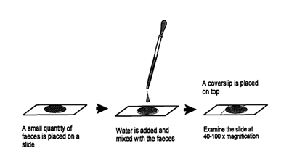
Figure 6: Direct smear technique

3.4.2 Test tube flotation technique
Approximately 3g feces were transferred to plastic container 1. 50 ml flotation fluid (NaCl) was poured into plastic container 1 by means of the measuring cylinder. Feces and flotation fluid were mixed thoroughly with a stirring device. Immediately after stirring, the fecal suspension was poured through a tea strainer or a single layer of cotton gauze into plastic container 2. Retained fecal debris was discarded and immediately the strained fecal suspension was poured from plastic container 2 into a test tube, which was placed in a vertical position in a test tube rack. The test tube was topped up with the fecal suspension, so that it had a convex meniscus at the top. A cover slip was placed on the top of the test tube. The test tube was leaved for about 20 minutes. The helminth eggs will float and thus accumulate just beneath the cover slip. The cover slip was lifted off vertically from the tube together with the adhering flotation fluid. Some of the accumulated helminth eggs were within the adhering fluid, and the cover slip transferred very carefully in order to retain as many eggs as possible. The cover slip was placed on a microscope slide, and examined the sample at 40-100 x magnification in a microscope.
Flotation technique is illustrated in Figure 7.
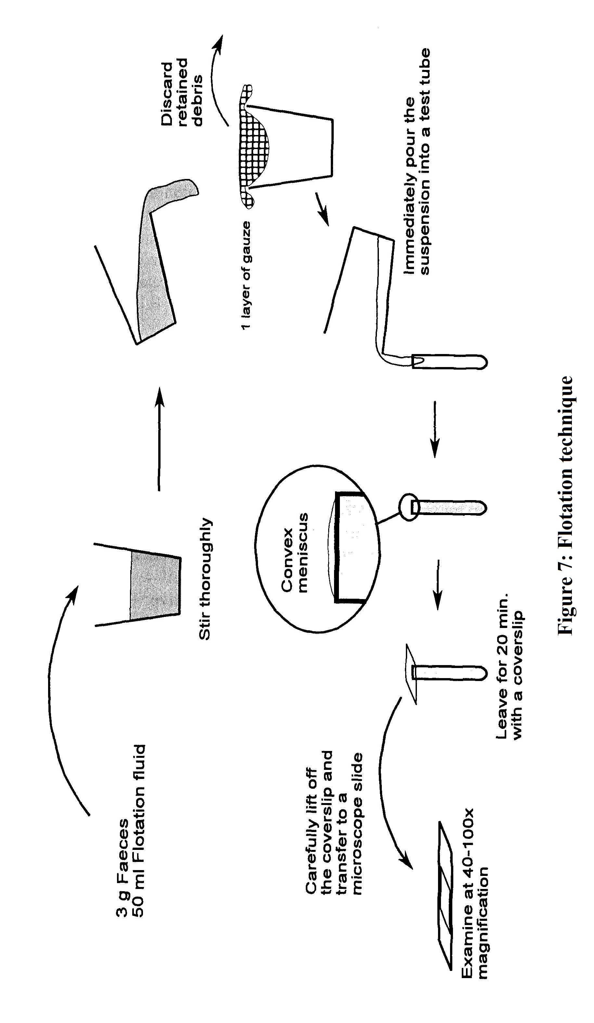
3.4.3 Sedimentation Technique
Approximately 3g feces were transferred (measured with pre-calibrated teaspoon) to plastic container 1. 50 ml tap water was poured into plastic container 1 by means of the measuring cylinder. Feces and tap water were mixed thoroughly with a stirring device. Immediately after stirring, the fecal suspension was poured through a tea strainer into a conic sedimentation beaker, and filled up the beaker with tap water. Alternatively sometimes the fecal suspension was poured through a tea strainer or a single layer of cotton gauze into plastic container 2 and transferred approximately 10 ml of the filtered suspension into a test tube placed in a test tube rack. The fecal particles were allowed, including the trematode eggs, to sediment for 10 minutes.
The supernatant was removed carefully in one steady movement (conic sedimentation beakers) or with a pipette (test tube sedimentation). Care was taken not to resuspend the sediment during the process. The supernatant was discarded. The sediment was resuspened in tap water. The sedimentation beaker was almost filled up. The fecal particles were allowed, including the trematode eggs, to sediment for 10 minutes. The supernatant was removed carefully in one steady movement with a pipette (test tube sedimentation). Proper care was taken not to resuspend the sediment during the process. The supernatant was discarded. 1-2 drops of Methylene Blue were added. The fecal particles were stained to deeply blue, while the trematode eggs remain unstained. This contrast staining allowed the brownish eggs to be discovered more easily. A few drops of the stained sediment were transferred to a microscope slide with a pipette and a cover slip was placed on the microscope slide, and examined the sample at 40-100 x magnification in a microscope. The last step was repeated until all the sediment had been examined.
Sedimentation technique is illustrated in Figure 8.
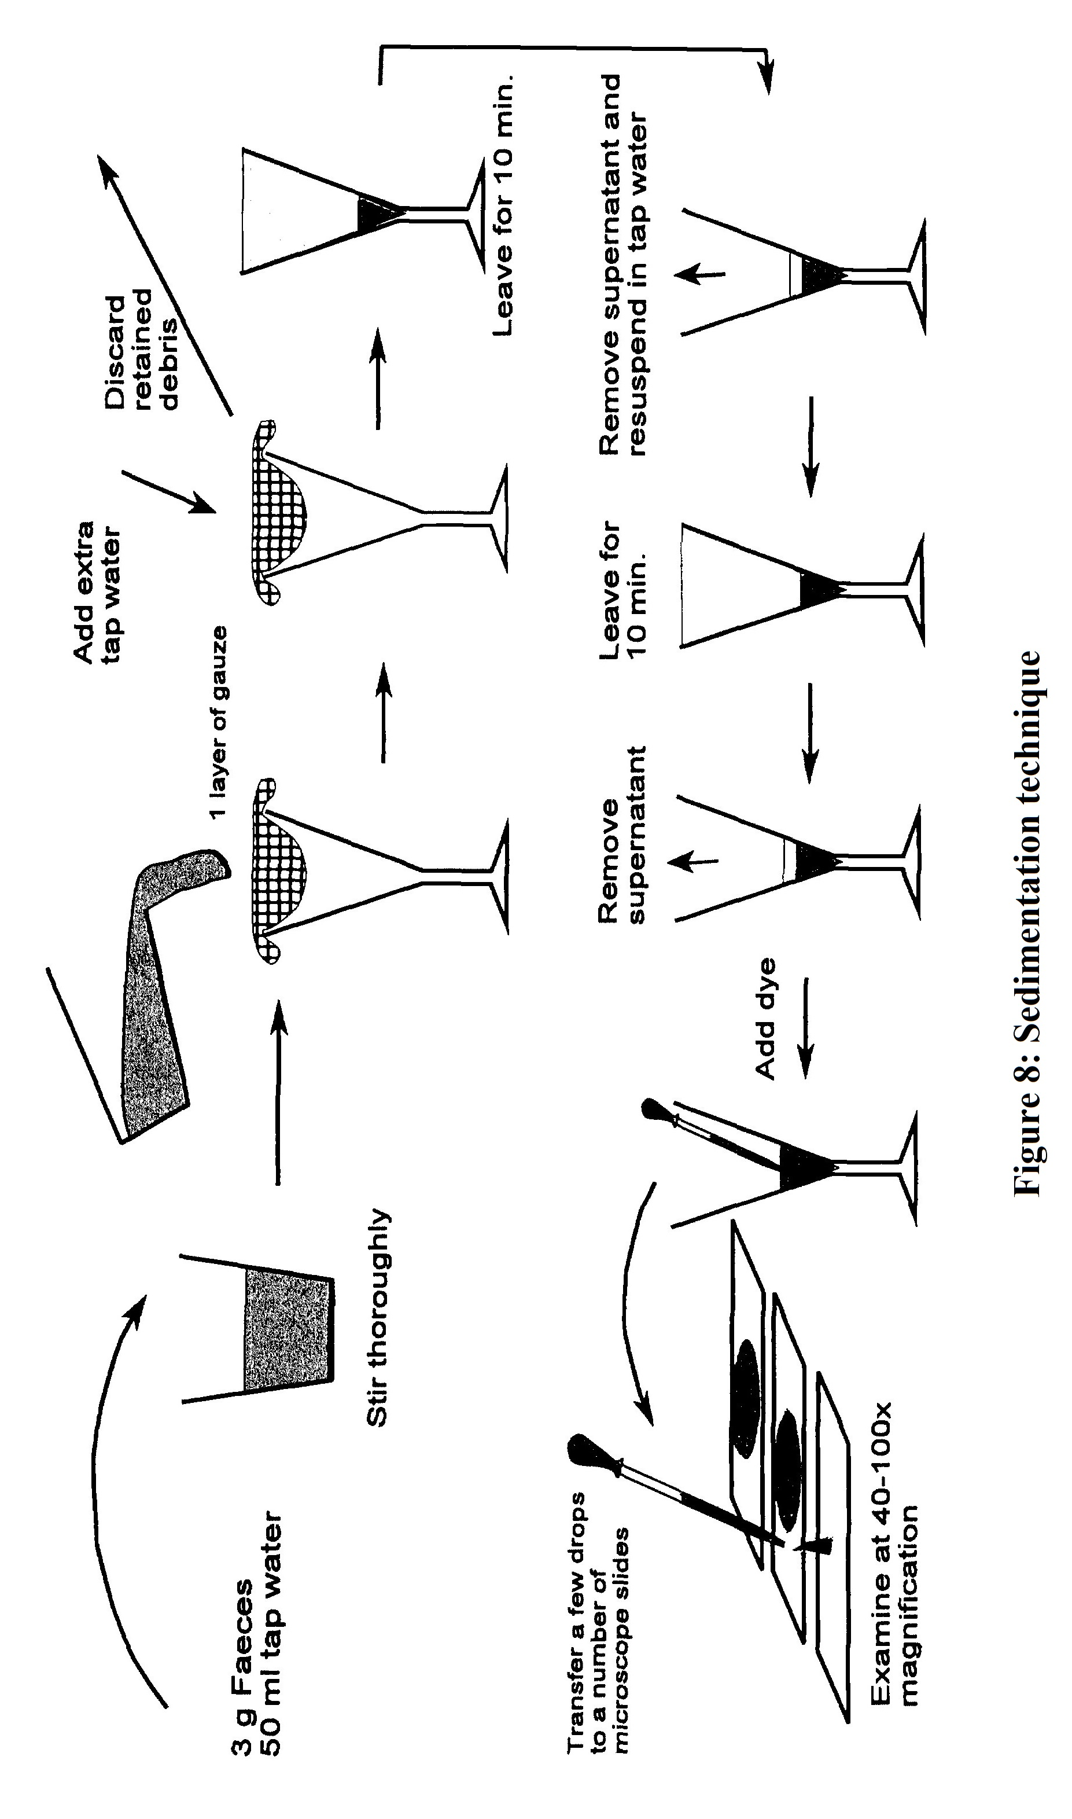
3.5 Statistical analysis
To compare the prevalence of enteric parasites in relation to sex, age, breed, type of housing and type of scavenging, the obtained data was imported into the spread sheet of MS excel-2007 for storing, sorting and categorization. Categorized data were then transformed to STATA/IC-13.0 (Stata Corporation College Station, Texas) for statistical analysis. Descriptive analysis was performed. Results were expressed in frequency number and percentage.

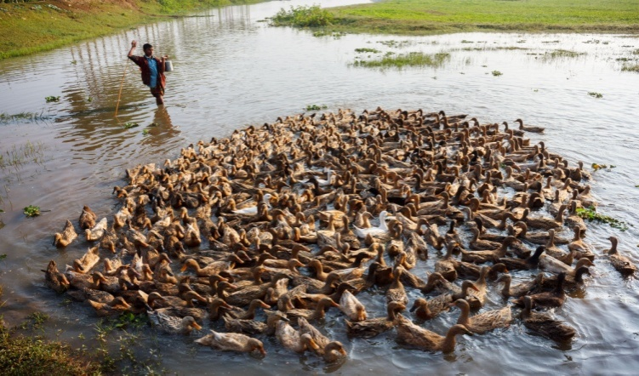

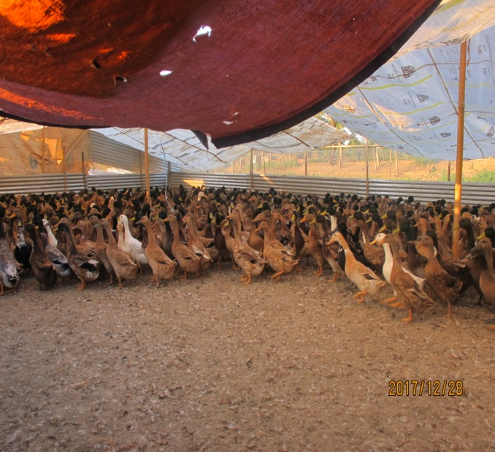

Figure 9: Duck of haor areas, Sylhet division
Chapter IV
Results
4.1 Occurrence of enteric parasites
During the investigation, a total of 600 fecal samples were examined where the examined ducks had a 48.33% (290/600) prevalence of helminths consisting of 6 types.
A total of six species of helminth parasitic eggs were identified, of which four species were nematodes: Capillaria spp., Ascaridia galli, Amidostomum spp., Tetrameres spp.; one was trematode, namely, Prosthogonimus spp.; one was cestode, viz, Hymenolepis spp. Among 6 species, single and mixed infections were found.
Regarding their susceptibility to helminth infection, the prevalence of Ascaridia galli was 4.67%, Capillaria spp. 17.83%, Prosthonimus spp. 9.33%, Amidostomum spp. 11.33%, Tetrameres spp. 5.83 & Hymenolepis spp. 3.33%.

Table 1: Prevalence of enteric parasites in winter, summer and monsoon seasons
Sl. | Enteric parasites | Results |  |  | Total  N=600
Sl. | Enteric parasites | Winter  (n=200) | Summer  (n=200) | Monsoon  (n=200) | Total  N=600
Sl. | Enteric parasites | n(%) | n(%) | n (%) | n(%)
1 | Ascaridia galli | 8 (4%) | 15 (7.5%) | 5 (2.5%) | 28 (4.67)
2 | Capillaria spp | 38 (19%) | 30 (15%) | 39 (19.5%) | 107 (17.83)
3 | Prosthogonimus spp | 11 (5.5%) | 30 (15%) | 15 (7.5%) | 56 (9.33)
4 | Amidostomum spp | 17 (8.5%) | 20 (10%) | 31 (15.5%) | 68 (11.33)
5 | Tetrameres spp | - | 15 (7.5%) | 20 (10%) | 35 (5.83)
6 | Hymenolepis spp | - | 10 (5%) | 10 (5%) | 20 (3.33)

Ascaidia galli were found in winter, summer and monsoon season 8 (4%), 15 (7.5%) and 5 (2.5%) respectively. Capillaria spp. were found more than other helminths 38(19%), 30(15%) and 39(19.5%) in winter, summer and monsoon season respectively. Prosthogonimus spp. were found in winter, summer and monsoon season 11 (5.5%), 30 (15%) and 15 (7.5%), respectively. Amidostomum spp. were found 17 (8.5%), 20 (10%) and 31 (15.5%) in winter, summer and monsoon seasons, respectively. Tetrameres spp and Hymenolepis spp were not found in winter season but in summer season they were found 15 (7.5%), 20 (10%) and in monsoon season 10 (5%), 10 (5%), respectively.
Table 2: Relationship between the breed of duck and season of helminth infections
Breed | Winter (%) | Summer (%) | Monsoon (%)
DPD | 33.33 (39/117) | 51.81 (57/110) | 57.38 (70/122)
KK | 40.50 (32/79) | 45.98 (40/87) | 38.16 (29/76)
Muscovy | 75 (3/4) | 100 (3/3) | 50 (1/2)

In Monsoon season, helminth infestation were found more in Deshi pati duck (57.38%), than in summer season (51.81%). In summer season, about 45.98% Khaki campbell and 100% of Muscovy duck were infested with helminth.
Table 3: Relationship between the breed of duck and the prevalence of helminths
Breed | Number examined | Positive number | Positive %
Deshi Pati Duck | 359 | 166 | 47.56
Khaki Campbell | 242 | 101 | 41.74
Muscovy | 9 | 7 | 77.78

There was a relationship between the prevalence of helminths and the breed of ducks. The prevalence of helminths among Deshi Pati Duck was 47.56% and Kakhi Campbell was 41.74%.
Table 4: Prevalence of parasites in relation to the age of ducks
Age (Months) | Number examined | Positive number | Infection%
> 6 | 40 | 13 | 32.5
7-12 | 82 | 40 | 48.78
13-18 | 236 | 120 | 50.85
19-24 | 138 | 72 | 52.17
24 < | 104 | 44 | 42.30
Total | 600 | 289 | 48.17

Regarding the relationship between the infection with helminths and the age of the ducks, the helminths infections occurred exclusively in 19-24 months old ducks and the infection rate was 52.17% (72/138).
Table 5: Invariable logistic regression analysis to evaluate the association between explanatory variables with Capillaria spp.
Explanatory variable | Category | Observation | Total positive (%) | OR | P-value
Flock size | 10-29 | 300 | 67 (22) | 1
Flock size | 520-4000 | 300 | 40 (13) | 0.54 | 0.02
Currently scavenging | Household premise | 18 | 2 (8) | 1
Currently scavenging | Pond | 227 | 59 (25) | 3.69 | 0.21
Currently scavenging | Rice paddy field | 205 | 20 (10) | 1.15 | 0.89
Currently scavenging | River | 6 | 3 (50) | 11 | 0.09
Currently scavenging | Wetlands | 144 | 23 (16) | 2.03 | 0.51
Duck housing type | Bamboo | 228 | 60 (26) | 1
Duck housing type | Metallic | 18 | 0 | 0 | 0
Duck housing type | Muddy | 294 | 33 (11) | 0.34 | 0.001
Duck housing type | Wooden | 60 | 14 (23) | 0.84 | 0.68
Location of house | Wet land | 210 | 11 (5) | 1
Location of house | Within house | 155 | 26 (22) | 5.4 | 0.001
Location of house | Yard | 235 | 60 (25) | 6.27 | 0.001

Flock size ranging from 520 – 4000 are less infected to Capillaria spp. infection than others flock size. Ducks scavenging in ponds are more prone to Capillaria spp. infection than others scavenging system like household premise, rice paddy field, river, wetlands. Location of the house also important . Duck reared in yard is more susceptible to Capillaria spp. Capillaria infection is more in bamboo made house than others like muddy, wooden and metallic housing type.

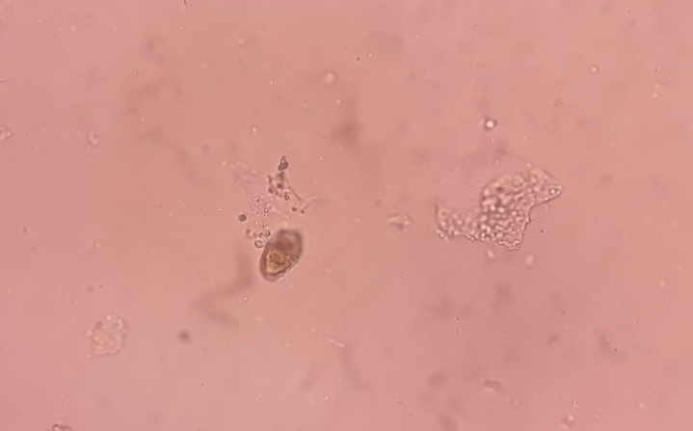
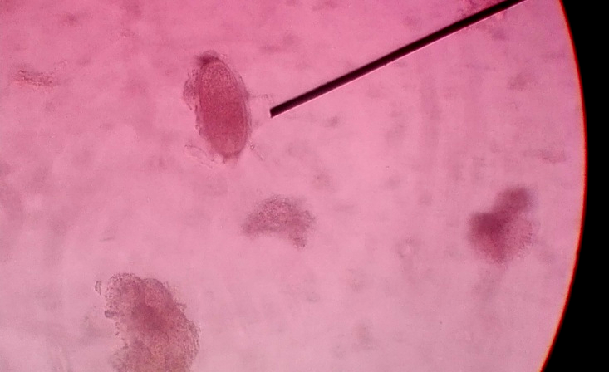

Figure 10: Egg of Prosthogonimus spp. Figure 11: Egg of Capillaria spp.

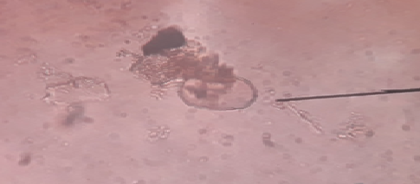
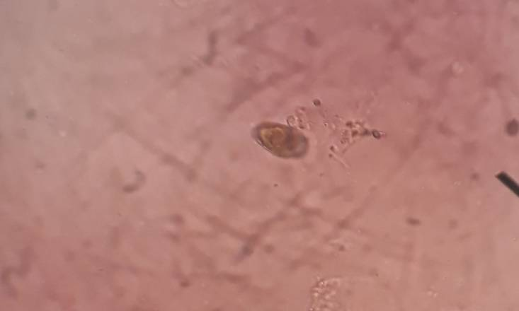
Figure 12: Egg of Ascaridia galli Figure 13: Egg of Amidostomum spp.
Chapter V
Discussion
In the present study, the infection rate of the helminths was 48.33%, which is higher than those reported in Egypt: from Giza, 30% (Haiba et al., 1955), 12.5% (Mahdy, 1988), and 17.1 % (Ibrahim, 1997); from Kafr El-Sheikh, 17.24% (Abdel-Fattah, 1996); from Kalubia, 24.35% (Khater, 1993); and from Sharkia, 31% (Desoky, 1981). The results of the present study were lower than those recorded from the Union of Soviet Socialist Republics (Shevtsov, 1966); from Czechoslovakia, 97% (Islam et al., 1988); from India, 65.7% (Matta and Ahluwalia, 1981); and from Canada, 89.1% (McLauglin and Burt, 1979), 97% (Noseworthy and Threlfall, 1978), 88% (Mahony and Threlfall, 1978), and 89.1% (Daniel and Burt, 1977).
During the study, 111 male and 489 female ducks were examined. Among them, 59 male (53.15%) and 236 female (48.26%) ducks were infected. Higher prevalence of helminth infection in female ducks (Farjana et al., 2004) may be due to their laying and eating habit. Islam et al. (1988) reported that the prevalence of Tetrameres spp. was higher in male than female. Betlejewska and Kalisinska (2001) did not find any difference in the prevalence of helminths in two sex groups.
Out of 600 ducks, 13 (32.5%); 40 (48.78%); and 120 (50.85%) ducks found to be infected in the age < 6 months, 6 months to 1 year and > 1 year, respectively. Higher prevalence of infection and density of helminths in older ducks were observed by Farjana et al. (2004). Islam et al. (1988) reported that Echinostoma robustum was higher in younger ducks (2 to 20 weeks old). Pham et al. (2002) recorded that ducks of 2-4 months ages were mostly infected (80.7%) by worms. Prevalence of entero parasites in adult ducks may be due to their free ranging system and loose management. Generally ducklings are kept confined to protect them from the predators. As a result they have relatively less chance to be exposed to the source of infections like various terrestrial and aquatic vectors/intermediate hosts of parasites.
Concerning the susceptibility of the different breeds of ducks to infection with helminths, Muscovy and Desi Pati Duck were found to be highly susceptible, followed by Khaki Campbell. AbouLaila et al. (2011) found White Peckin was more highly susceptible than Native ducks.
The seasonal variation of helminths infection were observed and recorded in three different seasons. The highest rate of infection was observed in monsoon season (52.5%) followed by summer (50%) and winter season (42.5%). Seasonal fluctuatiion of helminth infection also observed by the earlier scientist. Anisuzzaman et al. (2005) observed relatively higher infection rate in rainy season (100%) followed by summer (98.1%) and winter (98.0%). Junkin et al. (2003) reported high prevalence of infection in rainy season but low in fall and winter. The highest rate of infection in monsoon may be due to pre-patent period and ability of parasites to remain in the host. On the other hand, in winter season ducks are reared in stagnant water resulting the intermediate hosts like frogs, beetle, earth worms to get chance to infect the hosts.
Chapter VI
Conclusion
The study was performed aiming to investigate the prevalence of enteric parasites and to determine the association of different factors such as breed, age, seasons in the occurrence of enteric parasites in ducks at Hakaluki and Tanguar haor of Sylhet division, Bangladesh. It is suggested that ducks commonly reared in Bangladesh (Deshi Pati Duck, Khaki Campbell, Jindin, Muscovy) are susceptible to enteric helminths infection irrespective to age and sex of ducks and seasons of the year. Mass deworming is essential routinely at definite interval with safety spectrum of anthelmintic.
Chapter VII
Recommendation
PCR-based molecular identification of egg of enteric parasites can be done in future for specific identification of enteric parasites. Quantitative test can also be done in future to quantify the enteric parasitic load of duck at Hakaluki and Tanguar haor of Sylhet division, Bangladesh.
Chapter VIII
References
AbouLaila, M., El-Bahy, N., Hilali, M., Yokoyama, N., & Igarashi, I. (2011). Prevalence of the enteric parasites of ducks from Behera governorate, Egypt. The Journal of protozoology research, 21(2): 36-44.
Adang, K. L., Asher, R., & Abba, R. (2014). Gastrointestinal Helminths of Domestic Chickens Gallus gallus domestica and Ducks Anas platyrhynchos Slaughtered at Gombe Main Market, Gombe State, Nigeria. Asian Journal of Poultry Science, 8(2), 32-40.
Ahmed, S. (1969). Survey on type of helminthes commonly found in country ducks. Pakistan Journal of Veterinary Science, 3, 110-112.
Anisuzzaman, A. M., Rahman, M. H., & Mondal, M. M. H. (2005). Helminth parasites in indigenous ducks: Seasonal dynamics and effects on production performance. Journal of the Bangladesh Agricultural University, 3, 283-290.
Baki, M. A., & Mondal, M. M. H. (1994). An investigation of the pathology of parasitic diseases of ducks in Bangladesh. Journal of Livestock Research, 1, 1-8.
BER (2015). Bangladesh Economic Review, Economic Advisers Wing, Finance Division, Ministry of Finance, Government of Peoples Republic of Bangladesh, Dhaka.
Borah, N., Phukan, S. C., Islam, S., Tamuli, S., Tamuli, S. M. and Rajbongshi, P. (2018). Prevalence of helminth parasites of domestic ducks in Upper Assam (India). International Journal of Chemical Studies, 6(4): 131-134
Cordón, G. P., Prados, A. H., Romero, D., Moreno, M. S., Pontes, A., Osuna, A., & Rosales, M. J. (2009). Intestinal and haematic parasitism in the birds of the Almunecar (Granada, Spain) ornithological garden. Veterinary parasitology, 165(3-4), 361-366.
Daniel, M. J. and Burt, M. D. B. (1977). A survey of the intestinal helminths of water fowls from New Brunswick, Canada. Canadian Journal of Zoology. 25: 801-807.
Desoky, E.A.H. 1981. Studies on the helminth parasites infesting aquatic Egyptian and migrant birds. M.V.Sc. thesis Faculty of Veterinary Medicine. Zagazig University, Egypt.
DLS (2014). A Brief of Organizational Structure and other Activities. DLS Report, Department of Livestock Services, Dhaka, Bangladesh.
Dolberg, F. (2008). Poultry sector review, FAO (Food and Agricultural Organization) Animal Production and Health Division, Food and Agriculture organization of the United Nations, August 2008, Retrieved March 17, 2010.
Farias, J. D., & Canaris, A. G. (1986). Gastrointestinal helminths of the Mexican duck, Anas platyrhynchos diazi Ridgway, from north central Mexico and southwestern United States. Journal of Wildlife Diseases, 22(1), 51-54.
Farjana, T., Islam, K. R., & Mondal, M. M. H. (2008). Population density of helminths in ducks: effects of host’s age, sex, breed and season. Bangladesh Journal of Veterinary Medicine, 6(1), 45-51.
Haiba, M. H., Fahmy, M. A. M., Abodou, A. H., & Selim, M. K. (1955). Survey on the incidence of parasites in farm animals of Faculty of Agriculture, Giza, Egypt. Veterinary Medicine Journal, 2, 181-186.
HIES (2010). Preliminary Report on Household Income and Expenditure Survey, Bureau of Statistics Division, Ministry of planning, Government of the People’s Republic of Bangladesh, Dhaka.
Hoque, M. A., Hassan, M. M., Haque, E., Shaikat, A. H., Khan, S. A., Alim, A., Day, T. K. (2014). A survey of gastro-intestinal parasitic infection in domestic and wild birds in Chittagong and Greater Sylhet, Bangladesh. Preventive veterinary medicine, 117(1), 305-312.
Hoque, M. A., Skerratt, L. F., Rahman, M. A., Alim, M. A., Grace, D., Gummow, B., ... & Debnath, N. C. (2011). Monitoring the health and production of household Jinding ducks on Hatia Island of Bangladesh. Tropical animal health and production, 43(2), 431-440.
Ibrahim,O.I.A. 1997. Morphological studies on some Nematodes infecting poultry. Ph.D. thesis Fac. Vet. Med. Cairo University, Egypt.
Islam, M. N., Huque, Q. M. E., Salahuddin, M., & Sarker, M. S. K. (2003). Potentiality of native genotypes of Ducks. In Proceedings of Third International Poultry Show and Seminar, Organized by World’s Poultry Science Association, Bangladesh Branch, Dhaka (pp. 259-270).
Islam, M. R., Shaikh, H., & Baki, M. A. (1988). Prevalence and pathology of helminth parasites in domestic ducks of Bangladesh. Veterinary parasitology, 29(1), 73-77.
Khater, H. F. (1993). Studies on enteric helminth parasites in domestic birds. Faculty of Veterinary Medicine, Zagazig University., Moshtohor (Egypt).
Larki, S., Alborzi, A., Chegini, R., & Amiri, R. (2018). A Preliminary Survey on Gastrointestinal Parasites of Domestic Ducks in Ahvaz, Southwest Iran. Iranian Journal of Parasitology, 13(1), 137-144.
Mahdy, O. A. (1988). Studies on parasitic worms infesting chicken and ducks in giza governorate, Egypt.
Mahoney, S. P., & Threlfall, W. (1978). Digenea, Nematoda, and Acanthocephala of two species of ducks from Ontario and eastern Canada. Canadian Journal of Zoology, 56(3), 436-439.
Matta, S. C., & Ahluwalia, S. S. (1981). Note on the survey of gastrointestinal helminths of domestic fowls in Uttar Pradesh. Indian journal of animal sciences.
McLaughlin, J. D., & Burt, M. D. (1979). A survey of the intestinal helminths of waterfowl from New Brunswick, Canada. Canadian Journal of Zoology, 57(4), 801-807.
Muhairwa, A. P., Msoffe, P. L., Ramadhani, S., Mollel, E. L., Mtambo, M. M. A., & Kassuku, A. A. (2007). Prevalence of gastro-intestinal helminths in free-range ducks in Morogoro Municipality, Tanzania. Prevalence, 1, 0-5.
Musa, S., Rahman, T., & Khanum, H. (2012). Prevalence and intensity of parasites in domestic ducks. Dhaka University Journal of Biological Sciences, 21(2), 197-199.
Noseworthy, S. M., & Threlfall, W. (1978). Some metazoan parasites of ring-necked ducks, Aythya collaris (Donovan), from Canada. The Journal of parasitology, 64(2), 365-367.
Pandey, V.S. and Jiang, J. (1992). Observation of helminth parasites of domestic fowls in Zimbabwe. Zimbabwe Veterinary Journal, 20, 15–17
Paul, B. T., Lawal, J. R., Ejeh, E. F., Ndahi, J. J., Peter, I. D., Bello, A. M., & Wakil, Y. (2015). Survey of helminth parasites of free range Muscovy ducks (Anas platyrynchos) slaughtered in Gombe, North Eastern Nigeria. International Journal of Poultry Science, 14(8), 466-470.
Permin, A., & Hansen, J. W. (1998). Epidemiology, diagnosis and control of poultry parasites. FAO Animal Health Manual (FAO).
Phiri, I. K., Phiri, A. M., Ziela, M., Chota, A., Masuku, M., & Monrad, J. (2007). Prevalence and distribution of gastrointestinal helminths and their effects on weight gain in free-range chickens in Central Zambia. Tropical Animal Health and Production, 39(4), 309-315.
Pratibha, J., Durge, S., & Uke, S. (2011). Prevalance of gastro-intestinal helminths in free-range domesticated ducks of Gadchiroli district of Maharashtra. Indian Journal of Field Veterinarians, 6(3).
Puttalakshmamma, G. C., Ananda, K. J., Prathiush, P. R., Mamatha, G. S., & Rao, S. (2008). Prevalence of Gastrointestinal parasites of Poultry in and around Banglore. Veterinary World, 1(7).
Rahman, M. M., Khan, M. J., Chowdhury, S. D., & Akbar, M. A. (2009). Duck rearing system in southern coastal districts of Bangladesh. Bangladesh Journal of Animal Science, 38(1-2), 132-141.
Shevtsoy, A. (1966). Distribution of helminth infections of domestic ducks and geese in the Ukraine and their treatment and prophylaxis. Organization of measures against helminth infections of farm animals and poultry.
Soulsby, E. J. L. (1965). Textbook of Veterinary Clinical Parasitology. Vol. I. Helminths. Textbook of Veterinary Clinical Parasitology. Vol. I. Helminths.
Soulsby, E. J. L. (1982). Helminths, arthropods and protozoa of domesticated animals (No. Ed. 7). Bailliere Tindall.
Tanveer, S., Ahad, S., & Chishti, M. Z. (2015). Morphological characterization of nematodes of the genera Capillaria, Acuaria, Amidostomum, Streptocara, Heterakis, and Ascaridia isolated from intestine and gizzard of domestic birds from different regions of the temperate Kashmir valley. Journal of parasitic diseases, 39(4), 745-760.
Thienpont, D., Rochette, F., & Vanparijs, O. F. J. (1986). Diagnosing helminthiasis by coprological examination (Vol. 1986, pp. 35-36). Beerse, Belgium: Janssen research foundation.
Tizard, I. R. (1996). Veterinary Immunology: An Introduction. 5th edn., WB Sounders Company, USA. pp. 531.
Urquhart, G. M., Armour, J., Duncan, J. L., Dunn, A. M. & Jennings, F. W. (1996). Veterinary Parasitology. 2nd edn., Blackwell Science Ltd., Oxford, London. p. 102.
Utpal, D., & Biswas, B. (1997). Prevalence of endoparasitic infestation in duck (Anas Platyrhynchos Domesticus) visa-a’-vis its public health significance in West Bengal. Indian Vet. J, 74, 743-744.
Waruiru, R. M., Mavuti, S. K., Mbuthia, P. G., & Njagi, L. W. (2018) Prevalence and intensity of gastrointestinal helminth infestations of free range domestic ducks in Kenya. Age, 75, 100.
Yousuf, M. A., Das, P. M., Anisuzzaman, M., & Banowary, B. (2009). Gastro-intestinal helminths of ducks: Some epidemiologic and pathologic aspects. Journal of the Bangladesh Agricultural University, 7(1), 91-97.
Annex I
Questionnaire for collection of data

Part 1: Interviewee Details and Farm Locations
- Farm identity number:
- Name:
- Age:
- Gender: 1=Male 2=Female
- Educational Status: 1= Illiterate 2=Primary 3=Secondary
4=Higher education 5=Tertiary 6=Other(explain)
- Length of time in duck farming:
- Main source of income (rank sources from 1-5 with 1 being the primary source and 5 being the smallest source):
Poultry rearing: ……………
Livestock rearing: ……………….
Crop production: ……………..
Daily labor: ……………..
GO/NGO job: ……………
Other (explain): ……………

- Farm location:
House/Bari/Para: ……………..
Village: …………………….
Union: …………………
Upazila (Sub-district): …………………
District: ………………..
Latitude (N): …………….
Longitude (E): ……………
- Farm Size: ………..

Part 2: Duck Flock
- What breed, ages, sex, number, and vaccination and dewormed status of duck do you have today?
Breed | Age | Sex: M/F/DN | Number | Vaccination:Y/N  If “Y” include approximate date | Dewormed:Y/N  If “Y” include approximate date

- Do you currently have any sick Ducks or other birds? If Yes, explain.
Part #: Farm Management Practices
- Where did your Ducks scavenge in the last 12 months?
1= Household premises 2=Rice Paddies
3=Rivers/Ponds/Wetlands 4= No scavenging 5= Others
- Where are they currently scavenging?
- Are the Ducks mixed with neighboring poultry or other poultry such as ducks or pigeons?
1=Yes 2=No 3= don’t know
- Duck housing type: 1= wooden 2=Bamboo 3= Muddy 4= Concrete 5=Metallic 6= Other (explain)
- Location of Duck Housing : 1= Yard 2= Within house 3= Other
- How is the Duck house ventilated?
1= Wall openings 2=Open air 3=No ventilation 4= other
- Duck feed: 1= Rice bran 2= Rice polish 3-Paddy/Whole rice 5=Cooked rice 6=Food scraps 7=Commercial feed 8=Grain 9=Slaughter remnants 10= Only what they find
- Cleaning Particles
 | House | Feeder | Waterer | Nest Box
19.1 Do you clean and disinfect? | 1=Clean only  2=Disinfect  3=Both  4=Neither  5=Others | 1=Clean only  2=Disinfect  3=Both  4=Neither  5=Others | 1=Clean only  2=Disinfect  3=Both  4=Neither  5=Others | 1=Clean only  2=Disinfect  3=Both  4=Neither  5=Others
19.2 How frequently do you clean? | 1=Daily  2=Once a Week  3=Twice a week  4=Once a month  5=Others | 1=Daily  2=Once a Week  3=Twice a week  4=Once a month  5=Others | 1=Daily  2=Once a Week  3=Twice a week  4=Once a month  5=Others | 1=Daily  2=Once a Week  3=Twice a week  4=Once a month  5=Others
19.3 How frequently do you disinfect? | 1=Daily  2=Once a Week  3=Twice a week  4=Once a month  5=Others | 1=Daily  2=Once a Week  3=Twice a week  4=Once a month  5=Others | 1=Daily  2=Once a Week  3=Twice a week  4=Once a month  5=Others | 1=Daily  2=Once a Week  3=Twice a week  4=Once a month  5=Others
19.4 How and what do you use to clean?
19.5 How and what do you use to disinfect?

- Do you or your family wash hands and feet before handling Ducks?
1= always 2= Often 3= Sometimes 4= Never
- Do you use soap?
1=Yes 2= No
- How often are litter / droppings cleaned/ removed?
1=Daily 2=Weekly 3= 2 week 4= Monthly
5= Never 6= Other (explain)
- How is litter disposed?
1= Spread on Fields 2= Compost 3= Bury 4= Throw in Bushes 5=Throw in pond 6=Left in yard 8= Roadside 9= Other
- How are dead birds disposed of?
1. Burry 2. Feed to other animals 3. Throw in pond 4. Throw in canal 5. Throw in bushes 6.Throw on roadside 7. Burn 8. Other
- What are the biggest challenges to Duck farming?
- Predators
- Disease and mortality
- Food/Water availability
- Flood/Tide water/Heavy rainfall
- Toxins/ Poisoning
- Poultry house
- Other

Interviewer

