Chapter-1: Introduction
Fish play a crucial role in the diet of Bangladeshi people by providing more than 60% of animal protein consumption. It serves as important source of crucial micro-nutrients, and posses a strong cultural attachment. Fish (including shrimp and prawn) is the second most valuable agricultural crop, and its production contributes to the livelihoods and employment of millions (Belton and Little, 2011). According to ‘Fisheries Statistics in Bangladesh: Issues, Challenges and Plans (DoF-2016)’, Fisheries had contributed 2.01 percent to the export earnings (2nd largest, next to Ready-Made Garments-RMG) .The sector supplies (≈) 60% animal protein and provides employment (full time & part time) to 17.80 million (≈ 11% of total population) people that includes 1.40 million women (≈ 8.5% of fisheries sector employment) (DoF-2016). According to the ‘Yearbook of Fisheries Statistics of Bangladesh 2016-17’, the country currently produces 4.134 million MT fish (56.44 percents of the total production is contributed by aquaculture) where the demand was 4.050 million MT. This statistics reveals that Bangladesh has become self sufficient in fish production. The sector contributes 3.61 percent to our national GDP and around one-fourth (24.41 percent) to the agricultural GDP. The fisheries sector of Bangladesh has been growing at a rate of 5.43 percent since the last ten years (DoF-2017). Bangladesh ranked 5th position as aquaculture producing country in the world (FAO, 2015). Inland aquaculture of tilapia, pangus and koi expanded massively in recent times.
Bangladesh is one of the most suitable countries in the world for small-scale freshwater aquaculture in rural areas, because of its’ so many resources and climate that supports agriculture. Pungas farming has achieved descent attention for supply of protein, increase income and employment opportunity. Thus we can understand the importance of this fish to ensure sustainable rural livelihoods. Pungas was introduced to Bangladesh from Thailand and because of it, the fish is popularly known as Thai pungas. Pungas can be stocked at a much higher density in ponds compared to other cultivable species. That is why the farmers love to culture this species for better production as well as profit.
Disease is the main constrain to improve the aquaculture production including Pungas culture where higher stocking density is maintained. The causative factors of disease in pungas are viruses, bacteria, fungus, parasites and other pathogens. The cost of disease prevention and treatment is 5 to 5.5 percent of total production cost (Hung and Huy, 2005; Khoi et al., 2008). To get rid of the diseases many aquadrugs (Chemicals including antibiotics) has been used so far in this country. Most farmers have no basic knowledge of monitoring, disease diagnosis, selection and application of antibiotics. The result of multiple case study show that most farmers do not exactly know what kind of antibiotic they should use during disease outbreak (Khoi et al.,2008). The capability of harmful agents (resistance against drugs) to resist against these drugs is increasing with the intense use of different drugs. The excess application of these antibiotics is detrimental for human consumption. Besides fishes with higher level of antibiotic residue cannot be exported to foreign countries which is alarming for the economy of Bangladesh.
Public awareness of the potential environmental and health risks associated with heavy chemical use has increased. The most suitable example of saying no to antibiotics is the 2006 banning of antibiotics in animal feed by the EU. Many countries have made hard and fast rules to remove both antibiotics and hormones from animal feeds. Removing antibiotic means the capabilities or characteristics of antibiotic must be replaced by some natural edible chemical or additive. Natural bioactive additives from plants such as 'polyphenol' have the potential to replace some of the functions of these additives. Polyphenols are secondary plant metabolites which have been shown to exert anti-oxidative and anti-inflammatory effects. Polyphenol is rich in minerals and nutrients, also has anti-bacterial properties.
Therefore the objectives of the present study were,
- To observe the effects of bioactive compound (polyphenol) in fishes (Growth, survivability, FCR, proximate composition, economic analysis and taste).
- To select good quality bioactive compound to improve productivity of the fisheries sector.

Chapter-2: Review of literature
Fish is the second most valuable agricultural crop, and its production contributes to the livelihoods and employment of millions (Belton, B. et al. 2011). Bangladesh ranked 5th position as aquaculture producing country in the world (FAO, 2015). A current focus is on promoting pungas farming to meet the demanded protein supply of the huge population. Pangus can be stocked at a much higher density in ponds compared to other cultivable species. Disease is the main constrain to improve the culture of pungas. McAndrew, K. (2002) mentioned that the two pathogens are the parasitic isopod Alitropus typus (Milne-Edwards, 1840) and epizootic ulcerative syndrome (EUS) frequently occurred in pungas culture. Aquadrugs is generally used in Bangladesh to solve this problem. The resistance in harmful agents against these drugs is increasing. As a result the farmers are overusing these chemicals and antibiotics which is detrimental for human consumption. Besides fishes with higher level of antibiotic residue cannot be exported to foreign countries which is alarming for the economy of Bangladesh. Natural bioactive additives from plants such as 'polyphenol' have the potential to replace some of the functions of these additives. Polyphenols can be introduced as secondary plant metabolites which have been shown to exert anti-oxidative and anti-inflammatory effects.
A lot of studies had been made to see the effect of antibiotics used in fish culture. The intensification of aquaculture has led to increasing use of various drugs and chemicals which are proved to be detrimental to aquatic ecosystems. Identified problems associated with the use of aquaculture drugs includes lack of knowledge regarding use of chemicals, inappropriate dose, wrong methods of application and indiscriminate use of chemicals in southwestern Bangladesh (Ali et al., 2014). Successful aquaculture is now depending on the chemicals (Faruk et al., 2008) which have been used in various methods for centuries (Subasinghe et al., 1996). In Bangladesh, commonly used aquaculture drugs are lime, rotenone, various forms of inorganic and organic fertilizers, phostoxin, salt, dipterex, antimicrobials, potassium permanganate, copper sulphate, formalin, sumithion, melathion etc. (Phillips, 2000; Brown and Brooks, 2002; Faruk et al., 2005). A study by Bangladesh Fisheries Research Institute found 10 types and 50 categories of chemicals being used in fish farms across the country. The chemicals include antibiotics, insecticides and growth agents. Bangladesh Agriculture University professor MA Salam said consumption of antibiotic-fed fish causes damage to several human organs including kidney, liver and heart (Source: bdnews24.com). Export of shrimp to Europe remained banned for eight months in 2009 for presence of antibiotics (Source: bdnews24.com). That made Bangladesh to take different measures to improve quality of fish feed and test practices.
According to Serrano (2005), Antibiotic use in fish farming had negative impact which continues to lead to antibiotic resistance in microorganisms. Using antibiotic in fish farming encourages bacterial resistance and could lead to the evolution of resistant strains of bacteria in animals and humans as well as the fish themselves. The antibiotics used are often non-biodegradable and remain in the aquaculture environment for long periods of time which encourages the growth of bacteria which can survive in the presence of antibiotics - antibiotic resistant bacteria (Environmental Microbiology, July 2006). The properties which make bacteria resistant can also be transferred to human and animal pathogens, leading to increased infectious disease in fish, animals and humans alike (Environmental Microbiology, July 2006). Therefore a more careful approach to the use of antibiotics is necessary.
The rise in bacterial antibiotic resistance and antibiotic residues has become global concerns, and there is a need to develop alternative therapies for bacterial pathogens in animal production, especially in aquaculture. Several studies had been conducted to examine the effect of using of plant extracts in various animal feeds for the purpose of replacing antibiotics and hormone. Essential oils (EOs) are volatile liquid fractions that contain the substances responsible for the aromas of plants; they are obtained from different organs, such as flowers, buds, seeds, leaves, twigs, bark, herbs, wood, fruits and roots (Bakkali et al., 2008). The essential oils of many plants contain phenolic compounds, and these comprise the majority of plant antimicrobial components (Consentino et al, 1999; Ultee et al, 2002). Interest is rising in the use of these natural compounds as an alternative to antibiotic growth promoters to improve gut health and control the pathogens carried in the guts of livestock, swine and poultry (Bampidis et al., 2006; Benchaar et al. 2008; Busquet et al., 2006; Calsamiglia et al., 2007; Jang et al., 2007; McIntoshet al., 2003; Muhl & Liebert, 2007; Cross et al., 2007; Maenner et al., 2011; Windisch et al., 2008; Yang et al., 2007).
All phenolic compounds share an aromatic ring with one or more hydroxyl groups in their chemical structure and commonly known phenolics include names such as flavonoids, tannins, oligomeric proanthocyanidins and lignans (Source: wattagnet.com). A basic feature of phenolics is their significant antioxidant activity and some phenolics may have additional beneficial properties applicable to animal gut health, such as anti-inflammatory or antimicrobial activity (Source: wattagnet.com). Baur et al., 2006; Chuang and McIntosh, 2011; Aguirre et al., 2014, conducted a research where they found that the polyphenols are most promising than the other secondary plant metabolites because it has anti- oxidative and gene regulatory properties. ‘Polyphenols are act as anti-inflammatory both in vitro and in vivo. It inhibits the activation of nuclear factor kappa B (NF-κB) and also able to induce antioxidative and cytoprotective effects by inducing nuclear factor’ (Rahman et al., 2006; Scapagnini et al., 2011; Tangney and Rasmussen, 2013). Polyphenols supplementation has potential benefit for athletes which is helpful to exercise performance or oxidative damage ( Kathryn H. Myburgh,2014).

Chapter-3: Materials and Methods
This chapter is about the materials and methods that were used to conduct the research and to obtain the objectives of the study. The acceptability of a scientific research depends on the exactness of the methodology. The present study was done to determine the effect of bioactive compound on on farmed pungas. To do so, following procedures were followed:
3.1 Study area
The current experiment was conducted from July to December, 2017 at the Experimental Fish Farm (The Halda Fisheries Ltd., Potenga, Chittagong) and Laboratory of department of Fisheries Resource Management of ‘Faculty of Fisheries’, ‘Chittagong Veterinary and Animal Sciences University (CVASU), Khulshi-4225, Chittagong, Bangladesh’.
3.2 Making of cages for ‘pungas’ culture
The ‘Pungas’ (Pangasius hypophthalmus) fish was cultured for 4 months in 16 cages in a rectangular pond which covers 43 decimal area. Four different treatments was applied where each treatment required 4 cages. At first the cages were made to conduct ‘pungas’ culture. The cages were made of a steel structure, rectangular in size covered by nylon net. Plastic drums were used to make the cages floating where pieces of bricks were used as sinker. The sizes of the cages were 26 feet × 13 feet.
3.3 Experimental design
The experiment was carried out for five months with four months culture period where set up period was 1 month and culture period was 4 months. In experiment, total 800 ‘pungas’ fish were allocated to four treatments with four replications in each. Fry of ‘pungas’ fish were equally and randomly distributed in 4 dietary treatment groups (T₀, T₁,T₂ and T₃) with 4 replications in each. There were 200 fish fry per treatment and 50 fish fry per replication. Diet T₀ was the control diet formulated without polyphenol. Diets T₁,T₂ and T₃ were formulated with three different doses of polyphenol. The statistical design used for the experiment was completely randomized design (CRD). Layout of the experiment is shown in Table-1.
Table-1: Layout of the experiment showing distribution of ‘pungas’ fishes in cages and applied treatments.
Dietary treatment groups | Treatment×Replication (T_{n}×R_{n}) | No. of fishes per cage | Total no. of fish per treatments
T₀ (without ‘Polyphenol’-Control group) | T₀R₁ (cage no.01) | 50 | 200
 | T₀R₂ (cage no.02) | 50
 | T₀R₃ (cage no.03) | 50
 | T₀R₄ (cage no.04) | 50
T₁ ( ‘0.2% Polyphenol’) | T₁R₁ (cage no.05) | 50 | 200
 | T₁R₂ (cage no.06) | 50
 | T₁R₃ (cage no.07) | 50
 | T₁R₄ (cage no.08) | 50
T₂ (‘0.4% Polyphenol’) | T₂R₁ (cage no.09) | 50 | 200
 | T₂R₂ (cage no.10) | 50
 | T₂R₃ (cage no.11) | 50
 | T₂R₄ (cage no.12) | 50
T₃ ( ‘0.6% Polyphenol’) | T₃R₁ (cage no.13) | 50 | 200
 | T₃R₂ (cage no.14) | 50
 | T₃R₃ (cage no.15) | 50
 | T₃R₄ (cage no.16) | 50
 | Grand Total |  | 800
3.4 Collection of Fry
The fry of ‘pungas’ fish was collected from the local supplier (Potenga, Chittagong) on 20/07/2017(all same size). The quality of these fry was examined to ensure good quality seed. Fish fry mortality was observed due to rough weather condition. Later on, ‘Halda Fisheries Ltd.’, a fish farm and hatchery beside the research area supplied the required amount of fry.
3.5 Collection of feed ingredients
Feed ingredients and feed additives were collected from local market at Firinggi Bazar, Kotoali, Chittagong Metropolitan.
3.6 Feeding standard
Feeding standard followed in the experiment was that of Bangladesh standard specification for ‘pungas’ fish culture. Feed was prepared first manually then mechanically from raw feed ingredients, which were collected from retail and wholesale market. All the rations were iso-caloric and iso-nitrogenous. Feeds were supplied in broadcasting method in the cages. Rations were formulated according to the requirement of ‘pungas’ fish. The fish fry were provided with dry powdered feed at different percentage of their body weight. Pellet feed was also provided to the fishes when they had a body weight over 30 g.
3.7 Feed formulation
The applied feed in the cages as treatment for ‘pungas’ was prepared in the feed mill of ‘Halda Fisheries Ltd., Potenga, Chittagong’ by adding appropriate amount of polyphenol. A total of 600 kg feed was prepared by mixing the ingredients with 2 liters of polyphenol (containing 0.2% [treatment-1, T₁], 0.4% [treatment-2, T₂] and 0.6% [treatment-3, T₃] to feed the fishes. The feed formulation chart clarifies that no hormones and antibiotics were used during the feed formulation. Ingredients used for preparing feed and their inclusion level are listed in ‘Table-2’. Total energy provided by the ingredients as well as energy provided by one kg feed is listed in ‘Table-3’ and proximate analys is in ‘Table-4’.

Table-2: Feed ingredients and their inclusion level
Ingredient | Inclusion (%)
Fish Meal 40% | 18.75
Fish Meal 60% | 18.75
Soya bean Meal | 10
Meat & Bone Meal | 15.63
Rice Bran | 10.62
Wheat Bran | 11.25
Mustard Oil Cake | 6.25
Maize | 5
Wheat Flour | 3.75
Total | 100
Additives
DCP | 0.5
Pellet binder | 0.5
Soybean oil | 0.5
Table -3: Feed ingredients used in experiment and energy provided by them (kcal./kg)
Sl. No. | Ig. Name | Protein (%) | Fat (%) | CHO (%) | Energy
1. | Fish Meal -1 | 7.50 | 2.10 | 0.33 | 63.32
2. | Fish Meal -2 | 11.25 | 2.10 | 0.33 | 84.32
3. | Soyabea Meal | 3.60 | 1.80 | 3.30 | 50.79
4. | Meat & Bone Meal | 7.81 | 0.70 | 0.33 | 51.78
5. | Rice Bran | 1.17 | 1.06 | 4.68 | 35.81
6. | Wheat Bran | 1.46 | 0.45 | 7.31 | 42.45
7. | Mastard Oil Cake | 1.88 | 0.81 | 2.13 | 26.93
8. | Maize | 0.40 |  |  | 2.24
9. | Wheat Flour | 0.64 | 0.15 | 2.81 | 16.49
 | Total= | 35.71 | 9.18 | 21.21 | 374.123
Table-4: Proximate composition analysis of prepared feed
Parameter | Percentage
Moisture | 14.91
Crude protein | 35.41
Crude lipid | 8.82
Ash | 22.4
3.8 Field trial to measure efficacy of the prepared feed
In the next step, field trial was conducted to see either the prepared ‘polyphenol’ mixed feed was effective for better performance [Growth performance, survival rate, feed conversion ratio (FCR), proximate composition and taste, economic analysis] of cultured species or not. General water quality parameters (temperature, pH, Dissolve oxygen, turbidity) were monitored to ensure proper environment for culture and for better calculation of the expected outcomes. Several things were strictly maintained during the culture period as listed below:
3.8.1 Bio-security
The cages were covered with mesh net so that fish catching birds may not enter the cages such as ‘pankouri’ bird, Kingfisher bird etc. Long ropes containing polybags ware fixed upon the cages which made sound and prevented the birds from coming to the cages. Lime was applied at regular interval to maintain the pH as well as to disinfect the pond. Lime also helps to control turbidity.
3.9 Record keeping
Following parameters were recorded throughout the experimental period.
3.9.1 Body weight
Body weight of the fishes was recorded at first day and then regular basis at the weekly intervals by a digital weighing balance for whole experimental period. The weight of the fishes was sampled 16 times during the four months culture period.
3.9.2 Feed supply
Feed supplied to the fishes was recorded regularly. Further the total feed supply was calculated by addition of that daily supplied feed. During the juvenile stage feed were supplied three times a day. When the fishes grew up, they were supplied with the feed for two times in a day.
3.9.3 Mortality
Mortality was recorded throughout the experimental period when death occurred in any replication.
3.10 Calculation of data
The data on growth performance, survival rate, feed conversion ratio (FCR), was collected on weekly basis. Data on proximate composition, taste of fish muscle was estimated at the last period of the research.
3.10.1 Body weight gain
The body weight gain was calculated by deducting initial body weight from the final body weight of the fishes.
Body weight gain = Final body weight - initial body weight
3.10.2 Feed conversion Ratio (FCR)
The amount of weight gained by fish from per unit of dry feed fed is known as ‘feed conversion ratio (FCR)’. This was calculated by using following formula.
Dry Feed Fed (kg)
FCR =
Live weight gain (kg)

3.10.3 Specific Growth Rate (SGR)
A term used in aquaculture to estimate the production of fish after a certain period. This was calculated by using following formula.
SGR = [ln (weight at harvest - weight at stocking) / production period] × 100
3.10.4 Condition Factor (CF)
This was calculated by using following formula.
CF = [Final weight / (Final Length)³] × 100
3.11 Collection of samples for laboratory analysis
When the culture period was finished, 5 fishes were selected from each replication randomly for collection of body mussel. Twenty fishes of each treatment were collected in polybags and soon after collection kept in freezing.
3.12 Sources of Polyphenol
Polyphenol were supplied by the “The Products Makers (Australia Pty Ltd.)” where they mainly provide their product named as “Polygain”. Polygain contains natural Polyphenol. The polyphenol content of Polygain supplied in the trial is 30,400 mg / Kg (dosage at 0.2% - 60mg Polyphenol / kg Feed, at 0.4% - 120mg Polyphenol/ kg Feed, 0.6% - 180mg Polyphenol / kg Feed).
3.13 Statistical Analysis and Reporting
All the data weight of fish, weight gain, length of fish, length gain, data of proximate composition analysis were entered into MS excel (Microsoft office excel-2007, USA). Experimental data were analyzed by using Microsoft excel and SPSS version 24.0 software.

3.14. Some Pictures

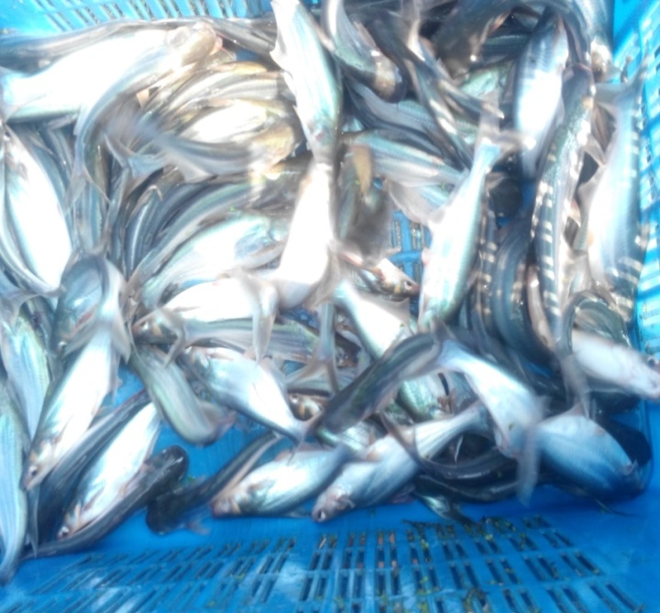
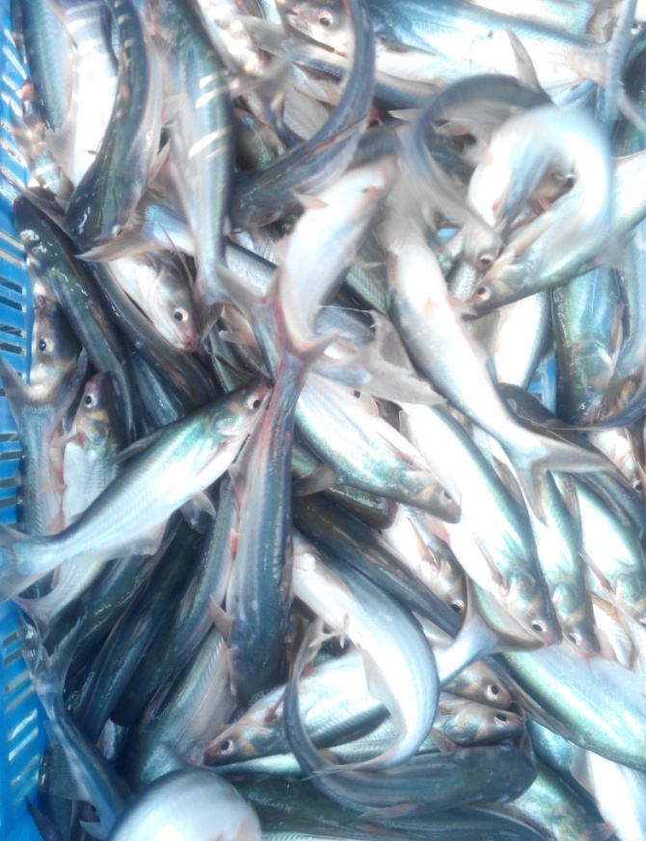

Plate.01: T₀ treated Pungas
Plate.02: T₁ treated Pungas
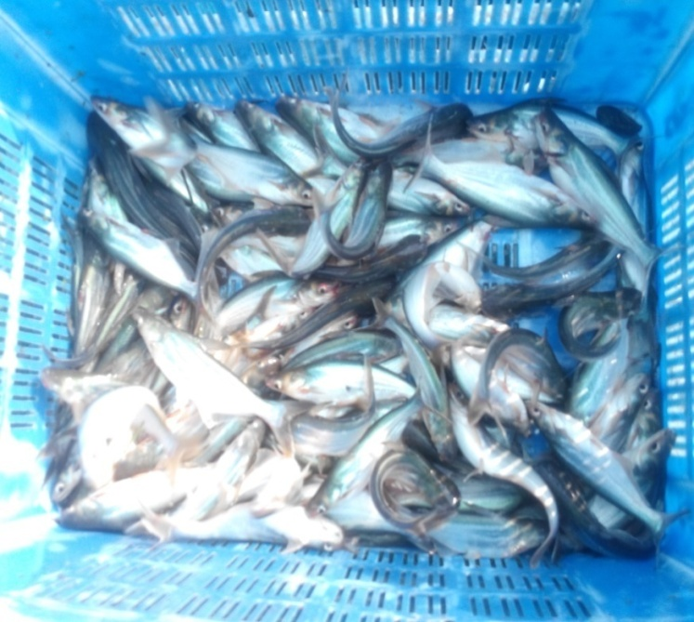
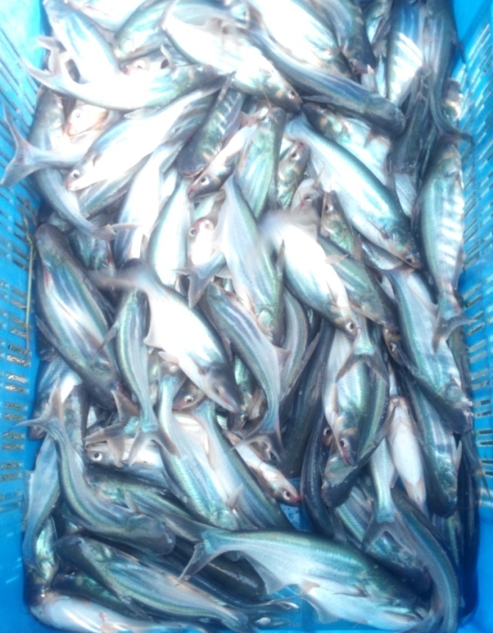

Plate.03: T₂ treated Pungas
Plate.04: T₃ treated Pungas

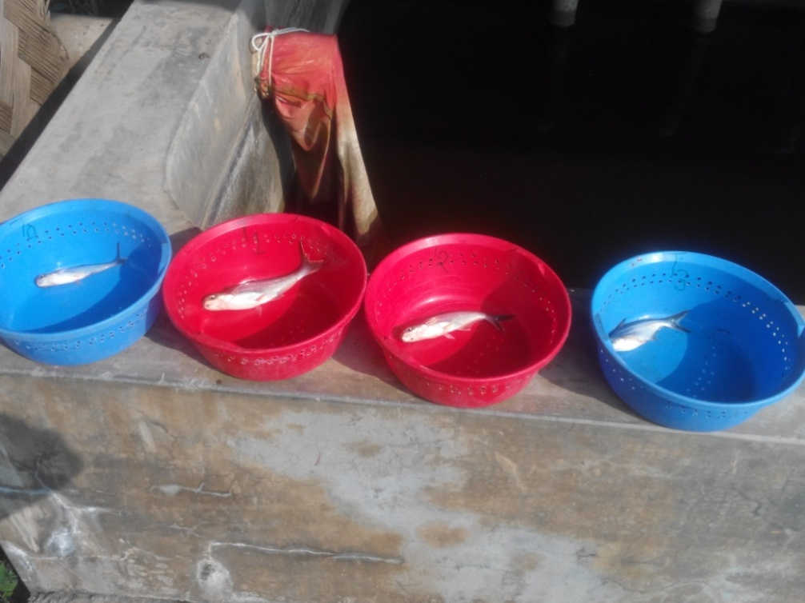
Plate.05: Comparison among T_{0,} T_{1,} T₂ andT₃ treated Pungas

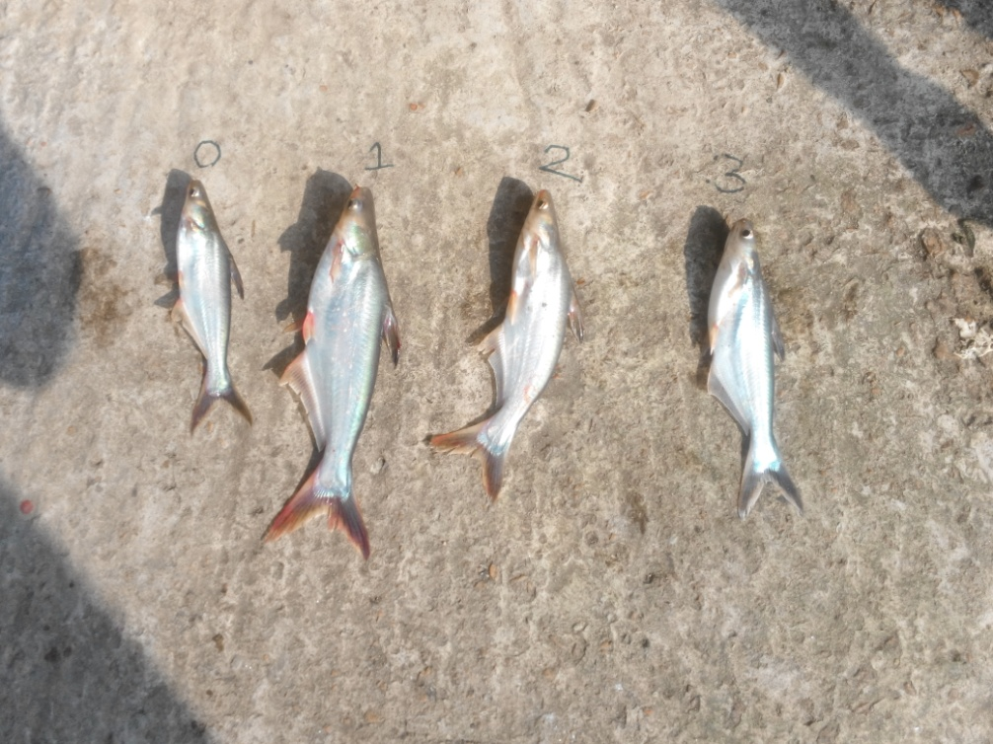

Plate.06: Comparison among T_{0,} T_{1,} T₂ andT₃ treatment group

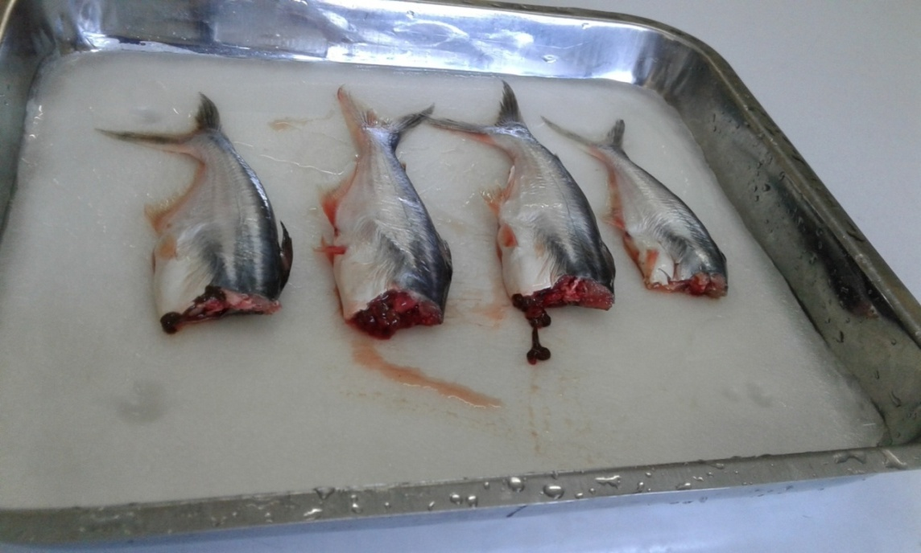

T₀
T₁
T₂
T₃

Plate.07: Muscle Comparison

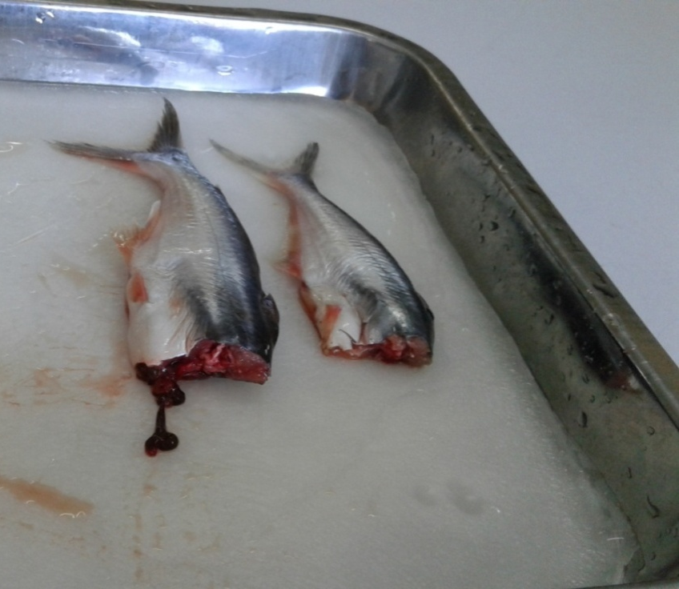

T₁
T₀

Plate.08: Muscle Comparison between T₀ and T₁

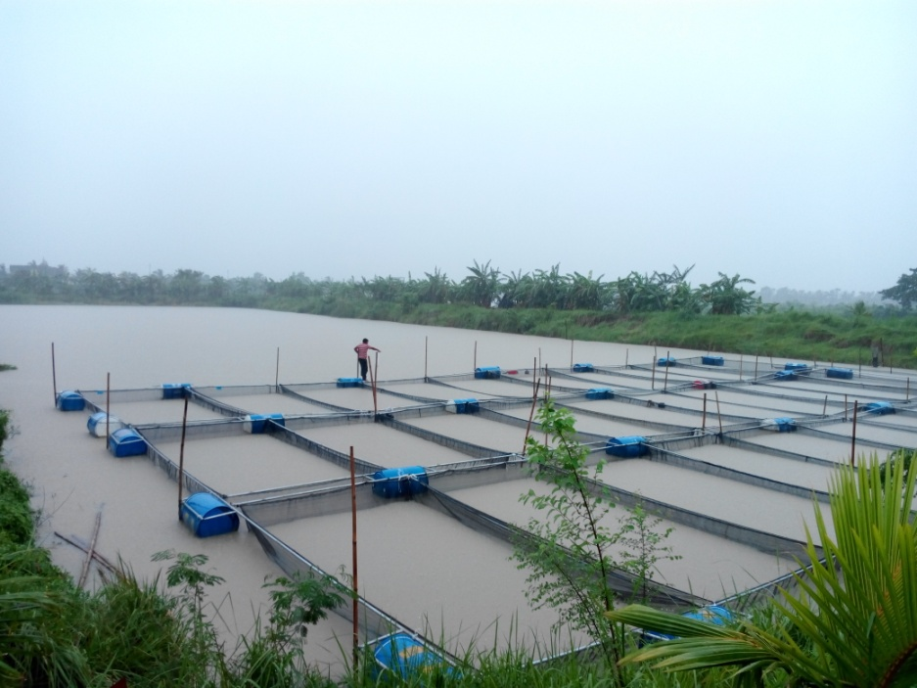

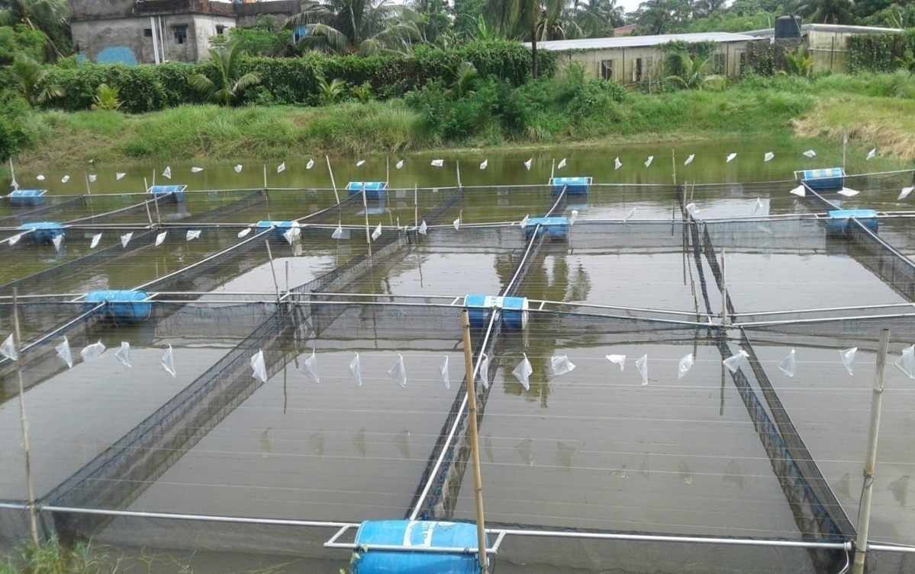
Plate11: Nylon Ropes are added over the cages to prevent birds from eating fish
Plate.09: Cage set up for Pungas
Plate.10: Cage set up for Pungas
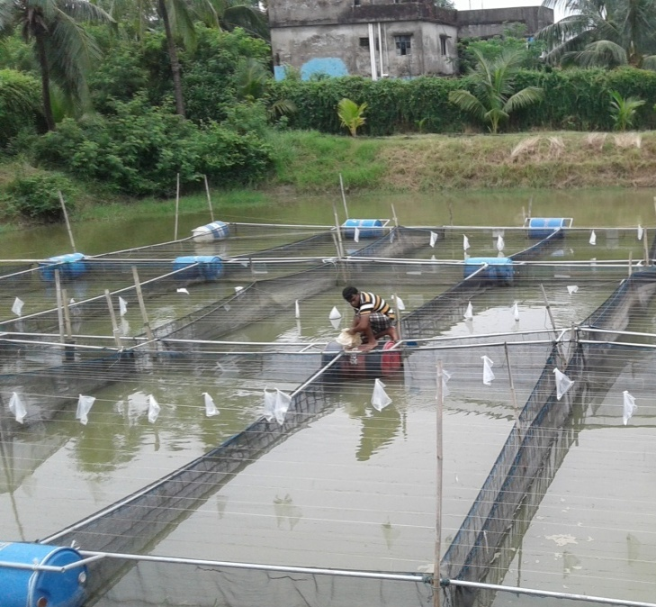
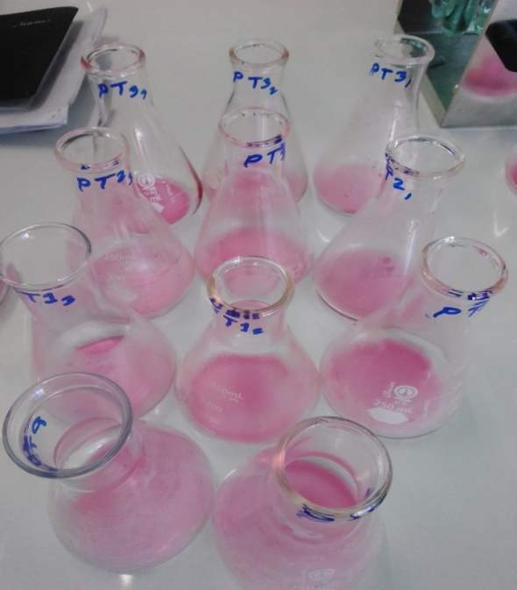
Plate.16: After titration
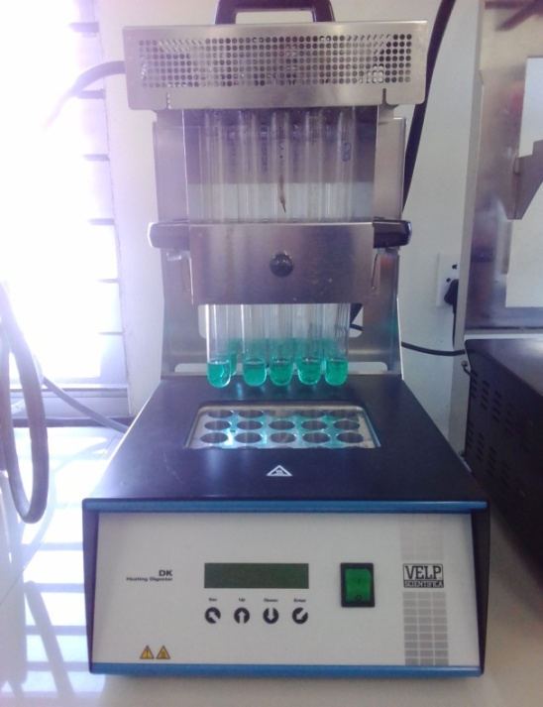
Plate.12: Sampling

Plate.13: Feeding

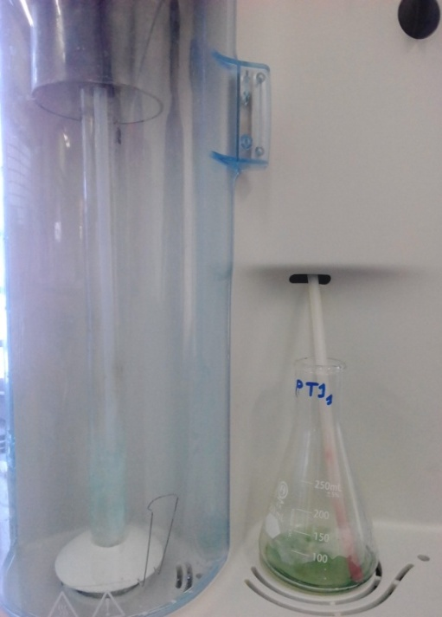
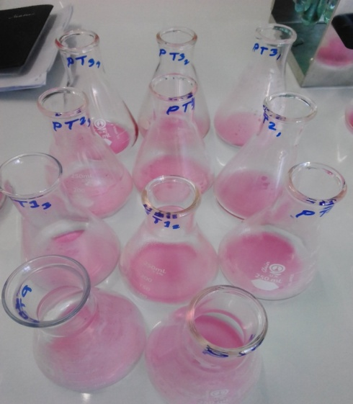

Plate.16: After titration
Plate.15: Distillation unit
Plate.14: Digestion unit

Chapter-4: Results
4.1 Weight and length measurement
Initial average weight of the fishes was 4.74g which had an average length of 5 cm. The cages of pungas fish have been sampled for sixteen times. From the last sampling (15/12/2017), the average weight was found to be 39.93(±0.75) g in T₀, 53.61(±7.88) g in T₁, 43.77(±2.66) g in T₂ and 45.14(±3.04) g in T₃. The average length was found as 17.1(±0.082) cm in T₀, 18.63(±0.95) cm in T₁, 17.8(±0.36) g in T₂ and 17.98(±0.39) cm in T₃. The above analysis can be concluded as the fishes provided with ‘Treatment-1(T₁)’ feed has higher and even growth (by weight and length) in comparison with other treatments. Slow growth rate of fishes has been observed because of temperature fall, raining and season change. Average growth was calculated weekly and graphically presented in ‘Figure-1’.

Figure-1: Mean growth progression in terms of weight over the experimental period

Average length was also calculated from the weekly sampling data which is showed below in ‘Figure-2’.

Figure-2: Mean growth progression in terms of length over the experimental period

Weight gain of fishes was calculated on weekly basis by subtracting current sampling weight by immediate previous weight and the results are given in ‘Figure-3’.

Figure-3: Average weight gain (week 1-16)
Length gain of fishes was calculated on weekly basis by subtracting current sampling length by immediate previous length and the results are illustrated in ‘Figure-4’.

Figure-4: Average length gain (week 1-16)

The data of growth performance of farmed pungas was collected from the farm weekly and analyzed by using SPSS software version 24.0 and the findings are listed in ‘Table-5’.
Table-5: Growth Performance analysis of farmed pungas
Treatment | Weight | Length | Condition factor | Specific growth rate
T₀ (Control) | 39.93±0.75^{b}  ( 39.17-40.96) | 17.1±.82^{b}  ( 17-17.2) | 0.65±.004  ( .8-.8) | 1.9±.016^{b}  ( 1.89-1.93)
T₁ (0.2 % Polyphenol) | 53.61± 7.88ª  ( 46.18-64.32) | 18.63±0.95ª ( 18-20) | 0.83±.033  (.79-.86) | 2.16±0.13ª  ( 2.03-2.33)
T₂ ( 0.4% Polyphenol) | 43.7±2.66^{b}  ( 40.89-46.38) | 17.8±0.36^{ab}( 17.5-18.2) | 0.78±.011  ( .76-.79) | 1.98±0.05^{b}  (1.92-2.04)
T₃ ( 0.6 % Polyphenol) | 45.1±3.04^{ab}  ( 42.16-48.78) | 17.98±0.39^{ab} ( 17.6-18.5) | 0.78±.043  (0 .73-0.84) | 2.01±0.06^{ab}  ( 1.95-2.08)
Level of significance | 0.006 | 0.014 | 0.079 | 0.004
*Values are means ± S.D. Within a row, means with the same letters are not significantly different (P > 0.05).
The data of mean weight was plotted in vertical axis while treatments are plotted in horizontal axis using SPSS to show the comparison among different treatments and the result is represented in ‘Figure-5’.
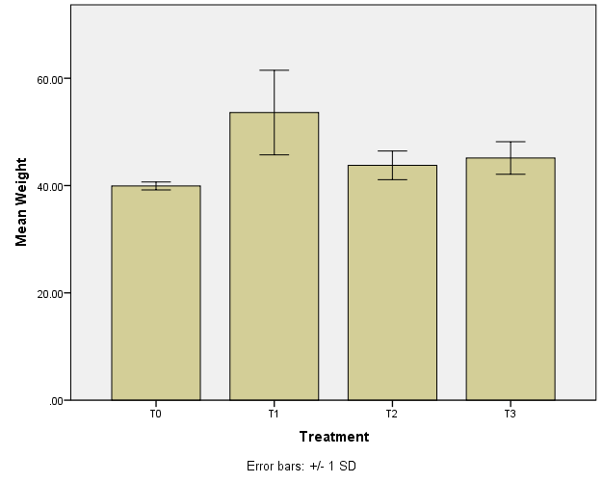
ab
b
a
b
Figure-5: Comparison of mean weight at different treatments
The data of mean length at different treatment was compared using SPSS to show the comparison and the result is represented in ‘Figure-6’.
a
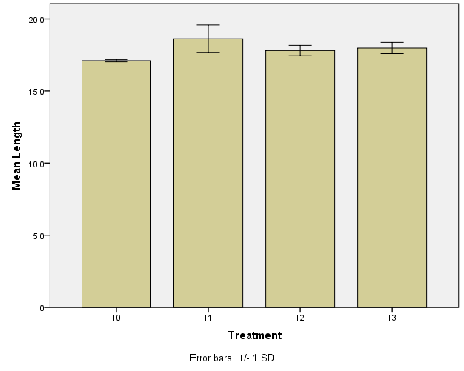
b
ab
ab
Figure-6: Comparison of mean length at different treatments
The data of mean specific growth rate was plotted in vertical axis while treatments are plotted in horizontal axis using SPSS to show the comparison among different treatments and the result is presented in ‘Figure-7’.
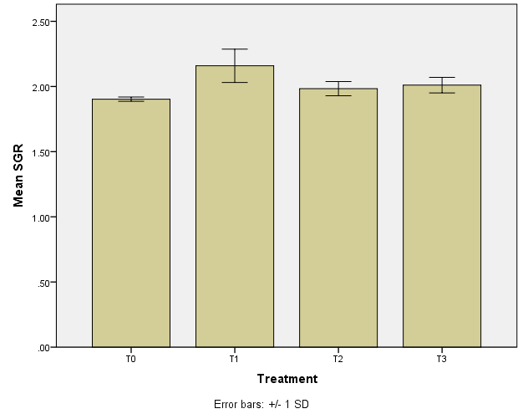
ab
a
b
b
Figure-7: Comparison of mean specific growth rate (SGR) at different treatments
The data of mean condition factor (CF) at different treatment was compared using SPSS to show the comparison and the result is represented in ‘Figure-8’.
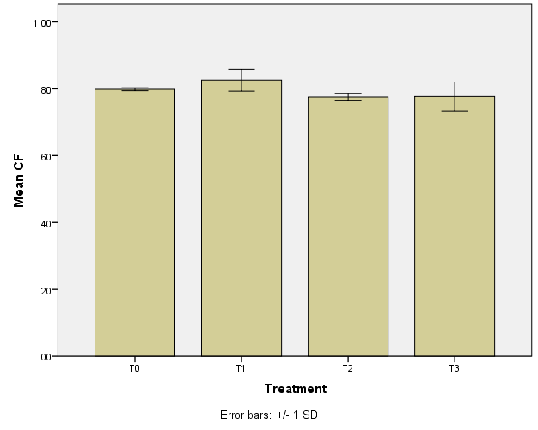
Figure-8: Comparison of mean condition factor (CF) at different treatments
4.2 FCR
As a representative part of each treatment 20 fishes were taken into account and the average weight as well as length of these fishes was measured. The amount of supplied feed was measured to calculate the FCR value. Best FCR (1.49) was found in 0.2% polyphenol treated feed fed to fish, whereas the FCR value of 0.4% and 0.6% polyphenol treated feed fed to fish were respectively 1.83 and 1.77. It reveals that polyphenol treated feed showed better FCR performance than control feed (2.004). It can be estimated that 514 gm feed can be saved to produce one kg pungas by using 0.2% polyphenol treated feed.
The findings are mentioned in ‘Table-6’.
Table-6: FCR analysis of each treatment
Treatment | FCR
T₀ | 2.004
T₁ | 1.49
T₂ | 1.83
T₃ | 1.77

4.3 Growth performance
The ‘Treatment-1 (T₁)’ treated pangus fishes exerted highest weight gain where inclusion of polyphenol in feed was 0.2%. The fishes of ‘Treatment-1 (T₁)’ achieved average weight of 53.61±7.88 g where the average weight of fishes in control (without polyphenol) gained 39.93±0.75 g. Which indicates average weight gain of 0.2% polyphenol treated fish was greater than control fish. The growth of fishes was higher not only 0.2% polyphenol treated fish but also other treatments containing polyphenol than control. The data of weight comparison at different treatments are listed in ‘Table-7’.

Table-7: Weight comparison of Polyphenol treated fish
Fish | Initial wt. (g) | Final wt. (g) |  | Wt. gain
Pangus | 4.74 | Control | 39.93(±0.75) | 35.45
 | 4.74 | 0.2% | 53.61±(7.88) | 48.87
 | 4.74 | 0.4% | 43.77(±2.66) | 38.97
 | 4.74 | 0.6% | 45.14(±3.04) | 40.4

4.4 Proximate composition analysis of fish
The sample fishes collected from the last sampling were brought into the laboratories of ‘Faculty of Fisheries’ at CVASU where proximate composition was estimated. The results of proximate composition analysis are showed in ‘Table-8’, ‘Table-9’, ‘Table-10’, and ‘Table-11’.

The proximate composition of fish muscle and fish feed were estimated by the below mentioned process,
- Protein was determined by kjeldahl apparatus,
- Lipid was calculated by soxhlet apparatus,
- Ash content was measured by muffle furnace and
- Moisture content was determined by hot air oven.
Table-8: Protein percentage
Name | Treatments | Percentage (%)
Pungas | Control (T₀) | 9.84
 | 0.2 % polyphenol(T₁) | 15.46
 | 0.4 % polyphenol(T₁) | 19.64
 | 0.6 % polyphenol(T₁) | 11.34

Table-9: Moisture content
Name | Treatments | Percentage (%)
Pungas | Control (T₀) | 88.07
 | 0.2 % polyphenol(T₁) | 81.64
 | 0.4 % polyphenol(T₁) | 79.61
 | 0.6 % polyphenol(T₁) | 78.77
Table-10: Ash content
Name | Treatments | Percentage (%)
Pungas | Control (T₀) | 0.87
 | 0.2 % polyphenol(T₁) | 1.28
 | 0.4 % polyphenol(T₁) | 1.31
 | 0.6 % polyphenol(T₁) | 1.44
Table-11: Lipid content
Name | Treatments | Percentage (%)
Pungas | Control (T₀) | 1.33
 | 0.2 % polyphenol(T₁) | 1.28

The proximate composition analysis showed that the protein, moisture, lipid, ash percentage in polyphenol treated fish is higher than the fishes which are not treated with polyphenol mixed feed.

Chapter-5: Discussion
The research showed that the difference in weight and length of the fishes among various treatments was significant (P<0.05) throughout the culture period. Significantly higher (P<0.05) weight gain was observed by the fishes of T₁, T₂ and T₃ groups. Highly significant (P<0.01) difference in specific growth rate was observed at the end of the experiment in polyphenol treated fishes. Weight gain by fishes of control group was lower than other three groups (T₁, T₂ and T₃). However, fishes of T₁ treated feed showed highest final weight at the end of the experiment. No difference in weight was found during the first part of the experiment, highest difference in weight gain was observed during the middle time and low growth rate was observed during the last weeks because of bad weather.
Odor, flavor and taste were examined by conducting experiments by some panelists soon after completing field survey. Panelists concluded that the polyphenol treated fish were tastier than the control fish and had no bad smell at all.
No feed residues were left in polyphenol treated fish than the control. Polyphenol seems to be acting as an attractant. Using polyphenol removes the fishy odor of fish meal used in formulating feed and creates a fresh smell in it. All fish were attracted to the feed, fighting and splashing to consume the feed containing polyphenol than the control. It showed to enhance feed consumption which ultimately increase the survival rate and also responsible for reducing wastage of feed. Thus enhance feed intake and growth rate. As lower amount of feed residue or no feed residue was left, water quality was maintained easily.
The growth of fish is directly dependent on feed composition and quality. The research showed that the different doses of polyphenol used as different treatment were significant during the whole culture period. Significantly higher feed consumption was observed by the fishes of T₁ , T₂ and T₃ treatment cages . Feed intake by the fishes of control group was lower than other three groups (T₁,T₂ and T₃). However, fishes of T₁ treatment exerted highest feed consumption. A few studies have been made on the effect of polyphenol in fish and fish feed. But a large number of studies have been made on poultry and other animals. Gessner et al. (2016) observed a significantly improved feed conversion ratio and similar to Sehm et al. (2006) an increased villus height: crypt depth ration in the duodenum. This is in agreement with a broiler study of Viveros et al. (2010) who observed an increased villus height in the small intestine by feeding polyphenol-rich products of wine/grape juice processing. It is assumed that an increased villus height leads to an improvement of digestive and absorptive functions of the intestine as a result of increased absorptive surface, expression of brush border enzymes and nutrient transport systems (Caspary, 1992). The result seems to be matching at final points in case of fish too.
Fishes of T₁ treatment group showed better feed conversion than other treatments. The differences in feed conversion ratio of fishes of different treatment groups were significant. Highly significant differences were observed. Feed conversion was better in T₁ , T₂ and T₃ groups compared to control. As the FCR value is calculated to be low in T₁, it can be concluded that using 0.2% of polyphenol in fish feed will be cost effective for the farmers.
During the whole research fish mortality was observed to be very low. No disease outbreak was seen during that time. The weather condition was rough for several periods of the culture period. The fishes struggled against the rough weather and remain alive as well as disease free. This may happen because of polyphenols as it helps to build strong immune system in animals which help them to sustain in rough weather. No research has yet been conducted concluding these result or similar to this result in case of fish. But it has been seen that polyphenols improve body immune system. In mice receiving oral treatment with polyphenols rich extracts from date palm tree, an increment of the immunocompetent cells, incluinding T helper 1 (Th1), natural killer (NK), macrophages and dendritic cells (DCs) in both Peyer’s patches and spleen (Karasawa et al.,2011) was observed. Similar effects were obtained in response to treatment of aged rats with polyphenols from Cassia auriculata, increasing splenic T and B cells (John et al.,2011).
The proximate composition shows that the percentage of protein, lipid, minerals are estimated to be higher in polyphenol treated fishes than the control group. This may happen because polyphenol is rich in anti-oxidants. ‘Polyphenols are act as anti-inflammatory both in vitro and in vivo. It inhibits the activation of nuclear factor kappa B (NF-κB) and also able to induce antioxidative and cytoprotective effects by inducing nuclear factor’ (Rahman et al., 2006; Scapagnini et al., 2011; Tangney and Rasmussen, 2013). Polyphenols supplementation has potential benefit for athletes which is helpful to exercise performance or oxidative damage ( Kathryn H. Myburgh,2014).
In the present study, the weight gain, specific growth rate, food conversion ratio were significantly different (P<0.05) in all the treatments. Still, the better growth performance was observed in treatment T₁ (treated with 0.2% polyphenol mixed feed). The higher specific growth rate is an indication of higher growth. Though Thai pungas and rohu has different feeding habits, it has been seen that these species mostly prefer balanced diet (DoF, 2000). So it can be said that including 0.2% polyphenol is making the feed more balanced for pungas fishes. There was no disease occurrence found in the fishes during the experiment ongoing. This may happen because of the antioxidant and antibacterial properties of the provided feed which in turn increase immunity of the fishes.
Besides using polyphenols in fish feed is safe for the consumer. Charming news is that polyphenols are now thought to be the natural inhibitor of some human diseases. Phenolic compounds have been of increasing interest to science and food industry for their beneficial health effects. Epidemiological data have related a high intake of phenolic-rich food to a decreased rate of chronic diseases such as diabetes, cardiovascular diseases, Alzheimer’s disease, Parkinson’s disease, and inflammation (Bravo, 1998). So, using polyphenols in fish feed may ensure the better profit for the farmer as well as food safety for the consumers.

Chapter-6: Conclusion
Pungas contributes a major part in our aquaculture production. A large number of people who lives from hand to mouth depend on this fish to fulfill their protein demand as the fish is cheap compared to other species of fish. Pungas fish can be stocked at higher density therefore useful for the poor farmers to benefit easily. Disease occurrence is a common issue and a matter of headache for the poor farmers in pungas farms because of higher stocking density and other environmental stress. Using high doses of antibiotic is a common phenomena which is very harmful for the consumer.
The results of this experiment are evidencing consumer protection by describing the way of preventing diseases in pungas fishes with the use of polyphenol. The research also showed the potential role of polyphenol in the growth performance, immune response of pungas, safety and disease free fishes as well as improved proximate composition of the fishes. Further research can be conducted on the effects of polyphenol in different fishes as well as effect of polyphenol in fish muscle. This type of research work will be a new dimension for improving fisheries industry in Bangladesh.

Chapter-7: Recommendations and future perspectives

According to this research work, the following recommendations may be done:
- Farmer may get lower FCR value and increased growth performance of pungas fishes with regular use of polyphenol in fish feed.
- Polyphenol may be used in improving the total production and food safety.
- Using polyphenol as additive in fish feeds should be approved by the government and included in national policy level.
- As it was a pilot study, further studies may be conducted on similar field to make a concrete remark.

References

Ahmed M., Lorica M.H., 2002. Improving developing country food security through aquaculture development lessons from Asia. Food Policy. 27:125–141.
Ali H., 2010. Cluster analysis of pangasius aquaculture in Bangladesh based on geographical location and distribution. Unpublished field report. SEAT project, BAU and University of Stirling.
Ali M., Hasan R.M.D., Hossain B.M., Minar M.F., 2012. Proximate composition of fish feed ingredients available in Lakshmipur Region, Bangladesh Am.-Eur. J. Agric. Environ. Sci., 12 (2012), pp. 556-560
Amin Sarker, A.K.M.R. 2010. Development of Cage-based Tilapia Farming in Dakatia River in Chandpur, Bangladesh: Study on Socio-economic and Technical Perspectives. MSc Dissertation. University of Stirling.
Bakkali F. et al., 2008. Biological effects of essential oils. British Industrial Biological Research Association. 46 (2), pp. 446-75.
Banglapedia, 2003. National Encyclopedia of Bangladesh. Vol 4, Asiatic Society of Bangladesh. Dhaka. March, 2003.
Baqui M.A., Bhujel R.C.A., 2011. Hands-on Training Helped Proliferation of Tilapia Culture in Bangladesh. Proceedings of the ninth international symposium on tilapia in aquaculture. pp. 311–322. Aqua Fish Collaborative Research Support Program.
BBS., 2006. Agricultural Sample Survey of Bangladesh 2005. Bangladesh Bureau of Statistics, Ministry of Planning, Dhaka.
Belton B., Little D.C., 2011. Contemporary visions for small-scale aquaculture. In: Chuenpagdee, R. (ed.) Contemporary Visions for World Small-Scale Fisheries. Eburon, Delft.
Benchaar C et al., 2008: A review of plant-derived essential oils in ruminant nutrition and production. In: Animal Feed Science and Technology. 145 (1-4), pp. 209-228.
Beverage, M.C.M. 1987. Cage Culture, Fishing News Book, 351p.
Bravo L., 1998. Polyphenols: Chemistry, dietary sources, metabolism, and nutritional significance. Nutrition Reviews, 56, 317–333
Brown D., Brooks A., 2002. A Survey of Disease Impact and Awareness in Pond Aquaculture in Bangladesh, the Fisheries and Training Extension Project-Phase 11. In: Primary Aquatic Animal Health Care in Rural, Small Scale and Aquaculture Development, pp: 85-93.
Busquet M et al., 2006. Plant extracts affectin vitro rumen microbial fermentation. In: Journal of dairy science. 89 (2), pp. 761-71.
Calsamiglia S et al., 2007. Invited review: Essential oils as modifiers of rumen microbial fermentation. In: Journal of dairy science. 90 (6), pp. 2580-95.
Caspary W.F., 1992. Physiology and Pathophysiology of Intestinal Absorption. The American Journal of Clinical Nutrition, 55, 299S-308S.
Chuang C.C., McIntosh M.K., 2011.Potential mechanisms by which polyphenol-rich grapes prevent obesity-mediated inflammation and metabolic diseases.Annual Review of Nutrition, 31, 155–176.
Cosentino S et al., 1999. In-vitro antimicrobial activity and chemical composition of Sardinian Thymus essential oils. In: Letters in applied microbiology.29 (2), pp.130-5.
Cross D.E. et al. 2007. The effect of herbs and their associated essential oils on performance, dietary digestibility and gut microflora in chickens from 7 to 28 days of age. In: British poultry science. 48 (4), pp. 496-506.
Dey B.K., Hossain M.M.M., Bappa S.B., Akter S., Khondoker S., 2014. Impact of diseases on fish production of baors in Jessore, Bangladesh. Journal of Fisheries 2(1): 70-75.
DoF. 2000. Commercial Basis of Pangus Culture–Farmers’ Guide (Published in Bengali). Published by Department of Fisheries, Dhaka, Bangladesh.
DoF. 2010. Fisheries Statistical Year Book of Bangladesh 2008–2009. Volume 26, No. 1. Fisheries Resource Survey System, Department of Fisheries, Ministry of Fisheries and Livestock.
DoF (2012). Sharonika, Matshya Saptah, 2012. Department of Fisheries, Ministry of Fisheries and Livestock, 13 pp.
DoF (2013). National Fish Week 2013. Compendium (in Bengali).Department of Fisheries, Ministry of Fisheries and Livestock, 144 pp.
DoF. 2016. Fisheries Statistics in Bangladesh: Issues, Challenges and Plans; Asia and Pacific Commission on Agriculture Statistics, 26th Session, Agenda Item 6.3, Thimphu, Bhutan, 15-19 February 2016.
DoF. 2017. Yearbook of Fisheries Statistics of Bangladesh 2016-17. Fisheries Resources Survey System (FRSS), Department of Fisheries. Bangladesh: Director General, DoF, 2017. Volume 34 : p. 129.
Environmental Microbiology, July 2006; “Over-use of antibiotics in fish-for-food industry encourages bacterial resistance and disease”. Source: https://www.eurekalert.org/pub_releases/2006-06/bpl-ooa062006.php
FAO (2002). Farming of Freshwater Prawns: A Manual For the culture of the giant river prawn (Macrobrachiumrosenbergii). Food and Agricultural organization, Fisheries Technical Paper, 428 pp.
FAO (2015). FAO Voluntary Guidelines for Securing Sustainable Small-Scale Fisheries in the Context of Food Security and Poverty Eradication. Food and Agriculture Organization, Rome, Italy (2015)
Faruk M.A.R., Sultana N., Kabir M.B., 2005. Use of chemicals in aquaculture activities in Mymensingh are a, Bangladesh. Bangladesh J. Fish. 29 (1-2): 1-10.
Faruk M.A.R., Ali M.M., Patwary Z.P., 2008. Evaluation of the status of use of chemicals and antibiotics in freshwater aquaculture activities with special emphasis to fish health management. J. Bangladesh Agric. Univ., 6: 381-390.
Gessner D.K., Ringseis R., Eder K., 2016. Potential of Plant Polyphenols to Combat Oxidative Stress and Inflammatory Processes in Farm Animals.
Hasan M.R., Ahmed G.U., 2002. Issues in carp hatcheries and nurseries in Bangladesh, with special reference to health management. Aquaculture Development. FAO Fish. Tech. Pap. No. 406. pp. 147-164.
Jang I. et al. 2007. Effect of a commercial essential oil on growth performance, digestive enzyme activity and intestinal microflora population in broiler chickens. In: Animal Feed Science and Technology. 134 (3-4), pp. 304-315.
John C.M., Sandrasaigaran P., Tong C.K., Adam A., Ramasamy R., 2011. Immunomodulatory activity of polyphenols derived from cassia auriculata flowers in aged rats. Cell Immunol, 271:474–479.
Karasawa K., Uzuhashi Y., Hirota M., Otani H., 2011. A matured fruit extract of date palm tree (Phoenix dactylifera L.) stimulates the cellular immune system in mice. J. Agric. Food Chem. 59 :11287–11293.
Kathryn H. Myburgh, 2014. Polyphenol Supplementation: Benefits for Exercise Performance or Oxidative Stress? Sports Med. 2014; 44(Suppl 1): 57–70. doi: 10.1007/s40279-014-0151-4
Le Cren E.D. 1951. The length–weight relationship and seasonal cycle in gonad weight and condition in the perch (Perca fluviatilis).
Maenner K., Vahjen W., Simon O., 2011. Studies on the effects of essential-oil-based feed additives on performance, ideal nutrient digestibility, and selected bacterial groups in the gastrointestinal tract of piglets. Journal of animal science. 89 (7), pp. 2106-12.
McAndrew K. 2002. Risks to small-scale cage farmers in Bangladesh, with emphasis on fish health experiences of the CARE-CAGES Project. p. 215-223. FAO Fish. Tech. Pap. No. 406.
Muhl A., Liebert F., 2007. Growth and parameters of microflora in intestinal and faecal samples of piglets due to application of a phytogenic feed additive. Journal of animal physiology and animal nutrition. 91 (9-10), pp. 411-8.
Paul S.K., 2008. Shrimp: Environment-Friendly Culture Technology, Socio-Economic and Quality Control Management. Momin offset press, 9, Nilkhet, Babupura, Dhaka, 304 pp.
Phenolic compounds in animal feeds; Source: https://www.wattagnet.com/articles/26671-phenolic-compounds-in-animal-feeds
Phillips M., 2000. The Use of Chemicals in Carp and Shrimp Aquaculture in Bangladesh, Cambodia, Lao PDR, Nepal, Pakistan, Sri Lanka and Viet Nam. Southeast Asian Fisheries Development Center, Philippines, ISBN-13: 9789718511497, Pages: 75-86.
Poison in fish, Reazul Bashar and Faijul Siddikii, Published: 2014-04-15. Source: https://bdnews24.com/bangladesh/2014/04/15/poison-in-fish

Quintero, Dino; et al. "Workload Optimized Systems: Tuning POWER7 for Analytics". Abstract.
Rahman I., Biswas S.K., Kirkham P.A., 2006. Regulation of inflammation and redox signaling by dietary polyphenols. Biochemical Pharmacology 72, 1439–1452.
Scapagnini G., Sonya V., Nader A.G., Colagero C., Zella D., Fabio G., 2011. Modulation of Nrf2/ARE pathway by food polyphenols: a nutritional neuro-protective strategy for cognitive and neurodegenerative disorders. Molecular Neurobiology 44, 192–201
Shelton W.L., 2002. Tilapia culture in the 21st Century. Proceedings of the International Forum on Tilapia Farming in the 21st Century (Tilapia Forum 2002), 184 p. Philippine Fisheries Association Inc. Los, Banos, Laguna, Philippines. pp. 1-20.
Subasinghe R.P., Barg U., Tacon A., 1996. Chemicals in Asian Aquaculture: Need, Usage, Issues and Challenges. Southeast Asian Fisheries Development Center, Aquaculture Department, Iloilo, Philippines, pp: 1-6.
Tangney C.C., Rasmussen H.E., 2013, Polyphenols, inflammation and cardio- vascular disease. Current Atherosclerosis Reports 15 , 324.
The good properties of polyphenols in animal feed by By Monika Korzekwa, product manager, Dr Eckel, Germany. Visit at: https://www.allaboutfeed.net/Feed-Additives/Articles/2015/1/The-good-properties-of-polyphenols-in-animal-feed-1563994W/
Viveros A., Chamorro S., Pizarro M., Arija I., Centeno C., Brenes A., 2010. Effects of dietary polyphenol-rich grape products on intestinal microflora and gut morphology in broiler chicks. Poult. Sci., 90 (3): 566-578

Windisch W et al., 2008. Use of phytogenic products as feed additives for swine and poultry. In: Journal of animal science. 86 (14 Suppl), pp. E140-8.
Yang W Z et al., 2007. Effects of garlic and juniper berry essential oils on ruminal fermentation and on the site and extent of digestion in lactating cows. In: Journal of dairy science. 90 (12), pp. 5671-81.

Appendices
Table: Record of weight of the fishes at different sampling
 | W-0 | W-1 | W-2 | W-3 | W-4 | W-5 | W-6 | W-7 | W-8 | W-9 | W-10 | W-11 | W-12 | W-13 | W-14 | W-15 | W-16
T R | Wt (g) | Wt (g) | Wt (g) | Wt (g) | Wt (g) | Wt (g) | Wt (g) | Wt (g) | Wt (g) | Wt (g) | Wt (g) | Wt (g) | Wt (g) | Wt (g) | Wt (g) | Wt (g) | Wt (g)
T₀R₁ | 4.74 | 8.33 | 10.76 | 15.00 | 15.33 | 18.00 | 22.00 | 25.90 | 28.00 | 30.00 | 31.24 | 33.14 | 35.06 | 36.00 | 36.85 | 38.51 | 40.96
T₀R₂ | 4.74 | 8.33 | 11.83 | 13.75 | 15.95 | 22.00 | 22.87 | 25.75 | 26.58 | 28.80 | 30.59 | 32.75 | 33.94 | 35.00 | 36.18 | 38.25 | 39.78
T₀R₃ | 4.74 | 7.56 | 10.60 | 11.66 | 15.29 | 21.33 | 22.62 | 24.00 | 26.00 | 27.90 | 29.50 | 32.29 | 33.72 | 34.50 | 36.04 | 37.33 | 39.82
T₀R₄ | 4.74 | 5.67 | 11.84 | 12.40 | 15.88 | 20.72 | 23.00 | 25.33 | 26.67 | 29.14 | 30.03 | 32.00 | 33.33 | 34.75 | 36.00 | 37.09 | 39.17
T₁R₁ | 4.74 | 9.09 | 12.06 | 13.00 | 15.40 | 20.60 | 25.50 | 29.25 | 38.70 | 42.67 | 44.19 | 46.33 | 47.44 | 49.00 | 52.78 | 58.00 | 64.32
T₁R₂ | 4.74 | 6.67 | 10.54 | 14.00 | 18.18 | 1.009 | 25.00 | 30.75 | 36.82 | 40.00 | 43.75 | 44.50 | 45.42 | 46.00 | 46.50 | 49.90 | 54.29
T₁R₃ | 4.74 | 8.33 | 12.29 | 14.72 | 17.60 | 23.50 | 29.48 | 32.66 | 34.67 | 36.57 | 39.49 | 41.00 | 42.78 | 43.50 | 45.78 | 47.37 | 49.63
T₁R₄ | 4.74 | 7.27 | 11.91 | 15.71 | 15.95 | 22.40 | 28.67 | 31.88 | 34.73 | 36.33 | 38.78 | 40.00 | 41.33 | 42.25 | 43.00 | 44.12 | 46.18
T₂R₁ | 4.74 | 6.22 | 9.27 | 11.76 | 13.83 | 16.50 | 19.93 | 22.71 | 26.76 | 30.00 | 32.49 | 35.60 | 37.04 | 40.00 | 43.83 | 44.95 | 46.38
T₂R₂ | 4.74 | 8.00 | 10.90 | 15.00 | 18.26 | 19.25 | 23.24 | 26.50 | 28.00 | 32.60 | 34.38 | 35.33 | 35.47 | 36.00 | 36.21 | 38.58 | 40.89
T₂R₃ | 4.74 | 6.92 | 11.60 | 15.77 | 16.00 | 21.00 | 23.80 | 25.50 | 26.47 | 28.75 | 30.48 | 32.00 | 33.33 | 36.67 | 38.38 | 40.00 | 42.14
T₂R₄ | 4.74 | 7.25 | 10.83 | 16.50 | 17.25 | 17.50 | 21.63 | 24.42 | 26.65 | 28.00 | 30.17 | 33.00 | 38.71 | 40.00 | 43.67 | 44.32 | 45.65
T₃R₁ | 4.74 | 7.00 | 11.66 | 12.00 | 17.03 | 21.20 | 24.08 | 26.00 | 28.57 | 31.67 | 32.73 | 33.80 | 36.00 | 40.00 | 43.75 | 44.45 | 46.43
T₃R₂ | 4.74 | 8.33 | 11.91 | 13.67 | 17.18 | 21.00 | 23.85 | 25.33 | 28.94 | 30.00 | 31.08 | 31.60 | 33.33 | 35.40 | 40.00 | 43.89 | 48.78
T₃R₃ | 4.74 | 8.00 | 11.83 | 12.00 | 17.25 | 19.50 | 22.46 | 27.36 | 28.66 | 29.50 | 30.67 | 34.00 | 35.96 | 37.00 | 38.26 | 40.67 | 43.17
T₃R₄ | 4.74 | 8.18 | 11.64 | 15.83 | 16.19 | 21.00 | 23.15 | 24.75 | 25.48 | 27.78 | 29.55 | 30.40 | 33.04 | 36.00 | 38.09 | 40.00 | 42.16

*W= Week, Wt= Weight, TR= Treatment × Replication

Table: Record of length of the fishes at different sampling
 | W-0 | W-1 | W-2 | W-3 | W-4 | W-5 | W-6 | W-7 | W-8 | W-9 | W-10 | W-11 | W-12 | W-13 | W-14 | W-15 | W-16
T R | L (cm) | L (cm) | L (cm) | L (cm) | L (cm) | L (cm) | L (cm) | L (cm) | L (cm) | L (cm) | L (cm) | L (cm) | L (cm) | L (cm) | L (cm) | L (cm) | L (cm)
T₀R₁ | 5 | 8.5 | 11.0 | 12.0 | 13.0 | 13.5 | 14.0 | 14.4 | 14.9 | 15.0 | 15.5 | 16.0 | 16.5 | 16.9 | 17.0 | 17.0 | 17.2
T₀R₂ | 5 | 8.0 | 10.7 | 11.5 | 12.3 | 13.5 | 14.0 | 14.3 | 14.5 | 15.0 | 15.5 | 16.0 | 16.3 | 16.5 | 16.8 | 17.0 | 17.1
T₀R₃ | 5 | 8.0 | 10.7 | 11.5 | 13.0 | 13.2 | 13.5 | 13.9 | 14.4 | 14.5 | 15.0 | 16.0 | 16.2 | 16.5 | 16.7 | 17.0 | 17.1
T₀R₄ | 5 | 7.5 | 10.7 | 12.5 | 13.0 | 13.0 | 13.5 | 14.0 | 14.5 | 15.0 | 15.5 | 15.5 | 16.0 | 16.5 | 16.5 | 17.0 | 17.0
T₁R₁ | 5 | 8.8 | 11.5 | 12.5 | 13.5 | 13.5 | 14.0 | 14.5 | 15.0 | 16.0 | 16.5 | 17.0 | 17.3 | 17.5 | 18.0 | 19.0 | 20.0
T₁R₂ | 5 | 7.0 | 10.7 | 12.0 | 14.0 | 14.0 | 14.7 | 15.0 | 15.5 | 16.0 | 16.5 | 16.8 | 17.0 | 17.0 | 17.2 | 18.0 | 18.5
T₁R₃ | 5 | 8.0 | 10.7 | 12.0 | 14.0 | 14.0 | 14.5 | 15.0 | 15.5 | 15.9 | 16.5 | 16.6 | 16.9 | 17.0 | 17.0 | 17.5 | 18.0
T₁R₄ | 5 | 7.5 | 11.0 | 12.0 | 13.5 | 13.5 | 14.0 | 14.4 | 14.7 | 15.0 | 16.0 | 16.5 | 16.7 | 17.0 | 17.0 | 17.5 | 18.0
T₂R₁ | 5 | 7.0 | 11.0 | 11.5 | 13.5 | 13.5 | 13.8 | 14.0 | 14.5 | 15.0 | 15.5 | 16.0 | 16.5 | 17.0 | 17.5 | 17.8 | 18.2
T₂R₂ | 5 | 7.9 | 11.5 | 12.0 | 12.5 | 13.5 | 14.0 | 14.4 | 14.8 | 15.0 | 15.4 | 16.0 | 16.4 | 16.5 | 16.6 | 17.0 | 17.5
T₂R₃ | 5 | 7.2 | 10.7 | 12.0 | 13.0 | 13.0 | 13.5 | 14.0 | 14.6 | 15.0 | 15.5 | 15.8 | 16.0 | 16.5 | 17.0 | 17.2 | 17.5
T₂R₄ | 5 | 7.0 | 10.7 | 12.0 | 13.5 | 13.5 | 13.9 | 14.0 | 14.3 | 14.5 | 15.0 | 16.0 | 16.5 | 16.9 | 17.2 | 17.5 | 18.0
T₃R₁ | 5 | 7.2 | 11.0 | 11.5 | 13.5 | 13.5 | 13.7 | 14.2 | 14.5 | 15.0 | 15.5 | 16.0 | 16.5 | 17.0 | 17.5 | 17.9 | 18.5
T₃R₂ | 5 | 8.0 | 11.0 | 13.0 | 14.0 | 14.2 | 14.5 | 14.5 | 15.0 | 15.0 | 15.4 | 16.0 | 16.5 | 16.7 | 17.0 | 17.5 | 18.0
T₃R₃ | 5 | 8.1 | 10.7 | 11.5 | 13.0 | 13.5 | 13.7 | 14.1 | 14.5 | 15.0 | 15.5 | 16.0 | 16.3 | 16.5 | 17.0 | 17.3 | 17.8
T₃R₄ | 5 | 8.5 | 11.0 | 12.5 | 13.5 | 13.5 | 13.5 | 14.0 | 14.2 | 15.0 | 15.5 | 15.8 | 16.0 | 16.5 | 17.0 | 17.3 | 17.6

*W= Week, L= Length, TR= Treatment × Replication

Table: Record of weight gain (weight gain= present sampling weight – immediate previous sampling weight) of the fishes at different weeks
 | W-1 | W-2 | W-3 | W-4 | W-5 | W-6 | W-7 | W-8 | W-9 | W-10 | W-11 | W-12 | W-13 | W-14 | W-15 | W-16
TR | WG (g) | WG (g) | WG (g) | WG (g) | WG (g) | WG (g) | WG (g) | WG (g) | WG (g) | WG (g) | WG (g) | WG (g) | WG (g) | WG (g) | WG (g) | WG (g)
T₀R₁ | 3.59 | 2.43 | 4.24 | 0.33 | 2.67 | 4.00 | 3.90 | 2.10 | 2.00 | 1.24 | 1.90 | 1.92 | 0.94 | 0.85 | 1.66 | 2.45
T₀R₂ | 3.59 | 3.5 | 1.92 | 2.2 | 6.05 | 0.87 | 2.88 | 0.83 | 2.22 | 1.79 | 2.16 | 1.19 | 1.06 | 1.18 | 2.07 | 1.53
T₀R₃ | 2.82 | 3.04 | 1.06 | 3.63 | 6.04 | 1.29 | 1.38 | 2.00 | 1.90 | 1.60 | 2.79 | 1.43 | 0.78 | 1.54 | 1.29 | 2.49
T₀R₄ | 0.93 | 6.17 | 0.56 | 3.48 | 4.84 | 2.28 | 2.33 | 1.34 | 2.47 | 0.89 | 1.97 | 1.33 | 1.42 | 1.25 | 1.09 | 2.08
T₁R₁ | 4.35 | 2.97 | 0.94 | 2.40 | 5.20 | 4.90 | 3.75 | 9.45 | 3.97 | 1.52 | 2.14 | 1.11 | 1.56 | 3.78 | 5.22 | 6.32
T₁R₂ | 1.93 | 3.87 | 3.46 | 4.18 | 0.82 | 6.00 | 5.75 | 6.07 | 3.18 | 3.75 | 0.75 | 0.92 | 0.58 | 0.50 | 3.40 | 4.39
T₁R₃ | 3.59 | 3.96 | 2.43 | 2.88 | 5.9 | 5.98 | 3.18 | 2.01 | 1.90 | 2.92 | 1.51 | 1.78 | 0.72 | 2.28 | 1.59 | 2.26
T₁R₄ | 2.53 | 4.64 | 3.8 | 0.24 | 6.45 | 6.27 | 3.21 | 2.85 | 1.60 | 2.45 | 1.22 | 1.33 | 0.92 | 0.75 | 1.12 | 2.06
T₂R₁ | 1.48 | 3.05 | 2.49 | 2.07 | 2.67 | 3.43 | 2.78 | 4.05 | 3.24 | 2.49 | 3.11 | 1.44 | 2.96 | 3.83 | 1.12 | 1.43
T₂R₂ | 3.26 | 2.90 | 4.10 | 3.26 | 0.99 | 3.99 | 3.26 | 1.50 | 4.60 | 1.78 | 0.95 | 0.14 | 0.53 | 0.21 | 2.37 | 2.31
T₂R₃ | 2.18 | 4.68 | 4.17 | 0.23 | 5.00 | 2.8 | 1.70 | 0.97 | 2.28 | 1.73 | 1.52 | 1.33 | 3.34 | 1.71 | 1.62 | 2.14
T₂R₄ | 2.51 | 3.58 | 5.67 | 0.75 | 0.25 | 4.13 | 2.79 | 2.23 | 1.35 | 2.17 | 2.83 | 5.71 | 1.29 | 3.67 | 0.65 | 1.33
T₃R₁ | 2.26 | 4.66 | 0.34 | 5.03 | 4.17 | 2.88 | 1.92 | 2.57 | 3.10 | 1.06 | 1.07 | 2.20 | 4.00 | 3.75 | 0.70 | 1.98
T₃R₂ | 3.59 | 3.58 | 1.76 | 3.51 | 3.82 | 2.85 | 1.48 | 3.61 | 1.06 | 1.08 | 0.52 | 1.73 | 2.07 | 4.60 | 3.89 | 4.89
T₃R₃ | 3.26 | 3.83 | 0.17 | 5.25 | 2.25 | 2.96 | 4.90 | 1.30 | 0.84 | 1.17 | 3.33 | 1.96 | 1.04 | 1.26 | 2.41 | 2.50
T₃R₄ | 3.44 | 3.46 | 4.19 | 0.36 | 4.81 | 2.15 | 1.60 | 0.73 | 2.30 | 1.77 | 0.85 | 2.64 | 2.96 | 2.09 | 1.91 | 2.16

*W= Week, WG= Weight Gain, TR= Treatment × Replication

Table: Record of length gain (length gain= present sampling length – immediate previous sampling length) of the fishes at different weeks
 | W-1 | W-2 | W-3 | W-4 | W-5 | W-6 | W-7 | W-8 | W-9 | W-10 | W-11 | W-12 | W-13 | W-14 | W-15 | W-16
TR | LG (cm) | LG (cm) | LG (cm) | LG (cm) | LG (cm) | LG (cm) | LG (cm) | LG (cm) | LG (cm) | LG (cm) | LG (cm) | LG (cm) | LG (cm) | LG (cm) | LG (cm) | LG (cm)
T₀R₁ | 3.5 | 2.5 | 1.0 | 1.0 | 0.5 | 0.5 | 0.4 | 0.5 | 0.1 | 0.5 | 0.5 | 0.5 | 0.4 | 0.1 | 0 | 0.2
T₀R₂ | 3.0 | 2.8 | 0.8 | 0.8 | 1.2 | 0.5 | 0.3 | 0.2 | 0.5 | 0.5 | 0.5 | 0.3 | 0.2 | 0.3 | 0.2 | 0.1
T₀R₃ | 3.0 | 2.8 | 0.7 | 1.5 | 0.2 | 0.3 | 0.4 | 0.5 | 0.1 | 0.5 | 0.1 | 0.2 | 0.3 | 0.2 | 0.3 | 0.1
T₀R₄ | 2.5 | 3.3 | 1.8 | 0.5 | 0 | 0.5 | 0.5 | 0.5 | 0.5 | 0.5 | 0 | 0.5 | 0.5 | 0 | 0.5 | 0
T₁R₁ | 3.8 | 2.7 | 1.0 | 1.0 | 0 | 0.5 | 0.5 | 0.5 | 1.0 | 0.5 | 0.5 | 0.3 | 0.2 | 0.5 | 1.0 | 1.0
T₁R₂ | 2.0 | 3.8 | 1.3 | 2.0 | 0 | 0.7 | 0.3 | 0.5 | 0.5 | 0.5 | 0.3 | 0.2 | 0 | 0.2 | 0.8 | 0.5
T₁R₃ | 3.0 | 2.8 | 1.2 | 2.0 | 0 | 0.5 | 0.5 | 0.5 | 0.4 | 0.6 | 0.1 | 0.3 | 0.1 | 0 | 0.5 | 0.5
T₁R₄ | 2.5 | 3.5 | 1.0 | 1.5 | 0 | 0.5 | 0.4 | 0.3 | 0.3 | 1.0 | 0.5 | 0.2 | 0.3 | 0 | 0.5 | 0.5
T₂R₁ | 2.0 | 4.0 | 0.5 | 2.0 | 0 | 0.3 | 0.2 | 0.5 | 0.5 | 0.5 | 0.5 | 0.5 | 0.5 | 0.5 | 0.3 | 0.4
T₂R₂ | 2.9 | 3.6 | 0.5 | 0.5 | 1 | 0.5 | 0.4 | 0.4 | 0.2 | 0.4 | 0.6 | 0.4 | 0.1 | 0.1 | 0.4 | 0.5
T₂R₃ | 2.2 | 3.6 | 1.2 | 1.0 | 0 | 0.5 | 0.5 | 0.6 | 0.4 | 0.5 | 0.3 | 0.2 | 0.5 | 0.5 | 0.2 | 0.3
T₂R₄ | 2.0 | 3.7 | 1.2 | 1.5 | 0 | 0.4 | 0.1 | 0.3 | 0.2 | 0.5 | 1.0 | 0.5 | 0.4 | 0.3 | 0.3 | 0.5
T₃R₁ | 2.2 | 3.8 | 0.5 | 2.0 | 0 | 0.2 | 0.5 | 0.3 | 0.5 | 0.5 | 0.5 | 0.5 | 0.5 | 0.5 | 0.4 | 0.6
T₃R₂ | 3.0 | 3.0 | 2.0 | 1.0 | 0.2 | 0.3 | 0 | 0.5 | 0 | 0.4 | 0.6 | 0.5 | 0.2 | 0.3 | 0.5 | 0.5
T₃R₃ | 3.1 | 2.6 | 0.8 | 1.5 | 0.5 | 0.2 | 0.4 | 0.4 | 0.5 | 0.5 | 0.5 | 0.3 | 0.2 | 0.5 | 0.3 | 0.5
T₃R₄ | 3.5 | 2.5 | 1.5 | 1.0 | 0 | 0 | 0.5 | 0.2 | 0.8 | 0.5 | 0.3 | 0.2 | 0.5 | 0.5 | 0.3 | 0.3

*W= Week, LG= Length Gain, TR= Treatment × Replication

Table: Data of average weight gain per treatment per week
 | W-1 | W-2 | W-3 | W-4 | W-5 | W-6 | W-7 | W-8 | W-9 | W-10 | W-11 | W-12 | W-13 | W-14 | W-15 | W-16
T | AWG | AWG | AWG | AWG | AWG | AWG | AWG | AWG | AWG | AWG | AWG | AWG | AWG | AWG | AWG | AWG
T₀ | 2.7 | 3.8 | 1.9 | 2.4 | 4.9 | 2.1 | 2.6 | 1.6 | 2.2 | 1.4 | 2.2 | 1.5 | 1.0 | 1.2 | 1.5 | 2.1
T₁ | 3.1 | 3.9 | 2.6 | 2.4 | 4.6 | 5.7 | 3.9 | 5.1 | 2.7 | 2.7 | 1.4 | 1.3 | 0.9 | 1.8 | 2.8 | 3.7
T₂ | 2.4 | 3.6 | 4.1 | 1.6 | 2.2 | 3.6 | 2.6 | 2.2 | 2.9 | 2.1 | 2.1 | 2.2 | 2.0 | 2.4 | 1.4 | 1.8
T₃ | 3.1 | 3.9 | 1.6 | 3.5 | 3.8 | 2.7 | 2.5 | 2.1 | 1.8 | 1.2 | 1.4 | 2.1 | 2.5 | 2.9 | 2.2 | 2.9
*T =Treatment, W=Week, AWG = Average Weight Gain
Table: Data of average length gain per treatment per week
 | W-1 | W-2 | W-3 | W-4 | W-5 | W-6 | W-7 | W-8 | W-9 | W-10 | W-11 | W-12 | W-13 | W-14 | W-15 | W-16
T | ALG | ALG | ALG | ALG | ALG | ALG | ALG | ALG | ALG | ALG | ALG | ALG | ALG | ALG | ALG | ALG
T₀ | 3.0 | 2.8 | 2.8 | 0.9 | 0.4 | 0.4 | 0.4 | 0.4 | 0.3 | 0.5 | 0.5 | 0.4 | 0.3 | 0.1 | 0.2 | 0.1
T₁ | 2.8 | 3.2 | 3.2 | 1.6 | 0.0 | 0.6 | 0.4 | 0.5 | 0.6 | 0.7 | 0.4 | 0.3 | 0.2 | 0.2 | 0.7 | 0.6
T₂ | 2.3 | 3.7 | 3.7 | 1.3 | 0.3 | 0.4 | 0.3 | 0.5 | 0.3 | 0.5 | 0.6 | 0.4 | 0.7 | 0.4 | 0.6 | 0.4
T₃ | 2.9 | 2.9 | 2.9 | 1.4 | 0.2 | 0.2 | 0.4 | 0.4 | 0.5 | 0.5 | 0.5 | 0.4 | 0.3 | 0.5 | 0.7 | 0.5
*T =Treatment, W=Week, ALG = Average Length Gain
Table: Data of average weight of fishes at different weeks
T | W-0 | W-1 | W-2 | W-3 | W-4 | W-5 | W-6 | W-7 | W-8 | W-9 | W-10 | W-11 | W-12 | W-13 | W-14 | W-15 | W-16
T₀ | 4.74 | 7.47 | 11.25 | 13.20 | 15.61 | 20.51 | 22.62 | 25.24 | 26.81 | 28.96 | 30.34 | 32.54 | 34.01 | 35.06 | 36.26 | 37.79 | 39.93
T₁ | 4.74 | 7.84 | 11.70 | 14.35 | 16.78 | 21.37 | 27.16 | 31.13 | 36.23 | 38.89 | 41.55 | 42.95 | 43.17 | 45.18 | 47.01 | 49.84 | 53.61
T₂ | 4.74 | 7.09 | 10.65 | 14.75 | 16.33 | 18.56 | 22.15 | 24.78 | 26.97 | 29.83 | 31.88 | 33.98 | 36.13 | 38.16 | 40.52 | 41.96 | 43.76
T₃ | 4.74 | 7.87 | 11.76 | 13.37 | 16.91 | 20.67 | 23.38 | 25.86 | 27.91 | 29.73 | 31.01 | 32.45 | 35.25 | 37.10 | 40.02 | 42.25 | 45.13
* T = Treatment, W = Week
Table: Data of average length of fishes at different weeks
T | W-0 | W-1 | W-2 | W-3 | W-4 | W-5 | W-6 | W-7 | W-8 | W-9 | W-10 | W-11 | W-12 | W-13 | W-14 | W-15 | W-16
T₀ | 5 | 8.00 | 10.8125 | 11.87 | 12.82 | 13.30 | 13.75 | 14.15 | 14.57 | 14.87 | 15.37 | 15.87 | 16.25 | 16.60 | 16.75 | 17.00 | 17.10
T₁ | 5 | 7.82 | 11.00 | 12.12 | 13.75 | 13.75 | 14.30 | 14.72 | 15.17 | 15.72 | 16.37 | 16.72 | 16.97 | 17.12 | 17.30 | 18.00 | 18.62
T₂ | 5 | 7.36 | 11.00 | 11.87 | 13.12 | 13.37 | 13.80 | 14.10 | 14.55 | 14.87 | 15.35 | 15.95 | 16.35 | 16.72 | 17.07 | 17.37 | 17.80
T₃ | 5 | 7.95 | 10.94 | 12.12 | 13.50 | 13.67 | 13.85 | 14.20 | 14.55 | 15.00 | 15.47 | 15.95 | 16.32 | 16.67 | 17.12 | 17.50 | 17.97
* T = Treatment, W = Week
Table: One way ANOVA table
ANOVA
 |  | Sum of Squares | df | Mean Square | F | Sig.
Weight | Between Groups | 399.135 | 3 | 133.045 | 6.741 | .006
 | Within Groups | 236.857 | 12 | 19.738
 | Total | 635.992 | 15
Length | Between Groups | 4.715 | 3 | 1.572 | 5.335 | .014
 | Within Groups | 3.535 | 12 | .295
 | Total | 8.250 | 15
Wt gain | Between Groups | 396.065 | 3 | 132.022 | 6.689 | .007
 | Within Groups | 236.857 | 12 | 19.738
 | Total | 632.922 | 15
Length gain | Between Groups | 4.715 | 3 | 1.572 | .553 | .656
 | Within Groups | 34.135 | 12 | 2.845
 | Total | 38.850 | 15
SGR | Between Groups | .137 | 3 | .046 | 7.913 | .004
 | Within Groups | .069 | 12 | .006
 | Total | .206 | 15
CF | Between Groups | .007 | 3 | .002 | 2.902 | .079
 | Within Groups | .009 | 12 | .001
 | Total | .016 | 15

Brief biography of the author

Sazeed Mehrab Souhardya completed his graduation degree on B.Sc. Fisheries (Hons.) from Chittagong Veterinary and Animal Sciences University (CVASU), Khulshi-4225, Chittagong, Bangladesh. As an intern student he received training from ‘Universiti Malaysia Terengganu’. Souhardya has a great enthusiasm in research and has participated in some fisheries related project researches. In order to complete his research work and collect data from the field, he conducted ‘pungas’ culture in ‘Halda Fisheries Ltd., Potenga, Chittagong’. His research interest is to produce quality fish feed and fish fry.

