CHAPTER-1

GENERAL INTRODUCTION
Bangladesh a livestock based developing country where Livestock plays the key role to promote national economy and human health. In the Fiscal Year (FY) of 2012-2013 the contribution to GDP from this sector was 3.49% (DLS, 2012-2013). This small share in GDP has greater contribution to meet up the demand of daily protein. Poultry constitutes 30% of animal protein and will increase up to 40% within 2015 (IFPRI, 2000). Poultry industry is creating a good number of employment opportunities in Bangladesh and is contributing a large scale in the economy of Bangladesh. Nowadays small and large scale poultry industry is being established which provide meat, eggs as well as job opportunity. DLS stated that, poultry production rose to 29, 32, and 35000 in 2012-2013. Total no. of chickens and poultry farms are 24, 66, 00000 (DLS, 2012-2013) and 50,000 (FFYP, 2003) respectively in Bangladesh.
Poultry as an economical, palatable and healthy food protein contributes almost 33% of total animal protein supplied in country (Ahmed and Islam, 1990). DLS stated that total production of meat was 25.32 million ton and egg was 51347 million in numbers in FY 2012-13. Hossain, 1999 stated that farm produced broilers, spent hens, cockerels constitute about 55% of the total chicken meat while farm produced eggs are 82% of the total eggs marketed in Dhaka. The per capita availability of meat was 20 gm/day and 40 eggs/ year in the year 2007-08. Total production in the years 2002-2008 was meat-0.91-1.04 million ton at a growth rate of 114.3% and eggs-4770-5653 million numbers at a growth rate of 118.5% (DLS, 2007). The demand was 15174 million numbers (104/head/year) and supply was 5653 (38.74/head/year) in the year of 2008 (BBS, 2009).
The demand of egg and meat is higher in our country than the supply. This data clearly indicate that the abundance of poultry meat and egg is still very much lower in Bangladesh in spite of the significant development in the commercial poultry sector during last 10 years.
Poultry feeds are mostly consist of grains Pattison, (2008). A portion of commercial feed, typically around a quarter, is known as bulk and is indigestible. The amount of bulk is referred to as bulk density Fuller, (2004). The quantity of feed and the nutritional requirements of the feed, depend on the weight and the age of the poultry as well as the season Damerow, (2012). Healthy poultry requires sufficient amount of protein and carbohydrates, along with the essential vitamins, minerals, and adequate amount of water. The feed should be cleaned and dried.
Poultry feeds are generally classified according to the amount of a specific nutrient they furnish in the ration. They are divided into 2 classes- roughages and concentrates. Concentrates are feeds containing relatively smaller amount (<18%) of fibre and have a comparatively high digestibility (Banerjee, 2005). Roughages are bulky feeds containing relatively large amount of less digestible material. There are various methods of feeding poultry. Some of the popular methods are- 1.Whole grain feeding system 2.Grain and mash method 3. All mash method 4. Pellet feeding (Singh, 2004).
The objective of poultry feeding is to convert the low quality feed like cereal grains, oil cakes into high quality feed like meat and eggs. About 30 to 40% of the total feed consumed is converted into meat and egg. The requirement for a given nutrient is the minimum quantity of that nutrient, when all other nutrients are supplied in adequate quantities that will maintain normal growth and production and prevent the development of symptoms of nutritional deficiency Verma, (2006).
In industrial agriculture, machinery is used to automate the feeding process, reducing the cost and increasing the scale of farming. For commercial poultry farming, feed serves as the largest cost of operation, James et al, (2010). Rosenberry, (2002) stated that, good quality feed has a several advantages over lower quality feeds i.e; better feed efficiency, faster growth rate, lower mortality, higher survivability and better meat and egg quality etc. Moreover, higher quality feeds also drastically reduce the risk of diseases. A good number of feed mills in Bangladesh are producing compound poultry feeds. These are purchased by farm-owners according to their need in order to nourish the poultry birds. Farmers do not have enough facility to evaluate the quality of the prepared or compound feeds. The level of nutrients in the ration prepared in different feed mill may vary from company standard. Deficiency of a particular nutrient in the ration, generally unnoticed by the farm owners can cause an undesirable effect on production.
The number of feed mills is increasing rapidly throughout the country keeping consistent with poultry industry in order to meet up the existing feed need of the farmers. The exact number of feed mills now in operation is not definitely known, but a report stated that there are 40 feed mills with 900 dealers at the private sector who are producing and distributing poultry feeds all over the country Latif, (1999). Banerjee, (2005) stated that most rations in the market are well balanced. Although a good number of feed mills are in operation in the country, only a few of these are serious in maintaining quality of their products. Provita, CP (Charoen Pokphand), Nourish is the three leading companies in Bangladesh producing feeds for broilers and layers.
Wilhelm Hennenberg and Friedrich Stohmann devised a method called Proximate analysis. Weende or Proximate Analysis is partitioning of compounds in a feed into six categories based on the chemical properties of the compounds. The six categories are: moisture, total ash (TA), crude protein (CP), crude fiber (CF), ether extracts (EE) and nitrogen-free extracts (NFE). It is a system for approximating the nutritive value of a feedstuff without actually using it in a feeding trial. It is simple and yet descriptive method for evaluating the nutritive value of feeds. That is why, though this method was discovered more than 100 years ago, it is being followed all over the world. Of the six proximate principles, only five are actually analyzed and the sixth principle, NFE is calculated by difference. The proximate principles are expressed on percentage by weight basis, and more commonly on dry matter basis Reddy, (2008)
Poultry is one of the most prospective sectors for development. It is a quick returnable enterprise that needs relatively small investment. To meet the shortage of protein supply with in a shortest possible time, expansion of the poultry sector is essential. The expansion of poultry sector depends on among other thing, on the profitability of chicken rearing and egg production at farmer’s level Alam et al., (1998). It is well known that feed represents the major cost of poultry meat and eggs production. According to McNab, (1999) this cost lies between 65 to 75%. So, any improvement in the performance of broilers and layer birds due to diet inevitability can have a profound effect on profitability. To ensure quality, different companies produce poultry feeds in their feed mills providing all the nutrients in required amount.
The objectives of this study are
- To ascertain the nutrient status of compound broiler grower feeds produced in three different feed mills in Bangladesh
- To compare between the company standard value and the actual value of nutrients in the ration of broiler grower in different companies.
- To explore the quality of compound Broiler feeds on the basis of laboratory analysis.
- To solve the problems faced by different poultry farms.
- To suggest the best poultry feed producing company following standard value.

CHAPTER-2

MATERIALS AND METHODS
Study Area
Three feed mills engaged in production were selected to collect feeds. These feed mills are located scatteredly in different parts of Bangladesh. Many broiler farms in Chittagong and Cox’s bazar use feed from these mills. Therefore, these broiler farms were selected as the study area for collection of sample.
Duration of study
3 months (from February to April)
Collection of Sample
Samples were collected by using simple random sampling technique. Several physical characteristics were seen during collection. The feed samples were brownish color with good flavor, free from foreign particles (soil, dust, weeds, iron, nails etc.) and no offensive odor was present. Samples were wrapped by polythene bags and preserved in the laboratory for chemical analysis.
Preparation of sample
The feed samples were ground by using micro-grinder to make it homogenous powder. Later on, it was mixed properly and exposed to shade to cool down for sampling.

Determination of nutrients content of feed sample
Proximate composition
Proximate analysis of feed samples was carried out to see the different nutrient level like moisture, dry matter (DM), crude protein (CP), crude fibre (CF), nitrogen free extracts (NFE), ether extracts (EE) and ash in Animal Nutrition Laboratory, Chittagong Veterinary and Animal Sciences University, Chittagong, Bangladesh.
Determination of Moisture
Moisture percentage was determined after determination of DM (dry matter).The enamel disc or crucible was dried in an oven regulated at 105°C which was cooled in a dessicator & weighted. 5gm of feed sample was weighted into the enamel disc and kept into the oven (105°C) for 24 hours. The enamel disc was removed from the oven with metal tong. After that it was cooled in dessicator and the final weight was taken after getting constant weight AOAC, (1990).

% Moisture = 100 - % DM
Determination of Ash
The crucible was cleaned & dried in hot air oven. Than it was cooled in dessicator and weighted. 5 grams of feed sample was placed there and the sample was burned upto no smoke in heater. The crucible with sample was cooled & transferred to the muffle furnace. Then the sample was ignited at 550-600°C for 6-8 hours until white ash. The furnace was cooled at 150°C & the sample was transferred to dessicator and weighted AOAC, (1990).
Determination of Crude fibre (CF)
Two gram feed sample was weighted and taken into a beaker. 125ml of 1.25% H2SO4 was added into the beaker. Than it was fitted in condenser and placed on
heater. The beaker was boiled for 30 minutes and removed from heater. After that it was cooled and filtered through filtering cloth. The sample was washed until it was free from acid. Residue of sample was transferred into same beaker. 125ml of 1.25% NaOH was added there and again fitted in condenser and placed on heater. It was boiled for 30 minutes and removed from heater which was cooled and filtered through filtering cloth. The sample was washed until it was free from alkali. Then residue of sample was transferred in a previously weighted crucible. The crucible was put into the muffle furnace & ignited at 600°C temp. for 5 hours. Then it was weighted after cooling.

Determination of Crude protein (CP)
0.5 gram sample was weighted and one spoonful catalyzer mixture (KOH, NaOH, Se) was added there. 10ml Conc. H₂SO₄ was added and the digestion flask was placed in Kzeldhal Digestion Set. After that heat was increased gradually & continued upto clear residue (45 min-1hr). The Flask was removed & cooled. 10ml 2%Boric Acid solution and 2 drops mixed indicator was taken in a conical flask. The conical flask was fitted in the collection arm of distillation set. 50ml distilled H₂O was added in the digestion tube and fitted in the distillation flask.40ml of 40%NaOH was added there & the distillation was continued upto 100ml of distillate. The Distillate was titrated against 0.1N HCl. Titration was continued until the color changed into pink. Then the Titration volume was calculated AOAC,(1990).

Determination of Ether extracts (EE)
One gram dry sample was taken in an extraction thimble having porocity then placed in the soxhlet flask. The cork of thimble was above the syphone tube. A receiving flask was weighted and fitted with soxhlet apparatus and was placed in water bath(50-60°C). Ether Extract was poured down into the soxhlet flask. The flask under soxhlet was full upto 3/4th portion with ether and was sured that water was running through the condenser. When extraction was over, the thimble with sample was removed and heated in the water bath to remove all the ether from receiving flask.
The receiving flask was placed into the oven (105°C) to eliminate left of the ether and water. After drying, the flask was taken out and weighted AOAC, (1990).

Calculation of Nitrogen free extracts (NFE)
The NFE content was calculated by deducting the sum of the values for moisture, crude protein, crude fat, crude fibre and total mineral matter in 100 Raghuramulu et al., (1983 ).
Metabolizable energy (ME)
The metabolizable energy content was calculated by using the following formula Lodhi et al.,(1976).
ME = 32.959 (% CP + % EE × 2.25 +% NFE) - 29.
Statistical analysis
Data related to chemical composition of Broiler grower were compiled by using Microsoft Excel 2007. Chi-square (÷²) test was performed to analyze the data by using SPSS 16.0. Statistical significance was accepted at 5 % level.

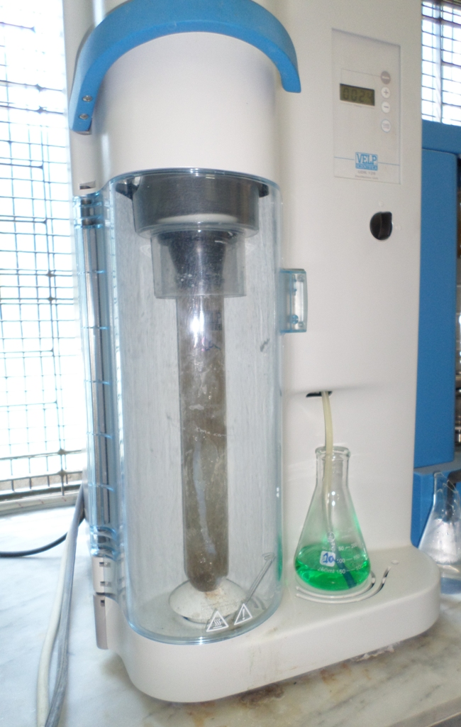
Figure 1: Kzeldhal Digestion to estimateCrude protein (CP)

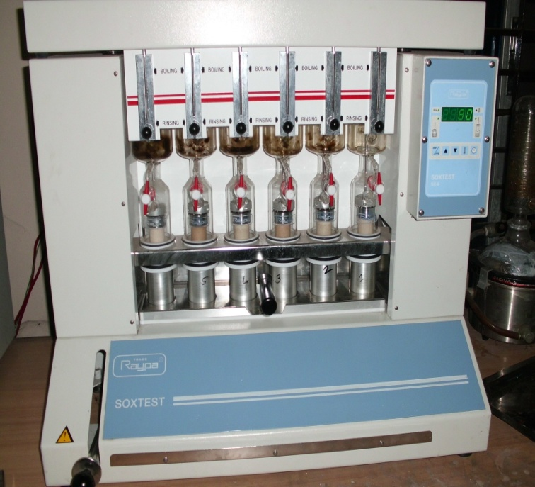

Figure 2: Estimation of Ether extract (EE)

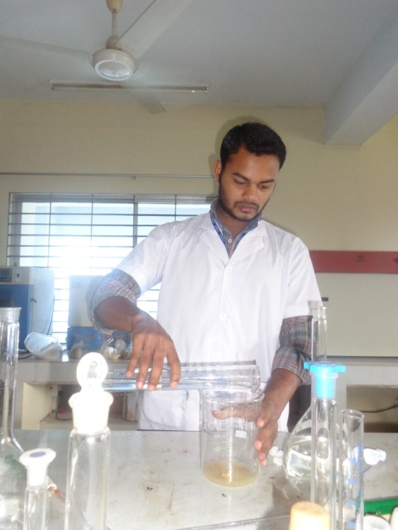
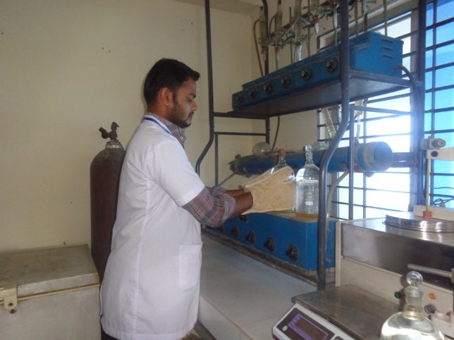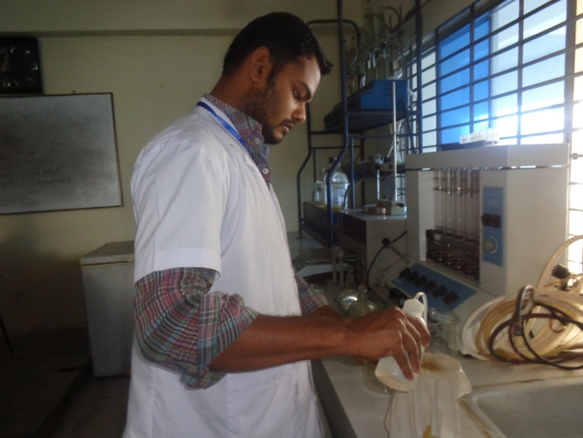
Figure 3: Estimation of Crude Fibre (CF)

CHAPTER-3

RESULTS AND DISCUSSIONS
Variation of nutrient contents in compound poultry feed:
The chemical compositions of the feed samples of three different feed mills are shown in table 1. Reference values for nutrients of Broiler Grower feeds recommended by different researchers are shown in table 2. The information regarding the levels of nutrients in the feeds as claimed by different companies and analytical levels are shown simultaneously for comparison. For convenience of better presentation, the quality of a feed with respect to its nutrient contents, the analytical values of nutrients of different feed mills are also discussed in graphical representation.

Variation of Nutrients in feeds of Broiler Grower of three different feed mills
Chemical composition of layer mash feeds from different feed millers company particularly, moisture, crude protein (CP), crude fiber (CF), ether extracts (EE) , ash contents have been presented in Table 1.
Table 1. Chemical composition (g/100gDM) of Broiler grower feeds from different feed mills:
Name of the company | Moisture | ME# | CP | CF | EE | Ash
Provita | 11.89 | 2680 | 19.95 | 6.5 | 3.2 | 5.8
CP(Charoen Pokphand) | 12.01 | 2755 | 19.77 | 4.95 | 3.5 | 5.8
Nourish | 11.50 | 2743 | 19.01 | 5.92 | 5.8 | 5.6
Level of Significance | NS | NS | NS | NS | NS | NS
^{NS}Non-significant (P>0.05); #Metabolizable energy (kcal/kg); ^{DM}Dry matter; ^{CP}Crude protein; ^{CF}Crude fibre; ^{NFE}Nitrogen free extract; ^{EE}Ether extract

Table 2. Reference values for nutrients of Broiler Grower feeds recommended by different researchers:
Reference | Moisture  (%) | ME  (kcal/kg) | CP  (%) | CF  (%) | EE  (%) | Ca  (%) | P  (%)
Larbier, M. and Leclerc, B.(1992) | 12 | 2750-2900 | 16-17 | 4 | 3.5-4.0 | 3.5 | 0.40
Banerjee, G.C. (1995) | 10 | 2700 | 18 | 8 | - | 2.75 | 0.50
Verma D. N.(2006) | - | 2700 | 18 | - | - | 3 | 0.45

Comparative study of nutrient concentrations of Broiler Grower feeds of different feed mills:
Table 3: Feed company report and analytical report of Provita
Nutrients | Feed Company report | Analytical report
Moisture% | 12 | 11.89
ME(kcal/kg) | 2800 | 2680
CP% | 20 | 19.95
CF% | 5 | 6.5
EE% | 3.8 | 2.95
Source of Company report: Specification attached with the collected feed bag.
Observation on the nutrient concentrations of Provita Broiler Grower feeds showed that moisture, CP, EE and ME contents were found lower in comparison to those shown by the feed company which are important ingredients in Broiler ration. On the other hand, CE content of this feed was found higher to the standard shown by the company.
Table 4: Feed company report and analytical report of CP
Nutrients | Feed Company report | Analytical report
Moisture% | 12 | 12.01
ME(kcal/kg) | 2800 | 2755
CP% | 20 | 19.77
CF% | 6 | 4.95
EE% | 4 | 3.5
Source of Company report: Specification attached with the collected feed bag.
All the chemical compositions found by the CP(Charoen Pokphand) Broiler Grower feed i.e. ME, CP, EE, CF contents were slightly lower than the company recommended value and moisture was slightly higher in contrast to the standard level of this feed company.
Table 5: Feed company report and analytical report of Nourish
Nutrients | Feed Company report | Analytical report
Moisture% | 12 | 11.50
ME(kcal/kg) | 3000 | 2743
CP% | 20 | 19.01
CF% | 5 | 5.92
EE% | 3.5 | 4.3
Source of Company report: Specification attached with the collected feed bag.
In case of Nourish Broiler Grower feed, moisture, CP, and ME contents were found lower in comparison to those shown by the feed company which are important ingredients in Broiler ration. On the other hand, CF, EE content of this feed were found slightly higher to the standard shown by the company.
Variation in Nutritional composition of Broiler Grower feeds of different feed mills (Graphical presentation)

Metabolisable energy: Metabolisable energy (kcal/kg) is higher provided by CP company than other companies which is 2755 kcal/kg. Nourish company provides 2743 kcal/kg (Graph-1). The specified level given by the two companies is 2800kcal/kg. But the standard level is 2750-2900 kcal/kg Larbier and Leclerc, (1992).

Figure 1 : Metabolisable Energy (Kcal/kg) of Broiler Grower feeds of different feed mills.

Crude protein (%): All companies provide crude protein almost nearer to the reported value given by the companies and the standard value. The standard level of crude protein is 19-20 % Larbier and Leclerc, (1992).
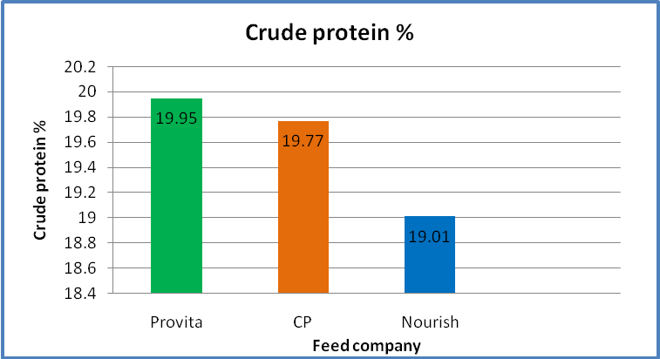
Figure 2: Crude protein (%) of Broiler Grower feeds of different feed mills.
Moisture (%) : Almost all companies follow the standard level of moisture that is 12% Larbier and Leclerc, (1992). The moisture (%) of different companies is almost nearer to the standard level given by the company.
Figure 3: Moisture (%) of Broiler Grower feeds of different feed mills.

Crude fibre (%): All companies provide crude fibre almost higher to the standard level. Provita provides higher crude fibre (6.5%) which is higher than the company standard (5%). Other company provides more or less same percentage in the ration (Graph-4) and the standard level is 5 % Larbier and Leclerc, (1992).
Figure 4: Crude Fibre (%) of Broiler Grower feeds of different feed mills.
Ether extract (%): CP and Provita and Nourish all three company provide higher level of EE (Graph-4) which is 3-3.5 % Larbier and Leclerc, (1992).

Figure 5: Ether extract (%) of Broiler Grower feeds of different feed mills.

CHAPTER-4
Limitations of the study:
- In this proximate analysis, we estimate total N₂, not the ultimate protein & NPN (Non Protein Nitrogenous Substance).
- Again it estimates %CP from N₂ multiplying by 6.25 assuming that all protein contains 14-18% N₂. So over & under estimation of N₂ can be happened.
- During estimation of %CF, acid & alkali boiling is going on the hemicelluloses is partially destroyed. So there can be a little variation from the real value of %CF.
- We can’t estimate vitamins, calcium and phosphorus level of feed by using this method.
- Any deviation in results may be due to environmental or experimental error.
- The study area was also limited.
- It was not all possible to get economic date from record sheet of those farms exactly because most interviews were done over phone call. So some deviation from exact data was occurred.

CHAPTER-5

CONCLUSION
Poultry requires more scientific ration than any other livestock. The deficiency of a nutrient in layer ration can greatly affect the production and quality of eggs. Fortunately the nutrient requirement of chicken is known as much detail and accurate than any other livestock. The data included in the study represents the variation among the quality of layer feeds from selected manufacturers and farms which are somewhat slightly differed from standard and also from their company standard. Each manufactures has its own formulation which doesn’t remain constant throughout the whole year but changes according to the feasibility of the constituents of the poultry feed. The existing information about the composition and nutritive value of the Broiler feed permits the Broiler farmers to select the best one for the better growth and health of the poultry on the basis of cost and profitability. All the companies and Broiler farm owners should be concerned during ration formulation of Broiler Grower birds to fulfill nutrient requirement of them and hence to increase productivity of meat and to make more profit to make a happy, poverty free Bangladesh.

CHAPTER-6

REFERENCES

Ahmed, S. and Islam, I., 1990. Backyard poultry development project in 100 village proceeding of the 1st conference of Bangladesh Animal Husbandry Association, Dhaka, Bangladesh. Pp:133-138.
AOAC, 1990. Official methods of Analysis, Association of Official Analytical Chemists, 20th edition, Washington, D.C.
Banerjee, G.C. 2005. Poultry, A Textbook of Animal Husbandry, 8th edition, Raju Primlani for Oxford and IBH Publishing Company Private Limited, New Delhi. Pp: 858-931.
BBS, 2009. Bangladesh Bureau of Statistics, Statistical Yearbook of Bangladesh. Ministry of Planning, Dhaka, Bangladesh.
Damerow, G. 2012. The Chicken Encyclopedia: An Illustrated Reference. Storey Publishing, Pp: 118–119, 135–136.
DLS (Department of Livestock Services), 2007. General information related to livestock, Monthly livestock and fisheries bulletin published by fisheries and livestock information office, Khamarbhari, Farmgate, Dhaka, Bangladesh.
DLS (Directorate of Livestock Services), 2012-13. General information related to livestock. Monthly livestock and fisheries bulletin published by fisheries and livestock information office, Kharmarbhai, Farmgate, Dhaka, Bangladesh
FFYP, 2003. The Fifth Five Year Plan, planning Commission, Ministry of Planning, Government of the Peoples Republic of Bangladesh.
Fuller, M.F. 2004. The Encyclopedia of Farm Animal Nutrition. CABI. p. 68. ISBN 978-0-85199-369-0. Retrieved 7 November 2012.
Hossain, S. 1999. Recent trends in the rural economy of Bangladesh poverty and development. Institute of Development Studies Journal. Dhaka, Bangladesh. Pp:216-236.
IFPRI, 2000. www.cgiar.org/IFPRI.
Latif, M. 1999. History of Poultry Industry in Bangladesh. Proceeding of the seminar of International Poultry Show. WPSA. Bangladesh Branch. Pp: 11-17.
McNab, J., 1999. Advance in poultry nutrition in the world. Proceeding of the seminar and international poultry show. WPSA. Bangladesh branch. Pp: 52.
Pattison, M. 2008. Poultry Diseases 6e. Elsevier Health Sciences. p. 550. ISBN 978-0-7020-2862-5. Retrieved 7 November 2012.
Reddy, D.V. 2008. Nutritional Terms, Proximate composition and chemical composition, Principles of animal nutrition and feed technology. Kalyani Publishers, New Delhi. Pp:18.
Rosenberry, B. 2002. Critical care of shrimp. Feed quality. Feed international. Pp:10.
Singh, R.A. 2004. , Poultry nutrition, Poultry production. 5th edition, Kalyani publishers, New Delhi. Pp:143-144.
Singh, R.A. 2004. Poultry feeding, Poultry production. 5th edition, kalyani publishers, New Delhi. Pp:197-198.
Verma, D.N. 2006. Feeding of Poultry, Atextbook of animal nutrition, 2nd edition, Kalyani publishers, New Delhi. Pp: 386-391.

ACKNOWLEDGEMENTS

It goes without saying that all praises goes to Almighty Allah ,the omnipotent, omnipresent and omniscient Who has enabled the author to complete this manuscript successfully.
The author does not have adequate words to express deepest sense of gratitude, heartfelt respect and immense indebtness to her honorable teacher and internship supervisor, Professor Goutam Buddha Das, Dept. of Animal Science and Nutrition, Chittagong Veterinary and Animal Sciences University for his scholastic guidance, sympathetic supervision, valuable advice, constant inspiration, radical investigation and constructive criticism in all phases of study.
The author wishes to give special thanks to DR. Mukti Barua, Lecturer, Dept. of Animal Science and Nutrition, DR. Mohammed Abdul Mannan, VS, SAQTVH for their helping hand in writing the report and analyze the collected data carefully.
The author would like to thank all the staff of the Dept. of Animal Science and Nutrition, Chittagong Veterinary and Animal Sciences University (CVASU) and also to the personnel of the Graduation Research division of the University, for their active cooperation and ongoing support in the course of this study.
Lastly but not the least, the author expresses thanks to all of his family members, friends, seniors, juniors and farm attendants for their cordial helping hands.

The Author
November, 2015

BIOGRAPHY

Mir Md. Afzal Hossain passed Secondary School Certificate (SSC) examination from Bangladesh Railway Govt. High School, Pahartali, Chittagong in 2006 and then Higher Secondary Certificate (HSC) examination from Hazi Mohammad Mohsin College, Chittagong in 2008. He enrolled his internship program for Doctors of Veterinary Medicine (DVM) Degree in Chittagong Veterinary and Animal Sciences University (CVASU), Bangladesh. He has immense interest to work in reproductive cases of veterinary field.

