A Report on Status of Love Bird in Bangladesh, Khulshi, Chittagong.
BY
NASIMA AKTER
Roll No: 2010/13
Reg. No: 492
Intern ID: A-08
Session: 2009-2010
A clinical report presented in partial fulfillment of the requirement for the degree of
DOCTOR OF VETERINARY MEDICINE

Faculty of Veterinary Medicine

CHITTAGONG VETERINARY AND ANIMAL SCIENCES UNIVERSITY, KHULSHI, CHITTAGONG-4225

A Report on Status of Love Bird in Bangladesh, Khulshi, Chittagong.
Approved

…………………………………………………………….
Professor Dr.Gouranga Ch. Chanda
Dept. of Dairy and Poultry sciences
Chittagong Veterinary and Animal Sciences University

CHITTAGONG VETERINARY AND ANIMAL SCIENCES UNIVERSITY
KHULSHI, CHITTAGONG-4225
December, 2015
TABLE OF CONTENTS
Contents Page No
LIST OF FIGURES………………………………………………………….. iv
LIST OF ABBREVIATION………………………………………………… iv
ABSTRACT…………………………………………………………………. v
Chapter I INTRODUCTION………………………………………………. 1-5
  - General Introduction with background
  - Objectives
Chapter II MATERIALS AND METHODS………………………………. 6
2.1 Study Area

2.2 Taking Photograph

2.3 Searching webs and printed materials

2.4 Observation
Chapter III RESULTS AND DISCUSSION……………………………… 7- 23
3.1 Breeds of Love birds………………………………………. 7-9
3.2 Social status………………………………………………… 9
3.3 Common food……………………………………………… 9 - 10
3.4 Common behavioral physiological characteristics……………. 10 - 14
3.5 Reproductive characteristics……………………………………. 15-17
3.6 Husbandry practices in cases of pets…………………………… 18-20
3.7 Diseases of love birds and remedial care………………… …… 20-23
Chapter IV CONCLUSION & LIMITATION……………………………… 24
ACKNOWLEDGEMENTS ……………………………………..... 25
REFFERENCES………………………………………………………………. 26-28
BIOGRAPHY………………………………………………………………….. 29
Table of Figures
Figure No | Contents | Page no
1 | Feeding | 10
2 | Feeding to female | 15
3 | Matting | 15
4 | Bathing | 14
5 | Sleeping | 14
6 | Hand feeding to baby Chicks | 11
7 | Sunflower seeds | 11
8 | Chicks | 17
9 | Nest with Eggs | 17
10 | Cage with Fischer’s love bird | 17
11 | Stuffing of paper between tail feather | 17

LIST OF ABBREVIATION
Abbreviation and Symbol | Elaboration
% | Percent
et al. | And his associate
CVASU | Chittagong Veterinary and Animal Sciences University
Fig | Figure
> | Greater than
⁰ | Degree
F | Farenhight
Etc | Et cetera

ABSTRACT
The study on common characteristics of Love birds was conducted during the period of September to November, 2015 at the different area of Bangladesh.This study was conducted to analyze present status and common characteristics of Love bird. The aim of the study was to know variety of Love bird, health status and behavioral and reproductive characteristics of Love bird. The method of this study includes phenotypic observation of Love bird through photography, collection of information from internet, interviewing people. Love birds are so loved by common people. The love birds are native to Africa and Madagascar. There are 9 species of love bird in the world whereas,only 5 species such as Peace faced (Agapornis roseicollis),Black winged (Agapornis taranta), Fischer’s (Agapornis fischeri), Lilian’s (Agapornis lilianae), Masked (Agapornis personatus) love bird available in Bangladesh. As an adult, Love bird mostly feeds on formulated diets, seeds, Fruits and Vegetables, Vitamins Supplements etc. Feed requirement of lovebird 1/2 to 2 ounces (45-60 grams) of feed daily for a single bird. The normal body temperature ranges between 101-108⁰F, respiration rate 40-45 per minute, heart rate 350-450 per minute. A temperature of 99⁰F-101⁰F that ideal heat for egg to incubate. Love bird attains sexual maturity at the ages of 5-6 months. Females are slightly larger than males in case of Dimorphic birds. The love bird is monogamous. At ten month old, they starts their courtship, sexually active until age 13.. The male usually regurgitates to feed the female on the nest before they mate. Each clutch usually contains between 4 and 6 eggs which are bluish in color. The cock also helps to incubate, but spends much of his time guarding the nest box entrance. Young chicks leave nest at about 38-50 days. The young are independent at 14 days after leaving nest. Common diseased are Psittacine Beak and Feather Disease, Polyoma Virus Infection, yeast infections (Candidiasis), Avian Pox Virus Infection, bacterial infections, internal parasites, mites, ticks, egg binding, intestinal influenza, coccidiosis, respiratory ailments, and diarrhea.. Common drugs used in SAQTVH, CVASU are Renamox powder, Enroflox, Civox vet, Doxy-A vet, Sulfatrim pow, Sumit vet pow, Furidon-vet, Cosomix plus, Coliprim pow, Denaguard, piper vet, Vit AD3E etc.

Key words: Photography, Interviewing people, Species, Phenotypic ovservation etc

1.1Introduction:
Bangladesh is the world largest deltaic region lies in north eastern part of South Asia between 20⁰34’ and 26⁰38’ North Latitude and 88⁰01′and 92⁰41′ East latitude, (Hossain; 2001). Bangladesh possesses of rich fanual diversity. The country has approximately more than 628 species of bird, (IUCN; 2000). More than 8000 species of birds live all over the world. Of these about 350 species are parrot, (Pamela leis Higdon; 1997). The love bird is a kind of bird in the parrot family, Psittacoidae. Lovebirds belong to thegenus Agapornis, (Alma B.Apostol; 2015) under Kingdom Animalia, Phylum Chordata, Class Aves, Order Psittaciformes, Super family Psittacoidea, Family Psittacoidae, Subfamily Agaporinithinae, Genus Agapornis (Selby; 1836).
The Greek word Agape means “love” Ornis means “birds”, (Vera Appleyard; 2001). Acquired their name because of their fondness for sitting in pairs while preening eachother’s feathers.Those originate from Africa and its adjacent islands. There are nine species of lovebirds. Eight of these species originate on the African continent, except the ninth (The Grey-headed Lovebird) which coming from the island of Madagascar, (Nikki Moustaki; 1970). Most lovebirds live close to the equator where they inhabit dry savannah regions, (Clarice Brough; 1998). There is one exception, a forest dwelling lovebird, the Black-collared Lovebird, (Clarice Brough; 1998).
This is the small first birds lived on earth long before humans during the Jurassic period, the day of Dinosaur, (Pamela leis Higdon; 1997). Fossils of ancient lovebird species have been unearthed in South Africa, dating to as far back as 1.9 million years ago, (Helen Thompson; 2014) The first love bird known to Europeans was the Red faced love bird. This bird was described about in the 1600s, (Nikki Moustaki; 1970) and was the first lovebird imported into Europe during the 19th century. It was found in more widely in the wild than any of the other species. Other species of lovebird were imported soon after the Red Faced except the Peach face which was thought to be variant of the Red Faced, although the Peach Faced lovebird was acknowledged by the British Museum in 1793. It wasn't until 1817 that the Peach Faced lovebird was recognized as a separate species of lovebird and were imported into Europe in the mid 1800's, (Nikki Moustaki; 1970).

Lovebirds are active, cheerful and beautifully decorative. These little 'pocket' parrots are very fascinating! They are very suited to captivity, because they evolved from a very harsh environment, (Clarice Brough; 1998). These charming, brilliantly colored, feisty little pets are very hardy, inquisitive, curious, always on the go, (Lafeber.com; 2015) and easy to care. It pack a lot of personality into a small package. They are very social and form deep bonds with their owners and are sometimes very cuddly birds, but their intense personalities can also make them prone to nipping and territorial aggressiveness and jealousy. Some experts believe that females are more prone to jealousy and territoriality than males, (Lianne Mc Leod; 2009).

A common myth about keeping lovebirds is that they should always be kept in pairs because they are often see photos of two lovebirds cuddled up against one another, (Lianne Mc Leod; 2009).No doubt, a lovebird often forms a deep bond with another lovebird than owner, (Lafeber.com; 2015)

A single lovebird will do well, as long as it gets the social interaction, contact, affection, and attention that it needs from its human family members. If anyone has short on time to spend with his/her lovebird, then it is best to get him or her a companion, (Lianne Mc Leod; 2009) as well as plenty of busy work in the form of toys such as wood, raw hide, bells, ladders ropes and mirrors etc, (Alma B. Apostol; 2015) safe items to chew up and destroy, (Lafeber.com; 2015) A female lovebird can become highly defensive of her territory(cage), (Lafeber.com; 2015) In the wild lovebirds live in flocks. They will often bond with a mate for life and show fierce loyalty and affection to their family. They are very social with both their keepers and their mate,(Clarice Brough; 1998). Love birds are approximately 5 ½ to 7 inches in length long from head to tail, (Mary Gorman; 1997). They weight between 40 and 60 grams characterized by a stocky build, a short blunt tail, and a relatively large, sharp beak, (Alma B. Apostol; 2015). Wild type lovebirds are mostly green with a variety of colors on their upper body, depending on the species. Love birds come in a wide range of bright colors. May find love birds that have greens, blues, yellows, purples, oranges, and whites in all shades and combinations. All of the Lovebirds will live for up to 20 years in captivity, (Mary Gorman; 1997 ).

Traditionally, lovebirds are divided into two groups, the sexually dimorphic species such as Madagascar, Abyssinian, and red-headed lovebird another one is Monomorphic contains Eye ring and Non eye ring love bird, (Roland G. Dubuc; 2011). Dimorphic means the cock is visibly different in color from the hen. Three of the nine species are dimorphic. Those species are Madagascar, Red-faced, and Abyssinian, (Roland G. Dubuc; 2011).
In particular, the peach faced, the fischer’s, and the masked love birds did particularly well in captivity. Unfortunately,the remaining six of nine species of love birds never become widely established in the fancy,as breeding birds, (Nikki Moustaki; 1970).
Lovebirds should be fed a variety of foods. A good pelleted diet , a variety of fresh foods, fresh fruits and vegetables and some seeds are provided (seeds should make up less than 25 percent of the total diet, Lianne Mc Leod; 2011). Breeding age hens should be placed on a calcium supplement to counteract the nutrients that they lose during egg-laying. A cuttlebone can be provided for extra calcium.
Lovebirds need a nest box in which to lay their eggs. The proper size for a Lovebird is about 12"x12"x12”, (Alyson Kalhagan; 2015).The space between bar is 3/8 to 7/16 inch, (Alma B.Apostol, 2015) with Proper nesting material, such as shredded paper, should also be provided. At ten month old, they starts their courtship, sexually active until age 13. Female Lovebirds will lay their eggs between 5 - 10 days after mating. Many will lay an egg every other day until they have all been laid. Each clutch usually contains between 4 and 6 eggs, (Alma B. Apostol; 2015). On average, Lovebirds incubate their eggs for about 21- 23 days, (Alyson Kalhagan; 2015).
Conservation status of the world’s love birds are Black-cheeked lovebird is vurnarable, Black collared lovebird is least concern. Black-winged lovebird is least concern, Fischer’s love bird is Not threatened, Peach-faced lovebird is Not threatened, Lilian's lovebird is Not threatened, Red-headed lovebird is least concern, Grey-headed lovebird is least concern, Yellow colored love bird is least concern, (IUCN Red List; 2013)
Species and subspecies:
peach-faced lovebird, Agapornis roseicollis, (Vieillot, 1818) Agapornis roseicollis catumbella, (B.P. Hall, 1952) Agapornis roseicollis roseicollis, (Vieillot 1818) Masked lovebird, Agapornis personatus (Reichenow, 1887) Fischer's lovebird: Agapornis fischeri (Reichenow, 1887) Lilian's lovebird: Agapornis lilianae (Shelley, 1894) Black-cheeked lovebird, Agapornis nigrigenis (W.L. Sclater,1906) Madagascar lovebird, Agapornis canus (Gmelin,1788) Agapornis canus ablectaneus (Bangs,1918) Agapornis canus canus (Gmelin,1788) Black-winged lovebird, Agapornis taranta, (Stanley,1814) Red-headed lovebird, Agapornis pullarius, (Linnaeus,1758) Agapornis pullarius pullarius, (Linnaeus,1758) Agapornis pullarius ugandae, (Neumann,1908) Black-collared lovebird, Agapornis swindernianus, (Kuhl, 1820) Agapornis swindernianus emini (Neumann,1908) Agapornis swindernianus swindernianus (Kuhl,1820) Agapornis swindernianus zenkeri (Reichenow,1895)

1.2:Objectives:
However, the main objectives of the study were-
- To study the common biophysical characteristics of love bird.
- To address some fundamental question of ecology, using reference studies in an environment largely untouched by civilization.
- To know the feeding, nutrition, breeding parameter of love bird.
- To analyze the communities primeval habitats as reference for the assesment of anthropogenic impact on species communities in Bangladesh.
- To determine the extent and location of existing habitat suitable for meeting the habitat requirement of individual population of priority species group.
- To know the common diseases of love bird and their prevention.

Chapter-II
METHODS AND MATERIALS
2.1 Study area:
The study was conducted in some areas in Bangladesh as per convenience. As an intern student some areas- Chittagong and Dhaka were visited for the study. So, there was a great chance for study and getting a chance for creating a informable, successful report writing.
2.2 Taking photographs:
It was a very difficult task to taking photographs of Love birds because it always moving.
2.3 Searching webs and printed materials:
There are many web sites are available about Love birds. Some journals are also available with various studies or experiments on Love birds. There are some books on Love Birds also written by some interested authors.
2.4 Observation:
Observation was also used as a tool for studying about Love Birds. This facilitates to study their body characteristics, habitats, feeds and feeding, breeding, diseases etc.

Chapter-III
RESULTS AND DISCUSSION
Love bird is native to Africa and its adjacent islands. There are nine species of lovebirds. Eight of these species originate on the African continent, except the ninth (The Grey-headed Lovebird) which coming from the island of Madagascar, (Nikki Moustaki; 1970). It the most widely distributed wild bird. There are under the parrot family. Lovebird belong to the genus Agapornis, (Alma B. Apostol; 2015). Among these 5 species are found in Bangladesh.
3.1:A short description about these species of are given in the following table:
Common and Other name | Species | Photograph | Description | Range
Yellow-collared lovebird  or masked lovebird | (Agapornis personatus) | 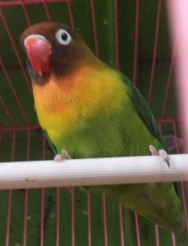 | 14 cm (5.5 in) long. It has a generally green plumage, with the head, including the lore’s and cheeks, brown to sooty black. A yellow collar, about half an inch wide at its narrowest point on the back of the neck, is widest on the breast. The cere, and bare skin area around the eye, is white. The bill is red, and the feet are blackish-gray. Yellow and green. It has blue tail feathers, (Roland G. Dubuc; 2011). | Northeast Tanzania
Fischer's lovebird | (Agapornis fischeri) | 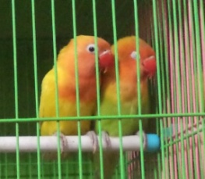  Mutant Fischer’s love birds | 14 cm (5.5 in) long. These are green, being darker on the wings and back, and lighter on the under parts.The forehead is bright orange-red, suffusing to dark olive, with cheeks and throat a paler orange. The rump and upper tail coverts are violet blue. The bill is coral red, the cero and bare skin around the eye is white and the feet are pale gray, (Roland G. Dubuc; 2011). | South and southeat of Lake Victoria in northern Tanzania
Lilian's lovebird  or Nyasa lovebird | (Agapornis lilianae) | 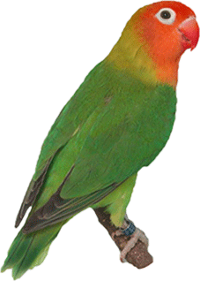 | Length is 13 cm (5 inch) long. Female is usually slightly bigger and heavier than male.Average weight 35 g, The head is bright salmon to orange, brighter on the forehead, and paler on the cheeks, throat and upper breast. The core and ring around the eye are bare white skin. The bill is red, and the feet are gray, (Roland G. Dubuc; 2011. | Malawi
Peach-faced lovebird  or rosy-faced lovebird) | (Agapornis roseicollis | 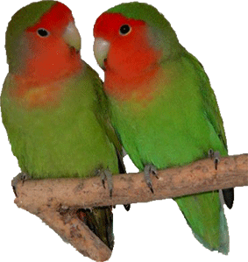 | 15 cm (6 in) long. It has an overall bright, almond-green plumage, which is yellow on the underside, with a brilliant blue rump. The frontal band is a deep rose-red, and the lore’s, sides of the head, and throat, are a paler rose-red. The bill is horn colored and greenish toward the tip. The feet are gray, (Roland G. Dubuc; 2011). | Namibia, South Africa, Angola
Black-winged lovebird  or Abyssinian lovebird | (Agapornis taranta) | 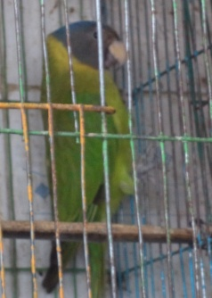 | 16.5 cm (6.5 inch)in long The cock is viridian green, small ring of feathers around the eye, are carmine red and the under wing coverts are black. Hens have no red on the head or eye area, their under wing coverts are green, but variable to black with some green, (Roland G. Dubuc; 2011). | southern Eritrea to southwet-ern Ethiopia
3.2:Social Behaviors
Lovebirds as pets, as well as in the wild, are very social birds. Generally and in most situations, it is thought to be essential for their good health and happiness that they be kept in pairs, not singly. If keeping a single lovebird, must provide the necessary social interaction that it is missing from another bird. Aside from their social nature toward you or their mate, lovebirds can be extremely aggressive towards other birds. (Clarice Brough, 1998)
3.3:Common Foods:
Foods available for Lovebirds include formulated diets, either pelleted or extruded, seeds, Fruits and Vegetables, Vitamins Supplements etc. A lovebird diet will consist of 1 1/2 to 2 ounces (45-60 grams) of feed daily for a single bird (Clarice Brough; 1998). A formulated diet provides a good nutritional base, so the addition of vitamins is less important in case of A formulated diet. However it does not contain the phytonutrients (antioxidant pigments) that are found in vegetables, fruits, grains, and seeds, which boost the immune system, help a body to heal itself, and to prevent some diseases. Also, parrots can become bored with formulated diet due to the lack of variety.
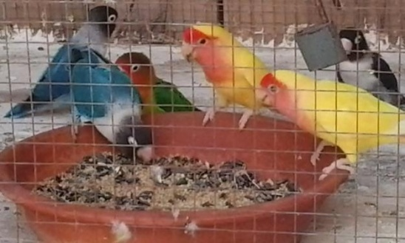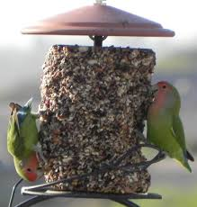
Fig: Feeding
A seed only diet offers much more variety (seeds should make up less than 25 percent of the total diet, Lianne Mc Leod; 2009) but requires additional vitamin and calcium supplements. Mixed seed can also be offered. But should keep in mind that loose seedmix is more likely to lovebird than mash. Nutri-berries, Avi-cakes, and Pellet-berries require to work to pry off a piece, so bird is more likely to get a variety of seeds. seed mixes may also contain canary seed, millet, rice, oats, safflower and a small amount of sunflower seeds,(www.wikihow.com) due to love birds need not only nutritional requirements met but also variety for psychological enrichment, (Clarice Brough; 1998).
Although, seed mixes and pelleted diet are supplied for love bird. Fruits and vegetable supplements will make the birds more happy and healthy.Vegetables such as yellow and dark green leafy varieties that are rich in vitamin-A, (Mary Gorman et al; 2005). Fresh vegetables, greens, tree branches for the bark, some fruits, and millet spray. Some of the
fruit supplements include berries, apples, grapes, pears, bananas, and kiwi. Some of the greens and vegetable supplements include spinach, endive, watercress,
Chick weed, radish, parsley, dandelions, carrot tops, corn on the cob, peas, endive, field lettuce, and various garden herbs. A bit of shredded carrot, a few Sprouts, a leaf Spinach, a sign of piper, a cube Melon, a pea pod etc provide a good variety of taste and nutrient for birds. Lovebirds drink a lot of water, so will need fresh drinking water every day, (Clarice Brough; 1998).
Home made Mixture:
- 40% Yellow millet - 18% Canary seed - 10% White millet - 9% Peeled oats - 5% Japanese millet - 4% Safflower - 4% Buckwheat - 3% Paddy rice - 3% Oats - 2% Linseed - 2% Hempseed, (www.wikipedia.com).
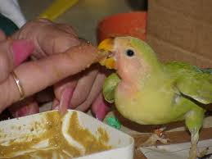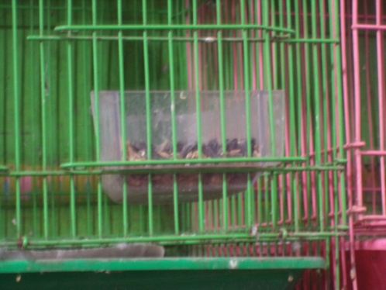
Fig: Hand feeding to baby Chicks Fig: Sunflower seed
Hand feeding Schedule of Baby Chicks:
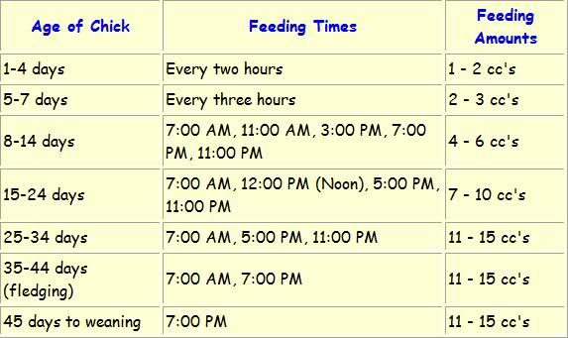
3.4;Common behavioral and Physiological characteristics:
Every love bird has its own individual personality; however there are some characteristics that are commonly found in most love birds.
Active and energetic: There is constant motion and activity when living with a love bird. They are not afraid of other people’s motion or activity, either. In busy households, love birds often fit right into the picture. A pet love bird can thoroughly enjoy riding around on your shoulder while you go about daily activities and household chores. Love birds can rarely stand still for long periods of time, so they are not very cuddly. Cuddle time with a pet love bird is most likely to happen late at night, when the bird is tired and ready for bed.
Curiosity killed the cat: Love birds are extremely inquisitive. They are practically fearless and insist on exploring all unknown things. This can be both a good and a bad trait. Pet love birds are open and willing to meet new people and travel to new places with their owners. If well socialized, they rarely become one-person birds. While they may choose a person to favor, they will also willingly play with other people. At the same time, many love birds have met their demise by investigating dangerous situations (including birds much larger than themselves).
Love birds have a mind of their own: If there is something a love bird has decided that it wants to do, it will try everything in its power to do it. Distracting a love bird that has a task or object in mind can be a challenge. Patience and persistence is the key. However, love birds rarely ever demand constant attention from their owners. When provided with enough toys to keep their minds active, love birds will happily play in their cage or on their play gym.
Domineering, commanding, and controlling: In the wild, love birds are flock birds. Their place in the flock must be established and protected. Young love birds need to establish their place in the flock as well, whether their flock be comprised of humans or other birds. This can be a challenging time for pet owners. A young lovebird can be expected to routinely challenge authority in order to determine what its role will be in the flock. A pet love bird owner needs to be able to calmly but firmly maintain their role as the leader of the flock. Once the love bird understands where they fit into the group, they will not challenge authority on a routine basis.
Smarter than the average bear: Don’t be fooled by their small size, love birds are very intelligent creatures. They can learn to mimic common household noises such as the beep of the microwave. They can also learn to imitate the sounds of other birds. Very few love birds will learn to talk. They do possess the gift of observation, and many love birds have learned how to let themselves out of their cages or dump their food dishes in order to get some new food or treat. With patience, a love bird can also be potty-trained. Pet owners find this trick to be especially useful.
No-guess, no-nonsense emotions: If your pet love bird is happy, then you will know it. If he desires to be let out of his cage, you will be made aware. If he’s feeling a bit moody and would like to be left alone, you will be notified. If he is mad at you or holding a grudge against you, then you will most certainly be the first to know about it. Love birds do not hide their emotions from their owners. You can expect total honesty from a pet love bird.
Sleeping: Sleep is important for lovebirds. If, lovebirds are keep in a cage indoors, should provide a cover for the cage or a smaller sleep cage to help sound sleep at night. Love birds sleep 10-12 hours every night. They sleep from 7pm-6am.Lovebird go to bed at the same time every night and awake at same time every morning, (www.wikihow.com).
Dominant and territorial nature: Lovebirds should be supervised when socializing with other species and genera (whether it be cat, dog, small mammal or other bird species). Lovebirds can be aggressive to other birds, even to other lovebirds. Toe biting can occur when lovebirds are socializing/housed with small birds (parrotlets, budgies, and even docile cockatiels). They should not be housed with other bird genera as they can be injured or pose a threat to other birds, (www.wikipedia.com).
Bathing: If you use a bathing dish, you will see the birds perch on the edge and dip their heads and upper bodies in the water and beating their wings. They prefer this kind of bath to getting into the water, (www.wikipedia.com).
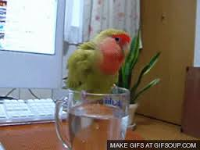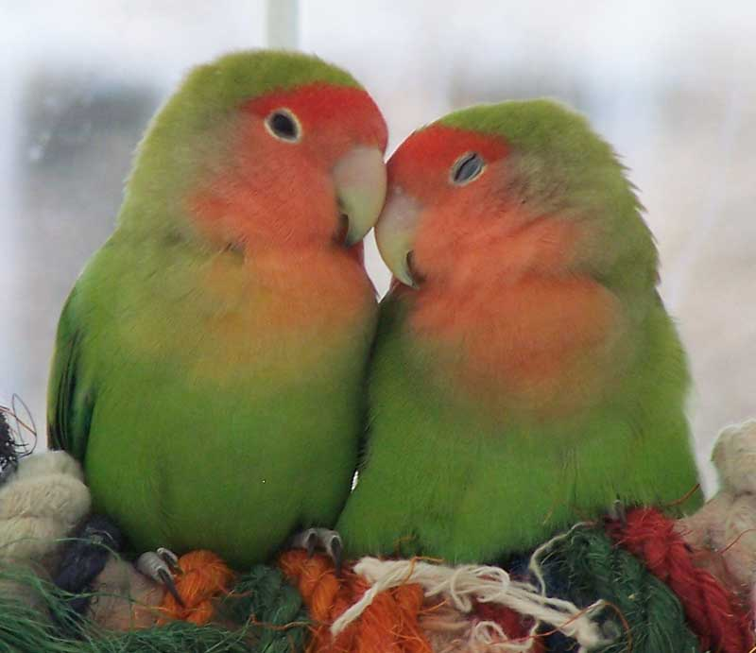
Fig: Bathing Fig: Sleeping
Bird Grooming: Lovebirds generally maintain their nails and beaks on their own through climbing and chewing. Another good use they make of their tree branches. Singing bird: They do sing, but their time for singing is around 12pm-2pm
Active bird: These birds are very active, flying and climbing about, gnawing on wood or chew toys, and grooming themselves many times all day
Toy lover: They love toys of all kinds such as seed bells, swings, ladders, mirrors, shiny objects, and wooden gnaws.
Temperament: Lovebirds are intelligent, affectionate, and playful little birds. With proper care and adequate socialization, many form especially strong bonds with their owners. Those that don't have a lot of time to spend with a Lovebird typically purchase a mate for their pet, as these birds are extremely social and cannot thrive without interaction.
Vocal bird: Vocal Lovebirds are very vocal birds, making loud, high-pitched noises. Some make noise all day, especially during dawn and dusk. This is a normal parrot behavior as flock animals, where they are calling to each other before the start of the day and just before they settle down for the night.

3.4:Reproductive Behaviours
Breeding and Courtship: In captivity, lovebirds breed any time during the year. In the wild, however, breeding seasons differ for different species. For peach-faced lovebirds, it's April, October and February through March. Fischer's lovebirds, breed during the dry season that lasts from January through July, (Jassey Kully; 2015). Lovebirds need to be at least 10 months old, though 12 to 13 months is better. Also birds that are 5 to 6 years or older should be retired from breeding, (Sibley Johnson,2011)
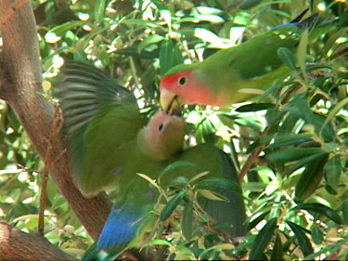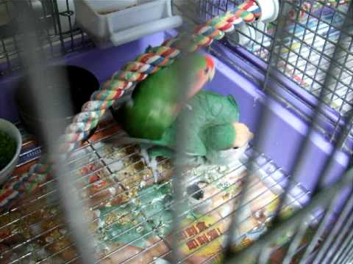
Fig: Feeding to female Fig: Matting
Courtship in lovebirds occurs when the female and male lovebirds attract each other prior to mating, at around 10 month of age,(Alma B.Apostol,2015). Lovebird pairs stay close to each other when they're due to mate. The lovebird partners often behave alike, sitting, perching, and sleeping next to each other. The only time they separate is when they are out collecting nesting materials or looking for food. The proximity of lovebirds is a clear sign that that courtship has started. Mutual grooming is another sign of lovebird courtship. The courting pair will groom and feed each other constantly during breeding season and throughout the year. When courting, the pair will feed each other. Mating often follows when the male feeds the female. The male usually regurgitates to feed the female on the nest before they mate, (Alma B.Apostol,2015). The female usually initiates this action by lowering herself closer to the perch with her mouth open. All lovebird species engage in courtship feeding.
The pair may mate several times per day. In captivity, a pair of lovebirds will generally bond, build a nest and mate, which is why a novice owner, who wants to bond with her pet bird, should stick with one lovebird and choose to be its companion, (Jassey Kelly; 2015). Once the lovebirds start constructing their nest, mating will follow, (www.wikipedia.com). Most breeders will allow the hen to feed the babies from hatching to the age of 2 or 3 weeks. From there, they will pull the babies out of the nest and place them in a brooder for hand feeding. Most Lovebirds need to be handfed until they are between 6 and 8 weeks old, when you can begin to wean them onto millet, soft pellets, and fresh fruits and vegetables, (Alyson Kalhagan; 2015).

Nesting Behavior: Lovebirds to exhibit nesting behavior is approximately 5 months of age, (Jessica Pineda; 2015) Both sexes take part in building the nest, but the female is better than the male at carrying nesting materials. The birds use a variety of materials to build a nesting area, (Kendal Elizaeth; 2015). Lovebirds enjoy tearing up items, such as paper, and create elaborate nests. For example, a peach-faced female exhibiting nesting behavior will shred thin strips of paper and ritualistically stuff them between her tail feathers before carrying them to her nesting area. Fischer's lovebirds will drag the material and create a tunnel nest, (Jassey Kully; 2015) and the masked lovebird carries nesting material back in its beak, (www.wikipedia.com). Some young males and females that are not yet sexually mature may also exhibit nesting behavior as they are learning to be adults.
In the wild, most species of lovebirds gather in large colonies, with many breeding couples building their nests in holes or cavities near each other. To build their nests, females tear up natural items, such as palm leaves and strips of bark, found in their home ranges
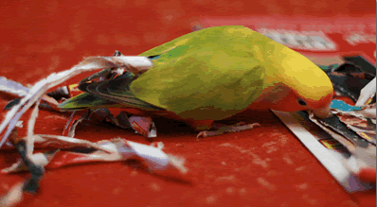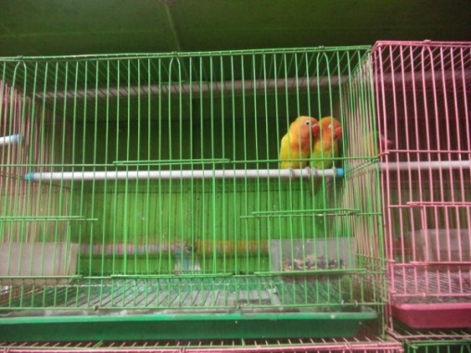
Stuffing of paper between tail feather Fig: Cage with Fischer’s Love birds

The Eggs and Chicks
Female lovebirds usually lay their first egg 4-6 days after copulation, with an additional egg being produced at intervals of 1-2 days thereafter. Usually, the hen sits and is fed by the male. Male Masked Lovebirds, however, often sit near the hen, but it is not clear if they are actually doing anything useful! The eggs hatch in 20-27 days, and the chicks leave the nest after 35-50 days. They are fed by their parents for an additional 2 weeks after fledging, by which time they are usually completely independent.
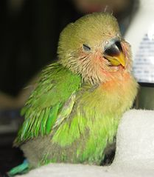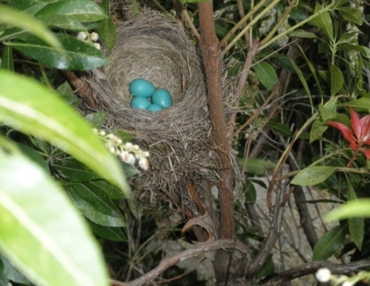
Fig: Chicks Fig: Nest with Eggs

3.6: Husbandry Practice as pet:
Housing: Lovebirds are very active birds. When housing your lovebird, bird cages or an aviary best suited to them must provide a lot of space, (Clarice Brough; 1998). A cage should recommend at least 2 feet wide by 2 feet long (and 2 feet tall), but a larger cage is definitely better (with the length being relatively more important than the height, Lianne Mc Leod; 2009). There should be room enough to place at least two perches, two toys, and three dishes (one for water, one for seed/pellet diet, and one for fresh foods) an area for a bath, leaving enough room for the bird to flap its wings freely.
The cage bars should be spaced at approximately ½ inches. Bars that are spaced too far apart will make it difficult for the bird to hold on to and climb around, (Sibylle Johnson; 2011). Avoid round cages. Provide a variety of perch sizes (including natural branches if possible) as this is healthier for a caged bird's feet, (Lianne Mc Leod; 2009).
Mixing species should be avoided because it can causes serious fights. House either one pair of lovebirds or three pairs, never two pairs or there will be fighting. Each pair needs about 35 cubic feet of space. The perches should place away from dishes so the food and water dish do not become soiled with bird droppings. Do not use plastic because love birds will chew and break the plastic and it can become hazardous. Tree branches of a similar size make good perches and will help to wear the claws down naturally.
The habit of chewing should be considered before building a cage. Wood parts should be wire covered, or else plan on replacing the as the bird destroys them. Lovebirds like special resting places. Nest boxes placed up high, all at the same level and all of the same type work well and help prevent fights, (Clarice Brough; 1998).
Weak, unfiltered sunlight on the cage is ideal as this gives your bird vital ultraviolet-B light to keep her healthy. If your lovebird’s cage is near a window with weak light, you may want to consider investing in a special light bulb that emits safe levels of ultraviolet-B light to hang over your lovebird’s cage. You can turn on the light for 8 to 10 hours a day to make sure your bird gets enough light, (www.wikihow.com). A small travel carrier is also a must. This will come in handy when taking pet love bird for a visit, traveling, or going to the vet.
Love bird as a pet:
Some of the smallest members of the parrot family, Lovebirds have captivated bird owners for over 100 years. Although they rarely talk or mimic, these beautiful little birds are exciting to watch and charming to interact with traits that have made them one of the most commonly kept pet bird species, (www.wikipedia.com).
Three of the nine lovebird species are most commonly available lovebirds for pets. The other six are more rare, and in some cases, absent at least in the United States. The three common species are the Peach-faced Lovebirds, the Masked Lovebirds, and the Fischer's Lovebirds, and all three make wonderful pets. There are a variety of color mutations in lovebirds, developed from these three common species. This is especially true for the Peach-faced Lovebird, which can be bred in hundreds of different combinations of mutations. As a result, there are many new lovebird colors available.
While it's important to consider a Lovebird's emotional needs, owners should take care in choosing cagemates for their pets. Lovebirds that do not get along often become very aggressive and can fatally injure each other. Because of this behavior, it's never a good idea to house a Lovebird with a bird of a different species. Those that choose to keep a pair of Lovebirds must be prepared for the possibility that they will breed. Lovebirds reproduce readily, and a single pair can produce 3 clutches of eggs per year.
Pets and safety
Lovebirds are also very active and love to chew things. When they are flying within a household, it is wise to watch them carefully and protect any furniture, electrical wiring or anything else that they could possibly chew on. The danger spots in the house, such as open toilet bowls for drowning, clear glass walls which might be rammed in full force by the bird, fumes from all teflon or anti-stick coating in the kitchen, microwave coatings, oven coatings and chemical fumes from regular household cleaning products. Interaction with other pets in the house must also be supervised, such as cats and dogs which may view the lovebird as a prey animal, (www.wikipedia.com). Be sure this room is safe with no open doors or windows, no toxic plants, no open water containers, and no hot stove, (www.wikihow.com).
Cost
Keeping and breeding Lovebirds takes time and money, even if all goes well. If medical problems arise, chicks are abandoned by parents, or you wind up keeping extra birds due to incompatibility, expenses can mount quickly. It is not realistic to think that earn a profit (or even break even!) by selling baby Lovebirds, as small and large scale breeders typically produce more birds than the market can bear. Most pet stores have established relationships with breeders, and do not accept birds from others.
3.7:Disease and Prevention of Love bird
The presence of signs of illness in a bird is sometimes termed "sick-bird syndrome." it is extremely important for bird owners to be aware of signs of illness in a bird, and monitor their birds at least twice daily for the presence of these signs.

Psittacine Beak and Feather Disease (Circovirus)
Psittacine beak and feather disease is caused by a virus. The name “beak and feather disease” is somewhat misleading, because the typical signs do not include beak abnormalities and are less likely to have the severe feather abnormalities. This serious infection has been reported in wild and domestic birds. Infection occurs primarily in young birds, with few instances of infection seen in birds over 3 years of age. Typical signs include feather loss, (including areas where the bird could not reach to pluck itself), abnormal pin feathers (constricted, clubbed, or stunted), abnormal mature feathers (blood in shaft), and lack of powder down in some species. Pigment loss may occur in colored feathers. More rapid infections can also occur, with several days of depression and sudden death.
Psittacine beak and feather disease is spread by direct contact with affected birds and by spread of feather dust, dander, and fecal material. Affected birds should be isolated; often it is recommended that they be euthanized. There is no effective treatment, but supportive measures may increase the length and quality of life.
Influenza:
Influenza virus is transmitted by direct contact with respiratory secretions and feces from an infected wild, domesticated, or pet bird. Signs of infection may include depression, loss of appetite, difficulty breathing, swelling of the head, discharge from the eyes, and diarrhea. Some infected birds may have no signs and recover, while others may die suddenly, without any signs of illness, (Teresa L Lightfoot; 2011)
Avian Pox
An epornitic of avian pox occurred in lovebirds. The infected birds showed a variety of lesions including cutaneous, diphtheritic, systemic and oncogenic entities. Proliferative changes with cytoplasmic inclusion bodies in the cornea, bursa of Fabricius, and cranial and nasal bones. Secondary infection of candidiasis was very common in cutaneous pox lesions.

Skin Infections
Inflammation of the skin may result from infection with various organisms. Bacteria, including staphylococci, streptococci, and Bacillus species, are thought to be responsible for most skin infections in love bird. Staphylococci are often isolated from areas of pododermatitis (bumblefoot) in many avian species. Veterinarian can identify and prescribe appropriate antibiotics for these bacterial infections, if necessary.

Ringworm:
A fungal infection, is occasionally reported in pet birds. Cryptococcus fungi have been rarely reported to cause facial dermatitis in birds, but because this organism may also cause infections in people, it should be considered in cases of true skin infection. Skin inflammation caused by the yeast Malassezia has been reported in caged birds.
Chlamydia:
Most frequently observed clinical signs were anorexia, weight loss, and diarrhea or yellowish droppings. Major gross lesions were splenohepatomegaly followed by enteritis sinusitis ,airsacculitis, pneumonitis and pericarditis (Mohan ; 1984)

Parasites
Feather mites rarely affect love birds, despite popular belief. Occasionally, infestation with red mites may be found in outdoor aviaries. Signs of feather mite infestation include restlessness (especially at night), anemia, and death, particularly in young chicks confined to the nest box. Covering the cage at night with a white sheet and examining the underside of the cover the following morning aids in collecting and identifying mites. A spray, powder, or other medication that is given by mouth or by injection for treatment. Nest box treatment includes mixing a medicated powder into the nest box bedding. Cages should be cleaned thoroughly.
Zoonotic Importance:
Some studies suggest that lovebirds can carry yeast bacteria (Cryptococcus neoformans) capable of infecting humans, but they only pick up the bacterial spores if they come into contact with pigeon feces. Other reports find evidence of a parasite called Encephalitozoon hellem in Fishers, peach-faced and masked lovebirds.The researchers hypothesize that the parasites can spread to humans with compromised immune systems, such as AIDS patients.
Population and conservation:
The love bird has a large range and population. So, it is assessed as Least Concern for conservation on the IUCN Red List. According to this list among 9 species, 3 species are estimated. Fischer’s love bird is about 290205-1002210 number, Lilian’s love bird is about 10,000-19999 number, Black checked is about 3500-15000 number in all over the world (IUCN Red List; 2013) But, the population of love bird decreasing in some areas of world.

Chapter-IV
CONCLUSION
Love birds are very active, intelligent birds. They are dominating and territorial nature. They are very good as companion birds. Many people are like to rare love birds as pet.. They are companion and good pet bird. As a companion, we must know about their behaviors, habitat, feeding, breeding, psychology, likes, dislikes and diseases. Mostly granivorous. Most of love bird species feeds on seed mixes, fruits, vegetables etc. Some species ingest insects also. They reach sexual maturity at the age of 5-6 months. They love to snuggle and often preen their favorite people. Love birds mate about 13 years. Their average life span is between 10-12 years with some living even longer. To improve relationship with love birds and make sound mental and physical health we must provide facilities to them. The aviary should face south or southeast. Skills of veterinarians should have to be improved in handling diseases and management of love birds. Love birds can be infected by different diseases like Psittacine Beak and Feather Disease, Polyoma Virus Infection, yeast infections (Candidiasis), Avian Pox Virus Infection, bacterial infections, internal parasites, mites, ticks, egg binding, intestinal influenza, coccidiosis, respiratory ailments, and diarrhea. The best way to keep the birds disease-free, we have to keep the coop, feed and water clean and disinfected. In a nutshell, it can be said that doves also be pet as companion birds.
Limitations of study:
The study covers only a limited area during the study period. Due to limitation of time duration whole area was not possible to include in the study. Love bird is very expensive. That’s why people are not interested to rare lovebirds in Bangladesh. This is simply an introduction to study on love bird.

ACKNOWLEDGEMENT

I Would like to express the deepest sense of gratitude to the Almighty Allah, Who has given me the ideas of writing complete this report
The author is also grateful to honorable professor Dr. Md. Ahasanul Hoque, Dean, Faculty of Veterinary Medicine of Chittagong Veterinary and Animal Sciences University and professor Dr.A.K.M. Saifuddin, Director of External Affairs Chittagong Veterinary and Animal Sciences University for arranging this type of research work as a compulsory part of this internship program.
The author expresses his sincere gratitude, humble respect heartfelt thanks to my internship supervisor, Professor Dr.Gourango Ch. Chanda, MSc, Ph.D, MBA. Department of Dairy and Poultry Science. Chittagong Veterinary and Animal Sciences University for his scholastic guidance, kind cooperation, sincere help, valuable suggestions, inspiration, who was involved with this study from its inception. I ever remain greatful to him.
Last but not least, the author extended his appreciation to his parents, bird owner and all well-wishers.

The Author

References
Alma.B.Apostol (2015). Love Birds as Pets : How I Raised cared, Training.Page:vii
Alyson Kalhagen(2015). Love bird Breeding basics. http://birds.about.com/od breeding basics/p/Ivbirdsbb.htm.
BirdLife International (2012). "Agapornis fischeri". IUCN Red List of Threatened Species. Version 2012.2. IUCN. Retrieved 2012-12-14.
BirdLife International (2012). "Agapornis lilianae". IUCN Red List of Threatened Species. Version 2012.2. IUCN. Retrieved 2012-12-14.
BirdLife International (2012). "Agapornis nigrigenis".IUCN Red List of Threatened Species. Version 2012.2. IUCN. Retrieved 2012-12-18.
Clarice Brough (1998). All about the birds, at Animal world. How to care for Love birds.animalworld.com>birds>Love birds.
Collar, N.J. (1997). Rosy-faced Lovebird. in J. Del Hoyo, A. Elliott, and J. Sargatal, eds. Handbook of the Birds of the World, Sandgrouse to Cuckoos, Lynx Edicions, Barcelona.Vol.4,Page:410.
Dr.Foster and Smith (1997). Sign of illness, Sign of diseases.Page :1-2
Helen Thomson (2014). Love birds from Africa http://www.smithsonianmag.com/ science-nature/14-fun-facts-about-lovebirds-180949742/#YZbx1bMQhuHrpJgW.99.
Hossain,M.K. (2001).Overview of the forest biodiversity in Bangladesh. In Assessment ,Conservation and sustainable use of forest biodiversity.Page:33-35.
Islam, S.S. (2003). State of forest genetic resources conservation and management in Bangladesh.Forest Genetic Resources Working PapersWorking Paper FGR/68E. Forest Resources Development Service, Forest Resources Division.FAO,Rome.Page: 31.
IUCN. (2000). Red list of threatened animals of Bangladesh. The World Conservation Union(IUCN), Bangladesh.Page: 54.
Jessica Pineda (2015). Lovebird Nesting Behaviour. Bird channel.com.
Jassey Kelly (2015). How Do Love bird Mate. http://www.ehow.com/how-does-4574037-Lovebirdsmate.html.
Kendal Elizabth (2015). Sign of courtship in Love birds.animal.mom.me/sign-courtship-lovebirds-6176.html.
Lianne Mc Leod(2009). Introduction to keeping love birds as pets.Exoticpets.about.com. Mary Gorman (1997). LoveBirds: A Complete Pet Owner’s Manual.Page:5
Mary Gorman, Michle Earle Bridges (2005). Everything about purchase, care, feeding, health. Page:18.
Mohan R (1984). Epidemiologic and laboratory observations of Chlamydia psittaci infection in pet birds.Page:184(11).
Mukul (2007). Bridging Livelihoods and Forest conservation in protected area: Exploring the role and scope of non-timber Forest products.Page:14.
Nikki Moustaki (1970). LoveBirds: A Guide to Caring for your Love Birds.Page:10.
Pamela Leis Higdon (1997). The Love Bird: An Owner Guide to a Happy healthy pet.Page:7.
Richard Crrimmett, Carol inskipp, Tim inskipp (1998). A guide to the Birds of India, Pakistan, Nepal, Banladesh, Bhutan, Sri-Lanka and Maldives.
Sibylle Johnson (2011). Breeding Love birds-beauty of birds. Beauty of birds.com/Lovebird breeding.html.
Sibylle Johnson, (2011). Common Diseases of LoveBird. window. Amznpobstudio Tag= avianhealth.
Teresa L. Lightfoot (2011). The merch Manual Pet Health edition.
Vera appleyard (2001). The love birds Hand Book.Page:iv
Zoological Nomenclature Resource: Psittaciformes (Version 9.004)". www.z oonomen. net. 2008-07-05.

Web Sites:
1.http://www.thatpetplace.com/lovebirds-article.
2.http://answer.yahoo.com/question/index.
3.http://www.pet4home.co.uk/pet-advice/understanding-yourbird-the-basics.html.
4.http://www.wikihow.com/keep-a-lovebird-as-a--pet
5.http://birds.about.com/od/birdcages/roundcsges.html.
6.http://www.africanlovebirdssociety.com/species.
7.http://animal-world.com/encyclo/birdslovebirds/Fischerslovebird.php
8.http://www.wikihow.com>Home>catagories>pets and Animals>birds.
9.http://www.parrot.com/lovebirds/breeding-lovebirds.
10.http://lafeber.com/pet-birds/species/housebird.
11. http://www.ehow.com/how-does_4574037_lovebirds-mate.html

BIOGRAPHY
I am Nasima Akter, Intern student of Chittagong Veterinery and Animal Sciences University. I am native toCox’sBazar. I have completed my secondary education in 2007 with G.P.A-5.00 and higher secondary education in 2009 with G.P.A-4.90 from Cox’sBazar, succesfully. From my childhood, I dream to be a doctor, finally I got chance in Chittagong Veterinery and Animal Sciences University. After getting admitted here, I was run towards my dream, to make true my dream, I have gathered and earned knowledge to become a competent doctor and build my carrier as veterinarian. I belive all these helps me to fulfill my dream in near future

Top of Form

