INTRODUCTION
Diabetes mellitus, or “sugar diabetes,” is a metabolism disorder found most often in dogs. Diabetes occurs in dogs in two forms: type 1 and type 2. Type 1 or Insulin dependent diabetes occurs when the dog body cannot produce enough insulin. This happen when the pancreas is damaged or not functioning properly. This is the most common type of diabetes in dogs. Type 2 or noninsulin dependent diabetes occurs when the pancreas is producing some insulin, but body cannot utilize as it should. This type of diabetes can especially occur in old and obese dog. Gestational diabetes has not been reported in cats, but dogs appear to develop an equivalent form during diestrus. The genetic and environmental influences vary with species and the type of diabetes too. (JS Rand et.al, 2004).Female dogs are also prone to develop temporary insulin resistance while in heat or pregnant (American kennel club, 2016). Diabetes typically occurs in dogs between 5 to 12 years of age, and is uncommon under 3 years of age. Breeds predisposed to diabetes include the Samoyed, Tibetan Terrier and Cairn Terrier, while others such as the Boxer, spitz and German Shepherd Dog seem less susceptible (Catchpole et.al, 2005).Diabetes mellitus can be diagnosed by the presence of the typical clinical signs like excess thirst, excess urination, excess appetite, and weight loss. However, persistently high level of glucose in the blood and the presence of glucose in the urine can confirm the level of diabetes.
In dog normal blood glucose level is 80-120 mg/dl (4.4-6.6 mmol/L). It may rise to 250-300 mg/dl (13.6-16.5 mmol/L) following a large or high-calorie meal, but diabetes is the only reason that can raise blood glucose level to 400 mg/dl (22 mmol/L). Some diabetic dogs will have a glucose level as high as 700-800 mg/dl (44 mmol/L), but the most will be in the range of 400-600 mg/dl (22-33 mmol/L, VCA Animal hospital).In Bangladesh dog rearing is becoming popular day by day as a pet. Pet lovers are used to rear them non-scientific way. They may not maintain proper diet and diet chart in according to their age, sex, body weight and breed. They are not concern about its vaccination and deworming schedule too. This all factors may impact on dog health and may produce diabetes in their dog.

Considering the above mentioned facts, present study was designed to find out the status of diabetes in dogs admitted in SAQTVH, CVASU. Risk factors influencing blood glucose level in dogs were also investigated in this study.
Objectives of the study:
- To find out the level of blood glucose in dogs in Chittagong.
- To know the factors influencing the glucose level in dogs.
- To find out the way of management of diabetes affected dog.

MATERIALS AND METHODS

STUDY AREA AND PERIOD
Present study was conducted at SAQTVH, CVASU for the period of April 2018 to June 2018.

SAMPLE SIZE:
A total of 25 dogs were selected to collect the blood samples. Among them 14 were males and 11 were females.

DATA COLLECTION:
Data were collected by a prescribed questionnaire survey from the owner brought the patient in SAQTVH. Age, feeding habit, exercise, disease, vaccination and deworming information were taken from the owner by direct questioning. Sex, breed and body weight information were collected from case information sheet of SAQTVH.

PROCEDURE OF BLOOD GLUCOSE TEST
At first battery, time, date, unit and species in the Woodley g-pet plus glucometer were fixed. The woodley g-pet plus test strip were very carefully inserted and meter turned on automatically. Blood were taken from dogs with insulin syringe and needle and putted one drop on the indicated sensor. Results were shown in 5 seconds on the screen and result was noted.
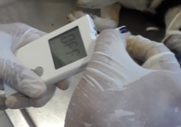
Step 1: Insert the test strips
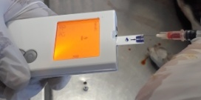
Step 2: Apply blood
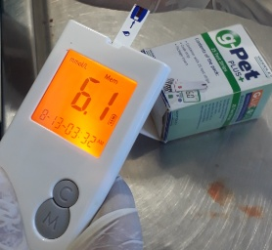
Step 3: Result in 6 seconds
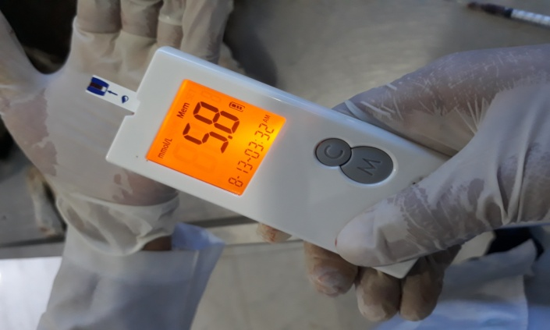
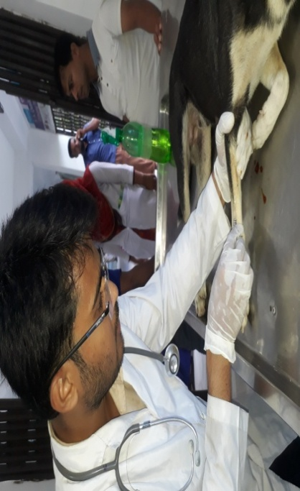
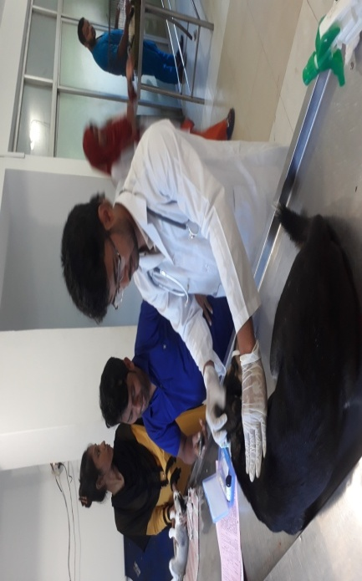
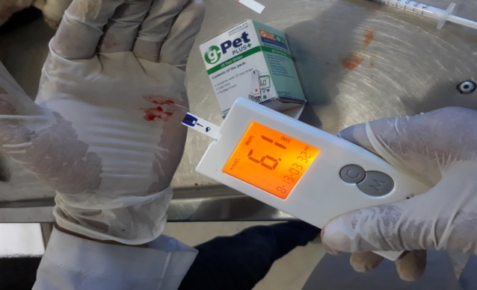
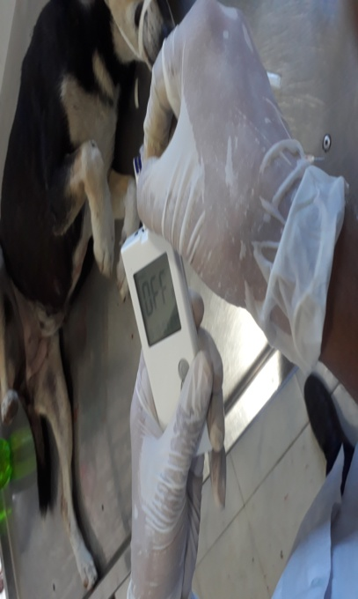
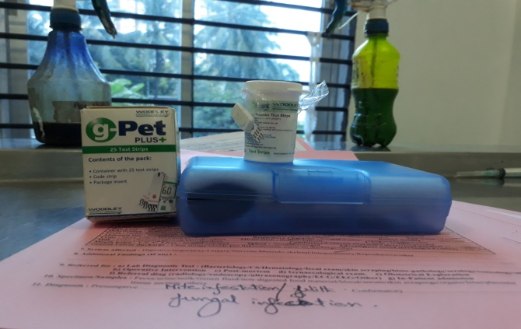
Figure 4: Strips setting
Figure 2: Blood collectionl
Figure 5: Observation of blood glucose level
Figure 3: Glucometer set
PHOTO GALLERY
Figure 1: Observation of animal
STATISTICAL ANALYSIS
The obtained information was imported, stored and coded accordingly using Microsoft Excel–2007 and transfer to STATA/IC-11.0 (Stata Corporation College Station) for analysis. Prevalence was determined by total number of positive animal / total number of animal examined and multiplied by 100 to expresses in percentage. The association between the independent factors such as age, sex, breed, body weight and exercise were evaluated using the chi-square test and p-value was considered as significant when p<0.05.

RESULT
The results of the study are show in the table 1, 2 and 3.
In table 1, total cases (N=25) were recorded of them 14(56%) were male and 11(44%) were female. Age, breed, sex, body weight and feed (5 variables) are shown with fasting and after feeding glucose levels. No diabetic dogs were found except some changes of glucose level.
In table 2, the prevalence of diabetes was calculated with different variable and categories. The prevalence of diabetes of the study is 0.
In table 3, glucose levels before and after feeding and the influences of the different risk factors on blood glucose levels in dogs are shown. In case of male dogs blood glucose levels are higher than the female one. Blood glucose level comparatively high in old dogs which are greater than 48 month than young dogs. Besides, local breeds are in normal blood glucose level than others. Golden retriever shows high glucose in blood. Feed habit influences the level of glucose in blood strongly. High carbohydrate feeded dogs found high blood glucose than low carbohydrate feeded dogs.

Sl. No. | Breed | Age  (month) | Sex | B.wt (kg) | Food | Result  1  mmol/L | Result  2  mmol/L
1 | L | 18 | F | 25 | Meat, veg. | 6.7 | 8.6
2 | GR | 54 | M | 40 | Meat,khichuri,pedigree | 9.8 | 13.2
3 | L | 36 | M | 30 | Meat, bread | 7.1 | 8.9
4 | L | 30 | M | 28 | Meat, biscuits | 4.6 | 8.2
5 | GS | 36 | M | 28 | Meat, veg. | 7.5 | 8.4
6 | L | 36 | F | 32 | Bread, pedigree | 7.1 | 8.9
7 | GS | 36 | M | 35 | Rice, veg, meat | 7.8 | 9.5
8 | GS | 36 | M | 34 | Meat, veb | 8.0 | 9.6
9 | L | 30 | M | 30 | Meat, biscuits | 6.7 | 9.0
10 | L | 30 | F | 26 | Meat, bread, veg | 7.1 | 8.8
11 | L | 30 | F | 24 | Rice, meat | 6.9 | 8.8
12 | GS | 48 | M | 38 | Canned food, meat | 7.9 | 9.3
13 | GS | 42 | M | 45 | Meat, pedigree | 7.6 | 8.6
14 | GR | 40 | M | 40 | Meat, biscuits | 6.9 | 8.8
15 | GR | 42 | M | 36 | Meat, bread, biscuits | 7.8 | 8.9
16 | L | 41 | M | 30 | Rice, veg, meat | 7.0 | 8.6
17 | L | 48 | M | 38 | Rice, meat | 6.5 | 8.6
18 | SPITZ | 28 | F | 22 | Meat, biscuits | 7.8 | 9.2
19 | SPITZ | 20 | F | 22 | Meat,biscuits, bread | 6.7 | 8.1
20 | L | 36 | F | 28 | Rice, meat | 7.1 | 8.2
21 | L | 36 | F | 27 | Veg, meat | 6.5 | 8.4
22 | GR | 52 | M | 38 | Meat, pedigree, bread | 8.1 | 11.8
23 | L | 65 | M | 25 | Meat, veg | 6.2 | 8.5
24 | L | 30 | F | 25 | Meat,rice | 6.6 | 8.6
25 | L | 25 | F | 23 | Meat, rice, veg | 6.3 | 8.7

Table 1: General description of the sampling dogs.

Categories | Categories level | Result | Prevalence (%)
Sex | Male (14)  Female (11) | Negative  Negative | 0  0
Age | <30 month  31–48 month  >48 month | Negative  Negative  Negative | 0  0  0
Body wt. | 20-30 kg  31-45 kg | Negative  Negative | 0  0
Breed | Local  GR  GS  Spitz | Negative  Negative  Negative  Negative | 0  0  0  0

Table 2: Shows the prevalence of diabetes in SAQTVH area with different variable.

Categories | Categories level | Average glucose level  Fasting After Feeding
Sex | Male (14)  Female (11) | 7.78 9.98  6.26 8.53
Age | <30 month  31–48 month  >48 month | 6.61 8.66  7.31 8.82  7.26 10.28
Body wt. | 20-30 kg  31-45 kg | 6.95 8.90  7.69 9.95
Breed | Local  GR  GS  Spitz | 6.33 8.58  7.95 10.67  7.72 9.10  7.25 8.65
Feed | High calore  Low calore | 7.75 10.05  6.83 8.43

Table 3: Shows the influence of different categories of variable in blood glucose level.

DISCUSSION:
Blood glucose level and diabetes of dogs is an important parameter of their general health condition. So the current study was designed to see the status of diabetes in dogs and know the factors influencing the levels of glucose of dogs in Chittagong. This study found no diabetic dog admitted in SAQTVH, CVASU. Prevalence may be influenced by different bias, method of selection, sampling area and sample size (Agrawal RP et al., 2006). In our study, we selected animals randomly but the population size was not enough to get the real prevalence. Moreover, study area was only Chittagong metropolitan and samples were collected from the patient brought to the hospital which may influence the findings of the study. Generally, diabetes mellitus in dogs is influenced by the variables like age, sex, breed, weight, neutering, drug treatment, physical inactivity, high carbohydrate diet (J.S. Rand et al., 2004) and seasons (Atkins CE et al., 1987). Local (indigenous) and German shepherd are found at significantly decreased risk (Marmor M et al., 1982) and Golden retriever and spitz at low risk (Wikipedia). Diabetes typically occurs in dogs between 5 and 12 years of age, and is uncommon under 3 years of age (B. Catchpole et al., 2005).
However, this study showed that, blood glucose level typically changes in different age, sex, breed and feed intake. Blood glucose level of male in fasting was 7.78 and after feeding 9.98) found to be higher than the female (fasting 6.26 and after feeding 8.53) though this result does not match with the findings reported by (Guptill L et al., 1970-1999). Blood glucose level also varies with ages. Young dogs showed lower level of glucose than aged dogs. Diet has direct effect on blood glucose level in dogs. High carbohydrate diet increasing blood glucose level than low carbohydrate diet and this result supported by the findings of previous study (J.S. Rand et al., 2004; Guptill L et al., 1970-1999).

CONCLUSION:

It is believed that 99 percent of health problems in dogs can control with proper management, which includes good sanitation, feeding high quality feed, taking time daily to clean and fill water and feed bowls, providing adequate room, cleaning sitting boards, cleaning ears and checking teeth and continually providing protection from cola, heat, wind and rain. Daily exercise and routine deworming also are very important for controlling diabetic in dog. Proper diet and regular check-up can make the dog healthy. The result from this study may boost up the importance of proper diet, regular exercise and check-up of the dog.

REFERENCES
- Atkins CE, Hill JR, Johnson RK (1979). Diabetes mellitus in the juvenile dog: a report of four cases. J Am Vet Med Assoc 175:362–368.
- Atkins CE, Macdonald MJ (1987). Canine diabetes mellitus has a seasonal incidence: implications relevant to human diabetes. Diabetes Res 5:83– 87.
- Atkins CE, LeCompte PM, Chin HP, Hill JR, Ownby CL, Brownfield MS (1988) Morphological and immunocytochemical study of young dogs with diabetes mellitus associated with pancreatic islet hypoplasia. Am J Vet Res 49:1577– 1581.
- (((Alberti, KGMM; Aschner, P.; et al. (1999). "Definition, Diagnosis and Classification of Diabetes Mellitus". World Health Organization. Retrieved 17 March 2010.
- Cook AK, Breitschwerdt EB, Levine JF, Bunch SE, Linn LO (1993). Risk factors associated with acute pancreatitis in dogs 101 cases (1985–1990). J Am Vet Med Assoc 203:673–679.
- Cook AK, Breitschwerdt EB, Levine JF, Bunch SE, Linn LO (1993) Risk factors associated with acute pancreatitis in dogs 101 cases (1985–1990). J Am Vet Med Assoc 203:673–679.
- Catchpole, B.; Ristic, J. M.; Fleeman, L. M.; Davison, L. J. (8 September 2005). "Canine diabetes mellitus: can old dogs teach us new tricks? "Diabetologia 48 (10): 1948–1956.
- Davison LJ, Herrtage ME, Catchpole B (2004). Canine diabetes mellitus in the UK: a study of 253 dogs with naturally occurring disease. Vet Rec 156:467–471.
- Foster SJ (1975). Diabetes mellitus a study of the disease in the dog and cat in Kent. J Small Anim Pract 16:295–315.
- Gepts W, Toussaint D (1967).Spontaneous diabetes in dogs and cats.A pathological study. Diabetologia 3:249–265.Guptill L, Glickman L, Glickman N (2003). Time trends and risk factors for diabetes mellitus in dogs: analysis of veterinary medical database records (1970–1999). Vet J 165:240–247.
- Hoenig M (2002).Comparative aspects of diabetes mellitus in dogs and cats. Mol Cell Endocrinol 197:221–229.
- Hall EJ, Bond PM, McLean C, Batt RM, McLean L (1991).A survey of the diagnosis and treatment of canine exocrine pancreatic insufficiency. J Small Anim Pract 32:613–619.
- Marmor M, Willeberg P, Glickman LT, Priester WA, Cypess RH, Hurvitz AI (1982). Epizootiologic patterns of diabetes mellitus in dogs. Am J Vet Res 43:465– 470.
- Mattheeuws D, Rottiers R, Kaneko JJ, Vermeulen A (1984). Diabetes mellitus in dogs: relationship of obesity to glucose tolerance and insulin response. Am J Vet Res 45:98–103.
- Nelson, RW (2014). "Chapter 6: Canine diabetes mellitus". In Feldman, EC; Nelson, RW; Reusch, CE; Scott-Moncrieff, JCR. Canine and feline endocrinology (4th ed.). Saunders Elsevier. pp. 213–257
- Nelson RW. Canine diabetes mellitus. In: Ettinger SJ, Feldman EC, editors. Textbook of veterinary internal medicine. 7th ed. St. Louis: Elsevier; 2010.
- Rand JS, Fleeman LM, Farrow HA, Appleton DJ, Lederer R (2004). Canine and feline diabetes mellitus: nature or nurture? J Nutr 134:2072–2080.
- Rucinsky R, Cook A, Haley S, Nelson R, Zoran DL, Poundstone M, American Animal Hospital Association AAHA diabetes management guidelines. JAm Anim Hosp Assoc. 2010;46(3):215–224.
- Wilkinson JS (1960). Spontaneous diabetes mellitus. Vet Rec 72:548–553.
- Wess G, Reusch C. Capillary blood sampling from the ear of dogs and cats and use of portable meters to measure glucose concentration. J Small Anim Pract. 2000;41(2):60–66

BIOGRAPHY
I am Rupom Devnath. I am 3rd son of Manik Lal Nath and Bela Rani Nath. I completed my SSC from Feni Govt. pilot high school, Feni and HSC from Birshrestho Noor Mohammad Public College, Dhaka. Now I am internship student of veterinary medicine of Chittagong Veterinary and Animal Sciences University. In future, I want to be a Veterinary Practitioner and try to be developed my sector in our country.

