Ostrich production in Bangladesh
A case study
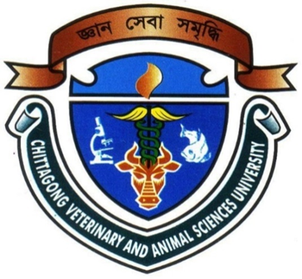

By:
Moni soungkor Roaja
Roll No: 11/32 Reg No: 00679
Intern ID: D-31
Session: 2010-2011

A production report submitted in partial satisfaction of the requirements for the degree of

Doctor of Veterinary Medicine

Faculty of Veterinary Medicine
Chittagong Veterinary and Animal Sciences University
Khulshi, Chittagong, Bangladesh

October, 2016
Ostrich production in Bangladesh
A case study

___________________________________
Md. Emran Hossain
Associate Professor
Department of Animal Science and Nutrition

Faculty of Veterinary Medicine
Chittagong Veterinary and Animal Sciences University
Khulshi, Chittagong-4225, Bangladesh

October 2016

