Chapter I

Introduction
Bangladesh is mainly depended on agriculture for her economy. Agriculture is the backbone of Bangladesh. Thousands of peoples depend on agriculture. About 60-70% people depends on agriculture. Agriculture is the main source of our countries economy. It comprises about 15% of the country's GDP and 60% of the total labor force. The dairy sector of the country is one of the principal agricultural industry. Since the basic national objectives is to provide inputs to farmers at low cost and to reduce the income gap between rich and the poor, the present Government is keen to undertake programmes in the country.
Livestock is an essential component of the rural economy. Dairying is one of the major components of animal agriculture and part of mixed farming system in Bangladesh. It accounts for about 14.08% (DLS 2013) of agricultural GDP and contributes to the livelihoods of many small scale farmers through income, employment and food (Bangladesh Economic Survey 2009). Increased milk production strategy is establishment of dairy enterprise in which small-scale farmers can successfully engage in order to improve their livelihoods (Hemme et al 2005). According to the national health strategy, the people of Bangladesh (153.6 million) should have 250ml of milk every day, then the annual national milk demand will be 14.02 million tonnes (DLS 2013-14). However, at present the country is producing only 6.09 million tonnes of milk which is only 43.5% of the milk demand in Bangladesh (DLS 2013-14).
In our country cows, there are very few amount of milk production per cow indicate lower milk production rate. Milk production depends on both genetic composition and environmental factors. To modify genetic constituents of local cows, Bangladesh started AI programme in 1958(BLRI). Usually high blood percentage cows are produced higher milk productions and poor quality low blood percentage parents produces lower milk producing cows. Milk production also depends on environment and nutritional status. Suitable environment and sufficient nutrient can shows higher milk productions. Nutrient requirements vary with the stage of lactation and gestation. Five distinct feeding phases can be defined to attain optimum production, reproduction and health of dairy cows.
Now a days, environment becomes changed gradually day by day in our country. As a result there is need to new study about blood percentage and milk production of exotic cows. Exotic cows are heat sensible and commonly attacked by various diseases.
Objectives:
- To find out the most suitable blood percentage for maximum milk production
- To know the suitable blood percentage for our environment of crossbreeds cattle.
- To know the disease resistance capacity of crossbred cattle

Chapter II

Methods and Materials

2.1. Study Area:
The study was conducted at Faridpur district in Bangladesh. Faridpur is a district in central Bangladesh. It is a part of the Dhaka Division. Faridpur District has a population of over 1.7 million people and is situated on the banks of the Padma river. In Nagarkanda upazila, there is a Govt. dairy farm named “Dairy and Livestock Development Farm” Faridpur. A total of 40 cows data were collected from the farm and which were selected randomly.
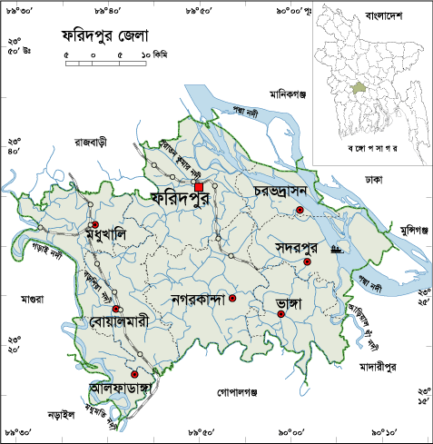
Figure 1: Map of study area ( Faridpur District )

2.2. Study Period:
The study was conducted between the period of 10 September, 2016 to 1 November, 2016, when I was in vacation of Eid-ul-Adha in our native village and farm is beside of my house.

2.3. Sources of data:
The data was obtained from the primary sources. The data of feeding and housing system of the farm was collected from the manager of the farm. And others important data was collected from Artificial Inseminator man and stuff of the farm.

2.4. Study Design:
The research design adopted for this study was of ex-post-facto in nature since the phenomenon has already occurred and researcher does not have direct control over independent variables, because their manifestation has already occurred or because they are not inherently manipulated Sevilla et al., (2007).

2.5. Methods of data collection:
Data were collected through direct interview schedule and recorded in a questionnaire. The schedule was prepared maintaining relevance with the objectives of the study. Before launching the survey, the questionnaire was pretested and improved accordingly. In order to collect the more purified data of the farms an organized questionnaire was formatted (Nauta et al., 2001; De Jong and Van Soest, 2001). Key informant technique was also employed to get the basic relevant information of the proposed study.Temperature of the farm was 25°C and humidity was 88%.

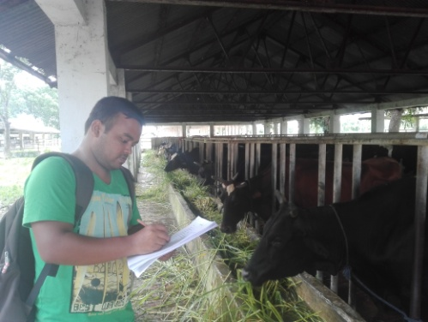
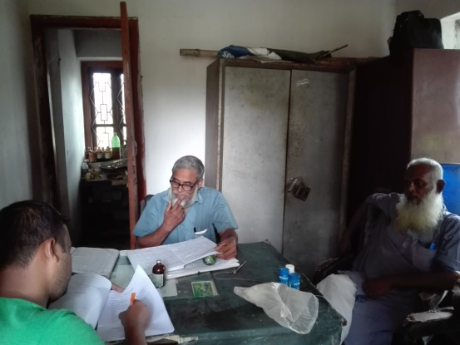

Figure 2: Data collection

2.6. Data Analysis:
The data were put on the master sheet in Microsoft Office Excel 2007 and were arranged in tabular form. The obtained data imported to software STATA/IC-11.0 for analysis. Descriptive statistics of some parameters were done. The comparison of different qualitative parameters was performed by using chi-square test. Comparison among the qualitative parameter were performed by using one way ANOVA. The difference of different parameters were considered significant when th p- values were <0.05 and highly significant when p- values were <0.01 .

Chapter III

Results and Discussion

3.1. Productive trait of the farm
The Table 1 represents the productive traits of the study farm. The number of the total population of crossbreed cows were above hundreds and randomly collected forty milch cows for the study. The mean and standard deviation along with there minimum and maximum ranges of blood percentage, milk production, age, weight, parity and service per conception are respectively 60 ± 11.39, 8.65 ± 1.81, 9.55 ± 1.65, 353.38 ± 32.96, 3.08 ± 0.92, and 2.01 ± 0.31 respectively.
Table 1: Some productive trait of the selected farm
Parameters | Mean ± SD | Minimum-maximum
Blood percentage | 60 ± 11.39 | 50-75
Milk production (Liters) | 8.65 ± 1.81 | 6-13
Age (Years) | 9.55 ± 1.65 | 4-12
Weight (Kg) | 353.38 ± 32.96 | 280-400
Parity | 3.08 ± 0.92 | 1-5
Service per conception | 2.01 ± 0.31 | 1.6-2.7
N: Number of cattle under study = 40; SD= Standard deviation

3.2. Milk production and service per conception rate
Table 2 shows the mean milk production and mean service per conception of the study populations. Highest milk production was 11.5 liters in Sahiwal 25% + Friesian 75% (SF75), followed by 9.75 liters, 9 liters, 8.5 liters and 7.74 liters, respectively in Local 25% × Friesian 75%, Sahiwal 50% × Friesian 50%, Local 37.5% × Friesian 62.5%, Local 50% × Friesian 50%. The lowest milk production was 7.74 liters in Local 50% + Friesian 50% (LF50) .The highest blood percentage (≥75%) is considered for good milk production in tropical country (Bhat et al. (1978).
The mean service per conception rate was observed highest in SF75% which is 2.6±0.07. The optimum number of services was 1.72±0.056, reported in a well managed herd (McDowell 1985). Mekonnen and Goshu (1987), and Asseged and Birhanu (2004) reported that the number of services per conception tended to increase significantly (p<0.05) with parity number (until parity 3).

Table 2: Milk production and service per conception rate (SCR) in different group of crossbred cattle
Parameters | LF50 | LF62.5 | LF75 | SF50 | SF75 | P value
Milk production (Mean ± SD) | 7.74ª±1.24 | 8.5ª±1.05 | 9.75^{ab}±1.74 | 9ª±4.24 | 11.5^{b}±0.71 | 0.03
Service per conception  (Mean ± SD) | 1.87ª±0.15 | 2.2^{b}±0.14 | 2.45^{c}±0.16 | 1.7ª±0.14 | 2.6^{c}±0.07 | 0.00
Note: Means with different superscripts in the same row differ significantly (P˂0.05), LF50: Local50% × Friesian 50%, SF50: Sahiwal 50% × Friesian 50%, LF62.5: Local 37.5% × Friesian 62.5%

SPC= Service per conception

Figure 3: Milk production and service per conception rate (SCR) in different group of crossbred cattle

3.3. Reproductive abnormalities and disease outbreak
Table 3: Reproductive abnormalities and disease outbreak in different exotic blood percentage cattle
variable | Categories | LF50 | LF62.5 | LF75 | SF50 | SF75 | P value
Dystocia | Present | 10.53 | 0.00 | 54.55 | 0 | 0 | 0.019
 | Absent | 89.47 | 100 | 45.45 | 100 | 100
Disease Outbreak | Mastitis | 10.53 | 33.33 | 18.18 | 0.00 | 0.00 | 0.820
 | FMD | 5.26 | 16.67 | 9.09 | 0.00 | 0.00
 | None | 84.1 | 50 | 72.73 | 100 | 100
N: Number of cattle under study =40.
The table 3 shows the reproductive abnormalities and disease outbreak of the different exotic blood percentage cows. Comparatively LF62.5% crossbreed are represents absent of Dystocia and higher value in disease outbreak. LF75% breed are represent higher number of Dystocia and lower chance of disease outbreak. SF50% and SF75% represents lower amounts means absence of disease outbreak and Dystocia. Three general causes of dystocia are fetal-maternal size mismatch, fetal malpresentation, and maternal related causes (Roughsedge and Dwyer, 2006; Lombard et al., 2007).
3.4 Environmental adaptability
The exotic crossbreed cows understudy were suitable in our environment in terms of pre-set assessment criteria (Table 4). None of the cattle showed environmental incompatibility reactions such as - restlessness, dullness, dyspnea, sweating, and panting.
Table 4 : Environmental adaptability
Parameters | Number of animals | Present
Restlessness | 0 | 0
Dullness | 0 | 0
Dyspnea | 0 | 0
Sweating | 0 | 0
Panting | 0 | 0
N: Number of cattle under study = 40.
Table 4 presents the assessment of environmental adaptability and shows that it is a suitable environment and response positive on environment in 50% to 75% crossbred.

Chapter IV

Conclusion
The Dairy farm is a great opportunity to increase our income source and total economy in our country. Now a day, available crossbreed cows are everywhere and producing high amount of milk production in livestock sector. Exotic crossbreed shows good environmental compatibility and environmental adaptability in our environment. Peoples are interested to rearing exotic breed cows due to more productivity. And our local breed should have improved by crossed day by day at a certain percentage. Further study required to identify the most suitable exotic blood percentage in Bangladesh as the present study was only based on different combination of blood percentage up to 75%.

Chapter V

Limitations of the study
There were some limitations in my study. The study period was limited and study area restricted to a particular district, for this reason the findings may not reflect the whole country. There was limited recording system in dairy farms under study as a result it was difficult to select valid data. The study was limited to a few categories of exotic blood percentage which cannot conclude about all blood percentages.

Chapter VI

References
Bhuiyan, A. H. 2003. A Comparative Economic Analysis of Poultry Under Supervision of AFTAB Bahumukhi Farm and own Management in Some Selected Areas of Kishoreganj district. M.S. Ag. Econ. thesis, Department of Agricultural Economics, Bangladesh Agricultural University, Mymensingh.

Casely, D. and Kunnar, K. 1988. The collection, analysis and use of monitoring and evaluation data Baltimore. The Hohnces Hopkins University Press, Department of Agricultural Economics and Business, Wye College.

Chabo, R.G., Kelacng, B. and Sekambo, M.M. 2000. The effect of house roof-type on ambient temperature, feed intake, egg production, egg size in commercial layer during the summer months in south- eastern Botswana. Tropical Animal Health and Production, 32: 135-139.

Craig, J.V. and Lee, H.Y. 1990. Beak trimming and genetic stock effects on behaviour and mortality from cannibalism in White Leghorn-type pullets. Applied Animal Behaviour Science, 25:107-123.

Cunningham, D.L. 1992. Beak trimming effects on performance, behavior and welfare of chickens: A review. Journal of Applied Poultry Research,1: 129-134.
Sevilla, C.G., Ochave, J. A., Punsalan, T.G., Regala, B.P. and Uriarte, G.G. 2007.Research methods. Third edition, Rex book store.

Sharma, L. R., Bhhati, J. P. and Ranveer, S. 1991. Emerging farming systems in Himachal Pradesh-Key issues in sustainability. Indian Journal of Agricultural Economics, 46(3): 422-427

Smith, A. J. 1993. Poultry-The tropical agriculturalist series. CTA Macmillan, London.

Struwe, F.J., Gleaves, E.W., Douglas, J.H. 1992. Stress measurements on beak-trimmed and untrimmed pullets. Poultry Science, 71: 1154-1162.

Sumy, M.C., Khokon, M.S.I., Islam, M.M. and Talukder, S. 2010. Study on the socio-economic condition and productive performances of backyard chicken in some selected areas of Pabna district. Journal of Bangladesh Agricultural University, 8(1): 45-50.

Chapter VII

Brief Biography of the student
Jakir Hossain is an intern student for the degree of Doctor of Veterinary Medicine (DVM), Faculty of Veterinary Medicine, CVASU. He passed the Secondary School Certificate Examination (SSC) in 2007 and got GPA 5.00 and then Higher Secondary Certificate Examination (HSC) in 2009 and earned GPA 5.00. Then he admitted to the degree of Doctor of Veterinary Medicine (DVM), Faculty of Veterinary Medicine, CVASU in 2009-2010 session. Now, he is working on animal nutrition.

