CHAPTER: I

INTRODUCTION

A deep-seated component of rice based agricultural production system in Bangladesh is documented as Livestock. Crops, livestock, fisheries and forestry are the four components of agriculture among which livestock plays a vital role in national economy, contributing about 6.5% of gross domestic products (GDP) and 13% of total foreign exchange earnings (GOB, 1991). An indispensible role is played in the traditional agriculture and largely subsistence economy of Bangladesh by livestock (Huq, 1997). The most expensive input of livestock production system is obviously the feed (Cruz et al., 2009) which accounts for 60-70% of the total production cost (Bulbul and Hossain, 1989). The fundamental nutrients obligatory for animal production, including energy, protein & amino acid as macro nutrients, as well as minerals, vitamins and other micro nutrients are provided by livestock feed (FAO, 1983). The production and accessibility of livestock feed is very less than the demand since there is scarcity of lands in our country and therefore the price is sky-high. The poor quality fibrous feed is deficient in readily fermentable carbohydrate (RFC), digestible protein and some minerals. Such fibrous feeds provide about 96, 91 and 84% of the dry matter (DM), metabolizable energy (ME) and crude protein (CP), respectively available for the ruminant animals of Bangladesh (Huque et al., 1992). Conversely, as agriculture of our country is rice based, rice straw is the most available feedstuff throughout the year. Hence, rice straw is the main energy source for ruminants comprising over 60% of the dietary energy supply in Bangladesh (Jackson, 1981).
The lower level of readily fermentable Nitrogen and energy for the rumen and volatile fatty acids, amino acids for the animal provided by the rice straw are primary limitations to ruminant production in this country (Haque and Chowdhury, 1994). Sugar cane molasses is one such non-conventional feed, which is rich in soluble carbohydrate (Shirely, 1986) and widely available in Bangladesh. So, on a straw based diet urea and molasses are added to upgrade the quality of the feed (Huque and Talukder, 1994; Huque and Chowdhury, 1995). Supplementation of poor quality roughage with molasses increased their intake (Khalili, 1993, Khalili et al., 1993) or growths of cattle (Bamah et al., 1992, Preston and Leng, 1987).
However, molasses is not always available due to poor distribution channel and higher cost. Supplementation of other high energy source is impractical. On contrary, every household and residential educational institute of our country produces considerable amount of rice gruel during cooking of rice, containing considerable amount of soluble starch material. Traditionally it is being used in the sheep diet as a drink with water.
Though some works have been carried out with rice gruel on sheep to assess the rural fattening program with traditional feeding practices (tethering, grazing and tree leaves with rice straw), no concise work has been done to evaluate the rice gruel as one of the major sources of energy after replacing the molasses. Keeping this view in mind, the present study was designed to investigate the possibility of rice gruel as a non conventional feed resource compared to other expensive energy source (molasses) on growth performance of native growing sheep with the following aims and objectives.
The aims and objectives of the present study:
- To observe the effect of rice gruel on growth performance of sheep.
- To observe the effect of rice gruel on rumen protozoa and bacteria of sheep.

CHAPTER - II

MATERIALS AND METHODS

2. 1. Baseline survey on production (quantity) of rice gruel

2. 1.1. Survey area
It was a bare necessity to select the area, which should provide maximum information, convenient to collect rice gruel, to analyze, to feed the selected animals regularly. The selection of study area depends on the objectives of the research.

Chittagong Veterinary and Animal Sciences University (CVASU), a governmental education institute with residential facilities for all students where a considerable amount of rice gruel is produced daily during cooking of rice in hostel dinning. Hence, CVASU was selected as the study area.

2. 1.2. Quantification of production of rice gruel
Rice gruel was collected from the hostel dining in large calibrated plastic buckets at noon and night for a period of fifteen (15) days. The measurement was done in the unit-liter per head per day. It was calculated by using the underlying formulae:

Production of rice gruel (liter/head/day) | $$=\frac{Production of rice gruel \left(noon+night\right)of a day}{Number of total boarders of that day }$$

Mean production of rice gruel (liter/head/day) | $$=\frac{Total production of rice gruel of 15 days }{15}$$

2. 1 .3. Collection of rice gruel for proximate analysis
Rice gruel was collected by using simple random sampling technique for chemical analysis in three (3) consecutive days. Each time 1000 ml of sample was collected and after cooling up to room temperature, immediately analyzed in the Animal Nutrition Lab of CVASU.

2. 1. 4. Chemical (Proximate) analysis of rice gruel
Sample of rice gruel was analyzed with three (3) replications each for dry matter (DM) and organic matter (OM) in the laboratory of Department of Animal Science and Nutrition, according to AOAC (2005).

2. 2. Feeding of animals
Feeding of ruminant is much more complicated than simple stomach animal as they require a large amount of roughage and concentrate feed for their maintenance and production. So it is very important to identify some readily available unconventional feed resources which can be used as a substitution of expensive conventional feeds.

2. 2. 1. Study area
The sufficient number of study population was available at CVASU sheep farm which is situated within the campus premises. This was easy to manage and to conduct any scientific trial. Therefore this farm was selected as the study area for feeding trial with rice gruel in addition to concentrate ration compared to the molasses as an energy source for a time period of 60 days (03.02.2016 to 40.04.2016).

2. 2. 2. Selection of animals
The animals were selected in healthy condition having shiny body coat, active and alert movement, normal feeding, rumination, eructation, defecation, urination with other physical parameters ( Rectal temperature, heart rate, pulse rate, respiration rate etc.) normal. A total number of nine (9) growing lambs of approximately same age and size but of different sexes were selected for the growth trial from sheep farm of Chittagong Veterinary and Animal Sciences University (CVASU). The animals were divided into three groups, T₁, T₂ and T₃ with 03 animals in each group having two male and one female and their age was within the range 6 to 8 months.

Table 2.1: Distribution of sheep according to treatment groups
Group | Sheep population |  | Average initial body weight(kg)
 | Male | Female
T₁ | 02 | 01 | 6
T₂ | 02 | 01 | 5.7
T₃ | 02 | 01 | 5.8

2. 2. 3. Preparation of experimental shed
The ceiling, walls and floor of experimental shed for sheep was properly washed and cleaned by using tap water before the experiment and the shed was washed in the same manner daily during the entire study period were also thoroughly cleaned. The whole shed was washed with disinfectant solution weekly. Faces of sheep and other dirt were regularly removed and disposed properly.

2. 2. 4. Examination of animals for parasites

2. 2. 4. a. External examination of animals
Clinical examination was done to all the selected animals thoroughly before starting the trial to detect the presence of ectoparasites or any other skin lesions.

2. 2. 4. a. i. Administration of Ivermectin drug
All the animals were administered with the Ivermectin injection @ 0.2mg/kg body weight subcutaneously.

2. 2. 4. b. Coproscopy
Before starting the trial, feces sample of the animals was collected early morning by using rectal palpation technique with gloves. The collected feces sample were packed separately for individual animal and transported immediately through sterilized sachet to the laboratory and then preparation of smear was done through the process saline wet mount, iodine wet mount & floation method for microscopic examination.

2. 2. 4. b. i. Deworming
The animals were make endoparasite free by using anthelmintic according to the parasites found.

2. 2. 4. c. Examination of peripheral blood smear
As above, before the trial, the peripheral blood smears of the animals were examined under microscope after Giemsa staining to identify whether there was any kind of blood protozoa present (if any).

2. 2. 5. Feed Offered
Required amount of roughage and concentrate feed was offered to the sheep on the basis of their individual body weight. Fresh and clean drinking water was offered to all animals round the day as ad-lib basis. The concentrate ration was offered to all groups of sheep at 9AM daily (once). The animal of T₁ was additionally supplied with the rice gruel instead of molasses at the same time for once.
Table 2.2: The composition of the concentrate mixture
Sl. No. | Feed ingredients | Amount (%)
 |  | T₁ | T₂ | T₃
1 | Wheat bran | - | - | 24.5
2 | Rice polish | - | - | 17.0
3 | Broken rice | - | - | 06.0
4 | Maize | - | - | 13.0
5 | Molasses | - | - | 02.0
6 | Pea bran | - | - | 20.5
7 | Soybean meal | - | - | 07.0
8 | Soybean oil cake | - | - | 08.5
9 | Salt | - | - | 01.5

Here in case of Group I the mixture was not full fill, because the lacking part was compensate with the supply of rice gruel @ 2.5 liters/100kg body weight.

Table 2.3: Animal groups with daily amount of feed offered
Group | Animal  ID. | Body weight (Kg) | Average  Body  weight | Grazing (hours) | UMS  (Kg) | URS  (Kg) | Concentrate Feed (kg)
T₁ | 1 | 6.2 | 6 | - | 0.51 | - | -
 | 2 | 5.9 |  | - | 0.47 | - | -
 | 3 | 6.1 |  | - | 0.50 | - | -
T₂ | 4 | 5.9 | 5.7 | - | - | 0.65 | -
 | 5 | 5.4 |  | - | - | 0.61 | -
 | 6 | 5.8 |  | - | - | 0.63 | -
T₃ | 7 | 5.7 | 5.8 | - | - | - | 0.25
 | 8 | 5.5 |  | - | - | - | 0.23
 | 9 | 5.9 |  | - | - | - | 0.27

2. 2. 6. Body weight gain
The body weight of animals was recorded at initial, final and in between fortnightly basis level of the trial by using digital weight machine. The body weight gain was calculated by deducting previous weight from current weight and the average value was calculated by dividing total weight gain by the number of days and animals.

2. 2. 7. Examination of rumen liquor
Rumen liquor was collected once before feeding and thrice after feeding at 0, 4, 8 hours of post feeding for one (01) day from each animal of each group.

2. 2. 7. i. Aspiration of rumen liquor/ rumenocentesis (needle puncture)
Rumen liquor collection was carried out by means of rumenocentesis after properly restraining the animal. The puncture site was located 5 to 6 cm caudal to the costo-chondral junction of the last rib, on a horizontal line level with the top of the patella. Before rumenocentesis, the puncture site was painted with disinfectant and then 5-10 ml of ruminal fluid was aspirated with a 20 ml syringe.

2. 2. 7. ii. Transportation of rumen liquor
Immediately after collection, the rumen fluid was transported from the collection site to the laboratory through a thermo flask to maintain the inner rumen temperature artificially.

2. 2. 7. iii. Physical characters of rumen liquor
The color, consistency and odor of individual animal ruminal fluid were examined by organoleptic test.
P^{H}: Normal P^{H} of rumen liquor varies from 5 to 7. However, under pathological conditions it may decreases towards acidic or it may increases towards alkaline side. Therefore, p^{H} of rumen liquor was studied to know the effect of different feeds.
Procedure
The p^{H} of the rumen liquor was determined using portable digital P^{H} meter (pen type) at the site of the collection. After collection and filtration of the rumen liquor, the electrode of the P^{H} meter was inserted inside the stained rumen liquor (SRL) and the P^{H} was determined.
Protozoal Motility
Rumen contains a large population of rumen protozoa which are ciliated and motile. They are anaerobic in nature and they live at P^{H} between 6 and 6.8, temperature 39-40 ⁰c and in presence of moderate concentration of volatile fatty acids along with billions of rumen bacteria. Since the protozoa motility gives a tentative idea about the digestion of feed in rumen, therefore, it was studied for the protozoal motility in rumen liquor to know the feed effect.
Procedure
Extract volume of 0.5 ml of stained rumen liquor (SRL) was transferred on a clean glass slide and was covered with cover slip. The movement of protozoa was examined under low power of microscope immediately.

The movement of protozoa was rated as follows:
++++ = Very rapid movement; whole mass is moving.
+++ = Rapid movement; very large population of protozoa showing their motility.
++ = Moderate movement; less number of protozoa is moving moderately.
+ = Slow movement; very few protozoa showing their slow movement.
0 = No movement; all the protozoa are dead.

2. 2. 7. iv. Chemical characters of rumen liquor
Estimation of Total Ruminal Bacteria
Apparatus required:
- Strained rumen liquor, test tube, pipettes, centrifuge, funnel, muslin cloth, glass slide, microscope, wire loop.
- Ten percent (10%) formalin solution: by mixing 10 ml of formalin with 90 ml of water.
- Saturated solution of Nigrosine stain: by dissolving 5g of water soluble Nigrosine in 20 ml of distilled water and adding 80 ml of methyl alcohol. It was mixed well and filtered before use.
Procedure
Collected and filtered rumen liquor was centrifuged @3000 rpm for 5 minutes. A volume of 5 ml of centrifuged content was taken in a test tube and 5 ml of 10 per cent formaline was added to kill the bacteria. Then 2 ml of formalin mixed rumen liquor was transferred in a test tube and 8 ml of distilled water was added to give 1 x 10⁻¹ dilution and serial dilutions up to 1x10⁻⁴ was made. Exactly 0.01 ml of sample from 1 x 10^{–4} dilution was placed on a clean glass slide on a marked area of 2 x 2 cm and a loopful of saturated solution of Nigrosine was taken on glass slide. Finally, both were mixed thoroughly and stained with the help of loop wire, spreaded on slide as thin as possible. The slide was kept on hot plate for 2 seconds to dry the smear and counting was done under oil immersion lens where bacteria appear colorless against black background. The bacteria were counted in 10 different fields in zig zag manner and the average number of bacteria per field was calculated by following formula:
Ruminal bacteria per ml of SRL= (Average number of bacteria per field x
microscopic factor (1000) x dilution factor (10⁶).

Estimation of Total Protozoa in Rumen Liquor
Apparatus required
- Glass slide, cover slip, microscope, rumen liquor, test tube, test tube rack, pipette, muslin cloth and funnel.
- Lugol’s Iodine solution was prepared by dissolving 5 g of iodine and 10 g potassium iodide in 60 ml of distilled water and 10 ml of formalin and 30 ml of glycerol was added. Finally the volume was made 100 ml.
Procedure
1 ml of SRL was placed into a test tube through a wide bore pipette. Exact volume of 9 ml of Lugol’s Iodine solution was added and mixed gently. Then 0.1 ml of sample was transferred swiftly to a dry clean slide and spread under a glass cover of known area (24 x 60 mm). Counting of protozoa was done under low power of microscope in a zig zag manner. Thirty fields were counted per slide both for ease, accuracy and average count per field was calculated. Total protozoal count per ml was calculated by following formula:
Total protozoa per ml of SRL = {(Average No. of protozoa count per field) x
(Microscopic factor) x (Dilution factor)}

2.2.8. Processing of Data
All the data obtained from the study were entered into Microsoft Excel 2007 according to the selective parameters.

2.2.9. Statistical analysis
All the data found of this study was analyzed by applying STATA-13 (Stata crop, 4905, Lakeway River, College Station, Texas 77845, USA) for statistical analysis. The ANOVA used at different trial was addressed at the respective parameters.
2.2.10. Photography
All the images related to this study were taken from study sites during field work and lab work. The images were slightly modified by using Photoshop software for better illustration of the study.

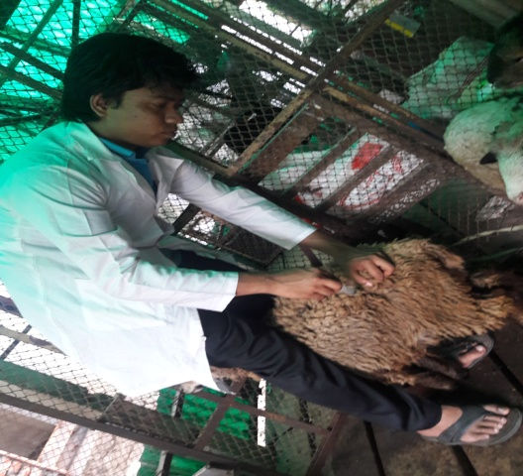
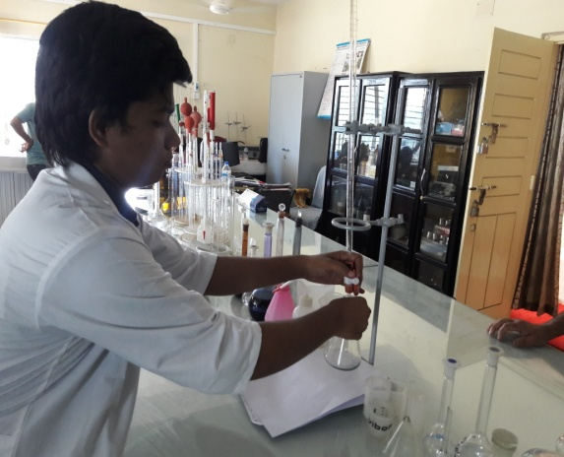

Figure 2.2: Estimation of Crude Protein

Figure 2.1: Collection of rumen liquor from sheep

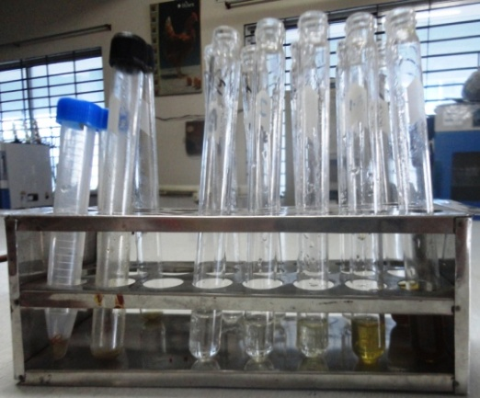
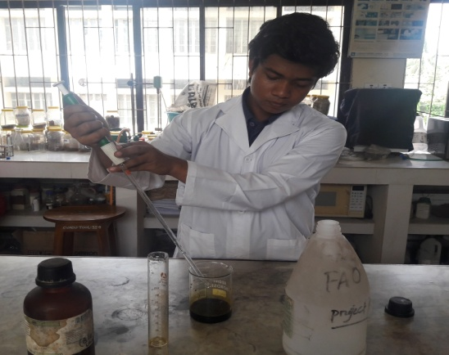

Figure 2.3: Dilution of SRL for bacterial count
Figure 2.4: Lugol’s Solution preperation

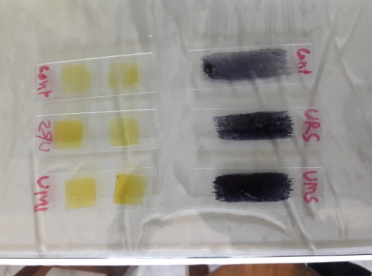
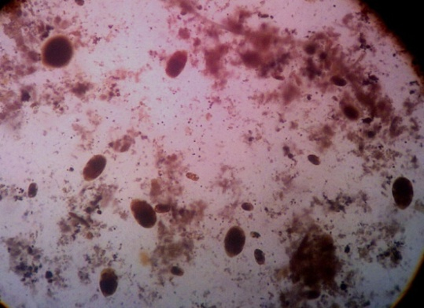

Figure 2.5: Slides for protozoal and bacterial count
Figure 2.6: Rumen protozoa under microscope (100X magnification)

CHAPTER - III

RESULTS

3.1. Quantification of rice gruel
Following table shows the production of rice gruel per day, number of boarders of same day as well as production of rice gruel per head per day.
Table 3.1: Production of rice gruel (RG) per head per day in liter
Days | Production of RG in liter (noon+night) | No. of boarders | Production of RG (liter/ head/day) | Mean production of RG (liter /head/day)
1 | 37 | 230 | 0.161 | 0.16
2 | 38 | 235 | 0.161
3 | 33 | 217 | 0.152
4 | 31 | 203 | 0.153
5 | 41 | 245 | 0.167
6 | 30 | 180 | 0.167
7 | 36 | 227 | 0.159
8 | 29 | 175 | 0.166
9 | 39 | 239 | 0.163
10 | 32 | 217 | 0.147
11 | 40 | 251 | 0.159
12 | 43 | 255 | 0.169
13 | 30 | 180 | 0.167
14 | 35 | 229 | 0.153
15 | 38 | 233 | 0.163

From the above table (3.1) it was found that the average production of RG in liter /head/day is 0.16 liter.

3.2. Chemical analysis of Rice Gruel
Samples of rice gruel were analyzed (in triplicate) for dry matter (DM) and organic matter (OM) according to AOAC (2005).
Table 3.2: Chemical analysis of rice gruel
Feedstuff | Dry matter (g/100g of fresh sample) | g/100g of dry matter
 |  | Organic matter
Rice gruel | 4.15 | 99.88
 | 4.05 | 99.80
 | 4.10 | 99.92
Mean | 4.10 | 99.86

3.3. Examination of animals for external parasites
This examination discovered that there were presence of lice and ticks more or less in all the selected animals. So animals were treated with the preparation of Ivermectin injection @ 0.20mg/kg body weight and dewormed with Triclabendazol and Levamisole @ 15mg and 7.5mg/kg body weight respectively.

Table 3.3: Microscopic examination of feces for parasitic egg/ Oocyst
Group | Saline wet mount | Iodine wet mount (cyst) | Floatation | Anthelmentics used
T₁ | +ve | -ve | +ve | Triclabendazol +Levamisole
T₂ | -ve | +ve | -ve | Albendazole
T₃ | -ve | +ve | +ve | Albendazole

3.4. Examination of animals for blood protozoa
The examination was done to detect the blood parasites and the result is shown in the table below.
Table 3.4: Examination of blood smears for blood protozoa
Group | Peripheral blood smear
T₁ | -ve
T₂ | -ve
T₃ | -ve

From the above table (3.4) it was observed that there was no existence of blood protozoa in experimental animals of this study; hence no extra care was needed to them.

3.5. Proximate analysis of feedstuff
Proximate analysis was done of the feedstuffs to estimate the dry matter (DM), crude protein (CP), crude fiber (CF), ether extract (EE), ASH and nitrogen free extract (NFE) according to AOAC (2005).

Table 3.5: Proximate value of UMS, URS and Concentrate feed
Feedstuff | DM (%) | CP (%) | CF (%) | ASH (%) | EE (%) | NFE (%)
UMS | 63.268 | 9.825 | 28.19 | 14.905 | 1.32 | 45.76
URS | 50.27 | 8.325 | 32.89 | 15.87 | 1.15 | 41.76
Concentrate | 90.82 | 13.45 | 25.02 | 4.927 | 1.92 | 53.253

[Here, UMS= Urea Molasses treated Straw, URS= Urea Rice gruel treated Straw]

3.6. Growth trial of animals

3.6.1. Body weight gain
The following table shows the mean and standard deviation of different treatments with repeated observation (Initial, 1st Fortnight, 2nd Fortnight, 3rd Fortnight, Final).
Table 3.6: Consecutive body weight gain of sheep groups (kg)
Group | Animal | Initial  (Kg) | 1st Fort-night  (Kg) | 2nd Fort-night  (Kg) | 3rd Fort-night  (Kg) | Final  (Kg) | Body weight  Gain (Kg) | Weight  Gain Average  (Kg)
T₁ | 1 | 6.2 | 6.6 | 7.1 | 7.7 | 8.3 | 2.1 | 2.0
 | 2 | 5.9 | 6.5 | 6.9 | 7.4 | 7.8 | 1.9
 | 3 | 6.1 | 6.5 | 7.1 | 7.6 | 8.1 | 2.0
 | Average | 6.07 | 6.53 | 7.03 | 7.57 | 8.07 | 2.0
T₂ | 4 | 5.9 | 6.3 | 6.9 | 7.5 | 8.1 | 2.2 | 2.07
 | 5 | 5.4 | 5.9 | 6.4 | 7.0 | 7.5 | 2.1
 | 6 | 5.8 | 6.4 | 6.8 | 7.2 | 7.7 | 1.9
 | Average | 5.7 | 6.53 | 6.7 | 7.23 | 7.77 | 2.07
T₃ | 7 | 5.7 | 6.1 | 6.7 | 7.3 | 7.9 | 2.2 | 2.0
 | 8 | 5.5 | 6.1 | 6.5 | 7.0 | 7.4 | 1.9
 | 9 | 5.9 | 6.4 | 6.8 | 7.2 | 7.8 | 1.9
 | Average | 5.7 | 6.2 | 6.67 | 7.17 | 7.7 | 2.0

From the above table (3.6) it was found that the average initial body weight of sheep in T_{1,} T₂ and T₃ were 6.07, 5.7 and 5.7 kg and the final body weight of T_{1,} T₂ and T₃ were 8.07, 7.77 and 7.7 kg respectively. The body weight gain for whole study period in T_{1,} T₂ and T₃ 2.0, 2.07 and 2.0 kg respectively. That was almost similar in all treatments.

T₁
T₂
T₃
Figure 3.1: Consecutive body weight gain of sheep groups

From the above graph (3.1) it was found that T₁ showed the highest value than others. T₂ and T₃ showed almost equal value.

3.6.2. Examination of rumen liquor
Rumen liquor was collected at 4h of pre feeding and 0, 4, 8h of post feeding for one (01) day from each animal of all the groups. The physical and chemical parameters of rumen liquor as well as the microbial count were conducted after collection of rumen liquor.

3.6.2. a. Physical characters
The values of various physical parameters of rumen liquor like color, odor, consistency, protozoal motility are shown in the following table.
Table 3.7: Effect of diet and time on various physical parameters of rumen liquor
Parameters | Group | Pre Feeding | Hours of post feeding
 |  | 4 h | 0 h | 4 h | 8 h
Color | T₁ | Grey | Grey | Greenish | Grey
 | T₂ | Grey | Grey | Grey | Greenish
 | T₃ | Grey | Grey | Grey | Grey
Odor | T₁ | Aromatic | Aromatic | Aromatic | Aromatic
 | T₂ | Aromatic | Aromatic | Aromatic | Aromatic
 | T₃ | Aromatic | Aromatic | Aromatic | Aromatic
Consistency | T₁ | Viscous | Viscous | Viscous | Viscous
 | T₂ | Viscous | Viscous | Viscous | Viscous
 | T₃ | Viscous | Viscous | Viscous | Viscous
Protozoal motility | T₁ | ++++ | ++++ | +++ | ++++
 | T₂ | ++++ | ++++ | +++ | ++++
 | T₃ | ++++ | +++ | +++ | ++++

[++++ = very rapid, +++ = rapid, ++ = moderate movement of rumen flora.]

Color:
The color of rumen liquor was found almost in all groups except 4 h of post feeding in T₁ & 8 h of post feeding in T₂ as greenish.
Odor:
There were no dissimilarities in odor of rumen liquor of all groups & was found as aromatic.
Consistency:
The consistency of ruminal fluid was found viscous in all groups.
Motility:
The protozoal motility of almost all groups was very rapid where moderate movement was present in all groups of 4 h of post feeding.

P^{H}: The P^{H} value of the SRL was estimated and data was shown in graph 3.1

Figure 3.2: Effect of diet and time on P^{H} of SRL
[Here, UMS= Urea Molasses treated Straw, URS= Urea Rice gruel treated Straw]

From the above graph (3.2) it was found that the highest value of P^{H} in T₁, T₂ and T₃ are at 8 h of post-feeding and lowest value at 0 h of post-feeding.

4.6.2. b. Chemical characters of SRL
Bacterial count
Bacterial population was counted from the SRL after collecting at 4 h of pre feeding and 0, 4, 8 h of post feeding from each treatment. The values are given in the following table where the number is expressed as (cell x 10¹⁰).

Figure 3.3: Effect of diet & time on bacterial count (cell x 10¹⁰)/ml of SRL

The microbial population (cell x 10¹⁰) in case of rumen bacteria ranged from 4.7 to 6.3, 4.9 to 5.8 and 4.9 to 6.1 per ml of SRL in T₁, T₂ and T₃ diets, respectively where it was higher in T₁ at 8 h of post feeding than others and lower in T₁ at 0 h of post feeding.

Protozoal count
Both ciliated and non-ciliated protozolal population was counted from the SRL after collecting SRL at 4h of pre feeding and 0, 4, 8 h of post feeding from each treatment. The values are given in the following graph 3.3 where the number is expressed as (cell x 10⁶).

Figure 3.4: Effect of diet & time on protozoal count (cell x 10⁶)/ml of SRL

The rumen mixed protozoal population (cell x 10⁶) ranged from 3.05 to 4.26, 2.34 to 3.38 and 2.12 to 2.89 per ml of SRL, respectively in T₁, T₂ and T₃ diet and being highest at 4 h of post feeding in diet of all groups and lowest in 4 h of pre feeding in diet of all groups.

CHAPTER - IV

DISCUSSIONS

There is a huge gap between demand and accessibility of feed for livestock In Bangladesh. Due to this imbalance, animals are mainly fed on poor quality feed or by-products, which are low in energy, protein and other essential nutrients. However, the use of balanced rations consisting locally available good quality unconventional feed resources can bridge the gap between the demand and supply and improve the efficiency of feed utilization and performance of animals. This is why rice gruel can be used as unconventional source of readily fermentable energy.
The amount of rice gruel production of different seven days was closest to each other. Here the mean production of rice gruel was 0.16 liter/head/day. (Hasanuzzaman, et al. 2014)
About 99.86 gm is organic matter in 100 gm dry matter of rice gruel (Hasanuzzaman, et al. 2014). By following AOAC (2005) from the proximate analysis of urea molasses treated straw (UMS) and urea rice gruel treated straw (URS) it is suspected that both feedstuffs are more or less equivalent by chemical composition (Haque and Chowdhury, 1995).
The body weight gain of the animals belonging T₁, T₂ and T₃ was respectively 2, 2.07 and 2 Kg where T₂ was numerically higher than the animals belongs to T₁ and T₃. The result was in close agreement with the findings of Chowdhury & Huque (1998). Further this body weight gain was closer to the findings of Hasanuzzaman, et al. (2014) and Pandya et al. (2009).
The P^{H} of the rumen liquor varied from 5.9 to 6.6, 6.0 to 6.7 and 6.1 to 6.6 in T₁, T₂ and T₃ respectively. The highest values of P^{H} were found at 8 h and lowest values were found at 4 h in T₂ and T₁ respectively. Mahouchi et al. (2003) reported lowest value of rumen pH in sheep at 1-2 h post feeding. In case of Cattle and buffalo, the pH of the rumen represented significantly lower levels at 3-4 h post feeding either in presence or absence of protozoa (Chaudhary et al., 2008; Kamra et al., 2000). Grazing on either natural grassland or silvi-pasture system maintained a rumen P^{H} of 7.30 to 7.96 (Samanta et al., 2006). The other experiment by (Samanta et al., 2005) showed that the sheep’s grazing on natural pasture; the rumen P^{H} was always highest above 6.8 irrespective of post feeding intervals. In the present investigation, T₂ was highest irrespective of post feeding intervals as compared to T₁ and T₃. It might be due to higher secretion of alkalizing agents through saliva, Hasanuzzaman, et al. (2014).
The color, odor, consistency, motility and P^{H} shown in table 4.9 were within the physiological limit as supported by Radostits, et al.(2000) and Hasanuzzaman, et al. (2014)

The microbial population (cell x 10¹⁰) in case of rumen bacteria ranged from 4.7 to 6.3, 4.9 to 5.8 and 4.9 to 6.1 per ml of SRL in T₁, T₂ and T₃ diets, respectively which recommended by Kurihara et al. (1967) . The bacterial population attained peak level at 8 h of post feeding and lowest values found at 4 h of pre feeding (Hasanuzzaman et al., 2011). The total number of bacteria was a bit higher but not significant in T₁ and T₃ diet which is significant in T1I. These results were supported by Thakur (2006), Chandanshive et al. (2007), Kurihara et al. (1967) and Hasanuzzaman, et al. (2014).

The rumen mixed protozoal population (cell x 10⁶) ranged from 3.05 to 4.26, 2.34 to 3.38 and 2.12 to 2.89 per ml of SRL, respectively in T₁, T₂ and T₃ diet and being highest at 4 h of post feeding in diet of all groups. The concentration of protozoal population in the SRL was supported by the Kurihara et al. (1967), Murug (2007), Hasanuzzaman et al. (2011).

CHAPTER - V

LIMITATIONS

The study was conducted in a small scale. The period of time is too short to construct the trial procedure during the internship placement from outside of the campus. The size of farm is small so that it was difficult to select the animal within correct range according to the study requirements. However, it was a new step at CVASU. Hence, the work should be repeated before publish the result publicly.

CHAPTER - VI

CONCLUSION

In Bangladesh there is a huge gap between demand and accessibility of feed for livestock. This study was conducted at CVASU sheep farm with the aim of observing the possibility of using rice gruel as a source of readily fermentable energy in compared to molasses in sheep for a period of 60 days. It was found that, rice gruel diet ensured a bit better rumen metabolites for growth and multiplication of rumen bacteria, protozoa because their number was slightly higher than molasses. . However, it can be said that rice gruel was more or less equivalent or sometime better to molasses as a source of fermentable energy. However, in situation where molasses is not available or costly, rice gruel does appear to have a place as readily fermentable energy source. No substantial conclusion could be drawn from a short term study; nevertheless, rice gruel in sheep farm would be advantageous for production according to the economical status of Bangladesh.

CHAPTER - VII

REFERENCES

A.O.A.C. 2005. Official Methods of Analysis 18th edition, Association of Official Analytical Chemist, Washington D. C. U.S.A
Bulbul, S.M. and Hossain, M.D. 1989. Probable problems of poultry feed formulation in Bangladesh. Poultry Advisor, 12(3):27-29.
Burte, R.G., Wadekar, V.V, Jadhav, P.V., Bhambure, C.V. and Dhekale, J.S. 2007. Performance of crossbred heifers on paddy straw based complete feed. Indian Journal of Animal Nutrition, 24(1):16-19.
Chandanshive, S.V., Mani, V., Kaur, H. and Kewalramani, N. 2007. Zinc supplementation to ameliorate the adverse effect of cadmium on rumen fermentation in sheep. Indian J. Anim.Nutr,24(2): 67-71.
Chaudhary, L.C., Kamra, D.N., Singh, R., Agarwal, N. and Pathak, N.N. 2000. Effect of feeding bentonite on rumen fermentation, enzyme activity and protozoal population in adult buffaloes (Bubalus bubalis). Buffalo Journal, 1: 73-79.
Chaudhary, L.C., Sahoo, A., Agarwal, N., Kumar, D.N. and Pathak, N.N. 2008. Effect of direct fed microbials on nutrient utilization, rumen fermentation, immune and growth response in crossbred sheep calves. Indian Journal of Animal Science, 78(5):515-521.
Chowdhury, S.A. and Huque, K.S. 1998. Effect of molasses or rice gruel inclusion to urea supplemented rice straw on its intake, nutrient digestibilities, microbial N yield, N balance and growth rate of native (bos indicus) growing bulls. Research Report, Animal Production Research Division, Bangladesh Livestock Research Institute, Savar, Dhaka 1341, Bangladesh. Asian Ausstralasian Journal of Animal Science, 11(2): 145-151.
Cruz, G. D., Rodríguez-Sánchez, J. A., Oltjen, J.W. and Sainz, R. D. 2009. Performance, residual feed intake, digestibility, carcass traits, and profitability of Angus-Hereford steers housed in individual or group pens. Journal of Animal Science, 88:324-329
Das, A and Singh, G.P. 2004. Effect of partial replacement of groundnut cake with green berseem on growth of crossbred calves. Indian Journal of Animal Nutrition, 21(4):224-228.
FAO.1983. Interactions between Livestock Production Systems and the Environment – Impact (www.fao.org/wairdocs/lead/x6123e/x6123e04.htm)
GOB (Government of Bangladesh), 1991. Report of the Task Forces on Bangladesh Development strategies of the 1990’s, University press Limited, Dhaka, Bangladesh. Vol. (2-4).
Hasanuzzaman, M., Sharma, V.K., Rani, D. and Parmar, A. 2011. Effect of seabuckthorn cake on rumen metabolites and microbial population in sheep. Presented in the conference on Seabuckthorn at Himachal Pradesh (November, 2011), India.
Hossain, K.M., Nahar, T.N., Talukder, A.I. and Kibria, S.S. 1995. Beef fattening by rural women. In: Success Stories of Women in Agriculture. Proceedings of a workshop on case studies. 27-28 August, 1995. Bangladesh Agriculture Research Council, Dhaka, Bangladesh, pp: 65-72.
Huq, M.A., Mondal, M.M.H., Collard, R.V. and Haq, M.A. 1997. Integrated Farming Development Project in Bangladesh. First Annual Report (1995-96), pp: 18-19.
Huque, K.S. and Chowdhury, S.A. 1995. Study on supplementing effects of feeding systems of molasses and urea on methane and microbial N production in the rumen and growth performance of bulls fed a straw diet. Research Report, Animal Production Research Division, Bangladesh Livestock Research Institute, Savar, Dhaka 1341, Bangladesh.
Huque, K.S. and Talukder, A.I. 1994. Effect of supplementation of straw diet with molasses on growth performance of growing bulls. Asian Australasian Journal of Animal Sciences, 8.
Islam, Awal, N., Islam, M. A., Sobhan, M.S. and Rahman, M.M. 2005. Efficacy of levamisole and triclabendazole against gastrointestinal nematodes and trematodes in crossbred cows. Indian Journal of Veterinary Medicine, 25(1):24-27.
Jackson, M. G. 1981. Evolving a strategy for maximum livestock production on minimum land: The first annual seminar and developments from it. In Maximum Livestock Production from Minimum Land. Proceedings of a seminar held in Bangladesh Agricultural University, Mymensing, Bangladesh, pp. 22-43.
Junquera, P. 2013. Albendazole anthelmentics for veterinary use on sheep, sheep, goats, pig, poultry, dogs and cats against against roundworms, tapeworms and liver flukes. Last Updated on Wednesday, January 02 2013 10:12
Kamra, D.N., Singh, R., Chaudhary, L.C., Agarwal, N. and Pathak, N.N. 2000. Soapnut as natural defaunating agent: its effect on rumen fermentation and in sacco degradability of jowar hay in buffaloes. Buffalo Journal, 1: 99-104.
M. Hasanuzzaman, N. Akter, M. R. Begum, M. Alam, T. Yeasmin and M. S. Sarker. 2014, Study on effect of rice gruel on growth performance of cattle. Wayamba Journal of Animal Science – ISSN: 2012-578X; P1051-P1058, 2014
Mahouchi, M., Haddad, L., Kayouli, C., Thewis, A. and Beckers, Y. 2003. Effects of nature of nitrogen supplement on voluntary intake, rumen parameters and ruminal degradation of dry matter in sheep fed oat silage based diets. Small Ruminant Research, 48: 181-187.
Pandya, P.R, Desai, M.C, Patel, G.R, Talpada, P.M, Pande, M.B. and Parnerkar, S. 2009. Economic rearing of crossbred calves on complete feeds, based on sugarcane bagasse and non conventional feeds. Indian Journal of Animal Nutrition, 26(3):211-215.
Radostits, O.M., Gay, C.C., Blood, D.C. and Hinchclife, K.W. 2000. Veterinary Medicine :A text book of the diseases of sheep, sheep, pigs, goats and horses, Ninth edition, Book Power publication, pp: 273,1302.
Samanta, A.K., Singh, K.K., Das, M.M., Pailan, G.H., Verma, N.C. and Rai, S. 2006. Influence of roughage source on rumen metabolites and microbial population with special reference to anaerobic fungus in sheep. Animal Nutrition and Feed Technology, 5: 179-193.
Samanta, A.K., Upadhyay, V.S. and Pathak, P.S. 1998. Effect of silvipasture system on rumen fermentation and growth in crossbred heifers. Indian J Anim. Nutr, 15: 18-20.
Singh, P.R., Singh, M. and Jaiswal, R. S. 2004. Constrain and strategies in rural livestock farming in Almora district of hilly Uttaranchal. Indian Journal of Animal Research, 38 (2): 91 – 96.
Talabi, A.O., Oladoja, A.M. and Talabi, A.M. 2002. A comparative study of albendazole and levamisole treatment of nematodes in sheep. African Journal of Livestock Extension, 1: 47-49.
Thakur, S. S., Tomar, S. K. and Malik, R. 2006. Effect of feeding total mixed rations on the performance of buffalo calves. Indian J. Anim. Nutri, 23(1): 5-9.
Theodorides, V.J. 1976. Anthelminitic activity of albendazole against liver flukes, tapeworms, lung and gastrointestinal roundworms. Experientia, 32 (702).
Y. Kurihara, J. Margaret Eadie, P. N. Hobson and S.O. Mann; 1967. Relationship between Bacteria and Ciliate Protozoa in the Sheep Rumen. J . gen. Microbiol. (1968), 51, 267-288

CHAPTER-VII

APENDIX

Table 8.1: Effect of diet and time on P^{H} of SRL
Treatment/Time | P^{H}
 | Pre -feeding | Post - Feeding
 | 4 h | 0 h | 4 h | 8 h
UMS (T₁) | 6.3 | 6.3 | 6.4 | 6.6
URS (T₂) | 6.2 | 6.1 | 6.3 | 6.4
Concentrate (T₃) | 6.2 | 6.0 | 6.4 | 6.5

Table 8.2: Effect of diet & time on bacterial count/ml of SRL
Treatment/ Time |  | Bacteria (cell x 10¹⁰)
 |  | Pre-feeding | Post-feeding
 |  | 4 h | 0 h | 4 h | 8 h
UMS (T₁) |  | 5.3 | 4.7 | 5.8 | 6.3
URS (T₂) |  | 5.1 | 4.9 | 5.4 | 5.8
Concentrate (T₃) | 4.9 |  | 5.1 | 5.3 | 6.1

Table 8.3: Effect of diet & time on protozoal count (cell x 10⁶)/ml of SRL
Treatment/ Time | Protozoa (cell x 10⁶)
 | Pre-feeding | Post-feeding
 | 4 h | 0 h | 4 h | 8 h
UMS (T₁) | 3.05 | 3.27 | 4.26 | 3.89
URS (T₂) | 2.34 | 2.94 | 3.38 | 3.12
Concentrate (T₃) | 2.12 | 2.17 | 2.89 | 2.15

CHAPTER - IX

BIOGRAPHY

This is Tridip Das son of Bimal Chandra Das and Laxmi Das who was born in Raozan Upazilla at Chittagong, Bangladesh. I completed my Secondary School Certificate (SSC) Examination in 2008 with GPA- 5.00 from Gohira A J Y M S Bohumukhi High School, Gohira, Raozan, Chittagong and Higher Secondary Certificate (HSC) Examination in 2010 with GPA- 4.60 from Chittagong Collegiate College, Chittagong. Currently I have been studying Veterinary Science at the Chittagong Veterinary and Animal Sciences University, Chittagong, Bangladesh. At present I am doing my Internship Programme which is compulsory for awarding my degree of Doctor of Veterinary Medicine (DVM) from CVASU. . My favorite hobby is playing football and exploring the unexplored. I feel much comfort and pleasure on voluntary community works for the betterment of e society as well as for the nation. I feel massive interest in the research of wildlife medicine and conservation, animal welfare and microbiology.

