CHAPTER 1
INTRODUCTION

Bangladesh is a small developing country with large population and burdened with serious problem of high unemployment, poverty, malnutrition and food insecurity. Protein deficiency has been taken as the major contributory factor in malnutrition. The protein consumption from animal origin in Bangladesh is significantly lower than other countries. Consumption of animal protein is only 11.8 grams (BBS, 2001) per capita per day where as the standard requirement of 36 grams as recommended by UNO (Ahmed and Islam, 1985). On the other hand poultry are considered as important source of protein all over the world. Shortage of protein especially of animal origin has been severely affected the health of the people of our country. It is obvious that poultry meat and eggs contain high quality proteins and can also be produced more economically than any other growers of equivalent quality. It is a quick returnable enterprise that needs relatively small initial investment (Raha, 2007). The expansion of poultry sector depends among other thing, on the profitability of poultry rearing and egg production at farmer’s level (Alam et al., 1998). According to DLS (2007), meat requirement is 120gm/day/head and 6.26 million metric ton/year. But our achievement is 20gm/day/head and 1.04 million metric ton/year. Poultry meats contributes approximately 37% of the total animal protein supplied in the country (Rahman et al., 1998).To reduce the gap between the supply and demand commercial poultry industry can play an important role. The poultry industry in Bangladesh is crucial to agricultural growth and improvement of diet of the people. This sub-sector is particularly important in the sense that it is a significant source for the supply of protein and nutrition in a household’s nutritional intake. It is an attractive economic activity as well, especially to women and the poorer sections of the country. The farm supplied DOC of Broiler and layer to small farmers (Pervin, 2004). In the beginning of early 1990’s the production of broiler and layer emerged as an agro-based industry. The poultry industry comprises Grand-parent stock, parent stock, broiler chicken, layer chicken, native chicken, and ducks. Among these, parent stock sector is most significant because it is connected to the production of broiler & layer chicken & as well as these broiler parent stock are used as a significant source of protein & nutrition when culled.
Poultry production has been constantly increasing over the past decades (watt 1996) and in a survey FAO showed that the whole poultry in the world reaches about 14 billion, among those 75% in the developing countries (FAO, 2000). With a high population and income growth, urbanization and high-income elasticity of demand, the demand for poultry products is expected to increase appreciably in the future. The poultry sector in Bangladesh is very important for the reduction of poverty and creation of employment opportunities and earning of foreign exchange. Many people are directly dependent on this industry for their livelihood (Selim Raihan and Nahid Mahmud, 2008).
The contribution of the livestock sub-sector to GDP at constant prices was 2.58 percent in financial year 2010-11. The estimated contribution to GDP during financial year 2011-2012 from this sub-sector was 2.50 percent. Though the share of the livestock sub-sector in GDP is small, it has immense contribution towards meeting the daily protein (animal protein) requirements.
Broiler breeder production is one of the profitable production activities than broiler and layer production. A broiler breeder could generate Rs. 786±49.8 % as net profit giving Rs. 106±7.34% return over the invested capital (Farooq, et. al. 2003) and layer farming Rs. 38.26±6.66 per layer (Farooq et al., 2003). In Bangladesh commercial poultry farms are supported by 130 parent stock farms and 8 grand parent farm, which however, not always in production (Saleque, 2007).
In Bangladesh the existing native breeds are Aseel, Sarail, Nacked neck etc. Their productive performance is not sufficient. So, the commercial poultry industry uses some exotic broiler breed such as Cobb-500, Cobb-100, Hubbard classic, Hybro-PN, Hybro-PG, Ross (Saleque, 2007).
Cobb 500 is an English strain which shows an excellent production & reproduction performance in standard condition. It starts laying at 18th weeks of age.
The main objectives of the study were…
- To investigate the management practices of broiler parent stocks (Cobb-500)
- To assess the performance of Cobb-500 with recommended standard.

CHAPTER 2
METHODS AND MATERIALS

2.1 Study area and study period:

The present study was conducted on a popular broiler parent stock Cobb-500 in CP Broiler breeder farm, Mirsharai, Chittagong reared in environmentally controlled house. The duration of the study was 23 August to 09 September 2016.

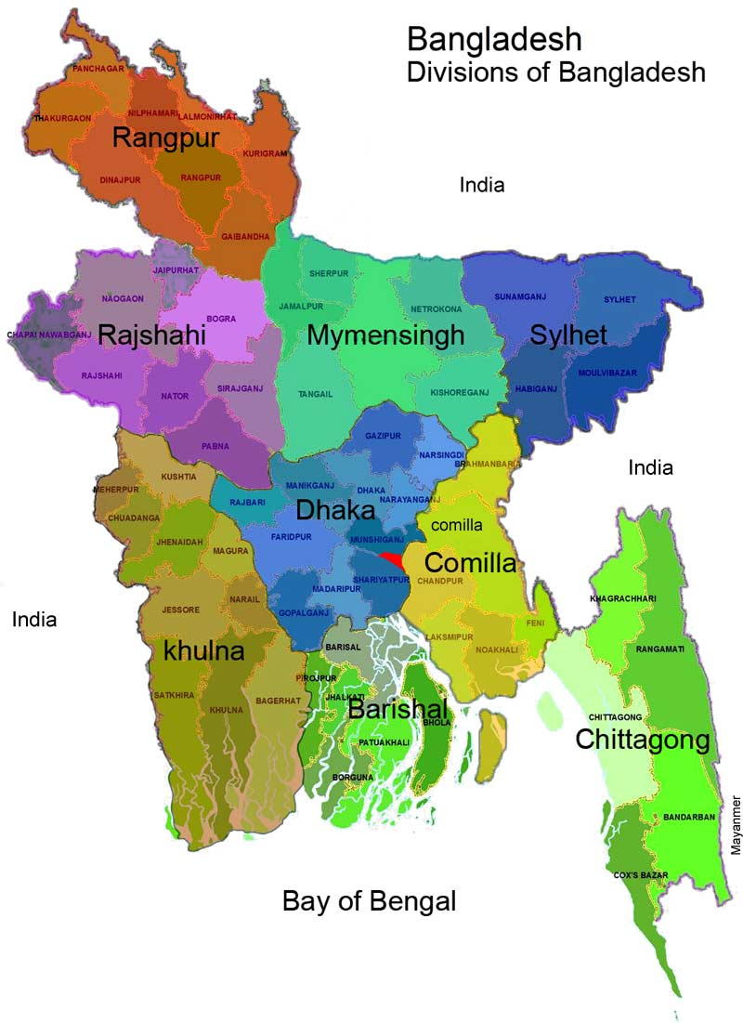
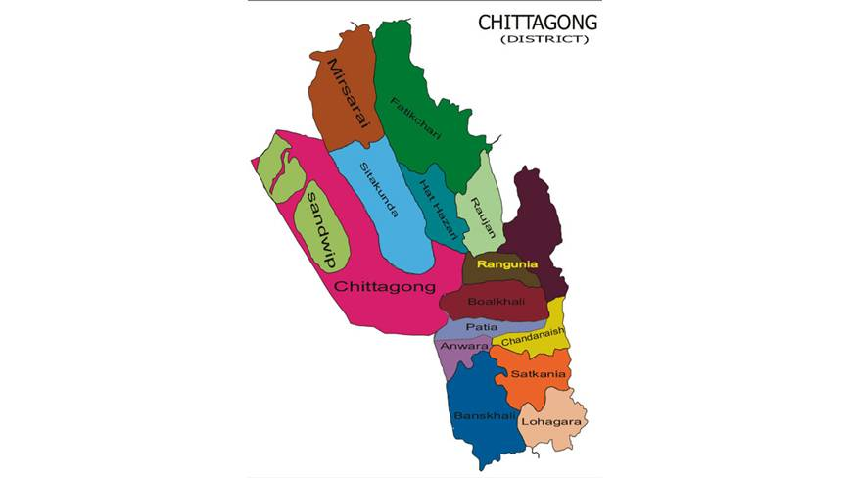
Figure-1: Study area indicating in the map of Bangladesh

2.2 Study Population:

The study population was 116320 broiler parent stock (cob-500) where female was 101377 and male was 14943

2.3 Data collection
Data were collected from record of the computer and registered book and also by asking question to the manager, supervisor and workers providing a questionnaire. Management data was taken from observation and information was collected from the responsible supervisors.

2.4 Housing System
There were total 12 houses in four buildings. Each house was 426.4 ft in length and 39.36 ft in width. Every house was divided into two area, one was litter area and another was slate area.

2.5 Ventilation system
Temperature and ventilation of the farm was maintained according to the condition of the birds. During brooding period when the chicks were gathered in the periphery then the hover was placed somewhat above from the previous height. But when the chicks gathered under the hover, then the hover placed down. The ventilation was maintained automatically with the help of TC5 machine, exhaust fan, cooling pad and air inlet.

2.6 Statistical analysis:
All related data were imported in MS Excel 2007.The summation, frequency distribution and other calculations were done and expressed accordingly.

2.7 Flock size under study:
Number of total birds was found to be higher in house no.5. House 7 occupies total 8863 birds which is lower than all other houses.
Table-1: Numbers of total birds in different flocks
House No. | Male | Female | Total
1 | 1386 | 9105 | 10491
2 | 1290 | 8510 | 9800
3 | 1391 | 9202 | 10593
4 | 1244 | 7954 | 9198
5 | 1380 | 8840 | 10220
6 | 1335 | 8717 | 10052
7 | 970 | 7893 | 8863
8 | 1294 | 8370 | 9664
9 | 1293 | 8308 | 9601
10 | 1037 | 8045 | 9082
11 | 1288 | 8368 | 9656
12 | 1035 | 8065 | 9100
Total | 14943 | 101377 | 116320

CHAPTER 3
RESULTS AND DISCUSSION

3.1 Temperature schedule:
Temperature showed little variation in brooding period. At 1st day the existing temperature was 31⁰C where the standard value was 32⁰C. In 21st days the existing and target temperature were 26⁰C and 27⁰C respectively (Table-2)

3.2 Vaccination system:
The vaccination program started against Marek’s disease at 1 day of age continued upto 42 weeks of age strictly following a definite schedule (Table-3)

3.3 Body Weight:
This study clearly indicated that achieved body weight was always higher than target body weight both in female and male birds. Achieved body weight at 5^{th,} 25th, 50th and 65th weeks of age in female birds were 660gm, 3105gm, 3893gm and 3995gm respectively where target body weight were 650gm, 3100gm, 3890gm and 3985gm respectively. Actual body weight gain at 5th weeks, 30th weeks and 60th weeks of age in male birds were 970 gm, 3875gm and 4648 gm and target body weight were 800gm, 3870gm and 4640gm respectively. The body weight of male always higher than the female birds (Table-4).

3.4 Uniformity:
Uniformity of the birds in a flock was fluctuated throughout the rearing period. Uniformity of female birds was always higher than males. At the age of 1-5th weeks uniformity in females was 62% where in case of male it was 60%. 81% and 80% uniformity was found at 61-65th weeks of age in female and male birds respectively. Uniformity in female was higher at the age of 43-49th weeks (88%) and lower at the age of 1-5th weeks (62%). In male it was higher at 61-65th weeks (80%) of age and lower at 1-5th weeks (60%) of age (Table-5 and Graph-1)
3.5 Egg production:
The egg production achieved at 24th weeks of age was 3% which was lower than the recommended value (5%). The peak production was 85% achieved at 31 weeks of age which is higher than the recommended egg production (83.5%).(Table-6)
The maximum hatching egg percent was observed 98.2% at 35 weeks of age which was somewhat higher than the standard hatching egg production percent 98% in that weeks (Table-7)

Table-2:Temperature status during brooding period:

Age (day) | Existing temperature (⁰C) | Standard Values
1 | 31 | 32
4 | 30 | 31
7 | 29 | 30
14 | 27 | 29
21 | 26 | 27

Table-3: Vaccination schedule in CP broiler parent stock:
Day | Vaccine
1 day | Marek’s Disease, Infectious Bronchitis
7 days | Newcastle Disease+Infectious Bronchitis,Reo
9 Days | Salmonellosis
14 Days | Infectious bursal disease
21 Days | Newcastle Disease+Infectious bronchitis Fowl Pox & Newcastle Disease (Killed)
6 Weeks | Coryza, Bivalent Reo & Salmonellosis
8 Weeks | Mycoplasmosis (Killed) & Newcastle Disease+Infectious Bronchitis
10 Weeks | Infectious Laryngotracheaitis & Fowl Pox+Avian Encephalitis.
15 Weeks | Newcastle Disease+Infectious bronchitis,Egg drop syndrome, Mycoplasmosis & Coryza.
18 Weeks | Salmonellosis & Newcastle Disease+Infectious Bronchitis
20 Weeks | Infectious Bronchitis+Newcastle Disease+Reo.
30 Weeks | Newcastle Disease+Infectious Bronchitis
36 Weeks | Newcastle Disease+Infectious Bronchitis
42 Weeks | Newcastle Disease+Infectious Bronchitis
Table-4: Achieved and target Body Weight of the broiler breeder flock–
Age  ( Wks) | Body Weight
 | Females |  | Males
 | Achieved body weight (gms) | Target body weight (gms) | Achieved body weight (gms) | Target body weight (gms)
5 | 660 | 650 | 970 | 800
10 | 1150 | 1160 | 1480 | 1460
15 | 1600 | 1590 | 2050 | 2040
20 | 2252 | 2250 | 2740 | 2730
25 | 3105 | 3100 | 3415 | 3400
30 | 3395 | 3390 | 3875 | 3870
35 | 3643 | 3640 | 4088 | 4090
40 | 3745 | 3740 | 4205 | 4200
45 | 3815 | 3820 | 4318 | 4310
50 | 3893 | 3890 | 4422 | 4420
55 | 3914 | 3920 | 4433 | 4530
60 | 3955 | 3960 | 4648 | 4640
65 | 3995 | 3985 | 4735 | 4730
70 | 4019 | 4010 | 4825 | 4820

Table-5: Uniformity observed in the broiler breeder flock (Both male and Female)

Age  (Wks) | Uniformity
 | Females (%) | Males ( % )
1-5 | 62 | 60
6-11 | 76 | 75
12-17 | 83 | 66
18-24 | 80 | 78
25-30 | 83 | 72
31-36 | 85 | 76
37-42 | 87 | 65
43-49 | 88 | 79
50-55 | 85 | 78
56-60 | 75 | 75
61-65 | 81 | 80

Graph-1: Uniformity of the birds at different age (Male and female)

Table-6: Recommended and achieved weekly egg production percentage (%).
Age  ( wks) | Weekly Egg Production  (%)
 | Recommended | Achieved
24 | 5 | 3
25 | 15 | 13
26 | 35 | 34
27 | 60 | 55
28 | 78 | 75
29 | 82.5 | 82
30 | 83.3 | 83
31 | 83.5 | 85
32 | 83 | 83
33 | 82 | 81
34 | 81 | 81
35 | 80 | 80
36 | 79 | 79
37 | 78 | 78
38 | 77 | 77
39 | 76 | 76
40 | 75 | 76
41 | 74 | 76
42 | 73 | 75
43 | 72 | 75
44 | 71 | 72
45 | 70 | 70
46 | 69 | 68
47 | 68 | 68
48 | 67 | 68
49 | 66 | 67
50 | 65 | 67
51 | 64 | 66
52 | 63 | 66
53 | 62 | 65
54 | 60 | 62
55 | 59.5 | 60
56 | 58.3 | 58
57 | 57 | 57
58 | 55.8 | 54
59 | 53 | 54.1
60 | 51 | 52
61 | 50 | 51.4
62 | 48 | 50
63 | 46 | 47
64 | 44 | 46.5
65 | 43 | 45

Table-7: Recommended and achieved weekly Hatching egg production percentage.
Age  ( wks) | Weekly Hatching egg production  (%)
 | Recommended | Achieved
25 | 40 | 50
30 | 93 | 94
35 | 98 | 98.2
40 | 98 | 98
45 | 98 | 97
50 | 98 | 96
55 | 96 | 95
60 | 96 | 95
65 | 94 | 94
70 | 93 | 91

CONCLUSION
Poultry farming has bright prospects in generating employment opportunities, poverty reduction, and supply of high protein to the people of Bangladesh. Management practices of the CP Broiler breeder farm were very good and overall production performances of the farm were satisfactory in environmentally controlled house and it was almost higher than the recommended value. At last the present study may be concluded saying that it is possible to achieve target body weight, production, hatching percentage of egg etc of Cobb-500 in our country in good management system.

REFERENCES
Ahmed S and Islam N (1985):"Backyard Poultry Development Project in 100 Villages."Bangladesh Agricultural University and assisted by UNICEF, Bangladesh. Proceedings of the 1st Conference of Bangladesh Animal Husbandry Association, February 23-24, BARC, Dhaka.
Alam J, Sayed A, Rahman A, Yasmin F and Begum J (1994-1998): An economic
study on poultry farms in Bangladesh. Bangladesh journal of livestock research. Pp:161-174.

Anonymous (2001) Bangladesh Bureau of Statistics, Ministry of planning Dhaka, Bangladesh.

FAO (2000). Food and agricultural organization of the united Nations statistical databases. FAO, Rome, Home page, w.w.w. Faw, org.
Farooq, Chowdhury S D, Das C, Pramanik H A M, Roy C R, and Shaha.K S (2003). Broiler parent stock production in Bangladesh: It is possible to achieve target body weight and acceptable uniformity in open sided housed? Proc.3rd WPSA International Poultry Show and Seminar. Pp: 15-23.
Management guideline of Cobb 500 broiler breeder.
Pervin S (2004): Broiler marketing in selected areas of Kishoreganj district, MS thesis
submitted to the Dept. of Cooperation and marketing, BAU, Mymensingh.

Raha S K (2007): Broiler industry in Bangladesh Some issues In proceeding of the 5th
international poultry show and seminar World’s poultry scince association, Bangladesh branch, March 01-03 At Bangladesh-China friendship center, Dhaka, Bangladesh. Pp: 1-9.

Rahman M M, Rahman M M, Rahman A, Islam A H M N, Miah A H, Mazumder J U, and Bhattacharjee A S (1998): Observation on out breaks and sub-sequent control of Infectious bursal disease in the central poultry farm in Bangladesh. Bangladesh Veterinary Journal.Pp:13-17.

Saleque M A (2007): Poultry industry in Bangladesh - Current status and its future, Presented in the seminar organized by Chittagong Veterinary University; Proceedings of the fourth annual scientific conference.
WATT, poultry statistical year book (1996). Poul. Inter.Pp:8.

ACKNOWLEDGEMENT

The author takes the privilege to acknowledge the almighty “Allah”, who has given the opportunity to accomplish of the production report.
The author would like to express his deep sense of gratitude to Professor Dr. Md. Ahsanul Hoque, Dean, Faculty of Veterinary Medicine, Chittagong Veterinary and Animal Sciences University (CVASU).
The author expresses his sincere gratitude, heartfelt respect and immense indebtedness to his supervisor DR.Mahabub Alam, Assistant Professor, Department of Animal Science and Nutrition, Chittagong Veterinary and Animal Sciences University.
The author is thankful to placement supervisor MD. Humayan Kobir Himu and Manager MD. Ataul Islam,CP Broiler Breeder Farm,Mirsharai,Chittagong for their kind co-operation. Author also grateful to all shed supervisors and the farm authority.
Finally the author extended his appreciation to his parents and all well-wishers.

The Author

BRIEF BIOGRAPHY
I am Md. Nur Uddin, son of Mr. Nur Nabi and Mrs. Nur Jahan. I am native to Chittagong. I have completed my secondary (2006) and higher secondary (2008) education from Mirsarai, Chittagong successfully. Then I got myself admitted in Doctor of Veterinary Medicine Course under Chittagong Veterinary and Animal Sciences University. During my internship programme I got a short time research on “Management system and productive performances in a selected broiler breeder farm in Mirsharai, Chittagong.” I believe all these will be helpful in progress of my career in future.

