The Impact of Herbal Liver Tonic (Superliv®) on the Growth Performance of Broilers Chick

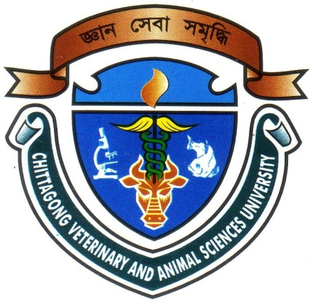

A Production Report Submitted
By
SYDUS SHALEKIN SHAKIL
Roll No: 13/01
Reg. No: 00906
Intern ID. : 01
Session: 2012 – 2013

Approved as to style and content by
……………………………….............
Signature of Supervisor
Dr. Goutam Buddha Das
Professor
Department of Animal Science and Nutrition, CVASU
…………………………......
Signature of Author
Sydus Shalekin Shakil
Roll No: 13/01
Reg. No: 00906
Intern ID: 01

C
Chittagong Veterinary and Animal Sciences University
Khulshi, Chittagong-4225, Bangladesh

The Impact of Herbal Liver Tonic (Superliv®) on the Growth Performance of Broilers Chick

A Production Report Submitted
By
SYDUS SHALEKIN SHAKIL
Roll No: 13/01
Reg. No: 00906
Intern ID. : 01
Session: 2012 – 2013

The report submitted in the partial fulfillment of the requirements for the Degree of Doctor of Veterinary Medicine (DVM)

Chittagong Veterinary and Animal Sciences University
Khulshi, Chittagong-4225, Bangladesh
Septamber, 2018

