Characterization and Comparative Analysis of Acid- Soluble Collagen Extracted from Fish By-Products: Insights into Their Resemblance to Commercial Food Collagen

Ayesha Chowdhury Roll No.: 0121/05 Registration No.: 974
Session: January-June, 2021

A thesis submitted in the partial fulfillment of the requirements for the degree of Master of Science in Food Chemistry and Quality Assurance

Department of Applied Chemistry and Chemical Technology Faculty of Food Science & Technology
Chattogram Veterinary and Animal Sciences University Khulshi, Chattogram-4225, Bangladesh

JUNE 2023

Authorization

I hereby declare that I am the sole author of the thesis. I also authorize the Chittagong Veterinary and Animal Sciences University (CVASU) to lend this thesis to other institutions or individuals for the purpose of scholarly research. I further authorize the CVASU to reproduce the thesis by photocopying or by other means, in total or in part, at the request of other institutions or individuals for the purpose of scholarly research.
I, the undersigned, and author of this work, declare that the electronic copy of this thesis provided to the CVASU Library, is an accurate copy of the print thesis submitted, within the limits of the technology available.

Ayesha Chowdhury June, 2023

PLAGIARISM VERIFICATION

Title of Thesis: Characterization and Comparative Analysis of Acid-Soluble Collagen Extracted from Fish By-Products: Insights into Their Resemblance to Commercial Food Collagen.

Name of the Student: Ayesha Chowdhury
Roll number: 0121/05
Reg. No: 974
Department: Applied Chemistry & Chemical Technology
Faculty: Food Science and Technology
Supervisor: Monsur Ahmad

For office use only

This is to report that as per the check …20…..% of the content of the above thesis is stated to be plagiarized and is covered/not covered as per plagiarism policy and institutions issued from CASR, Chattogram Veterinary and Animal Sciences University. The report has been sent to the coordinator, CASR via email.

The thesis may/may not be considered for the evaluation.

Monsur Ahmad
Associate Professor & Head
Department of Applied Chemistry and Chemical Technology Faculty of Food Science and Technology

Characterization and Comparative Analysis of Acid- Soluble Collagen Extracted from Fish By-Products: Insights into Their Resemblance to Commercial Food Collagen
Ayesha Chowdhury Roll No.: 0121/05 Registration No.: 974
Session: January-June 2021

This is to certify that the mentioned Master's thesis has been reviewed, and that all necessary adjustments have been made, concluding that it is full and satisfactory in all regards.

-------------------------------------------
---------------------------------------------------------

Chairman of the Examination Committee
Supervisor
Monsur Ahmad
Associate Professor & Head Department of Applied Chemistry and Chemical Technology Faculty of Food Science and
Technology

Monsur Ahmad
Associate Professor & Head Department of Applied Chemistry and Chemical Technology
Faculty of Food Science and Technology

Department of Applied Chemistry and Chemical Technology Faculty of Food Science & Technology
Chattogram Veterinary and Animal Sciences University Khulshi, Chattogram-4225, Bangladesh

JUNE 2023

Acknowledgements
In the Name of Allah, the Most Beneficent, the Most Merciful. All the praises and thanks be to Allah, the Lord of the Alamin (mankind, jinns and all that exists).
First and foremost, I would like to express my gratitude to the “Almighty Allah” from my deepest sense of gratitude, whose blessing has enabled me to complete the thesis for the degree of Masters of Science (MS) in Food Chemistry and Quality Assurance under the Dept. of Applied Chemistry and Chemical Technology, Chattogram Veterinary and Animal Sciences University, Chattogram, Bangladesh.
I express my sincere gratitude to Professor ASM Lutful Ahasan, Vice-Chancellor, Chattogram Veterinary and Animal Sciences University (CVASU) for giving me special opportunity and providing such research facilities.
I am expressing a deep debt of gratitude, cordial thanks, deepest sense of respect and heartfelt indebtedness to my reverend teacher and supervisor Monsur Ahmad (Associate Professor and Head, Department of Applied Chemistry and Chemical Technology, CVASU) for his effective steerage during my whole study period who ploughed through several preliminary versions of my text, making critical suggestions and posing challenging questions. His expertise, invaluable guidance, constant encouragement, affectionate attitude, understanding patience, and healthy criticism added considerably to my experience.
I feel proud in expressing my regard and immense indebtedness to Professor Md. Ashraf Ali Biswas Dean, Faculty of Food Science and Technology for kind co- operation, valuable suggestions and constructive criticism.
I would like to express my deep sense of gratitude to all my honorable teachers of the Department of Applied Chemistry and Chemical Technology, CVASU for their advice and encouragement.
Indeed, I owe deeply to my parents, family members and well-wishers for their heartfelt blessings, immeasurable sacrifice and continuous inspiration, which lead me to all my success in study.
The Author June, 2023

Table of Content

  - : Aims of the Research 4
  - : Objectives 4
  - : Expected Outcome 5
  - : Limitation of the study 5
  - Collagen 7
  - Fish Collagen and By-products 9
    - Fish Skin 9
    - Fish Scale 10
  - Advantage and Disadvantage of Fish Collagen 11
  - Methods for Extracting Collagen 12
  - Characterization Techniques 13
    - Fourier-Transform Infrared Spectroscopy (FTIR) 14
  - Functional Properties 15
  - Health Benefits 16
  - Collagen Applications 16
    - Food Industry 16
    - Cosmetics Industry 17
    - Pharmaceuticals and Biomedical Applications: 17
  - Challenges and Future Directions 18
    - Challenges 18
    - Future Directions: 19
  - General 21
  - Site and Period of Study 21
  - Sample Collection 21
  - Sample Preparation 21
    - Fish Skin Preparation 21
    - Fish Scale Preparation 21
  - Extraction of Acid Soluble Collagen 22
    - Raw Materials 22
    - Reagent 22
    - Reagent Preparation 22
    - Apparatus & Equipment 22
    - Collagen Extraction and Characterization from Fish Skin and Scale 23
    - Characterization of Commercial Collagen 25
  - : General 26
  - : Analysis of Extracted Collagen 26
  - : General 30
  - : Availability of Collagen in Several Fish By Products 30
  - Sources of Type-I collagen 30
  - : Collagen in Fish Skin 31
  - : Collagen in Fish Scale 32
  - : Collagen in Fish Skin & Scale 33
  - : Collagen in Other By Products 34
  - Similarities of Commercial Collagen with Type-I Collagen 34
Insights into Resemblance and Functional Properties: 38
Sustainability and Economic Implications: 38
Potential Challenges and Future Directions: 38
Global Impact: 39
Appendix A: Picture Gallery 55

List of Tables

Sl. No. | Title of the table | Page No.
Table 4.1 | Infrared spectroscopic distribution of commercial collagen and collagens extracted from snakehead fish skin, snakehead fish scale, and Anguilla  bengalensis fish skin. | …. | 28

List of Figures

SL No. | Title | Page No.
1.1 | Estimated collagen content in various  tissues | 1
2.1 | Fish byproducts as potential sources for  obtaining collagen | 9
2.2 | Benefits and drawbacks of fish collagen | 12
2.3 | The use of fish collagen in various  industrial fields | 18
4.1 | FT-IR result of Collagen extracted from  Skin of Snakehead fish | 26
4.2 | FT-IR result of Collagen extracted from  Scale of Snakehead fish (Channastriata) | 27
4.3 | FT-IR result of Collagen extracted from  Skin of Anguilla bengalensis | 27
4.4 | FT-IR result of Commercial Collagen | 27

Abstract

Collagen, a ubiquitous protein in the animal kingdom, serves as a critical structural component in various biological tissues and has gained significant attention in the food industry for its multifaceted functional properties. In this study, acid-soluble collagen extracted from fish by-products was comprehensively characterized and compared to commercially available food-grade collagen sources to elucidate their structural and functional similarities. Fish by-products, often considered waste in seafood processing, represent a sustainable and underutilized source of collagen. The acid extraction method was employed to obtain collagen from fish skin and scale by-products. Comprehensive analytical technique, including Fourier-transform infrared spectroscopy (FTIR) was utilized to assess. The results of this study revealed that acid- soluble collagen from fish by-products exhibited a high degree of resemblance to commercial food-grade collagen in terms of its amino acid profile. These findings highlight the potential of fish by-products as a valuable and sustainable source of collagen for various food applications. The characterization and comparative analysis presented in this study offer valuable insights into the suitability of fish by-product- derived collagen as a viable alternative to commercial food collagen. This research contributes to the growing interest in sustainable sourcing of collagen for the food industry and opens up possibilities for the utilization of fish by-products in value-added food products and functional ingredients.

Keywords: Collagen, fish by-products, FTIR and food-grade collagen

Introduction
Collagen is a critical structural protein found in various organisms, including mammals and fish. In recent years, the interest in collagen derived from fish by-products has grown, as it offers a sustainable alternative to traditional sources of collagen. This paper discusses the characterization and comparative analysis of acid-soluble collagen from fish by-products and its resemblance to commercially available food-grade collagen. Understanding these similarities and differences can provide insights into the potential applications and advantages of fish-derived collagen in the food industry.
Depending on the process and product type, fish solid waste accounts for 50-70% of the original raw material. Instead of being used as pet food, these wastes have piqued the interest of researchers as high-protein human foods (Montero et al., 1991; Shahidi, 1994). Because of its abundance, collagen from skin, scale, and bone has grown in popularity as a value-added product derived from those wastes. Collagen is a protein that is abundant in vertebrates, accounting for 30% of total animal protein (Muyonga et al., 2004). Animal organs primarily structured by collagen include tendon, skin, bone, the vascular system, and connective tissue sheaths surrounding muscle (Foegeding et al., 1996).

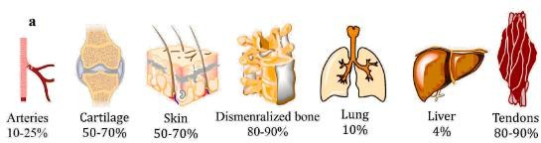

Figure 1.1: Estimated collagen content in various tissues

Collagen degrades as a result of aging, ultraviolet light exposure, and tobacco use. Because collagen degradation causes wrinkles, sagging skin, stiff joints, and dry skin, it is critical to identify new collagen resources for regenerative tissue applications. (Chang et al., 2014; Aguda et al., 2014).
So far, the main collagen sources have been limited to land-based animals, such as bovine or porcine skin and bone. However, the outbreaks of bovine spongiform encephalopathy (BSE) and the foot-and-mouth disease (FMD) crisis have caused

concern among users of land animal collagen and collagen-derived products (Helcke, 2000). Furthermore, collagen derived from porcine skin or bone is not permitted in some foods due to aesthetic and religious concerns (Sadowska et al., 2003). As a result, alternative sources for collagen extraction, such as fish processing waste, including skin, bone, and scale, have received increased attention.
Fish offal, such as bones, scales, and skins, contain a high concentration of collagen (Gomez-Guillen et al., 2002; Ikoma et al., 2003; Kimura, 1992; Nagai et al., 2000, Nomura et al., 1996).
The main structural body protein is collagen, a natural biopolymer. Recently, researchers discovered at least 29 collagen variants based on sequence homology and molecular structure (Wang et al., 2008). Collagen Type-I is the most important collagen protein, and it is widely used due to its excellent biocompatibility and biodegradability (Wang et al., 2018; Levillain et al., 2016). Its content varies depending on the species, age, and season of the fish (Ciarlo et al., 1997; Foegeding et al., 1996; Montero et al., 1991; Nagai et al., 2002). Among them are nineteen collagen variants known as types I-XIX (Bailey et al., 1998).
Because of its availability, lack of dietary restrictions, and high collagen content, collagen from aquatic species is considered an alternative source. Snakehead fish (Channa striata), a Channidae family aquatic species. Snakehead fish skin, a major by- product of the filleting industry, contains a high concentration of collagen (Rosmawati & Abustam, 2018). According to Rosmawati (2018), 9.53% acid soluble collagen (ASC) extracted from snakehead fish skin is equivalent to 53.62% total skin-protein. These fish skins can be extracted and used in place of terrestrial mammalian collagen sources. Utilization of fish skin wastes for collagen extraction may be the best waste management option. As a result, snakehead fish skin by-product was chosen as a collagen source for this study.
Snakehead fish (Channa striata) is a potential freshwater fish species that has grown in popularity in the health food industry. By-product processing after filleting can reach 60- 70% (Szpak, 2011) or approximately 75% of total fish weight (Garcia et al., 2011). Skin, bone, and scales account for approximately 30% of byproducts (Regenstein et al., 2010). Skin and bone are significant byproducts of the fishing industry, containing both organic and inorganic ingredients (Szpak, 2011). Anguilla bengalensis, also known as the Indian freshwater eel, is an intriguing source of collagen. Extracted collagen from

Anguilla bengalensis holds promise for a variety of biomedical and cosmetic applications, making it a hotly debated topic.
Many papers (Koladziejaka et al., 1999; Nagai et al., 2002; Nagai et al., 2000; Ogawa et al., 2004; Sadowska et al., 2003) dealt with the practical use of marine animals to produce collagen. A few cases, however, involved collagen from freshwater animals (Kimura et al., 1991; Zhang et al., 2007). The goal of this study was to isolate acid soluble collagens from the skin and scale of Snakehead fish (Channastriata) as well as the skin of Anguilla bengalensis.
Fish production and byproducts are related; greater production results in higher costs to lessen the effects of environmental pollution. In contrast, using fishery byproducts can both address the issue of waste disposal and result in products with added value (Alfaro et al., 2015). So proper handling is necessary to avoid damaging environmental effects. One strategy to raise the added value of fishery by-products is the valorization of skin and fish bones for production. In addition to raising the utility and financial worth of the byproduct, using skin and fish bones can lessen their negative effects on the environment.
Consequently, many studies focused their effort toward the extraction and characterization of collagen from skins of different fish, such as small-spotted catshark (Scyliorhinus canicula), rabbitfish (Chimaera monstruosa), lantern shark (Etmopterus spp.), catshark (Galeus spp.), cuckoo ray (Leucoraja naevus), common Atlantic grenadier (Nezumia aequalis), cod (Gadus morhua), and the scales and fins of Catla catla and Cirrhinus mrigala (Yin et al., 2016, Muyonga et al., 2004). The low denaturation temperature (25-30˚C for the majority of fish species) and variable composition of collagen from fish skin, bones, and fins prevents it from being used in biomedical applications (Wu et al., 2011, Gam et al., 2005). Fish collagen is difficult to work with because it denatures at a low temperature due to the low amino acid content (proline and hyp) in marine collagen.
Collagen is a ubiquitous protein found in various biological tissues, playing a pivotal role in providing structural integrity and functionality to organs and connective tissues within the human body. Beyond its essential biological functions, collagen has gained significant attention in the food industry due to its numerous applications as a functional ingredient. It is commonly utilized in the formulation of various food products,

including gummies, protein bars, beverages, and supplements, primarily for its texture- enhancing, gelling, and stabilizing properties.
This thesis focuses on the characterization and comparative analysis of acid-soluble collagen extracted from fish by-products, with a particular emphasis on understanding their similarities with commercial food collagen.
The objectives of this research are multifaceted:
    - Characterization of Fish By-Product Collagen: The first goal is to comprehensively characterize the collagen extracted from fish by-products. Understanding the intrinsic characteristics of fish-derived collagen is fundamental to evaluating its potential applications in the food industry.
    - Sustainability and Economic Viability: Given the sustainability concerns associated with collagen sourcing from terrestrial animals, this study will evaluate the environmental and economic aspects of utilizing fish by-products for collagen extraction, aiming to shed light on its potential as a more sustainable alternative.
Understanding the characteristics of collagen extracted from fish by-products and its potential as a viable alternative to conventional collagen sources holds great promise not only for the food industry but also for sustainable resource management. This research seeks to contribute valuable insights into the utilization of fish-derived collagen in food applications and its role in addressing both economic and environmental challenges associated with collagen sourcing.

: Aims of the research
The aim of this study is to comprehensively characterize acid-soluble collagen extracted from fish by-products, and to conduct a comparative analysis with commercial food collagen, in order to assess their functional and structural similarities, thereby contributing to a better understanding of their potential applications in the food industry.

: Objectives
The objectives of this study are as follows:
- Extraction of acid-soluble collagen from various fish by-products through optimized methods.

- Assess the characteristics of fish-derived collagen using technique such as Fourier-transform infrared spectroscopy (FTIR), and compare these with the features of commercial food collagen.
- Analyze the potential applications of fish-derived collagen in the food industry, considering its functional and structural resemblance to commercial food collagen.
- Explore the sustainability and economic aspects of utilizing fish by-products as a source of collagen for food applications.

: Expected Outcome
The feasibility of adding fish-derived collagen into a variety of food products to improve their quality and nutritional value.

: Limitation of the study
- Comprehensive chemical characterisation of fish-derived collagen, including amino acid composition, molecular weight distribution, and collagen content determination
- Compare the thermal, rheological, and solubility properties of fish-derived collagen to those of commercial food-grade collagen.
- The structural characteristics of fish-derived collagen are assessed using techniques such as scanning electron microscopy (SEM) and compared to the structural characteristics of commercial food collagen.
- The functional properties of fish-derived collagen, such as gelation, emulsification, and water-holding capacity, will be investigated and compared to those of commercial food collagen. The functional properties of collagen are critical to its use in food products.
- Beyond its functional properties, collagen is of interest for its potential health benefits, such as its role in promoting skin health and joint function, which can investigate the bioactive properties of fish-derived collagen and evaluate its nutritional value, especially in comparison to conventional collagen sources.
- The long-term goal of this study is to look into the feasibility of incorporating fish by-product collagen into food formulations. This will entail evaluating its

compatibility, sensory properties, and consumer acceptance in a variety of food products, potentially opening up new avenues for its use in the food industry.

In conclusion, the characterization and comparative analysis of fish-derived collagen are vital for understanding its potential as a sustainable and cost-effective alternative to commercial food-grade collagen. This research contributes to the broader discussions on sustainability, waste reduction, and innovative applications of natural resources in various industries. It paves the way for further exploration and commercialization of fish-derived collagen in the global market.

Collagen

Chapter-2: Literature Review

Collagen, a structural protein, plays a crucial role in various industries, including the food, pharmaceutical, and cosmetic sectors. Its versatility stems from its ability to form gels, films, and fibers, making it an essential component in a wide range of products. The sourcing of collagen, however, often faces challenges related to cost and sustainability. In this context, the utilization of collagen derived from fish by-products offers an environmentally friendly alternative. This literature review aims to provide an overview of the characterization and comparative analysis of acid-soluble collagen obtained from fish by-products and assess their resemblance to commercially available food-grade collagen.
The European Commission approved a long-term plan called "Blue Growth" that has been put into action to pay special attention to fish resources in order to protect the environment from industrial pollution. This is done in order to exploit natural resources as much as possible. One of the most alluring features of seafood by-products is the enormous amount of valuable protein that could be extracted (Pal et al., 2015; Jia et al., 2012; Wang et al., 2008; Wang et al., 2017; Nagai et al., 2004). The fish tissues that are thrown away as waste, such as the fins, heads, skin, and viscera, are used to make more than 20 million tons of them every year (Silvipriya et al., 2015; Shaw et al., 2022; de Melo Oliveira et al., 2021). The use of fish by-products as a new source of collagen has attracted growing interest due to their high protein content, lack of risk of disease transmission, high bioactivity, and less significant religious and ethical restrictions (Sorushanova et al., 2019; Shavandi et al., 2019).
According to research by Mishra et al., enormous amounts of solid waste are produced during the processing of fish and other seafood, which accounts for about 70% of all fish and seafood sold today (Mishra et al., 2021). The fish industry uses more than half of the weight of fresh fish as byproducts. The majority of these byproducts are burned or buried, which has negative effects on the environment, human health, and the economy. A small percentage are used as cheap ingredients in animal feeds. Fish waste is a growing issue that needs quick, original approaches and solutions. The prevention of food waste has been the focus of numerous initiatives and programs worldwide. Investing in fish industry waste can provide the chance to recover additional valuable substances like oils, proteins, pigments, bioactive peptides, amino acids, collagen,

chitin, and gelatin in addition to lowering the cost of waste disposal (Xu et al., 2019; Al Khawli et al., 2019; Caruso et al., 2020).
Fish collagen is a type I collagen predominantly extracted from the skins, scales, and bones of various fish species. Fish processing generates significant by-products, such as skin and bone, which are typically discarded. However, these by-products contain valuable collagen that can be extracted using acid solubilization methods. The utilization of fish by-products not only reduces waste but also provides a sustainable source of collagen.
Collagen extraction from fish waste has been the subject of research for more than 20 years. The extracellular matrix of connective tissues, such as skin, bones, tendons, ligaments, cartilage, intervertebral discs, and blood vessels, contains collagens, one of the most prevalent proteins in animals (Nimni et al., 2018). Collagens play regulatory roles (i.e., through mechano-chemical transduction mechanisms) during tissue growth and repair in addition to being involved in tissue architecture maintenance and strength (Coppola et al., 2021). Collagens are intrinsically bioactive, biocompatible, and biodegradable due to their nature. Collagens are therefore regarded as the most frequently needed and used biomaterials in a variety of industries, including the medical, cosmetic, nutraceutical, food, and pharmaceutical ones. They can be found in the form of injectable solutions, thin substrates, porous sponges, Nano fibrous matrices, micro- and nano-spheres, and more (El Blidi et al., 2021; Sbricoli et al., 2020). Despite the fact that fish collagen typically has a lower molecular weight and lower denaturation temperature than mammalian collagen, recent studies have found many similarities in the molecular structure and biochemical properties between collagen derived from fish and mammalian sources (de Melo Oliveira et al., 2021; El Blidi et al., 2021; Xu et al., 2021; Coppola et al., 2020; Gallo et al., 2020; Jafari et al., 2020). Various fish collagen extraction methods have been created depending on the chosen tissue type and fish species. This has led to the development of a sizable body of literature (Ikoma et al., 2003; Nomura et al., 1996; Nagai et al., 2000). Researchers have only recently focused on creating novel materials with enhanced properties in addition to creating extraction methods for mass production. The goals of this study were to extract collagen Type-I from snakehead fish skin and scale (Channa striata) and Anguilla bengalensis skin.

Pretreatment to remove grease, hydrolysis to remove undesirable protein, and extraction with acetic acid to obtain acid-soluble collagen (ASC).

Fish Collagen and By-products
Mammalian collagen can be obtained from a variety of tissues, including skin, bones, tendons, lung tissue, and connective tissues. Research has focused on the creation of a new source of extraction due to limitations in terms of health, cultural, social, and religious issues that are implied by traditional sources. Diverse marine resources, including vertebrates and invertebrates, have been investigated and considered as sources for collagen extraction. In particular, several fish species (such as Rachycentroncanadum, Esoxlucius, Spotless smooth hound, Sciaenopsocellatus, Sardinella fimbriata, Coryphaenahippurus, Alaska pollock, Takifuguflavidus, Pacu, Labeorohita, Labeocatla, Tuna, Thunnusobesus, Scomber japonicus, Gadusmorhua, Fish by-products like skin, scales, bones, skulls, swimming bladders, and remaining viscera can be used as collagen sources. The best source of fish collagen extraction among all fish by-products has historically been reported to be skin (Subhan et al., 2021; Heidari et al., 2022; Morikawa et al., 2022; Felician et al., 2018).
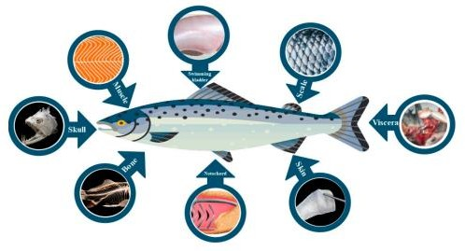

Figure 2.1: Fish byproducts as potential sources for obtaining collagen

Fish Skin
Depending on the species, age, and season, fish skin typically contains type I collagen with a high degree of purity (around 70%) (Chinh et al., 2019). Collagen from fish skin has an excellent water retention capacity (about 6% of its weight when exposed to 63% humidity for 24 hours) and no irritant potential, making it suitable for dermal applications (Cumming et al., 2019). (Blanco et al. )(Chinh et al., 2019) found collagen denaturation temperatures in the range of 23 to 33˚C in the skin of two species of teleost and two species of Chondrichthyes, whereas collagen isolated from codfish skin

denatured around 16˚C, which could be due to the species' habitat (Sionkowska et al., 2014). Collagen from the skin of tilapia, catfish, pomfret, and mackerel, on the other hand, necessitates a low extraction temperature (slightly lower than 13.26˚C), a long extraction time (74 h), and yields of 2.27% (based on dry mass content) (Liu et al., 2016). Wijaya et al. (2020) investigated the allergenic properties of collagen from Parang-Parang in another study. The skin of a fish collagen was isolated in 12 hours using 0.1 M NaOH, and it was hydrolyzed using before the experiment, prepare 0.5 M acetic acid (AcOH). The protein content of non-collagen was 0.2163 mg/mL. with a 1.915% return. (Govindharaj et al., 2019) looked into the use of eel skin-derived collagen for 3D printing applications (type I). The final collagen yield was around 4.2%. A similar result was reported (Veeruraj et al., 2013), with the yield of collagen extracted from eel fish being 4.7%. As an alternative method, Ahmed et al. (Ahmed et al., 2018) investigated the use of bacterial collagenolytic proteases (CP) to extract collagen from fish skin. They produced CP using two bacteria, Bacillus cereus FORC005 and Bacillus cereus FRCY9-2. The total yield of collagen from bacteria treatments and when combined with acid-soluble collagen was 188 and 177 g/kg, respectively, which was higher than the yield from acid extraction alone (134.5 g/kg). Another method for extracting collagen from fish skin is to use CO2-acidified water, which was previously used to isolate collagen from Atlantic cod (Gadus morhua) (Sousa et al., 2020). The total content of proline-like amino acids in acidified water- extracted collagen was 151/1000 residues, with an extraction yield of 13.8% (w/w) (Sousa et al., 2020).

Fish Scale
Fish scales account for a significant portion of the waste generated by the fish processing industries. Recent research (Van De Water et al., 2013; Jeevithan et al., 2014; Liang et al., 2014) suggested that collagen derived from fish scales has properties similar to type I collagen. A study on collagen from tilapia scales (Oreochromis sp.) revealed a high denaturation temperature (57.9-79.0˚C), which could be attributed to its high amino acid content and higher intra/interchain bonds (hydrogen bonds, dipole- dipole bonds, ionic bonds, and Van der Waals interactions) (Jeevithan et al., 2014). Collagen isolated from fresh carp (Cyprinus carpio) scales, on the other hand, had a low denaturation temperature (32˚C) (Liang et al., 2014). Collagen extracted from tilapia, catfish, pomfret, and mackerel scale requires a higher extraction temperature (range

16.6-19.03˚C) and a longer extraction time (77.51 h), with lower extraction yields (0.13%) compared to fish skin (4.3%) (Chen et al., 2016). Collagen derived from fish scales has also been shown to have adequate water absorption (13.3%) and retention (15%) properties, making it suitable for medical and therapeutic applications (Jeevithan et al., 2014). Through a disk diffusion method, collagen-based wound dressing (paste and sheet) derived from tilapia and grey mullet scales demonstrated excellent antimicrobial activity against Staphylococcus aureus and E. coli.
Furthermore, the wound dressing had a high wound closure capacity (up to 99.63%), indicating that fish scale collagen plays a role in the acceleration of re-epithelialization (Van De Water et al., 2013; Jeevithan et al., 2014; Liang et al., 2014; Chen et al., 2016; Shalaby et al., 2020). However, due to the high calcium content (16-59% mineral content in weight) in fish scales, decalcification with ethylenediaminetetraacetic acid (EDTA) is required (Gauza-Włodarczyk et al., 2017).

Advantage and disadvantage of Fish Collagen
Several benefits, including
- Aquaculture and availability of fishing byproducts;
- Lower risk of disease transmission compared to mammalian collagen due to significant ontogenetic differences between fish and humans;
- Capability of purification and extraction;
- No restrictions based on religion or culture;
- slightly different chemical make-up;
- low viscosity;
- Non-toxic;
- Acceptable homeostatic characteristics;
- The ability to bioresorb;
- A simpler extraction technique;
- Greater adaptability and compatibility with metabolism; and
- A minimal inflammatory reaction (Figure 2). (Lu et al., 2022; Sanchez et al., 2018).
Although fish collagen has many benefits, it also has many drawbacks, including a low denaturation temperature, poor mechanical properties, and a rapid rate of degradation (Subhan et al., 2021). The lower denaturation temperature of fish collagen as compared

to mammalian collagen is its main disadvantage and restricts its use in medicine (Tihăuan et al., 2022). Collagen loses its structural function and conformation-related biological activity during denaturation, which turns it into gelatin and breaks down the hydrogen bonds that support the helical structure (Bächinger et al., 2010; Ricard-Blum, 2011). The low mechanical resistance of fish-derived collagen, which restricts its uses, is the second major flaw. Its mechanical properties and degradation profiles have been improved through a variety of methods, such as chemical or enzymatic cross-linking (Ahn et al., 2021; Liu et al., 2022).
Figure 2 displays the various benefits and drawbacks of fish collagen.
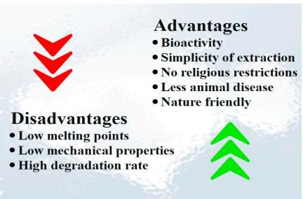

Figure 2.2: Benefits and drawbacks of fish collagen

Methods for Extracting Collagen
Various extraction techniques can be used, depending on the marine sources. Nonetheless, preparation, extraction, and recovery are steps in the general collagen isolation process.
In order to facilitate the samples' subsequent pretreatment, the preparation primarily entails washing, cleaning, separating animal parts, and reducing the size of the samples by chopping or mincing them (Jongjareonrak et al., 2005). A light chemical pretreatment is applied following the preparation in order to eliminate non-collagenous materials and improve extraction efficiency. Generally speaking, different pretreatments (alkaline or acid treatment) can be carried out based on the raw materials and the extraction technique. Because animal connective tissue contains crosslinked collagen, pretreatment using a diluted acid or base is used to break down the collagen

before extraction (Schmidt, M. et al., 2016). It's true that some hydrolysis occurs, maintaining the integrity of the collagen chains (Prestes et al., 2013).
The raw materials are dipped into the acid solution during the acidic pretreatment. The non-covalent inter and intramolecular bonds in the collagen structure cleave as a result of the penetrated solution causing the structure to swell two or three times its initial volume (Draget et al., 2000).
Sodium hydroxide (NaOH) and calcium hydroxide (Ca(OH)2) are the main ingredients used in the alkaline pretreatment, which can be carried out over a few days to several weeks (Prestes et al., 2013). Nonetheless, employing NaOH is more practical because of its increased capacity to swell, which makes it easier to extract collagen by speeding up the mass's transfer within the tissue matrix (Liu et al., 2015).
Furthermore, to improve the efficiency of removing collagen from body parts like bone, cartilage, and scales that have a high mineral content, the raw materials must be demineralized before the extraction phase. EDTA or HCl are typically used for demineralization (Kittiphattanabawon et al., 2010; Zelechowska et al., 2010).
Because of their triple helix structure and strong intra and intermolecular hydrogen bond crosslinks, collagen fibers are insoluble in water. Therefore, in order to increase the solubilization of collagen proteins and achieve their isolation during the extraction process, specific extraction techniques must be used. Collagen isolation from fish by- products can be achieved primarily through the extraction of acid-solubilized collagen (ASC), pepsin-solubilized collagen (PSC), deep eutectic solvent (DES), and supercritical fluid (SF) extractions, as documented in the literature (Ibáñez et al., 2016).

Characterization Techniques
To evaluate the suitability of fish-derived collagen for commercial food applications, extensive characterization is necessary. Various techniques have been employed to assess the physicochemical and functional properties of fish collagen, including amino acid composition analysis, Fourier-transform infrared spectroscopy (FTIR), scanning electron microscopy (SEM), X-ray diffraction (XRD), and rheological studies. These techniques provide insights into collagen's molecular structure, thermal stability, solubility, and gelling properties.

Fourier-Transform Infrared Spectroscopy (FTIR)
Fourier-Transform Infrared Spectroscopy (FTIR) is a widely employed analytical technique in the characterization and comparative analysis of acid-soluble collagen derived from fish by-products, offering valuable insights into their molecular structure and resemblance to commercial food-grade collagen. FTIR spectroscopy is based on the principle that molecules absorb infrared radiation at characteristic frequencies, providing information about their chemical composition and molecular structure.

Principle of FTIR Spectroscopy
FTIR spectroscopy measures the absorption of infrared radiation as it passes through a sample. When infrared light interacts with a molecule, it causes vibrations of the chemical bonds within that molecule. These vibrations occur at specific frequencies corresponding to the energies needed to stretch, bend, or rotate the bonds. The resulting spectrum, called an infrared spectrum, provides a unique fingerprint of the functional groups and molecular structure present in the sample.

Preparation of Samples

The following sample preparation steps are typically followed when performing FTIR analysis on acid-soluble collagen from fish byproducts and commercial food collagen:
      - Sample Drying: Thoroughly dry the collagen samples to remove any moisture, as water can interfere with the FTIR analysis.
      - Sample Grinding: To ensure uniformity and consistency, the dried collagen samples can be ground into a fine powder if necessary.
      - Sample Dispersion: For analysis, the collagen sample is mixed with spectroscopic-grade potassium bromide (KBr) powder and compressed into a thin, transparent pellet or disc.

Data Gathering

An FTIR spectrometer with an infrared light source, interferometer, and detector is used to collect FTIR spectra. The data collection procedure is outlined in the following steps:
- Background Measurement: To account for any interference or impurities in the instrument, a background spectrum is obtained by measuring the reference beam (without passing it through the sample).

- Sample Measurement: The collagen-KBr pellet or disc is placed in the FTIR spectrometer's sample compartment, and the infrared beam is passed through the sample. The absorbance spectrum that results is recorded over a specific wavelength range (typically 4000-400 cm1).
- Data Averaging: Multiple scans are frequently averaged to improve the signal- to-noise ratio and spectrum quality.

Results Interpretation

The FTIR spectra of fish-derived collagen and commercial food-grade collagen are compared and analyzed for key features such as:
- Amide Bands: The amide I (C=O stretching) and amide II (N-H bending and C-N stretching) bands are important for collagen characterization. The positions and intensities of these bands reveal information about collagen's secondary structure.
- Functional groups: Peaks associated with functional groups such as hydroxyl groups (OH), amine groups (NH2), and carbonyl groups (C=O) are identified and compared across samples.
- Secondary Structure Analysis: Advanced spectral analysis techniques, such as deconvolution and curve-fitting, can be used to estimate the proportions of collagen's secondary structures, which include the -helix, -sheet, and random coil.

Conclusion

FTIR spectroscopy is a powerful tool for characterizing and comparing acid-soluble collagen derived from fish byproducts to commercial food-grade collagen. Researchers can gain valuable insights into the structural resemblance and composition of these collagen sources by analyzing the unique spectral features and molecular vibrations. The FTIR results help us understand the suitability of fish-derived collagen for a variety of applications in the food industry and beyond.

Functional Properties
Fish collagen exhibits favorable functional properties for various food applications. Its solubility in acidic conditions, gel-forming ability, and film-forming capabilities make it suitable for use as a gelling agent, stabilizer, and film-forming agent in the food

industry. Moreover, the absence of religious or cultural restrictions associated with fish- derived products in comparison to bovine or porcine sources makes it a more versatile option for global markets.

Health Benefits
In addition to its functional properties, fish collagen has gained attention for its potential health benefits. Studies suggest that fish collagen peptides may contribute to skin health, joint mobility, and bone density. These bioactive properties have prompted the development of collagen-based nutraceutical and cosmeceutical products. The use of fish collagen in the healthcare, pharmaceutical, food, and cosmetic industries is discussed.

Collagen applications
Collagen is a crucial protein with a wide range of applications across various industries, including food, cosmetics, and pharmaceuticals. Its importance in these sectors stems from its unique properties and versatile characteristics.

Food Industry
A variety of products, including meat products, beverages, soups, and others, have been prepared in the past using collagen (Wang et al., 2018; Hashim et al., 2015). It helps to maintain and improve their physical, chemical, and sensory attributes. Patties made with fish collagen have better texture, a higher protein content, less fat, and comparable sensory acceptance compared to patties made without fish collagen. Collagen has replaced half-content pork fat in processed foods like sausages, sausage rolls, ham, hotdogs, and hamburgers, resulting in improved hardness and chewiness, better stability after cooking, and a higher water-holding capacity. Due to its higher protein content, bioavailability, moderate viscosity, and excellent water solubility, fish collagen can also be added to beverages, such as natural fruit juice, to improve their nutritional and functional qualities (Bilek et al., 2015; Nur Ibrahim et al., 2018; Sousa et al., 2017; Bhagwat, 2016; Pal et al., 2016). More recently, research is being done on the use of waste fish (minced fillet) in food production (Zapata et al., 2017).
Nutritional Benefits: Collagen is a natural protein found in animal tissues, including skin, bones, and connective tissues. It is rich in essential amino acids, particularly glycine, proline, and hydroxyproline. These amino acids have several health benefits, such as supporting joint health, promoting skin elasticity, and aiding digestion.

Texture and Mouth feel: Collagen is used as a gelling agent, stabilizer, and thickening agent in various food products. It enhances the texture and mouthfeel of products like gummies, desserts, and soups.
Improved Product Quality: Collagen can improve the quality and appearance of meat products, such as sausages and processed meats, by increasing water-binding capacity and reducing cooking loss.
Functional Foods: Collagen is increasingly used in functional food and beverage products to promote skin health, joint health, and overall well-being.

Cosmetics Industry:
Skin Health: Collagen is a major component of the skin's extracellular matrix, providing structural support and elasticity. Collagen-based cosmetics and skincare products are used to promote skin hydration, reduce the appearance of fine lines and wrinkles, and enhance skin elasticity.
Wound Healing: Collagen-based dressings and creams are used in wound care to promote tissue regeneration and wound healing.
Hair and Nail Health: Collagen supplements are marketed to improve the health and appearance of hair and nails.

Pharmaceuticals and Biomedical Applications:
Tissue Engineering: Collagen is used as a biomaterial in tissue engineering and regenerative medicine. It serves as a scaffold for growing cells and tissues, making it valuable for applications like cartilage and bone repair.
Drug Delivery: Collagen-based drug delivery systems are used to encapsulate and release drugs or bioactive compounds in a controlled manner.
Wound Care: Collagen-based wound dressings are employed in medical settings to promote wound healing and tissue repair.
Dental Applications: Collagen can be used in dental implants, bone grafts, and other oral healthcare products to support tissue regeneration and implant integration.
In summary, collagen plays a pivotal role in various industries due to its multifaceted properties, which include its contribution to nutrition, its ability to improve product quality and texture in the food industry, its significance in skincare and wound healing applications, and its use in tissue engineering and drug delivery in the pharmaceutical

and biomedical fields. As research continues to uncover new applications and benefits of collagen, its importance across these industries is likely to expand further.
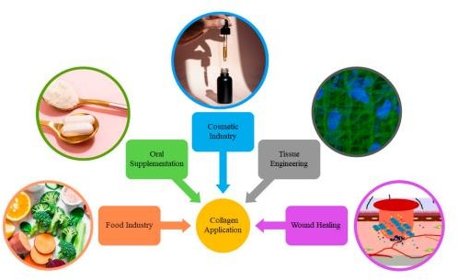

Figure 2.3: The use of fish collagen in various industrial fields

Challenges and Future Directions

Challenges
      - Standardization of Extraction Methods: Different extraction methods may yield varying results. Developing standardized protocols for collagen extraction from fish by-products is essential to ensure consistency and comparability of data.
      - Variability in Fish Species and By-Products: The collagen composition can vary significantly depending on the fish species, age, and body part from which it is extracted. Researchers must account for this variability and its impact on collagen properties.
      - Contaminant Removal: Fish by-products may contain contaminants such as heavy metals and toxins. Ensuring the safety of extracted collagen for food applications requires effective purification and removal of these contaminants.
      - Collagen Structure and Properties: Understanding the structural differences between fish-derived collagen and commercial food collagen is crucial. Characterizing their properties, such as solubility, gelling ability, and viscosity, is essential to determine their suitability for specific food applications.

      - Functional Performance: Assessing the functional performance of fish- derived collagen in various food matrices (e.g., gels, emulsions, and films) is necessary to determine its potential as a food ingredient.
      - Consumer Acceptance: Investigating consumer preferences and acceptability of products containing fish-derived collagen is essential for market adoption.

Future Directions:
      - Tailored Collagen Extraction: Develop specialized extraction methods for different fish species and by-products to optimize collagen yield and quality.
      - Bioactive Compounds: Explore the presence of bioactive compounds within fish-derived collagen, such as peptides with potential health benefits, and study their functional properties.
      - Sustainable Sourcing: Focus on sustainable sourcing practices for fish by- products to reduce environmental impact and align with the principles of circular economy.
      - Nutritional Enhancement: Investigate methods to enhance the nutritional profile of fish-derived collagen, such as fortification with vitamins, minerals, or other functional ingredients.
      - Biodegradable Packaging: Explore the use of fish-derived collagen in the development of biodegradable and edible packaging materials, contributing to reduced plastic waste.
      - Clinical Applications: Investigate the potential therapeutic applications of fish- derived collagen in wound healing, tissue engineering, and nutraceuticals.
      - Regulatory Approval: Collaborate with regulatory bodies to establish clear guidelines and safety standards for the use of fish-derived collagen in food products.
      - Market Expansion: Identify novel food applications and markets where fish- derived collagen can serve as a viable alternative to commercial collagen, such as in functional foods, cosmetics, and pharmaceuticals.
      - Biotechnological Approaches: Explore biotechnological methods like genetic modification or tissue engineering to produce collagen with tailored properties from fish cells or microorganisms.

      - Consumer Education: Educate consumers about the sustainability and benefits of using fish-derived collagen to increase market acceptance.
Despite the promising attributes of fish-derived collagen, several challenges remain. These include the variability in collagen properties based on fish species and processing methods, potential allergenicity concerns, and the need for standardized extraction protocols. Future research should focus on optimizing extraction techniques, conducting more extensive clinical trials to confirm health benefits, and addressing quality control and safety issues.
In conclusion, the characterization and comparative analysis of acid-soluble collagen from fish by-products offer exciting opportunities to diversify the sources of collagen for the food industry. Overcoming the challenges and pursuing these future directions can lead to innovative, sustainable, and safe food products with enhanced nutritional and functional properties.

General

Chapter 03: Materials and Methods

To compare acid-soluble collagen from fish by-products with commercial food collagen, researchers employed various analytical techniques. These methods may include amino acid analysis, electrophoresis, spectroscopy, and rheological studies to evaluate collagen's composition, structure, and functional properties. In addition, the study involved the collection of samples from multiple fish species and various parts of the fish to explore the diversity of collagen types and sources.

Site and Period of Study
The study was conducted in the laboratory of the department of Applied Chemistry and Chemical Technology at Chattogram Veterinary and Animal Sciences University (CVASU), Chattogram-4225. The study was conducted for a period of six months from the 1st of July to 30th December 2022.

Sample Collection
Sample is the first and foremost need of any experiment. For the best result and study, collection of fresh sample is a must. That’s why, fish samples included Snakehead fish (Channastriata) and Anguilla bengalensis were collected from nearby local market in Chattogram. Other materials and chemicals were collected from laboratory stocks.

Sample Preparation

Fish Skin Preparation
Snakehead fish (Channastriata), Anguilla bengalensis were obtained from local market of Chattogram, Bangladesh. To get desired skin, residual meat was removed manually and cleaned samples were washed with chilled tap water. The skin was descaled, followed by thorough washing. Descaled samples were then cut into small pieces (0.5×0.5 cm²), placed in polyethylene bags and stored at -20˚C to -25˚C until used.

Fish Scale Preparation
Between two fish samples, as Anguilla bengalensis does not contain any scales that’s why the samples of scales will be from Snakehead fish (Channastriata).To get the desired scale, the scales were removed manually. The scales were thoroughly washed and then stored in an airtight polyethylene bags. Finally, the prepared sample (scale) were kept at -20˚C until used.

Extraction of Acid Soluble Collagen

Raw Materials
Skin and scale of Snakehead fish (Channastriata), skin of Anguilla bengalensis and a commercial collagen were used as raw materials.

Reagent
Reagents like Tris-HCl, ethylenediaminetetraacetic acid (EDTA), ethanol, sodium hydroxide (NaOH), acetic acid were used.

Reagent Preparation
      - Preparation of 0.1M Tris-Hcl Reagent
12.1g Tris base was dissolved in 800mL deionized water in a 1L beaker. Appropriate volume of concentrated HCl (0.1M) was added to adjust pH at 7.4. Here, pH was checked by pH meter. After adjusting pH, finally the final volume was made into 1L with deionized water & kept in 1L volumetric flask. After that, it was autoclaved and stored at room temperature.

Preparation of 4mM EDTA Solution
1.5g Disodium ethylenediaminetetraacetate was added in 80mL distilled water. After that, it was properly mixed through vigorously stirring. Appropriate volume of NaOH solution or NaOH pallets was added to adjust pH at 8. Here, pH was checked by pH meter. After adjusting pH, finally the volume was diluted into 1L with distilled water. By using a 0.5 micron filter, the solution was filtered and stored in a volumetric flask at room temperature.

Preparation of Biuret Reagent
1.5 g Copper (II) sulfate (CuSO4) and 6g Sodium Potassium tartarate were dissolved in 500mL distilled water in a 1L beaker. In another 1L beaker, 30g NaOH was added in 375mL water to make 375mL 2M NaOH solution. After that, both the solution was mixed in 1L volumetric flask. After mixing, the final volume was made into 1000mL by adding distilled water.

Apparatus & Equipment
Knife, weight machine, stirrer, filter paper, volumetric flask, beaker were used as apparatus. As for equipment, Refrigerator &Fourier-transform infrared spectroscopy (FTIR) were used. Fourier-transform infrared spectroscopy (FTIR) is a

technique used to obtain an infrared spectrum of absorption or emission of a solid, liquid, or gas. FTIR stands for "Fourier transform infrared" and is the most common type of infrared spectroscopy. All infrared spectroscopies work on the principle that some infrared (IR) radiation is absorbed when it passes through a sample. The radiation emitted by the sample is measured. A typical FTIR spectrometer is made up of a source, an interferometer, a sample compartment, a detector, an amplifier, an A/D converter, and a computer. The source emits radiation, which passes through the interferometer and into the detector. The frequency range is typically measured in wave numbers ranging from 4000 to 600 cm⁻¹. Light is measured using an infrared spectrometer, which generates an infrared spectrum, during FTIR testing. The FTIR spectrum is a graph that shows the absorbance of infrared light by a substance on the vertical axis and the frequency (wavelength) on the horizontal axis.
    - Collagen Extraction and Characterization from Fish Skin and Scale Collagen is extracted using three steps: pretreatment to get rid of grease, hydrolysis to get rid of unwanted proteins, and extraction to get acid-soluble collagen (ASC). At 4°C, all extraction procedures were carried out. Fish skin was frozen, defrosted at 50°C, and then cut into small pieces. 100 g of wet fish skin was stirred in 1 L of double-distilled water for 30 minutes, then the process was repeated once. To remove the grease, the water was replaced with 1 L of 50% ethanol, which was stirred slowly for 30 minutes. After discarding the ethanol, the fish skin was thoroughly cleaned. For 18 hours, fish skin was soaked in 1 L of a solution containing 4 mM EDTA and 0.1 M Tris-HCL. The liquid was drained, and then double-distilled water was used to wash the fish skin. For 48 hours, fish skin was hydrolyzed with 0.1 NaOH 1:10 (w/v). Fish skin was washed with double distilled water, and the solution was tested with the biuret reagent to make sure that unwanted protein was eliminated. 0.5 M acetic acid 1:10 (w/v) was used to extract collagen for 48 hours at 4°C. Filtering was done on the collagen-containing solution. To obtain functional groups, Fourier Transform Infrared Spectroscopy (FTIR) was used to characterize the ASC after it had been obtained and lyophilized. These tests were conducted in Applied Chemistry & Chemical Technology Laboratory, Department of Applied Chemistry & Chemical Technology, Chattogram Veterinary & Animal Sciences University.

Flow Chart of Method
Thawed at 50˚C
Frozen Fish (at 4˚C)

The water was replaced with 1L ethanol 50%
Fish Skin was cut off into small pieces (100g wet wt.)

Stirred slowly for 30 mins (Remove grease)

Ethanol was discarded & Fish skin washed until neutral

Fish skin was soaked in 1L mixture of 4mM EDTA and 0.1M Tris-HCl
for 18 hrs.
Fish skin was hydrolyzed with 0.1 NaOH 1:10 (w/v) for 48 hrs.
The liquid was removed and fish skin washed with double distilled water

Collagen was extracted with 0.5M acetic acid 1:10 (w/v) for 48 hrs.
At 4˚C
Solution was tested with biuret reagent to ensure undesirable protein was removed and fish skin was washed with double distilled water

Finally. ASC (acid soluble collagen) was obtained and lyophilized to be characterized by FTIR with spectral range of 4000 to 400cm-1 to obtain functional groups
The solution containing collagen was filtered

Characterization of Commercial Collagen
15g of commercial collagen powder was diluted by distilled water and make it into 1L solution. After dilution, it was characterized by FTIR with spectral range of 4000 to 400cm⁻¹ to obtain functional groups. This test were also conducted in Applied Chemistry & Chemical Technology Laboratory, Department of Applied Chemistry & Chemical Technology, Chattogram Veterinary & Animal Sciences University.

The characterization of acid-soluble collagen from fish by-products revealed several important findings. The structural analysis of fish-derived collagen showed that it shares a high degree of similarity with commercial collagen. This suggests that the collagen's triple-helical structure remains intact during the extraction process from fish by-products. Maintaining this structure is crucial for its functional properties, such as gelling, emulsification, and water-binding capacity, which are essential in food applications.

: General

Chapter 04: Results

Fourier transform infrared (FTIR) is a tool that is used to evaluate and recognize the collagen presence and chemical composition, and it is also used to identify its type. Moreover, it can be used to compare the collagen composition extracted with different approaches or investigate the effect of isolation methods on collagen composition (Jeevithan et al., 2014; Chuaychan et al., 2015). It was utilized to characterize the chemical composition and structural properties of extracted collagen and commercial collagen samples. The FTIR spectra obtained for both samples were analyzed for key absorption peaks indicative of collagen structure and composition.

: Analysis of extracted collagen
The extracted collagen from snakehead fish skin, snakehead fish scale and Anguilla bengalensis fish skin were analyzed using FTIR. Figure 1, 2, 3 and 4 show the FTIR results of extracted collagens and commercial collagen. Commercial collagen was used to compare the functional groups of commercial collagens with extracted collagens from snakehead fish skin, snakehead fish scale and Anguilla bengalensis fish skin. Extracted collagens has the same peaks with commercial collagen as shown in Table 1. This result indicates that the extraction process was done successfully.
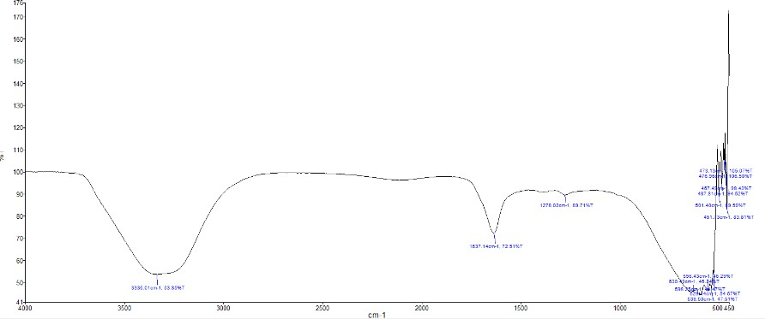

Figure 4.1: FT-IR result of Collagen extracted from Skin of Snakehead fish

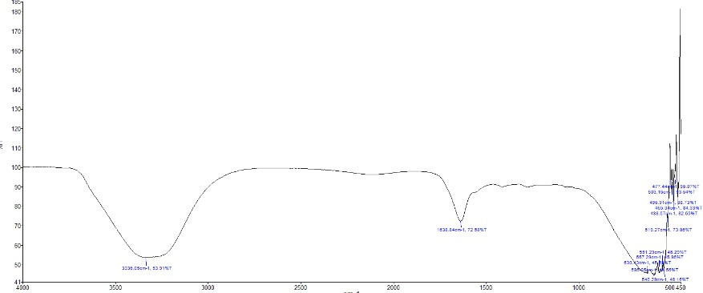
Figure 4.2: FT-IR result of Collagen extracted from Scale of Snakehead fish

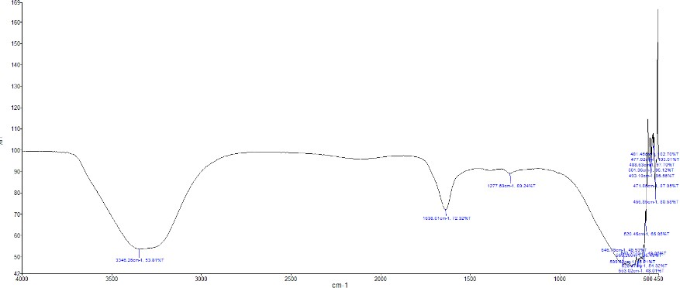

Figure 4.3: FT-IR result of Collagen extracted from Skin of Anguilla bengalensis

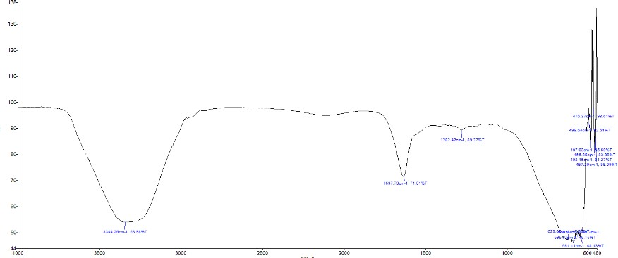

Figure 4.4: FT-IR result of Commercial Collagen

TABLE 4.1: Infrared spectroscopic distribution of commercial collagen and collagens extracted from snakehead fish skin, snakehead fish scale, and Anguilla bengalensis fish skin.

Region | Types of Collagen |  | Wavelength (cm-1) | Assignment
Amide A | Extracted Collagen | Skin of Snakehead fish (Channastriata) | 3336.01 | N-H stretch
 |  | Scale of Snakehead fish (Channastriata) | 3336.05
 |  | Skin of Anguilla bengalensis | 3346.26
 | Commercial Collagen |  | 3344.26
Amide I | Extracted Collagen | Skin of Snakehead fish (Channastriata) | 1637.14 | C-O stretch
 |  | Scale of Snakehead fish (Channastriata) | 1638.84
 |  | Skin of Anguilla bengalensis | 1638.01
 | Commercial Collagen |  | 1637.73
Amide III | Extracted Collagen | Skin of Snakehead fish (Channastriata) | 1278.02 | N-H bending and C-H stretching
 |  | Skin of Anguilla bengalensis | 1277.69
 | Commercial Collagen |  | 1282.42

: FTIR Spectra of ASC from Extracted Collagen and Commercial Collagen

The FTIR spectra of skin and scale ASCs from snakehead fish also FTIR spectra of skin ASC’s from Anguilla bengalensis are shown in Figure (16-18). Rather FTIR spectra of commercial collagen is shown in figure 19. All spectra exhibit similar characteristic peaks associated with collagen.
All samples had amide A (3400–3440 cm⁻¹), amide I (1600 to 1700 cm⁻¹) and amide III (1200 to 1300 cm⁻¹) bands, which were in agreement with the research of. Amide A of all ASCs wereobserved at a wavenumber of 3336.01, 3336.05, 3346.26 and 3344.26, respectively. Furthermore, the spectra wavenumber included amide I (1637.14, 1638.84, 1638.01 and 1637.73 cm⁻¹ in ASC from skin and scale of Snakehead fish (Channastriata), Skin of Anguilla bengalensisand commercial collagen respectively), and amide III (1278.02, 1277.69 and 1282.42 cm⁻¹in ASC from skin of Snakehead fish (Channastriata), Skin of Anguilla bengalensisand commercial collagen respectively). Amide A, normally associated with N–H stretching vibrations coupled with hydrogen bonds, appears in the spectra range of 3400–3440 cm⁻¹. Amide I bands are associated with C=O stretching vibrations in peptides, with the main function to form a secondary protein structure and to indicate the protein backbone in all samples. Amide II (~1500 cm−1) represents N–H bending coupled to C–N stretching, corroborating the presence of collagen's characteristic secondary structure. The triple-helix structure of collagen is involved with amide III.
The FTIR spectra also revealed peaks in the region of 1000-1200 cm⁻¹, corresponding to the fingerprint region of collagen. These peaks are attributed to various functional groups, including C-C, C-N, and C-O bonds, further confirming the presence of collagen in all samples.
Overall, the FTIR analysis of extracted collagens and commercial collagen demonstrates similar spectral patterns, indicating the preservation of collagen's structural and chemical properties in the extracted sample compared to the commercial counterpart.
This example provides a concise and structured summary of the FTIR analysis results for extracted collagens and commercial collagen, highlighting key absorption peaks and similares among the samples.

: General

Chapter-5: Discussion

Fish processing by-products, traditionally seen as waste, are a rich source of collagen. By converting these by-products into valuable collagen, the study aligns with the principles of a circular economy, waste reduction, and sustainability. The comprehensive characterization of fish-derived collagen through techniques like FTIR spectroscopy provides a deeper understanding of its properties. This characterization allows researchers and industry professionals to determine the type, purity, and thermal stability of the collagen extracted from fish by-products. The comparative analysis with commercial collagen is a pivotal aspect of this study. It offers insights into the resemblance and differences between fish-derived collagen and established commercial products (Cheng et al., 2017).

: Availability of Collagen in Several Fish By Products
This study has demonstrated that the process of successfully extracting collagen from the skin and scales of snakehead fish and the skin of Anguilla bengalensis was carried out. Furthermore, Type-I collagen was identified as the type of collagen. Fourier Transform Infrared Spectroscopy (FTIR) was used to analyze functional groups in the extracted collagen. Numerous researchers have identified Type-I collagen from by- products of different fish species. For this study, as a byproduct fish & scale are used (Sousa et al., 2020).

Sources of Type-I Collagen
Type I collagen is primarily found in the connective tissues of animals, and it is the most abundant type of collagen in the human body. Type I collagen can be obtained from various sources, depending on your specific needs and intended applications. Collagen Type I is abundant in the skin of mammals, including cows (bovine collagen), pigs (porcine collagen), and other animals. Bovine collagen, in particular, is a widely used source for Type I collagen extraction. Certain fish species, such as cod and salmon, have skin rich in Type I collagen. Fish collagen is gaining popularity as a source of collagen due to its potential bioavailability and lower risk of diseases such as bovine spongiform encephalopathy (BSE) associated with mammalian collagen sources. Chicken sternum cartilage is another source of Type I collagen, often used for collagen extraction. Collagen Type I is also present in the tendons, ligaments, and bones of animals, including mammals and birds. Collagen can be extracted from the hides (skin)

of cattle, which contains a mix of collagen types, with Type I being one of the major components. Marine collagen, sourced from fish scales and skin, is increasingly used due to its potential advantages, including smaller peptide size and potential bioavailability. In recent years, there has been interest in developing synthetic collagen, which may be used in various applications, including regenerative medicine and tissue engineering. These synthetic collagens are engineered to mimic the properties of natural Type I collagen.

: Collagen in Fish Skin
In this study, the functional groups in the extracted collagen from snakehead fish skin was analyzed at Amide A (3336.01 cm⁻¹), Amide I (1637.14 cm⁻¹) and Amide III (1278.02 cm⁻¹). Furthermore, the collagen was also extracted from the skin of Anguilla bengalensis where functional group was analyzed at Amide A (3346.26 cm⁻¹), Amide I (1638.01 cm⁻¹) and Amide III (1277.69 cm⁻¹). Whereas, the extraction of collagen from snakehead fish skin at Amide A (3414 cm⁻¹), Amide I (1637 cm⁻¹) and Amide III (13338 cm⁻¹) refers to collagen Type-I. (Issains, F. B. et al., 2019).
Thus, the similarity of the results indicates that the collagen taken from the skin of snakehead fish is Type-I.
One of the most prevalent elasmobranchs in the Northeastern Atlantic Ocean is the small-spotted catshark. Despite the fact that this species is primarily landed for human consumption, its commercial value is generally low, and in certain European fisheries, the discard rate can reach 100% (Wijaya et al., 2020; Govindharaj et al., 2019). Fish skins are a great and plentiful source of marine collagens, which are being used more and more in place of mammalian collagens in tissue engineering, cosmetics, and other applications. Skin of small-spotted catshark (Scyliorhinus canicula) can be termed as significant source of Type-I collagen. (Blanco et al., 2019). Type-I collagen is primarily extracted from skin, which is an essential fish byproduct. The protein known as type I collagen is found in skin, tendons, and other connective tissues. The skin of Rabbitfish (Chimaera monstrosa), Small-spotted catshark (Scyliorhinus canicular), Lantern shark (Etmopterus spp.), Catshark (Galeus spp.), Cuckoo ray (Leucoraja naevus), Common Atlantic grenadier (Nezumia aequalis), Atlantic cod (Gadus morhua), Parang-Parang, Eel fish, Eel fish (Evenchelys macrura), Giant croaker (Nibea japonica), Sole fish

(Aseraggodes umbratilis), Atlantic cod (Gadus morhua) is widely utilized to extract Type-I collagen. (Sotelo et al., 2016; Sionkowska et al., 2014).
Additionally, collagen types I and III promote the synthesis of amino acids, specifically glycine. The amino acid glycine is in charge of both fat burning and muscle growth. The best collagen for skin is typically thought to be type I. Fish collagen is unique because it is bioavailable and comes from a plentiful marine source. With the exception of cartilaginous tissue, Type I collagen is the kind that is present almost everywhere in the body (Veeruraj et al., 2013; Coelho et al., 2017).

: Collagen in Fish Scale
In this study, Amide A (3336.05 cm⁻¹) and Amide I (1638.84 cm⁻¹) were the functional groups in the collagen that was extracted from the scale of snakehead fish that were examined. As mentioned the functional group is in the range so the collagen that was extracted from the scale of snakehead fish termed to be type-I (Issains et al., 2019).
Fish scales, often considered a byproduct in the fishing industry, are an increasingly recognized and valuable source of Type I collagen for various applications. Here's why fish scales are considered important and how they are used for collagen extraction. Fish scales are rich in Type I collagen, which is highly sought after for its biocompatibility and biodegradability. This collagen type is particularly useful in the field of regenerative medicine and tissue engineering. Using fish scales for collagen extraction is a sustainable practice, as it makes use of a part of the fish that might otherwise go to waste. This aligns with principles of reducing waste and utilizing the entire fish for various purposes. Unlike some collagen sources from mammals, such as bovine hides, fish do not carry the same disease risks. This makes fish collagen a safer option for certain applications (Van De Water et al., 2013).
Some studies suggest that collagen from fish scales may have better bioavailability due to its smaller peptide size compared to collagen from other sources. This can make it more effective for certain dietary supplement and biomedical applications. Fish collagen is commonly used in the cosmetics and nutraceutical industries for its potential skin health benefits. Collagen supplements derived from fish scales are marketed for improving skin elasticity and reducing the signs of aging. Fish collagen extracted from scales is also used in various biomedical applications, including wound dressings, tissue scaffolds, and drug delivery systems, where biocompatibility and low risk of rejection

are essential. The utilization of fish scales aligns with sustainable practices in the fishing industry. It promotes the responsible use of marine resources and helps reduce waste. The extracted type-I collagen can be derived from the scale of Tilapia (Oreochromis sp.), Tilapia and Grey mullet, Tropical freshwater carp fish (C. carpio) (Jeevithan et al., 2014). While fish scales are an important byproduct for collagen extraction, it's essential to ensure that the sourcing and extraction methods are conducted in an environmentally responsible and ethical manner. Sustainable and ethical practices are crucial in the harvesting and processing of fish scales to minimize the environmental impact and maintain healthy fish populations (Liang et al., 2014).

: Collagen in Fish Skin & Scale
Both skin and scales are important byproducts used as sources of collagen. These collagen-rich materials are valuable for various applications, and they are often considered sustainable and eco-friendly options. Here's how both skin and scales are utilized for collagen extraction. The skin of mammals, such as cows (bovine collagen) and pigs (porcine collagen), contains collagen Type I and is commonly used for collagen extraction. Bovine and porcine collagen are widely employed in biomedical and cosmetic applications. Fish skin, especially from species like cod, salmon, and snakehead fish, is rich in Type I collagen. It is gaining popularity as a source of collagen due to its potential bioavailability and sustainable sourcing. Fish scales are abundant in Type I collagen and are considered a valuable byproduct in the fishing industry. They are increasingly recognized as a sustainable source of collagen for various applications. Collagen derived from fish scales is sometimes referred to as marine collagen. It is used in cosmetics, dietary supplements, and biomedical applications due to its biocompatibility and potential benefits for skin health (Salamone et al., 2016).
Using both skin and scales as sources of collagen promotes sustainable practices, minimizes waste, and contributes to the responsible utilization of animal and marine resources. These collagen sources offer various advantages depending on the intended application, and they are increasingly preferred in industries focused on reducing environmental impact and enhancing product quality. There are also some species of fish whose skin & scale both are the rich source of Type-I collagen. As for the study, the skin & scale of snakehead fish are the potential source of type-I collagen. But for the Anguilla bengalensis, as they do not possess any scale so the collagen extraction from its scale is not applicable. Studies also show that, the skin & scale of Tuna and

Tilapia (Oreochromis niloticus) are also the potential source of Type-I collagen (Ahmed et al., 2018).

: Collagen in Other by Products
Apart from skin and scales, various other fish byproducts are also used as sources of collagen. These byproducts are often obtained from parts of the fish that might otherwise go to waste, contributing to sustainable practices and reducing environmental impact. Some of these fish byproducts used for collagen extraction include. Collagen can be extracted from fish bones, particularly the collagen-rich bones of certain fish species. This collagen is used in the production of collagen supplements, biomedical materials, and as a gelling agent in the food industry (Ramli et al., 2019). The fins of some fish species contain collagen and are utilized for collagen extraction. Fish fin collagen is employed in cosmetics and personal care products for its potential benefits in promoting skin health. Collagen can be found in the connective tissues of fish heads, and it is extracted from this byproduct. Fish head collagen is used in various applications, including the production of collagen-based wound dressings and tissue engineering. Collagen can also be obtained from various fish organs, including the swim bladder. Fish organ collagen is used in both food and biomedical applications. Some fish species produce mucus that contains collagen (He et al., 2019). While less common, fish mucus collagen has been explored for potential uses in cosmetics and skincare products. Utilizing these fish byproducts for collagen extraction is part of a broader effort to reduce waste in the fishing industry and promote sustainable practices. It not only maximizes the utilization of fish resources but also provides valuable raw materials for various industries, including cosmetics, biomedicine, and food production. Lots of researchers identified Type-I collagen from different by products such as from bone of the Tilapia (Oreochromis mossambicus), Lutjanus sp., Aristichthys nobilis fish Type-I collagen has been identified. Ahmed et al. (2019) suggested that from the swim bladder of Atlantic cod. Mahboob (2015) also suggested that from the Skin, scales, and fins of Catla catla and Cirrhinus mrigala Type-I collagen can be found.

Similarities of Commercial Collagen with Type-I Collagen
In this study, one of the leading commercial collagen is used to analyze to detect if it is Type-I collagen or not. For this purpose, functional group of commercial collagen was detected at Amide A (3344.26 cm⁻¹), Amide I (1637.73 cm⁻¹) and Amide III (1282.42

cm⁻¹). According to the above mentioned range the Amide A, Amide I & Amide III for Type-I collagen was detected.
Commercial collagen is a type of collagen that is produced and sold by various companies for a wide range of applications, including the food industry, cosmetics, biomedical and pharmaceutical fields, and dietary supplements. Commercial collagen is typically extracted from natural sources, most commonly animals, and sometimes marine organisms, and it is processed and purified for specific uses. Here are some key aspects of commercial collagen. Commercial collagen can be sourced from various animals, including cows, pigs, chickens, and fish. Additionally, marine collagen from fish scales and skin is gaining popularity due to its potential advantages. Collagen can be categorized into different types, with Type I collagen being the most common and widely used for its properties, including skin health, wound healing, and tissue regeneration. The extraction of collagen involves breaking down connective tissues, such as skin, bones, scales, and other collagen-rich parts of animals. The extracted collagen is then processed to remove impurities and achieve the desired properties, such as solubility and purity (Yunoki et al., 2003).
Commercial collagen is a versatile and valuable ingredient in a wide range of products, and it plays a significant role in various industries. Consumers should choose collagen products from reputable manufacturers and be aware of the intended use and potential benefits associated with these products. The extraction of collagen from fish by- products and its similarities with commercial collagen is a topic of interest in the fields of food science, cosmetics, and pharmaceuticals. Let's discuss this process and the commonalities it shares with commercially available collagen.
In summary, the extraction of collagen from fish by-products shares several commonalities with commercial collagen sources, making it a viable alternative in various applications. The sustainability of sourcing, similar protein structure, bioavailability, amino acid composition, and safety considerations are among the key factors that connect fish-derived collagen with its commercial counterparts. This convergence of qualities makes fish collagen a promising option in the growing market for collagen-based products.

Chapter-6: Conclusions
Collagen, a fundamental structural protein, plays a pivotal role in various industries, including food, pharmaceuticals, and cosmetics. Fish by-products, often overlooked and discarded, represent a promising source of collagen due to their rich collagen content. The efficient extraction of collagen from these by-products holds significant economic and environmental potential. This paper explores the methods, challenges, and applications of collagen extraction from fish by-products, shedding light on a sustainable approach to harnessing this valuable biomaterial. Collagen is widely used in the food, pharmaceutical, cosmetic, biomedical materials and leather industries.
In recent years, the utilization of natural resources has become an increasingly important focus in various industries, with a particular emphasis on sustainability and waste reduction. One such resource that has gained considerable attention is fish by- products, which often go underutilized and are discarded as waste. Among the valuable components hidden within these by-products is collagen, a protein with a wide range of applications in the food, pharmaceutical, and cosmetic industries. The extraction of collagen from fish by-products represents a promising avenue for not only reducing waste but also harnessing a valuable protein source with diverse potential uses. This process offers a sustainable and economically viable solution, aligning with the principles of both environmental conservation and industrial innovation. In this exploration of collagen extraction from fish by-products, we will delve into the methods, benefits, and applications of this intriguing process, shedding light on its role in promoting resource efficiency and advancing various sectors of the global economy.
Not only are innovative biotechnologies and sustainable biomass already significantly altering human life, but they also offer a glimpse into the future of research in a number of fields, including chemical engineering, biotechnology, pharmaceutical sciences, and marine and food sciences. Collagen is a vital biopolymer for human health and well- being due to its wide range of applications and anticipated roles in tissue engineering. Finding more affordable and sustainable collagen production sources is crucial, as is minimizing the usage of animals in the process, given the increasing demand for collagen. (Jafari H et al., 2020). The use of fish by-products for collagen extraction offers several advantages, including sustainability, as it utilizes underutilized resources, reduces waste, and provides an alternative to land-based sources of collagen.

Additionally, fish-derived collagen may appeal to consumers seeking novel and eco- friendly food products.
In conclusion, acid-soluble collagen derived from fish by-products holds great potential as a sustainable alternative to commercial food-grade collagen. Extensive characterization studies have revealed its resemblance to traditional collagen sources and its favorable functional properties. Further research and development efforts are essential to harness its full potential and overcome existing challenges, paving the way for a more sustainable and versatile collagen source in various industries.
The findings from this study provide valuable insights into the potential applications of fish-derived collagen in the food industry. It can be used in a wide range of products, such as meat analogs, dairy alternatives, and bakery items, to enhance texture and nutritional value. Furthermore, the sustainable nature of fish-derived collagen aligns with the increasing consumer demand for environmentally responsible food choices. Such as, Acid Soluble Collagens were taken out from the skin and scales of tilapia (Oreochromis niloticus) (Chen, J et al., 2016).
The characterization and comparative analysis of acid-soluble collagen derived from fish by-products indicate its resemblance to commercial food collagen in terms of amino acid composition, structure, and functional properties. These findings highlight the potential of fish-derived collagen as a sustainable and versatile ingredient for food applications. Future research may further explore the optimization of extraction processes and evaluate the sensory and nutritional aspects of products containing fish- derived collagen. This knowledge can help food manufacturers and researchers harness the benefits of fish-derived collagen in creating innovative and eco-friendly food products.

Chapter-7: Recommendations and Future perspectives

The study on the characterization and comparative analysis of acid-soluble collagen derived from fish by-products is significant in several respects, providing valuable insights into the potential of fish-derived collagen as a sustainable and cost-effective alternative to commercial food-grade collagen. Here, we provides the recommendations and future perspectives of the present study:

Insights into Resemblance and Functional Properties:
- Understanding the resemblance of fish-derived collagen to commercial counterparts is vital for formulators and manufacturers. If fish-derived collagen exhibits similar properties, it can be a promising candidate for substituting or complementing commercial collagen in a variety of products.
- The study's findings may inform the development of collagen-based food products, pharmaceuticals, and cosmetics. This, in turn, could offer consumers a wider range of sustainable and affordable options.

Sustainability and Economic Implications:
- The study's emphasis on the sustainability and economic aspects of using fish-derived collagen is noteworthy. Reducing waste in the seafood industry, along with creating value-added products, can lead to a more sustainable and economically viable seafood industry.
- By promoting the use of fish by-products, this research contributes to more environmentally friendly practices and potentially increased profitability in the industry.

Potential Challenges and Future Directions:
- It is essential to acknowledge potential challenges, such as variability in fish-derived collagen depending on species and source, as well as potential allergenicity concerns.
- Future directions might include more in-depth studies on the safety, storage stability, and long-term effects of fish-derived collagen in various applications.

Global Impact:
- As consumers and industries increasingly seek sustainable alternatives, this research has the potential for significant global impact. Fish-derived collagen can be especially attractive in regions with a strong fishing industry and a need to reduce waste.
Nevertheless, it is quiet impossible to do something without limitation. While extracting collagen from fish skin and scales has its advantages, it also comes with limitations and challenges. Here are some limitations associated with this process:
- Species Variability: The collagen content and quality can vary significantly depending on the fish species. Some species may have collagen that is less suitable for certain applications, making it important to carefully select the species for collagen extraction.
- Processing Costs: The extraction of collagen from fish skin and scales can be costly, particularly when dealing with large quantities of by-products. Specialized equipment and processes are required, which can increase production costs.
- Environmental Concerns: The overfishing of certain fish species for their collagen-rich by-products can raise environmental concerns, as it may impact fish populations and ecosystems. Sustainable sourcing practices are essential to address this issue.
- Odor and Taste: Collagen extracted from fish by-products can carry a mild fishy odor and taste, which can limit its use in certain applications, particularly in the food industry. Efforts to reduce or mask these sensory qualities are necessary.
- Allergenic Potential: Collagen from fish sources may still pose allergenic risks for individuals with seafood allergies. While it may be less allergenic than some terrestrial animal-derived collagens, it's not suitable for all consumers.
- Contaminants: Fish collagen may contain contaminants like heavy metals and pollutants from the marine environment. Rigorous testing and purification processes are necessary to ensure safety and quality.

- Lower Collagen Yield: Fish skin and scales contain lower collagen content compared to other parts of the fish, such as bones and swim bladders. This can result in a lower yield of collagen during the extraction process, making it less efficient in terms of raw material usage.
- Texture and Purity: Achieving the desired texture and purity of fish collagen can be challenging. Depending on the source and processing methods, the collagen may not meet the requirements for specific applications, such as cosmetics or biomedical uses.
- Regulatory Compliance: Meeting regulatory standards for collagen extracted from fish by-products can be complex and may vary by region. Compliance with health and safety regulations is essential but can pose challenges.
- Shelf Life: Fish collagen products may have a shorter shelf life compared to certain other collagen sources. This can limit storage and distribution capabilities, particularly in regions with long supply chains.
To address these limitations, ongoing research and technological advancements are focused on optimizing the extraction processes, improving collagen quality, and finding ways to reduce environmental impacts. Additionally, proper sourcing, safety measures, and adherence to regulatory standards are vital to ensure the sustainability and safety of fish collagen extraction.

References

Aguda, A. H., Panwar, P., Du, X., Nguyen, N. T., Brayer, G. D., & Brömme, D. 2014. Structural Basis of Collagen Fiber Degradation by Cathepsin K. Proceedings of the National Academy of Sciences of the United States of America, 111, 17474– 17479.
Ahmed, R., Getachew, A. T., Cho, Y. J., & Chun, B. S. 2018. Application of bacterial collagenolytic proteases for the extraction of type I collagen from the skin of bigeye tuna (Thunnus obesus). LWT, 89, 44-51.
Ahmed, R., Haq, M., & Chun, B. S. 2019. Characterization of marine-derived collagen extracted from the by-products of bigeye tuna (Thunnus obesus). International Journal of Biological Macromolecules, 135, 668-676.
Ahn, H., Gong, D. J., Lee, H. H., Seo, J. Y., Song, K. M., Eom, S. J., & Yeo, S. Y.

2021. Mechanical Properties of Porcine and Fish Skin-Based Collagen and Conjugated Collagen Fibers. Polymers, 13, 2151.
Al Khawli, F., Pateiro, M., Domínguez, R., Lorenzo, J. M., Gullón, P., Kousoulaki, K., & Barba, F. J. 2019. Innovative Green Technologies of Intensification for Valorization of Seafood and Their By-Products. Marine Drugs, 17, 689.
Alfaro, A. D. T., Balbinot, E., Weber, C. I., Tonial, I. B., & Machado-Lunkes, A. 2015. Fish gelatin: characteristics, functional properties, applications and future potentials. Food Engineering Reviews, 7, 33-44. doi: 10.1007/s12393- 014-9096-5.
Bächinger, H. P., Mizuno, K., Vranka, J. A., & Boudko, S. P. 2010. Collagen Formation and Structure. In Comprehensive Natural Products II Chemistry and Biology, 5, 469–530.

Bailey, A., Paul, R. G., & Knott, L. 1998. Mechanisms of maturation and ageing of collagen. Mechanisms of Aging and Development, 106, 1–56.
Bhagwat, P. K., & Dandge, P. B. 2016. Isolation, characterization and valorizable applications of fish scale collagen in food and agriculture industries. Biocatalysis and Agricultural Biotechnology, 7, 234–240.
Bilek, S. E., & Bayram, S. K. 2015. Fruit juice drink production containing hydrolyzed collagen. Journal of Functional Foods, 14, 562–569.
Blanco, M., Vázquez, J. A., Pérez-Martín, R. I., & Sotelo, C. G. 2019. Collagen extraction optimization from the skin of the small-spotted catshark (S. canicula) by response surface methodology. Mar. Drugs, 17, 40.
Caruso, G., Floris, R., Serangeli, C., Di Paola, L. 2020. Fishery Wastes as a Yet Undiscovered Treasure from the Sea: Biomolecules Sources, Extraction Methods and Valorization. Marine Drugs, 18, 622.
Chang, S.-W., & Buehler, M. J. 2014. Molecular Biomechanics of Collagen Molecules.

Materials Today, 17, 70–76.

Chen, J., Li, L., Yi, R., Xu, N., Gao, R., & Hong, B. 2016. Extraction and characterization of acid-soluble collagen from scales and skin of tilapia (Oreochromis niloticus). LWT-Food Science and Technology, 66, 453-459.
Chen, Y., Dan, N., Wang, L., Liu, X., & Dan, W. 2016. Study on the cross-linking effect of a natural derived oxidized chitosan oligosaccharide on the porcine acellular dermal matrix. RSC Advances, 6, 38052-38063.
Chinh, N.T.; Manh, V.Q.; Trung, V.Q.; Lam, T.D.; Huynh, M.D.; Tung, N.Q.; Trinh, N.D.; Hoang, T. 2019. Characterization of Collagen Derived From Tropical Freshwater Carp Fish Scale Wastes and Its Amino Acid Sequence. Nat. Prod. Commun, 14, 1–12.

Chuaychan, S., Benjakul, S., & Kishimura, H. 2015. Characteristics of acid-and pepsin- soluble collagens from scale of seabass (Lates calcarifer). LWT Food Science and Technology, 63, 71–76.
Ciarlo, A. S., Paredi, M. E., & Fraga, A. N. 1997. Isolation of soluble collagen from hake skin (Merluccius hubbsi). Journal of Aquatic Food Product Technology, 6(1), 65–77.
Coelho, R. C., Marques, A. L., Oliveira, S. M., Diogo, G. S., Pirraco, R. P., Moreira- Silva, J., Mano, J. F. 2017. Extraction and characterization of collagen from Antarctic and Sub-Antarctic squid and its potential application in hybrid scaffolds for tissue engineering. Materials Science and Engineering C, 78, 787- 795.
Coppola, D., Lauritano, C., Esposito, F. P., Riccio, G., Rizzo, C., & De Pascale, D. 2021. Fish Waste: From Problem to Valuable Resource. Marine Drugs, 19, 116. Coppola, D., Oliviero, M., Vitale, G. A., Lauritano, C., D’Ambra, I., Iannace, S., & de Pascale, D. 2020. Marine Collagen from Alternative and Sustainable Sources:
Extraction, Processing and Applications. Marine Drugs, 18, 214.

Cumming, M.H.; Hall, B.; Hofman, K. 2019. Isolation and Characterisation of Major and Minor Collagens from Hyaline Cartilage of Hoki (Macruronus novaezelandiae). Mar. Drugs, 17, 223.
de Melo Oliveira, V., Assis, C. R. D., de Aquino Marques Costa, B., de Araújo Neri,

R. C., Monte, F. T. D., da Costa Vasconcelos Freitas, H. M. S., ... Figueiredo Porto, A. L. 2021. Physical, biochemical, densitometric and spectroscopic techniques for characterization collagen from alternative sources: A review based on the sustainable valorization of aquatic by-products. Journal of Molecular Structure, 1224, 129023.

Draget, K., Philips, G., & Williams, P. 2000. Handbook of Hydrocolloids. Woodhead Publishing.
El Blidi, O., Omari, N. E. l., Balahbib, A., Ghchime, R., El Menyiy, N., Ibrahimi, A., & Barkiyou, M. 2021. Extraction Methods, Characterization and Biomedical Applications of Collagen: A Review. Bio interface Research in Applied Chemistry, 11, 13587–13613.
Felician, F., Xia, C., & Qi, W. 2018. Collagen from marine biological sources and medical applications. Wiley Online Library, 15, e1700557.
Foegeding, E. A., Lanier, T. C., & Hultin, H. O. 1996. Collagen. In O. R. Fennema (Ed.), Food Chemistry (3rd ed., pp. 902–906). New York: Marcel Dekker, Inc.
Gallo, N., Natali, M. L., Sannino, A., & Salvatore, L. 2020. An Overview of the Use of Equine Collagen as Emerging Material for Biomedical Applications. Journal of Functional Biomaterials, 11, 79.
Gam, L. H., Leow, C. Y., & Baie, S. 2005. Amino acid composition of snakehead fish (Channa striatus) of various sizes obtained at different times of the year.
Malaysian Journal of Pharmaceutical Science, 3(2), 19-30.

Garcia-Rodríguez, F. G., & De La Cruz-Aguero, J. 2011. Fisheries and Aquatic Science. Fisheries and Aquatic Science, 6(2), 186–193.
Gauza-Włodarczyk, M., Kubisz, L., Mielcarek, S., & Włodarczyk, D. 2017. Comparison of thermal properties of fish collagen and bovine collagen in the temperature range 298–670 K. Materials Science and Engineering C, 80, 468- 471.
Gomez-Guillen, M.-C., Turnay, J., Fernandez-Diaz, M.-D., Ulmo, N., Lizarbe, M. A., & Montero, P. 2002. Structural and physical properties of gelatin extracted

from different marine species: A comparative study. Food Hydrocolloids, 16, 25–34.
Govindharaj, M.; Roopavath, U.K.; Rath, S.N. 2019. Valorization of discarded Marine Eel fish skin for collagen extraction as a 3D printable blue biomaterial for tissue engineering. J. Clean. Prod, 230, 412–419.
Hashim, P., Mohd Ridzwan, M. S., Bakar, J., & Mat Hashim, D. 2015. Collagen in food and beverage industries. International Food Research Journal, 22, 1–8.
He, G., Yan, X., Wang, X., & Wang, Y. 2019. Extraction and structural characterization of collagen from fishbone by high-intensity pulsed electric fields. Journal of Food Process Engineering, 42, e13214.
Heidari, M. G., & Rezaei, M. 2022. Extracted pepsin of trout waste and ultrasound- promoted method for green recovery of fish collagen. Sustainable Chemistry and Pharmacy, 30, 100854.
Helcke, T. 2000. Gelatin, the food technologist's friend or foe?. International Food Ingredients, 1, 6–8.
Ibáñez, J.A.M.E., & Castro-Puyana, M. 2016. Supercritical Fluid Extraction. In Encyclopedia of Food and Health (pp. 227–233).
Ikoma, T., Kobayashi, H., Tanaka, J., Walsh, D., & Mann, S. 2003. Physical properties of type I collagen extracted from fish scales of Pagrus major and Oreochromis niloticas. International Journal of Biological Macromolecules, 32, 199–204.
Issains, F. B., Trinanda, A. F., Basyir, A. M., Benaya, A., Yuwono, A. H., & Ramahdita,

G. 2019. Extraction of collagen Type-I from snakehead fish skin (Channa striata) and synthesis of biopolymer for wound dressing. In AIP Conference Proceedings (Vol. 2193, No. 1).

Jafari H, Lista A, Siekapen MM, Ghaffari-Bohlouli P, Nie L, Alimoradi H, Shavandi

A. 2020. Fish Collagen: Extraction, Characterization, and Applications for Biomaterials Engineering. Polymers, 12(10), 2230.
Jeevithan, E., Bao, B., Bu, Y., Zhou, Y., Zhao, Q., & Wu, W. 2014. Type II collagen and gelatin from silvertip shark (Carcharhinus albimarginatus) cartilage: Isolation, purification, physicochemical and antioxidant properties. Marine Drugs, 12, 3852–3873.
Jia, Y., Wang, H. H., Wang, H. H., Li, Y., Wang, M., & Zhou, J. 2012. Biochemical properties of skin collagens isolated from black carp (Mylopharyngodon piceus). Food Science and Biotechnology, 21, 1585–1592.
Jongiareonrak, A., Benjakul, S., Visesssanguan, W., Nagai, T., & Tanaka, M. 2005. Isolation and characterization of acid and pepsin-solubilized collagens from the skin of Brownstripe red snapper (Lutjanus vitta). Food Chemistry, 93, 475–484.
Kimura, K., Miyauchi, Y., & Uchida, N. 1991. Scale and bone type I collagen of carp (Cyprinus carpio). Comparative Biochemistry and Physiology, 99B(2), 473– 476.
Kimura, S. 1992. Wide distribution of the skin type I collagen α3 chain in bony fish.

Comparative Biochemistry and Physiology Part B, 102, 255–260.

Kittiphattanabawon, P., Benjakul, S., Visessanguan, W., & Shahidi, F. 2010. Isolation and characterization of collagen from the cartilages of brownbanded bamboo shark (Chiloscyllium punctatum) and blacktip shark (Carcharhinus limbatus). LWT-Food Science and Technology, 43, 792–800.
Koladziejaka, I. E., Silorski, Z., & Niecikowska, C. 1999. Parameters affecting the isolation of collagen from squid (Illex argentinus) skins. Food Chemistry, 66, 153–157.

Levillain, A., Orhant, M., Turquier, F., & Hoc, T. 2016. Contribution of collagen and elastin fibers to the mechanical behavior of an abdominal connective tissue. Journal of Mechanical Behavior of Biomedical Materials, 61, 308–317.
Liang, Q., Wang, L., Sun, W., Wang, Z., Xu, J., & Ma, H. 2014. Isolation and characterization of collagen from the cartilage of Amur sturgeon (Acipenser schrenckii). Process Biochemistry, 49, 318-323.
Liu, D., Wei, G., Li, T., Hu, J., Lu, N., Regenstein, J.M., & Zhou, P. 2015. Effects of alkaline pretreatments and acid extraction conditions on the acid-soluble collagen from grass carp (Ctenopharyngodon idella) skin. Food Chemistry, 172, 836–843.
Liu, H.; Huang, K. 2016. Structural Characteristics of Extracted Collagen from Tilapia (Oreochromis mossambicus) Bone: Effects of Ethylenediaminetetraacetic Acid Solution and Hydrochloric Acid Treatment. Int. J. Food Prop, 19, 63–75.
Liu, S., Lau, C. S., Liang, K., Wen, F., & Teoh, S. H. 2022. Marine collagen scaffolds in tissue engineering. Current Opinion in Biotechnology, 74, 92–103.
Lu, W.-C., Chiu, C.-S., Chan, Y.-J., Guo, T.-P., Lin, C.-C., Wang, P.-C., & Li, P.-H.

2022. An In Vivo Study to Evaluate the Efficacy of Blue Shark (Prionace glauca) Cartilage Collagen as a Cosmetic. Marine Drugs, 20, 633.
Mahboob, S. 2015. Isolation and characterization of collagen from fish waste material- skin, scales, and fins of Catla catla and Cirrhinus mrigala. Journal of Food Science and Technology, 52, 4296-4305.
Mishra, P. K., Gautam, R. K., Kumar, V., Kakatkar, A. S., & Chatterjee, S. 2021. Synthesis of Biodegradable Films Using Gamma Irradiation from Fish Waste. Waste and Biomass Valorization, 12, 2247–2257.

Montero, P., Jimenez-Colmenero, F., & Borderias, J. 1991. Effect of pH and the presence of NaCl on some hydration properties of collagenous material from trout (Salmo irideus Gibb) muscle and skin. Journal of the Science of Food and Agriculture, 54(2), 137–146.
Morikawa, T., Reátegui-Pinedo, N., Salirrosas, D., Sánchez-Tuesta, L., Quiñones, C., Jáuregui-Rosas, S. R., & Barraza, G. 2022. Characterization of Collagen from Three Genetic Lines (Gray, Red and F1) of Oreochromis niloticus (Tilapia) Skin in Young and Old Adults. Molecules, 27, 1123.
Muyonga, J. H., Cole, C. G. B., & Duodu, K. G. 2004. Characterisation of acid soluble collagen from skins of young and adult Nile perch (Lates niloticus). Food Chemistry, 85, 81-89.
Nagai, T., & Suzuki, N. 2000. Isolation of collagen from fish waste material—skin, bone and fins. Food Chemistry, 68, 277–281.
Nagai, T., Araki, Y., & Suzuki, N. 2002. Collagen of the skin of ocellate puffer fish (Takifugu rubripes). Food Chemistry, 78, 173–177.
Nagai, T., Izumi, M., & Ishii, M. 2004. Fish scale collagen. Preparation and partial characterization. International Journal of Food Science & Technology, 39, 239– 244.
Nimni, M. E., & Harkness, R. D. 2018. Molecular Structure and Functions of Collagen.

In Collagen; CRC Press: Boca Raton, FL, USA, 2018; Volume 1, pp. 1–78.

Nomura, Y., Sakai, H., Ishii, Y., & Shirai, K. 1996. Preparation and some properties of type I collagen from fish scales. Bioscience, Biotechnology, and Biochemistry, 60, 2092–2094.

Nur Ibrahim, F., Rashedi Ismail-Fitry, M., Mat Yusoff, M., & Shukri, R. 2018. Effects of Fish Collagen Hydrolysate (FCH) as fat replacer in the production of buffalo patties. Journal of Advanced Research in Applied Sciences and Engineering Technology, 11, 108–117.
Ogawa, M., Portier, R. J., Moody, M. W., Bell, J., Schexnayder, M. A., & Losso, J. N.

2004. Biochemical properties of bone and scale collagens isolated from the subtropical fish black drum (Pogonia cromis) and sheepshead seabream (Archosargus probatocephalus). Food Chemistry, 88, 495–501.
Pal, G. K., & Suresh, P. V. 2016. Sustainable valorisation of seafood by-products: Recovery of collagen and development of collagen-based novel functional food ingredients. Innovative Food Science & Emerging Technologies, 37, 201–215.
Pal, G. K., Nidheesh, T., & Suresh, P. V. 2015. Comparative study on characteristics and in vitro fibril formation ability of acid and pepsin soluble collagen from the skin of catla (Catla catla) and rohu (Labeo rohita). Food Research International, 76, 804–812.
Prestes, R.C. 2013. Colágeno e seus derivados: Características e aplicações em produtos cárneos. Journal of Health Sciences, 15.
Ramli, L., Natsir, H., Dali, S., & Danial, S. 2019. Collagen Extraction from Bone of Lutjanus sp. and Toxicity Assay. Jurnal Akta Kimia Indonesia, 12, 67-72.
Regenstein, J. M., Zhou, P., Wong, Y., & Boran, G. 2010. Fish Gelatin: An unmet opportunity. In P. J. Bechtel & S. Smiley (Eds.), Proceedings of the Symposium on A Sustainable Future: Fish Processing Byproducts (pp. 27-40). Alaska Sea Grant College Program, University of Alaska Fairbanks, pp. 340. doi: 10.4027/sffpb.2010.03.

Ricard-Blum, S. 2011. The Collagen Family. Cold Spring Harbor Perspectives in Biology, 3, a004978.
Rosmawati, &Abustam, E. 2018. Chemical Composition, Amino Acid, and Collagen Content of Snakehead (Channa striata) Fish Skin and Bone. Scientific Research Journal VI, ISSN 2201–2798.
Sadowska, M., Kolodziejska, I., & Niecikowska, C. 2003. Isolation of collagen from the skin of Baltic cod (Gadus morhua). Food Chemistry, 81, 257–262.
Salamone, J. C., Salamone, A. B., Swindle-Reilly, K., Leung, K. X.-C., & McMahon,

R. E. 2016. Grand challenge in biomaterials-wound healing. Regenerative Biomaterials, 3, 127-128.
Sanchez, A., Blanco, M., Correa, B., Perez-Martin, R. I., & Sotelo, C. G. 2018. Effect of fish collagen hydrolysates on type I collagen mRNA levels of human dermal fibroblast culture. Marine Drugs, 16, 144.
Sbricoli, L., Guazzo, R., Annunziata, M., Gobbato, L., Bressan, E., & Nastri, L. 2020. Selection of collagen membranes for bone regeneration: A literature review. Materials, 13, 786.
Schmidt, M., Dornelles, R., Mello, R., Kubota, E., Mazutti, M., Kempka, A., & Demiate, I. 2016. Collagen extraction process. International Food Research Journal, 22, 913–922.
Shahidi, F. 1994. Seafood processing by-products. In F. Shahidi & J. R. Botta (Eds.), Seafoods chemistry, processing, technology and quality (pp. 320–334).
Glasgow: Blackie Academic and Professional.

Shalaby, M., Agwa, M., Saeed, H., Khedr, S. M., Morsy, O., & El-Demellawy, M. A. 2020. Fish Scale Collagen Preparation, Characterization and Its Application in Wound Healing. Journal of Polymers and the Environment, 28, 166-178.

Shavandi, A., Hou, Y., Carne, A., McConnell, M., & Bekhit, A. E.-D. A. 2019. Marine Waste Utilization as a Source of Functional and Health Compounds. Advances in Food and Nutrition Research, 87, 187–254.
Shaw, C., Knopf, K., & Kloas, W. 2022. Fish Feeds in Aquaponics and Beyond: A Novel Concept to Evaluate Protein Sources in Diets for Circular Multitrophic Food Production Systems. Sustainability, 14, 4064.
Silvipriya, K. S., Krishna Kumar, K., Bhat, A. R., Dinesh Kumar, B., John, A., & Lakshmanan, P. 2015. Collagen: Animal Sources and Biomedical Application. Journal of Applied Pharmaceutical Science, 5, 123–127.
Sionkowska, A.; Kozlowska, J. 2014. Fish Scales As A Biocomposite of Collagen and Calcium Salts. In Key Engineering Materials; Trans Tech Publications Ltd.: Stafa-Zurich, Switzerland, Volume 587, pp. 185–190.
Sorushanova, A., Delgado, L. M., Wu, Z., Shologu, N., Kshirsagar, A., Raghunath, R., Raghunath, M. 2019. The Collagen Suprafamily: From Biosynthesis to Advanced Biomaterial Development. Advanced Materials, 31, 1801651.
Sotelo, C. G., Comesaña, M. B., Ariza, P. R., & Pérez-Martín, R. I. 2016. Characterization of collagen from different discarded fish species of the west coast of the Iberian Peninsula. Journal of Aquatic Food Product Technology, 25, 388-399.
Sousa, R. O., Martins, E., Carvalho, D. N., Alves, A. L., Oliveira, C., Duarte, A. R. C., Silva, T. H., & Reis, R. L. 2020. Collagen from Atlantic cod (Gadus morhua) skins extracted using CO2 acidified water with potential application in healthcare. Journal of Polymer Research, 27, 1-9.
Sousa, S. C., Fragoso, S. P., Penna, C. R. A., Arcanjo, N. M. O., Silva, F. A. P., Ferreira,

V. C. S., & Araújo, I. B. S. 2017. Quality parameters of frankfurter-type

sausages with partial replacement of fat by hydrolyzed collagen. LWT-Food Science and Technology, 76, 320–325.
Subhan, F., Hussain, Z., Tauseef, I., Shehzad, A., & Wahid, F. 2021. A review on recent advances and applications of fish collagen. Critical Reviews in Food Science and Nutrition, 61, 1027–1037.
Szpak, P. 2011. Fish bone chemistry and ultrastructure: implications for taphonomy and stable isotope analysis. Journal of Archaeological Science, 38, 3358-3372. doi:10.1016/j.jas.2011.07.022.
Tihăuan, B.-M., Pircalabioru, G. G., AxinieBucos, M., Marinas, I. C., Nicoară, A.-C., Mărut,escu, L., ... & Maier, S. S. 2022. Crosslinked Collagenic Scaffold Behavior Evaluation by Physico-Chemical, Mechanical and Biological Assessments in an In Vitro Microenvironment. Polymers, 14, 2430.
Van De Water, L., Varney, S., & Tomasek, J. J. 2013. Mechanoregulation of the myofibroblast in wound contraction, scarring, and fibrosis: Opportunities for new therapeutic intervention. Advances in Wound Care, 2, 122-141.
Veeruraj, A.; Arumugam, M.; Balasubramanian, T. 2013. Isolation and characterization of thermostable collagen from the marine eel-fish (Evenchelys macrura). Process Biochem, 48, 1592–1602.
Wang, B., Jia, D. Y., Ruan, S. Q., & Qin, S. 2007. Structure and Properties of Collagen- konjac Glucomannan-sodium Alginate Blend Films. Journal of Applied Polymer Science, 106, 327–332.
Wang, J., Pei, X., Liu, H., & Zhou, D. 2018. Extraction and characterization of acid- soluble and pepsin-soluble collagen from skin of loach (Misgurnus anguillicaudatus). International Journal of Biological Macromolecules, 106, 544–550.

Wang, L., An, X., Xin, Z., Zhao, L., & Hua, Q. 2008. Isolation and characterization of collagen from the Skin, scale, and bone of deep-sea red fish (Sebastes mentella). Food Chemistry, 108, 616–623.
Wang, S., & Zhang, Y. 2017. Study of writing problem in college general English course—Reflection on the reform of college English course. Journal of Language Teaching and Research, 8, 176–183.
Wijaya, H., Putriani, S., Safithri, M., & Tarman, K. 2020. Isolation and Allergenicity of Protein Collagen from Parang-Parang Fish Skin (Cirocentrus dorab). In IOP Conference Series: Earth and Environmental Science (Vol. 411, p. 012054). IOP Publishing: Bristol, UK.
Wijaya, H.; Putriani, S.; Safithri, M.; Tarman, K. 2020. Isolation and Allergenicity of Protein Collagen from Parang-Parang Fish Skin (Cirocentrus dorab). In IOP Conference Series: Earth and Environmental Science; IOP Publishing: Bristol, UK, Volume 411, p. 012054.
Wu, G., et al. 2011. Proline and hydroxyproline metabolism: Implications for animal and human nutrition. Amino Acids, 40(4), 1053-1063. doi: 10.1007/s00726- 010-0715-z.
Xu, C., Nasrollahzadeh, M., Selva, M., Issaabadi, Z., Luque, R. 2019. Waste-to-wealth: Biowaste valorization into valuable bio (nano) materials. Chemical Society Reviews, 48, 4791–4822.
Xu, Q., Torres, J. E., Hakim, M., Babiak, P. M., Pal, P., Battistoni, C. M., & Liu, J. C. 2021. Collagenand hyaluronic acid-based hydrogels and their biomedical applications. Materials Science and Engineering: R: Reports, 146, 100641.

Yin, T., Du, H., Zhang, J., & Xiong, S. 2016. Preparation and Characterization of ultrafine fish bone powder. Journal of Aquatic Food Product Technology, 25(7), 1045-1055. doi: 10.1080/10498850.2015.1010128.
Yunoki, S., Suzuki, T., & Takai, M. 2003. Stabilization of low denaturation temperature collagen from fish by physical cross-linking methods. Journal of Bioscience and Bioengineering, 96, 575-577.
Zapata, J. I. H., & De La Pava, G. C. R. 2017. Physicochemical analysis of frankfurter type sausages made with red tilapia fillet waste (Oreochromis sp) and quinoa flour (Chenopodium quinoa W.). Brazilian Journal of Food Technology, 21, 1– 8.
Zelechowska, E., Sadowska, M., & Turk, M. 2010. Isolation and some properties of collagen from the backbone of Baltic cod (Gadus morhua). Food Hydrocolloids, 24, 325–329.
Zhang, Y., Liu, W. T., Li, G. Y., Shi, B., Miao, Y. Q., & Wu, X. H. 2007. Isolation and partial characterization of pepsin-soluble collagen from the skin of grass carp (Ctenopharyngodon idella). Food Chemistry, 103, 906–912.

Appendix

Appendix A: Picture Gallery

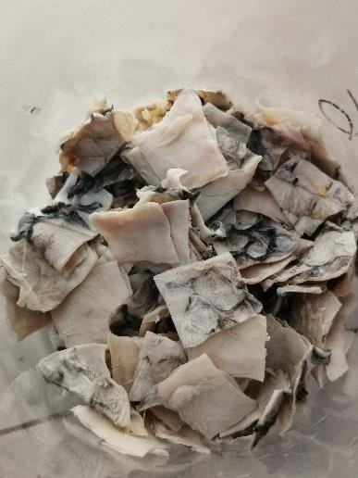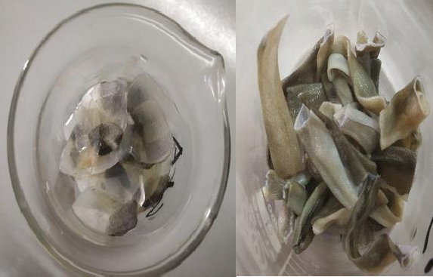
Picture of Raw Materials (Skin of Snakehead Fish, Scale of Snakehead fish, Skin of Anguilla bengalensis)

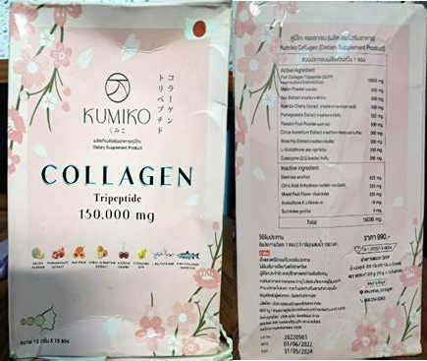

Picture of Commercial Collagen

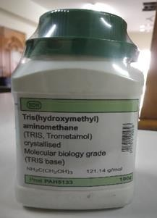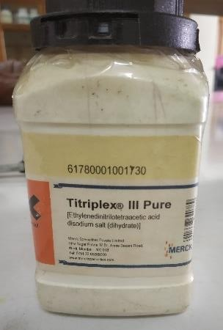

Reagent that are used (TRIS base & EDTA)
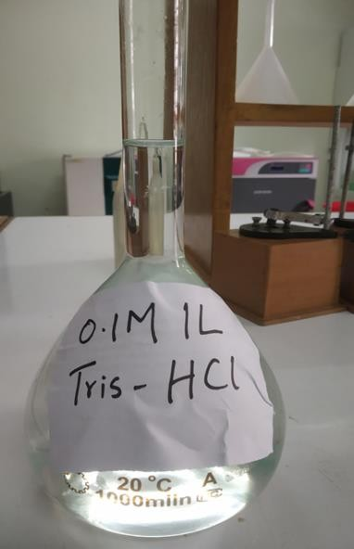
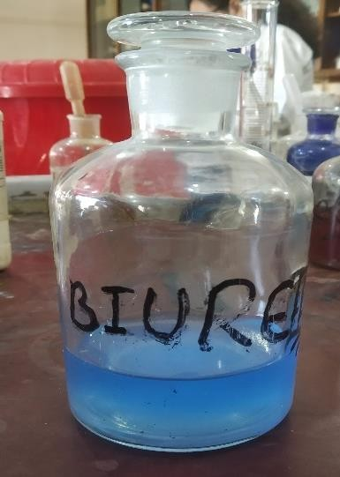

Prepared TRIS-HCl Reagent & Biuret Reagent

Process Flow:

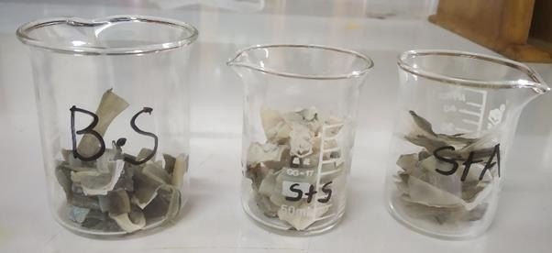

- Cut Anguilla bengalensis’s skin (B.S), Snakehead fish’s skin (S+S) & Snakehead fish’s scale (S+A) into small pieces.

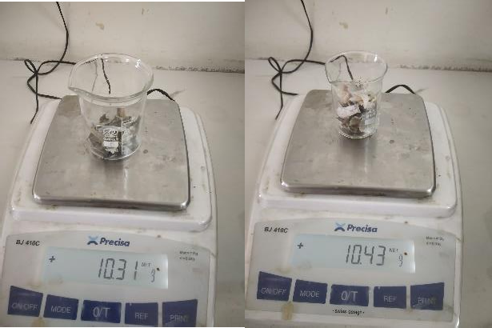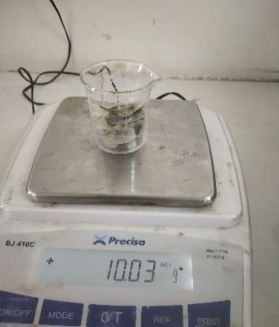

Weight them in the weight machine (10g)

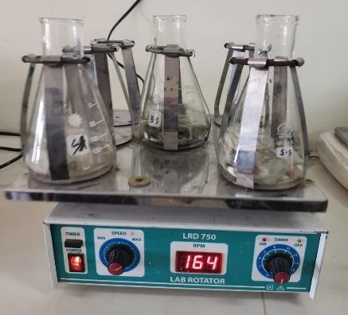
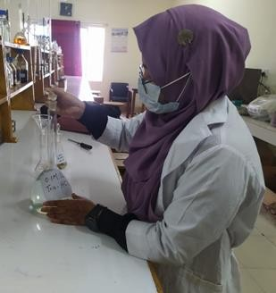

- Stirred the sample in 1L of double distilled water for 30 mins while repeating once.

Preparation of 0.1M Tris-HCl

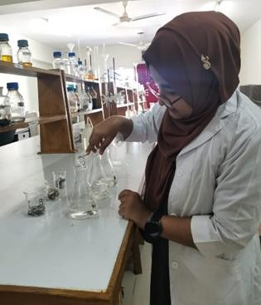

- Fish skin soaked in 1L mixture of 4mM EDTA and 0.1M Tris-HCl for 18hrs.

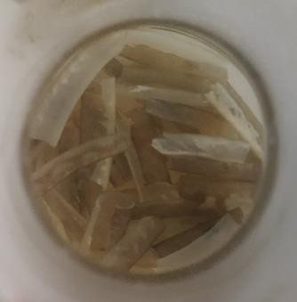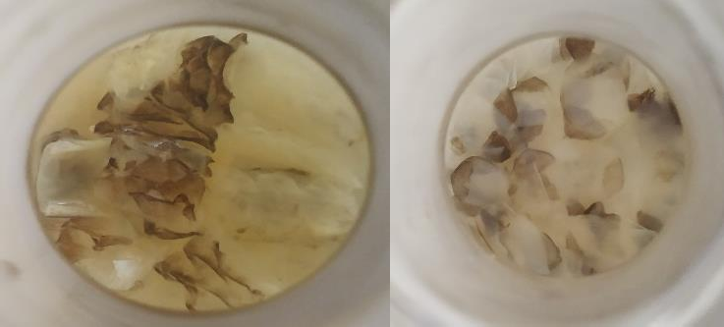

Anguilla bengalensis’s skin (B.S), Snakehead fish’s skin (S+S) &Snakehead fish’s scale (S+A) after soaking into a mixture of
EDTA & Tris-HCl

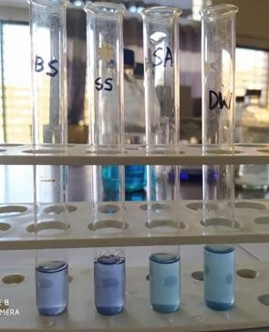
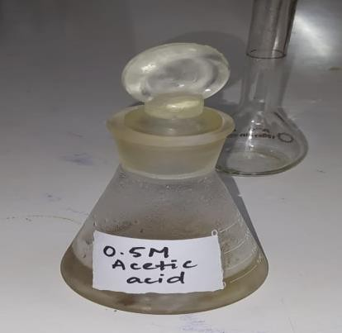

Solution was tested with Biuret reagent to ensure removal of undesirable protein
- Sample was kept in 0.5M acetic acid for 48hrs at 4˚C

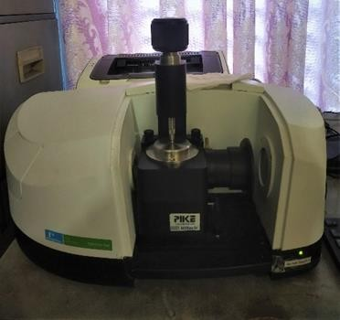

Finally, the filtered acid soluble collagen was characterized by FTIR

Brief Biography

Ayesha Chowdhury passed the Secondary School Certificate Examination in 2012 from St. Scholastica’s Girls’ High School with Grade Point Average (GPA) 5.00, and then Higher Secondary Certificate Examination in 2014 from Government Hazi Mohammad Mohsin College, Chattogram with GPA 5.00. She obtained her B.Sc. (Honors) in Food Science and Technology from the Faculty of Food Science and Technology at Chattogram Veterinary and Animal Sciences University, Chattogram, Bangladesh with Cumulative Grade Point Average (CGPA) 3.81. Now, she is a candidate for the degree of Master of Science in Food Chemistry and Quality Assurance under the Department of Applied Chemistry and Chemical Technology, Chattogram Veterinary and Animal Sciences University (CVASU). She has an immense interest to work in improving the health status of people through proper guidance and suggestions and to create awareness among people about food safety and nutrition.

