CHAPTER: 1
INTRODUCTION
Livestock is recognized as an integral component of rice based agricultural production system in Bangladesh. The economy of the country largely depends on agriculture. Livestock being one of the four components of agriculture (such as crops, livestock, fisheries and forestry) which plays a vital role in national economy, contributing about 6.5% of gross domestic products (GDP) and 13% of total foreign exchange earnings (GOB, 1991). Livestock plays an indispensible role in the traditional agriculture and largely subsistence economy of Bangladesh (Huq, 1997). Feed is the most expensive input within any livestock production system (Cruz et al., 2009) which accounts for 60-70% of the total production cost (Bulbul and Hossain, 1989). Livestock feed provides the basic nutrients required for animal production, including energy, protein & amino acid as macro nutrients, as well as minerals, vitamins and other micro nutrients (FAO, 1983). Since there is scarcity of lands in our country, the production and availability of livestock feed is very less than the demand and therefore the price is high. On the other hand rice straw is mostly available throughout the year due to rice based agriculture of our country. Hence, rice straw is the main energy source for ruminants comprising over 60% of the dietary energy supply in Bangladesh (Jackson, 1981).
Works in the laboratory of Bangladesh Livestock Research Institute, Savar, Dhaka, on the supplementation of rice straw with graded levels of common grasses, Leucaena foliage, wheat bran or rice mill feed, clearly demonstrate that the lower level of readily fermentable N and energy for the rumen and volatile fatty acids and amino acids for the animal provided by the rice straw are primary limitations to ruminant production in this country. So, on a straw based diet urea and molasses are added to grade up the quality of the feed (Huque and Talukder, 1994; Huque and Chowdhury, 1995). But it is not always possible due to poor distribution channel and high cost of molasses. Supplementation of other high energy source is impractical. On contrary, every household and residential educational institute of our country produces considerable amount of rice gruel, during cooking of rice, containing considerable amount of soluble starch material. Traditionally it is being used in the cattle diet as a drink with water.

Though some works have been carried out with rice gruel on cattle to assess the rural beef fattening program with traditional feeding practices (tethering, grazing and tree leaves with rice straw), no concise work has been done to evaluate the rice gruel as one of the major sources of energy after replacing the molasses. Keeping this view in mind, the present study was designed to investigate the possibility of rice gruel as a non conventional feed resource compared to other expensive energy source (molasses) on growth performance of native growing cattle with the following aims and objectives.
The aims and objectives of the present study:
- To reduce the feed cost by using rice gruel (kitchen waste).
- To observe the effect of rice gruel on growth performance of cattle.
- To observe the effect of rice gruel on rumen microbes of cattle.

CHAPTER: 2
REVIEW OF LITERATURE
2.1. Animal feeding and growth performances
Ikhar et al. (2011) conducted an experiment to study the effect of different feeding regimen on growth and reproductive performance of Sahiwal heifers, of 2.5-3 years having 170.55±19.02 kg body weight. Heifers in control (T₁) group were fed concentrate mixture as per their nutritional requirement along with wheat straw as ad-lib., whereas those in groups T₂ and T₃ were fed same diet except that the supply of DCP and TDN were only 80 per cent and 70 per cent of requirement recommended by ICAR (1998) respectively. The effect of different feeding regime on economics of growth revealed that the 80 per cent levels was comparable to that of control group, while the 70 per cent level was a costlier means of heifer rearing. Hence, it is concluded that 20 per cent reduction in the level of DCP and TDN as compared to ICAR recommendation did not affect DM intake, growth, nutrient utilization and economic of heifer rearing adversely.
A growth experiment of 40 weeks duration was carried out by Pandya et al. (2009) on 18 crossbred (Jersey x Kankrej and HF x Kankrej) calves randomly allotted to three groups of 6 each viz. complete feed based on wheat straw (30 per cent) and conventional ingredients (WSBCF), complete feed based on sugarcane bagasse (30 per cent) and non conventional ingredients (SBBCF) and conventional system of feeding (control). Average daily gain was 418, 477 and 473 g in WSBCF, SBBCF and control groups, respectively, with non significant treatment differences. Average daily intake of DM (kg) and DMI (% body weight) were similar among the treatments. The digestibility coefficients of DM, EE and CF were similar among the groups, however, CP and NFE digestibility were higher (P<0.01) in control than WSBCF and SBBCF groups. The intake of CP, DCP and TDN were similar in WSBCF and SBBCF but TDN intake was more in control. The protein utilization efficiency was higher (P<0.05) in SBBCF while energy utilization efficiency was higher (P<0.01) in both the complete feed groups. The calves under all groups were on recommended plane of nutrition. The balances of nitrogen, phosphorus and calcium were positive in all the groups. The TVFA, NPN and ammonia nitrogen content of rumen liquor were higher (P<0.01) in rumen liquor of animals than that of other two groups. The cost of feed per kg weight gain was lower by 33 and 38 per cent in SBBCF group over control and WSBCF group, respectively. It may be concluded that growing crossbred calves can be economically reared on complete feed with 30 per cent sugarcane bagasse and non conventional feeds.
Another experiment was conducted by Chaudhary et al. (2008) to test efficacy of direct fed microbials (DFM) for the improvement of performance in crossbred cattle calves reared on the diet devoid of cereal grains. 32 day old calves with average body weight of 23 kg were divided into 4 groups and feed on concentrate mixture to meet 50 per cent DM requirement and green fodder ad-lib. Group 1 serves as a control. The 100 ml DFM culture was fed to group 2 (curd, 10⁸ cfu/ml). The DM intake and feed conversion efficiency were not affected due to supplementation of any of the DFM. Improved body weight gain in calves by supplementation of all 3 microbial additives was observed. The digestibility of nutrients and plane of nutrition was similar in all 4 groups at 14 weeks and 52 weeks except a significance increase in digestibility of ether extract and acid detergent fibers in S. cerevisae fed group at 14 weeks and 52 weeks, respectively. There were no difference among the groups in the level of lactic acid, NH₃-N, total and molar proportion of VFAs, ciliated protozoa count and activities of filter papers degrading enzyme, carboxymethylcellulase, xylanase, alpha-amylase, beta-xylosidase, beta-glucosidase, alpha-glucosidase and protease at 52 weeks of age. However, microcrystalline cellulose activity was significantly higher in L. acidophilus fed group. The blood biochemical characteristics (plasma, glucose, serum protein, albumin and globulin) and immunological status of the calves of all the groups were similar at 52 weeks of age. It was concluded from the study that long term (first birth to one year of age) feeding of DFM improve the growth performance of crossbred cattle calves fed diet devoid of cereal grains.
Three complete feeds viz. without paddy straw (PS₀), 15 per cent paddy straw (PS₁₅) and 30 per cent (PS₃₀) were evaluated by Burte et al. (2007) on crossbred heifers (21, divided into 3 equal groups ) through a growth trial for 70 days . The DM intake was 3.38, 3.33 and 3.42 kg/100kg BW. Significantly (P<0.05) higher average daily gain was observed in complete feed PS₁₅ than PS₃₀. The digestibility of nutrients except NFE was statistically similar in all groups. All the animals were in positive N, Ca, and P balances. The DCP content was similar in all the treatments, however the TDN was higher (P<0.05) in PS₀ and PS₁₅ than PS₃₀ treatment. The cost of feed was Rs. 3.76, 3.58, 3.60 in PS₀, PS₁₅ and PS₃₀, respectively. The complete diet comprising of 15 per cent paddy straw (PS₁₅) supplemented with cereal bran, urea, jaggare could support optimum growth in crossbred heifers.
In an experiment by Kumar et al. (2001), fifteen crossbred male calves (10-12 months) were randomly divided into three equal groups of 5 each on body weight basis. Control group (T₁) was fed on groundnut cake based concentrate mixture, whereas, in the concentrate mixture of group T₂ and T₃, protein of groundnut cake was replaced with de-oiled sunflower cake at the rate of 33 and 66 percent, respectively. After experimental feeding of 105 days, a metabolism trial of 7 days duration was conducted. Daily body weight gain (g) in group T₁ was highest (533.3) as compared to T₂ (503.3) and group T₃ (606.7), however, variation among groups was not significant. DM intake in term of kg/100 kg body weight, digestibility co- efficient of nutrients except EE, as well as DCP and TDN did not differ significantly among the various groups. Lower digestibility of EE was observed in group T₃ than that in group T₁. All the experimental animals were in positive nitrogen balance and retention of N (as % intake) remained similar among groups.
A feeding trial was conducted by Chowdhury and Huque (1997) using rice gruel compared to that of the cane molasses as a source of readily fermentable energy for a urea supplemented straw diet. Where twelve negative growing bulls of 273 ± 8.7 kg live weight and 35 months old were randomly allocated to three treatments fed solely rice straw enriched with : (1) 3% urea (US), (2) 3 %urea +15% molasses(UMS) and (3) 3% urea +30% rice gruel (UGS). The feeding trial continued for sixty days. Organic matter (OM) intake was significantly (P < 0.05) higher in the UMS (64gm/kg W^{0.75} /d) followed by UGS (53g/kg W ^{0.75}/ d) and US (49g/kg W ^{0.75} /d). Estimated (from digestable OM intake) metabolizable energy (ME) intake was 396, 348 and 301 kJ/kg W^{0.75}/d for UMS, UGS and US respectively. The maintenance (i.e., no change in live weight) ME intake calculated to be 308±7.4 kJ/kg W^{0.75}/d. Urinary purine derivatives excretion was non-significantly higher in the UMS (51.73 mmol/d), followed by UGS (42.53 mmol/d), followed by UGS (42 .53 mmol/d) and US (35.26 mmol/d). The estimated microbial N (MN) yield was 21.10, 14.00 and 11.60g/d for UMS, UGS and US respectively. For each MJ increase in ME intake, MN yield increased by 1.29±0.134g. Observed live weight changes during the experimental period were 292, 125 and -19 g/d respectively for UMS, UGS and US. They were concluded that supplementation of readily fermentable N (urea) alone was not enough to optimize the rumen function and a source of readily fermentable energy was required. Rice gruel was less effective than molasses as fermentable energy source to remove a restriction on voluntary intake and provide less amino acids of microbial origin for absorption from the small intestine, thus more substrate for protein synthesis and gluconeogenesis were available for growth in the molasses than the rice gruel supplemented animals. However, in situation where molasses is not available or costly, rice gruel does appear to have a place as readily fermentable energy source on a urea supplemented straw diet.
2.2. Animal feeding and rumen ecology
Feed-efficient animals have lower production costs and reduced environmental impact. Given that rumen microbial fermentation plays a pivotal role in host nutrition, the premise that rumen microbiota may contribute to host feed efficiency is gaining momentum. Since diet is a major factor in determining rumen community structure and fermentation patterns, an investigation was conducted by Carberry et al. (2012) to see the effect of divergence in phenotypic residual feed intake (RFI) on ruminal community structure of beef cattle across two contrasting diets. PCR-denaturing gradient gel electrophoresis (DGGE) and quantitative PCR (qPCR) were performed to profile the rumen bacterial population and to quantify the ruminal populations of Entodiniumspp., protozoa, Fibrobacter succinogenes, Ruminococcus flavefaciens,Ruminococcus albus, Prevotella brevis, the genus Prevotella, and fungi in 14 low (efficient)- and 14 high (inefficient)-RFI animals offered a low-energy, high-forage diet, followed by a high-energy, low-forage diet. Canonical correspondence and Spearman correlation analyses were used to investigate associations between physiological variables and rumen microbial structure and specific microbial populations, respectively. The effect of RFI on bacterial profiles was influenced by diet, with the association between RFI group and PCR-DGGE profiles stronger for the higher forage diet. qPCR showed that Prevotellaabundance was higher (P < 0.0001) in inefficient animals. A higher (P < 0.0001) abundance of Entodinium and Prevotella spp. and a lower (P < 0.0001) abundance of Fibrobacter succinogenes were observed when animals were offered the low-forage diet. Thus, differences in the ruminal microflora may contribute to host feed efficiency, although this effect may also be modulated by the diet offered.
An experiment was conducted by Hasanuzzaman et al. (2011) aimed to see the effect of Seabuckthorn (SBT) cake on rumen metabolites and microbial population in cattle. Three adult fistulated cattle (BW~250 kg) were maintained on three dietary combinations. The crude protein contents of the basal diet (control, T₁) were replaced with SBT cake CP at 50 (T₂) and 75 (T₃) per cent CP in the bull ration. In addition, green grasses and water was offered ad-lib. to all the treatment groups. The pH of the rumen liquor varied from 6.10±0.06 to 7.37±0.03. The highest and lowest values of pH were found at 12 h and 24 h in all the treatments. The TVFA concentration in rumen liquor varied 18.33±0.88 to 71.67±1.20 mEq/dl and reached to the peak levels at 24 h, 4 h, and 16 h post feeding in T₁, T₂ and T₃ diet treatment groups. The NH₃-N concentration in rumen liquor ranged from 14.00±0.58 to 30.67±0.67 mg/dl, with the highest concentration recorded at 4h post feeding in T₁ diet, 2 h post feeding in T₂ and T₃ diet, and lowest concentration was observed at 20 h post feeding in all the treatments. The total-N concentration in rumen liquor ranged from 95.20±5.83 to 247.93±7.06 mg/dl, with the highest concentration recorded at 12 h, 16 h, and 12 h post feeding in T₁, T₂ and T₃ diet, respectively and lowest concentration was observed at 24 h post feeding in T₁ and T₂, and 0 h post feeding in T₃ diet. The TCA-N concentration ranged from 69.58±1.67 to 179.20±5.60 mg/dl, with the highest concentration recorded at 12 h, 16 h, and 12 h post feeding in T₁, T₂, and T₃ diet, respectively and lowest concentration was observed at 24 h post feeding in all the treatments. The NPN concentration ranged from 12.58±4.47 to 68.73±2.06 mg/dl with the highest concentration recorded at 12 h post feeding in all the treatments and the lowest concentration was recorded at 24 h post feeding in T₁, and 0 h post feeding in T₂ and T₃ diets. The bacterial population (cellx10¹⁰) ranged from 0.93±0.07 to 11.13±0.13 with peak level at 16 h, 20 h and 2 h post feeding and lowest values found at 24 h, 20 h and 24 h post feeding in T₁, T₂ and T₃ diets, respectively. The rumen protozoal population (cellx10⁶) ranged from 1.33±0.03 to 4.27±0.03 per ml being highest at 12 h post feeding in T₁ and T₂ diet, and 20 h of post feeding in T₃ diet. It is concluded that T₂ diet ensured better rumen metabolites for growth and multiplication of rumen bacteria and protozoa.
Balanche et al. (2011) studied with the aim of investigating the effect of presence or absence of protozoa on rumen fermentation and efficiency of microbial protein synthesis under different diets. Of 20 twin paired lambs, 1 lamb of each pair was isolated from the ewe within 24 h after birth and reared in a protozoa-free environment (n = 10), whereas their respective twin-siblings remained with the ewe (faunated, n = 10). When lambs reached 6 mo of age, 5 animals of each group were randomly allocated to 1 of 2 experimental diets consisting of either alfalfa hay as the sole diet, or 50:50 mixed with ground barley grain according to a 2 × 2 factorial arrangement of treatments. After 15 d of adaptation to the diet, the animals were euthanized and total rumen and abomasal contents were sampled to estimate rumen microbial synthesis using C₃₁ alkane as flow marker. Different (¹⁵N and purine bases) and a novel (recombinant DNA sequences) microbial markers, combined with several microbial reference extracts (rumen protozoa, liquid and solid associated bacteria) were evaluated. Absence of rumen protozoa modified the rumen fermentation pattern and decreased total tract OM and NDF digestibility in 2.0 and 5.1 percentage points, respectively. The effect of defaunation on microbial N flow was weak, however, and was dependent on the microbial marker and microbial reference extract considered. Faunated lambs fed with mixed diet showed the greatest rumen protozoal concentration and the least efficient microbial protein synthesis (29% less than the other treatments), whereas protozoa-free lambs fed with mixed diet presented the smallest ammonia concentration and 34% greater efficiency of N utilization than the other treatments. Although ¹⁵N gave the most precise estimates of microbial synthesis, the use of recombinant DNA sequences represents an alternative that allows separate quantification of the bacteria and protozoa contributions. This marker showed that presence of protozoa decrease the bacterial-N flow through the abomasum by 33%, whereas the protozoa-N contribution to the microbial N flow increased from 1.9 to 14.1% when barley grain was added to the alfalfa hay. Absolute data related to intestinal flow must be treated with caution because the limitations of the sampling and maker system employed.
To evaluate bacterial population dynamics during adaptation to a high-grain diet, an experiment was done by Fernando et al. (2010) where 04 ruminally cannulated beef steers were adapted to a high-grain diet using a step-up diet regimen containing grain and hay at ratios of 20:80, 40:60, 60:40, and 80:20. The rumen bacterial populations were evaluated at each stage of the step-up diet after 1 week of adaptation, before the steers were transitioned to the next stage of the diet, using terminal restriction fragment length polymorphism (T-RFLP) analysis, 16S rRNA gene libraries, and quantitative real-time PCR. The T-RFLP analysis displayed a shift in the rumen microbial population structure during the final two stages of the step-up diet. The 16S rRNA gene libraries demonstrated two distinct rumen microbial populations in hay-fed and high-grain-fed animals and detected only 24 common operational taxonomic units out of 398 and 315, respectively. The 16S rRNA gene libraries of hay-fed animals contained a significantly higher number of bacteria belonging to the phylum Fibrobacteres, whereas the 16S rRNA gene libraries of grain-fed animals contained a significantly higher number of bacteria belonging to the phylum Bacteroidetes. Real-time PCR analysis detected significant fold increases in the Megasphaera elsdenii, Streptococcus bovis, Selenomonas ruminantium, andPrevotella bryantii populations during adaptation to the high-concentrate (high-grain) diet, whereas the Butyrivibrio fibrisolvens and Fibrobacter succinogenespopulations gradually decreased as the animals were adapted to the high-concentrate diet. This study evaluates the rumen microbial population using several molecular approaches and presents a broader picture of the rumen microbial population structure during adaptation to a high-grain diet from a forage diet.
The effect of graded levels of cadmium (Cd) on in vitro rumen fermentation and amelioration of its adverse effects through Zn supplementation was studied in cattle by Chandanshive et al. (2007). Karan Fries male crossbred calves (14; 4-5 m old) divided into three groups with 4, 5 and 5 calves in each group were offered conventional control diet © or C supplemented either with 10 ppm Cd (T1) or 10 ppm Cd and 100 ppm Zn (T₂) for 30 days. There was no change in TVFA and TCA-N concentration. However, NH₃-N concentration was high (P<0.05) in T₂. There was increase (P<0.05) in the alnine transaminase (AST) and urease in T2 which tende to decrease in group T₃. It was evident that zinc supplementation at 100 ppm level reduced NH₃-N concentration observed due to feeding of 10 ppm Cd in crossbred male calves.
An experiment was conducted by Samanta et al. (2006) to see the effect of feeding complete feed blocks on rumen microbes and metabolites in crossbred cattle. Adult rumen fistulated male cattle (3; 8 years old of 400kg BW) divided into three groups in 3x3 Latin square switch over design were offered iso-nitrogenous complete diet containing dried grass (predominated by Heteropogon contortus and Sehima nervosum) and concentrate mixture in 60:40 ratio in mash form (CFM) or CFM in which concentrate mixture contained Leucaena leaves (LL-CFM) or as complete feed block (LL-CFB). The TCA-ppt N was significantly (P<0.05) higher in CFB feeding regime than either CFM or LL-CFM diets. The NPN was significantly higher (P<0.05) in mash form of diets (CFM and LL-CFM) than the CFB diets. Total viable bacteria as well as anaerobic fungal population was higher (P<0.05) in CFB fed animals than either CFM or LL-CFM diet because of propionate intake of roughage and concentrate from the block form of diets. Results conclusively revealed that the complete diets in the form of blocks created conductive environment for higher growth of rumen bacteria as well as fungi as compared to the mash form of diets.
A rumen fermentation study was conducted by Thakur et al. (2006) where rumen fistulated male buffalo calves (9; 2.0-3.0 yr old of 238.36±13.97 kg BW) were divided into three equal groups and fed total mixed rations (TMR) containing concentrate: green maize fodder: wheat straw in 50:25:25 proportions on DM basis for 120 days. Concentrate of TMR₁ comprised of traditional feed ingredients whereas that of TMR₂ and TMR₃ contained concentrates in which maize and barley grains were replaced with wheat, groundnut cake with mustard cake and urea, mineral mixture reduced by 0.5 per cent and common salt increased by 0.5 per cent. The type of TMR did not have any significant effect on rumen metabolites or microbial counts. The N, Ca and P retention was statistically similar in all groups. The average daily gain was significantly (P<0.01) higher in calves fed TMR₃ as compared to those fed TMR₁ and TMR₂. Feed cost (Rs/kg BW gain) was significantly (P<0.01) lower in calves fed TMR₂ and TMR₃ than that of TMR₁. It was concluded that the feeding of TMR based on locally available cheap feed ingredients improved the growth rate and reduced the cost of feeding in buffalo calves.
Hristov et al. (2004) studied to investigate the effects of sodium salts of individual fatty acids on protozoal numbers and ruminal fermentation variables in vitro. Ruminal inoculum was obtained from two heifers fed a finishing diet consisting of (DM basis) 90% rolled barley grain, 4% barley silage, 5% soybean meal, and 1% mineralized salt. Fatty acids (FA) were included individually in the inoculum as follows: C6:0, C8:0, and C10:0 at concentrations (wt/vol) of 0.0625, 0.125, and 0.25%; C14:0 and C18:0 at concentrations of 0.125, 0.25, and 0.5%; and C12:0, C16:0, C18:1, C18:2, and C18:3 at concentrations of 0.25, 0.5, and 1.0%. ¹⁵N-Labeled casein was included as a N tracer. In the presence of medium-chain saturated FA (particularly C10:0 and C12:0), no ciliate protozoa (99.8% Entodinium spp.) were recovered from the incubation medium. Long-chain unsaturated FA (C18:3, C18:2, C18:1) also decreased (P < 0.05) protozoal numbers. At all concentrations tested, C10:0 and C12:0 decreased (P < 0.05) ammonia and total VFA concentrations (by 29 and 22%, respectively) and increased (P < 0.05) concentrations of total free amino acids, reducing sugars, and soluble protein. At the greatest concentrations of these FA, xylanase and amylase activities of the incubation media were decreased (P < 0.05). The C18 unsaturated FA increased (P < 0.05) the polysaccharide-degrading activities of the media. These in vitro results suggest that long-chain unsaturated FA in combination with medium-chain saturated acids have the potential to decrease protozoal numbers and ruminal ammonia utilization in cattle fed high-grain diets.

CHAPTER-3

MATERIALS AND METHODS

3. 1. Baseline survey on production (quantity) of rice gruel

3. 1.1. Study area
It was a bare necessity to select the area, which should provide maximum information, convenient to collect rice gruel, to analyze, to feed the selected animals regularly. The selection of study area depends on the objectives of the research.

Chittagong Veterinary and Animal Sciences University (CVASU), a governmental educational institute (residential). Being a residential institute, daily a considerable amount of rice gruel is produced here during cooking of rice in hostel dinning and there is a cattle shed also. Therefore, CVASU was selected as study area.

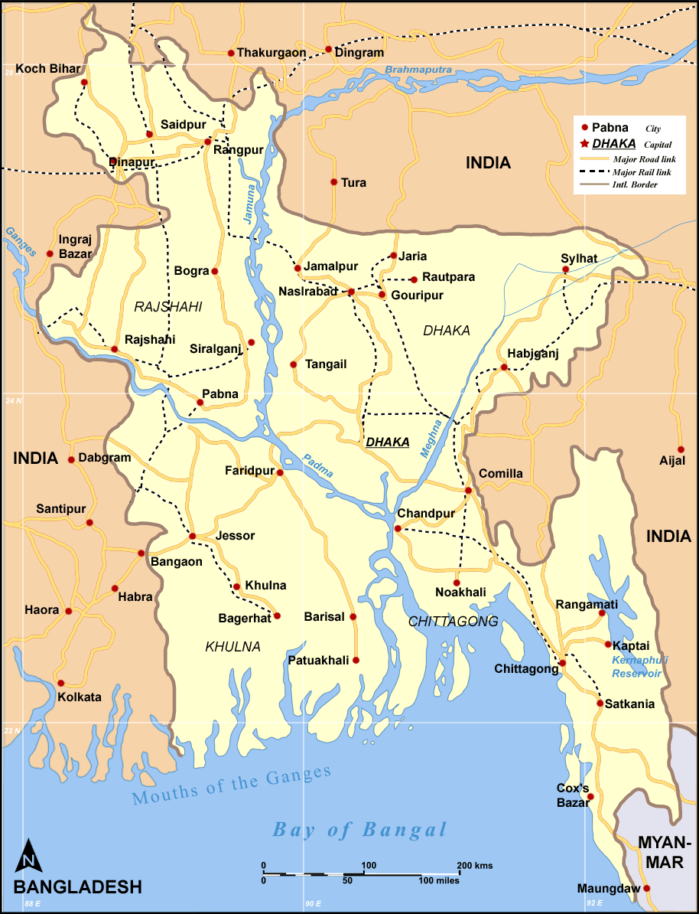

Fig 3.1 : Study area map

3. 1.2. Quantification of rice gruel
Rice gruel was collected from the hostel dining in large calibrated plastic buckets at noon and night for a period of five (5) days. The measurement was done in the unit-liter per head per day. It was calculated by using the underlying formulae:

Production of rice gruel (liter per head per day) | $$=\frac{Production of rice gruel \left(noon+night\right)of a day}{Number of total boarders of that day }$$

Mean production of rice gruel (liter per head per day) | $$=\frac{Total production of rice gruel of 05 days }{05}$$

3. 1 .3. Collection of rice gruel for analysis
Rice gruel was collected by using simple random sampling technique for chemical analysis in three (3) consecutive days. Each time 1000 ml of sample was collected and after cooling up to room temperature, immediately analyzed in the Animal Nutrition Lab of CVASU.

3. 1. 4. Chemical analysis of rice gruel
Sample of rice gruel was analyzed with three (3) replications each for dry matter (DM) and organic matter (OM) in the laboratory of Department of Animal Science and Nutrition, according to AOAC (2005).

3. 2. Feeding of animals
Feeding of ruminant is much more complicated than simple stomach animal as they require a large amount of roughage and concentrate feed for their maintenance and production. In case of beef fattening program the main constraint in our country is the scarcity of green grass and high price of concentrate feed. So it is very important to identify some readily available non conventional feed resources which can be used as a substitution of expensive conventional feeds.

3. 2. 1. Study area
The sufficient number of study population was available at CVASU cattle farm which is situated within the campus premises. This was easy to manage and to conduct any scientific trial. Therefore this farm was selected as the study area for feeding trial with rice gruel in addition to concentrate ration compared to the molasses as an energy source for a time period of 60 days (21.07.2013 to 20.09.2013).
3. 2. 2. Selection of animals
The animals were selected in healthy condition having shiny body coat, active and alert movement, normal feeding, rumination, eructation, defecation, urination and with other physical parameters ( Rectal temperature, heart rate, pulse rate, respiration rate etc.) normal. A total number of six (6) yearling animals of approximately same age and size but of different sexes were selected for the growth trial from cattle farm of Chittagong Veterinary and Animal Sciences University (CVASU). The animals were divided into two groups, group I and group II with 03 animals in each group, where 02 were male and another was female and their age was within the range 18 to 22 months.

Table 3.1: Distribution of cattle according to treatment groups
Group | Cattle population |  | Average initial body weight(kg)
 | Male | Female
Group: I | 02 | 01 | 193.33
Group: II | 02 | 01 | 203.33

3. 2. 3. Preparation of experimental shed
The experimental shed for cattle was properly washed and cleaned by using tap water every before the experiment and the shed was washed in the same manner during the entire study period. Ceiling, walls and floor were also thoroughly cleaned. The whole shed was washed with disinfectant solution weekly. Cow-dung and other dirt were regularly removed and disposed.

3. 2. 4. Examination of animals for parasites
3. 2. 4. a) External examination of animals
All the selected animals were thoroughly examined before starting the trial for the presence of any kind of ectoparasite or lesions.
i) Administration of Ivermectin drug
All the animals were administered with the Ivermectin injection @ 0.2mg/kg body weight subcutaneously.
3. 2. 4. b) Coproscopy
Before starting the trial, feces sample of the animals was collected early morning by using rectal palpation technique with gloves. The collected feces sample were packed separately for individual animal and transported immediately through sterilized sachet to the laboratory and then preparation of smear was done through the process saline wet mount, iodine wet mount & floation method for microscopic examination.
3. 2. 4. b. i) Deworming
The animals were make endoparasite free by using anthelmintic according to the parasite found.
3. 2. 4. c) Examination of peripheral blood smear
As above, before the trial, the peripheral blood smears of the animals were examined under microscope after Giemsa staining to identify whether there was any kind of blood protozoa present or not.

3. 2. 5. Feed Offered
Required amount of roughage and concentrate feed was offered to the cattle on the basis of their individual body weight. Fresh and clean drinking water was offered to all animals round the day as ad-lib basis. The concentrate ration was offered to both the groups of cattle at 9AM daily (once only). The animal of group I was additionally supplied with the rice gruel instead of molasses at the same time for once.

Table 3.2: The composition of the concentrate m+ixture
Sl. No. | Feed ingredient | Amount (%)
 |  | Group I | Group II
1 | Wheat bran | 24.5 | 24.5
2 | Rice polish | 17.0 | 17.0
3 | Broken rice | 05.0 | 06.0
4 | Maize | 13.0 | 13.0
5 | Molasses | 0.00 | 02.0
6 | Pea bran | 20.5 | 20.5
7 | Soybean meal | 07.0 | 07.0
8 | Soybean oil cake | 08.5 | 08.5
9 | Salt | 01.5 | 01.5

Here in case of Group I the mixture was not full fill, because the lacking part was compensate with the supply of rice gruel @ 2.5 liters/100kg body weight.

Table 3.3: Animal groups with daily amount of feed offered
Group | Animal  no. | Body weight (Kg) | Concentrate feed (kg) | Grazing (hours) | Straw  (Kg) | Rice gruel (liter)
Group: I | 1 | 200 | 4.00 | 3 | 4.00 | 5.00
 | 2 | 210 | 4.00 | 3 | 4.00 | 5.00
 | 3 | 170 | 3.80 | 3 | 3.00 | 4.00
Group: II | 4 | 220 | 4.50 | 3 | 4.00 | -
 | 5 | 210 | 4.00 | 3 | 4.00 | -
 | 6 | 180 | 3.80 | 3 | 3.00 | -

3. 2. 6. Body weight gain
The body weight of animals was recorded at initial, mid & final level of the trial by using digital weight machine.
3. 2. 7. Examination of rumen liquor
Rumen liquor was collected at 0, 4, 8, 12, 16, 20 and 24 h of post feeding hours for one (01) day from each animal of both group.
3. 2. 7. i) Aspiration of rumen liquor/ rumenocentesis (needle puncture)
Rumen liquor collection was carried out by means of rumenocentesis after properly restrain the animal. The puncture site was located 12 to 15 cm caudal to the costochondral junction of the last rib, on a horizontal line level with the top of the patella. Before rumenocentesis, the puncture site was painted with disinfectant and then 5-10 ml of ruminal fluid was aspirated with a 20 ml syringe.
3. 2. 7. ii) Transportation of rumen liquor
Immediately after collection, the rumen fluid was transported from the collection site to the laboratory in a thermo flask to prevent the changing of temperature.
3. 2. 7. iii) Physical characters
The color, consistency and odor of individual animal ruminal fluid were examined organoleptically.
P^{H}: Normal p^{H} of rumen liquor varies from 5 to 7. However, under pathological conditions it may decreases towards acidic or it may increases towards alkaline side. Therefore, p^{H} of rumen liquor was studied to know the effect of different feeds.
Procedure
The pH of the rumen liquor was determined using portable digital pH meter (pen type) at the site of the collection. After collection and filtration of the rumen liquor, the electrode of the pH meter was inserted inside the SRL and the pH was determined.
Protozoal Motility
Rumen contains a large population of rumen protozoa which are ciliated and motile. They are anaerobic in nature and they live at p^{H} between 5 to 7, temperature 39-40 ⁰c and in presence of moderate concentration of volatile fatty acids along with billions of rumen bacteria. Since the protozoa motility gives a tentative idea about the digestion of feed in rumen, therefore, it was studied for the protozoal motility in rumen liquor to know the feed effect.
Procedure
Extract volume of 0.5 ml of stained rumen liquor (SRL) was transferred on a clean glass slide and was covered with cover slip. The movement of protozoa was examined under low power of microscope immediately.
The movement of protozoa was rated as follows:
++++ = Very rapid movement, whole mass is moving.
+++ = Rapid movement, very large population of protozoa showing their motility.
++ = Moderate movement, less number of protozoa is moving moderately.
+ = slow movement, very few protozoa showing their slow movement.
0 = No movement, all the protozoa are dead.
3. 2. 7. iv) Chemical characters
Estimation of Total Protozoa in Rumen Liquor
Apparatus required
- Glass slide, cover slip, microscope, rumen liquor, test tube, test tube rack, pipette, muslin cloth and funnel.
- Lugol’s Iodine solution was prepared by dissolving 5 g of iodine and 10 g potassium iodide in 60 ml of distilled water and 10 ml of formalin and 30 ml of glycerol was added. Finally the volume was made 100 ml.
Procedure
1 ml of SRL was placed into a test tube through a wide bore pipette. Exact volume of 9 ml of Lugol’s Iodine solution was added and mixed gently. Then 0.1 ml of sample was transferred swiftly to a dry clean slide and spread under a glass cover of known area (24 x 60 mm). Counting of protozoa was done under low power of microscope in a zig zag manner. Thirty fields were counted per slide both for ease, accuracy and average count per field was calculated. Total protozoal count per ml was calculated by following formula:
Total protozoa per ml of SRL = {(Average No. of protozoa count per field) x (Microscopic factor) x (Dilution factor)}
Estimation of Total Ruminal Bacteria
Apparatus required:
- Strained rumen liquor, test tube, pipettes, centrifuge, funnel, muslin cloth, glass slide, microscope, wire loop.
- Ten (10) per cent formalin solution: by mixing 10 ml of formalin with 90 ml of water.
- Saturated solution of Nigrosine stain: by dissolving 5g of water soluble nigrosine in 20 ml of distilled water and adding 80 ml of methyl alcohol. It was mixed well and filtered before use.
Procedure
Collected and filtered rumen liquor was centrifuged 3000 rpm for 5 minutes. A volume of 5 ml of centrifuged content was taken in a test tube and 5 ml of 10 per cent formalin was added to kill the bacteria. Then 2 ml of formalin mixed rumen liquor was transferred in a test tube and 8 ml of distilled water was added to give 1 x 10⁻¹ dilution and serial dilutions up to 1x10⁻⁴ was made. Exactly 0.01 ml of sample from 1 x 10^{–4} dilution was placed on a clean glass slide on a marked area of 2 x 2 cm and a loopful of saturated solution of nigrosine was taken on glass slide. Finally both were mixed thoroughly and stained with the help of loop wire, spreaded on slide as thin as possible. The slide was kept on hot plate for 2 seconds to dry the smear and counting was done under oil immersion lens where bacteria appear colorless against black background. The bacteria were counted in 10 different fields in zig zag manner and the average number of bacteria per field was calculated by following formula:
Ruminal bacteria per ml of SRL
= (Average number of bacteria per field x microscopic factor (1000) x dilution factor (10⁶).
3.2.8. Statistical analysis
All the data found of this study was analyzed by applying GraphPad InstatTM 1990-1994, SAS 9.2, and SPSS 16 as statistical software packages. The ANOVA used at different trial was addressed at the respective parameters.

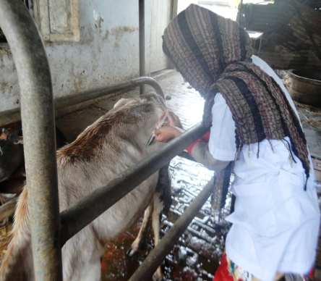
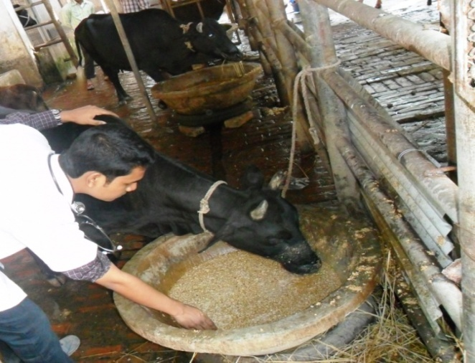

Figure 3.2: Feeding of RG with concentrate mixture
Figure 3.3: Collection of rumen liquor from cattle

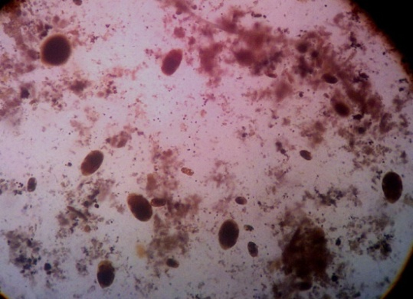
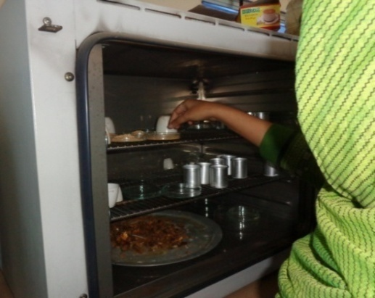

Figure 3.4: Estimation of DM of RG
Figure 3.5: Dilution of SRL for bacterial count

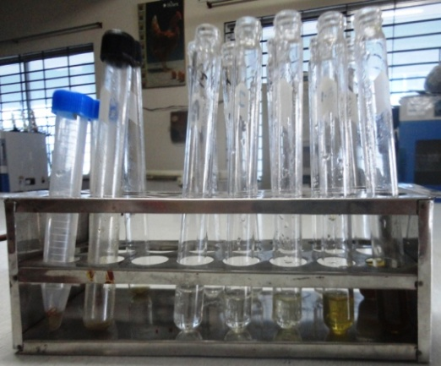
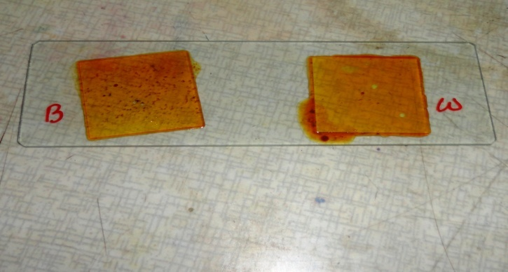

Figure 3.7: Rumen protozoa under microscope
Figure 3.6: Slide of protozoal count

CHAPTER-4
RESULTS AND DISCUSSIONS

In Bangladesh there is a huge gap between demand and availability of feed for livestock. Due to this imbalance, animals are mainly fed on poor quality feed or by products, which are low in energy, protein and other essential nutrients. It is, however, the use of balanced rations consisting of locally available good quality non conventional feed resources can bridge gap between the demand and supply, can improve the efficiency of feed utilization and performance of animals.
4.1. Quantification of rice gruel
Following table shows the production of rice gruel per day, number of boarders of same day as well as production of rice gruel per head per day.
Table 4.1: Production of rice gruel (RG) per head per day in liter
Days | Production of RG (liter) (noon+night) | No. of boarders | Production of RG (liter/ head/day) | Mean production of RG (liter /head/day)
1 | 30 | 215 | 0.139 | 0.165
2 | 30 | 203 | 0.147
3 | 32 | 175 | 0.182
4 | 33 | 186 | 0.177
5 | 30 | 166 | 0.180

From the above table it was found that the amount of rice gruel production of different 05 days (where the days were randomly selected for calculation of production) was closest to each other. Here the mean production of rice gruel was 0.165±0.041 liter/head/day. No available work was found in this aspect.

4.2. Chemical analysis of RG:
Samples of rice gruel were analyzed (in triplicate) for dry matter (DM) and organic matter (OM) according to AOAC (2005).

Table 4.2: Chemical analysis of rice gruel
Item | Dry matter (g/100g of fresh sample) | g/100g of dry matter
 |  | Organic matter
Rice gruel | 4.20 | 99.88
 | 4.00 | 99.80
 | 4.10 | 99.92
Mean | 4.10 | 99.86

4.3. Examination of animals for external parasites
This examination revealed that there were presence of lice and ticks more or less in all the selected animals. So animals were treated with the preparation of 01% Ivermectin injection. According to Radostits, et al. (2000) Ivermectin is very effective against any kind of external parasites than other preparations.
Table 4.3: Microscopic examination of feces for parasitic egg/ Oocyst
Group | Saline wet mount | Iodine wet mount (cyst) | Floatation | Anthelmentics used
Group: I | +ve | -ve | -ve | Triclabendazol +Levamisole
Group: II | +ve | +ve | -ve | albendazole

Group I animal Coproscopy examination found nematode egg mainly Haemonchus sp and mixed infection with other nematodes causing parasitic gastroenteritis (PGE), along with Paramphistomum sp. The animals were treated with combined preparation of triclabendazole and levamosole. According to Islam et al., (2005) levamisole and triclabendazole is effective against gastrointestinal nematodes and trematodes. In fecal nematode egg counts also reduced 96.10% while those treated with levamisole Talabi et al. (2002). Group II animals having small parasitic load with Paramphistomum sp and Haemonchus sp. They are treated with albendazole @10 mg / kg body weight. According to Theodorides, et al. (1976) albendazole is a broad spectrum anthelmintic, effective against: roundworms, tapeworms, and flukes of domestic animals and humans. Junquera, (2013) stated that albendazole is effective against gastrointestinal adults and L4-larvae of the most important species in young animal. A low dose of Eimeria Oocyst is found in iodine wet mount (Group I and II) which is insignificant, as >5000 oocyst /g feces is significant (Radostits, et al., 2000).

4.4. Examination of animals for blood protozoa
Table 4.4: Examination of blood smears for blood protozoa
Group | Peripheral blood smear
Group: I | -ve
Group: II | -ve

From the table 4.4, it was observed that there was no existence of blood protozoa in experimental animals of this study; hence no extra care was needed to them.

4.5. Growth trial of animals
A growth trial was conducted with 6 cattle having mostly similar age and weight. The data collected from that trial are analyzed and the results found are discussed below:
4.5.1. Repeated measures of Analysis of Variance (ANOVA) with two factors: A two-way repeated measures ANOVA also known as a two-factor repeated measures ANOVA, often used where a dependent variable measured over two or more time points. The primary purpose of a two-way repeated measures ANOVA is to understand if there is an interaction between these two factors on the dependent variable. In this study, dependent variable was weight gain repeatedly observed in Day 0, Day 15 and Day 60 for molasses and rice gruel treatment. Sphericity is an important assumption of a repeated measures ANOVA. It refers to the condition where the variances of the differences between all possible pairs of groups are equal developed by Mauchly (1940). Mauchly's test of sphericity is a popular test to evaluate whether the sphericity assumption has been violated.
The following table shows the mean and standard deviation of different treatments with repeated observation (Day 0, Day 15, and Day 60). It was observed that the mean weight gain for molasses was numerically higher than rice gruel.

Table 4.5: Consecutive body weight gain of cattle group (kg)
Diet | Day 0 | Day 15 | Day 60
Control (Molasses) | 203.33±20.82 | 209.67±21.73 | 228.0±22.11
Treatment (Rice gruel) | 193.33±20.82 | 197.33±21.78 | 211.67±22.19
The mean of weight gain (in different days) was significantly different (p-value=0.021) by using multivariate test (Roy's Largest Root). The Mauchly’s test of sphericity showed the variance were equal within subjects (Mauchly's criteria=0.36, p-value=0.655). The following ANOVA table showed that treatment had no significant effect but the weight gain for different ages was significantly different, graphical presentation also showed that in figure-4.1.

Table 4.6: Repeated measures Analysis of Variance
Sources of variation | SS | DF | MS | F-value | P-value
Treatment | 389.967249 | 1 | 389.967249 | 1.75 | 0.317
Age | 4816.666667 | 1 | 4816.666667 | 21.60 | 0.043
Age*Treatment | 368.166667 | 1 | 368.166667 | 1.65 | 0.328
Error | 446.000000 | 2 | 223.000000

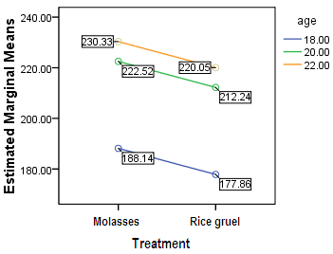 | 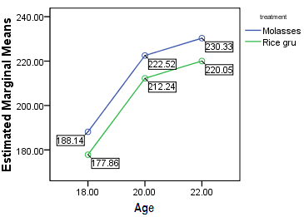
Fig. 1a. Marginal mean of weight gain for treatment across different age | Fig. 1b. Marginal mean of weight gain for age across different treatment
Figure 4.1: Marginal mean of weight gain for treatment vs age and age vs treatment

Table 4.7: Body weight gain
Group | Body weight  gain (gm) | p value | Level of significance
Group: I | 303.33± 14.53 | 0.0073 | Highly significant (***)
Group: II | 406.67±14.53

Fig 4. 2: Body weight gain of two groups

From table 4.7 & fig 4.2, it can be said that the body weight gain of the animals belongs to Group I (303.33±14.53) was significantly lower than the animals belongs to Group II (406.67±14.53). The result was in close agreement with the findings of Chowdhury & Huque (1998). Further thisbody weight gain was closer to the findings of Pandya et al. (2009).
4.5.2. Examination of rumen liquor
Rumen liquor was collected at 0, 4, 8, 12, 16, 20 and 24 h of post feeding for one (01) day from each animal of both groups. The physical and chemical parameters of rumen liquor as well as the microbial count were conducted after collection of rumen liquor.
4.5.2. a) Physical characters
pH: The pH value of the SRL was estimated and data was shown in table 4.8 figure 4.3.
Table 4.8: Effect of diet and time on pH of SRL (Mean± SD)
pH
Treatment/Time | 0 h | 4 h | 8 h | 12 h | 16 h | 20 h | 24 h | Overall
Rice gruel(G I) | 6.10±0.56 | 6.27±0.95 | 6.30±0.17 | 7.30±0.46 | 6.13±0.57 | 5.40±0.35 | 6.20±0.40 | 6.24±0.70
Molasses(G II) | 7.63±1.20 | 7.6±0.75 | 7.23±1.53 | 7.87±0.42 | 6.30±0.90 | 7.07±0.31 | 7.33±0.50 | 7.29 ±0.90
Time (F=2.43, p-value=0.046) and treatment (F=21.70, p-value<0.001) were significantly different observed by two way analysis of variance (ANOVA). pH recorded at 12 h of post feeding was significantly different from 16 h and 20 h was observed by post hoc analysis of least significant difference test.

Fig 4.3: pH of rumen liquor at different post hours of feeding
The pH of the rumen liquor varied from 5.4±0.35 to 7.3±0.46 and 6.3±0.90 to 7.87±0.42 in G-I and G-II respectively. The highest values of pH were found at 12 h and lowest values were found at 20 h and16 h in G-I and G-II respectively. Mahouchi et al. (2003) reported lowest value of rumen pH in sheep at 1-2 h post feeding. In case of buffalo, the pH of the rumen represented significantly lower levels at 4 h post feeding either in presence or absence of protozoa (Chaudhary et al., 2008; Kamra et al., 2000). Grazing on either natural grassland or silvi-pasture system maintained a rumen pH of 7.30 to 7.96 (Samanta et al., 2006). The other experiment by (Samanta et al., 2005) showed that the cattle’s grazing on natural pasture, the rumen pH was always highest above 7.0 irrespective of post feeding intervals. In the present investigation, G-II was highest irrespective of post feeding intervals as compared to G-I. It might be due to higher secretion of alkalizing agents through saliva.

Table 4.9: Effect of diet and time on various physical parameters of rumen liquor
Parameters | Group | Hours of post feeding
 |  | 0 h | 4 h | 8 h | 12 h | 16 h | 20 h | 24 h
Color | G-I | Grey | Grey | Greenish | Grey | Grey | Grey | Grey
 | G-II | Grey | Grey | Grey | Greenish | Grey | Grey | Greenish
Odor | G-I | Aromatic | Aromatic | Aromatic | Aromatic | Aromatic | Aromatic | Aromatic
 | G-II | Aromatic | Aromatic | Aromatic | Aromatic | Aromatic | Aromatic | Aromatic
Consistency | G-I | Viscous | Viscous | Viscous | Viscous | Viscous | Viscous | Viscous
 | G-II | Viscous | Viscous | Viscous | Viscous | Viscous | Viscous | Viscous
Protozoal motility | G-I | ++++ | ++++ | +++ | ++++ | ++++ | ++ | +++
 | G-II | ++++ | ++++ | +++ | ++++ | ++ | ++ | ++

++++ = very rapid, +++ = rapid, ++ = moderate movement of rumen flora

Color:
The color of rumen liquor was found mostly grey in both groups except 8 h of post feeding in G-I & 12 h & 24 h of post feeding in G-II.

Odor:
There was no dissimilarities in odor of rumen liquor of both groups & was found as aromatic.

Consistency:
The consistency of ruminal fluid was found viscous in both groups.

Motility:
The protozoal motility of G-I was very rapid up to 20h but in G-II it was fluctuating, very rapid in 0 h, 4 h & 12 h, rapid in 8 h & moderate in 16 h & 24 h of post feeding

The quality of color, odor, consistency, motility and pH shown in table 4.9 were within the physiological limit as supported by Radostits, et al.(2000).

4.5.2. c) Chemical characters
Bacterial count
Table 4.10: Effect of diet & time on bacterial count/ml of SRL (Mean± SD)
Treatment  / Time | Bacteria (cell x 10¹⁰)
 | 0 h | 4 h | 8 h | 12 h | 16 h | 20 h | 24 h | overall
Rice gruel  (G I) | 9.6±0.26 | 7.33±0.50 | 8.60±0.26 | 8.50±0.30 | 8.17±0.65 | 9.67±0.15 | 8.33±0.50 | 8.6±0.85
Molasses  (G II) | 6.3±0.17 | 6.13±0.57 | 5.23±0.25 | 8.47±0.15 | 7.33±0.50 | 7.07±0.31 | 6.33±0.12 | 6.70±1.02
Time (F=5.11, p-value=0.001) and treatment (F=69.82, p-value<0.001) were significantly different observed by two way ANOVA. Bacterial count of 0 h was significantly different from 4h and 8h; 4 h was significantly different from 12 h, 16 h and 20 h; 8 h was significantly different from 12 h and 20 h; 12 h was significantly different from 24h; 20 h was significantly different from 24 h; observed by post hoc analysis of least significant difference test.

Protozoal count
Table 4.11: Effect of diet & time on protozoal count/ml of SRL (Mean± SD)
Treatment/Time | Protozoa (cell x 10⁶)
 | 0 h | 4 h | 8 h | 12 h | 16 h | 20 h | 24 h | overall
Rice gruel(G I) | 6.60±0.26 | 4.53±0.50 | 5.30±0.17 | 6.57±0.21 | 6.60±0.85 | 7.33±0.50 | 4.60±0.26 | 5.93±1.12
Molasses(G II) | 6.47±0.42 | 3.87±0.42 | 4.63±1.20 | 4.53±1.42 | 5.57±1.15 | 6.57±1.07 | 3.30±1.05 | 4.99±1.47

Time (F=12.82, p-value=<0.001) and treatment (F=15.18, p-value<0.001) were significantly different observed by two way ANOVA.
Protozoal count of 0 h was significantly different from 4 h, 8 h, 12 h and 24 h; 4 h was significantly different from 12 h, 16 h and 20 h; 8 h was significantly different from 16 h, 20 h and 24 h; 12 h was significantly different from 20 h and 24 h; 16 h was significantly different from 24 h; 20 h was significantly different from 24 h; observed by post hoc analysis of least significant difference test.

Fig 4. 4: Bacterial cell count at different post hours of feeding

The microbial population (cellx10¹⁰) in case of rumen bacteria showed in table 4.10, fig 4.4 ranged from 7.33±0.50 to 9.67±0.15 and 5.23±0.25 to 8.47±0.15 per ml of SRL in G-I and G-II diets, respectively. The bacterial population attained peak level at 0 h & 20 h of post feeding in G-I and at 12 h in G-II and lowest values found at 4 h and 8 h of post feeding in G-I and G-II diets, respectively. The total number of bacteria was a bit higher but not significant in G-I diet. The positive balance of protein and energy in rumen of animals in rice gruel group (G-I).

Fig 4.5: Protozoal cell count at different post hours of feeding

These results were supported by Thakur (2006) and Chandanshive et al. (2007).The rumen protozoal population (cellx10⁶) ranged from 4.53±0.50 to 7.33±0.50 and 3.30±1.0 to 6.57±1.07 per ml of SRL, respectively in G-I and G-II diet and being highest at 20 h of post feeding in both G-I and G-II diet. The concentration of protozoal population in the SRL was supported by the Murug (2007). All values are shown within physiological limit as supported by (Hasanuzzaman et al., 2011).

CHAPTER- 5
CONCLUSION

This study was conducted at CVASU cattle farm with the aim of observing the possibility of using rice gruel as a source of readily fermentable energy in compared to molasses in cattle for a period of 60 days. Here higher live weight gain was observed in G-II as compared to G-I where the values were found as 406.67±14.53 and 303.33±14.53 gm, respectively. The rumen liquor pH varied from 5.4±0.35 to 7.3±0.46 in Group I and 6.3±0.90 to 7.87±0.42 in Group II with highest value at 12 h in both groups and lowest value at 20 h and 16 h of post feeding in G-I and G-II, respectively. The bacterial population (cellx10¹⁰) per ml of SRL ranged from 7.33±0.50 to 9.67±0.15 in G-I and 5.23 ±0.25 to 8.47±0.15 in G-II with peak level at 20 h and 12 h in G-I and G-II diets, respectively and lowest value found at 4 h and 8 h of post feeding in G-I & G-II diets, respectively. The protozoal population (cellx10⁶) per ml of SRL ranged from 4.53±0.50 to 7.33±0.50 in G-I and 3.30 ±1.0 to 6.57±1.70 in G-II being highest at 20 h of post feeding in both G-I & G-II diets and lowest at 4 h and 24 h of post feeding in G-I & G-II diets, respectively. From the above results it can be said that rice gruel was less effective than molasses as fermentable energy source, however in situation where molasses is not available or costly, rice gruel does appear to have a place as readily fermentable energy source. Additionally rice gruel diet ensured a bit better rumen metabolites for growth and multiplication of rumen bacteria, protozoa because their number was slightly higher than molasses. No substantial conclusion could be drawn from a short term study, however, rice gruel in cattle farm would be beneficial for production. The protein supplement should be maintained in such cases to maintain the P/E ratio of the rumen.

CHAPTER: 6

REFERENCES

A.O.A.C. 2005. Official Methods of Analysis 18th edition, Association of Official Analytical Chemist, Washington D. C. U.S.A
Balanche, A., Abecia, L., Holtrop, G., Guada, J.A., Castrillo, C., Fuente, G.D.L. and Balcells, J. 2011. Study of the effect of presence or absence of protozoa on rumen fermentation and microbial protein contribution to the chime. Journal of Animal Science, 89(12): 4163-4174.
Baset, M.A., Rahman, M.M., Islam, M.S., Das, G.B. and Ara, A. 2002. Beef cattle production in Bangladesh – A review. Online Journal of Biological Sciences,2(6): 429-432.
Bulbul, S.M. and Hossain, M.D. 1989. Probable problems of poultry feed formulation in Bangladesh. Poultry Advisor, 12(3):27-29.
Burte, R.G., Wadekar, V.V, Jadhav, P.V., Bhambure, C.V. and Dhekale, J.S. 2007. Performance of crossbred heifers on paddy straw based complete feed. Indian Journal of Animal Nutrition, 24(1):16-19.
Carberry, C.A.,Kenny, D.A., Han, S., McCabe, M.S. and Waters, S.M. 2012. Effect of phenotypic residual feed intake and dietary forage content on the rumen microbial community of beef cattle. Journal of Applied and Environmental Microbiology, 78(14): 4949-4958.
Chandanshive, S.V., Mani, V., Kaur, H. and Kewalramani, N. 2007. Zinc supplementation to ameliorate the adverse effect of cadmium on rumen fermentation in cattle. Indian J. Anim.Nutr,24(2): 67-71.
Chaudhary, L.C., Kamra, D.N., Singh, R., Agarwal, N. and Pathak, N.N. 2000. Effect of feeding bentonite on rumen fermentation, enzyme activity and protozoal population in adult buffaloes (Bubalus bubalis). Buffalo Journal, 1: 73-79.
Chaudhary, L.C., Sahoo, A., Agarwal, N., Kumar, D.N. and Pathak, N.N. 2008. Effect of direct fed microbials on nutrient utilization, rumen fermentation, immune and growth response in crossbred cattle calves. Indian Journal of Animal Science, 78(5):515-521.
Chowdhury, S.A. and Huque, K.S. 1998. Effect of molasses or rice gruel inclusion to urea supplemented rice straw on its intake, nutrient digestibilities, microbial N yield, N balance and growth rate of native (bos indicus) growing bulls. Research Report, Animal Production Research Division, Bangladesh Livestock Research Institute, Savar, Dhaka 1341, Bangladesh. Asian Ausstralasian Journal of Animal Science, 11(2): 145-151.
Cruz, G. D., Rodríguez-Sánchez, J. A., Oltjen, J.W. and Sainz, R. D. 2009. Performance, residual feed intake, digestibility, carcass traits, and profitability of Angus-Hereford steers housed in individual or group pens. Journal of Animal Science, 88:324-329
Das, A and Singh, G.P. 2004. Effect of partial replacement of groundnut cake with green berseem on growth of crossbred calves. Indian Journal of Animal Nutrition, 21(4):224-228.
FAO.1983. Interactions between Livestock Production Systems and the Environment – Impact (www.fao.org/wairdocs/lead/x6123e/x6123e04.htm)
Fernando, S.C., Purvis, H.T., Najar, F.Z., Sukharnikov, L.O., Krehbiel, C.R., Nagaraja, T.G., Roe, B.A. and DeSilva, U. 2010. Rumen microbial population dynamics during adaptation to a high-grain diet. Journal of Applied and Environmental Microbiology,76(22): 7482-7490.
GOB (Government of Bangladesh), 1991. Report of the Task Forces on Bangladesh Development strategies of the 1990’s, University press Limited, Dhaka, Bangladesh. Vol. (2-4).
Hasanuzzaman, M., Sharma, V.K., Rani, D. and Parmar, A. 2011. Effect of seabuckthorn cake on rumen metabolites and microbial population in cattle. Presented in the conference on Seabuckthorn at Himachal Pradesh (November, 2011), India.
Hossain, K.M., Nahar, T.N., Talukder, A.I. and Kibria, S.S. 1995. Beef fattening by rural women. In: Success Stories of Women in Agriculture. Proceedings of a workshop on case studies. 27-28 August, 1995. Bangladesh Agriculture Research Council, Dhaka, Bangladesh, pp: 65-72.
Hristav. A.N., Ivan, M. and McAllister,T.A.2004. In vitro effects of individual fatty acids on protozoal numbers and on fermentation products in ruminal fluid from cattle fed a high concentrate, barley-based diet. Journal of Animal Science, 82(9): 2693-2704.
Huq, M.A., Mondal, M.M.H., Collard, R.V. and Haq, M.A. 1997. Integrated Farming Development Project in Bangladesh. First Annual Report (1995-96), pp: 18-19.
Huque, K.S. and Chowdhury, S.A. 1995. Study on supplementing effects of feeding systems of molasses and urea on methane and microbial N production in the rumen and growth performance of bulls fed a straw diet. Research Report, Animal Production Research Division, Bangladesh Livestock Research Institute, Savar, Dhaka 1341, Bangladesh.
Huque, K.S. and Talukder, A.I. 1994. Effect of supplementation of straw diet with molasses on growth performance of growing bulls. Asian Australasian Journal of Animal Sciences, 8.
Ikhar, U.V., Singh, S.K. and Mudgal, V. 2011. Effect of different feeding regimen on growth and reproductive performance of Shahiwal heifers. Indian Journal of Animal Nutrition, 28(2): 181-184.
Islam, Awal, N., Islam, M. A., Sobhan, M.S. and Rahman, M.M. 2005. Efficacy of levamisole and triclabendazole against gastrointestinal nematodes and trematodes in crossbred cows. Indian Journal of Veterinary Medicine, 25(1):24-27.
Jackson, M. G. 1981. Evolving a strategy for maximum livestock production on minimum land: The first annual seminar and developments from it. In Maximum Livestock Production from Minimum Land. Proceedings of a seminar held in Bangladesh Agricultural University, Mymensing, Bangladesh, pp. 22-43.
Junquera, P. 2013. Albendazole anthelmentics for veterinary use on cattle, sheep, goats, pig, poultry, dogs and cats against against roundworms, tapeworms and liver flukes. Last Updated on Wednesday, January 02 2013 10:12
Kamra, D.N., Singh, R., Chaudhary, L.C., Agarwal, N. and Pathak, N.N. 2000. Soapnut as natural defaunating agent: its effect on rumen fermentation and in sacco degradability of jowar hay in buffaloes. Buffalo Journal, 1: 99-104.
Kumar, A., Paliwal, V.K. and Kapoor, V. 2001. Effect of feeding de-oiled sunflower cake on growth and utilization in crossbred calves. Indian Journal of Animal Nutrition, 18(3): 217-221.
Mahouchi, M., Haddad, L., Kayouli, C., Thewis, A. and Beckers, Y. 2003. Effects of nature of nitrogen supplement on voluntary intake, rumen parameters and ruminal degradation of dry matter in sheep fed oat silage based diets. Small Ruminant Research, 48: 181-187.
Mauchly, J.W. (1940). Significance Test for Sphericity of a Normal n-Variate Distribution. The Annals of Mathematical Statistics, 11 (2): 204–209.
Nissanka, N.P.C., Bandara, R.M.A.S. and Disnaka, K.G.J.S. 2010. A comparative study of feeding of total mixed ration on weight gain in weaned Friesian heifers under tropical environment. The Journal of Agricultural Sciences,5(1): 42.
Pandya, P.R, Desai, M.C, Patel, G.R, Talpada, P.M, Pande, M.B. and Parnerkar, S. 2009. Economic rearing of crossbred calves on complete feeds, based on sugarcane bagasse and non conventional feeds. Indian Journal of Animal Nutrition, 26(3):211-215.
Petri, R.M., Schwaiger, T., Penner, G.B., Beauchemin, K.A., Forster, R.J., McKinnon, J.J. and McAllister, T.A. 2013. Changes in the rumen epimural bacterial diversity of beef cattle as affected by diet and induced ruminal acidosis. Journal of Applied and Environmental Microbiology,79(12): 3744-3755.
Radostits, O.M., Gay, C.C., Blood, D.C. and Hinchclife, K.W. 2000. Veterinary Medicine :A text book of the diseases of cattle, sheep, pigs, goats and horses, Ninth edition, Book Power publication, pp: 273,1302.
Samanta, A.K., Singh, K.K., Das, M.M., Pailan, G.H., Verma, N.C. and Rai, S. 2006. Influence of roughage source on rumen metabolites and microbial population with special reference to anaerobic fungus in cattle. Animal Nutrition and Feed Technology, 5: 179-193.
Samanta, A.K., Upadhyay, V.S. and Pathak, P.S. 1998. Effect of silvipasture system on rumen fermentation and growth in crossbred heifers. Indian J Anim. Nutr, 15: 18-20.
Singh, P.R., Singh, M. and Jaiswal, R. S. 2004. Constrain and strategies in rural livestock farming in Almora district of hilly Uttaranchal. Indian Journal of Animal Research, 38 (2): 91 – 96.
Tajima, K., Aminov, R. I., Nagamine, T., Matsui, H., Nakamura, M. and Benno, Y. 2001. Diet dependent shifts in the bacterial population of the rumen revealed with Real-Time PCR. Journal of Applied and Environmental Microbiology, 67(08): 2766-2774.
Talabi, A.O., Oladoja, A.M. and Talabi, A.M. 2002. A comparative study of albendazole and levamisole treatment of nematodes in cattle. African Journal of Livestock Extension, 1: 47-49.
Thakur, S. S., Tomar, S. K. and Malik, R. 2006. Effect of feeding total mixed rations on the performance of buffalo calves. Indian J. Anim. Nutri, 23(1): 5-9.
Thakur, S. S. and Tomar, S. K. 2004. In sacco evaluation of total mixed rations. Indian Journal of Animal Nutrition, 21(3):180-183
Theodorides, V.J. 1976. Anthelminitic activity of albendazole against liver flukes, tapeworms, lung and gastrointestinal roundworms. Experientia, 32 (702).
Tyagi, A., Das, S. and Singhal, K.K. 2008. Effect of dietary gluconinolates on nutrient utilization and growth of crossbred calves. Indian Journal of Animal Science, 78(5): 510-514.
Waldern, D.E. and Cedeno, G. 1970. Comparative acceptability and nutritive value of barley, wheat mixed feed, and a mixed concentrate ration in meal and pelleted forms for lactating cows. Journal of Dairy Science, 53(3):317-324.

