INFLUENCE OF DIETARY ENERGY AND PROTEIN INTAKE ON YIELD AND COMPOSITION OF MILK IN CROSSBRED
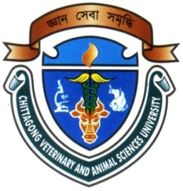
DAIRY COWS.

A Report
By

(SABUJ KANTI NATH)
Roll No: 2008/58, Reg. No: 400
Internship ID: D-39, Session : 2007-2008

Submitted in partial of the requirement for the fulfillment of the degree of Doctor of Veterinary Medicine (DVM)

Approved as to style and content by

(MD. EMRAN HOSSAIN)
Associate Professor
Department of Animal Science & Nutrition

Chittagong Veterinary and Animal Sciences University

Khulshi, Chittagong-4202
INFLUENCE OF DIETARY ENERGY AND PROTEIN INTAKE ON YIELD AND COMPOSITION OF MILK IN CROSSBRED
DAIRY COWS.

INDEX

Sl. No | Contents | Page No
1. | Abstract | 1
2. | Introduction | 2-3
3. | Materials And Methods | 4-6
4. | Results And Discussion | 7-11
5. | Conclusion | 12
6. | References | 13-15

