**CHAPTER 1: INTRODUCTION**

Bangladesh is considered as the most densely populated country in the world. Most of its population lives in rural area and their per capita income is very low. With continuous growing of its population, the demand for food particularly animal source food is increasing rapidly. Rearing livestock species can be the only way to fulfill this demand. About 36% of total animal protein comes from the livestock products in our everyday life (Hoque and Samad 1996). Moreover, livestock plays a vital role to national GDP through producing organic manure, supplying fuel, leather, horns, hoofs, generating cash income and earning foreign remittance. There are about 25.7 million cattle and 14.8 million goats in our country (DLS, 2014-2015). Most of the animals are weak, emaciated and non satisfactory productive performance due to mainly malnutrition and diseases. Veterinary hospital is an ideal and reliable source of information about animal diseases and their solution. People from the neighboring areas bring their sick animals to the Veterinary hospital every day. Analysis of the case record gives a comprehensive idea about different diseases at local areas of different animals . Some reports on clinical prevalence of different diseases of cattles and goats from Bangladesh Agricultural University Veterinary Clinic (Rahman *et al*., 1972; Hossain *et al*., 1986; Das and Hashim, 1996; Samad, 2001; Samad *et al*., 2002), Haluaghat Upazila Veterinary Hospital, Mymensingh (Sarker *et al*., 1999) and Dairy Cooperatives in Pabna district (Pharo, 1987), Baghabari Milking zone of Bangladesh (Sarker *et al*., 2013), Ulipur Upazila Veterinary Hospital, Kurigram (Kabir *et al*., 2010), Khagrachari Sadar Veterinary Hospital, Khagrachari (Ali *et al*., 2011), Upazilla Veterinary Hospital, Mohammadpur, Magura (Karim *et al*., 2014), Chandanaish Upazila of Chittagong district, Bangladesh (Pallab *et al*., 2012) and Patuakhali Science and Technology University Veterinary Clinic (Rahman *et al*., 2012) are available. Badruzzaman *et al*.,(2015) recorded 4.74% FMD, 8.11% Myiasis, 12.24% Acidosis,1.30% Mastitis,10.44% Fasciolosis , Kabir *et al.,* (2010) reported 1.14% mastitis, 20.8% myiasis in total surgical cases, Karim *et al*.,(2014) reported 2.5% FMD, 0.7% papillomatosis in cattle, 1.1% and 1.6% Mastitis diagnosed in cows and does ,5.3% cases of PPR in goats and Sarkar *et* *al*., (2013) also reported 7.02% FMD. 8.11% Myiasis and 3.04% Papillomatosis in their study area.

Although some study were done in cattles and goats in different areas of Bangladesh but similar types of study are very limited in Debidwar upazila of Comilla district of Bangladesh. So it is very important to make a study regarding prevalence of different diseases of cattles and goats in this area and it will be very helpful for control of some diseases and also very helpful in further surveillance study of different diseases in this area.

Therefore the main objectives of this study were to determine clinical prevalence of diseases and disorders in cattle and goats at the Upazilla Veterinary Hospital, Debidwar, Comilla.

**CHAPTER 2: MATERIALS AND METHODS**

**2.1 Place and duration of the study**

This clinical study was undertaken at the Upazilla Veterinary Hospital, Debidwar, Comilla to determine the prevalence of clinical diseases and disorders in cattle and goat during the two months study period (from 01.03.17 to 06.04.17 and from 05.07.17 to 03.08.17).

**2.2 Selection of the Cases**

All diseased cattles and goats were brought for treatment to the Veterinary Hospital and firstly the entry of them into the registered book and collected the details information of the patients by a questionnaire from the owner. Then categorized the patients wheather it was medicinal, surgical or reproductive case on the basis of history and owners complaint of the animals and then go for the clinical examination.

**2.3 Clinical Examination**

Clinical examination was based on distant and close inspection of the patients. Distant inspection includes Physical condition, behaviour, posture, gait, superficial skin wound, salivation, nasal discharge, distension of the abdomen, locomotive disturbance etc. Then go for the close inspection. It includes examination of different parts and system of the body of each of the sick animals by using procedure of palpation, percussion, auscultation, needle puncture etc. Then the temperature, pulse, and respiratory rate from each of these sick animals were recorded.

**2.4 Diagnosis of the Cases**

Diagnosis was done on the basis of owner’s complaint, clinical history, clinical signs and symptoms and consult with veterinary surgeon/ upazilla livestock officer and sometimes microscopic examination were done specially for fecal samples to identify the actual causes where necessary ( Samad *et al*.,1988). Coproscopy was done by the direct smear method. Firstly took small amount of feces on microscopic slide. Then Add a drop of liquid to the feces and mix thoroughly. Then add a cover slip above the slide and finally examine the slide using the 10X objective, and then go over it with the 40X objective.

**2.5 Data Analysis**

During the study period , registered all data of cattles and goats that were brought to the hospital and then data were organized in the Microsoft® Excel spreadsheet and percentages of disease conditions prevalent in different diseases were calculated.

**Different diseases diagnosed on the basis of important clinical signs:**

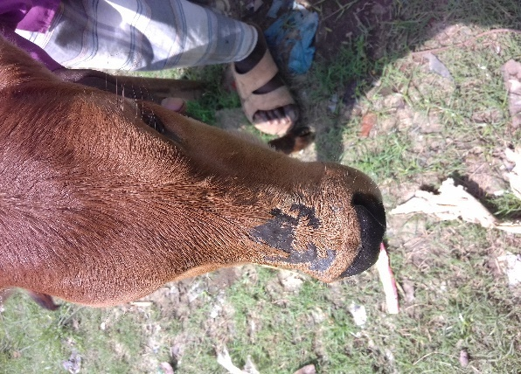 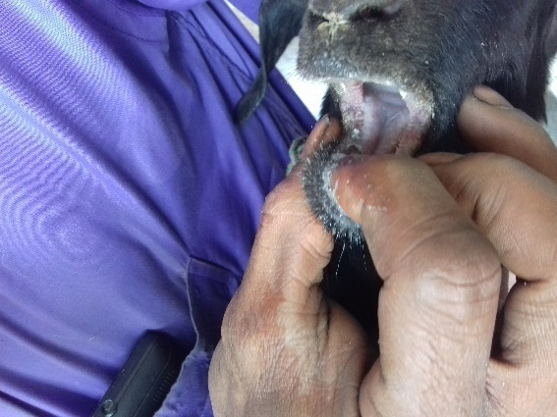

**Figure 1: Dermatitis in Cattle (Alopecia in head region)**

**Figure 2: PPR in Goat(Stomatitis) (Alopecia)**

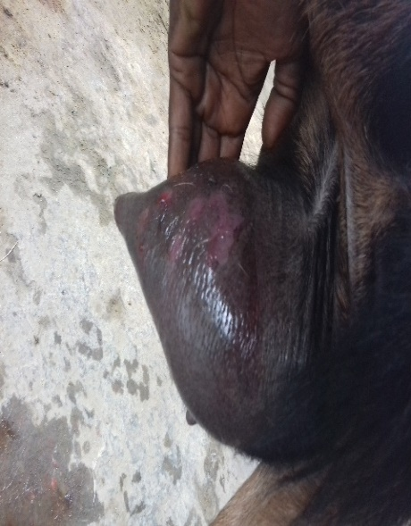 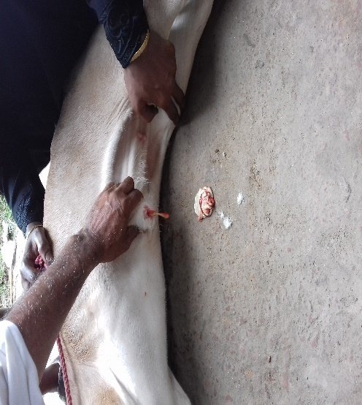

**Figure 4:Navel Abscess in Calf (Caseous Pus found)**

**Figure 3:Mastitis in Goat(Gangrenous )**

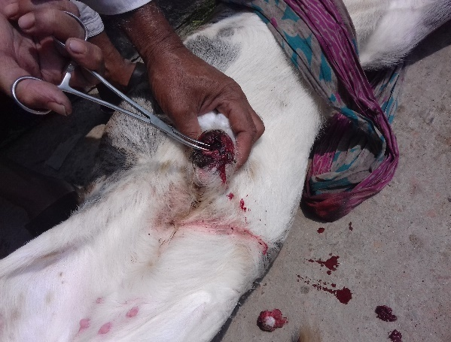 

**Figure 5: Myiasis in calf (umbilical region)**

**Figure 6: FMD in Cattle( Frothy Salivation)**

**CHAPTER 3: RESULTS**

The clinical study was performed in the Upazilla Veterinary Hospital, Debidwar, Comilla to determine the clinical prevalence of different diseases in cattles and goats during the 2 months study period (from 01.03.17 to 06.04.17 and from 05.07.17 to 03.08.17). During the study period, a total of 102 cases were recorded where 35 cases (34.31%) and 67 cases(65.69%) were found in cattles and goats respectively. Among 102 cases, 68.63% cases were medicinal , 31.37% cases were surgical and no reproductive cases were found in hospital during the study period.

**Graph 1: Overall prevalence of different diseases and disorders of cattles and goats are shown in Graph 1(n=102)**

**Graph 2: Prevalence of different diseases according to categories of diseases (medicinal and surgical) of cattles and goats are shown below in Graph 2(n=102)**

**Graph 3: Prevalence of different diseases according to sex are shown below in Graph 3(n=102)**

**Table-1: Clinical prevalence of diseases and disorders of cattles at upazilla veterinary hospital, Debidwar, Comilla**

|  |  |  |  |
| --- | --- | --- | --- |
| **SL NO.** | **Diseases** | **Number of affected cattles** | **Percentage (%)** |
| 1 | FMD | 5 | 14.29 |
| 2 | Dermatitis | 6 | 17.14 |
| 3 | Mastitis | 3 | 8.57 |
| 4 | Fasciolosis | 3 | 8.57 |
| 5 | Paramphistomiasis | 1 | 2.86 |
| 6 | Keratoconjunctivitis | 3 | 8.57 |
| 7 | Papillomatosis | 2 | 5.71 |
| 8 | Abscess | 3 | 8.57 |
| 9 | Calf scour | 3 | 8.57 |
| 10 | Myiasis | 2 | 5.71 |
| 11 | Acidosis | 1 | 2.86 |
| 12 | Castration | 1 | 2.86 |
| 13 | Wound | 2 | 5.71 |
| **Total** |  | **35** |  |

**Table-2: Clinical prevalence of diseases and disorders of cattles according to sex at upazilla veterinary hospital, Debidwar ,Comilla.**

|  |  |  |  |  |  |
| --- | --- | --- | --- | --- | --- |
| **SL NO.** | **Diseases** | **Number of male affected** | **Percentage(%)** | **Number of female affected** | **Percentage(%)** |
| 1 | FMD | 3 | 8.57 | 2 | 5.71 |
| 2 | Dermatitis | 3 | 8.57 | 3 | 8.57 |
| 3 | Mastitis |  |  | 3 | 8.57 |
| 4 | Fasciolosis | 2 | 5.71 | 1 | 2.86 |
| 5 | Paramphistomiasis | 1 | 2.86 |  |  |
| 6 | Keratoconjunctivitis | 2 | 5.71 | 1 | 2.86 |
| 7 | Papillomatosis | 1 | 2.86 | 1 | 2.86 |
| 8 | Abscess | 1 | 2.86 | 2 | 5.71 |
| 9 | Calf scour | 3 | 8.57 |  |  |
| 10 | Myiasis |  |  | 2 | 5.71 |
| 11 | Acidosis | 1 | 2.86 |  |  |
| 12 | Castration | 1 | 2.86 |  |  |
| 13 | Wound | 1 | 2.86 | 1 | 2.86 |
| **Total** |  | **19** |  | **16** |  |

**Table-3: Clinical prevalence of diseases and disorders of cattle according to age at Upazilla Veterinary Hospital, Debidwar, Comilla.**

|  |  |  |  |  |  |
| --- | --- | --- | --- | --- | --- |
| **SL NO.** | **Diseases** | **Number of affected(<2 years )** | **Percentage (%)** | **Number of affected(≥2 years)** | **Percentage (%)** |
| 1 | FMD | 2 | 5.71 | 3 | 8.57 |
| 2 | Dermatitis | 2 | 8.57 | 4 | 11.43 |
| 3 | Mastitis |  |  | 3 | 8.57 |
| 4 | Fasciolosis | 2 | 5.71 | 1 | 2.86 |
| 5 | Paramphistomiasis | 1 | 2.86 |  |  |
| 6 | Keratoconjunctivitis | 2 | 5.71 | 1 | 2.86 |
| 7 | Papillomatosis |  |  | 2 | 5.71 |
| 8 | Abscess | 1 | 2.86 | 2 | 5.71 |
| 9 | Calf scour | 3 | 8.57 |  |  |
| 10 | Myiasis | 1 | 2.86 | 1 | 2.86 |
| 11 | Acidosis |  |  | 1 | 2.86 |
| 12 | Castration | 1 | 2.86 |  |  |
| 13 | Wound | 1 | 2.86 | 1 | 2.86 |
| **Total** |  | **16** |  | **19** |  |

**Table 4: Clinical prevalence of diseases and disorders in goats at the Upazilla Veterinary Hospital, Debidwar, Comilla.**

|  |  |  |  |
| --- | --- | --- | --- |
| **SL NO.** | **Diseases** | **Number of affected animals** | **Percentage(%)** |
| 1 | PPR | 26 | 38.81 |
| 2 | Castration | 18 | 26.87 |
| 3 | Mastitis | 2 | 2.99 |
| 4 | Fasciolosis | 1 | 1.50 |
| 5 | Paramphistomiasis | 1 | 1.50 |
| 6 | Keratoconjunctivitis | 1 | 1.50 |
| 7 | Dog bite | 7 | 10.45 |
| 8 | Abscess | 2 | 2.99 |
| 9 | wound | 1 | 1.50 |
| 10 | Myiasis | 3 | 4.48 |
| 11 | Acidosis | 5 | 7.47 |
| **Total** |  | **67** |  |

**Table 5: Clinical prevalence of diseases and disorders of goat according to sex at Upazilla Veterinary Hospital, Debidwar, Comilla.**

|  |  |  |  |  |  |
| --- | --- | --- | --- | --- | --- |
| **SL NO.** | **Diseases** | **Number of male affected** | **Percentage**  **(%)** | **Number of female affected** | **Percentage**  **(%)** |
| 1 | PPR | 15 | 22.39 | 11 | 16.42 |
| 2 | Castration | 18 | 26.87 |  |  |
| 3 | Mastitis |  |  | 2 | 2.99 |
| 4 | Fasciolosis | 1 | 1.50 |  |  |
| 5 | Paramphistomiasis |  |  | 1 | 1.50 |
| 6 | Keratoconjunctivitis | 1 | 1.50 |  |  |
| 7 | Dog bite | 4 | 5.97 | 3 | 4.48 |
| 8 | Abscess | 2 | 2.99 |  |  |
| 9 | wound | 1 | 1.50 |  |  |
| 10 | Myiasis | 2 | 2.99 | 1 | 1.50 |
| 11 | Acidosis | 2 | 2.99 | 3 | 4.48 |
| **Total** |  | **46** |  | **21** |  |

**Table 6: Clinical prevalence of diseases and disorders of goat according to age at Upazilla Veterinary Hospital, Debidwar, Comilla.**

|  |  |  |  |  |  |
| --- | --- | --- | --- | --- | --- |
| **SL NO.** | **Diseases** | **Number of affected**(<2 **years )** | **Percentage**  **(%)** | **Number of affected**(≥2 **years)** | **Percentage**  **(%)** |
| 1 | PPR | 18 | 26.87 | 8 | 11.94 |
| 2 | Castration | 18 | 26.87 |  |  |
| 3 | Mastitis |  |  | 2 | 2.99 |
| 4 | Fasciolosis |  |  | 1 | 1.50 |
| 5 | Paramphistomiasis | 1 | 1.50 |  |  |
| 6 | Keratoconjunctivitis | 1 | 1.50 |  |  |
| 7 | Dog bite | 4 | 5.97 | 3 | 4.48 |
| 8 | Abscess | 2 | 2.99 |  |  |
| 9 | wound | 1 | 1.50 |  |  |
| 10 | Myiasis | 2 | 2.99 | 1 | 1.50 |
| 11 | Acidosis | 4 | 5.97 | 1 | 1.50 |
| **Total** |  | **51** |  | **16** |  |

**CHAPTER 4:DISCUSSION**

**Foot and Mouth Disease:**

FMD was recorded 14.29% in cattle shown in Table 1 and also observed 5.71% in <2 years, 8.57% in ≥2 years, 8.57% in male and 5.71% in female cattle during study period (Table 2 & 3). Sarker *et al*., (2013) reported FMD 7.02% which is in support of recorded study. Badruzzaman *et al*.,(2015) also recorded prevalence of FMD 4.74%, which is lower than performed study.

**Mastitis**

Mastitis is an economically important disease of milch animal, was diagnosed on the basis of history and physical abnormalities of udder (Radostits, *et al*., 2007). Clinical mastitis was recorded 8.57% in cattle shown in (Table 1) and 2.99% in goats shown in (Table 4) during the period of study. It was also recorded 8.57% in ≥2 years of age of cattle shown in (Table 3) and 2.99% in ≥2 years of age of goat shown in (Table 6). Kabir *et al.,* (2010) reported clinical mastitis 1.14%, which is lower than recorded study. Karim *et al.,* (2014) also reported prevalence of mastitis in cows as 1.1%.

**Myiasis**

Myiasis or maggot infestation was recorded 5.71% in cattle (Table1) and 4.48% in goat(Table 4). It was also recorded 2.86% in calf and also 2.86% in ≥2 years cattle and 5.71% in female cattle (Table 2&3).It was also recorded 2.99% in male goats,1.50% in female goats(Table 5 &6). Karim *et al*., (2014) reported myiasis 20.8% in total surgical cases. It has also been reported that myiasis was recorded 8.11% by Badruzzaman *et al*., (2015), which is higher than recorded data.

**Acidosis**

Acidosis was recorded 2.86% in male adult cattle (Table 1,2&3) and 7.47% in goats(Table 4). In goat, it was also recorded 5.97% in <2 years goat, 1.50% in ≥2 years goat, 2.99% in male and 4.48% in female goats(Table 5&6). Badruzzaman *et al.,* (2015) reported ruminal acidosis 12.24%, which is higher than recorded study.

**PPR**

This study recorded 38.81% cases of PPR in goats (Table 4).It was also recorded 22.39% in male,16.42% in female,26.87% in <2 years and 11.94% in ≥2 years of goats. Rahman *et al*., (2012) reported 5.2% PPR cases in goats which is much lower than my recorded study.

**Papillomatosis**

This study recorded 5.71% cases of papillomatosis in cattle (Table 1). It was also recorded 2.86% in male,2.86% in female and all of the cases were found in adult cattles. Nooruddin and Dey (1990), Samad (2001) and Rahman *et al*., (2012) reported 0.7%, 0.58% and 0.19% prevalence of papillomatosis in cattle from Bangladesh, respectively which are much lower than my recorded study. However, Nooruddin *et al*., (1986) reported 3.04% prevalence of warts under rural cattle.

**Keratoconjunctivitis**

Keratoconjunctivitis was recorded 8.57% in cattle (Table 1) and 1.50% in <2 years of age and also in male goats(Table 4). It was also recorded 5.71% in male ,2.86% in female cattles. Nooruddin and Dey Rahman *et al*., (2012) reported 1.9% and 9.9% cases of Keratoconjunctivitis in cattle and goats, respectively.

**Abscess**

Abscess was recorded 8.57% in cattle and 2.99% in goats (Table 1,4,5&6).It was also recorded 2.86% in male and <2 years and 5.71% in female and ≥2 years of cattles (Table 2&3). Rahman *et al*., (2012) reported 1.1% cattle and 1.3% goats affected with abscess at Patuakhali Science and Technology University Veterinary Clinic, Babugonj, Barisal and Hossain *et al*., (1986) who recorded 1.2% cases of abscess in cattle which are lower than my recorded study.

**Fasciolosis**

Fasciolosis was recorded 8.57% in cattles(Table 1) and 1.50% in male goat(Table 4,5&6).It was also recorded 5.71% in male and <2 years and 2.86% in female ≥2 years of cattles (Table 2&3). Howlader *et al*., (1990) reported 21% sub clinical prevalence of Fascioliasis in cattle which is higher than my study.

**LIMITATIONS**

The number of clinical cases of cattles and goats was small (102 cases) and duration of study period was short (2 months). Lack of diagnostic tools, so the diagnosis was only based on clinical history and clinical symptoms.

**CONCLUSION**

The present study was undertaken at the Upazilla Veterinary Hospital, Debidwar, Comilla to determine the general clinical prevalence of different diseases and disorders in cattle and goats during the two months study period (from 01.03.17 to 06.04.17 and from 05.07.17 to 03.08.17). During the study period total 102 cases were found in this area. This study was conducted to detect the present situation of occurrence of clinical diseases and disorders in the study area. From the study, it was observed that FMD (14.29%), Dermatitis (17.14%) and Mastitis (8.57%) are more prevalent in cattles and PPR (38.81%) and castration(26.87%) are more prevalent in goats. It was also observed that medicinal cases (68.63%) are more common than surgical cases(31.37%) and males(63.73%) are more susceptible than females(36.27%) in different diseases of cattles and goats. So proper planning and program should be undertaken to prevent and control diseases and disorders of cattle and goat in the study area.

**REFERENCES**

Badruzzaman ATM, Siddiqui MSI, Faruk MO, Lucky NS, Zinnah MA, Hossain FMA and

Rahman MM(2015).Prevalence of infectious and non infectious diseases in

cattle population in chittagong districtof Bangladesh.*International Journal of*

*Biological Research*,3(1):1-4

Das BC and Hashim MA (1996). Studies on surgical affections in calves. *Bangladesh Veterinary*

*Journal* 30: 53-57.

Hossain MA, Shaidullah M and Ali MA (1986). A report on surgical diseases and reproductive

Disorders recorded at the Veterinary Hospital of Bangladesh Agricultural

University, Mymensingh.*Bangladesh Veterinary Journal* 20: 1-5.

Hoque MS and Samad MA (1996). Prevalence of clinical diseases in dairy cross-bred cows and

calves inthe urban areas in Dhaka. *Bangladesh Veterinary Journal* 30: 118-129.

Howlader MMR, Chowdhury SMZH, Taimur MJFA and Johan S (1990). Fluke infestations of

cattle in some selected villages of Bangladesh . *Bangladesh Veterinarian* 7: 45-47.

Kabir MH, Reza MA, Razi KMA, Parvez MM, Bag MAS and Mahfuz SU (2010). A report on

Clinical prevalence of diseases and disorders in cattle and goat at the Upazilla

Veterinary Hospital,Ulipur, Kurigram. *International Journal of Biological Researc*h

2: 17-23.

Nooruddin M, Sarker AJ, Baki MA, Ali MR, Dey AS and Hoque MF (1986). Prevalence of

diseases of external organs of cattle. *Bangladesh Veterinary Journal* 20: 11-16.

Pallab MS, Ullah SM, Uddin MM and Miazi OF (2012). A cross sectional study of several

diseases in cattle at Chandanaish Upazilla of Chittagong district. *Scientific Journal*

*of Veterinary Advances* 1: 28-32.

Pharo HJ (1987). Analysis of clinical case records from dairy co-operatives in Bangladesh.

*Tropical Animal Health and Production* 19: 136-142.

Prasad J, Uoshi SV and Rekib A (1980). Studies on the clinico-pathics of grazing animals in

tropics –corneal opacity syndrome. *Indian Veterinary Journal* 57: 310-315.

Rahman MA, Islam MA, Rahman MA, Talukder AK, Parvin MS, and Islam MT (2012). Clinical

diseases of ruminants recorded at the Patuakhali Science and Technology

UniversityVeterinary Clinic. *Bangladesh Journal of Veterinary Medici*

10(1&2): 63-73.

Rahman MM, Ali M and Hashem A (1999). Livestock disease problems in a selected area of

Sherpur district. *Bangladesh Journal of Training and Development* 12: 205-210.

Rosenberger G (1979). *Clinical Examination of Cattle*. 2nd edn., Verlag Poul Parey, Germany.

Samad MA (2001). Observations of clinical diseases in ruminants at the Bangladesh Agricultural

University Veterinary Clinic. *Bangladesh Veterinary Journal* 35: 93-120.

Samad MA, Islam MA and Hossain A (2002). Patterns of occurrence of calf diseases in the

district of Mymensingh in Bangladesh. *Bangladesh Veterinary Journal* 36: 01-05.

**ACKNOWLEDGEMENT**

The author wishes to acknowledge the immeasurable grace and profound kindness of Almighty “GOD” the supreme authority and supreme ruler of universe, who empowers the author to complete the work successfully.

The author great pleasure to express his deepest sense of gratitude and indebtedness to his supervisor Dr. Bhajan Chandra Das, Professor, department of medicine and surgery, Chittagong Veterinary and Animal Sciences University for his scholastic guidance, valuable suggestions, constant inspiration and encouragement throughout the entire period of my study.

The author gratefully admits the help of Dr. A F M Rakibul Hasan Bhuiyan, Upazilla Livestock Officer and Dr. Karna Chandra Mallik, Veterinary surgeon, Upazilla Veterinary Hospital, Debidwar, Comilla for their cordial supervision, scholastic guidance, and valuable suggestion during the entire period of the study and also would like to express his special gratitude to his family and friends for their immeasurable support.

**BIOGRAPHY**

I am Sharif Ahamed, son of Hafez Ahammed and Sahida Begum. I passed Secondary School Certificate examination in 2009 (G.P.A-5.00) followed by Higher Secondary Certificate examination in 2011 (G.PA-5.00). Now I am an intern veterinarian under the Faculty of Veterinary Medicine in Chittagong Veterinary and Animal Sciences University. In the future I would like to work in the field of veterinary Epidemiology and Research.