Investigation of Gastrointestinal Parasites of Wild Mammals at Safari Park in Gazipur
A Clinical Report Submitted By
Sabrina Ferdous
Intern ID: A-09
Roll No: 12/09
Registration No: 00729
Approved as to style and content by

…………………......
Signature of Author
Sabrina Ferdous
Intern ID: A-09
Roll No: 12/09
Reg. No: 00729
Session: 2011-2012
…………………………..
Signature of Supervisor
Dr. Md. Mizanur Rahman
Professor
Department of Medicine and Surgery
Chittagong Veterinary and Animal Sciences University, Khulshi, Chittagong-4225

Faculty of Veterinary Medicine Chittagong Veterinary and Animal Sciences University, Khulshi, Chittagong-4225 November, 2017

Table of Contents

Chapter | Topics | Page No
 | CONTENTS | I
 | LIST OF TABLES | Ii
 | LIST OF FIGURES | Ii
 | LIST OF GRAPHS | Iii
 | LIST OF ABBREVIATIONS | Iii
 | ABSTRACT | Iv
I | INTRODUCTION | 01-02
II | MATERIALS AND METHODS | 03-07
- STUDY AREA
- ANIMALS’ SAMPLES
- STUDY PERIOD
- SAMPLE COLLECTION, PRESERVATION AND TRANSPORTATION/SHIPMENT
- METHODS
  - SIMPLE TEST TUBE FLOTATION METHOD
  - SEDIMENTATION METHOD
  - MCMASTER TECHNIQUE
  - MEASUREMENT OF PARASITES’ EGGS
III | RESULT | 08-14
IV | DISCUSSION | 15-16
V | LIMITATION | 17
VI | CONCLUSION AND RECOMMENDATION | 18
 | REFERENCES | 19-20
 | ACKNOWLEDGEMENT | 21
 | BIOGRAPHY | 22

LIST OF TABLE

Table No | Contents | Page No
 | List of animal species with their Scientific Name and no of samples collected | 04
 | Prevalence of parasitic infection in Carnivores and Herbivores | 08
 | Prevalence of single and multiple parasitic infection in wild mammals | 09
 | Prevalence of types of parasites in wild mammals | 10
 | Distributions of the species studied and parasites observed in fecal samples from wild mammals at Gazipur Safari Park | 11
 | Eggs or oocysts of different gastrointestinal parasites found in wild mammals’ fecal sample along with measurement and pictorial references | 12-14

LIST OF FIGURES

Figure No | Contents | Page No
 | Map showing The Area of Bangabandhu Sheikh Mujib Safari Park, Gazipur | 03
 | Different Wild Mammals of Gazipur Safari Park. | 04
 | Collection of fecal sample from field. | 05
 | Fresh fecal sample of Gaur (Bos gaurus). | 05
 | McMaster slide with samples examined. | 06
 | Measurement of egg length and width diameter with ocular micrometer. | 07

LIST OF GRAPHS

Graph No | Contents | Page No
 | Graphical presentation of Parasitic Infection In Carnivores and herbivores | 08
 | Graphical presentation of single and multiple parasitic infection in wild mammals | 09
 | Graphical presentation of types of parasites in wild mammals | 10

LIST OF ABBREVIATIONS

Abbreviation and Symbol | Elaboration
% | Percent.
et al. | And other co-authors
CVASU | Chittagong Veterinary and Animal Sciences University
Lab. | Laboratory

Abstract
The aim of this study was to investigate the load and variety of gastro-intestinal parasites among free-living as well as captive wild mammals housed in Safari park of Gazipur. A total of 26 fecal samples were collected from wild mammals from August to September, 2017 and were analyzed by sedimentation and flotation methods. The number of eggs per gram of feces was determined by using the MC master Technique. In 76.66% of the cases the fecal samples were positive for parasite eggs, oocysts and/or cysts. Toxocara cati, Toxascaris leonina, Diphyllobothrium lattum, and Isospora spp oocyst were frequently identified in fecal samples of Lions and Tigers. In Blackbuck, Bleezbuck, and Wildebeest Stongyloides spp eggs were found. Strongylus spp, Trichostongylus spp eggs were found in Giraffe, Elephant, Horse, Kangaroo, and in Zebra. Apart from round worms’ eggs, mainly Fasciola spp and Paramphistomum spp were found in most herbivorous animals’ samples. This study provided evidence that despite the small number of samples, the diversity of parasites found was significant and noteworthy. Loads of nematodal and round worm infections were higher than cestodal and coccidial infections. Further comprehensive epidemiological investigation is necessary to better understand the exact parasitic load in free-living as well as associated risk factors of parasitism in wild animals in safari park environment.
Keywords: Gastro-intestinal, parasites, eggs, wild mammals, safari park

Chapter I: Introduction

Safari park is park-like zoos in which wild animals are allowed to roam free in an environment designed to resemble their natural habitat and are observed by visitors riding through the park in cars or buses. Besides the recreational purposes animals are also kept for educational and research purposes (Varadharajan and Pythal, 1999; Adeniyi & Morenikeji 2015). Bangabandhu Sheikh Mujib Safari Park, one of the major attractions this harbours is the country’s biggest safari park. The park was established in 2011 and has been quite an attraction to the public. This park is occupied with 3690 acres of land and beautifully decorated with trees of 63 types and 220 types of animal species that roam free.
The existence of wild animals in Bangladesh is greatly threatened by different factors such as habitat loss due to deforestation, unavailability of adequate foods in their former habitat, human-animal conflicts and another major threat is wildlife diseases, particularly diseases arising from gastrointestinal parasites. Though animals might have a natural resistance against parasitic infections as they live in a balanced system with their parasites, parasitic infections may be a major problem. Factors like sudden environmental change or sudden change in living condition may obsess the ecology of wild animals which may aggravate the sensitivity for parasitic infections (Goossensa et al 2005; Singh et al 2006; Thawait et al 2014; Adeniyi & Morenikeji 2015).
Natural habitats provide large area to wild animals to roam and that abate the exposure to the parasitic infection. Due to limited or low exposure of parasites there developed a low genetic resistance against parasitic infections in wild animals. When groups of these wild animals are brought from wild to captivity and kept in confined spaces in Safari park, there developed a stressful, unfavorable and unnatural environment which may cause drastic increase of parasitic infection and impose serious threats along with sudden local fatalities or deaths (Muoria et al. 2005, Van Wyk and Boomker, 2011, Rahman et al 2014 ). In safari park or zoos the occurrence of parasitic infection in animals varies according to the type of husbandry or management, parasite prophylaxis and type of parasitic treatment provided. If deworming is effectuated in a regular basis, wild animals in captivity usually do not show fatal signs of parasitism (Parsani et al. 2001, Rahman et al 2014).
Parasitic infection seems inseparable to the animals and thus it becomes one of the major challenges in wild animal in captivity. Parasites play key role to the life of wild animals with effects that are ranged from negative influences on wild population to host survival, reproduction and reflex of host behavior to combat parasites. Even though it seems that wildlife have adapted to the existence of parasites, they have not adapted completely to the hostile effects of parasitism (Singh et al 2006; Emikpe et al 2007; Bliss 2009).Parasitic infections may abate competitive fitness (Brassard et al. 1982; Scott 1988), influence population cycles (Hudson et al. 1998) and regulate host population abundance (Anderson&May 1978). Often, parasitic infections tend to be over dispersed, to where many individual hosts have low parasite intensities and few individuals have high intensities of parasites (Scott 1988; MüllerGraf 1995; Junkeretal 2008).Thus many animals may maintain low levels of infection whereas few actually succumb to disease. Furthermore, some wild canids have evolved to cope with a certain level of chronic parasitic infection that has little or through these proximate mechanisms; parasites can potentially regulate host populations (Gregory 2000, Thawait et al 2014). Infection routes are directly related to causal agents,which means that knowledge of the disease transmission chain may provide an opportunity to ascertain how these agents reach new susceptible hosts. Thus, in relation to epidemiological factors, wild animals may have an extremely important role in the transmission of zoonoses, both in captivity and in the wild (Marvulo, 2007). The emergence of infectious diseases with zoonotic potential has dominated research on wildlife pathogens over recent years (McCallum; Dobson, 1995; Holmes, 1996; Daszak et al.,2000; Rhyan; Spraker, 2010). As a result, not only have studies on the biodiversity and ecology of parasites been neglected, but also efforts to control them have been impaired. The research focus has been directed toward humans and domestic animals. However, there is also a need to obtain greater understanding of how these emerging pathogens interact with sets of organisms living together in wild ecosystems (Thompson et al., 2010).

Specific objectives:
There appears to be no report on the prevalence of gastrointestinal parasites in wild mammals of Bangabandhu Sheikh Mujib safari park. Keeping that in view the present work was undertaken to study the prevalence of gastrointestinal parasites in wild mammals of the safari park, Gazipur.

Chapter II: Methods and Materials
- Study area:
The study was conducted on wild mammals of Bangabandhu Sheikh Mujib safari park in Gazipur. Morphological identification of parasitic eggs and oocysts were examined in the laboratory of the Chittagong Veterinary and Animal Sciences University, Chittagong, Bangladesh.

FIG-1: Map showing the area of Bangabandhu Sheikh Mujib Safari Park, Gazipur.

- Study period
This investigation was carried out from of August to October, 2017.

- Animal Samples
A total of 30 freshly voided fecal samples were collected from wild mammals of the safari park that as listed below:-
Table 1: List of animal species with their Scientific Name and no of samples collected
Name of the animals | Scientific names | Total sample collected
Tiger | Panthera tigris | 5
Lion | Panthera leo | 2
Bear | Ursus thibetanus | 2
Elephant | Elephas maximus | 5
Pony | Equus ferus caballus | 2
Zebra | Equus zebra | 1
Giraffe | Giraffa camelopardalis | 2
Hippopotamus | Hippopotamus amphibious | 1
Blackbuck | Antilope cervicapra | 1
Blezbuck | Damaliscus pygargus phillipsi | 1
Nyala | Tragelaphus angasii | 1
Spotted deer | Axis axis | 2
Kangaroo | Macropus rufus | 1
Wildebeest | Connochaetes taurinus | 2
Gaur | Bos gaurus | 2

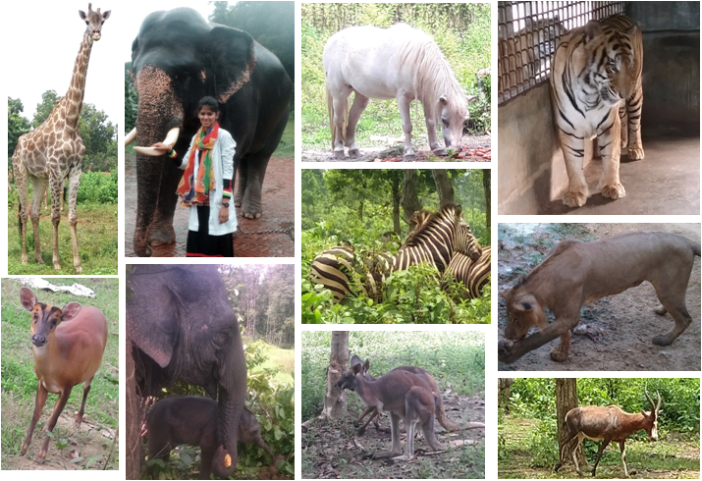
FIG 2: Different Wild Mammals of Gazipur Safari Park
- Sample collection procedure, preservation and transportation/shipment
All samples were collected early in the morning with the help of caretakers/assistants of different animal’s section. Immediately after collection samples were placed in dry, clean and individually labeled plastic sample container and preserved with 10% formalin up to shipment of the samples. Shipment of fecal samples was done with icebox to bring to the Parasitology laboratory of CVASU. All tests were done within 3 weeks from the day of collection.
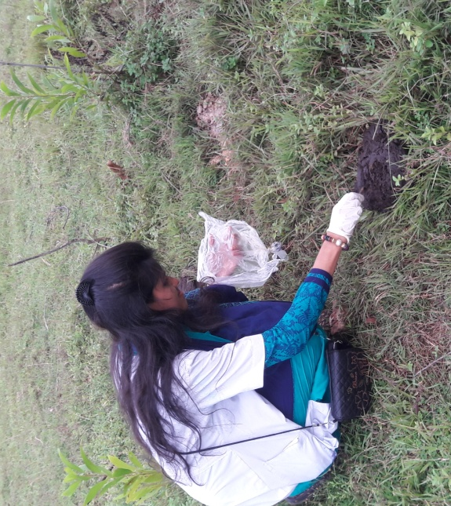
Fig 3: Collection of fecal sample from field
Fig 4: Fresh fecal sample of Gaur (Bos gaurus)

- Methods:
The fecal samples were examined by means of simple sedimentation and flotation methods in saturated salt solution (d = 1.2 g/cm3) and quantitative test by Mc master technique for detecting eggs per gram (EPG) to assess the intensity of different helminthic infections. The level of severity of infection was graded into three categories based on EPG of feces; below 500 (+), from 500 to 1000 (++), and more than 1000 (+++). Measurement of parasites’ eggs was done through ocular micrometry.

- Simple Test tube Flotation Method:
The simple test tube flotation method was useful for the detection of nematode and cestode eggs and coccidial oocysts in the faeces. It was based on the separating of eggs from faecal material and concentrating them by means of a flotation fluid with an appropriate speciﬁc gravity. Approximately 3 g of faeces was thoroughly mixed with 50ml of flotation fluid (saturated salt solution) and resulting fecal suspension was poured through a tea strainer to remove coarse fecal materials. The filtrate was then poured into a test tube and the test tube placed in a test tube-rack to stand for 15 minutes after placing a coverslip on top of the test tube. After 15 minutes, the cover slip was lifted off from the test tube together with the drop of fluid adhering to it, and immediately placed on a clean, dry glass slide and examined under low power (10 x) of the microscope.

- Sedimentation method:
The sedimentation technique is a qualitative method for detecting trematode eggs (Paramphistomum and Fasciola) in the faeces. Most trematode eggs are relatively large and heavy compared to nematode eggs. This technique concentrates them in sediment.
Approximately 3 g of faeces was mixed with 40-50 ml of tap-water. The faecal suspension was filtrated through a tea strainer .The ﬁltered material was poured into a test tube and allowed to stand for 15 minutes. After 15 minutes the supernatant was removed very carefully and transferred a drop of the sediment onto a clean, dry glass slide with a coverslip and examined under low power (10x) of the microscope.

- McMaster technique:
The McMaster counting technique is a quantitative technique to determine the number of eggs present per gram of faeces (e.p.g.). A flotation fluid is used to separate eggs from faecal material in a counting chamber (McMaster) with two compartments.
Approximately 4 g of faeces was mixed thoroughly with 56 ml of flotation fluid. The faecal suspension was filtrated through a tea strainer. A sub-sample was taken with a Pasteur pipette and both sides of the McMaster counting chamber was filled with the sub-sample. The counting chamber was allowed to stand for 5 minutes and examined under a microscope at 10 x 10 magniﬁcation. All eggs and coccidial oocytes were counted within the engraved area of both chambers. The number of eggs per gram of faeces was alculated as follows: EPG = Number of eggs x 100 (where 100 is the dilution factor).

- Ocular Micrometry
Micrometry is the microscopic measurement (length & width) of parasite, parasitic eggs, oocyst, larvae as well as virus, bacteria, spore etc. In ocular micrometry an Ocular micrometer having 05-100 calibrations was used for measuring parasitic eggs and oocyst.
At first an ocular micrometer was placed on eye piece and the calibrated scale was focused. Length and width of the parasites’ egg and oocysts were measured through rotating the eye piece as needed. Calculation was done assuming the distance of 1 ocular mark/unit and with the help of following formulas:-
- Length of egg of parasite/ oocysts/ larva = [X line (No. of calibration) ×2.53] µm
- Width of egg of parasite/ oocysts/ larva = [Y line ( No. of calibration)×2.53]µm

Chapter III: Results of The Study
Prevalence of gastrointestinal parasites in wild mammals:
A total of 30 fecal samples were examined (9 carnivore samples and 21 herbivores samples) and 23 samples were found to be infected with different types of parasites. The overall prevalence of parasitic infection was 7 6.66% among which prevalence of Nematodal, Trematodal Cestodal and Protozoan infection were respectively 90%, 35%, 5%, and 15%. This results indicate that nematodal infections were more common than trematodal, cestodal or protozoan infections in wild mammals.
Among different captive and free-roaming wild mammals, the prevalence of GI parasites was 33.33% in carnivores and 90.4% in herbivores indicating higher prevalence of GI parasites in herbivores than carnivores in the safari park. Among carnivores the highest prevalence of GI parasites was recorded in Lion (100%) followed by Tigers (20%). This study shows that Lions are highly infected (EPG ranged from 7000-100000) and also habour mixed infections of Toxocara spp, Toxascaris spp., Diphyllobothrium spp, and Isospora spp oocysts. On the other hand, Tigers had single infections of Isospora spp, having EPG ranged from 100-200.
Among herbivores, all showed 100% prevalence of GI parasites except Hippopotamus showing no infection. Infected herbivores had single infections of Strongylus spp. and Strongyloides spp as well as single infections of Fasciola spp. were found in captive wild herbivores. EPG varied from 100-800 indicating mild to heavy infection.
Table 1: Prevalence of infection in carnivores and herbivores
Types of animals | No of Samples | Positive case no | Prevalence
Carnivores | 9 | 3 | 33.33%
Herbivores | 21 | 20 | 95%
TOTAL | 30 | 23 | 76.66%

Graph 1: Prevalence of parasitic infection in Herbivores and Carnivores of Safari park

Table 2: Prevalence of single and multiple parasitic infections in wild mammals
Total Positive Samples
Infected with Single parasite |  |  | Infected with Multiple parasites
Name of parasites | Positive sample no | Prevalence | Name of parasites | Positive sample no | Prevalence
Stronglus spp | 9 | 39.13% | Fasciola spp  Stongyloides spp | 4 | 17.39%
Fasciola spp | 2 | 8.6% | Fasciola spp  Stongylus spp | 3 | 13.09%
Isospora spp | 1 | 4.34% | Fasciola spp Paramphistomum spp  Strongylus spp | 2 | 8.6%
 |  |  | Toxocara cati Toxascaris leolina Spirometra spp Isospora spp | 2 | 8.6%
Total | 12 | 52.17% | Total | 11 | 47.82%

GRAPH 2: Prevalence of single and multiple parasitic infections in wild mammals of Safari park

Table 3: Prevalence of types of parasites in wild mammals
Type of parasite | Name of parasites | Number of cases | Prevalence (%)
Nematodes | Toxocara cati  Toxascaris leolina  Strongyloides spp  Strongylus spp  Diphyllobothrium spp | 18 | 90
Trematode | Fasciola spp  Paramphistomum spp  Dicrocoelium spp | 7 | 35
Cestode | Taenia spp | 1 | 5
Protozoan | Isospora spp | 3 | 15

GRAPH 3: Prevalence of different types of parasitic infection in wild mammals of Safari park

Table 4: Distributions of the species studied and parasites observed in fecal samples from wild mammals at Gazipur Safari Park
Name of the animal | Name of parasites | No of positive case | Egg per gm of feces
Carnivores(9 samples)
Tiger( Panthera tigris) | Isospora sp | 1(5) | 100-200
Lion ( Panthera leo) | Toxocara cati  Toxascaris leolina  Diphyllobothrium lattum  Fasciola spp  Isospora spp | 2(2) | 7000-100000
Bear(Ursus thibetanus) | Nil | 0(2) | 0
Herbivores(21 samples)
Pony(Equus ferus caballus) | Stongylus spp  Fasciola spp | 2(2) | 200-300
Elephant(Elephas maximus) | Strongylus spp | 5(5) | 100-300
Zebra (Equus zebra) | Strongyloides spp  Faciola spp | 1(1) | 400
Giraffe( Giraffa camelopardalis) | Strogylus spp | 2(2) | 100-300
Hippopotamus (Hippopotamus amphibious) | Nil | 0(1) | 0
Blackbuck (Antilope cervicapra) | Stongyloides spp  Paramphistomum spp | 1(1) | 100
Blezbuck(Damaliscus pygargus phillipsi ) | Stongyloides spp  Paramphistomum spp | 1(1) | 1000
Nyala (Tragelaphus angasii) | Strongylus app  Faciola spp | 1(1) | 200
Spotted deer (Axis axis) | Faciola spp | 2(2) | 100-200
Kangaroo(Macropus rufus) | Fasciola spp  Strongylus spp | 1(1)
Wildebeest(Connochaetes taurinus) | Strongyloides spp  Taenia spp  Fasciola spp  Dicrocoelium spp | 2(2) | 200-400
Gaur(Bos gaurus) | Fasciola spp  Paramphistomum spp | 2(2) | 200-300
Total |  | 23(30)

Table 6: Eggs or oocysts of different gastrointestinal parasites found in wild mammals’ fecal sample along with measurement and pictorial references:-
Name of the parasite | Picture of parasites’ egg from Internet | Parasites’ egg found in samples examined
Toxocara cati  - Lion | 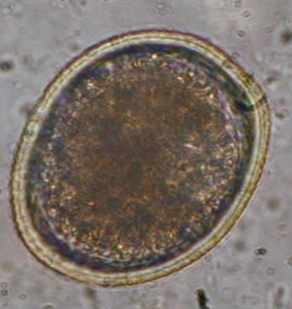 | 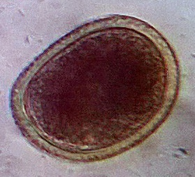  75x90 µm
Toxascaris leolina  - Lion | 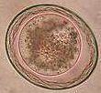 | 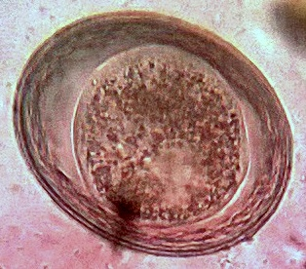  75x85 V µm
Strongylus spp  - Horse  - Giraffe  - Zebra  - Elephant  - Nyala  - Kangaroo |  | 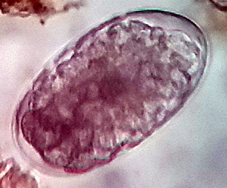  88x45 µm

Name of the parasite | Picture of parasites’ egg from Internet | Parasites’ egg found in samples examined
Strongyloides spp  - Wildebeest  - Blezbuck | 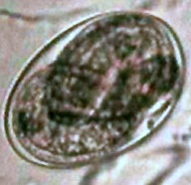 | 75x40 µm
Spirometra spp  - Lion | 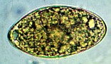 | 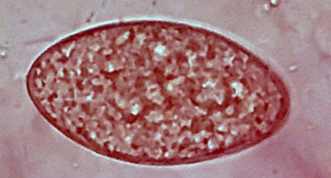  78x37 µm
Taenia spp  - Wildebeest | 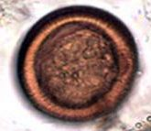 | 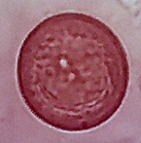  25x20 µm

Name of the parasite | Picture of parasites’ egg from Internet | Parasites’ egg found in samples examined
Fasciola spp  - Nyala  - Gaur  - Spotted deer  - Zebra | 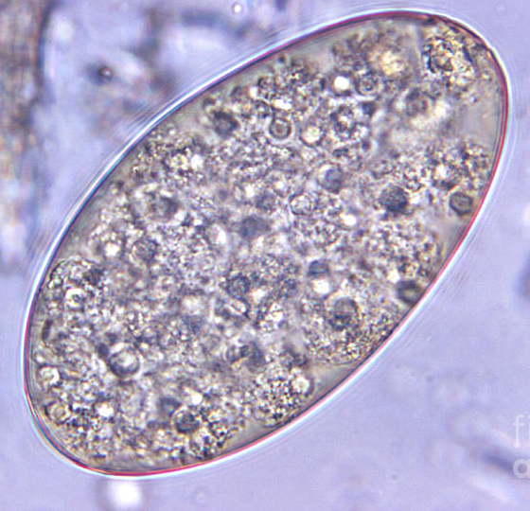 | 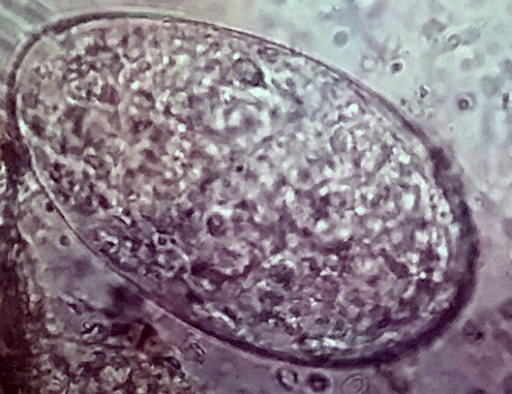  110x76 µm
Paramphistomum spp  - Blezbuck  - Gaur | 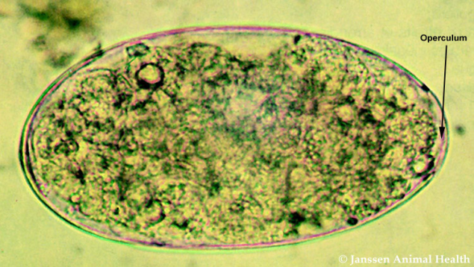 | 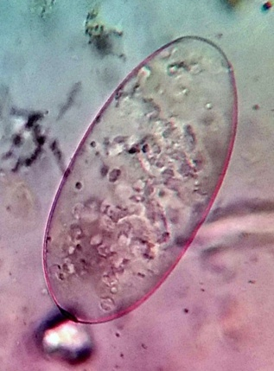  131x 71 µm
Diphyllobotrium spp  - Lion | 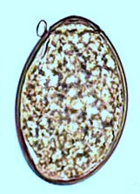 | 55x42 µm

Chapter IV: Discussion
In this study we found 76.66% of the faceal samples infected with parasites which are similar to earlier reports by Opara et al., (2010), Rahman et al (2014) who revealed 76.6% and 76.9% positive cases respectively. This finding is slightly higher than the report of Corden et al., (2008), Luciane et al (2013) having the prevalences 72.5% and 71% respectively. As well, higher prevalence were found by Mutani et al. (2003) and Raja et al (2014) who reported 88.7% and 78.72% postitive samples respectively. On the contrary, the lower prevalence rate than the present study was recorded as 60.7% by Parasani et al., (2001), 56.3%; Lim et al., (2008), 48.1%; Modi et al.(1997), 46.2%; Virendra et al(2014), 42.4%; Reddy et al., (1992) and 40.4%; and Chakraborty and Islam (1996). These variations in prevalence may result from different geographic conditions, captivity conditions, husbandry practices, feeding management and source of feeds for the animals.
The prevalence of helminthic infection (86.95%) was found to be higher than that of protozoan infections (13.04%). The present study differs from the report of Parasani et al. (2001), Opara et al., (2010) and Raja et al (2014) who revealed 68.8%, 82.2% and 52.06% animals positive for helminthic infections and 18.8%, 17.8% and 27.66% for protozoan infections. All studies were conducted in a captive setting and included a variety of animal groups.
The occurrence of high GIT helminthes which comprised more nematodes, agrees with Rossanigo-Gruner(1995) and Virendra et al (2014).The high prevalence of helminths encountered in the survey explained by the existence of favorable climatic conditions which support prolonged survival of infective nematode larvae. (Raja et al 2014)
In this study, overall prevalence of mixed infection was 47.82%. Mixed infection was observed in the 11 animals samples such as Wildebeest, Nyala, Zebra, Lion, Kangaroo Gaur, Balckbuck, and Blezbuck. Prevalence of mixed infection were Fasciola spp and strongyle eggs (18.18%); Strongyle eggs, Paramohistomum spp and Fasciola sp. (18.18%); Fasciola spp and Strongyloides sp. (18.18%); Fasciola spp, Taenia spp and Strongyloides spp (18.18%), Toxocara cati, Toxascaris leolina and Isospora spp (9.09%), Toxocara cati, Toxascaris leolina and Isospora spp (9.09%). This suggests that there is a fairly high rate of transmission of the parasites observed between individuals either because of the gregarious nature or because of suitable environmental conditions. The finding of mixed infection in this study might be due to presence of different aged animals in the same cages, feeding management and improper disposal of feces. (Rahman 2014).

In this present study, Tigers were found to be infected with Coccidial oocysts ( Isospora spp) that has been already reported by Chauhan et al(1973), Muraleedhan et al (1984) and Mahali et al (2006) whereas Lions were severely infected with Toxascaris leolina which has already been reported by Fagiolini et al. (2010) and Gonzalez et al. (2007). Lions were infected with Toxocara cati ,Toxascaris leonina, Spirometra spp, Diphyllobothrium spp. And Isospora spp. which supports the findings of Fagiolini et al. (2010), Luciane et al (2013) , Virendra et al (2014) and Raja et al (2014). According to the report of Raja et al (2014), Spirometra was reported for the first time in captive lions in Bangladesh as to date this parasite has only been reported in wild lions, where it was found to be the most common parasite (Barutzki et al. 1985, Ghoshal et al. 1988, Tang et al. 1988, Muller-Graf 1995). The occurrence of Spirometra in this study might be due to the feeding management and the availability of intermediate hosts in the environment. Two intermediate hosts are required to complete the life cycle of Spirometra sp.; crustaceans are the first intermediate host and snakes, birds and mammals are second intermediate host (Soulsby 1982). The presence of Spirometra sp. in the lions of safari park might be due to ingestion of contaminated beef with infective secondary stage of larvae.
The diameter of egg or cyst of different gastrointestinal parasites found in the present study is almost similar with the findings of Hendrix and Robinson (2006), Christensen (1938) and Soulsby (1982). But sometimes differ from the present study e.g. the diameter of egg of Fasciola sp. (87 x 43.5 µm.) is comparatively lower than that recorded by Soulsby (1982) who measured as 130-150 x 63-90µm. On the other hand, the result of present study revealed that the diameter of cyst of Balantidium coli was same in Deer and Hippopotamus (43.5 x 29.0µm.). But Hendrix and Robinson (2006) indicated the diameter of cyst of Balantidium coli to be 40-60 µm. This variation of size with the previous findings might be due to the method of measurement, strains of the parasite, species of the host and climatic factors.

Chapter V: Limitations

- The period of the study was too short.
- The results that are generated from a small sample size (30) may misinterpret the findings.
- True prevalence of parasitic infection may not be completely estimated as this study did not consider healthy wild mammals.
- Molecular techniques were not applied to identify the species of parasites accurately. Diagnosis of parasites’ egg and oocysts was done on the basis of morphological characteristics and ocular micrometry which were not enough to assure the genus and species of parasites.

Chapter VI: Conclusion and Recommendation
The study provides scientific evidence that gastrointestinal parasitic infections are very common in wild mammals and it’s not only important to the animal health but also significant for their zoonotic potentials. Further detailed epidemiological investigation is needed on the prevalence of gastrointestinal parasites in wild mammals with respect to seasons, age, climate etc. to build up a complete picture of parasitism in wild mammals. Fecal examination should be done on regular basis and the improvement of diagnostic procedures should be of concern. For the proper identification of different parasites, molecular techniques can be adopted along with improvement. As per diagnosis of parasitic infections, effective, desired and group specific parasitic drugs should be administrated. As animal caretakers remain in close contact with the wild mammals, there is possibility of cross transmission of infection through them. On the other hand animals also act as reservoir host which may result in active transmission of zoonotic diseases to zoo keepers as well as to other park visitors.
Proper hygienic measures and better management practices such as supplying fresh and contamination-free foods to animals, regular cleaning and disinfection of animal houses, proper disposal of waste or fecal materials and treating the infected animal separately may reduce the prevalence of parasitic infections in wild mammals of safari park.

References

- Raja, M.M.R.U., A.R. Dey, N. Begum, U.K. Kundu & F.A. Ashad(2014). Coprological prevalence of gastrointestinal parasites in carnivores and small mammals at Dhaka zoo, Bangladesh. Journal of Threatened Taxa 6(3): 5574–5579; http://dx.doi.org/10.11609/JoTT.o3569.5574-9
- Corden, P., G.H. Prados, A. Romero, M.S. Sanchez, M. Pontes, A. Osuna & M.J. Rosales (2008). Intestinal parasitism in the animals of the zoological garden ‘‘Pen˜aEscrita’’ (Almun˜ecar, Spain). Veterinary Parasitology 156: 302–309.
- Opara, M.N., C.T. Osuji & J.A. Opara (2010). Gastrointestinal parasitism in captive animals at the zoological garden, NekedeOwerri, southeast Nigeria. Report and Opinion 2(5): 21–28
- Thawait VK, Maiti SK and Dixit AA (2014) Prevalence of gastro-intestinal parasites in captive wild animals of Nandan Van Zoo, Raipur, Chhattisgarh. . Veterinary World 7(7): 448-451
- Luciane Holsback,Mauro José Lahm Cardoso,Rafael Fagnani,Thaís Helena Constantino Patelli (2013) - Natural infection by endoparasites among free-living wild animals, Rev. Bras. Parasitol. Vet., Jaboticabal, v. 22, n. 2, p. 302-306,
- Singh, P., M.P. Gupta, L.D. Singla, N. Singh & D.R. Sharma (2006). Prevalence and chemotherapy of gastrointestinal helminthic infections in wild carnivores of Mahendra Choudhury Zoolgoical Park, Punjab. Journal of Veterinary Parasitology 20: 17–23
- Mahali, A.K., D.N. Panda, M.R. Panda, B.N. Mohanty & B. Sahoo (2010). Incidence and seasonal variation of gastrointestinal parasitic infections in captive carnivores in Nandankanan Zoological Park, Orissa. Journal of Veterinary Parasitology 24: 111–115.
- Chauhan, P.P.S., B.B. Bhatia, G.S. Arora, R.D. Agrawal & S.S. Ahluwalia (1973). A preliminary survey of parasitic infections among mammals and birds at Lucknow and Delhi Zoos. Indian Journal of Animal Sciences 43: 163–68.
- Muraleedharan, K. & V. Iswaraiah (1984). Coccidial infection in tiger (P. tigris) cubs. Indian Journal of Parasitology 8: 285–286.
- Goossensa, E., Dornya, P., Boomkerd, J. and Vercammen, F. (2005)A12-month survey of the gastro-intestinal helminths of antelopes, gazelles and giraffes kept at two zoos in Belgium. ,127:303-312.
- McCallum H, Dobson A. Detecting disease and parasite threats to endangered species and ecosystems. Trends Ecol Evol 1995; 10(5): 190-194. http://dx.doi.org/10.1016/S0169-5347(00)89050-3
- Holmes JC. Parasites as threats to biodiversity in shrinking ecosystems. Biodivers Conserv 1996; 5(8): 975-983. http://dx.doi.org/10.1007/ BF00054415
- Daszak P, Cunningham AA, Hyatt AD. Emerging infectious diseases of wildlife – threats to biodiversity and human health. Science 2000; 287(5452): 443-449. PMid:10642539. http://dx.doi. org/10.1126/science.287.5452.443
- Rhyan JC, Spraker TR. Emergence of disease from wildlife reservoirs. Vet Pathol 2010; 47(1): 34-39. PMid:20080482.http://dx.doi. org/10.1177/0300985809354466
- Thompson RCA, Lymbery AJ, Smith A. Parasites, emerging disease and wildlife conservation. Int J Parasitol 2010; 40(10): 1163-1170. PMid:20452354. http://dx.doi.org/10.1016/j.ijpara.2010.04.00
- Khatun, M.M., N. Begum, M.A.A. Mamun, M.M.H. Mondal & M. Shakif-Ul-Azam (2014). Coprological study of gastrointestinal parasites of captive animals at Rangpur Recreational Garden and Zoo in Bangladesh. Journal of Threatened Taxa 6(8): 6142–6147; https://www.researchgate.net/publication/264319413_Coprological_study_of_gastrointestinal_parasites_of_captive_animals_at_Rangpur_Recreational_Garden_and_Zoo_in_Bangladesh
- Parsani, H.R., Momin, R.R., Maradia, M.G. and Singh, V. (2001) A Survey of gastrointestinal parasites of captive animals at Rajkot Municipal Corporation Zoo, Rajkot, Gujarat. 16(10 :604-606.
- Marvulo MFV. Zoonoses. In: Cubas ZS, Dias JLC, Silva JCR. Tratado de Animais Selvagens. São Paulo: Roca; 2007. p. 1250-1256
- "Bongobondhu Sheikh Mujib Safari Park - Bangladesh Parjatan". bangladeshparjatan.com.
- Bliss, H. (2009). The control of gastro-intestinal nematodes of hoofed wildlife in North America. Mid American Ag. Res.53:593
- Gregory, R.D. and Hudson, P.J. (2000) Population biology: parasitestakecontrol. ,406:33-34
- Cable, M.R. 1965. An illustrated Laboratory Manual of Parasitology. 5th edition, Burgress publishing company Minneapolis, USA. pp. 5-6.
- Soulsby, E.J.L. 1982. Helminths, Arthopods and Protozoa of Domesticated Animals. 7th Edition. Bailliere and Tindal, London. pp. 766-771.
- VanWyk, I.C. and Boomker, J. 2011. Parasites of South African wildlife. XIX. The prevalence of helminths in some common antelopes, warthogs and a bushpig in the Limpopo province, South Africa’, Onderstepoort Journal of Veterinary Research 78: 1-11.
- Varadharajan A, Pythal C (1999). A preliminary investigation on the parasites of wild animals at the Zoological Garden, Thiruvananthapuram, Kerala.Zoo’s Print J. 14(312):159-164
- Emikpe BO, Adeniran GA, Alaka OO, Ohore OG, Antia RE, Ajayi OL, Omobowale OT (2007). Valvular endocarpditis in a captive monkey in Ibadan, Nigeria: a case report. Niger. Veterimnary. Journal. 28 (3):49-52
- Singh P, Gupta MP, Singla LD, Sharma S, Sandhu BS, Sharma DR (2006b). Parasitic infections in wild herbivores in the Mahendra Choudhury Zoological Park, Chhat Bir, Punjab. Zoo’s Print Journal. 21(11) :2459-2461
- Borkovcova M, Kopriva J (2005). Parasitic Helminthes of Reptiles (Reptilia), South Moravia, Czech Republic. Parasitol. Res. 95:77-78
- Mullar-Graf,C.D.(1995) A coprological survey of intestinal parasites of Wild Lions (Panthera leo) in the Serengeti and the Ngorongoro crater. The Journal of Parasitology 81(5): 812–814
- Adeniyi & Morenikeji, O.A & Emikpe, Benjamin. (2015). The prevalence of gastro-intestinal parasites of carnivores in university zoological gardens in South West Nigeria. Journal of Veterinary Medicine and Animal Health. 7. 135-139. 10.5897/JVMAH2014.0336.

Acknowledgement
First praise is to Allah, the Almighty, on whom ultimately the author depends for sustenance and guidance. With the nonpareil and immense blessings, the author has successfully planned, materialized and fulfilled her research work or study.
Second, the author wishes to extend her unabated, heartfelt and profound respect to her supervisor teacher, Dr. Md. Mizanur Rahman, Professor, Department of Medicine and Surgery of Chittagong Veterinary and Animal Sciences University, for his spiffy guidance, heedful reading and constructive comments which helped the author to frame the report in a significant way.
The author wants to take the privilege to acknowledge her deepest sense of gratitude to Professor Dr.A.K.M. Saifuddin, Director External Affair and Mohammad Samsul Azam, Project Director of Bangabandhu Sheikh Mujib Safari Park for allowing entrance of author to the safari park to collect samples for the study.
Author also wishes to pay Special thanks, tribute and appreciation to Dr.Md. Nizam Uddin Chowdhury , Assistant Veterinary Surgeon of the Bangabandhu Sheikh Mujib Safari Park, Gazipur, for fitting out such a nice idea for research as well as giving necessary advices and guidance along with arranging all facilities to make field works easier.
Author chooses this moment to acknowledge her perfervid gratitude to those peoples who had shared their work experiences, knowledge, helped to collect sample and so on, which were extremely valuable for my study both theoretically and practically.
Finally, the author wishes to radiant sentiment to place on record her best regards, deepest sense of gratitude to her beloved parents, sisters, friends and all wishers for their untold patience, precious guidance, inspiration, and inestimable sacrifices without which the successful completion of the study was completely impossible.

Author
November 2017

Biography:
I am Sabrina Ferdous, daughter of MD Abdul Momen and Shalina Akter. I have completed my Scondary School Education from Chittagong Government Girls’ High School, Chittagong in 2009 and Higher Scondary Education from Hazi Mohammad Mohsin College,Chittagong in 2011. Currently I am continuing final year’s academic study in Chittagong Veterinary and Animal Sciences University under Faculty of Veterinary Medicine. From 4th year to till now I am involved with wildlife conservation activities and in future I would like to work as a wildlife conservationist.

