RESULTS
Natural Carotenoids effects and their mechanisms of action have been widely studied in different animals. However, there is no information regarding the utilization of natural carotenoids in blue gourami fish diets as feed additive. The present study was conducted to know the effects of natural carotenoids meal for better coloration performance of blue gourami fish. A number of changes have been documented in this present study such as carotenoid gain, growth rate, survival rate etc.
4.1 Total carotenoid gain in fish tissue:

After each 07 days of feeding, the carotenoid content in skin of fishes were measured by the spectrophotometer’s optical density calculation. The carotenoid absorbance reading of blue gourami (Trichogaster trichopterus) fed with different dietary levels of natural carotenoids content in terms of gain of natural carotenoid by fish bodies during the experimental period is presented in Figure 2. Average initial carotenoid contents absorption in four treatments were 0.1109 mg/100kg, 0.1035 mg/100kg, 0.123 mg/100kg, and 0.1158 mg/100kg in treatments T₀, T₁, T₂ and T₃ respectively (Appendix-7). At the end of the 120 days experimental period, average final carotenoid absorption of the fishes of four treatments were 0.1226± 0.0115 mg/100kg, 0.1296± 0.0169 mg/100kg, 0.1669±0.0298 mg/100kg and 0.1487±0.0228 mg/100kg in treatments T₀, T₁, T₂ and T₃ respectively. (Figure. 03). In case of carotenoids gain higher result was found in T₂ treatments (marigold) (0.1669±0.0298 mg/100kg) followed by T₃, T₁ and T₀ and the lower carotenoid gain result found in T₀ treatment (control) (Figure: 3). Statistical analysis by ANOVA showed that there was no significant difference (P< 0.05) among the carotenoid gain of T₀, T₁, T₂ and T₃ at the end of 120 days experimental period.

Figure 2: Weekly carotenoid gain of blue gourami (Trichogaster trichopterus) fish.
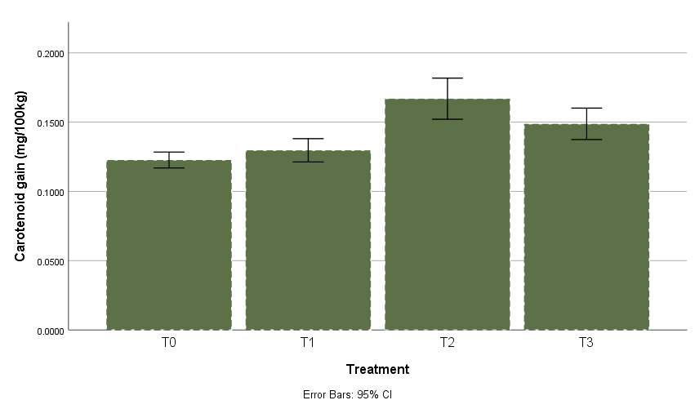
Figure 3: Final carotenoid gain of blue gourami (Trichogaster trichopterus)
4.2 Growth Rate:
The growth of blue gourami (Trichogaster trichopterus) fed with different dietary levels of natural carotenoid content in terms of gain in weight (weekly) during the experimental period is presented in Figure 4 and the weight gain trend is presented in Figure 5. The average initial weights in four treatments were 4.413 gm, 4.213 gm, 4.31 gm, 3.313 gm in T₀, T₁, T₂ and T₃ respectively (Appendix-8). At the end of the 120 days experimental period, average final weight of the fishes of four treatments were 5.455±0.821 gm, 4.504±0.2196 gm, 4.764±0.727 gm and 3.776±0.418 gm in treatments T₀, T_{1,} T₂ and T₃ respectively (Figure. 05). In case of weight gain higher result was found in T₀ (5.455±0.821 gm) followed by T₃, T₂ and T₁. Statistical analysis by ANOVA showed that there was no significant difference (P< 0.05) among the weight gain of T₀, T₁, T₂ and T₃ at the end of 120 days experimental period.

Figure 4: Weekly weight gain of blue gourami (Trichogaster trichopterus).
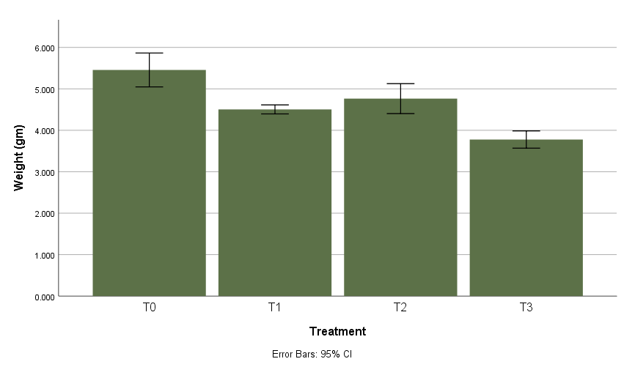
Figure 5: Final weight gain of blue gourami (Trichogaster trichopterus).
On the other the highest length gain was founded in T₂ & T₃ treatment (marigold, carrot) final mean gained length was of these treatment was 0.8 cm and lowest length gain was founded in T₁ treatment (china flower) final mean gained length of these treatment was 0.566 cm. Showed in figure:7.

Figure 6: Weekly length of blue gourami (Trichogaster trichopterus).
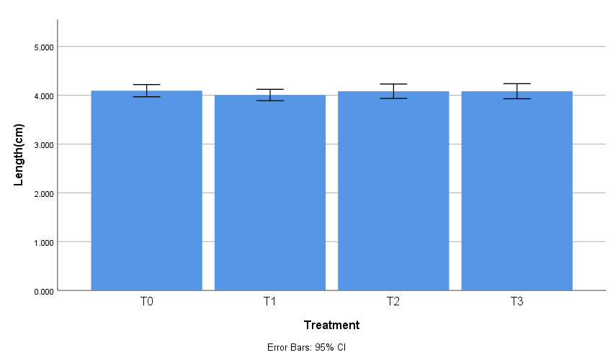
Figure 7: Final length gain of blue gourami (Trichogaster trichopterus).

4.3 Survival rate:
Survival rate of experimental fish of different treatment are given in the Figure-8. Experimental fish showed good performance in T₀ & T₂ treatment in which survival rate is about 100% and the lowest performance was showed in T₁ treatment (75%).

Figure 8: Survival rate of blue gourami (Trichogaster trichopterus).
4.4 Water quality parameters: The water quality parameters as water temperature, dissolved oxygen (DO) and pH were monitored weekly throughout the experimental period. Average water quality parameters (pH, DO and temperature) during the research work are shown in Table 6.
Table 6: Water quality parameters:
Treatments | P^{H} | DO (dissolved oxygen) (mg/dl) | Temperature (℃)
T₀ | 7.5-8.5 | 5-7 | 24-27.8
T₁ | 7.2-8.0 | 6-7.2 | 24-27
T₂ | 7.5-8.2 | 5.5-7.5 | 25-28
T₃ | 7.0-8.0 | 5-7.5 | 23-28

