Chapter-1: Introduction
Fish farming in Bangladesh is playing an important role to the entire value of this country. Bangladesh is a south Asian country and there are hardly any areas within the country where river or the other water source isn't available. In a word, Bangladesh is surrounded by various sorts of water sources like river, pond, stream, lake and so on. And most of the part of the entire population of this country are directly or indirectly involved fish or fish related business. Southern area of Bangladesh (Khulna, Barisal, Bagerhat, Satkhira etc.) are considered the ideal place for commercial fish farming in Bangladesh.
Bangladesh features a long history of introduction of ornamental fish species. But there is no consideration and no quarantine measures adopted during import of this species and as a result they were introduced into the country without proper documentation. Initially aquarium were set in restaurant for aesthetic enjoyment and also for beautification. Its demand has increased over time and farmers have started to culture ornamental fish species.
In Bangladesh, Aquarium fish culture was oriented in mid-1980, at Kataban in Dhaka (Mostafizur et al., 2009). Aquarium or ornamental fish business is becoming very fashionable throughout the country as its easy operating system and less operating costs. Beyond sales of aquaria, air pumps, feed, medications and other supplies, the first product of the aquarium industry is fish (Cheong, 1996).
In Bangladesh there are only a couple of native fish species that are considered ornamental fish species e.g. Rani fish (Botia sp.) and others are exotic species. Among them, goldfish and comets are being managed to breed artificial in various hatchery of Feni district, under Chittagong division (Mostafizur et al., 2009). The aquarium fish business leads to rapid cash production and is comparatively easy to start out as a hobby or small scale farming enterprises. Aquarium fish trade is a vast multi-million dollar market that has grown significantly over the last 20 years (Cheong, 1996). The probable global import value of aquarium fishes is US$ 321 million (Dawes, 2001), from which US$ 21-48 million belong to the marine aquarium fish trade (Wood, 2001). The worldwide wholesale value of live aquarium fish in 2000 was estimated by FAO of the United Nations to be US$ 900 million with a retail value of US$ 3 billion (Whittington and Chong, 2007). USA, Europe and Japan are the most important markets for aquarium fish but quite 65% of the exports come from Asia. It’s encouraging news for the developing countries that more than 60% of the total world trade goes to their economies (Ghosh et al., 2003). Although Bangladesh has huge resources but remains during a marginal position (Mostafizur et. al., 2009) and therefore the majority of the shops of aquarium fish are located in Dhaka city (Galib, 2010a). But it's good news for us that its trade is developing rapidly in our country.
In view of the overall rising enthusiasm for aquarium fish, ornamental fish culture industry is consistently extended around the world. Guppy, Poecilia reticulata, is that crucial species which contain features of a high market price. It is a member of the family Poeciliidae. The live bearer Guppy fish are the foremost popular among hobbyists due to their vibrant colors and besides they're easy to breed in aquariums. They are highly adaptable and thrive in many various environmental and ecological conditions which make them populous over other ornamental fish species (Ahmed et al., 1985).
Environmental parameters influence on good aquaculture practices. Background color is one of them. It is an important factor to consider during fish cultivation mostly for the ornamental fish species. Because it is related to the coloration of fish. For this reason, the effects of environmental (tank background) color on fish are increasingly studied during this century. The reported effects of background color on fish mostly involve production variables, like growth, feeding, reproduction, stress and survival.
  - Objectives
This study would provide new insights on diverse growth pattern occurs due to use of different background colors. The broad objectives of this experiment are:
- To observe the effect of background color on Guppy fish (Poecilia reticulata) from larvae to adult (growth, specific growth rate, survival rate, breeding performance and skin pigmentation).
- To inform people about the effect of background color on fish physiology and identify the appropriate color that is more desirable for fish.

1.2. Scope of the study
This type of research effort can help to set up a suitable policy for a faster and more sustainable development of aquarium fish production in our country. It also adds a new dimension to improve our fisheries industry and keeps our country renowned over the world.

Chapter-2: Review of Literature
2.1. Aquarium Fishes in Bangladesh
Bangladesh has a lavishness of regular assets like suitable climate, streams, lakes and so on. The individuals of Bangladesh has also conventional involvement with the culture of fish so that the Bangladeshi farmer can readily culture aquarium fish. Thinking about the significance of this recently rising field, numerous farmers are engaged with aquarium fish exchange and aquarium fish business turned out to be truly elegant in numerous urban areas of Bangladesh. There are immense chances of aquarium area inside the nearby market as well as in world market. Yet, it's actually couldn't create steady with the desire of the purchaser additionally in light of the fact that the supplier.
History shows that, majority of ornamental fishes were introduced in our country from Thailand. In 1952, the Siamese Gourami (Trichogaster pectoralis) was first introduced into Bangladesh from Singapore. Then the Gold fish (Carassius auratus) was introduced into Bangladesh from Pakistan in 1953. But in Bangladesh the culture of aquarium fish was started in 1980 at Kataban in Dhaka (Mostafizur et al., 2009). More than 70 species of exotic and native ornamental as well as aquarium fishes are recorded from different cities of Bangladesh. Nowadays the ornamental fish culture practice is expanding day by day.
The greater part of the aquarium fish shops are found inside the capital (Dhaka) and other significant city (for example, Rajshahi, Khulna and so forth) of Bangladesh (Mostafizur et al.,2009). Katabon market is the most common and popular market in Dhaka city for aquariums and other aquarium products like aquarium fishes, aquarium foods, chemicals, toys, plants etc. Galib (2010a) found that a minimum of 30 aquarium shops are available in Katabon market of Dhaka city where all types of aquarium products are often found. In another study, Galib (2010b) stated that about 2 shops are in Rajshahi city and 12 shops in Khulna city.12 shops and seven breeders are found in Khulna region where 29 distinctive aquarium fish species were promoted from which 12 species were reproduced for fry creation (Mostafizur et al., 2009). Rahman 2005 recorded a minimum of 25 aquarium fish species in Bangladesh. A complete of 78 sorts of exotic ornamental fishes were identified under 45 species, 41 genera (excluding 2 cross-bred), 18 families and 5 orders (Galib, 2010a). Artificial breeding techniques of a minimum of 17 sorts of exotic ornamental fishes are developed by amateur fish breeders (Galib, 2010a). There are found about 12 exotic and a couple of indigenous aquarium fishes in Rajshahi city (Mohsin et al., 2007). About 30 species of aquarium fishes are found in Khulna district (Mostafizur et al., 2009).
2.2. Guppy Fish Culture in Bangladesh
Popular aquarium fish, Guppy was introduced in various countries for mosquito control and sometimes loosely called “mosquito fish”. It’s been found to determine itself in both fresh and polluted waters (Ahmed et al., 1985). It introduced in India as early as 1910 to regulate mosquito (Kaira et al., 1967). This larvivorous fish are quite tolerant of a spread of water conditions thus are often used as predators of mosquito larvae and that they are often moved to water areas where they're needed (Travis, 1957). Synthetic insecticides are widely used for mosquito control throughout the planet and a few of those has long residual activities and affect the environment adversely. Among the varied vector control measures, the biological control method is favored thanks to its cost effectiveness. Larvivorous fish are used in mosquito control on and off for several years in several countries (Ahmed et al., 1985). Guppies have the ability to endure and increase in both new and contaminated waters to disentangle this issue. It's a viviparous fish and is fit for quickening its populace in shallow water (Menon and Rajagopalan, 1977).
As a freshwater fish of the family poecilidae, guppies (P. reticulata) are easy to stay and breed in aquaria and are getting more popular having adaptive capability and affordable price. They typically accept all quite foods including dried and live.
2.3. Effects of Background Color on Fish Physiology
Fish kept in artificial environment, which is incredibly not quite the same as their common territories, may impact the fish physiology and behavior. Fish have chromatic vision and their ability to acknowledge feed and consequently their food intake, growth and survival rate might be influenced by background color (Papoutsoglou et al., 2005; Strand et al., 2007). Moreover, different background colors could cause differences in physiological state, skin pigmentation (Van der Salm et al., 2004; Doolan et al., 2008). Thus, the fish reactions to various background colors differ considerably counting on fish species and life stage (Papoutsoglou et al., 2005).
In the majority of the previous studies, the foremost noticeable variations in physiological responses (stress‐induced hormones and melatonin) also as growth, caused by background color, are observed in white and black backgrounds counting on fish species (Papoutsoglou et al., 2000, 2005; Amiya et al., 2005; Van der Salm et al., 2005). Either blue light or ambient color was also demonstrated to reinforce fish growth and alter fish physiological responses (Ruchin, 2004; Karakatsouli et al., 2007; Banan et al., 2011). Additionally, blue and green background colors had very similar effects (Ruchin, 2004; Banan et al., 2011). On the opposite hand, the red light or background is understood to affect negatively fish growth and convey about impaired physiology (Ruchin, 2004; Luchiari and Pirhonen, 2008; Banan et al., 2011; Ebrahimi, 2011).
2.4. Effects of Background Color on Fish Coloration
Fish color can be altered by environmental factors through the rearrangement of chromatophore in the skin (Bagnara and Hadley, 1973; Sugimoto, 1993). Changes in color and pattern are considered as a result of physiological adaptation through chromatophore reallocation or an aftereffect of morphological variation by varying the amount of pigmentary materials under skin. According to Bagnara (1998), the change of background color could incite physiological color variation, commonly known as camouflage, to decrease predator–prey interactions. Cryptic coloration enables animals to conceal in which they change their color property and patterns to blend into the background (Moyle and Cech, 2004). Most color changes in fish result from the migration of melanophores, dark brown pigment cells, xanthophores, and iridophores (Oshima et al., 1989).
Lots of researches had been conducted to analyze the effect of different background color like light or dark color effects on skin pigmentation. Yasir and Qin 2009 demonstrated that a blue or green background could enhanced the orange color. Cultivation of freshwater catfish (Lophiosilurus alexandri) in white and yellow tanks produced individuals with a pale skin color, while cultivation in blue and black tanks resulted in juveniles with a darker and more pigmented skin (Costa et al., 2017).
Besides, Fish may show an inclination for a particular background color, likely to diminish their conspicuousness (Bradner and McRobert, 2001). A clear difference in body color was marked for Oreochromis niloticus kept in dark and clear aquaria, almost dark shaded fish coming from the black aquaria and very pale fish coming from the clear aquaria (Opiyo et al. 2014). The change in the color of the fish could be as result to Melanin Concentrating Hormone (MCH). Comparable perceptions were recorded for rainbow trout (Oncorhynchus mykiss) and Arctic charr (Salvelinus alpinus) raised on high contrast backgrounds where it was seen that MCH levels were extraordinarily expanded in the pituitary organ of the fish raised in white backgrounds (Green et al., 1991; Höglund et al. 2002). MCH has been contended to advance development in fish as revealed in barfin flounder (Verasper moseri) which had an expansion in substantial development when raised in a white background in which the creation of MCH was increased (Yamanome et al., 2005).
Different species showed different results for same background color. Eslamloo et al. 2013 carried out a research to demonstrate the effects of background color on skin pigmentation of Gold fish (Carassius auratus). It was found that, Skin carotenoid content and the intensity of fish skin color extremely lessened in white background aquarium. But Yasir and Qin 2009 suggested that a white or transparent background made fish less color saturated but brighter. Otherhand, Parisenti et al. 2011 found that background color influences the color of shrimp (Litopenaeus vannamei), but does not interfere significantly in the carotenoid amount accumulated in shrimp. Along these lines, it can be said that, there are endless debates about the impacts of background color on fish pigmentation.
2.5. Effects of Background Color on Guppy (Poecilia reticulata)
Some researches on the effect of background colors on the strain and growth responses of cyprinid like common carp are conducted before (Papoutsoglou et al., 2000; Ebrahimi, 2011). Moreover, in ornamental fish sector several fish species like gold fish have been studied to show the effects of background color (Eslamloo et al., 2013). But there is no information available on their effects on physiological and immunological responses also as growth of guppy fish. Therefore, this investigation was administered on the expansion performance of P. reticulata in a controlled way by using colorful aquarium.

Chapter-3: Materials and Methods
Methodology is an integral part of any research. In a scientific research the acceptability of the results depends to a great intent on the appropriate methodology. This chapter deals with the methods that are followed and materials that are used to achieve the objectives of the study. The results may be erroneous for the use of imperfect methodology. To avoid it, researcher has tried to follow a scientific and logical methodology. The present study was carried out at the wet lab of Chattogram Veterinary and Animal Sciences University by providing facility and maintaining optimum conditions for experimental procedures. In order to achieve the objectives of this research, the following steps were followed:
3.1. Collection of Experimental Fish
The fry of ‘Guppy’ fish (Poecilia reticulata) was collected from local market of Chattogram. The qualities of these fry were visually examined to ensure good quality seed. There was about 6 guppy fry in each tank. About eighty guppy fry were kept in several rectangular aquaria without any background color (transparent glass) to acclimatize to the treatment conditions.
3.2. Set up the Fish Tank
Materials such as glass, measuring tape, glue etc. were collected for constructing aquarium. A total of 12 glass aquaria (9.3inch × 7inch × 11inch) with 8L of water holding capacity were made. After that, 9 rectangular glass aquaria were thoroughly covered the outside wall and bottom by using color papers. Three different colors (red, blue and green) were used in triplicate for this study and 3 rectangular glass aquaria kept transparent to provide no background color. All aquaria were tagged individually for indicating different treatment and replications.
3.3. Water Quality Management
The tap water was used as a source of water. Salt and lime were used for treatment of water. The water quality parameter (DO, pH, water temperature, CO₂) were measured weekly using water analysis kits and physiochemical parameters were recorded also.
3.4. Feed Management
Commercial diet (protein 20%, fat 3%, fiber 7% etc) was provided at a daily rate of 5% of their body weight twice per day. During the next morning before supplying feed, feed residues were removed by siphoning which was done to maintain water quality. Feeding rate and feeding frequency were adjusted by their body weight.
3.5. Experimental Setup
Four different background colors (Transparent, Red, Blue and Green) were used as treatment. Each treatment was replicated three times. So the total number of Fish tanks (aquaria) was 12 [white (1×3) + red (1×3) + blue (1×3) + green (1×3)] in numbers. 6 fish were provided for each treatment and the total no of experimental fish was 72 (Table 1).
Table-1: Layout of the experiment showing the distribution of ‘Guppy’ fishes in aquariums and the applied treatments:
Treatment | T₁  (Transparent  background) | T₂  (Red background) | T₃  (Blue background) | T₄  (Green background)
Replication
R₁ | 6 | 6 | 6 | 6
R₂ | 6 | 6 | 6 | 6
R₃ | 6 | 6 | 6 | 6
Total | 18 | 18 | 18 | 18
3.6. Sampling
Sampling of the experimental fish was done in regular interval of two weeks (15 days). The growth development of fish was checked by measuring weight and length of fish. Weight of fish was taken by using a weight machine and length of fish was taken by using measuring scale.
3.7. Growth Performance Determination
The growth performances were determined by average weight and average length of fish. Not only average weight and average length of fish were measured but also weight gain and length gain were recorded for determination of growth performance. Average body weight, average length, weight gain and length gain were recorded. Moreover, SGR and survival rate were also measured to analyze the overall effects of background color on growth. The following formula was used:
Weight gain (g) = Final body weight – Initial body weight
Length gain (cm) = Final length of the fish body – Initial length of the fish body
Specific growth rate (%) = $\frac{Mean final Wt.-Mean Initial Wt}{experimental period}$ x 100
Survival rate (%) = $\frac{Final no. of live fishes}{Initial no. of fishes}$x 100
3.8. Carotenoid Content Analysis
Carotenoid content of fish muscle is an important factor for ornamental fish species. The color enhancement was monitored by visual examination and from that percentage of coloration was estimated.
Percentage of coloration (%) = $\frac{Number of total colorful fish }{Number of total fish }x 100$
Moreover, the estimation of carotenoid content of experimental fish was done after the completion of experiment. The method of Torrissen and Naevdal (1984) was followed to perform the analysis. First of all, the sample of fish muscle was taken and appropriately weighed. Then the fish samples were used to making paste through mortar. After that, the samples put into the centrifuge tube and added acetone up to 10ml. Then the specimens were centrifuged for 5mins at 5000rpm. Thereafter, the solutions were refrigerated at 4⁰c temperature for 72hrs (3days). Following 3 days, the samples were extracted three or four times until no more color could be obtained. At last, the specimens were ready to measure the absorbance of sample to analyze the carotenoid content. Finally the absorptions were measured in a spectrophotometer using the wave length of 470nm. The concentration of carotenoid was estimated and expressed as µg/g carotenoid using the following equation:
Carotenoid value = $\frac{Abs×10000×V}{1900×W}$
Where,
V is total volume of the extract
W the weight of the sample
Abs is the absorbance rate measured by spectrophotometer.
3.9. Statistical Analysis
Statistical analyses were performed by using MS excel (Microsoft office excel-2010, USA) and IBM SPSS Statistics 25 Version. Values were expressed as means ± standard deviation (SD). Data were analyzed by one-way analysis of variance (ANOVA). Statistical significance was set at P < 0.05.

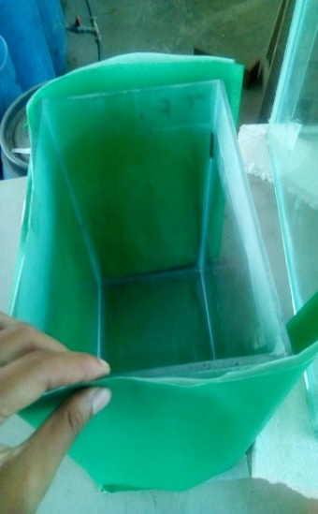
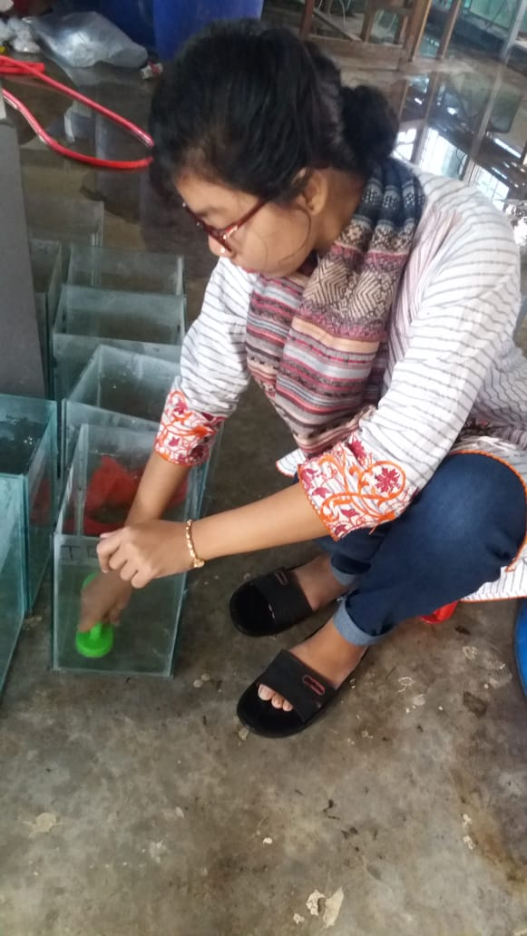
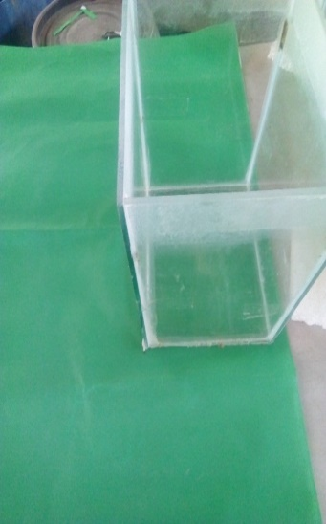
Some Pictures
Plate 1: Tank preparation

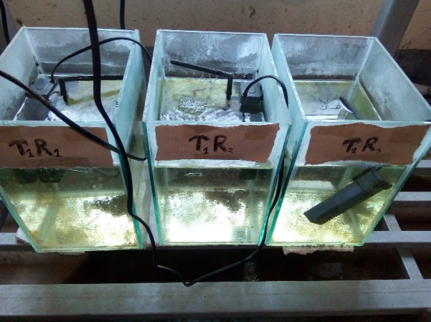
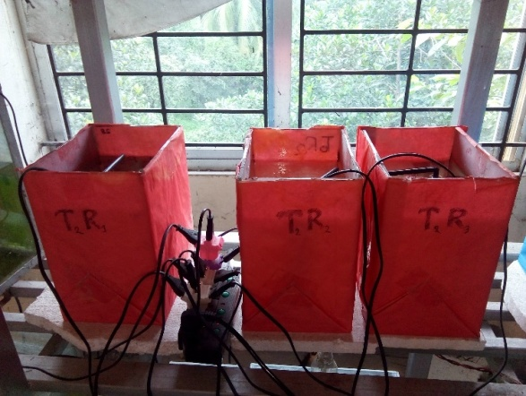
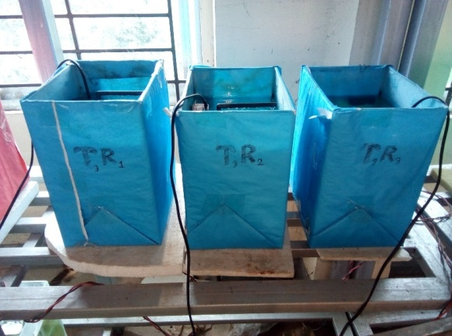
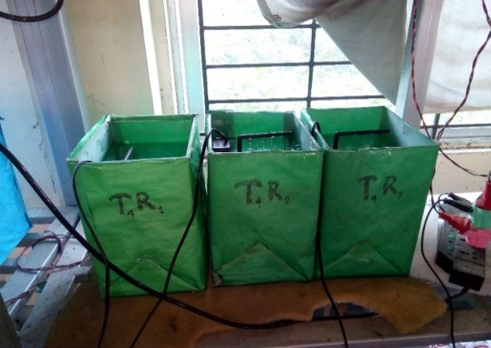

Plate 2: Experimental setup

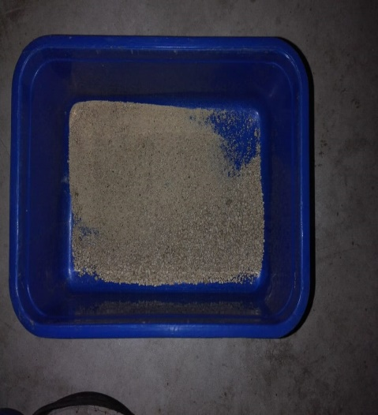
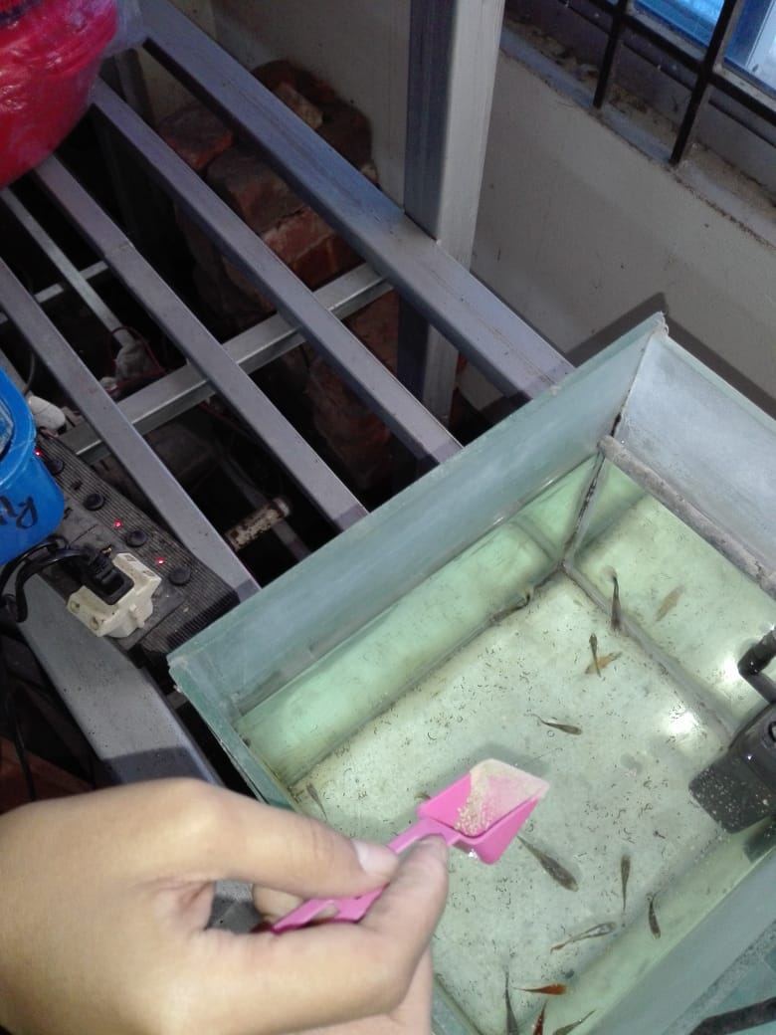

Plate 3: Feeding

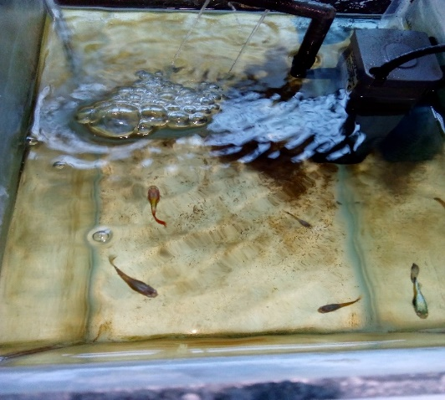
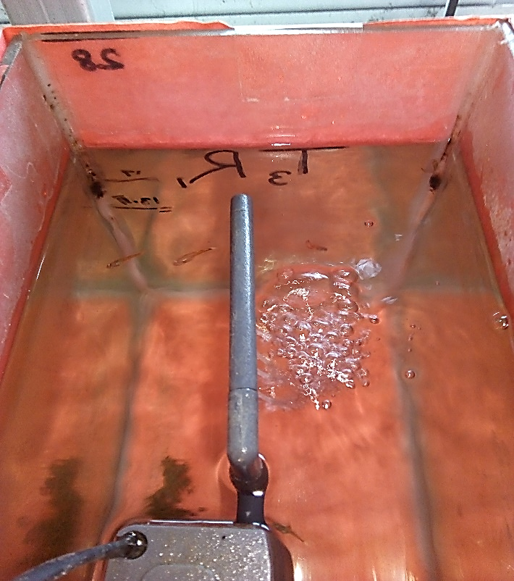
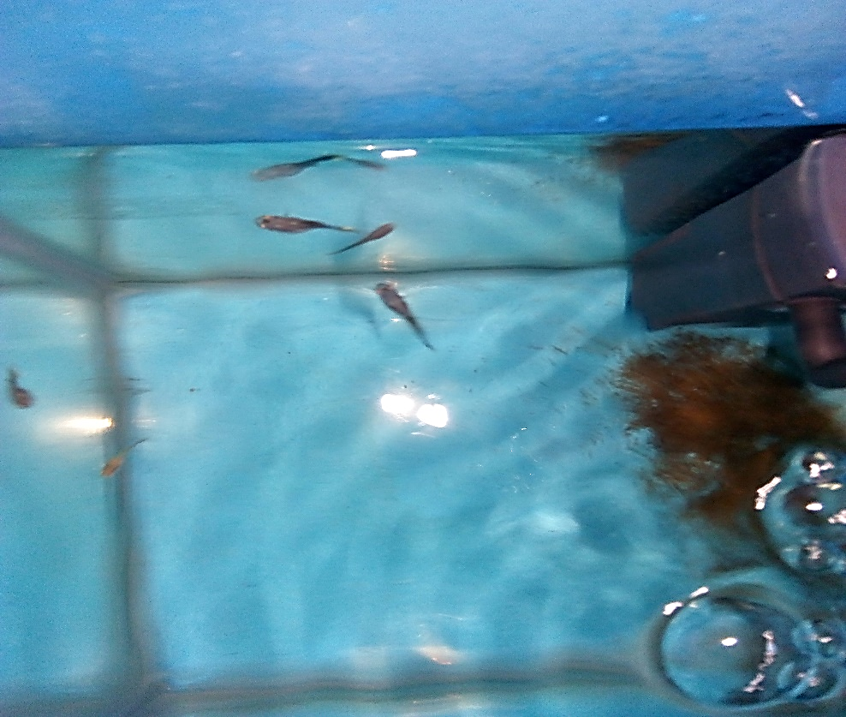
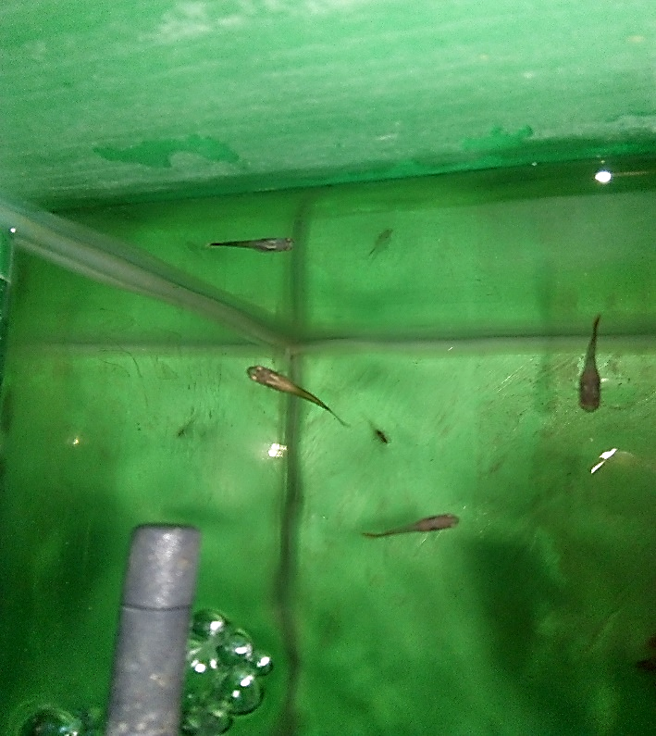
Plate 4: Regular Monitoring

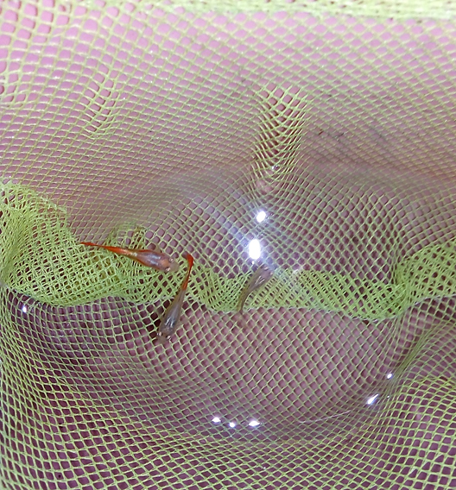
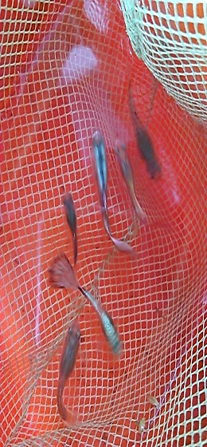
Plate 5: Sampling

T₁ T₂ T₃ T₄

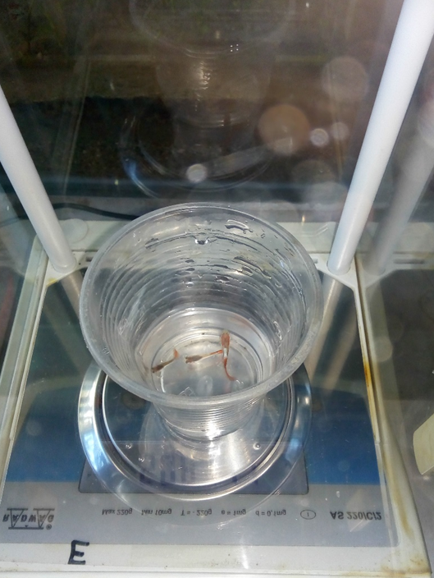
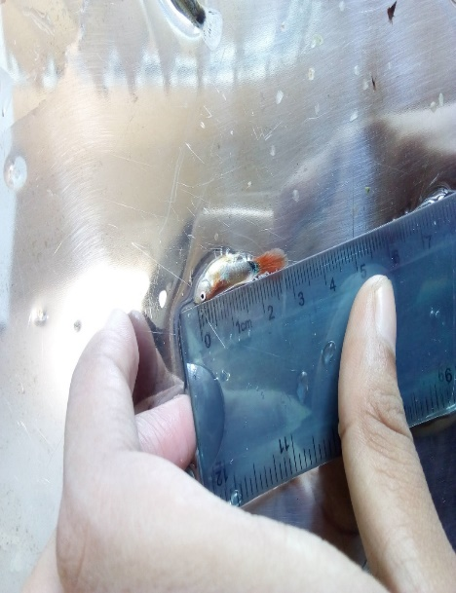

Plate 6: Measuring weight and length of fish

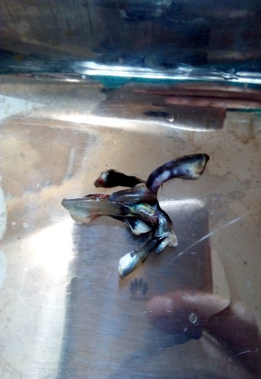
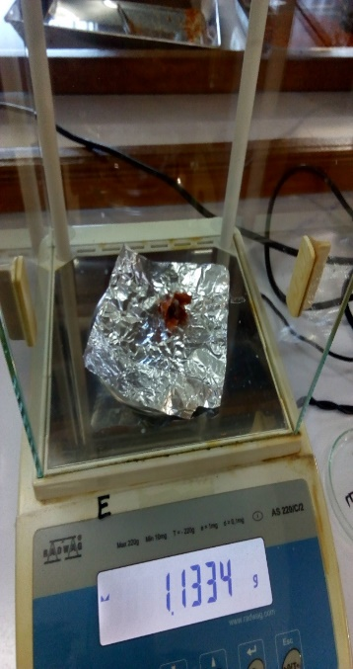
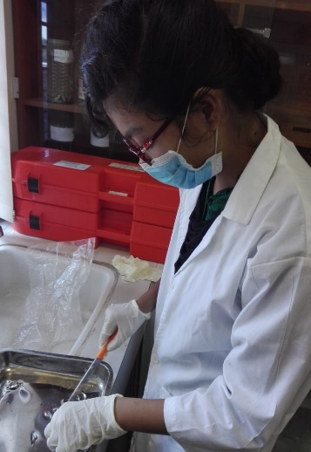
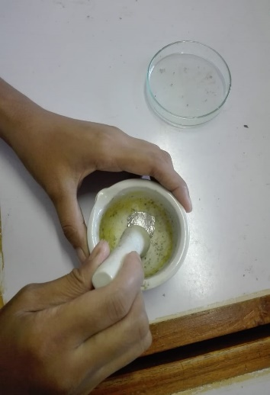

Plate 7: Preparation of sample for laboratory analysis

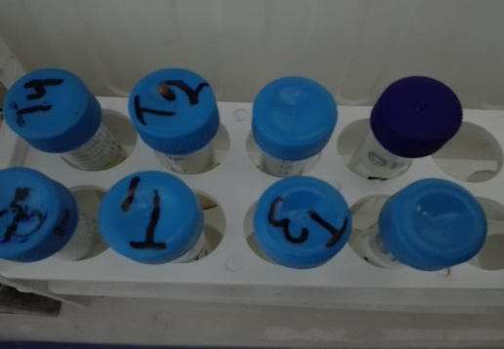
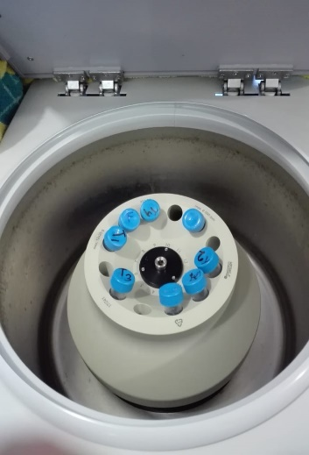
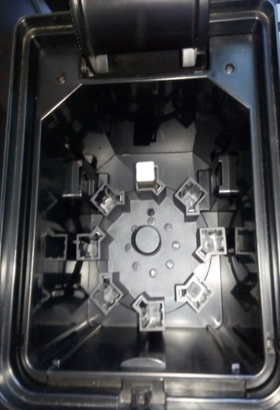
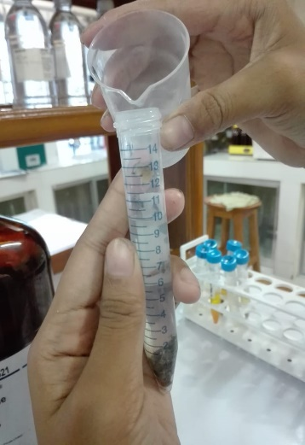

Plate 8: Carotenoid content analysis by spectrophotometer

Chapter-4: Results
Effect of environmental color on the physiology and behavior of various animals is a developing field. Studies have concentrated on showing the effects of environmental colors on some mammals, birds and fishes. In fish, some studies have shown that environmental color affects growth, feeding, stress, aggression and egg development. An attempt has been undertaken in the present study to demonstrate the effects of background color on guppy fish body.
4.1. Effects of Background Color on Fish Weight
Sampling of the experimental fish was done in every 15days where weights of fish were taken by weight machine (Appendix 1). For conducting research, fish had been sampled for 10 times (without initial weight). In final sampling, it showed that the average weight of each treatment such as T_{1,} T_{2,} T₃ and T₄ were 0.259 ±0.018 g, 0.167± 0.025 g, 0.192±0.009 g and 0.188±0.011 g respectively. The data showed that the fishes provided with ‘Treatment-1 (T₁)’ means in transparent tank plays role in higher growth in terms of weight while comparing with the other treatments (Figure-1).

Figure 1: Average growth by weight (gm.)

4.2. Effects of Background Color on Fish Length
The initial length (average) of fish was 1 cm. In final sampling, it showed that the average length of each treatment such as T_{1,} T_{2,} T₃ and T₄ were 3.067±0.208cm, 2.53±0.058 cm, 2.67±0.035 cm and 2.64±0.051 cm respectively. The data showed that the fishes provided with ‘Treatment-1(T₁)” means in transparent tank plays role in higher growth in terms of length while comparing with other treatments (Figure-2).

Figure 2: Average growth by length (cm)

4.3 Effects of Background Color on Weight Gain
Weight gain of fishes was calculated after 15days basis (Appendix 3) by subtracting of current sampling weight by immediate previous sampling fish weight (Figure 3).
Figure 3: weight gain in gm
4.4 Effects of Background Color on Length Gain
Length gain of fishes was calculated after 15days (Appendix 4) basis by subtracting of current sampling length by immediate previous sampling fish length (Figure 4). Figure 4: Length gain in cm

4.5. Growth Performance of Guppy Fish
Growth performances of Guppy are summarized in Table-2. Among treatments, significant differences (p<0.05) were observed for final weight (Appendix 5), weight gain (Appendix 7), final length (Appendix 6), length gain (Appendix 8) and Specific growth rate. Growth parameters were significantly higher in fish of T₁ (Transparent) tank which were shown in Figure 5, 6 and 7.
Table-2: Growth performance of Guppy fish
Treatment | Weight (g) | Length (cm) | SGR(Specific Growth Rate)
T₁  (Transparent Background) | 0.259 ±0.018ª  (0.214 -0.303) | 3.067±0.208ª  (2.55-3.58) | 0.165±0.012ª  (0.136-0.194)
T₂  (Red Background) | 0.167± 0.025^{b}  (0.104-0.229) | 2.53±.0.058^{b}  (2.39-2.68) | 0.104±0.017^{b}  (0.062-0.146)
T₃  (Blue Background) | 0.192±0.009^{b}  (0.169-0.214) | 2.67±0.035^{b}  (2.58-2.75) | 0.12±0.006^{b}  (0.105-0.135)
T₄  (Green Background) | 0.188±0.011^{b}  (0.161-0.149) | 2.64±0.051^{b}  (2.52-2.77) | 0.118±0.007^{b}  (0.099-0.137)
Level of Significance | 0.001 | 0.002 | 0.001

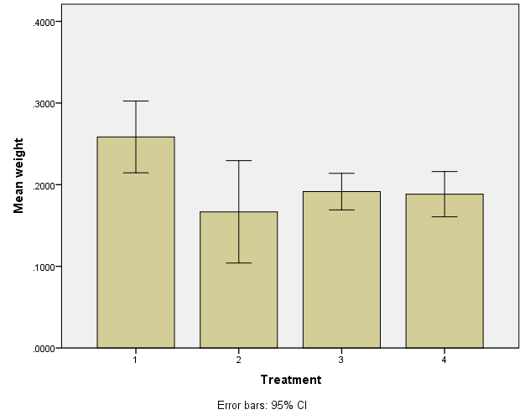
a
b
b
b
T1
T2
T3
T4

Figure-5: Effects of background color on weight of fish body (Mean ± SD) after 5 months. The weight of fishes of T₁, T₂, T₃ and T₄ were compared to each other.
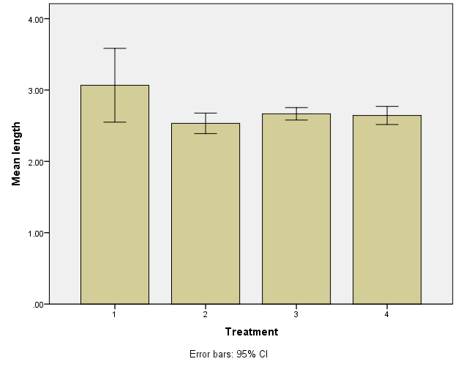
a
b
b
b
a
b
b
b
T1
T2
T3
T4

Figure-6: Effects of background color on length of fish body (Mean ± SD) after 5 months. The length of fishes of T₁, T_{2,} T₃ and T₄ were compared to each other.

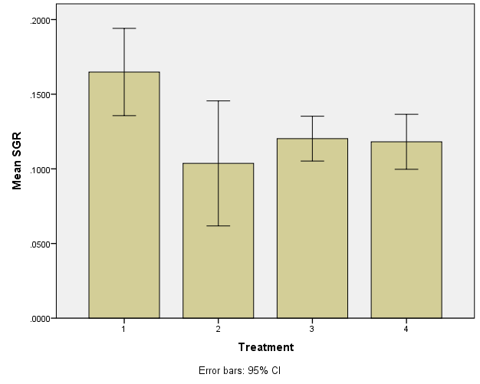
a
b
b
b
a
b
b
b
T2
T3
T1
T4

Figure-7: Effects of background color on specific growth rate (Mean ± SD) after 5 months. The specific growth rate of fishes of T₁, T₂, T₃ and T₄ were compared to each other.

4.6. Effects of Background Color on Coloration of Guppy Fish
In carotenoid content analysis after T₁ (Transparent) tank, fish of T₄ (Green) tank gave high amount of carotenoid from others (Appendix 9). Coloration percentage of each treatments was also summarized in table-3.
Table-3: Skin Pigmentation and Carotenoid Content of Guppy fish
Treatment | Carotenoid Content (mg/g) | Percentage of coloration | Color formation of fish
T₁ (Transparent Background) | 0.00175±0.00004ª  (0.00165-0.00185) | 93.75% | Vibrant color  (Orange, red, blue)
T₂ (Red Background) | 0.00092±0.000035^{c}  (0.00084-0.00101) | 66.67% | Blackish but orange fin found in several fishes
T₃ (Blue Background) | 0.00095±0.000025^{c}  (0.00089-0.00102) | 73.33% | Bluish-gray color and blue fin
T₄ (Green Background) | 0.00143±0.000046^{b}  (0.00132-0.00154) | 86.67% | Mostly orange in color
Level of Significance | 0.00 | ̶ | ̶

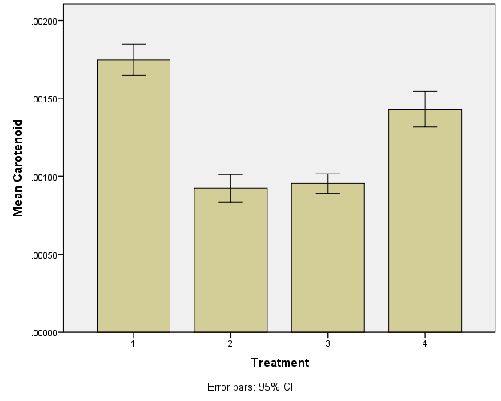
a
c
c
b
T1
T4
T3
T2

Figure-8: Effects of background color on carotenoid content (Mean ± SD) after 5 months. The carotenoid contents of fishes of T₁, T₂, T₃ and T₄ were compared.Values are statistically significant and different to each other. (P < 0.05, n=4)
4.7. Effects of Background Color on Survival Rate of Guppy Fish
Survival rate of experimental fish of different treatment were listed in Table-4. Experimental fish showed good performance in T₁ treatment in which survival rate is about 88.89%.
Table-4: Survivability measurement of Guppy fish
Treatment | Survival Rate
T₁ (Transparent Background) | 88.89%
T₂ (Red Background) | 66.67%
T₃ (Blue Background) | 83.33%
T₄ (Green Background) | 83.33%

4.8. Effect of Background Color on Breeding Performance of Guppy Fish
Breeding performance was assessed according to the number of fry given and time taken to give birth. Among different color backgrounds, experimental fish in transparent tank provided good performance in breeding (Table-5).
Table-5: Breeding performance of Guppy fish
Treatment | First given birth (time) | Age | Total no of fry (by the end of the experiment)
T₁ (Transparent Background) | 11.08.2019 | 4 months 7days | 4
T₂ (Red Background) | -- | -- | --
T₃ (Blue Background) | 20.08.2019 | 4 months 16 days | 2
T₄ (Green Background) | -- | -- | --

Chapter-5: Discussion
The present study was conducted to know the potentials of background color for better performance of Guppy (Poecilia reticulata). A number of changes have been documented in this present study such as length, weight, specific growth rate etc. It was also showed differences in carotenoid content analysis.
5.1. Effects of background color on fish weight
After completion of research work, highest weight was found in T₁ (0.259 ±0.018) treated fish than the T₂ (0.167± 0.025), T₃ (0.192±0.009) and T₄ (0.188±0.011). The present work represents that fish in transparent tank means experimental fish without background color show higher weight than the other fish kept in different background color.
During research period, 10 samplings were done where 1st two samplings (in between 1month) showed higher growth rate and higher weight gain because it is normal for fish to gain weight in their early life stages. But they showed significantly different growth rate according to the background colors and T₁ treatment gave high growth rate than others. After 1st month, lower weight gain was found in all experimental fish during sampling time due to fluctuation of temperature and weather change. In spite of fish maturation, higher weight gain was found lately and it was occurred at different time for different treatments. As example, T₁ gave higher growth rate at 5th sampling; on the other hand T₂ gave at 8th sampling, T₃ and T₄ gave during 7th sampling.
All growth parameters considerably improved in guppy reared on a transparent background (T₁ treatment) in comparison with the others. The growth performance of barfin flounder (Verasper moseri), eurasian perch (Perca fluviatilis) and white sea bream (Diplodus sargus) rose by rearing in transparent tanks (Amiya et al., 2005; Karakatsouli et al., 2007; Strand et al., 2007). The significant increase in the growth performance of fish raised in transparent background could be due in part to the high contrast between feed and background color and consequently improving the visibility of feed in light tanks as suggested in other studies (Jentoft et al., 2006; Strand et al., 2007).
Among the colorful background, fish reared in red tank (T₂ tank) showed lowest growth rate. Similarly, Ruchin 2004 have revealed that red light reduces the growth of juvenile goldfish. Volpato et al. 2013 conducted an experiment about red light effects on nile tilapia and found that, red light stimulates fish to feed, but not growth. These findings undoubtedly indicate that red background is stressful for fish growth.
But in between blue and green tank, similar values were found due to their acceptability through the fish. Blue is usually water alike color which is associated with openness, peace and tranquility. On the other hand, green color is environmental related which reduces the level of stress hormone of fish.
5.2. Effects of background color on fish length
During stocking of fish, initial length was 1 cm. In final sampling, highest length was found in T₁ (3.067±0.208) treated fish than the T₂ (2.53±.0.058), T₃ (2.67±0.035) and T₄ (2.64±0.051) treated fish. Background color effects on length is similar to the effects on weight and this experiment showed significantly different length values for different treatments (p<0.05).
5.3. Effects of Background color on the growth performance
In the present study, red background negatively effected the mean body weight, length, SGR, weight and length gain. Blue tank showed higher values than green and red tank. However from a study of Opiyo et al. (2014), higher value of final body weight and SGR was recorded for O. niloticus reared in blue backgrounds and could be related to the good contrast between the food particle and the tank background color. But green tank gave less but close value to blue tank. From some research it was found that, blue or green leads to better performances than red. On the contrary, transparent background showed positive growth performance. Eslamloo et al. 2013 also suggested that, white backgrounds will preferably be used for the culture of goldfish for best fish growth.
The specific growth rate is widely used dealing with the growth of aquatic organisms under experimental conditions. Here the SGR values of T₁ (Transparent), T₂ (Red), T₃ (Blue) and T₄ (Green) were 0.165±0.012, 0.104±0.017, 0.12±0.006 and 0.118±0.007 respectively. From the value, the order of growth increment of guppy can be categorized and that was transparent > blue> green> red.
5.4. Effects of background color on fish coloration
After completion of research work, highest amount of carotenoid content was found in fish of transparent tank ( 0.00175±0.00004 mg/g). The reason behind that could be the proper light penetration in between tank which helps in developing vibrant colors on fish skin. In addition, Melanin concentrating hormone (MCH) levels in the brain and pituitary were higher in the white tank fish (Amiya et al., 2008). Similar observations were recorded for rainbow trout (Oncorhynchus mykiss) and arctic charr (Salvelinus alpinus) reared on black and white backgrounds where it was observed that MCH levels were incredibly expanded in the pituitary gland of the fish raised in white backgrounds (Green et al., 1991; Höglund et al., 2002).
In between other tanks, carotenoid content was much higher in green tank (0.00143±0.000046mg/g) and strengthened the orange color. Whereas blue tank provided 0.00095±0.000025 mg/g carotenoid which was less than green tank. Yasir and Qin 2009 suggested that, blue or green tanks may be more suitable to produce red orange clownfish, the favorite color for most aquarium hobbyists.
Finally red tank was not showed any good performance both in fish growth and coloration. Carotenoid content of fish reared in red tank was about 0.00092±0.000035. Similarly in the study of Yasir and Qin (2009), the red background did not regulate fish hue and brightness.
5.5 Effects of background color on survival rate of fish
Background color significantly affected the percent survival of the fish. Percentage of survival fish reared in transparent tank was recorded the highest value of survival (88.89%) while fish population reared in red tank showed the lowest percent survival of 66.67%. On the other hand, percent survival of fish reared in blue and green tanks were similar (83.33%). Blue and green colors are similar to environment which can be the reason to place blue tank and green tank in second position. Moreover, guppy fish are habituated to transparent tank but different color background can be stressful to them so the rate of survivability was comparatively lower in blue, green and red tank.
Eslamloo et al. 2013 reported that, background color represent a potential chronic stress for goldfish. From this, it is cleared that the stress stimuli works on different background color can be the reason for fish death. The color and orientation of prey items, the color of a tank affects the ability of fish larvae to detect, capture and ingest food items which can affect in feed efficiency and survival (Duray et al., 1996; Martinez-Cardenas and Purser, 2007; McLean et al., 2008). In Nile tilapia, light blue to blue background can significantly improve its survival rate, while the use of red background should be avoided (McLean et al., 2008).
5.6. Effects of background color on fish breeding
In this study, breeding rate of guppy was high in transparent tank and it took less time to breed than other treatments. It occurred due to their acceptability of transparent tank. Guppy is a viviparous fish and is capable of increasing its population in shallow water. Gonads of transparent tank fishes was prominent compare to others.
In this study, birth of fry started at 8th sampling (11.08.2019) in transparent tank. Generally, Guppy began fry birth in February and ended in November with a peak in July. In February, comparatively few number of mother guppies abled to give fry. Hidebrand 1921 reported that, In the Southeastern U. S. the breeding season of guppy begins in May and ends in September and October. Davis 1978 detailed that in South-central Texas, the breeding season of Gambusia affinis, a closely related fish of guppy ranges from March to October with a peak in April. It was showed in some research, that the gestation period of guppy was 25-35 days with an average of 28 days. Guppy was reported to bring out broods at approximately four-week intervals (Ahmed et al., 1985). Krumholz (1948) reported that the average gestation period of G. affinis, a closely related fish of guppy (P. reticulata), was 23-24 days.
In this study, also the fishes reared in blue tanks abled to give birth before ending of the experiment (august) but the mother guppy was comparatively few in numbers. This was similar In Nile tilapia (Oreochromis niloticus). The relation-ship between background color and spawning (Volpato et al., 2004) and hatchability (Brian, 2015) of Nile tilapia which were examined and it has been revealed that the blue color can positively affect the reproductive motivation of males, exhibited by larger nest area and reproduction frequency (Volpato et al., 2004). Tilapia egg hatchability was not significantly influenced by background color, but tilapia of blue tanks gave numerically higher eggs (Brian, 2015).

Chapter-6: Conclusions
Based on the results of the present study, the color of the tanks affects growth performance and skin pigmentation of fish hence it is advisable to consider the tank colors when setting-up an aquaculture facility. In addition, coloration is the most considerable factor to count in ornamental fish culture. Particularly, this study revealed that the growth performance of guppy fish was significantly improved by rearing the fish in a transparent background. The red background was found to be more stressful for this species suggesting that this backgrounds are inappropriate for guppy rearing. Transparent and blue backgrounds should be preferred for better growth and breeding performance. However, the amount of skin carotenoid and the intensity of skin color were appreciably lowered in blue treatment than green. Thus, when fish growth rate is not a main concern, guppy could be reared in green background to improve skin color. Nevertheless, the white background is suggested to be used for promoting growth performance and strengthen skin pigmentation.

Chapter-7: Recommendation and Future Perspectives
According to this research work, the following recommendations may be done:
- Environmental color may be an important factor to consider in the culture of aquarium fishes, as it is known to affect skin pigmentation.
- Background color may induce a variety of responses in relation to food intake and growth, behavior, stress and other factors which can be beneficial for farmers to improve the total production.
- Most of the ornamental fishes are imported from foreign country which costs a lot of money. In this case, background color may add new dimension by improving coloration on fish body and may help to meet the requirement of the country.
- Nowadays, Feeding of carotenoids diet become very popular to enhance coloration of fish. Besides environmental color may subsidiary to create pigmented fish for ornamental fisheries sector.
- As it is a pilot study, further studies may be conducted on similar field to make a concrete remark. Moreover, by continuing this type of research effort may help to set up a suitable policy for a faster and more sustainable development of aquarium fish production in our country.

References
Ahmed TU, Bhuiyan M, Rabbani K. 1985. Observation of the larvivorous efficiency of Poecilia reticulata (Cyprinodontiformes: cyprinodontidae). Bangladesh Journal of Zoology. 13: 7-12.
Amiya N, Amano M, Takahashi A, Yamanome T, Kawauchi H, Yamamori K. 2005. Effects of tank color on melanin-concentrating hormone levels in the brain, pituitary gland, and plasma of the barfin flounder as revealed by a newly developed time-resolved fluoroimmunoassay. General and Comparative Endocrinology, 143(3), pp. 251–256.
Amiya N, Amano M, Yamanome T, Yamamori K, Takahashi A. 2008. Effects of background color on GnRH and MCH levels in the barfin flounder brain. General and Comparative Endocrinology. 155(1): 88–93.
Bagnara, JT, Hadley ME. 1973. Chromatophores and color changes: the comparative physiology of animal pigmentation. Prentice Hall International, London, UK.
Bagnara, JT. 1998. Comparative anatomy and physiology of pigment cells in non-mammalian tissue. In: Hearing VJ, King RA, Ortonne JP, Nordlund JJ, Boissy RE, editors. The pigmentary system: physiology and pathophysiology. Oxford University Press, USA. pp. 9-40
Banan A, Kalbassi MR, Bahmani M, Sadati MY. 2011. Effects of colored light and tank color on growth indices and some physiological parameters of juvenile beluga (Huso huso). Journal of Applied Ichthyology. 27(2): 565–570.
Bradner J, McRobert SP. 2001. Background coloration influences body colour segregation in mollies. Journal of Fish Biology. 59(3): 673-681.
Brian O. 2015. Effect of tank background colour on the hatchability of O. niloticus eggs and survival of fry. International Journal of Fisheries and Aquatic Studies. 2(6): 81–86.
Cheong L. 1996. Overview of the current international trade in ornamental fish with special reference to Singapore, Revue Scientifique et Technique de l’Office. International des Epizoonties. 15: 445-481.
Costa DC, Silva WS, Filho RM, Filho KCM, Santos JCE, Luz RK. 2017. The effect of environmental color on the growth, metabolism, physiology and skin pigmentation of the carnivorous freshwater catfish, Lophiosilurus alexandri. Journal of Fish Biology. 90(3): 922–935.
Davis JR. 1978. Reproductive season in Gambusia affinis and Gambusia geiseri (Osteichthyes: Poeciliidae) from Southcentral Texas. Texas Journal of Science. 30(1): 97-99.
Dawes J. 2001. International aquatic industry perspectives on ornamental fish conservation. In: Chao L.N., Petry P., Prang G., Sonneschien L. and Tlusty M. (eds.). Conservation and Management of Ornamental Fish Resources of the Rio Negro Basin, Amazonia, Brazil – Project Piaba. EDUA, Manaus, Brazil. pp. 100-121.
Doolan BJ, Allan GL, Booth MA, Jones PL. 2008. Effect of carotenoids and background colour on the skin pigmentation of Australian snapper Pagrus auratus (Bloch & Schneider, 1801). Aquaculture Research. 39(13): 1423–1433.
Duray MN, Estudillo CB, Alpasan LG. 1996. The effect of background color and rotifer density on rotifer intake, growth and survival of the grouper (Epinephelus suillus) larvae. Aquaculture. 146: 217–224.
Ebrahimi, G. 2011. Effects of rearing tank background color on growth performance in juvenile common carp, Cyprinus carpio. Agricultural Journal. 6(5): 213–217.
Eslamloo K, Falahatkar B, Ashouri G, Morshedi V. 2010. Effects of background color on survival and growth performance in convict cichlid (Cichlasoma nigrofasciatum) in Aquaculture Europe. European Aquaculture Society, Porto, Portugal. pp. 440–441.
Eslamloo K, Akhavan SR, Eslamifar A, Henry MA. 2013. Effects of background color on growth performance, skin pigmentation, physiological condition and innate immune responses of goldfish, Carassius auratus. Aquaculture Research. 46(1): 202-215.
Galib SM. 2010a. Aquarium Fisheries in Dhaka City, Bangladesh. Feature/Trade/Ornamental fish and Aquarium, Bangladesh Fisheries Information Share Home.
Galib SM. 2010b. Aquarium Fisheries in Rajshahi City, Bangladesh. Feature/Trade/Ornamental fish and Aquarium, Bangladesh Fisheries Information Share Home.
Ghosh A, Mahapatra BK, Datta NC. 2003. Ornamental Fish Farming- Successful Small Scale Aqua Business in India. Aquaculture Asia. 8(3): 14-16.
Green JA, Baker BI, Kawauchi H. 1991. The effect of rearing rainbow trout on black or white backgrounds on their secretion of melanin-concentrating hormone and their sensitivity to stress. Journal of Endocrinology. 128: 267-274.
Höglund E, Balm PHM, Winberg S. 2002. Behavioural and neuroendocrine effects of environmental background colour and social interaction in Arctic charr (Salvelinus alpinus). The Journal of Experimental Biology. 205: 2535-2543
Hidebrand SF. 1921. Use of top minnows in malaria control. U. S. Public health Bull. 114: 34.
Jentoft S, Oxnevad S, Aastveit AH, Andersen O. 2006. Effects of tank wall color and up-welling water flow on growth and survival of Eurasian perch larvae (Perca fluviatilis). Journal of the World Aquaculture Society. 37(3): 313–317.
Kaira NL, Wattal BL, Raghavan NGS. 1967. Occurrence of larvivorous fish Lebister reticulatus (Peters) breeding in silage water at Nagpur-India. Bull. Ind. Soc. Mal. Com. Dis. 4: 253-254.
Karakatsouli N, Papoutsoglou SE, Pizzonia G, Tsatsos G, Tsopelakos A. 2007. Effects of light spectrum on growth and physiological status of gilthead seabream (Sparus aurata) and rainbow trout (Oncorhynchus mykiss) reared under recirculating system conditions. Aquacultural Engineering. 36: 302–309.
Krumholz LA. 1948. Reproduction in the Western mosquito fish, Gambusia affinis, and its use in mosquito control. Ecol. Monorg. 18: 1-43.
Luchiari AC, Pirhonen J. 2008. Effects of ambient colour on colour preference and growth of juvenile rainbow trout Oncorhynchus mykiss (Walbaum). Journal of Fish Biology. pp. 72, 1504–1514.
Martinez-Cardenas L, Purser GJ. 2007. Effect of tank color on Artemia ingestion, growth and survival in cultured early juvenile pot-bellied seahorses (Hippocampus abdominalis). Aquaculture. 264:92-100.
McLean E, Cotter P, Thain C, King N. 2008. Tank color impacts performance of cultured fish. Ribarstvo. 66:43-54.
Menon PKB, Rajagopalan PK. 1977. Mosquito control potential of some species of indigenous fishes in Pondicherry. Indian Journal of Medical Research 66: 765.
Mohsin ABM, Haque ME, Islam MN. 2007. Status of Aquarium Fisheries of Rajshahi City. Journal of Biological Science 15: 169-171.
Mostafizur MR, Rahman SM, Khairul MI, Rakibul HMI, Nazmul MA. 2009. Aquarium business: A case study in Khulna district, Bangladesh. Bangladesh Research Publication Journal. 2(3): 564-570.
Moyle PB, Cech JJ. 2004. Fishes, an introduction to ichthyology. Prentice-Hall: Upper Saddle River, NJ.
Opiyo MA, Ngugu CC, Rasowo J. 2014. Combined effects of stocking density and background color on growth performance and survival of nile tilapia (Oreochromis niloticus, L.) fry reared in aquaria. JournaROTLLANTl of FisheriesSciences.com. 8(3): 228-237
Oshima, N, Kasukawa H, Fujii R. 1989. Control of chromatophore movements in the blue-green damselfish, Chromis viridis. Comparative Biochemistry and Physiology Part C: Comparative Pharmacology. 93(2): 239-245.
Papoutsoglou SE, Mylonakis G, Miliou H, Karakatsouli NP, Chadio S. 2000. Effects of background color on growth performances and physiological responses of scaled carp (Cyprinus carpio L.) reared in a closed circulated system. Aquacultural Engineering. 22(4): 309–318.
Papoutsoglou SE, Karakatsouli N, Chiras G. 2005. Dietary L-tryptophan and tank colour effects on growth performance of rainbow trout (Oncorhynchus mykiss) juveniles reared in a recirculating water system. Aquacultural Engineering. 32(2): 277–284.
Parisenti J, Beirao LH, Mourino JL, Maraschim M. 2011. Effect of background color on shrimp pigmentation. Boletim do Instituto de Pesca Journalszisch 37(2): 177 – 182.
Rahman AA. 2005. Freshwater fishes of Bangladesh. Zoological Society of Bangladesh.
Rotllant J, Tort L, Montero D, Pavlidis M, Martinez M, Bonga SEW, Balm PHM. 2003. Background colour influence on the stress response in cultured red porgy Pagrus pagrus. Aquaculture, 223(1-4), pp. 129–139.
Ruchin AB. 2004. Influence of colored light on growth rate of juveniles of fish. Fish Physiology and Biochemistry, 30(2), pp. 175–178.
Strand A, Alanara A, Staffan F, Magnhagen C. 2007. Effects of tank colour and light intensity on feed intake, growth rate and energy expenditure of juvenile Eurasian perch, Perca fluviatilis L. Aquaculture, 272(1-4), pp. 312–318.
Sugimoto M. 1993. Morphological color changes in the medaka, Oryzias latipes, after prolonged background adaptation. I. Changes in the population and morphology of melanophores. Comparative Biochemistry and Physiology Part A: Physiology. 104:513.
Szisch V, Van der Salm AL, Wendelaar Bonga SE, Pavlidis M. 2002. Physiological colour changes in the red porgy, Pagrus pagrus, following adaptation to blue lighting spectrum. Fish Physiology and Biochemistry. 27(1): 1–8.
Travis BV. 1957. Present status and future possibilities of biological control of mosquitoes. Mosquito News. 17: 143-147.
Torrissen, OJ, NaevdaI, G. 1984. Pigmentation of salmonids - genetical variation in carotenoid deposition in rainbow trout. Aquaculture. 38: 59-66.
Van der Salm AL, Martınezc M, Flika G, Wendelaar Bonga SE. 2004. Effects of husbandry conditions on the skin colour and stress response of red porgy, Pagrus pagrus. Aquaculture. 241(1-3): 371–386.
Van der Salm AL, Spanings FAT, Gresnigt R, Wendelaar Bonga SE, Flik G. 2005. Background adaptation and water acidification affect pigmentation and stress physiology of tilapia, Oreochromis mossambicus. General and Comparative Endocrinology. 144(1): 51–59.
Volpato GL, Daurte CRA, Luchiari AC. 2004. Environmental color affects nile tilapia (Oreochromis niloticus) reproduction. Brazilian Journal of Medical and Biological Research. 37: 479-483
Volpato GL, Bovi TS, de Freitas RHA, da Sliva DF, Delicio HC. 2013. Red Light Stimulates Feeding Motivation in Fish but Does Not Improve Growth. PLoS ONE. 8(3): e59134.
Whittington RJ, Chong R. 2007. Global trade in ornamental fish from an Australian perspective: The case for revised import risk analysis and management strategies. Preventive Veterinary Medicine. 81: 92-116.
Wood E. 2001. Collection of coral reef fish for aquaria: global trade, conservation issues and management strategies. UK: Marine Conservation Society, Ross-on-Wye. p.80.
Yamanome T, Amano M, Takahashi A. 2005. White background reduces the occurrence of staining, activates melanin concentrating hormone and promotes somatic growth in barfin flounder. Aquaculture. 244: 323-329.
Yasir I, Qin JG. 2009. Effect of light intensity on color performance of false clownfish, Amphiprion ocellaris Cuvier. Journal of the World Aquaculture Society. 40: 337–35.

APPENDICES
Appendix 1: Weight data of the fishes at different sampling
TR | 1st sampling | 2nd sampling | 3rd sampling | 4th sampling | 5th sampling | 6th sampling | 7th sampling | 8th sampling | 9th sampling | 10th sampling
T₁R₁ | 0.0733 | 0.1103 | 0.1636 | 0.1882 | 0.2152 | 0.2208 | 0.2319 | 0.2406 | 0.2594 | 0.2629
T₁R₂ | 0.0807 | 0.097 | 0.1003 | 0.1157 | 0.1893 | 0.2046 | 0.2283 | 0.2445 | 0.2569 | 0.2736
T₁R₃ | 0.0633 | 0.0873 | 0.0881 | 0.0939 | 0.1677 | 0.1913 | 0.2059 | 0.2177 | 0.2203 | 0.239
T₂R₁ | 0.0643 | 0.0767 | 0.079 | 0.0827 | 0.092 | 0.1019 | 0.1215 | 0.1563 | 0.1722 | 0.1951
T₂R₂ | 0.048 | 0.054 | 0.0628 | 0.0775 | 0.0833 | 0.0932 | 0.1045 | 0.1289 | 0.1443 | 0.1584
T₂R₃ | 0.0537 | 0.0647 | 0.0723 | 0.0744 | 0.0912 | 0.0988 | 0.106 | 0.1207 | 0.1368 | 0.1467
T₃R₁ | 0.0463 | 0.0667 | 0.0773 | 0.086 | 0.0957 | 0.1172 | 0.1355 | 0.1575 | 0.1744 | 0.1892
T₃R₂ | 0.049 | 0.0683 | 0.0702 | 0.0816 | 0.0982 | 0.1204 | 0.1501 | 0.1769 | 0.1911 | 0.2015
T₃R₃ | 0.0477 | 0.062 | 0.0675 | 0.0708 | 0.1087 | 0.1121 | 0.1394 | 0.1563 | 0.1709 | 0.1839
T₄R₁ | 0.0547 | 0.0787 | 0.0832 | 0.0895 | 0.0975 | 0.1035 | 0.1395 | 0.1558 | 0.1712 | 0.1819
T₄R₂ | 0.0367 | 0.0557 | 0.0722 | 0.0841 | 0.1042 | 0.1164 | 0.1349 | 0.1566 | 0.1889 | 0.2013
T₄R₃ | 0.0637 | 0.0807 | 0.0825 | 0.0883 | 0.0954 | 0.1096 | 0.1284 | 0.1501 | 0.1728 | 0.182
* TR= Treatment × Replication

Appendix 2: Length data of the fishes at different sampling
TR | 1st sampling | 2nd sampling | 3rd sampling | 4th sampling | 5th sampling | 6th sampling | 7th sampling | 8th sampling | 9th sampling | 10th sampling
T₁R₁ | 1.8 | 2.1 | 2.17 | 2.2 | 2.3 | 2.4 | 2.6 | 2.8 | 2.9 | 3.3
T₁R₂ | 1.77 | 1.97 | 2 | 2.03 | 2.12 | 2.2 | 2.56 | 2.7 | 2.8 | 3
T₁R₃ | 1.4 | 1.9 | 1.97 | 2.03 | 2.15 | 2.2 | 2.46 | 2.56 | 2.73 | 2.9
T₂R₁ | 1.4 | 1.5 | 1.63 | 1.67 | 1.75 | 1.83 | 1.9 | 2.17 | 2.4 | 2.6
T₂R₂ | 1.5 | 1.6 | 1.67 | 1.7 | 1.77 | 1.83 | 1.9 | 2.03 | 2.3 | 2.5
T₂R₃ | 1.63 | 1.7 | 1.77 | 1.83 | 1.9 | 1.9 | 1.97 | 2.1 | 2.4 | 2.5
T₃R₁ | 1.5 | 1.53 | 1.57 | 1.6 | 1.7 | 1.87 | 2 | 2.2 | 2.56 | 2.63
T₃R₂ | 1.5 | 1.53 | 1.6 | 1.63 | 1.77 | 1.83 | 2.1 | 2.3 | 2.56 | 2.67
T₃R₃ | 1.53 | 1.57 | 1.63 | 1.7 | 1.83 | 1.9 | 2 | 2.4 | 2.63 | 2.7
T₄R₁ | 1.4 | 1.5 | 1.6 | 1.73 | 1.8 | 1.9 | 2.1 | 2.3 | 2.56 | 2.7
T₄R₂ | 1.5 | 1.53 | 1.57 | 1.63 | 1.77 | 1.86 | 2 | 2.2 | 2.5 | 2.63
T₄R₃ | 1.5 | 1.53 | 1.6 | 1.67 | 1.77 | 1.8 | 2 | 2.3 | 2.46 | 2.6
* TR= Treatment × Replication

Appendix 3: Weight gain (current sampling weight- immediate previous sampling weight) data of the fishes
Treatment | wt gain - 1 | wt gain -2 | wt gain -3 | wt gain -4 | wt gain -5 | wt gain -6 | wt gain -7 | wt gain -8 | wt gain -9 | wt gain -10
T₁R₁ | 0.0621 | 0.247 | 0.0533 | 0.025 | 0.03 | 0.006 | 0.011 | 0.01 | 0.02 | 0.004
T₁R₂ | 0.0695 | 0.109 | 0.0033 | 0.015 | 0.074 | 0.02 | 0.024 | 0.016 | 0.0124 | 0.017
T₁R₃ | 0.0521 | 0.16 | 0.0008 | 0.006 | 0.074 | 0.024 | 0.015 | 0.012 | 0.0026 | 0.019
T₂R₁ | 0.0531 | 0.083 | 0.0023 | 0.004 | 0.01 | 0.01 | 0.02 | 0.035 | 0.0159 | 0.023
T₂R₂ | 0.0368 | 0.04 | 0.009 | 0.015 | 0.006 | 0.01 | 0.0113 | 0.024 | 0.0154 | 0.0141
T₂R₃ | 0.0425 | 0.073 | 0.0076 | 0.0021 | 0.0168 | 0.0076 | 0.0072 | 0.015 | 0.0161 | 0.01
T₃R₁ | 0.0351 | 0.136 | 0.0106 | 0.0087 | 0.0097 | 0.0215 | 0.0183 | 0.022 | 0.0169 | 0.0148
T₃R₂ | 0.0378 | 0.129 | 0.002 | 0.0114 | 0.017 | 0.0222 | 0.0297 | 0.027 | 0.014 | 0.0104
T₃R₃ | 0.0365 | 0.095 | 0.0055 | 0.0033 | 0.0379 | 0.0034 | 0.0273 | 0.017 | 0.0146 | 0.013
T₄R₁ | 0.0435 | 0.16 | 0.0045 | 0.0063 | 0.008 | 0.006 | 0.036 | 0.0163 | 0.02 | 0.011
T₄R₂ | 0.0255 | 0.127 | 0.0165 | 0.0119 | 0.02 | 0.012 | 0.0185 | 0.0217 | 0.0323 | 0.0124
T₄R₃ | 0.0525 | 0.113 | 0.0018 | 0.006 | 0.0071 | 0.0142 | 0.0188 | 0.022 | 0.023 | 0.01
*wt = weight

Appendix 4: Length gain (current sampling length- immediate previous sampling fish length) data of the fishes

Treatment | length gain-1 | length gain-2 | length gain-3 | length gain-4 | length gain-5 | length gain-6 | length gain-7 | length gain-8 | length gain-9 | length gain-10
T₁R₁ | 0.8 | 0.3 | 0.07 | 0.03 | 0.1 | 0.1 | 0.2 | 0.2 | 0.1 | 0.4
T₁R₂ | 0.77 | 0.2 | 0.03 | 0.03 | 0.09 | 0.08 | 0.36 | 0.14 | 0.1 | 0.2
T₁R₃ | 0.4 | 0.5 | 0.07 | 0.06 | 0.12 | 0.05 | 0.26 | 0.1 | 0.17 | 0.17
T₂R₁ | 0.4 | 0.1 | 0.13 | 0.04 | 0.08 | 0.08 | 0.07 | 0.27 | 0.23 | 0.2
T₂R₂ | 0.5 | 0.1 | 0.07 | 0.03 | 0.07 | 0.06 | 0.07 | 0.13 | 0.27 | 0.2
T₂R₃ | 0.63 | 0.07 | 0.07 | 0.06 | 0.07 | 0 | 0.07 | 0.13 | 0.3 | 0.1
T₃R₁ | 0.5 | 0.03 | 0.04 | 0.03 | 0.1 | 0.17 | 0.13 | 0.2 | 0.36 | 0.07
T₃R₂ | 0.5 | 0.03 | 0.07 | 0.03 | 0.14 | 0.06 | 0.27 | 0.2 | 0.26 | 0.11
T₃R₃ | 0.53 | 0.04 | 0.06 | 0.07 | 0.13 | 0.07 | 0.1 | 0.4 | 0.23 | 0.07
T₄R₁ | 0.4 | 0.1 | 0.1 | 0.13 | 0.07 | 0.1 | 0.2 | 0.2 | 0.26 | 0.14
T₄R₂ | 0.5 | 0.03 | 0.04 | 0.06 | 0.14 | 0.09 | 0.14 | 0.2 | 0.3 | 0.13
T₄R₃ | 0.5 | 0.03 | 0.07 | 0.07 | 0.1 | 0.03 | 0.2 | 0.3 | 0.16 | 0.14
* TR= Treatment × Replication

Appendix 5: Average weight (gm.) data of fishes

Treatment | 1st Sampling | 2nd sampling | 3rd sampling | 4th sampling | 5th sampling | 6th sampling | 7th Sampling | 8th Sampling | 9th Sampling | 10th Sampling
T₁ | 0.0724 | 0.0982 | 0.1173 | 0.1326 | 0.1907 | 0.2056 | 0.222 | 0.2343 | 0.2455 | 0.2585
T₂ | 0.0553 | 0.0651 | 0.0714 | 0.0782 | 0.0888 | 0.09796 | 0.1107 | 0.1353 | 0.1511 | 0.1667
T₃ | 0.0477 | 0.0657 | 0.0717 | 0.0795 | 0.1009 | 0.1166 | 0.1417 | 0.1636 | 0.1788 | 0.1915
T₄ | 0.0517 | 0.0717 | 0.0793 | 0.0873 | 0.099 | 0.1098 | 0.1343 | 0.1542 | 0.1776 | 0.1884

Appendix 6: Average length (cm) data of fishes

Treatment | 1st sampling | 2nd sampling | 3rd sampling | 4th sampling | 5th sampling | 6th sampling | 7th Sampling | 8th Sampling | 9th Sampling | 10th Sampling
T₁ | 1.66 | 1.99 | 2.045 | 2.087 | 2.19 | 2.267 | 2.55 | 2.687 | 2.81 | 3.07
T₂ | 1.51 | 1.6 | 1.69 | 1.733 | 1.807 | 1.853 | 1.923 | 2.1 | 2.367 | 2.53
T₃ | 1.5 | 1.543 | 1.6 | 1.643 | 1.767 | 1.867 | 2.033 | 2.3 | 2.583 | 2.667
T₄ | 1.467 | 1.52 | 1.59 | 1.677 | 1.78 | 1.853 | 2.033 | 2.267 | 2.507 | 2.643

Appendix 7: Data of average weight gain (current sampling weight- immediate previous sampling weight) per treatment per sampling

Treatment | wt gain -1 | wt gain -2 | wt gain -3 | wt gain -4 | wt gain -5 | wt gain -6 | wt gain -7 | wt gain -8 | wt gain -9 | wt gain -10
T₁ | 0.0612 | 0.172 | 0.019 | 0.015 | 0.059 | 0.0167 | 0.017 | 0.013 | 0.012 | 0.013
T₂ | 0.0441 | 0.065 | 0.0063 | 0.007 | 0.011 | 0.009 | 0.013 | 0.025 | 0.016 | 0.016
T₃ | 0.0365 | 0.12 | 0.006 | 0.008 | 0.022 | 0.016 | 0.025 | 0.022 | 0.0152 | 0.013
T₄ | 0.0405 | 0.133 | 0.0076 | 0.0081 | 0.012 | 0.011 | 0.024 | 0.02 | 0.0251 | 0.011
*wt = weight

Appendix 8: Data of average length gain (current sampling length- immediate previous sampling fish length) per treatment per sampling

Treatment | length gain-1 | length gain-2 | length gain-3 | length gain-4 | length gain-5 | length gain-6 | length gain-7 | length gain-8 | length gain-9 | length gain-10
T₁ | 0.657 | 0.333 | 0.057 | 0.04 | 0.103 | 0.077 | 0.273 | 0.15 | 0.123 | 0.26
T₂ | 0.51 | 0.09 | 0.09 | 0.043 | 0.073 | 0.047 | 0.07 | 0.177 | 0.267 | 0.17
T₃ | 0.51 | 0.033 | 0.057 | 0.043 | 0.123 | 0.1 | 0.167 | 0.27 | 0.28 | 0.083
T₄ | 0.467 | 0.053 | 0.07 | 0.087 | 0.103 | 0.073 | 0.18 | 0.23 | 0.24 | 0.137

Appendix 9: Data of coloration of fish during sampling

Sampling number, Treatment | T₁R₁ | T₁R₂ | T₁R₃ | T₂R₁ | T₂R₂ | T₂R₃ | T₃R₁ | T₃R₂ | T₃R₃ | T₄R₁ | T₄R₂ | T₄R₃
1st Sampling (29.04.2019) | 1 | 1 | × | × | × | × | × | × | × | × | × | ×
2nd Sampling (14.05.2019) | × | × | 1 | × | × | × | × | × | × | 1 | × | ×
3rd Sampling (29.05.2019) | 1 | 1 | 1 | 1 | 1 | × | 1 | × | × | × | 1 | 1
4th Sampling (13.06.2019) | 1 | 1 | × | × | × | 1 | × | 1 | × | 1 | × | 1
5th sampling(28.06.2019) | 1 | 1 | × | × | × | × | × | × | 1 | × | × | ×
6th sampling(13.07.2019) | 1 | × | 1 | × | × | × | × | × | × | 1 | 1 | ×
7th Sampling(28.07.2019) | × | 1 | 1 | × | 1 | 1 | × | 2 | 1 | 1 | 1 | ×
8th Sampling(11.08.2019) | × | 1 | × | 2 | × | × | 2 | × | 2 | 1 | × | 1
9th Sampling(27.08.2019) | × | × | × | × | × | × | × | × | × | × | 1 | ×
10th sampling(11.09.2019) | × | × | × | × | × | 1 | 1 | × | × | × | × | ×
Total= | 5 | 6 | 4 | 3 | 2 | 3 | 4 | 3 | 4 | 5 | 4 | 4
* TR= Treatment × Replication

