Chapter-I

INTRODUCTION

Bangladesh is one of the world’s most densely populated and least urbanized countries, and about 116 million (i.e. 72% of total population) live in rural areas (Biswas et al., 2011).About 47% of the total population has access to electricity and only 6% have access to natural gas through the national pipeline grid (Chakrabarty ,2014) moreover these services remain largely unreliable. The per capita energy consumption in Bangladesh (about 180 kWh) is one of the lowest in the South Asia region (Bangladesh Power Development Board, 2010) and the national energy demand is growing rapidly, at a rate of 10% annually (Mondal et al., 2013). For the case of rural populations, the energy consumption is much lower. As per the Bangladesh Rural Electricity Board, 45% of the country’s villages have been electrified through connection to the national grid but, despite this, only 22% of the rural population has access to electricity (Bangladesh Rural Electrification Board, 2010). As there is no natural gas pipeline connection in rural and remote areas, the rural population traditionally uses non-commercial biomass energy sources for cooking (fuel wood, cow dung, and agricultural waste), which accounts for 62% of energy consumption (Ashekuzzaman et al, 2011) kerosene is often employed for lighting. The 44 million tons of fuel wood that is used for cooking and heating purposes which are inefficiently burned and poorly managed (Islam et al. 2011). Though efficiency of traditional village cooking stoves is about 5–15% (Hossain, 2003). Traditional biomass-fired cooking stoves have two major drawbacks: low efficiency and indoor air pollution created by pollutants released inside the kitchen. (Reddy et al, 1997) because a large portion of the population is exposed, the total indoor air pollution exposure (from domestic biomass combustion) is likely to be greater for most important pollutants than from out-door urban pollution in all the, world’s cities combined. To overcome the negative consequences of traditional biomass use pattern, biogas digesters have been disseminated in Bangladesh .The combination of increasing energy demand, limited amount of natural resources available, and lack of clean renewable energy has led to a burgeoning interest in biogas technology in Bangladesh. Anaerobic digestion (AD) holds great potential for manure stabilization, sludge reduction, odor control, and energy production (Cantrell et al .,2008). It provides clean and efficient fuels that can be used for several end uses, including cooking, water heating and thermally-driven cooling. Another important application of biogas is electric power generation through internal combustion engines to drive electric generators (Monteiro et al 2011). Whereas using biogas for only cooking is more common, generating electricity is relatively rare in Bangladesh, despite the fact that internal combustion engine technology is mature .Efforts have been made by the government, as well as by non-governmental and international organizations, to address the widespread rural energy problem.

Objectives:
This study was done with the following objectives:
- To see the current scenario and socio-economic status of the farmers possessing biogas plant.
- To explore the economy behind biogas plant construction.

Chapter-II

MATERIALS AND METHODS

The study was conducted in close accordance with the objectives. Particular attention was paid to objectively verifiable indicators depending on the level of factual, quantitative and statistical information available, and the degree to which it was possible to quantify and extrapolate conclusions from field investigation and observation.

2.1. Study Area:
Due to having placement during intern programme it was scheduled to visit different places of Bangladesh. Thats why different farms (Keraniganj, Manikganj, Kushtia, Chittagong) were selected for the production based work on biogas plant.

2.2. Study duration:
The study was conducted during a period of 9 (nine) months started from January to September2017.

2.3. Study tools:
The main instrument of the study was done by a structured questionnaire and open-ended unstructured interviews with the respective plant user. Additional investigation tools included observations, especially of different components of biogas plants, household kitchen and slurry pits in the sampled households, and informal discussions with the farmer. During the field survey process, we adopted an interactive approach was addopted rather than a ‘question and answer session’ with the respondents to enhance the quality of data and information collected.

2.4. Statistical analysis:
The data collected from each farm were entered into MS excel (Microsoft office excel-2013, USA). Data management and descriptive analysis was done in Excel Sheet.

The general methodology followed during the study has been illustrated in the following diagramme.

Preliminary Phase: Desk Study and Mobilization

Sampling of Biogas Households for study
↓
Desk study of secondary data and information
↓
Preparation of questionnaires, checklists and interview guidelines
↓
Consultative Meetings with experts to fine-tune the questionnaire
↓
Field-testing of the questionnaires
↓
Finalization of the questionnaire
↓
Mobilization for field investigation and data collection

Investigation and Data Collection Phase: Field Study

Field study using participatory tools and techniques to collect data and information on present status biogas plants
↓
Observation, walk through and case studies
↓
consultation and informal discussions with community people

Concluding Phase: Data Analysis, Interpretation and Report Preparation

Field data compilation, analysis and interpretation
↓
Preparation of Draft Final Report
↓
Receiving of comments and suggestions on Draft Final Report
↓
Preparation of Final Report
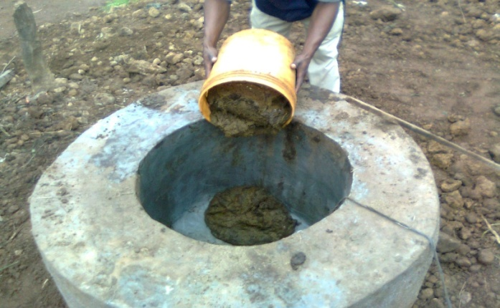
Figure-1: Feeding material in the digester
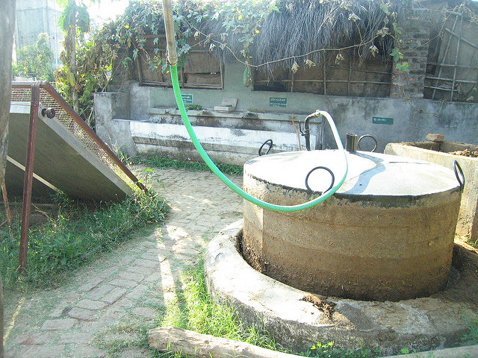
Figure-2: Collection of biogas
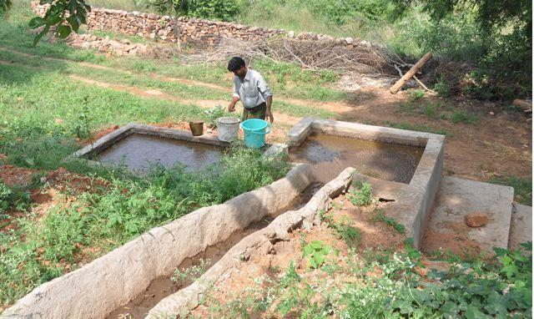
Figure-3: Collection of biogas slurry
Chapter-III

RESULTS AND DISCUSSIONS

The outcome of the study indicated that most of the individual biogas households were well off by rural Bangladeshi standards, as characterized by higher income level, large and medium land holdings, plenty of livestock, and many educated family members. The findings on socio-economic characteristics of the plant owners under study are described below-

3.1. Socio-Economic Charecteristcs
3.1.1.Demography
The total population of the 8 households under study was found to be 58 among which 28 (48.27%) were female members and 30 (51.73%) were male members. The average family size was 7.25, which is higher than the national average size of 5.18 (Report of the Household Income & Expenditure Survey, 2000). Household with maximum number of family members had 15. Table-1 and the Figure- 1 show the population composition and distribution of family members respectively in the studied households.

Table-1: Population Pattern
Age group | Number of people
 | Male | Female | Total
Less than 6 (Infants | 1 | 1 | 2
6 to 16 | 8 | 7 | 15
17 to 45 | 15 | 14 | 29
46 to 60 | 2 | 1 | 3
61 to 75 | 1 | 2 | 3
Above 75 Total | 3 | 3 | 6
Total | 30 | 28 | 58

Figure: 4 : Distribution of Family Members

As can be seen from the table, economically active population has share of 64% in the total population size. Interestingly, 28% of the populations are below 16 years of age. Another fact as seen is the predominance of 6-10 member-sized families among the biogas users, which comprises of 50% of the total households under study. The finding indicated that biogas plants have been installed in households with comparatively higher number of family members.

3.1.2.Land Holdings
The average land holding size of the households under study was 5.25 acre (3.67 acre -arable and 1.58 acre – non-arable) per households, with a minimum of 0.13 and maximum of 54 acres.
The average size is much higher than the national average of 1.38, which indicates that the biogas plants are installed in comparatively bigger holding households.

3.1.3.Livestock Farming
The biogas households owned, during the time of survey, 252 cattle and average of 31.5 cattle per household which is much higher than the national average of 2.64. The maximum number of cattle was 60 and the minimum was 20.

3.2.Construction, Operation And Maintenance Of Biogas Plant
3.2.1. Construction
For the construction of a biogas plant the farmers consider some factors such as plant location, reasons behind their installation of plant, their financing ability etc.

Plant Location
The biogas households sampled for the study represented three districts from all the six divisions in Bangladesh. All the plants were located in easily accessible areas, where basic infrastructure services existed. Easily accessible approach roads and electricity grid connections in all the sampled households indicated that these plants were installed in relatively developed areas.

Reason of Installation
The respondents were asked to give most important reasons/motivating factors for the installation of biogas plants. As per them, the most popular motivating factors were the
economic benefits including saving of time and money (62.5%),environmental benefits (12.5%), availability of subsidy (12.5%) and health benefits including the reduction in smoke borne diseases (12.5%).

Decision Making for the Installation
When asked the respondents on who made the final decision to install biogas plant, 57% of them told that the decision was taken after discussions in the family, followed by the household head – the males in 75% and the females in 5% of the cases; and the younger members – son or daughters in the family in 20% of the cases. The respondents told that they knew about the technology through service providers (33%), biogas users (23%), friends and relatives (20.5%), government officials (7.5%) and the publicity media (4%). The remaining 12% knew about it through more than one of the above-mentioned .

3.2.2.Financing for Construction
Biogas plants in Bangladesh, in majority of the cases, are financed in two ways – a flat rate subsidy from the government on the investment cost and cash contribution from respective plant owners to fill gap. The subsidy provided by the government is insufficient to meet the total cost of installation and a gap exists which the farmers must bridge. Total investment cost of biogas plants ranged from BDT 11,800 for biogas plant of capacity 100 cft gas production per day to BDT 30,500 for plant of capacity 300cft gas production per day.Only 1 plant owner took loan form their friends and relatives. Those who took loans from friends and relatives did not pay any interest rates . The outcome of the study revealed a fact that taking loan for constructing biogas plant is not a common practice in Bangladesh. The reasons as mentioned by the respondents not to take loan were: good economic condition (37.5%; 3), attitude against the philosophy of taking loans (25% ; 2), higher interest rates (25%) and cumbersome process of loan sanctioning (12.5%) .

3. 3.3.Maintenance
Effective and timely management of routine repair and maintenance works are key to the sustainability of biogas plants. As long as operational activities are carried out efficiently and routine maintenance works are carried out in time, biogas plants function properly. During the study, when farmers were asked if they could carry out repair and maintenance works by their own, only one respondent replied in positive. All the respondents expressed urgent need of training on minor repair and maintenance works to effectively manage their biogas plants. Out of the 8 biogas plants under study, 4 plants (50%) have received some sorts of maintenance works. The following were the major repair works carried out as responded by the users :

Table-2 : Amount Spent on Repair Works
Total amount spent in the last 12 month | No. of plants | Total amount spent(BDT)
BDT 100-600 | 3 | 1200
BDT 601-1000 | 2 | 1400
BDT 1001-2000 | 2 | 2000
More than 2000 | 1 | 4000
Total | 8 | 8600

As shown in Table-2 a total of BDT 8600 was spent by the plant owners to repair their plants. The average maintenance cost per plant was, therefore, found to be BDT 1075 per year

3.3. Gas Production and Use
The outcome of the study indicated that the main application of biogas was for cooking. Biogas was used only for cooking purpose in 5 (62%) of the households. Gas stoves (single burner stoves in 1 hhs, double burner stoves in 4 hhs ) were installed in all the biogas households. Biogas lamps were installed only in three households. Users reported that the lamps were used only during the time of power cut. While calculating the gas production, use of gas for cooking has only been considered as the share of lamp was reported to be negligible.

Table no:3: Gas production and use by per households
Number of households | Stove burning hours |  | Production of gas  (m³) | Expected production of gas (m3)
1 | 5 |  | 25 | 36
2 | 4 |  | 8 | 14
3 | 3 |  | 6 | 8
4 | 2.5 |  | 5 | 7.2
5 | 3.5 |  | 9 | 16
6 | 3 |  | 7 | 16.8
7 | 2 |  | 4 | 9.6
8 |  | 3 | 6 | 10.8
Total |  | 26 | 70 | 118.4
Average |  | 3.25 | 8.75 | 14.8

Total burning hours of stove in the sampled households was calculated to be 26 hours with an average of 3.25 hours/household per day which is shown in table no : 3. The gas demand in these households was reported to be 47 hours with an average of 5.88 hours per day per household. Gas was reported to be sufficient only in 2 (25%) households. When asked about the reasons for lesser gas production, the famers felt that it was small-sized plant ( 25%), under-fed plants (37.5%) defective construction and technical failures ( 12.5%), lack of timely repair and maintenance work (12.5%), less gas production during cold season (12.5%) Interestingly, the amount of dung feed into the digester in totality is enough to meet the demand. The theoretical gas production from the dung fed into the digester per day has been calculated to be enough for the stove burning hours of 47 per day. The theoretical burning hours of stove based upon the size of plants under study has been 75, which is far more than the actual amount of gas being received .

3.4. Impacts of Uses of biogas plant
3.4.1.Impact On Saving Of Conventional Fuel Sources
Saving in the quantity of cooking and/or lighting fuel is directly an economic benefit of biogas plant to the concerned household. Theoretically, based on effective heat produced, a plant producing 2 cum of biogas each day can replace about 110-150 kilograms of firewood per month depending upon its quality. In monetary values, if the quantity of gas is used to replace fuel wood in Bangladesh, it saves BDT 4400 to BDT 6000. The field finding revealed that 34 cum of biogas is produced by the plants under study per day which is higher in amount than that is reported . This saves about 150 kgs of fire wood per day. The average saving of firewood was therefore 1200 kg/year/hh

Table-4: Financial Gain from Saving of Conventional Fuel
Conventional Fuel | Quantity use and saving (unit/year/hr) |  |  | Average cost  in BDT/kg | Total Saving  In BDT/hh/year
 | Before | After | Saving
Firewood (kg) | 3273 | 1395 | 1877 | 40 | 75080
LPG (cylinder) | 2.02 | 1.54 | .48 | 533 | 255.84
Dried Dung (kg) | 1153 | 641 | 512 | 10 | 5120
Agricultural  residues (kg) | 1386 | 750 | 636 | .7 | 445.2
Natural Gas (BDT) |  |  | 5 | 800 | 4000
 |  |  |  | Total=84901.04

Average financial saving from biogas plant was calculated to be BDT 84901.0 4 shown at table no: 4 per year/household, which a significant amount.
3.4.2. Impact of Bio-slurry
Biogas slurry when composed, stored, handled and applied properly is considered to be of high nutrient value. It is well-recognized fact that the economic benefit of biogas technology is greatly increased if the slurry bi-product is used effectively on farms. During investigation process, it was observed that 6 (75%) users were using bio-slurry in one or other ways; where as the remaining 25% were not using it. Majority of the users (78%) who did not use the slurry drain it directly to watercourses. Draining slurry to the watercourse means the farmers are loosing nutrient fertilizer in one hand and in the other excessive accumulation of slurry in watercourse expedites the process of peutrification, which is environmentally hazardous. Users who used slurry on farm reported that it is of high nutrient value than the farmyard manure. Though the users expressed their views that the production of crop and fish has increased after the use of bio-slurry, they could not exactly quantify the increment.

3.5. Annual income
Annual income from plant includes saving on conventional fuel sources and saving on chemical fertilizer because of the use of bio-slurry. However, it does not include added nutrient value of slurry and other health, social or environmental benefits. The relationships between the quantity of gas produced, the amount of conventional fuels saved and the value of such savings for different plant sizes are based on the following assumptions: 0.040 cum of gas is produced per kg of fresh dung 1 cum of gas is equivalent to 4 kgs of firewood given the good quality of firewood used in Bangladesh (Khan et al, 2013). The cost of fuel is the average of all the cost as responded by the users which is BDT 84901.04 per plant per year for average plant capacity of 129 cft gas production per day as calculated based upon size of sampled plants. Selling and saving in chemical fertilizer because of the use of slurry is BDT 1200 and BDT 851.66 per household per year respectively and The salvage value of biogas plant is not included in the benefit stream of financial analysis because after 10 years of operation, the plant or its parts will not be re-salable. In such calculation, quantity of conventional fuels saved has been taken into consideration not the value of total gas produced as equivalent to the cost of fuels.

Chapter-IV

CONCLUSION
The outcome of the study indicated that-
- most of the individual biogas households were well off by rural Bangladeshi standards, as characterized by higher income level, large and medium land holdings, plenty of livestock.
- Annual income from plant includes saving on conventional fuel sources and saving on chemical fertilizer because of the use of bio-slurry which are significant in amount though threre are many scopes for further improvement .

Chapter-V

LIMITATIONS

- This study was conducted in selected areas in the eight districts as mentioned above. Given the limited sample size and confined coverage, the findings of the study may not represent the whole country. However, the outcome will be significantly same in areas with similar socio-economic, cultural and geographical settings. The outcome of the study therefore is more indicative than representative
- Among many others, the study had intended to explore some basic family/household level information on land holding, income and expenditure. It is possible that there were some shortcomings in dragging actual information on these aspect
- Despite of genuine effort, this study having been conducted within a short period of timeframe and with many other constraints might possess some errors methodologically and in the findings presented here in.

Chapter-VI

REFERENCES

Ashekuzzaman S.M., Poulsen T.G.,( 2011) Optimizing feed composition for improved methane yield during anaerobic digestion of cow manure based waste mixtures. Bioresource Technology.102:2213-2218

Bangladesh Power Development Board (BPDB); 2010. Available at :http://www.bpdb.gov.bd/bpdb/ (cited on 5th November 2017).

Bangladesh Rural Electrification Board (BREB); 2010. http://www.reb.gov.bd/ (cited on 19th July 2017).

Biswas M.M., Das K. K., Baqee I.A., Sadi M.A.H., Farhad H.M.S. ( 2011) Prospects of Renewable Energy and Energy Storage Systems in Bangladesh and Developing Economics. Global Journal of researches in engineering: J General Engineering.,11

Cantrell K.B., Ducey T., Ro K.S., Hunt P.G. (2008) Review Livestock waste-to-bioenergy generation opportunities. Bioresource Technology 99:7941–53

Chakrabarty S., Boksh F.I.M., Chakraborty A. ( 2013 ) Economic viability of biogas and green self employment opportunities. Renewable and Sustainable Energy Reviews 28:757–66

Chowdhury N.R., Reza S.E., Nitol T.A., and Mahbub A.F.I.,(2012) "Present Scenario of Renewable Energy in Bangladesh and a Proposed Hybrid System to Minimize Power Crisis in Remote Areas", International Journal of Renewable Energy Research. 2:280-288

Halder P.K., Paul N., Beg M.R.A.(2014) Assessment of biomass energy resources and related technologies practice in Bangladesh.39:444-460
Hossain G.M.M.,(2003) Improved cookstove and biogas programmes in Bangladesh. Energy for Sustainable Development. 7:97–100

Islam M.S., Khan A.M.H.R., Nasreen S., Rabbi F., Islam M.R., ( 2011) Renewable energy: the key to achieving sustainable development of rural Bangladesh. Journal of Chemical Engineering. 26: 9-15

Maya C.R., Marcuello J.U., Gracia A.M., Rújula A.A.B.(2011) Design optimization of a polygeneration plant fuelled by natural gas and renewable energy sources. Applied Energy.88:449–57

Mondal M.A.H., Denich M.(2011) Assessment of renewable energy resources potential for electricity generation in Bangladesh. Renewable and Sustainable Energy Reviews.14:2401-2413

Monteiro E., Mantha V., Rouboa A.(2011) Prospective application of farm cattle manure for bioenergy production in Portugal. Renewable Energy .36:627–631

Ullah M.H., Haque T., Hasib M. M., (2012)."Current Status of Renewable Energy Sector in Bangladesh and a Proposed Grid Connected Hybrid Renewable Energy System", International Journal of Advanced Renewable Energy. 1: 618-627

.

ACKNOWLEDGEMENT

All praise to Almighty God, who enables the author to complete the report successfully.

These are few lines of acknowledgement can never substitute the deep appreciation that I have for all those without whose help, support and inspiration this dissertation would not have taken its present shape.

I would like to express the first and foremost heartiest appreciation, deepest sense of gratitude, immense indebtness to my supervisor Professor, Dr. Md. Hasanuzzaman, Department of Animal Science and Nutrition, Chittagong Veterinary and Animal Sciences University (CVASU), Chittagong for his valuable advice and scholastic guidance.

I am also grateful to the participating farmers for their cooperation with my study.
My sincere thanks to all of my Friends and well Wishers for their help, encouragement and inspiration during the study period and preparations of report.

Author

BIOGRAPHY

Towhida Kamal
Born: 01 August, 1992.
Dhaka.
Education: DVM Intern, CVASU.

Huddling into the exuberant verdure capital Dhaka is like a sight of paradise. The journey of my life started from there. I completed my S.S.C examination getting CGPA-5 from Motijheel Govt. Girls High School and H.S.C examination getting CGPA-5 from Viqarunnisa Noon School and College .The bonding with my family, make me more softer, more patient and more confident to cherish my desire. The desire of my life is to construct a world where human and animal will live happily together in the nature. So I am proud of my journey through CVASU to prostrate my desire of being a veterinarian. I have interests in molecular biology, Parasitology, Surgery, Epidemiology and Wildlife Medicine. I like reading books and travelling. I hope the journey of my life will be more longer will all of my interests.

.

