Chapter 1: Introduction
Bangladesh is a small country with a large population about 160 million, situated between 88º10' and 92º41' East longitudes and between 20º34' and 26º38' North latitudes in south Asia with flat land area (147,570 sq.km). Traditional backyard poultry keeping has been practiced in this country since time immemorial (Besbes, 2009). The worldwide poultry sector consists of chickens (63%), ducks (11%), geese (9%), turkeys (5%), pigeons (3%) and guinea fowls (3%). From the last decade, demand for poultry products has been increased rapidly in Bangladesh, and propelled by rising levels of income, population and urbanization. Experience shows that climate of Bangladesh is convenient to rear different poultry species. Poultry meat alone contributes 37% of the total meat production in Bangladesh (Begum et al., 2011). Poultry transform feed into animal protein very rapidly. Poultry consumption in developing countries is projected to grow at 3.4% per annum to 2030, followed by beef at 2.2% and ovine meat at 2.1%, and in the world as a whole, poultry consumption is projected to grow at 2.5% per annum to 2030, with other meats growing at 1.7% or less (FAO, 2007). The environmental impact of poultry production is a continuing challenge and it is predicted that global consumption of poultry meat will increase between 2000 and 2030 at an average annual rate of 2.51% (Fiala, 2008). Poultry keeping is an integral part of the rural household that provides family income for the small, marginal and landless poor. The farmers who cannot afford to rear cattle and goat can easily rear poultry. However, among the livestock sector, the poultry industry (specially, commercial broiler and layer) is in the line to be destroyed due to severity of avian influenza (bird flu). Thus, it is crying need to search the alternative protein source to meet up the increasing demand. In order to maximize food production and meet protein requirements in developing countries, variable options need to be explored and evaluated (Owen et al., 2008). Turkey meat may be a one of the best options for alternative protein source in Bangladesh. Turkey production is an important and highly profitable agricultural industry with a rising global demand for its products (Yakubu et al., 2013), and they are adaptable to wide range of climatic conditions (Ogundipe and Dafwang, 1980; Karki, 2005) stated that consumption of turkeys and broilers as white meat was rising worldwide and a similar trend also existed in developing countries. In the whole world, total production of turkey meat was 5.6 million ton in 2012, which was higher than 5.1 million ton in 2003, a decade earlier (FAO STAT, 2012). Turkey represented 6.5% of the world poultry meat production in 2004.Turkey is an excellent insect forager and most crops that are troubled by insect population including vegetables are candidates for insect control by turkeys (Grimes et al., 2007). Turkey thrives better under arid conditions, tolerates heat better, and has higher quality meat (Yakubu et al., 2013). Moreover, turkey farming has experienced a steady growth in demand for turkey products by consumers in Bangladesh. Turkey is an important agricultural species and is largely used as meat bird, occupying an important position next to chickhen, duck and quail in contributing to the most evolving sector, which is playing a significant role in the economic and nutritional status of varied population. In Bangladesh turkey is mostly found in Dhaka, Gazipur, Rangpur, Dinajpur, Nilphamari, Bogra, Narshinghdi, Mymensingh, Natore, Naogaon, Pabna, Sirajgonj, Chittagong, Sylhet, Khulna, Satkhira, Barisal, Kushtia, Rajbari and Noakhali districts (Asaduzzaman et al., 2017).In chittagong district there are some turkey farms in the city area as well as some rural areas.In city area some small farms are in agrabad,jalalabad and in rural areas there are some farms located in patiya,hathajari etc.
Turkey (Meleagris Gallopavo) is a large gallinaceous bird of the family Meleagridae which is native to the Americas. Meleagris gallopavo which is commonly known as domestic turkey or wild turkey were first domesticated by the Mayans (Thornton et al., 2012). Although turkey domestication was thought to have occurred in central Mesoamerica at least 2000 years ago, recent research suggests a possible second domestication event in the South western United states between 200 BC and AD 500. However all of the commercial domestic turkey varieties today descend from the turkey raised in central mexico that was subsequently imported into europe by the Spanish in the 16th century (Speller et al., 2010). Turkey farming is very popular in western countries and the major turkey producing countries are United States of America, Canada, Germany, France, Italy, Netherlands and the United Kingdom. The Annual per capita consumption of turkey meat in the above said countries ranges from 4-8 kg per year. Turkey population touched 259 millions in 1992(Singh, 1996). Regardless of the above statement, turkey production has not been fully exploited in Bangladesh including other developing countries despite its huge potential over other poultry species. Turkey is a newly introduced poultry species in Bangladesh. Farmers are rearing turkey as an ornamental bird with a limited extent without having prior experience. Mainly interested farmers started turkey farming by importing day-old turkey chicks (Poult) from neighboring country, India as well as other places like Bogura, hatajhari (Chittagong), and Dhaka also. Its popularity is increasing gradually because of gamey flavor of meat with lower fat content. So, it may have high potential for production and marketing in Bangladesh. However, there is scanty study conducted previously regarding turkey production in Bangladesh. Therefore, the study has been undertaken to investigate the present status and production system of turkey and turkey farmers, and the problems, possibility and prospects of turkey production and marketing in Bangladesh.
Objectives of this study were therefore to:
1. Characterization of the farming and production system as well as present status of the turkey business in chittagong.
2. Investigation of the potentiality, problems and prospects of turkey farming in Chittagong district.

Chapter 2: Materials and methods
2.1 Study area and duration:
The study was conducted in Chittagong district. The farms are situated in Jalalabad, Agrabad, Patiya. From which jalalabad and agrabad situated in the city area and patiya is situated in rural areas. The turkeys were reared commercially as well as foraging extensively in backyards with other poultry species as household farming. The information of this study was geathered from october 2017 to November 2017.
2.2 Study population:
A total of three farms were visited during the study period. The name and the populalation of that farms were patiya turkey farm, the present number of birds were 170, Jalalabad turkey farm where 20 birds were rearing and Agrabad farm where 19 birds were reared.
2.3 Questionnaire construction and data collection:
Data were collected through direct interview of the farmer by setting a designed questionnaire on turkey rearing and management. Turkey farmers were selected in towns and villages randomly. Information of the farmer as well as their family, time of the establishment of the farm information about the turkey, housing, management purpose of farming, feeding, watering, daily cost, feed type, frequency of feeding and watering, name of vaccine used, common diseases, biosecurity, uses of turkey, and productivity of the birds these information were collected.
2.4. Breeds of turkey:
Turkeys are not classified into breeds, however seven standard varieties are available: Bronze, White Holland, Bourbon red, Narragansett, Black, Slate, Beltsville small white. In Chittagong mainly black bronze, Royel bronze, White bronze etc are mostly found.

2.4.1. Board breasted bronze:
Basic plumage color is black not bronze. The females have black breast feathers with white tips, which help in sex determination as early as 12 weeks of age.
2.4.2. Board breasted White:
It is a cross between Board breasted bronze and white Holland with white feathers. This variety was developed at the Cornell university. White plumage turkeys seems to be suitable Indian –Agro climatic conditions as they have better heat tolerance and also good and clean in appearance after dressing.
2.5. Management practices in turkey:
2.5.1.Housing management:
2.5.1.1. Incubation:
The incubation period is 28 days in turkey. There are two methods of incubation.
(a) Natural incubation with broody hens:
Naturally turkeys are good brooders and the broody hen can hatch 10-15 numbers of eggs. Only clean eggs with good eggshell and shape should be placed for brooding to get 60-80% hatchability and healthy poults (Turkey management guide, 2012). During the study period traditional natural brooding system was mostly used as those were a small scale farms.
(b) Artificial Incubation:
In artificial incubation, eggs are hatched with the help of incubators. Egg should be turned at hourly intervals daily. Eggs should be collected frequently to prevent soiling and breakage and also to get better hatchability. Starting temperature is 95⁰F followed by weekly reduction of 5⁰F per week upto 4 weeks of age. The temperature and relative humidity in setter and hatcher are as follows:
Table 2.1: Temperature and relative humidity (Turkey management guide,2012)
 | Temperature(Degree F) | Relative humidity(%)
Setter | 99.5 | 61-63
Hatcher | 99.5 | 85-90

In case of commercial farm, they generally use the incubator, but in the small scale farm they use broody hen due to lackage of incubator.
2.5.1.2. Brooding:
In turkey 0-4 weeks period is called as brooding period. However, in winter brooding period is extended upto 5-6 weeks. As a thumb rule the turkey poults need double hoover space as compared to chicken. Brooding of day old poults can be done using infra red bulbs or gas brooder and traditional brooding systems (Turkey management guide, 2012). During this study period traditional brooding system was mostly used. The floor space requirement for 0-4 weeks is 1.5 – 2 sq.ft. per bird (Turkey management guide, 2012). During this study 1.5-2 sq.ft. of floor space per poult was used per bird for the first 6 to 8 weeks of age. Generally 350 poults per brooder should be placed. The brooder house should be made ready at least two days before the arrival of poults. The litter material should be spread in a circular manner with a diameter of 3-4 inches initially , but during this study period firstly about 2 inches of loose litter was put down and then added to it at intervals frequent enough to provide a dry resilient walking surface.The litter material should be wood shaving, chopped straw, peat moss and other commercial litter, but during this study wood shavings were used as litter materials. Poult guard should be at least 1 feet height and must be provided to prevent the poults from wandering away from source of heat.
2.5.1.3. Lighting schedule:
Light intensity must be adequate during the light period to allow birds to navigate their surrounding and for daily inspections . Light intensity may only be reduced temporarily to correct abnormal behavior. Generally lighting schedule should be as follows:
Table 2.2: Lighting schedule (Turkey management guide, 2016).
Age in days | Hours of light/day
1 | 24
2 | 23
3-5 | 20
6-9 | 18
9-105 | 16
106-126 | 16-18

One hour darkness should be given to allow them to sleep and to develop 24 hours day/night rhythms which helps in immune function, growth rate, digestion. Generally a minimum of 8 footcandles (80 lux) (Turkey management guide, 2012) of light should be used in a house. During this study lighting was maintained about 23 hours for the bird of their first 4-5 weeks of age and 40 watt bulb was used for 15-20 birds as well as 60 watt bulb was used during cold season. The adult birds were kept in normal day light.
2.5.1.4. Temperature:
A dependable source of artificial heat is required to brood poults. Generally starting temperature should be 95⁰F followed by weekly reduction of 5⁰F per week upto 5 weeks of age (Turkey management guide, 2012). The schedule should be as follows:
Table 2.3: Temperature schedule (Turkey management guide, 2012
Age | Temperature ranges
1-7 days | 90-95°F
1-5 weeks | Lowers by 5°F
6-10 weeks | 68-75°F
11 weeks | 55-75°F

This is generally used until supplementary heat is needed. Supplementary heat is only used when there is any abnormal condition. During the study conduction 95°F was used at the first week and gradually decreased at 5°F until it reached 70°F.
2.5.1.5. Humidity:
Humidity should be maintained in a turkey farm properly. Though relative humidity does not significantly affect the density of air, temperature. As a general rule, increasing the temperature of air by 50°F decreases its density by approximately 10%. As a result, the hotter the air, the lighter it becomes, the faster it will move towards the ceiling in a poultry house. So, though it is true that air on a cold, rainy day will tend to fall to the floor more quickly than on a warm dry day making it more of a challenge to properly ventilate a house. Generally 60-65% humidity should be maintained and during this study this was also seen in maintaining.
2.5.1.6. Housing system:
A) Intensive system:
Intensive system is popular as it improves the production efficiency and better management and disease control .Housing protects turkeys from sun, rain, wind, predators and provides comfort. In hotter parts of the country the long axis of the house should run from East to West. The usual distance between two houses should be 20 meters and the young stock house should be at least 50 to 100 meters away from the adult house. The width of the open house should about 9 meters (Turkey management guide, 2012), but during this study the width was followed as 8 meters. The height of the house should vary from 2.6 to 3.3 meters from the floor to roof and in this study about 3 meters was maintained. An overhang of one meter is provided to avoid the rainwater splash. The floor of the houses were cheap, durable and safe preferably concrete with moisture proof.
B) Free range:
In some of the farms, the farmers follow both the intensive and free range. It reduces the feed cost by fifty percent. Low investment is required and the cost benefit ratio is high. In the free range system, in one acre of fenced land the turkey farmers should rear 200-250 adult turkeys (Turkey management guide, 2012). But during this study conduction about 250 adult turkeys were reared along with other birds in one acre of land. Usually shelter should be provided during night at the rate of 3-4 sq.ft. per bird and during this study this was also followed. They are protected from predators during scavenging. Planting of trees is desirable for providing shade and cooler environment.

2.5.1.7. Space requirement:
a) Floor space:
Generally it should be allowed 1.5 square ft of floor place per poult upto 8 weeks of age. From 8 weeks to market age 5-8 square ft of housing space per bird should be provided depending on the size to which they will be grown but in this study 3-4 square ft of housing space was maintained.
b) Feeder space:
For turkeys generally up to 8 weeks of age, allow 2 linear inches of feeding space, counting both sides of trough feeders, per bird. For older turkeys, including breeding stock, allow 1 linear inch of feeding space per bird. But during this study period it was revealed by the farmer that they use one 48 inch (120cm) feeder for every 100 poults.
c) Waterer space:
Adequate amount of water is essential in case of all kinds of poultry. The minimum amount of linear waterer space should be .5 inch for 0-4 weeks of age per poult, 1 inch for 4-8 weeks of age per poult and 1.5 inch per turkey to market age. During the study 1-1.5 inch per poult were used.
Table 2.4: Space requirement (Turkey management guide, 2012
Age | Floor Space  (Sq .Ft) | Feeder Space (cms)  (Linear feeder) | Waterer Space (cms)  (Linear waterer)
0-4 weeks | 1.25 | 2.5 | 1.5
5-16 weeks | 2.5 | 5.0 | 2.5
16-29 weeks | 4.0 | 6.5 | 2.5
Turkey breeder | 5.0 | 7.5 | 2.5

Above those space requirements for floor, feeder and waterer are generally followed in a turkey farm.
2.5.2. Feeding management:
Usually the methods of feeding which is followed in a turkey farm are about mash feeding and pellet feeding. But during this study they also use kalmi leaf as well as Green grass as roughage. The energy, protein, vitamin and mineral requirements for turkey should high when compared to chicken. Feeds should be given in feeders and not on the ground in commercial farm and in this study conduction this is also followed by the farmers. Whenever changes were made from one diet to another it was carried out gradually. The daily usual feed requirement which is about 200-250 grams per day per bird, but during this study 150-200 grams were used.
2.5.2.1. Frequency of feeding:
Usually in a turkey farm the frequency of feeding should be maintained properly and two times of feeding is required by the birds. One is morning time and another one should be in the evening time (Asaduzzaman et al., 2017). And during the study this was also maintained.
2.5.2.2.Feeds offered:
2.5.2.2.1.Readymade feeds: Generally readymade feed ingredients are used in the form of layer feed as well as broiler feed. During the study it was revealed by the farmer that they use the readymade feed ingredients as pellet feeding from various established company such as Aga poultry, CP, Fresh feed company etc.
2.5.2.2.2. Free range feeding:
Turkeys are very good scavengers, it consumes earthworms, small insects, snails, kitchen waste and termites, which are rich in protein and that will reduce the feed cost by fifty percent. Apart from this leguminous fodder like lucerne, desmanthus, stylo etc, can be fed. To avoid leg weakness and lameness in free ranging birds, calcium should be supplemented at the rate of 250 gm per week per bird in the form of oyster shell (Turkey management guide, 2012). Ten percent of feed should be substituted with vegetable waste to reduce the cost of feed which was also followed during this study.
2.5.2.3. Watering:
Turkeys were provided with a constant and clean water supply at all times. Some farmers provided more number of waterers during summer. In most cases the sources of water was tape water. Usually the water requirements which is about 250 liters for 1000 turkey, but during this study 2-4 liters were used for 20 birds which was more or less similar according to the guideline.
2.5.3. Health management:
Although effective drugs now are available for the prevention and treatment of certain turkey diseases, emphasis should be placed on prevention through management. Some management practices that may help to prevent the introduction and spread of diseases and parasites in turkeys.
2.5.3.1. Common disesses found on turkey:
Diseases that are commonly found on turkey is to be Fowl cholera,ND,Black head disese,Coccidiosis, common respiratory disease affected bird,pendulous crop etc.
Table 2.5: Vaccination Schedule (Turkey management guide, 2012):
Day Old | ND – B1 Strain
4th & 5th Week | Fowl Pox
6th Week | ND – (R2B)
8 – 10 Week | Cholera Vaccine

2.5.4. Debeaking:
Debeaking means removing the beak at about one half of the distance from nostril to the tip of the beak.Poults were debeaked to control feather picking and cannibalism. Usually debeaking should be done at day old or 3 to 5 weeks(Turkey management guide, 2012). of age which was also followed during the study period.
2.5.5. Detoeing or toe clipping:
It is done by removing the tip of the toe just to the inside of the outer most toe pad including the entire toe nail at day old of age.
2.5.6. Biosecurity:
The biosecurity should be strictly maintained in a turkey farm as it can prevent many diseases.Restriction of the entry should be maintained.Foot bath should be kept in front of the shed.During this study period net,potash water as spray,restricted entry into the farm this was followed to maintain the biosecurity.

Chapter 3: Result and Discussions
The results obtained from the analysis of collected data is discussed in this chapter. Following tables show the information, cost of farming and net return of three of the farms as well as the comparison of the findings which are given below:
Table 3.1: Information of the turkey farms:
Parameters | Name of the farms
 | Patiya | Jalalabad | Agrabad
Time of establishment | May 2016 | march, 2017 | March,2010
Number of birds during establishment | 250 | 50 | 3
Present number of bird | 170 | 20 | 19
Amount of concentrate feed/Bird/day | 100-150gm | 120-140gm | 140-150 gm
Amount of concentrate feed for all bird/day | 17-25.5kg (170 birds) | 2.4-2.8kg (20 birds) | 2.6-2.8 kg (19 birds)
Amount of concentrate feed/Bird/month | 3-4.5kg | 3.6-4.2kg | 4.2-4.5 kg
Amount of concentrate feed for all bird/Month | 510-765kg (170 birds) | 72-84kg (20 birds) | 80-90 kg (19 birds)
Amount of roughage/bird/day | 130-140gm | Free range | 150-160 gm
Amount of roughage /bird/month | 3.9-4.2kg | Free range | 4.5-4.8 kg
Amount of roughage for all bird/day | 22.1-23.8kg (170 birds) | Free range | 2.85-3 kg (19 birds)
Amount of roughage for all bird/month | 663-714kg (170 birds) | Free range | 85.5-91.2 kg (19 birds)

Table 3.2: Cost of the farming:
Parameters | Name of the farm
 | Patiya | Jalalabad | Agrabad
Investment during establishment | 300000tk | 40000tk | 50000
Cost of feeding/bird/day | 4-6 taka | 5.5-6.5 taka | 4-5 taka
Cost of feeding/bird/month | 120-180 taka | 165-195taka | 120-150 taka
Cost of feeding for all bird/day | 680-1020taka (170 birds) | 110-130 taka (20 birds) | 76-95 taka (19 birds)
Cost of feeding for all bird/month | 20400-30600 taka (170 birds) | 3300-3900 taka (20 birds) | 2280-2850 taka (19 birds)
Daily labor cost of the farm | 200 taka | ---- | 200 taka
Total cost /bird/day | 5-7 taka | 5.5-6.5 taka | 5-6 taka
Total cost/bird/month | 150-210taka | 165-195taka | 150-180 taka
Total cost of the farm for all  bird/Month | 30000-40000 taka (170 birds) | 3300-3900 taka (20 birds) | 8280-8850 taka (19 birds)
Total cost/100 bird/day | 500-700 taka | 550-650 taka | 500-600 taka
Toal cost /100bird/month | 15000-21000 taka | 16500-19500 taka | 15000-18000 taka

From the table (3.2) it is seen that the total cost per bird of the patiya,jalalabad,and agrabad which is 5-7,5.5-6.5,5-6 taka which reveals more or less similar to each other. Though there was no labour cost in the jalalabad farm, but per bird costing was same because the high retail price of the readymade feed ingredients compared to the patiya and agrabad farm.The farmer used to purchase readymade feed from the retail market..On the other hand there was no history of making any homemade feed ingredients given to the birds jalalabad farm.
Table3.3: Net return from the farm:
Parameters | Name of the farm
 | Patiya | Jalalabad | Agrabad
Main sell products during establishment | Meat | Live bird | Breeding pair
Main sell products now | Meat and fertile egg | Live bird | Breeding pair
Number of selling bird/month | 40-50 | 3-4 | 3 breeding pair
Net income of the farm/Month | 160000-180000 taka | 12000-16000 taka | 21000-23000 taka
Net profit/month | 130000-140000 taka | 8700-12100 taka | 12720-14150 taka
Net profit of the farm/Year | 1560000-1680000 taka | 104400-145200 taka | 152640-169800 taka
Net profit of the farm per 100 bird/year | 917647-988235 taka | 522000-726000 taka | 803369-893685 taka
Net profit of the farm per bird/year | 9176-9883 taka | 5220-7260 taka | 8034-8937 taka

From the table (3.3), it revealed about the comparison on the net profit during the study period on visiting three turkey farms. The study showed the net profit of patiya, jalalabad and agrabad turkey farm was about 917647-988235 taka, 522000-726000 taka, and 803369-893685 taka per 100 bird per year. The result reveals that patiya turkey farm is getting the highest amount of profit per year. This may be due to its large scale farming as well as higher number of selling bird per month. They also get fertile eggs and incubate them through traditional brooding system which helps the farm for flock replacement. During the visit the housing and other managements of that farm was well established and managed as per manual. Per kg concentrate feed cost was relatively cheaper (35 taka per kg) as they buy them in wholesale due to maximum amount needed as per requirement. The daily investment was relatively higher than compared to jalalabad turkey farm. The net profit of jalalabad is seen getting lower in amount. This is may be due to it was a small scale farming business as well as poult mortality due to rainy season which leads to eye infection and causes death of the poult. The farm maintained a low number of bird selling per month. On the other hand high feed cost at the rate of 45 taka per kg due to the owner buy them in a retail market may be due to the lower requirement per day as well as lower investment. They did not go for incubation of the fertile egg yet due to they did not go for egg production till now that’s why the flock replacement can not taking place. This could be the reason for their lower profit. The owner of the farm also revealed that they faced some difficulties in contacting with the customer. On the other hand the net profit of agrabad turkey farm remains in the middle position and more or less near to the profit of potiya turkey farm. The owner rear turkey for ornamental purpose along with other poultry species. They mainly sell breeding pair to the other farmers who wants to do farming. They produce fertile eggs and incubate them by their own broody hen on the farm that’s why they can produce new birds which helps in flock replacement. Most of the farmers use traditional broiler and layer brooding system for turkey (Asaduzzaman et al., 2017).
Table 3.4: Comparison of feeding cost per 100 bird/month in three farms
Name of farm | Cost of feeding cost/100 bird/month
Patiya | 15000
Jalalabad | 18000
Agrabad | 13500

Figure: Comparison of feed cost/100birds/ month
From the table ( 3.4) it was found that the feeding cost is higher in jalalabad turkey farm due to its high retail pricing as compared to other two farms. It may be due to lower number of birds and low investment .May be that’s why the farmer was not interested in buying a 50 kg sacks as like as potiya and agrabad as he maintained a small scale farming. Similar things was happened in Nigeria as reported that turkey production in Nigeria has largely remained at the smallholder level due to high cost of feed (Ojewola et al., 2002).
Turkey farming is a new farming enterprise in Bangladesh. Comparatively young population get involved with this farming and ownership of farming mostly belonged to male farmers( Yakubu et al. 2013). Turkey is a unique bird which is suitable for rearing in hot humid climatic condition like in Bangladesh. But due to unknown reasons it has not been explored in Bangladesh and other developing countries. In fact, turkeys are adaptable to wide range of climatic conditions and can be raised successfully almost anywhere in the world if they are well fed and protected against diseases and predators. The meat of turkey is considered by many as a luxury meat. Moreover, it has an aesthetic value due to their beauty (Ogundipe and Dafwang, 1980). For this reason turkey is becoming popular gradually in developing countries like in Bangladesh. Commercial turkey farming is becoming popular in India (Anandh et al., 2011).
Table 3.5: Comparison of net profit/bird/month in three farms
Name of farm | Net profit/year/bird in tk
Patiya | 9529.5
Jalalabad | 6240
Agrabad | 8485.5

Figure: Comparison of net profit/bird/ month
From the table 3.5 which reveals about the yearly profit per bird of the three farms patiya, jalalabad, and agrabad which was about 9176 to 9883,5220 to 7260,8034 to 8937 taka. It seems that the profit per year is higher in case of patiya turkey farm compared to jalalabad turkey farm and in the agrabad turkey farm the profit is more or less close to the patiya turkey farm. This may be due to the farm owner of the patiya was maintaining a high number of selling per month compared to jalalabad farm and the farmer was rearing turkey for hatching egg and meat purposes, but in case of jalalabad farm they did not start it yet, they did not get fertile egg till now that’s why they did not get the poults so there is no supply of new birds, that could be the reason for their low profitability compared to patiya but it was suggested them to follow this which may help them in flock replacements as well as to increase the farm profitability.On the other hand the agrabad farm sell breeding pair to the customers who wants to start farming. A large percent of farmers were raising turkey only for ornamental purpose. But there is a big opportunity to increase production for meat purposes because of its increasing demand to consumers of Bangladesh (Asaduzzaman et al., 2017)
Table 3.4 reveales the feed cost of potiya, jalalabad, agrabad which was about 15000,18000,13500 taka on an average per 100 bird per month. It is shown that the feed cost is relatively higher in case of jalalabad turkey farm. Talking to the farmer, it is known that they buy the commercial feed from a retail market a the rate of 45 taka per kg compared to other two farms as both of them buy from the wholesale market at the rate of 35 taka per kg. The reason behind this may be due to less number bird in jalalabad farm and the requirement of feed is lesser, there is a chance to spoilage of the feeds if it was kept for a long time if he bought a 50 kg sacks which may lead him a cost efficient, may be that’s why he prefer to buy from retail market. But the importance of feed efficiency is high due to the high cost of feed, which represents approximately 70% of the total cost of a turkey production system (Wood and Willems, 2014). Similar findings were found by Ojewola et al. (2002) in Nigeria and they reported that the farmers fed their breeder turkeys with different classes of commercial chicken feed probably because of insufficient knowledge of the levels of nutrient requirements of breeder turkeys. Similar things was happened in Nigeria as reported that turkey production in Nigeria has largely remained at the smallholder level due to high cost of feed (Ojewola et al., 2002).
The owner of jalalabad also revealed that they faced severe poult mortality. The reason could be many. Usually young poults by nature are reluctant to eat and drink in the first few days of life because of poor eye sight and nervousness; and for this reason force feeding is necessary during brooding period. But farmers were not aware about it. It was found that sometimes farmers fed poults manually without knowing the main reason. Most of the farmers were not aware about turkey management in terms of housing, lighting, maintenance of hot and cold period (Asaduzzaman et al., 2017). Most of the farmers supplied concentrate feed in the morning and evening. Supply of adlibitum water was not practiced in all the farms. It was observed that they did not follow nutrient requirement rules for turkey; even most of the farmers did not know it. But Turkey poults have high protein requirements for their first seven week (Robbins, 1983).
It was revealed by the owner of jalalabad farm that they found it some difficulties in contacting with the customers for selling , this may be due to there are not any structured market value chain has been identified yet in Bangladesh. Farmers buy and sell turkey mainly through personal communication, Internet services (bikroy.com, Facebook etc.) and at the market of ornamental birds. Turkey selling problems is also identified in other developing countries ( Peters et al 1997).

3.1. Case study-1: patiya turkey farm:
Here is the story of the activities of Mr.masud who was rearing turkey in the patiya upazilla. At present he has 170 birds. The number of his selling bird was about 40/50 per month at the rate of 4200-4500 taka per bird bearing 6-7 kg body weight. His net income was about 160000-180000 taka per month and he got profit from the farm was about 1560000-1680000 taka per year.
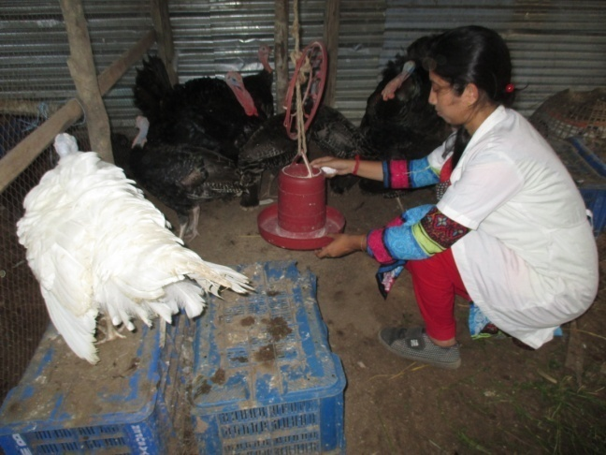
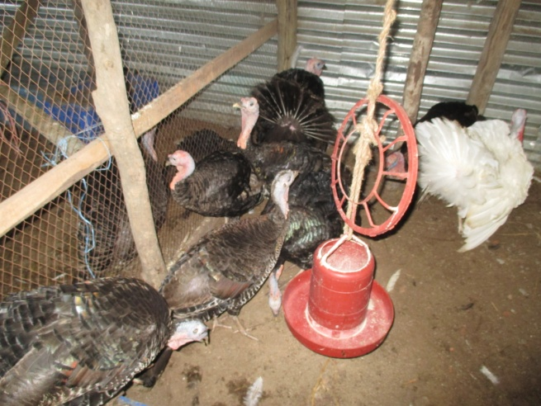

Fig 3.1: Feeding management in patiya turkey farm
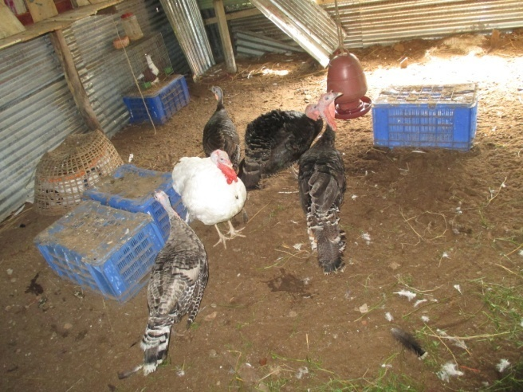
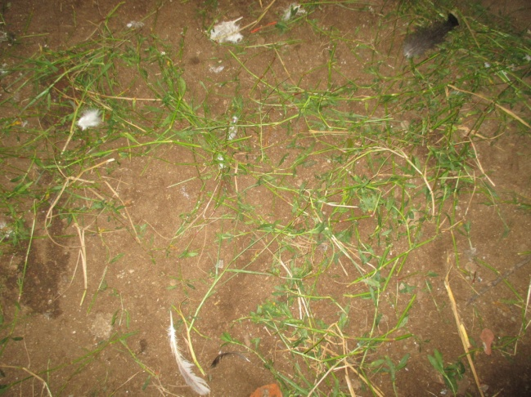

Fig 3.3: Kalmi leaf feeding as roughage

Fig 3.2: Birds are reared in litter system

3.2. Case study-2: Jalalabad turkey farm:
Here is the story of the activities of Mr. maqbool who was rearing turkey in the jalalabad, khulshi, chittagong. At present he has 20 birds. The number of his selling bird was about 40/50 per month at the rate of 4000-4500 taka per bird bearing 6-6.5 kg body weight. His net income was about 12000-16000 taka per month and he got profit from the farm was about 104400-145200 taka per year.
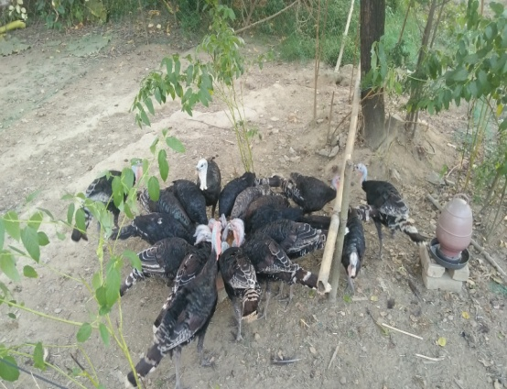
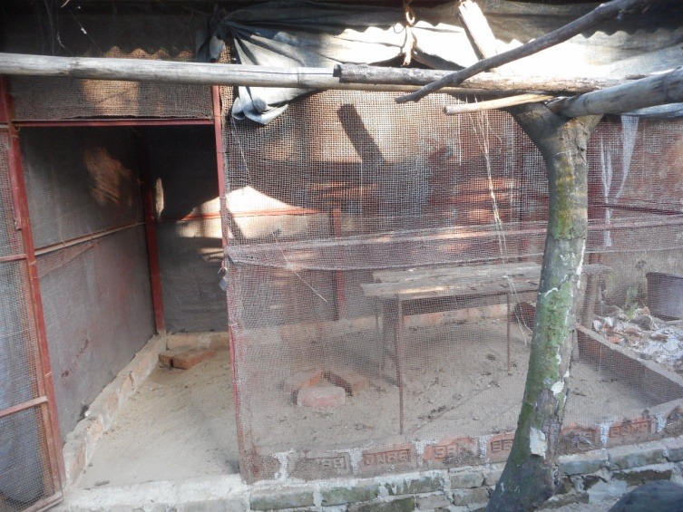

Fig3.4: Housing system in jalalabad farm Fig 3.5:Group feeding
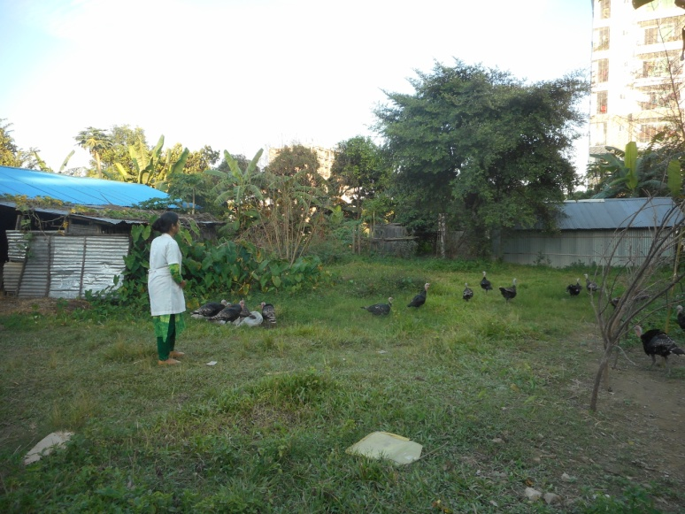
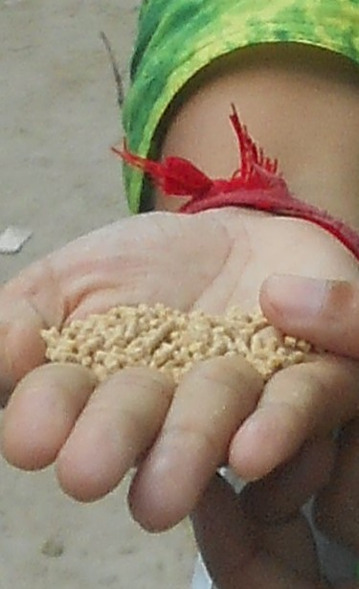

Fig 3.6:Pellet feeding Fig 3.7: Free range rearing system

3.3. Case study-3: Agrabad turkey farm:
Here is the story of the activities of Mr. abdul malek who was rearing turkey in the agrabad, chitttagong. At present he has 19 birds. The number of his selling breeding pair was about 2-3 per month at the rate of 7000 taka per pair. His net income was about 21000-23000 taka per month and he got profit from the farm was about 152640-169800 taka per year.
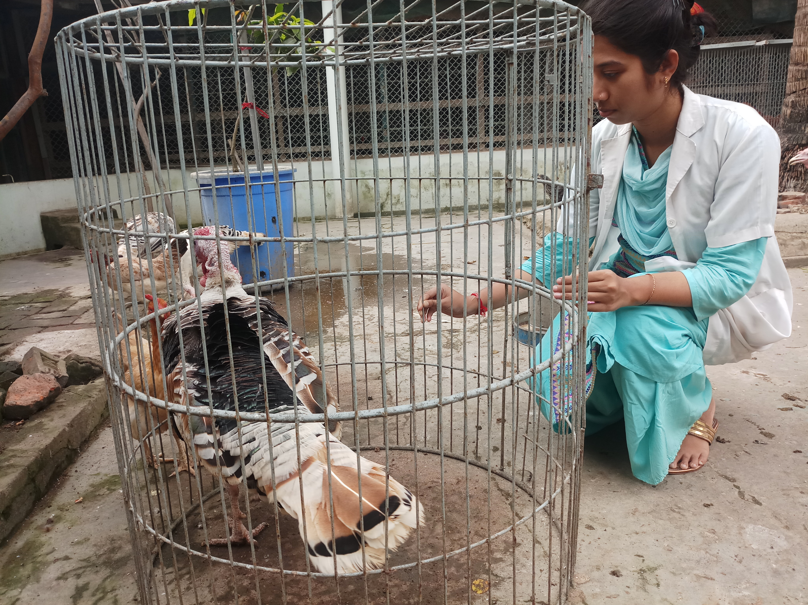
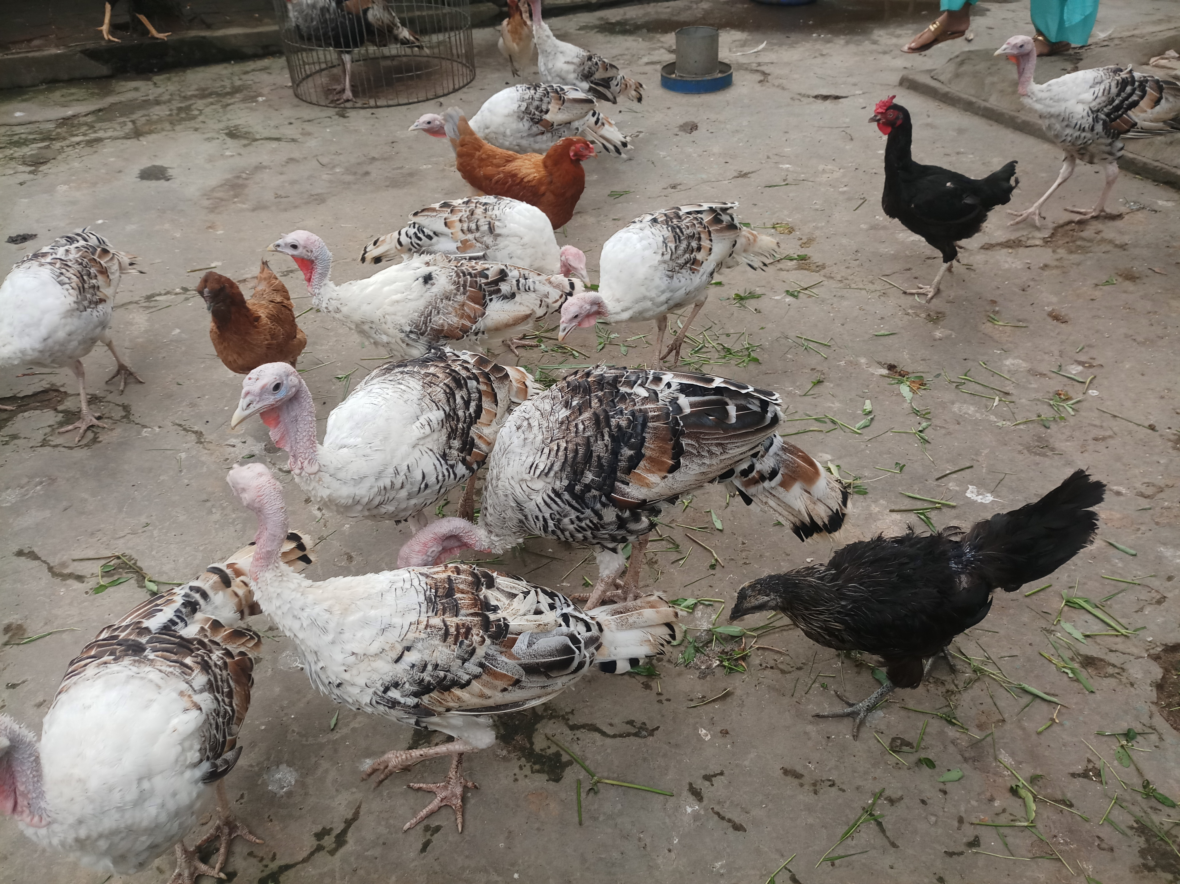

Fig 3.9:Inspection of the male bird

Fig3.8:Turkey rearing along with other poultry species

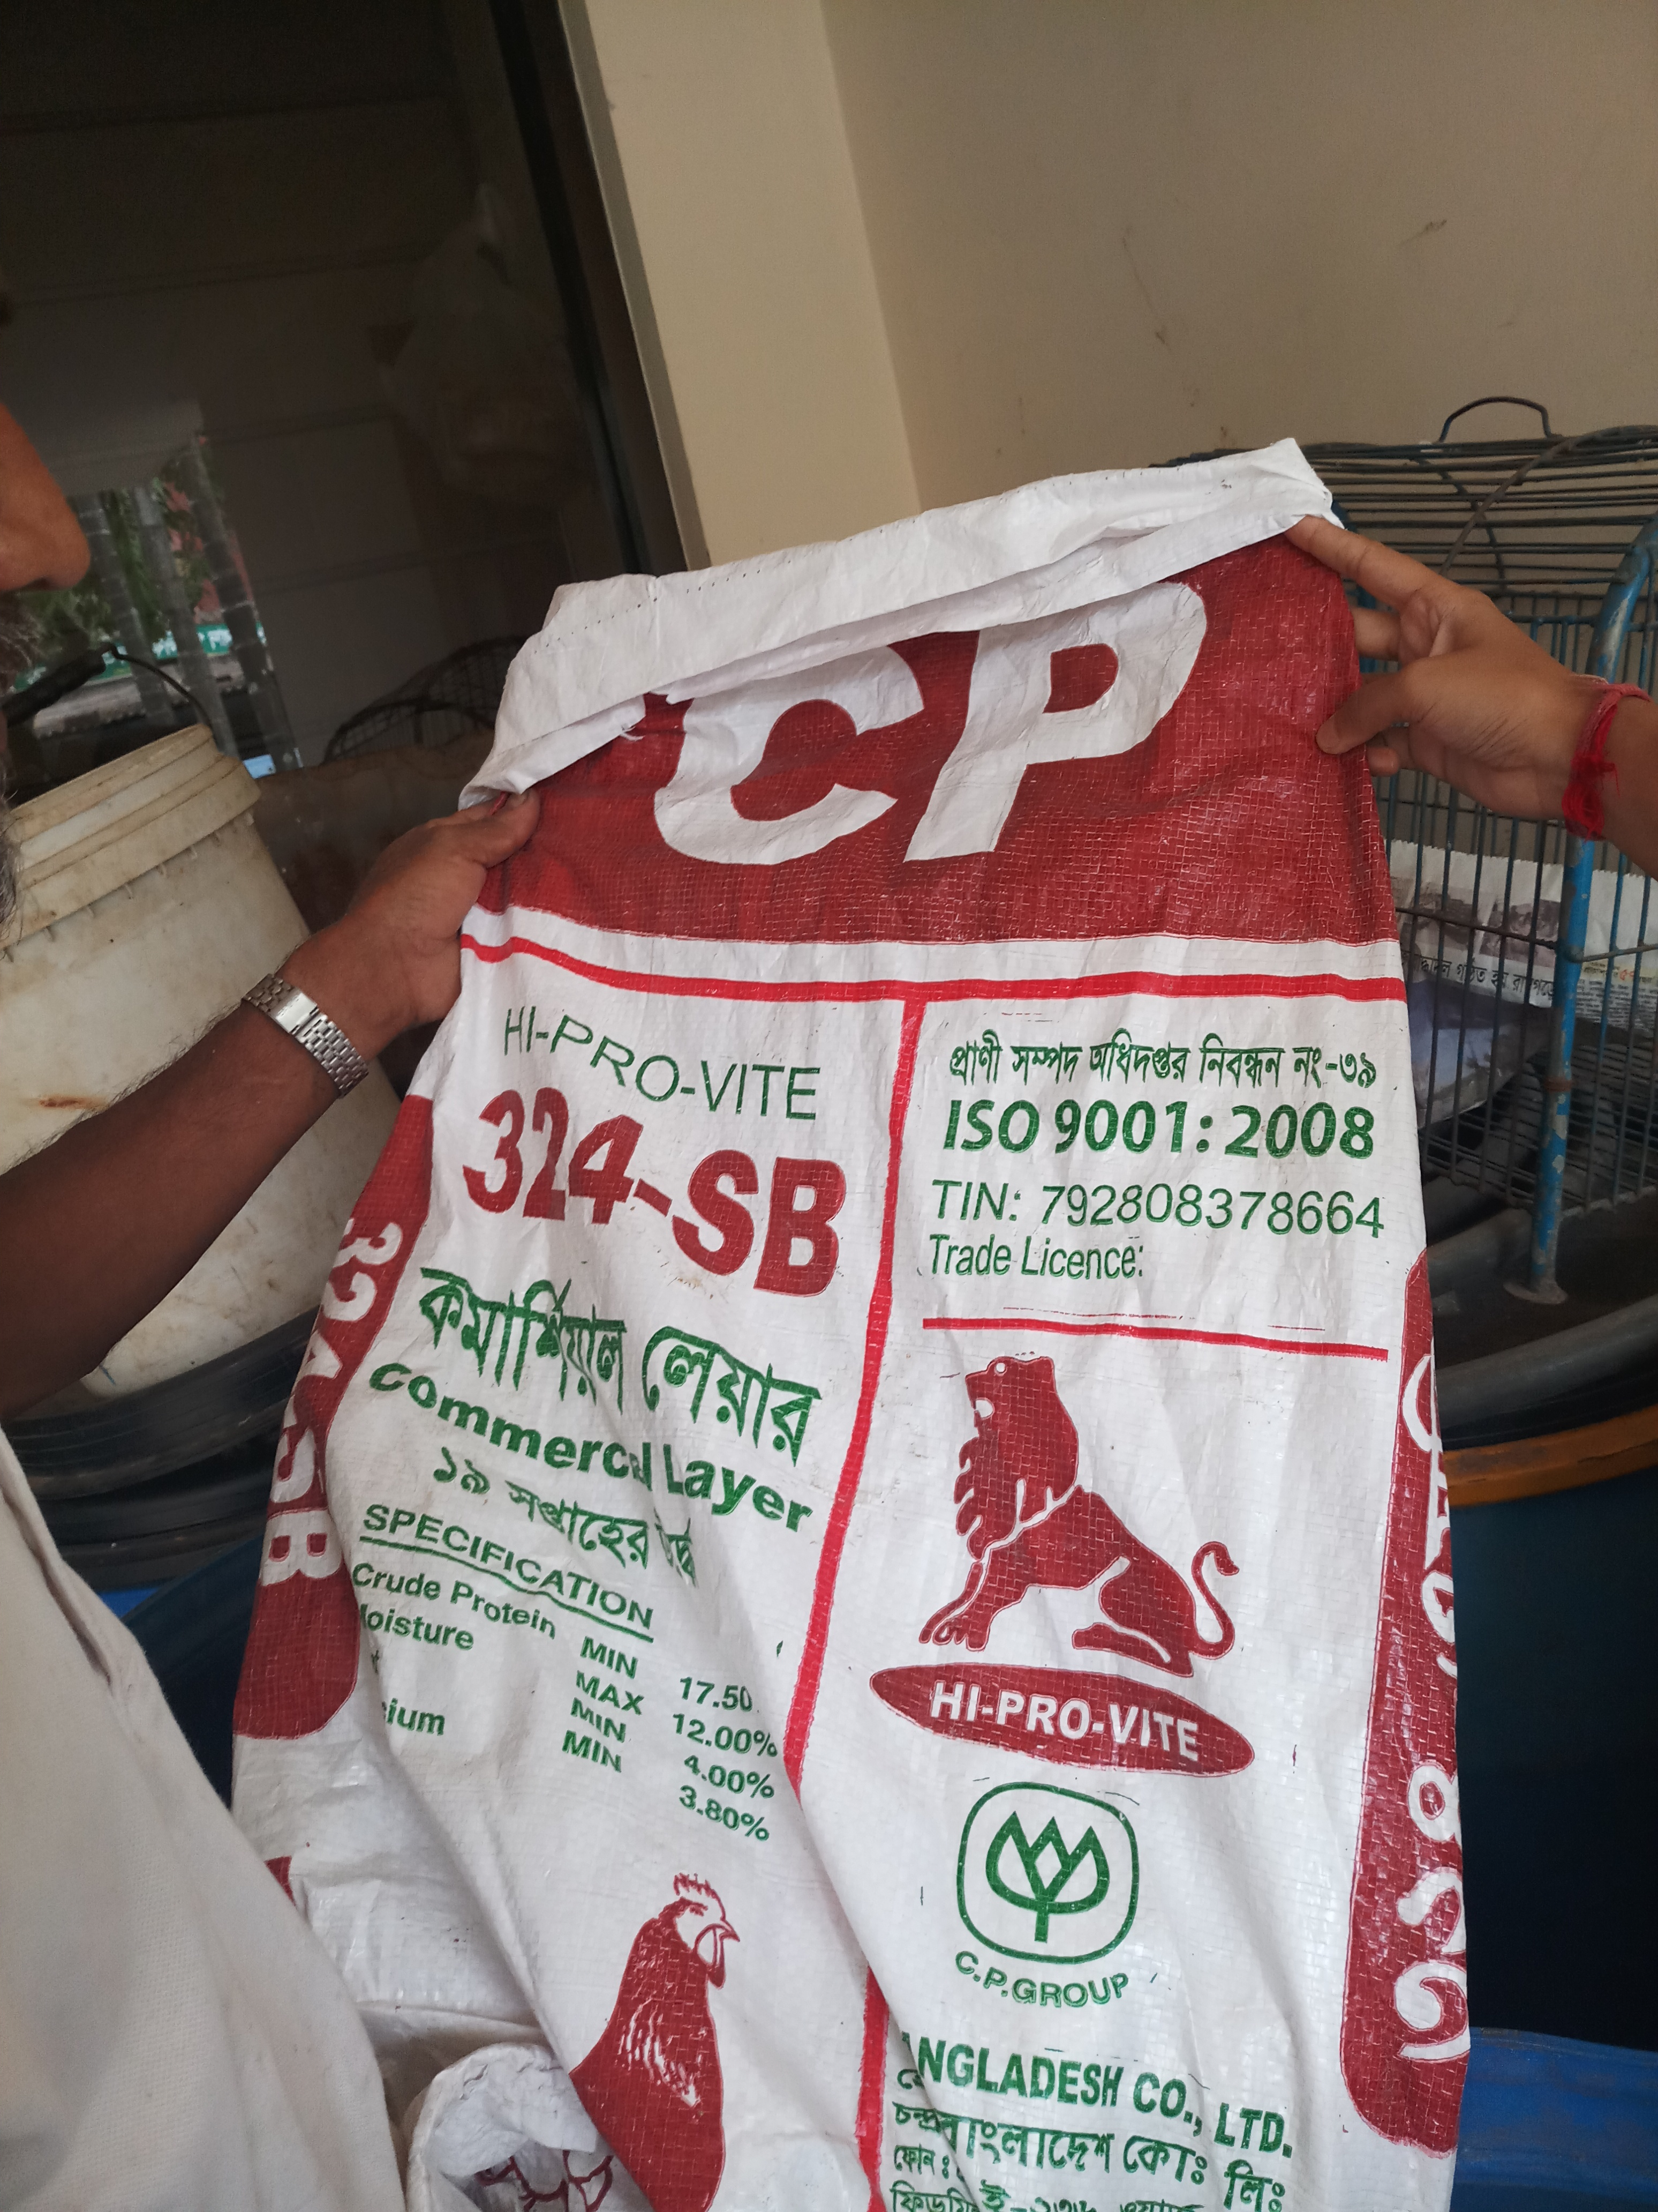
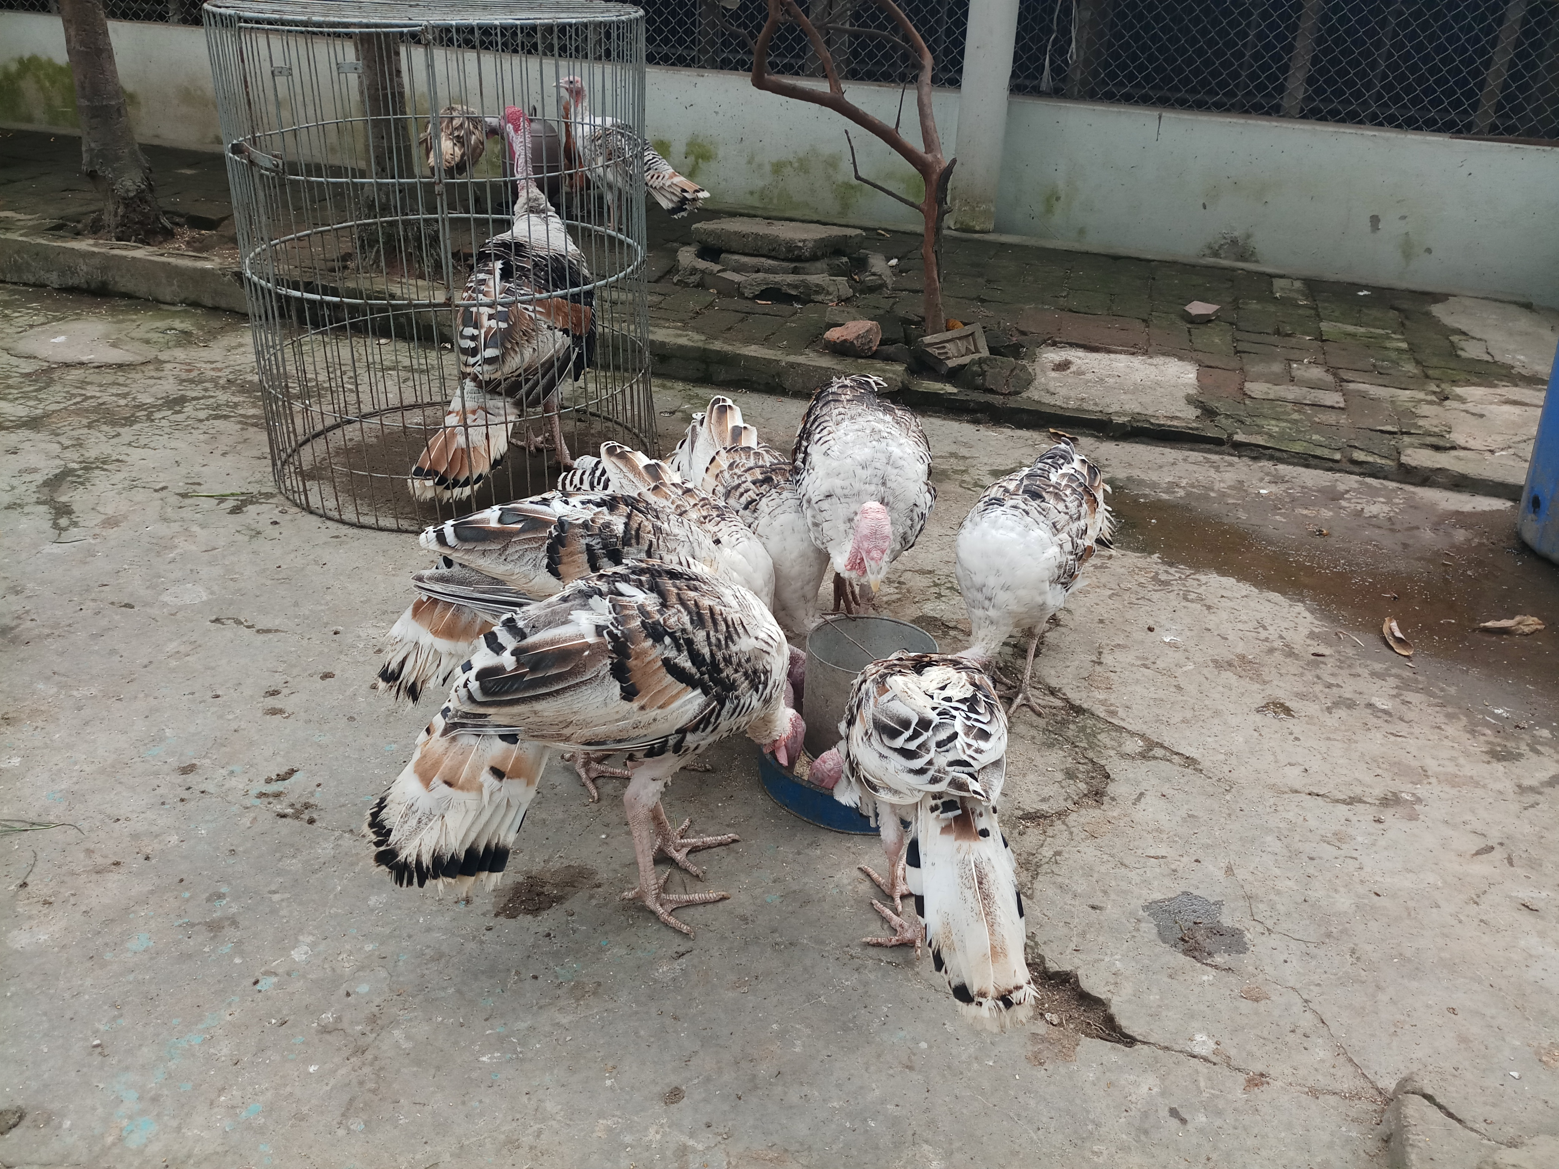

Fig 3.11: Layer feed from CP company.
Fig 3.10:Group feeding observed in agrabad farm

Conclusion
The present study was conducted at three different farms as Patiya, Jalalabad and Agrabad in Chittagong district with the aim of observing the existing of turkey rearing system in chittagong district. During the comparison among the three farms it was found that there were a variation on the farm profitability. The net yearly profit per bird of the three farms patiya, jalalabad, and agrabad which were about 9176 to 9883,5220 to 7260,8034 to 8937 taka. The cost of management per bird per day was about 5-7 , 5.5-6.5 and 5-6 taka. The feed cost of jalalabad farm was higher without having the labour cost compared to other 2 farms. The feed cost can be reduced by giving home made feed to the birds. No substantial conclusion could be drawn from a short term study. The poultry traders are now also taking initiatives to set up new farms with turkey birds.

References
Anandh, M.A., Jagatheesan,P.N.R.,Kumar,P.S.,Paramasivam,A., Rajarajan,G. 2012. Effect of Rearing Systems on Reproductive Performance of Turkey. Veterinary World, 5: 226-229.
Asaduzzaman,M.,Salma,U., Ali,H.S., Hamid,M.A., Miah,A.G. 2017.Problems and prospects of turkey(Meleagris gallopavo) production in Bangladesh. Res. Agricultural. Livestock. Fisheries, 4(2): 77-90.
Begum, I.A.,Alam,M.J., Buysse,J., Frija,A., Huylenbroeck,G.V. 2011. A comparative efficiency analysis of poultry farming systems in Bangladesh: A Data Envelopment Analysis approach. Applied Economics, 44: 3737-3747.
Besbes, B. 2009. Genotype evaluation and breeding of poultry for performance under sub-optimal village conditions. World’s Poultry Science Journal, 65: 260-271.
Brad, B.,Elena,T., Gernat,A. 2010. Maximizing Foraging Behaviour. University of Florida, IFAS Extension,12-13.
BUT, 2005. British United Turkeys .Commercial Performance Goals. 5th ed. British United Turkeys Ltd, Warren Hall, Broughton, UK.
Dzoma, B.M., Motshegwa,K. 2009. A retrospective study of egg production, fertility and hatchability of farmed ostriches in Botswana. International Journal of Poultry Science, 8: 660-664.
Etuk, E.B. 2007. Nutritional composition and feeding value of sorghum in turkey diets. Ph.D. Thesis,Federal University of Technology Owerri, Nigeria.
FAO, 2007. The State of the World’s Animal Genetic Resources for Food and Agriculture, edited by B.Rischkowsky and D. Pilling. Rome.
Fiala, N. 2008. Meeting the demand: An estimation of potential future greenhouse gas emissions from meat production. Ecological Economics, 67: 412-419.
Juliet, A.L., Bakst,M.R. 2008. The current state of semen storage and AI technology. Biotechnology and Germplasm Laboratory, Beltsville Agricultural Research Center, Agricultural Research Service, USDA, Beltsville, MD, U.S.A.
Karki ,M. 2005. Growth, efficiency of utilization and economics of different rearing periods of Turkeys.Nepal Agricultural Research Journal, 6: 89-88.
Malecki, I.A.,Cloete,S.W.P., Gertenbach,W.D.,Martin,G.B. 2004. Sperm storage and duration of fertility in female ostriches. South African Journal of Animal Science, 34: 158-165.
Nixey, C. 1986. A comparison of growth and fat deposition of commercial avian species. 7th European Poultry Conference, Tours, Paris, 24-28.
Ogundipe, S.O., Dafwang, 1980. Turkey Production in Nigeria. National Agricultural Extension Research and Liaison Service (NAERLS), 22: 2-22.
Ojewola, G.S., Udokainyang,A.D., Obasi,V. 2002. Growth, carcass and economic response of local turkey poults to various levels of dietary energy.Proceedings of the 27th Annual Conf. of Nigeria Society for Animal Production, Akure, Nigeria, pp: 167-169.
Okoruwa,V,O.,Obayelu.A.E.,2006. Profitability of Semi-intensive Egg Production in South-West and South-South Zones of Nigeria. Nigerian Journal of Animal Production,33: 118 -125.
Owen, O.J., Amakiri,A.O., Ngodigha,E.M.,Chukwuigwe,E.C. 2008. The Biologic and Economic Effect of Introducing Poultry Waste in Rabbit Diets. International Journal of Poultry Science, 7: 1036-1038.
Peters,S.O.,Ikeobi,C.O.N.Bamkole,O.O. 1997. Smallholder local turkey production in Ogun State,Nigeria, Proceedings of International Network for Family Poultry Development (INFPD). M-Bour, Senegal,9-13,197-208.
Sampath,K.T. 2012. Turkey farming: A profitable enterprise, National Institute of Animal Nutrition and Physiology, Adugodi Bangalore, India, 21: 2.
Soliven, M.E. 1984. Rural turkey rearing in the Philippines. Poultry International, 23: 94.
Speller,C.F.,kemp,B.M.,Wyatt,S.D.,Monroe,C,,Lipe,W.D.,Arndt,U.M.,Yang,D.Y.,2010. Ancient microchondrial DNA analysis reveals complexity of indigenous north Americans Canham domestication.Proceedings of the national of Sciences,107(7):2807-2812.
Turkey Management Guide, 2012. Central poultry development organization (SR), Hessarghatta, Bangalore 560088, Website: http://www.cpdosrbng.Kar.nic.in. Accessed in January 2016.
Wood, B.J., Willems,O.W. 2014. Selection for improved efficiency in poultry, progress to date and challenges for the future. Proceedings of the 10th World Congress on Genetics Applied to Livestock Production,111.
Yakubu, A.K., Abimiku, I.S., Azara,M., Idahor,K.O., Akinsola,O.M. 2013. Assessment of flock structure, preference in selection and traits of economic importance of domestic turkey (Meleagris gallopavo) genetic resources in Nasarawa state, Nigeria. Livestock Research for Rural Development,25: 18.
Yassin,O,E.,Gibril,G.,Hassan,A.H.A., Bushara,B.A. 2013. A Study on Turkey (Meleagris Gallopavo) Raising in the Sudan. Journal of Applied and Industrial Sciences, 1: 11-15.
Zavala,L.A.Rico,T.C.M.,Camacho,H.C.,ChassinNoria,O.,Reyes,U.A., Páram,M.G.Z. 2008. Native turkey (Meleagris gallopavo) backyard production systems’ characterization in the physiographic regions of the state of Michoacan, Mexico. TécPecuMéx. 46: 303-31

Appendix
Prospects and possibilities of turkey in Chittagong district
Questionnaire that was followed during study:
General Informations:
1. Name of the owner:……….2. Age:…
3. Education:Primary/Secondary/Illiterate:
4. Family members:…..Male……female……..
5. Main earning source:………………..
6. Monthly income:………………..
7. Year of establishment of farm:…………..
8. Number of turkey during establishment:…………..
9. Age of birds (during establishments):…………..
10. Male:Female(during establishment):……………….
11. Age of bird during first egg production:……………
12. Purpose of farming (during establishment): Meat/Egg
13. Purpose of farming (present day):Egg selling/Selling of turkey
14. What is the main sell product now:
15. Amount of selling per month:
16. Amount of selling per week:
17. Earn by selling:
18. Cost of farming:Daily………..Monthly………
Cost:
1. Area of farm:…………….
2. Price of farm area:…………
3. Farm made by:Bamboo/Tinshed/Brick:
4. Measurement:Length…………Wide:…………..Height:………………
5. Permanent labour:………..Salary of worker: Daily……….Monthly……….
6. Do you work(owner):yes/no
7. Your family member work in the farm…….Number:…………
8. Freerange for birds:yes/no.. Space…………..
9. Fencing:yes/no space……………..
10. Permanent feed cost:…………………….
Daily temporary cost:
1. Labour:Daily/Weekly/Monthly
2. Daily feed cost:…………..
3. Feed ingredients:…………….
4. Feed type:Ready made/Home made
5. Name of feed company: (If ready made):……….
6. Name of feed ingredients (If home made):…………………
7. Mixing type:…………
8. Mixing ratio:……….
9. Daily feed given:……………
10. Cost of per kg feed:……………
Feeding Management:
1. Frequency of feeding (daily)………
2. Amount:……………..
3. Feeding type: Group/individual:……………..
4. Male and female birds fed on same place or group:……..
5. Watering frequency (daily):……….
6. Amount of water given:…………
7. Water pot: Temporary/Permanent
8. Supplement used in feed: yes/No
Routine Work:
1. Who perform the work:………….
2. Time of working in farm:………….
3. Time of egg collection:…………
4. Number of egg(daily):……….percentage:…………
5. Litter material:……….
6. Amount and thickness of litter:……….
7. Frequency of litter changing:………….
Disease management and vaccination:
1. Name of vaccine used with age:……………..
2. Name of common diseases:

Biosecurity:
1. Cleaning of feeder: Every………2.Cleaning of waterer: Every……..
3. Biosecurity management:…………
4. use of…net……spray……fencing……
5. What disinfectant is used to wash the vehicle:……..
6. What are the by products/waste products;……
7. Do you sell the by products:………
8.Income from selling by products:………..
9. Do you use this for biogas production:…………….
Equipment and hatchery management:
1. Do you have incubator:…………
2. Days in hatcher:……………Days in setter…………….
3. Hatchability percentage:………….
4. Mortality percentage:……….
5. Liability:……………
Others:
1. Age of selling male birds:…………..
2. Weight of male during selling:…………
3. Selling price:…………
4. Age of maturity of female:…………..
5. Number of egg/year:……….
6. How many weeks remain in egg production:………..
7. Price of egg:Fertile………………Table:…………..
8. Ratio of table egg and fertile egg:………………..
9. Problems of turkey rearing:
- -
- -
- -
10. What is your future plan about turkey rearing-

Name of Interviewee Name of Interviewer
Date: Date:
Signature: Signature:

Acknowledgements
The author wishes to acknowledge the immeasurable grace and profound kindness of Almighty “GOD” the supreme authority and supreme ruler of universe, who empowers the author to handle the case and to complete the case report successfully.
The author wishes to express his deep sense of gratitude and thanks to Proffesor Dr. Md. Hasanuzzaman, Department of Animal science and Nutrition, Chittagong Veterinary and Animal Sciences University for his skillful supervision and guidance to make this report.
The author would like to thank to the Director of External affairs, Professor. Dr. A.K.M. Saifuddin, Department of Physiology, Biochemistry and Pharmacology, Chittagong Veterinary and Animal Sciences University.
Finally the author expresses thanks and warmest sense of gratitude to her parents and all well-wishers.

The author,
December,2017

Biography
Intern Doctor of Veterinary Medicine
Chittagong Veterinary and Animal Sciences University
E-mail: kaberycvasu17@gmail.com
Mobile: +8801863347809

Personal Profiles:
Name: Kaberi Talukder
Father’s name: Pranesh Chandra talukder
Mother’s name: Khela Rani Talukder
Permanent address: Vill: Gangadharpur, Thana: Jamalgonj
Zilla: Sunamgonj.
Date of birth: 31st October, 1994
Nationality: Bangladeshi
Religion: Hindu
Blood group: B+

Academic Qualification:

Name of the Examination/  Course | Educational Institution | Educational Board | Year of passing | Grade
SSC | Agrabad Balika Bidyalay | Chittagong | 2009 | 5.00(out of 5)
HSC | Govt. Hazi mohammad Mohsin College | Chittagong | 2011 | 5.00(out of 5)
DVM | Chittagong Veterinary and Animal Sciences University | CVASU | ----- | -------

My Goal:

As a human being, I have a long cherished dream to serve my nation through my knowledge, creativity and profession. As a veterinarian, I think I have a great opportunity to fulfill my dream by developing my career in the field as a veterinary practitioner. By dealing as a veterinary surgeon, I would be able to expand and spread my knowledge also.I have also a high interest in Medical Research, Wildlife Conservation and Eco health approach.

