Nutritional Status of Different Tree Leaves for Poultry and Livestock Diet
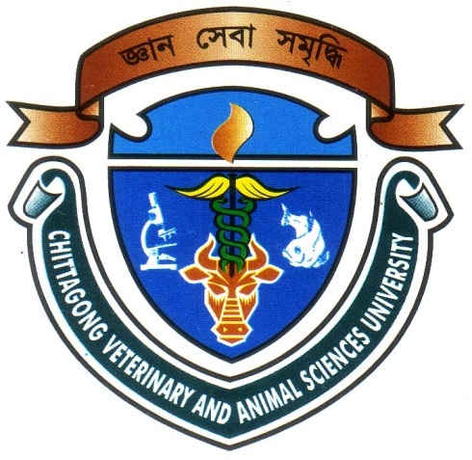

Submitted By

Roll No: 12/10

Registration No: 00730

Intern ID: A-10

Session: 2011-2012

A production report submitted in partial fulfillment of the requirements for the degree of

Doctor of Veterinary Medicine

Faculty of Veterinary Medicine

Chittagong Veterinary and Animal Sciences University

Khulshi, Chittagong- 4225

December 2017
Nutritional Status of Different Tree Leaves for Poultry and Livestock Diet

-------------------------------
(Signature of the supervisor)
Dr. Md. Manirul Islam
Professor & Head

Department of Animal Science & Nutrition

Faculty of Veterinary Medicine

Chittagong Veterinary and Animal Sciences University

Khulshi, Chittagong- 4225

December 2017
Table of contents
Contents Page no.
Abstract ………………………………………………......................................... iv
Chapter 1: Introduction………………………………………………………......1
Chapter 2: Materials and Methods…………………............................................3
2.1. Study area…………………………………………………………………......….3
2.2. Collection of plant material…………………………………………………….......3
2.3. Preparation of sample………………………………………………………….......3
2.4. Analysis of sample…………………………………………………………….......3
2.5. Calculation of ME…………………………………………………………......…..6
2.6. Statistical analysis...................................................................................................6
Chapter 3: Results…………………………………………………………......….8
3.1. Dry matter…………………………………………………………………......…8
3.2. Crude protein…………………………………………………………….....…….8
3.3. Crude fiber…………………………………………………………………......…9
3.4. Ether extract……………………………………………………………….....…..9
3.5. Nitrogen free extract……………………………………………………….....…...9
3.6. Total ash……………………………………………………………………........9
3.7. Metabolizable energy.............................................................................................10
Chapter 4: Discussion……………………………………………………...……11
Chapter 5: Conclusion…………………………..................................................13
Chapter 6: References………………………………...........................................14
Limitations.............................................................................................................16
Acknowledgements………………………………………………………...…….17
Biography…………………………………………………………………...……18

Abstract

Satisfying the nutritional requirement of a particular class of livestock is rapidly becoming a difficult task. This is due to scarcity and high cost of feed and feed ingredients. The study was conducted to ascertain the nutrient status of olive and carambola leaves in order to use in poultry and livestock diet and to examine for cheaper non-conventional feed resources that can be used as plant protein instead of high cost animal protein. Chemical analyses of the samples were carried out in triplicate for moisture, dry matter (DM), crude protein (CP), crude fiber (CF), nitrogen free extract (NFE), ether extract (EE) and total ash (TA) in the Animal Nutrition Laboratory, Chittagong Veterinary and Animal Sciences University, Chittagong, Bangladesh. Metabolizable energy (ME) was also calculated mathematically for all samples by using standard formula. The nutritive value of carambola leaves are 12.54% CP, 14.76% CF, 2.02% EE, 7.27% TA and 52.24% NFE. The olive leaves contain10.44% CP, 35.94% CF, 1.60% EE, 3.45% TA and 41.40% NFE. The ME content of carambola and olive leaves are 2745.38 kcal/kg and 2979.17 kcal/kg respectively. So, the carambola and olive leaves may be considered as non-conventional feed sources in poultry and livestock diet as they contain moderate levels of fiber and protein and also other nutrients. This study will also help in further study if a feed trial in poultry and livestock with these leaves will be held.

Keywords: Non-conventional feed, carambola, olive, leaves, nutritive value

